**Task 5**

**Date:** 14 Oct 2020

**Author:** Shelley Zhao

**Application:** BlogEngine.NET version 3.2

**Environment:** Test Environment

**Test Environment configuration:**

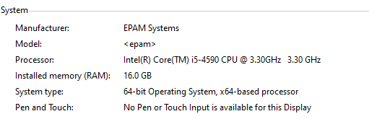

1. **Goals:**

* Design editor script and scenario
* Get base line on performance of particular editors’ regular actions.

1. **Prerequisites:**

* Create 2 edit user
* editor 111111
* editor2 111
* Generated 100 posts

1. **Test script description**

Edit script

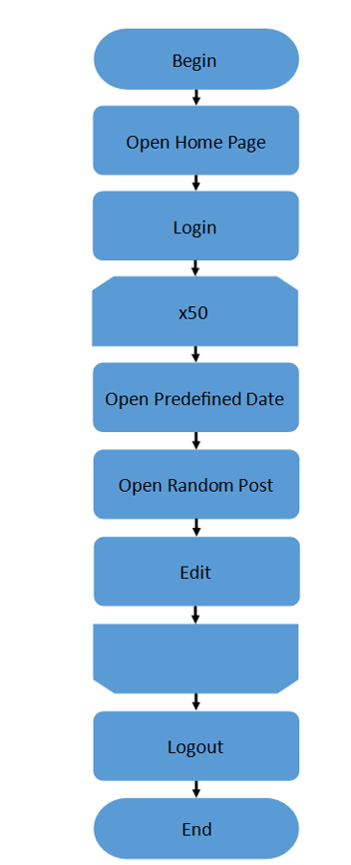

1. **Tests:**

**User Defined Variables**

user_num 2

host epcnszxw0226.princeton.epam.com

PostRegex (test-post-[1-9]\d*)

Protocol http

* 1. **Smoke Testing**

**Settings:**

* Ramp-up period=10s
* Number of Threads =1
* Loop Count=1

**Result**

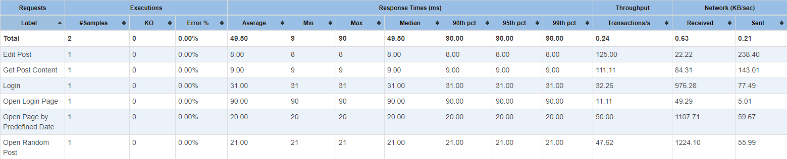

**Conclusion**

All the requests have been executed in proper response time without error there the smoke testing **PASSED.**

* 1. **Load testing**

**Settings:**

* Ramp-up period=20s
* Number of Threads =1
* Loop Count=50

**Result**

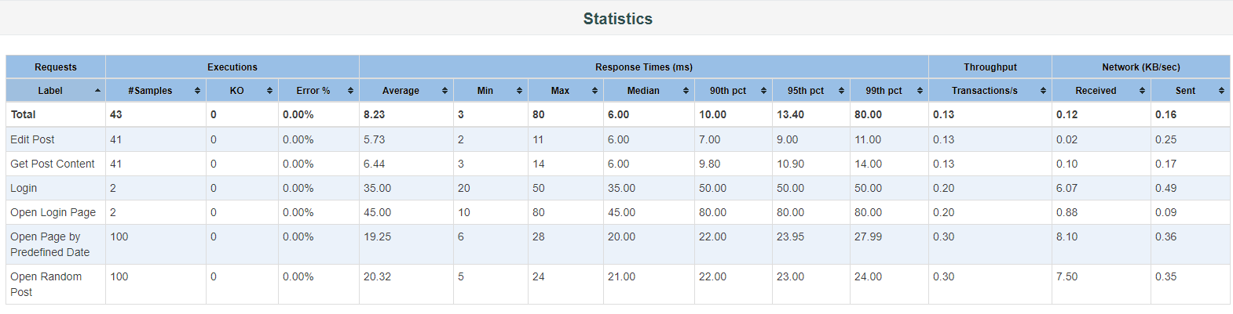

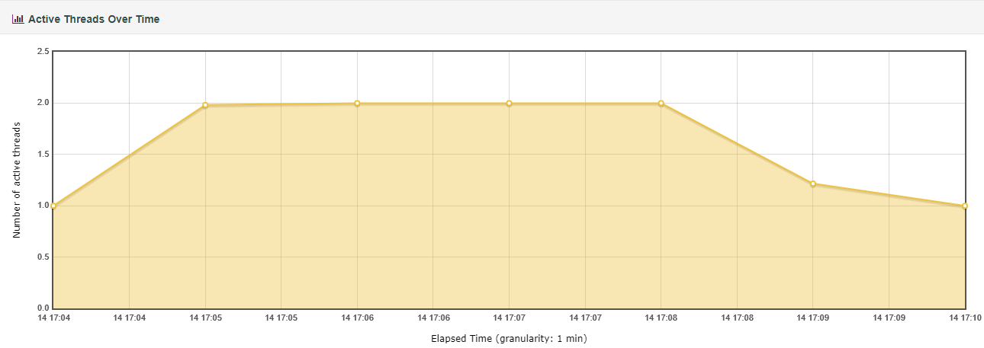

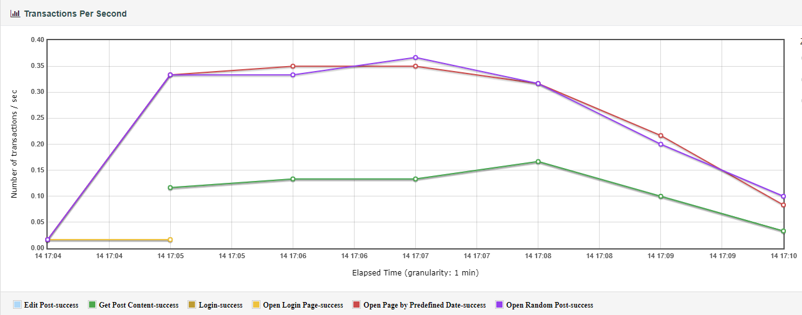

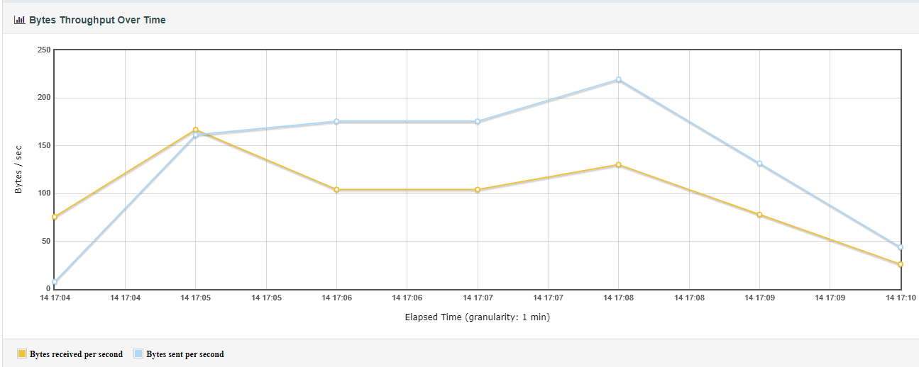

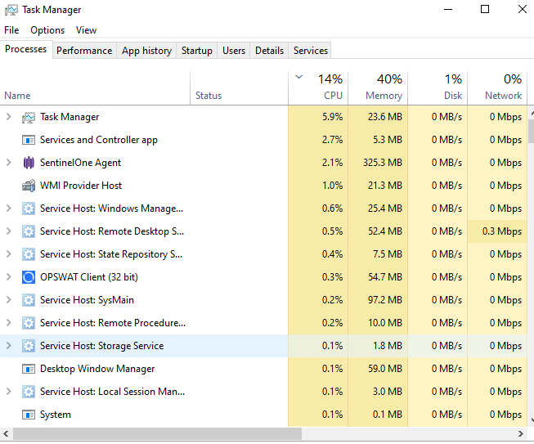

**Conclusion**

* During the baseline testing the system behavior is stable.
* The baseline of response time for user edit is 6ms