**Task 6**

**Date:** 22 Oct 2020

**Author:** Shelley Zhao

**Application:** BlogEngine.NET version 3.2

**Environment:** Test Environment

**Test Environment configuration:**

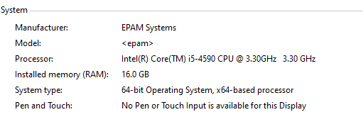

1. **Goals:**

* Get an experience of smooth update of the script according to new requirements and cases
* Get an experience in regression testing (like after new version uploaded)
* Get an experience in volume testing
* Improve skills in comparison and analysis

1. **Prerequisites:**

* Generated 100 posts
* Generated 1000 posts

1. **Test script description**

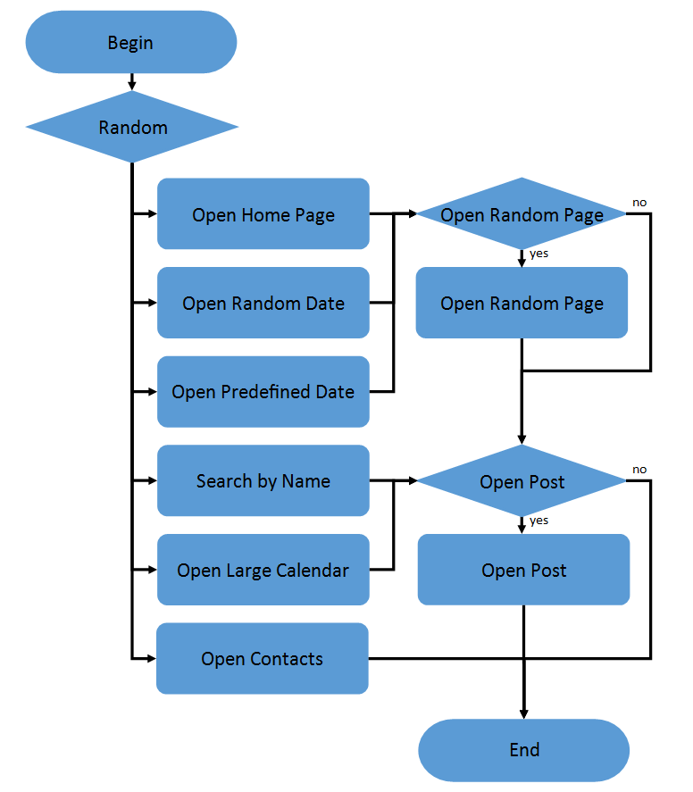 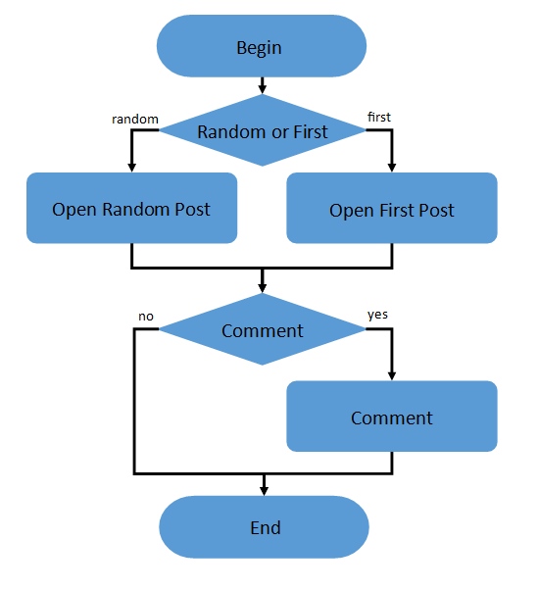

1. Home Page: 15%

2. Open Random Date: 10%

3. Open Predefined Date: 30%

4. Search by Name: 30%

5. Open Large Calendar: 10%

6. Open Contacts: 5%

Open Random page (yes/no):

50% / 50%

Open post (yes/no):

80% / 20%

Random or First (yes/no):

65% / 35%

Comment (yes/no):

20% / 80%

1. **Tests:**

**User Defined Variables**

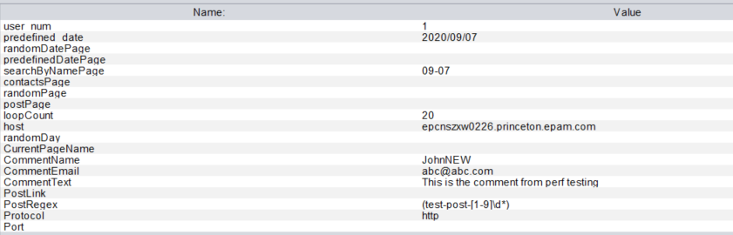

* 1. **Smoke Testing**

**Settings:**

* Ramp-up period=10s
* Number of Threads =1
* Loop Count=10

**Result**

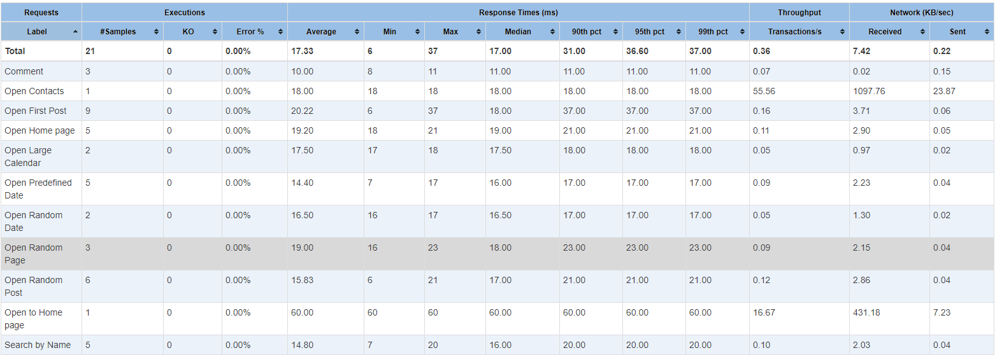

**Conclusion**

All the requests have been executed in proper response time without error there the smoke testing **PASSED.**

* 1. **Capacity testing**

**Round 1 – 100 post**

**Settings**

* Ramp-up period=10s
* Number of Threads =65
* Duration= 800
* Loop Count=60

**Result**

1. **Task 3**

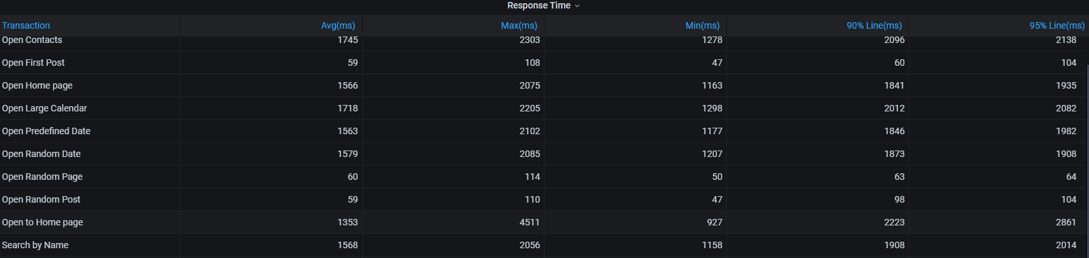

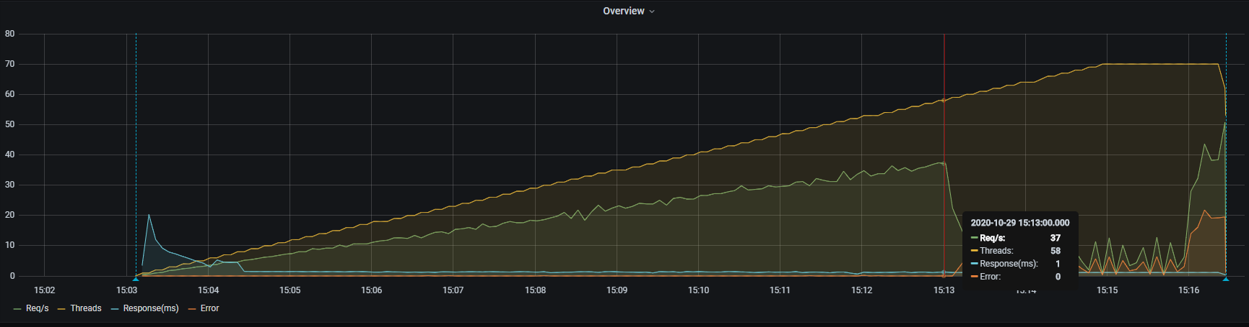

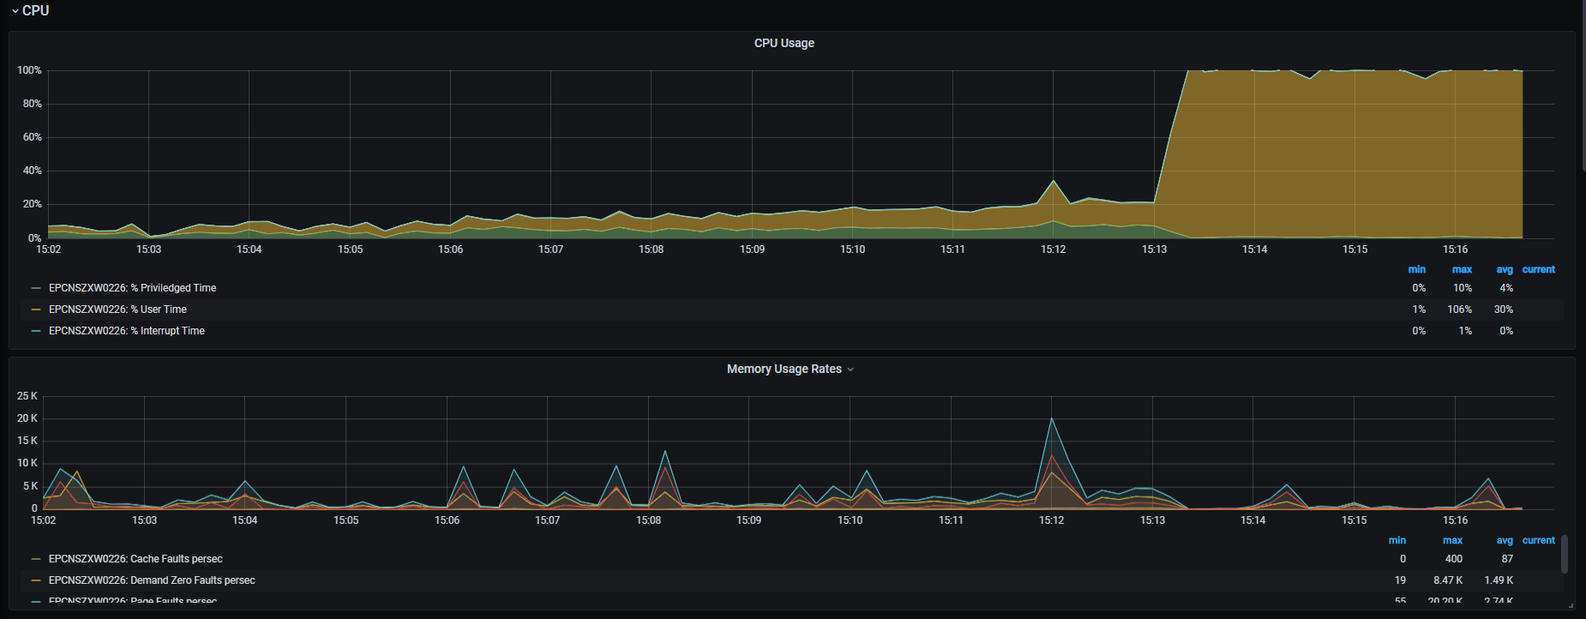

Snaphost：<https://snapshot.raintank.io/dashboard/snapshot/bhXJSkIsQUfZB1CgtsaIDH5U76ugffMC>

At this period, the avg response time and CPU% began to increase but req/s decrease at the same time, so it is means that **saturation** point was met when thread=**58**

**B . Task 6**

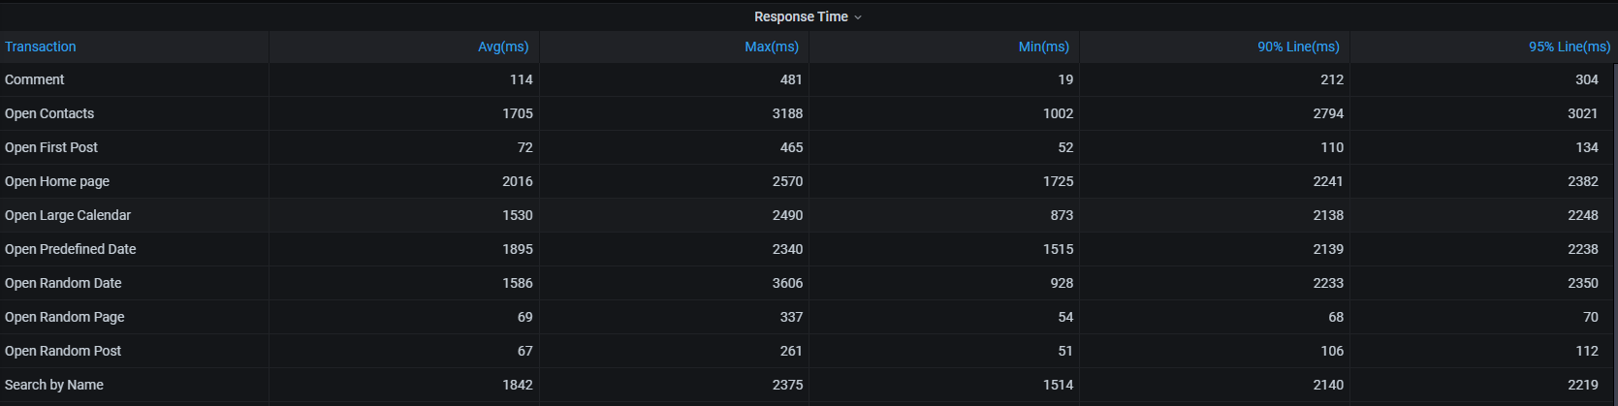

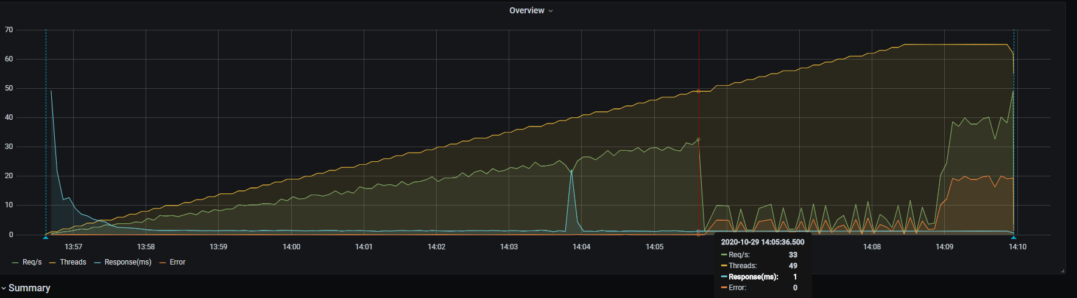

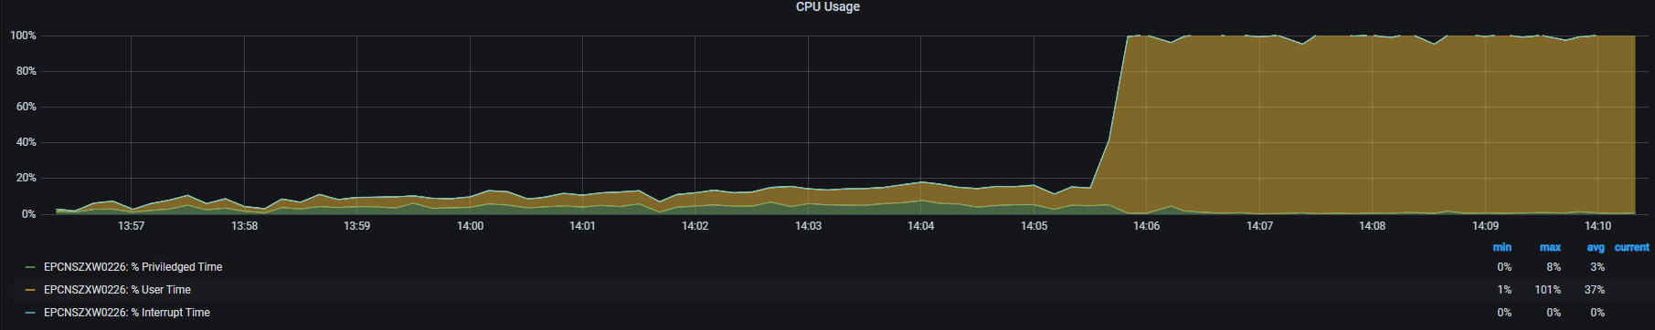

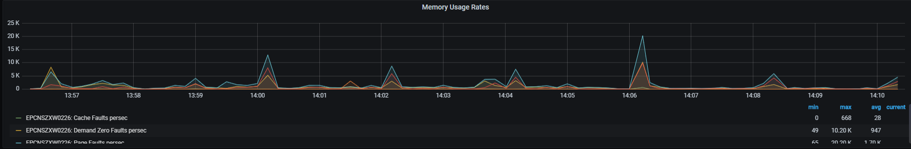

Snapshot： <https://snapshot.raintank.io/dashboard/snapshot/e9BZstXEc2gTmOt4XmbOGMPijgOqiyYf>

At this period, the avg response time and CPU% began to increase but req/s decrease at the same time, so it is means that **saturation** point was met when thread=**49**

**Round 2 – 1000 post**

**Settings**

* Ramp-up period=10s
* Number of Threads =65
* Duration= 800
* Loop Count=60

**Result**

1. **Task 3**

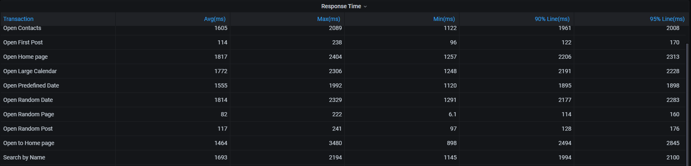

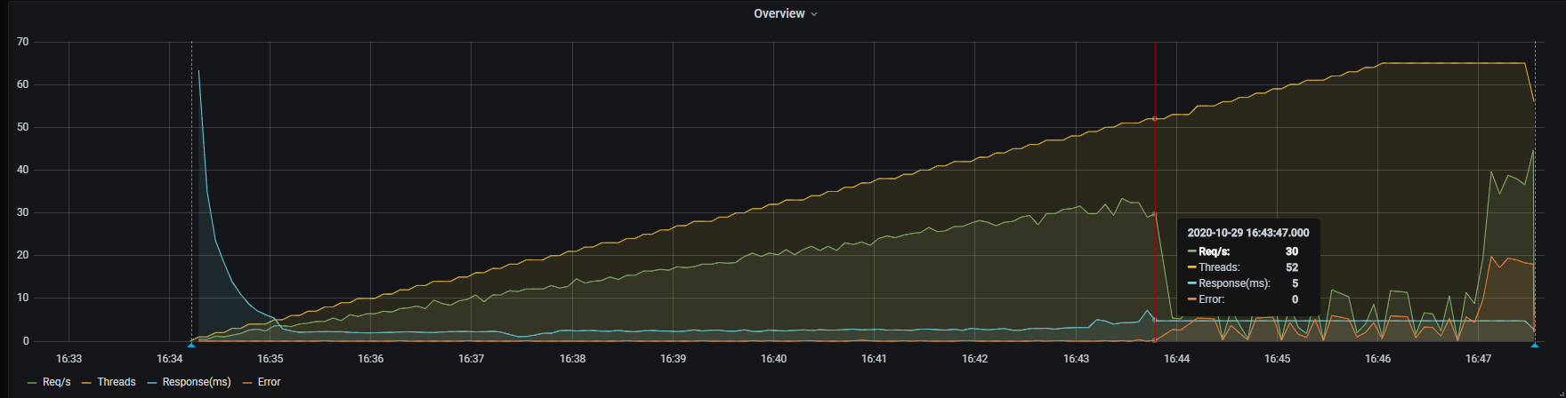

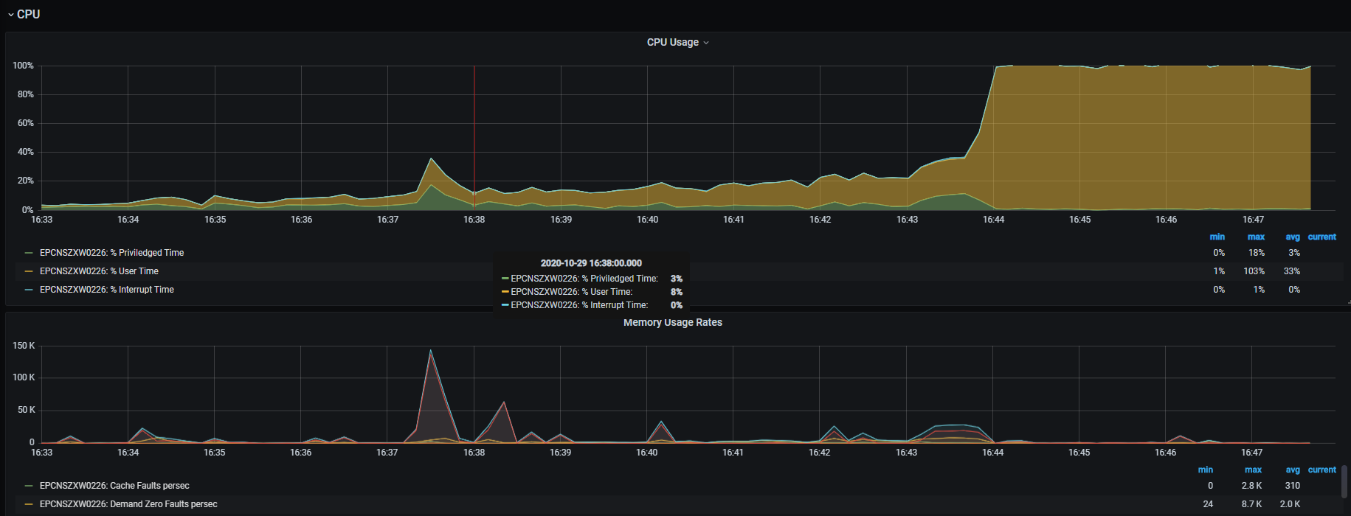

Snapshot： <https://snapshot.raintank.io/dashboard/snapshot/ccuQpxXP8QFT37nCcCcYdS0x7jwSivdr>

https://snapshot.raintank.io/dashboard/snapshot/SdybFzk9uG8ASo10P3mnYBpv3Fp2NH3l

At this period, the avg response time and CPU% began to increase but req/s decrease at the same time, so it is means that **saturation** point was met when thread=**52**

1. **Task 6**

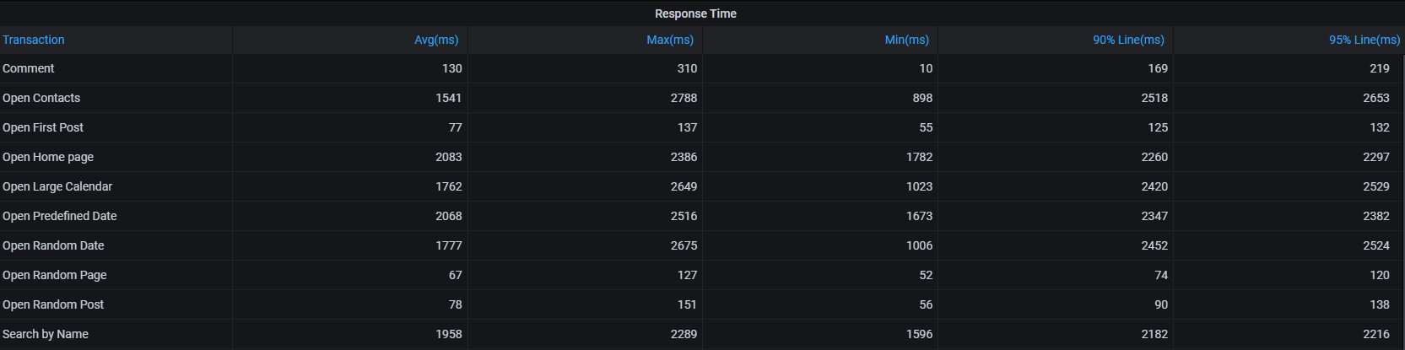

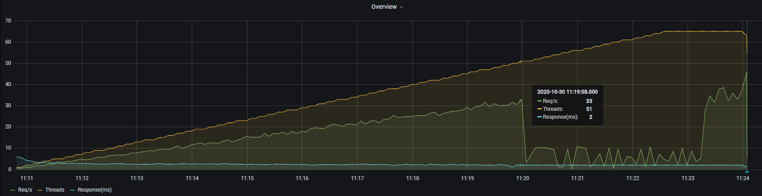

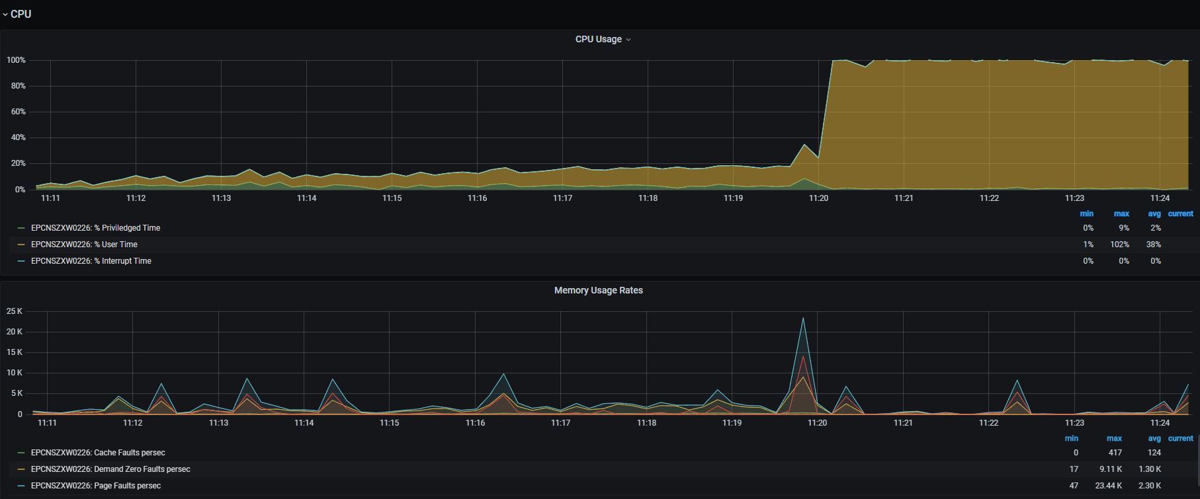

Snapshot <https://snapshot.raintank.io/dashboard/snapshot/6SmUbW2820RYc0QpxzgXIq48lPn6GTSi>

<https://snapshot.raintank.io/dashboard/snapshot/lpd9PXHkBdUePsmU4Xp01TBLMSynrP22>

At this period, the avg response time and CPU% began to increase but req/s decrease at the same time, so it is means that **saturation** point was met when thread=**51**

**Conclusion**

|  |  |  |
| --- | --- | --- |
| **Capacity** | **Round1(100)** | **Round2(1000)** |
| Task 3 | 58 | 52 |
| Task 6 | 49 | 51 |

Base on above test data

* The system capacity is different according to user behavior in small volume.
* The system capacity is quite similar under big volume.