**Task 7**

**Date:** 2 Nov 2020

**Author:** Shelley Zhao

**Application:** BlogEngine.NET version 3.2

**Environment:** Test Environment

**Test Environment configuration:**

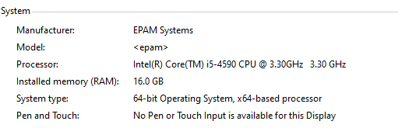

1. **Goals:**

* Design combined script and scenario
* Get an experience of combined testing with different user roles

1. **Prerequisites:**

* Generated 1000 posts

1. **Test script description**

**Anonymous**

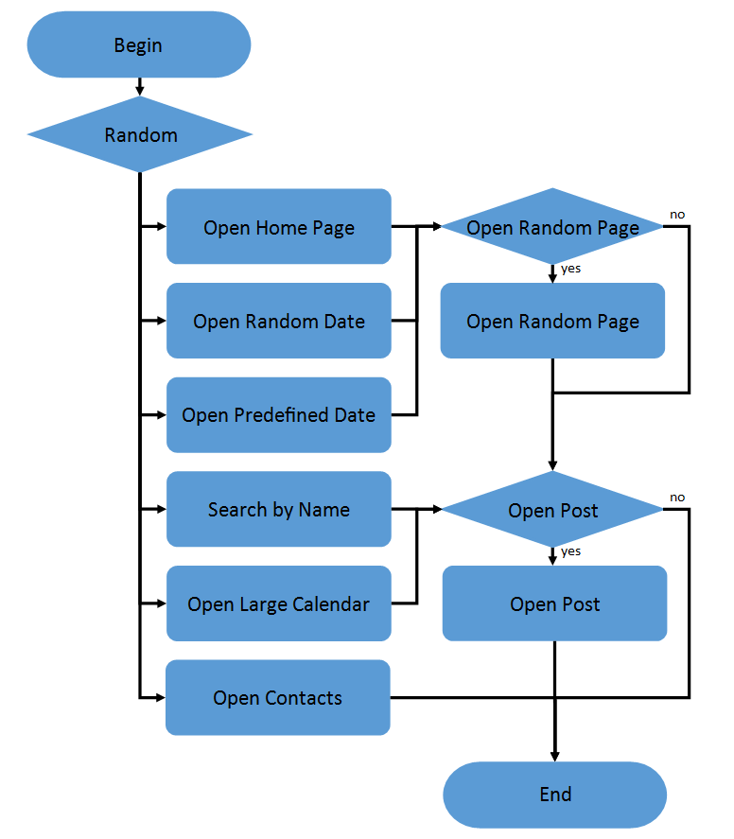 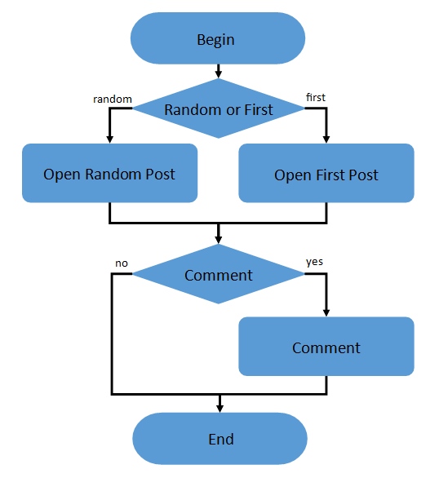

1. Home Page: 15%

2. Open Random Date: 10%

3. Open Predefined Date: 30%

4. Search by Name: 30%

5. Open Large Calendar: 10%

6. Open Contacts: 5%

Open Random page (yes/no):

50% / 50%

Open post (yes/no):

80% / 20%

Random or First (yes/no):

65% / 35%

Comment (yes/no):

20% / 80%

**Admin**

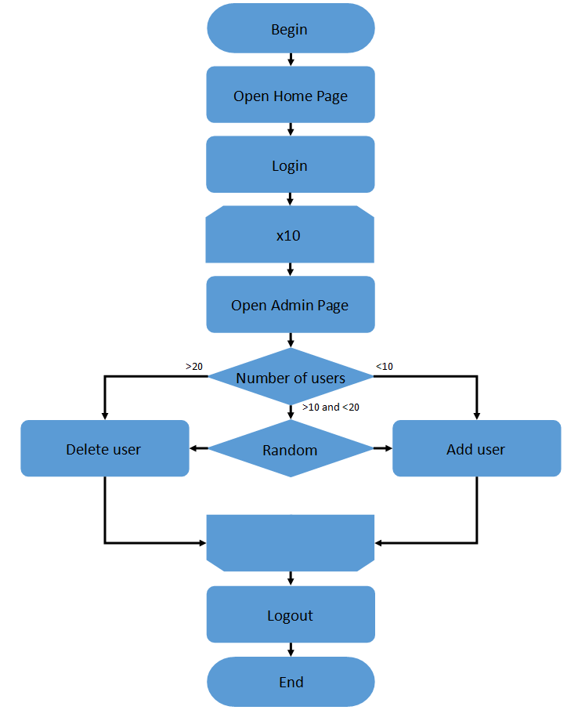

**Editor**

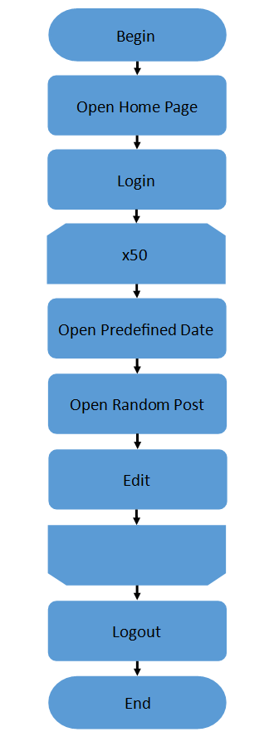

1. **Tests:**

**User Defined Variables**

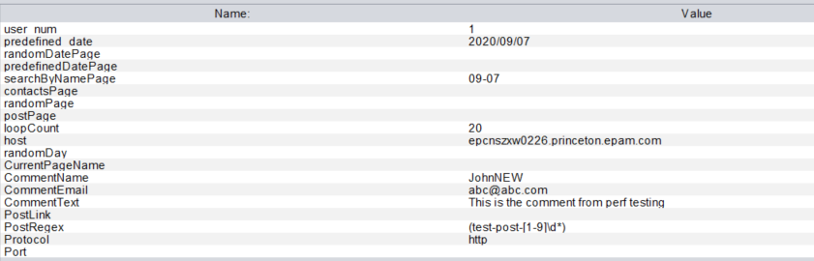

* 1. **Smoke Testing**

**Settings:**

* Ramp-up period=5s
* Number of Threads =1
* Loop Count
  + Main = 15
  + Admin=5
  + Editor=1

**Result**

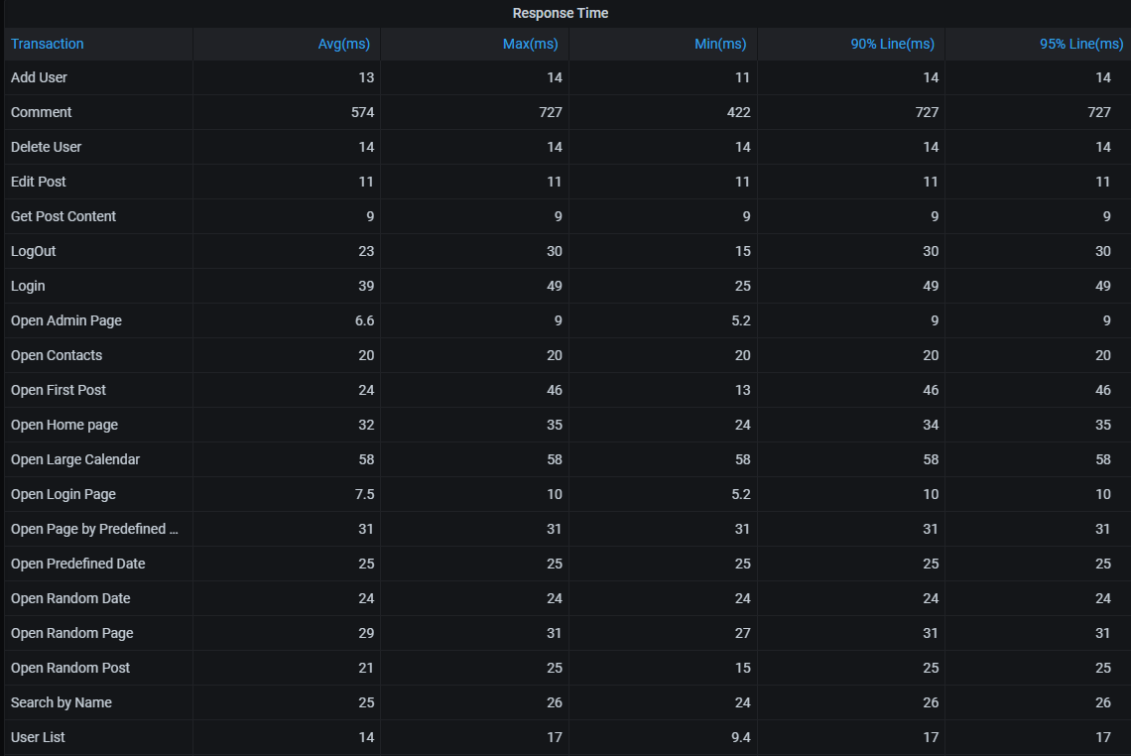

**Conclusion**

All the requests have been executed in proper response time without error there the smoke testing **PASSED.**

* 1. **Capacity testing**

**Settings**

According to pervious testing result the system is unstable around 45 concurrent users so in this testing is using 40 thread for main script.

* Ramp-up period=600
* Duration= 720
* Number of Threads
  + Main=40
  + Admin=2
  + Editor=2

**Result**

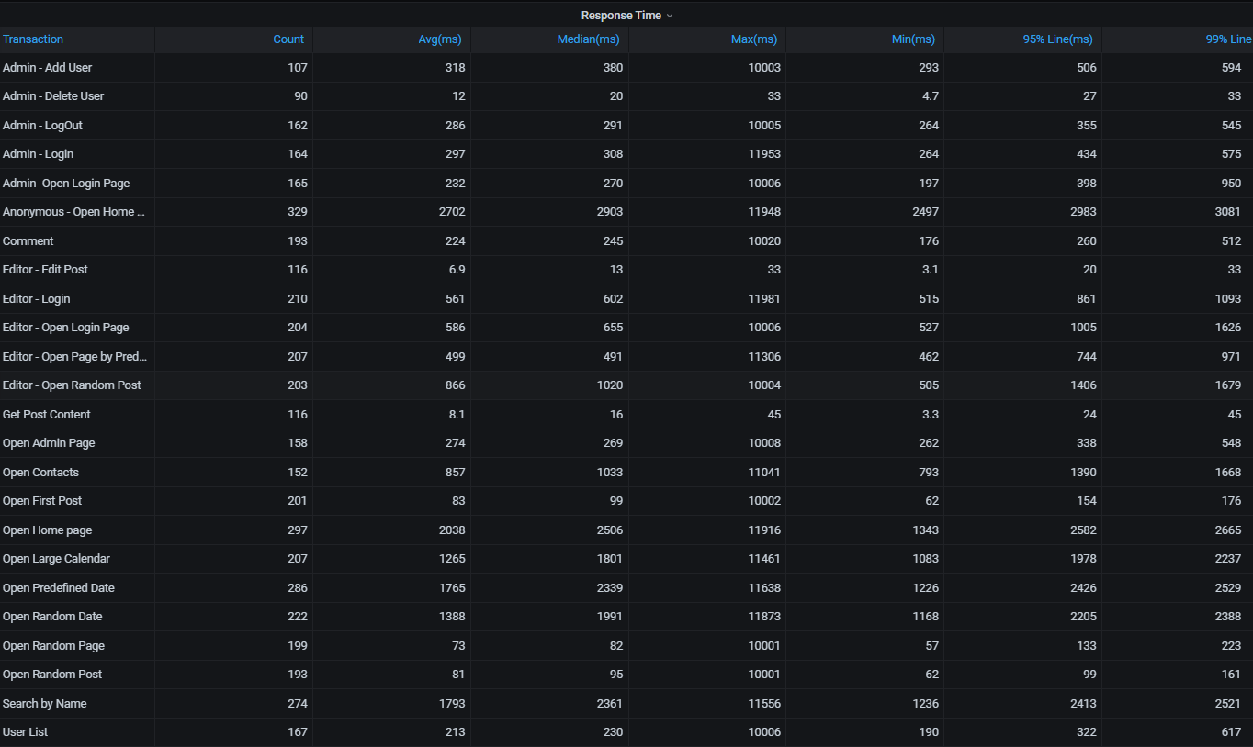

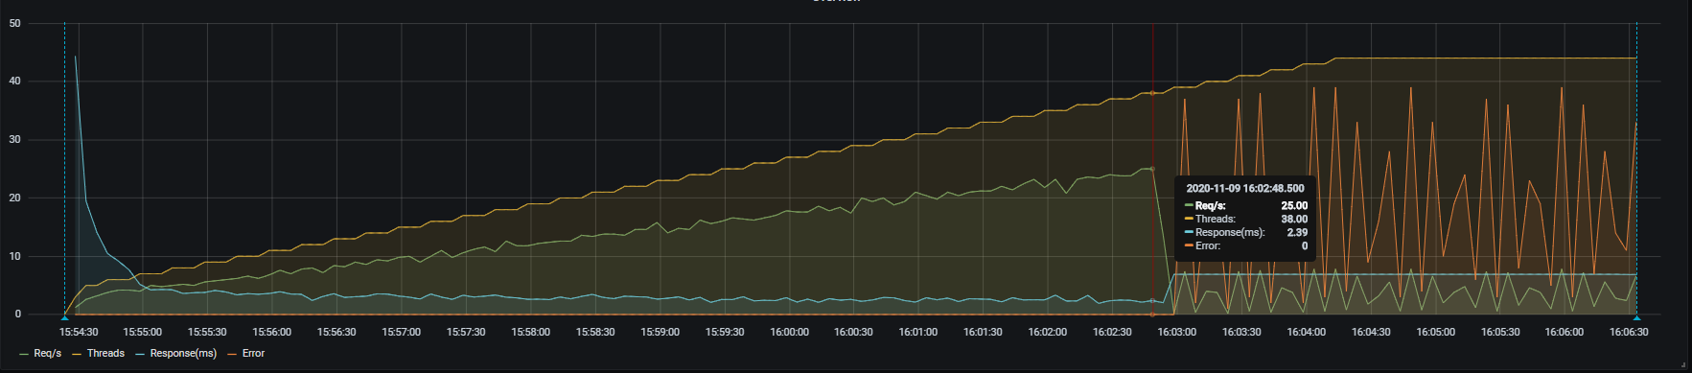

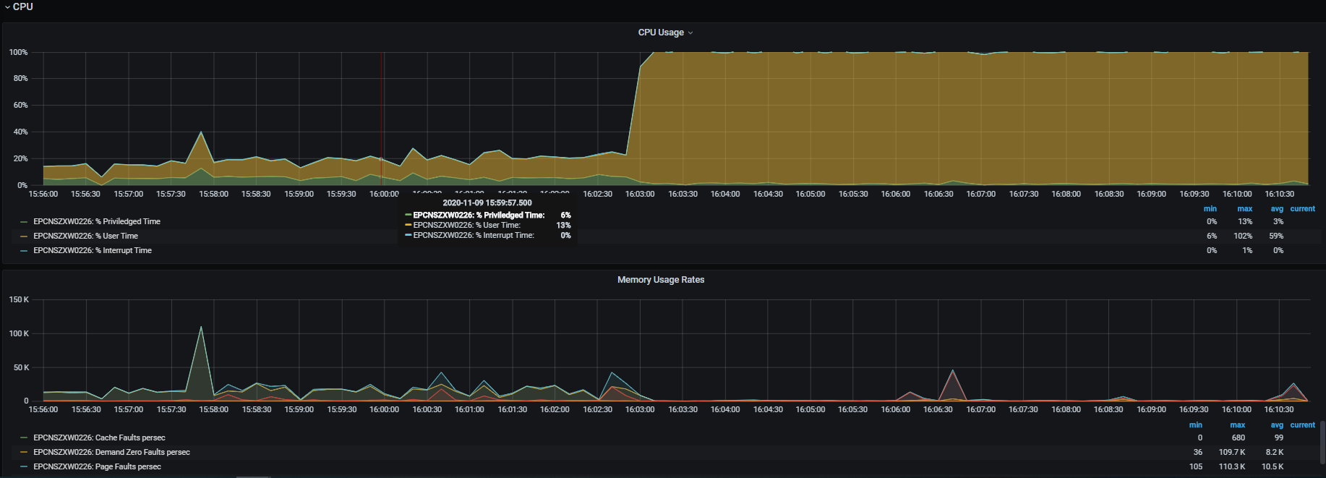

Snaphost：https://snapshot.raintank.io/dashboard/snapshot/9u91bnvma7A9nJkSaBdyvvdS1T1ylHAy

https://snapshot.raintank.io/dashboard/snapshot/6jQrnn2WewvRZMRrSLwy2GpN8AChdq6A

**Conclusion**

* At this period, the avg response time and CPU% began to increase but req/s decrease at the same time, so it is means that **saturation** point was met when thread=**38** with **25reqs/s**