**Task 8**

**Date:** 20 Nov 2020

**Author:** Shelley Zhao

**Application:** BlogEngine.NET version 3.2

**Environment:** Test Environment

**Test Environment configuration:**

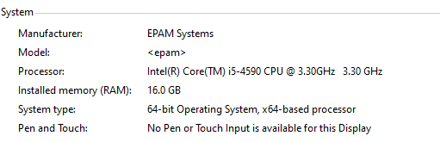

1. **Goals:**

* Get an experience on regular load definition.
* Get an experience on KPI definition and calculation.
* Get an experience of scalability testing.

1. **Prerequisites:**

* Generated 1000 posts
* Results of Capacity testing from Task 7.

1. **Test script description**

**Anonymous**

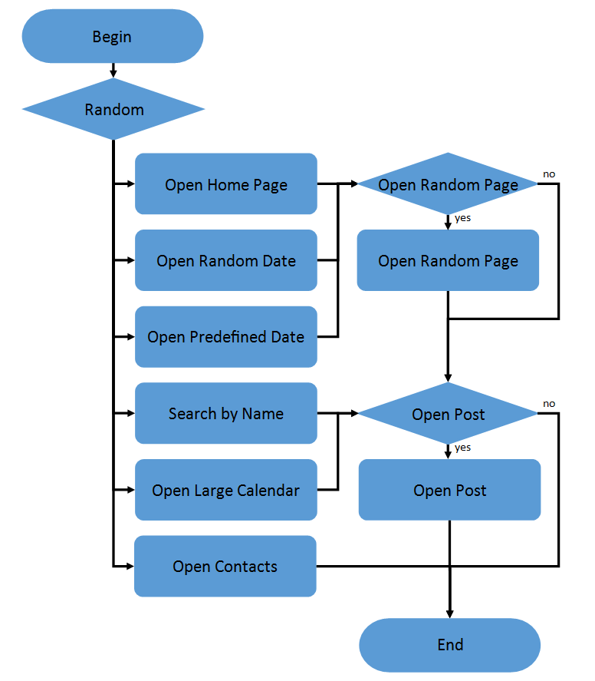 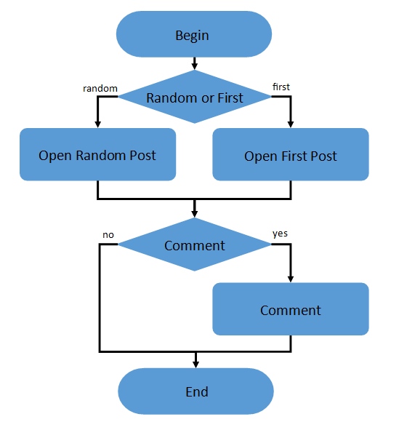

1. Home Page: 15%

2. Open Random Date: 10%

3. Open Predefined Date: 30%

4. Search by Name: 30%

5. Open Large Calendar: 10%

6. Open Contacts: 5%

Open Random page (yes/no):

50% / 50%

Open post (yes/no):

80% / 20%

Random or First (yes/no):

65% / 35%

Comment (yes/no):

20% / 80%

**Admin**

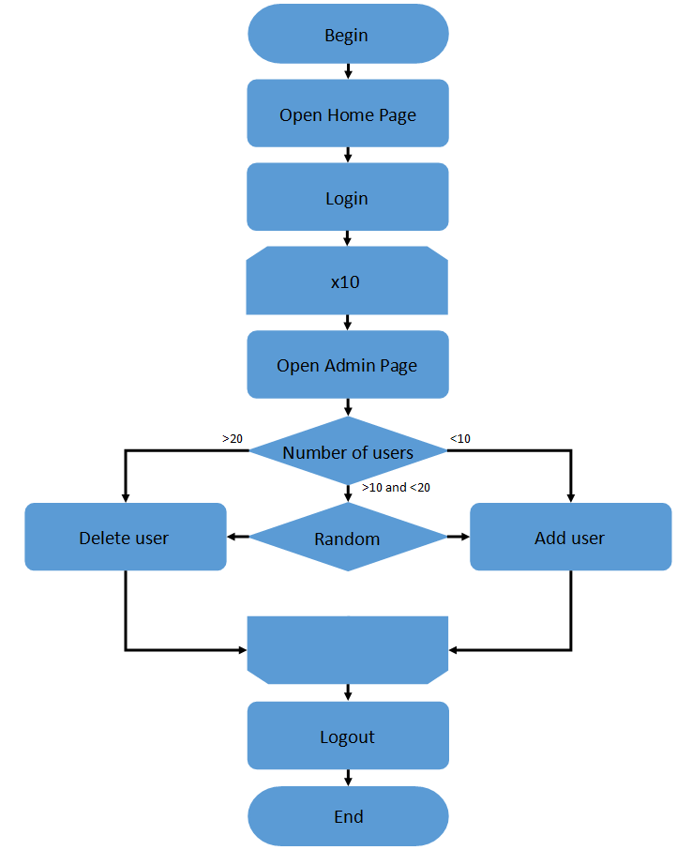

**Editor**

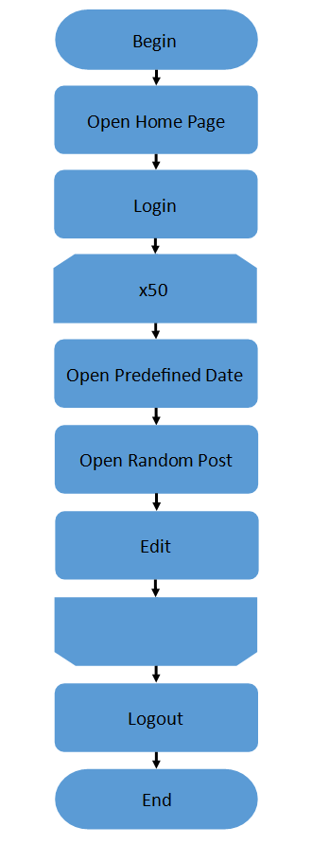

1. **Tests:**

**User Defined Variables**

|  |  |  |
| --- | --- | --- |
| **Variables Name** | **Value** | **Description** |
| predefined_date | 9/7/2020 | The date use to create post |
| searchByNamePage | 7-Sep | Search post by name |
| loopCount | 60 | loop controller setting |
| host | epcnszxw0226.princeton.epam.com | Server name |
| CommentName | JohnNEW | add comment - user |
| CommentEmail | abc@abc.com | add comment - email |
| CommentText | This is the comment from perf testing | add comment - content |
| PostRegex | (test-post-[1-9]\d*) | Extract post link |
| Protocol | http |  |

* 1. **Scalability Testing**

**Settings:**

|  |  |  |  |
| --- | --- | --- | --- |
| **Role** | **Ramp-up period(s)** | **Number of Threads** | **Loop Count** |
| Anonymous | 30 | 32 | 50 |
| Admin | 5 | 2 | 10 |
| Editor | 5 | 2 | 50 |

**Scaling CPU – 1 Result**

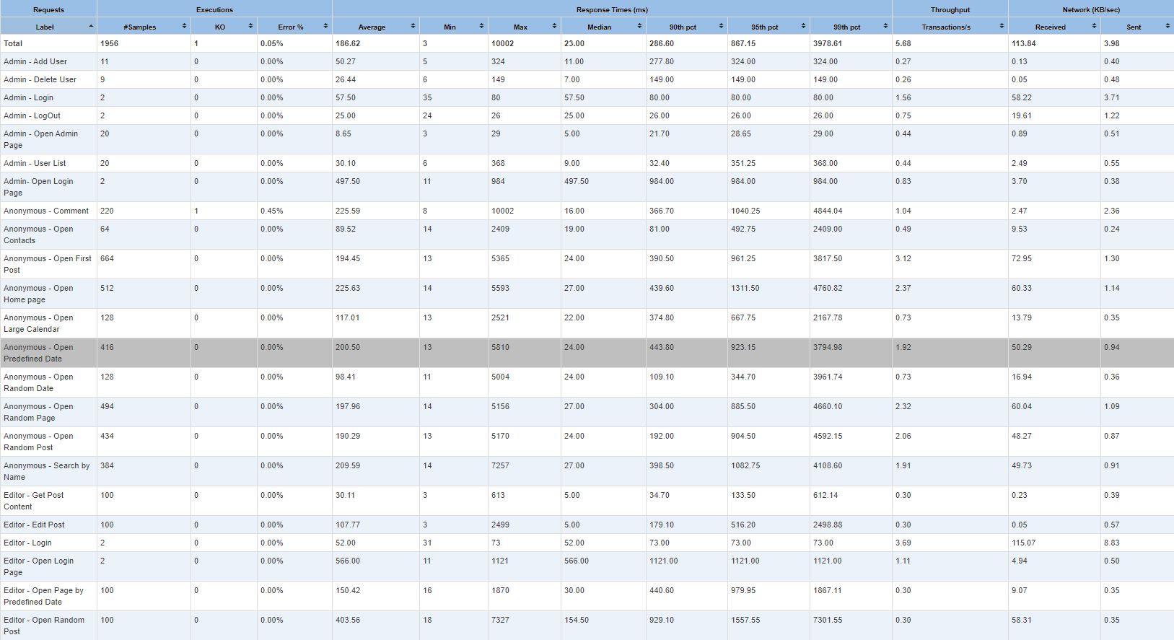

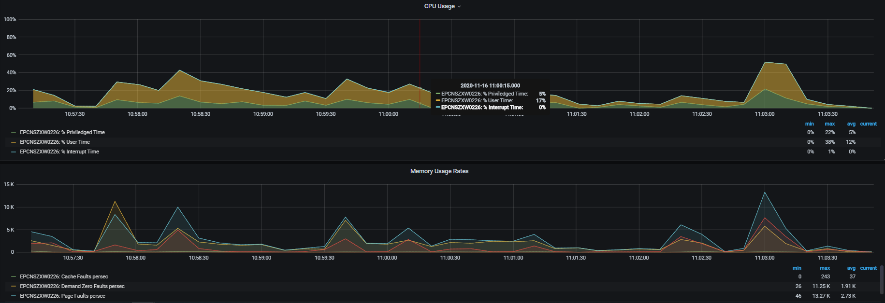

**https://snapshot.raintank.io/dashboard/snapshot/nhomCwJXwHqdFVYTettnytGAQiujmBt7**

**Scaling CPU – 2 Result**

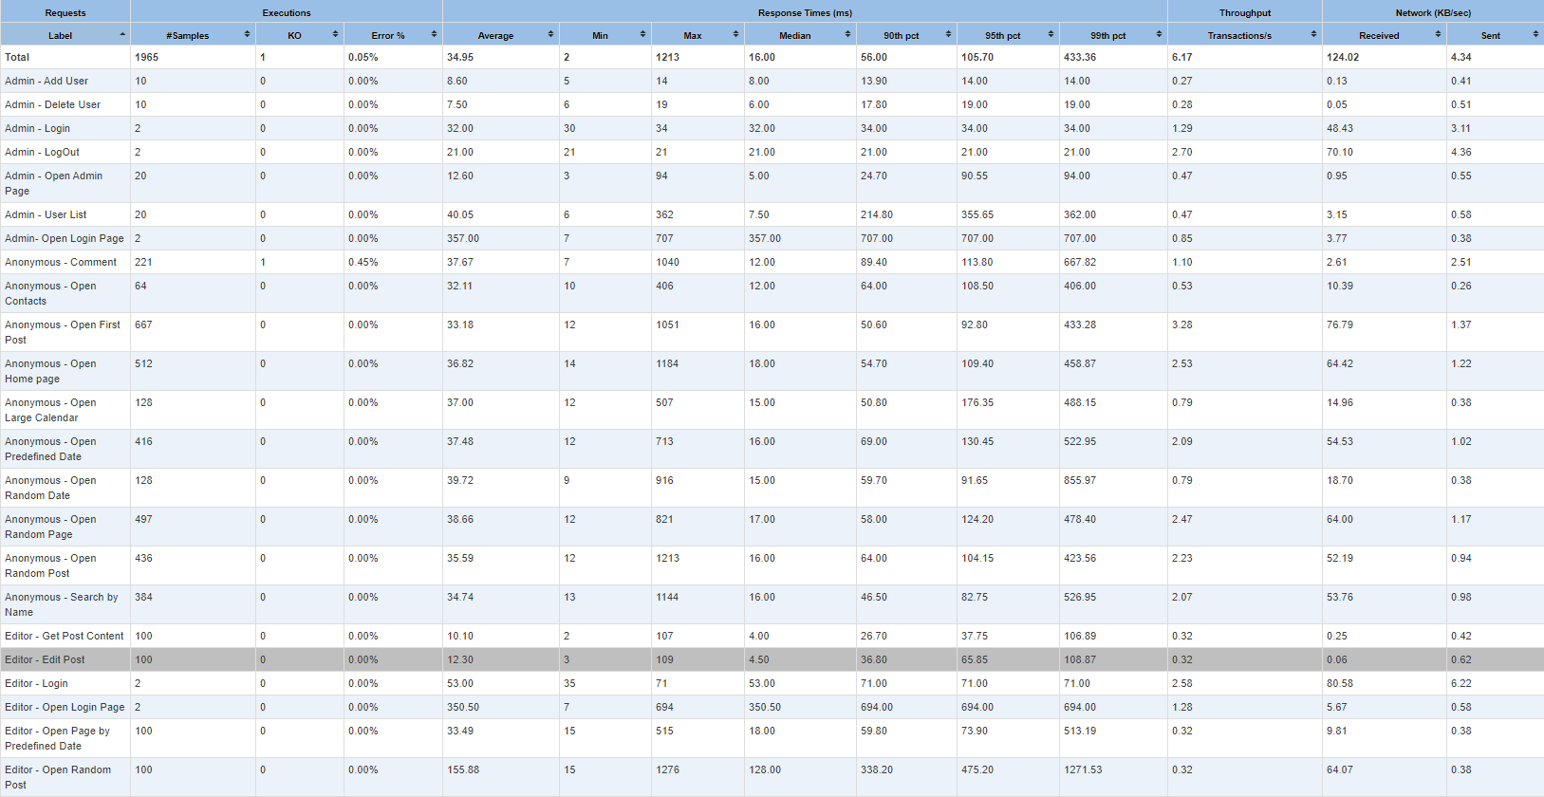

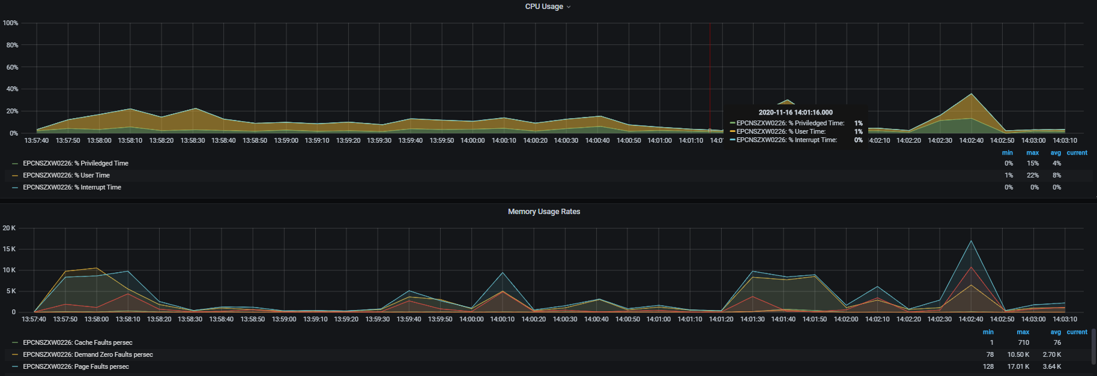

[**https://snapshot.raintank.io/dashboard/snapshot/4Tk8oQWPI1IuTb0z7zOgndy0LoDYF3zX**](https://snapshot.raintank.io/dashboard/snapshot/4Tk8oQWPI1IuTb0z7zOgndy0LoDYF3zX)

**Scaling CPU – 3 Result**

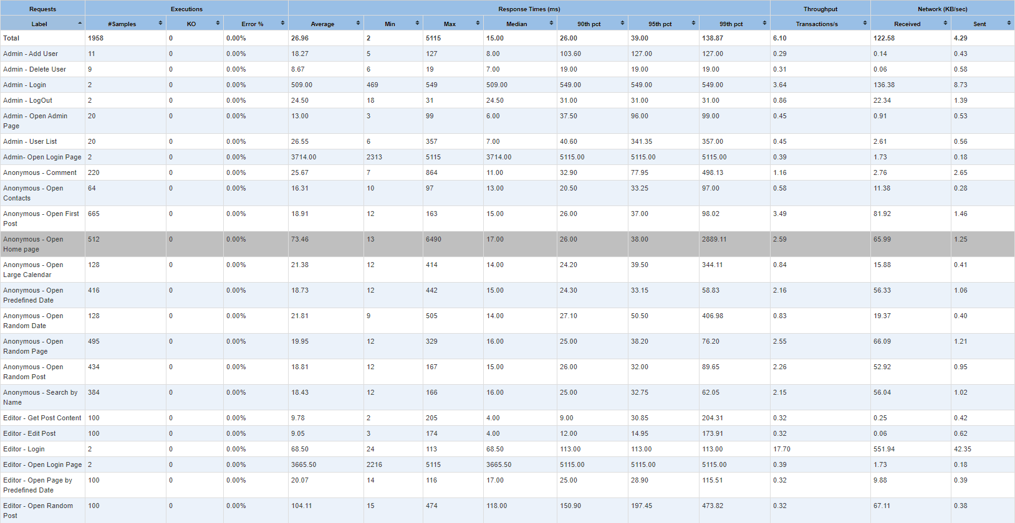

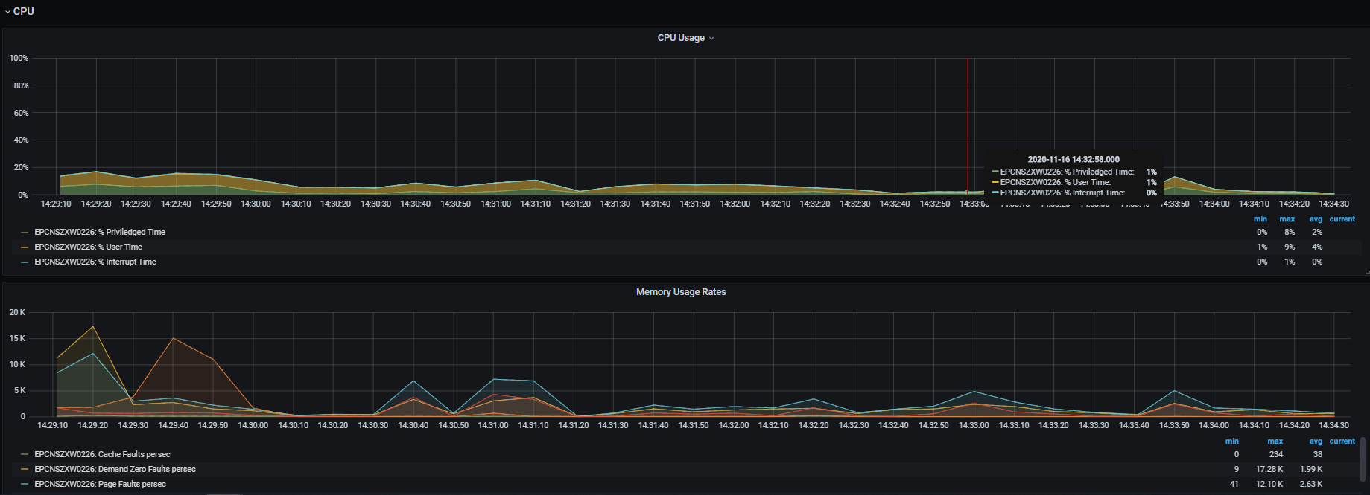

[**https://snapshot.raintank.io/dashboard/snapshot/m2h5FjgvMKTwXW7eU7tl3yUNdxQMpUXh**](https://snapshot.raintank.io/dashboard/snapshot/m2h5FjgvMKTwXW7eU7tl3yUNdxQMpUXh)

**Scaling CPU – 4 Result**

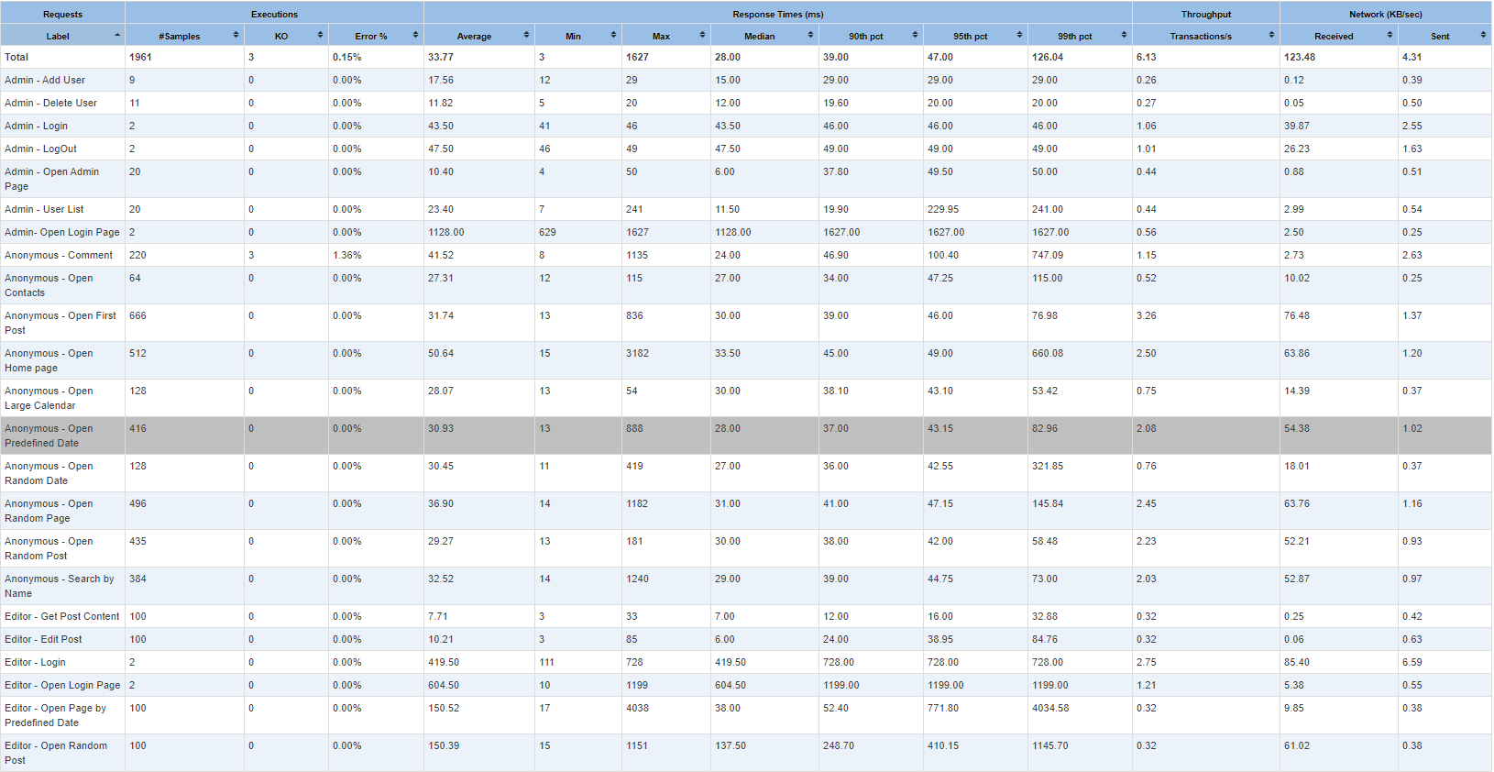

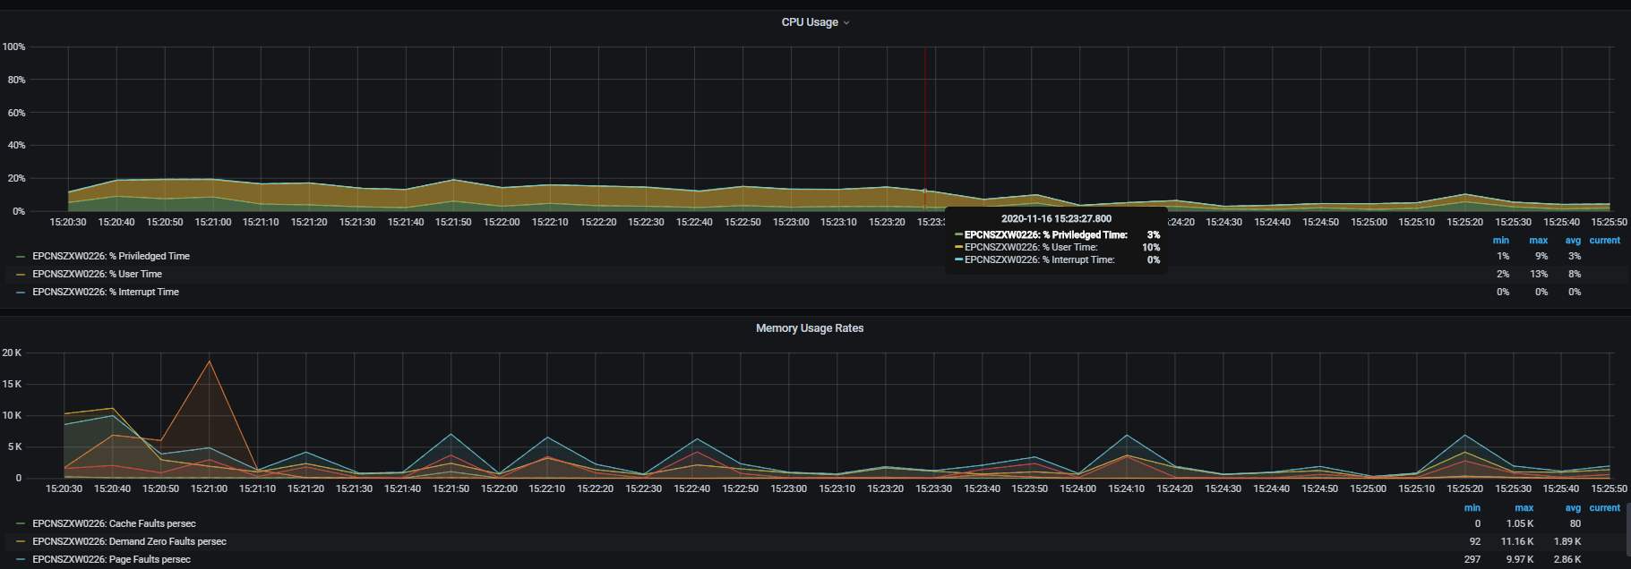

[**https://snapshot.raintank.io/dashboard/snapshot/Lpn3U4zfkMKSBM24tMiRE7wqL6KSjMkO**](https://snapshot.raintank.io/dashboard/snapshot/Lpn3U4zfkMKSBM24tMiRE7wqL6KSjMkO)

**CPU Scaling Comparison**

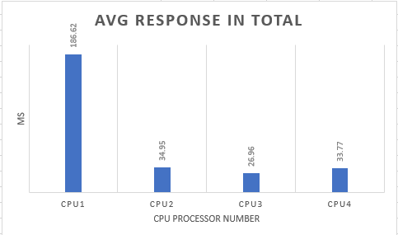 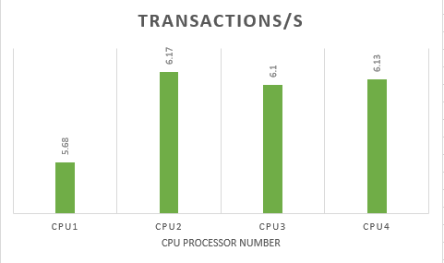

* Application could work properly in all the processor setting
* From above chart when CPU processor=1 the response time is high than others and throughput is lower at the same time
* There is no significant differ of the application performance during processor increase from 2-4

**Scaling Memory – 4G Result**

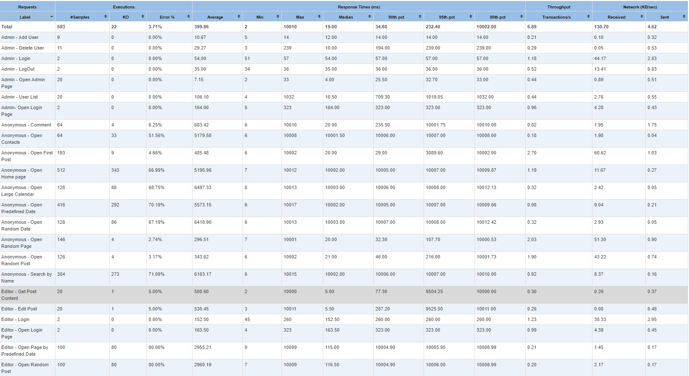

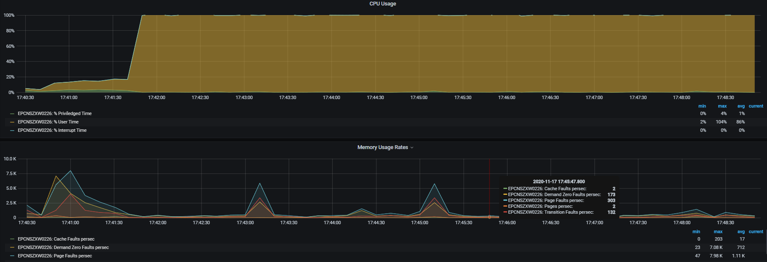

<https://snapshot.raintank.io/dashboard/snapshot/H7Ke1JHxtGn8uoGWsMSlRAb9BO1Eh9P0>

**Scaling Memory – 8G Result**

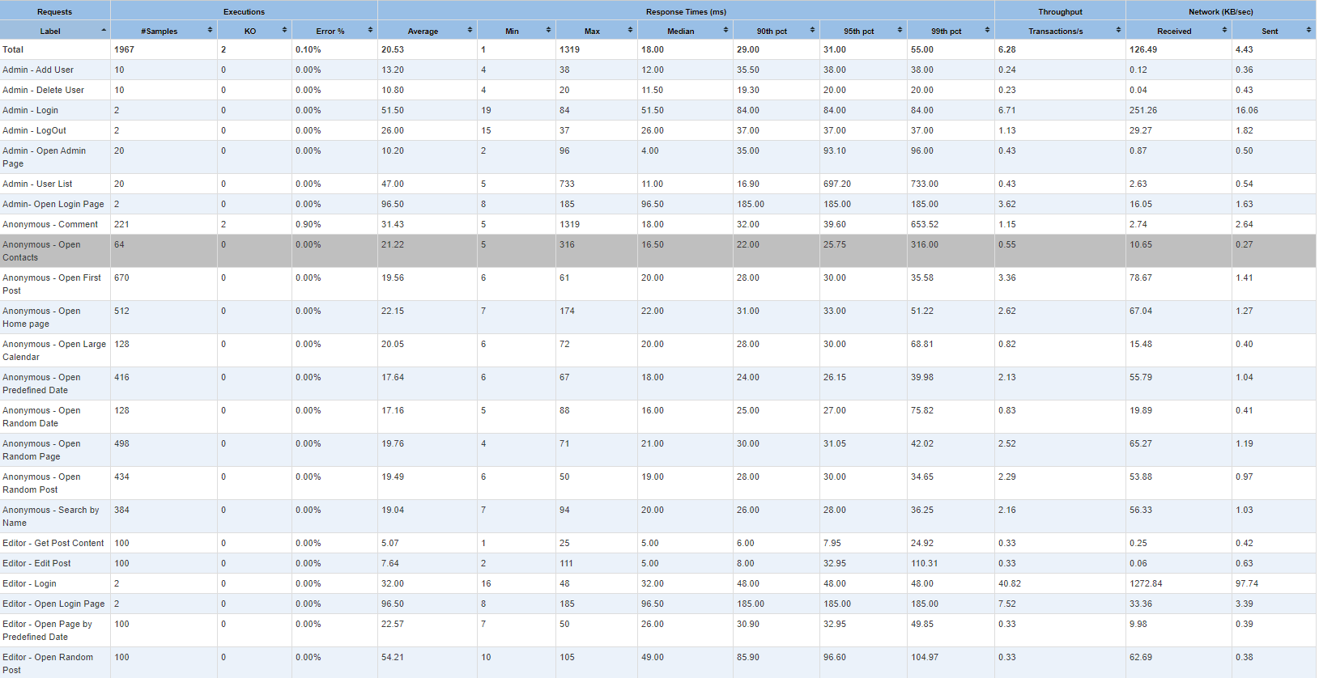

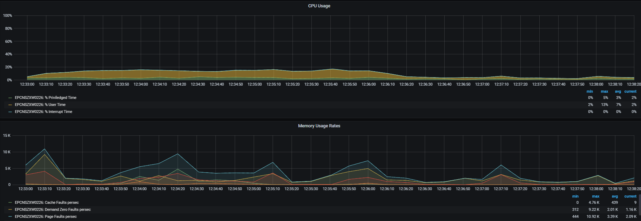

<https://snapshot.raintank.io/dashboard/snapshot/jFbIIEEP6h72cPtr9fqROZvWFlt8f37t>

**Scaling Memory – 12G Result**

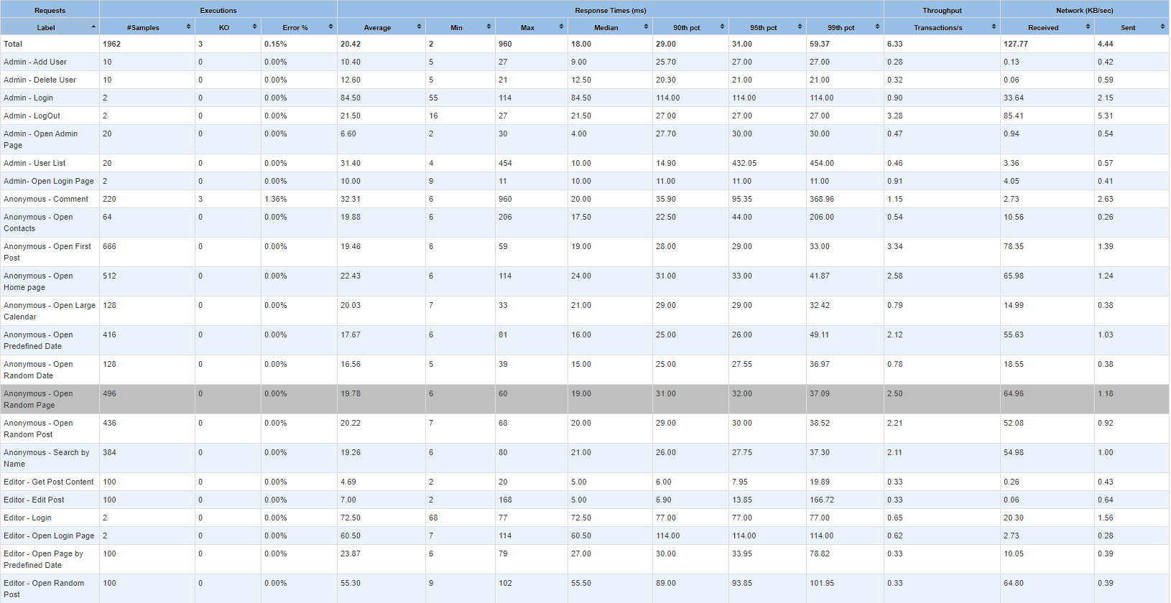

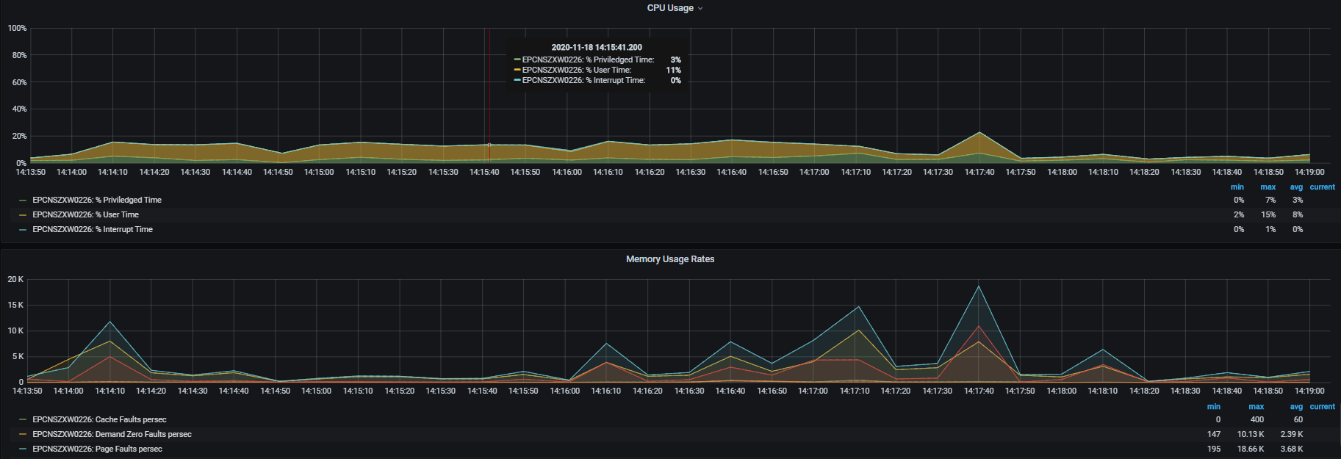

<https://snapshot.raintank.io/dashboard/snapshot/cBMYG5anrCMIuiCE3XK9lbTB13mn6W0x>

**Scaling Memory – 16G Result**

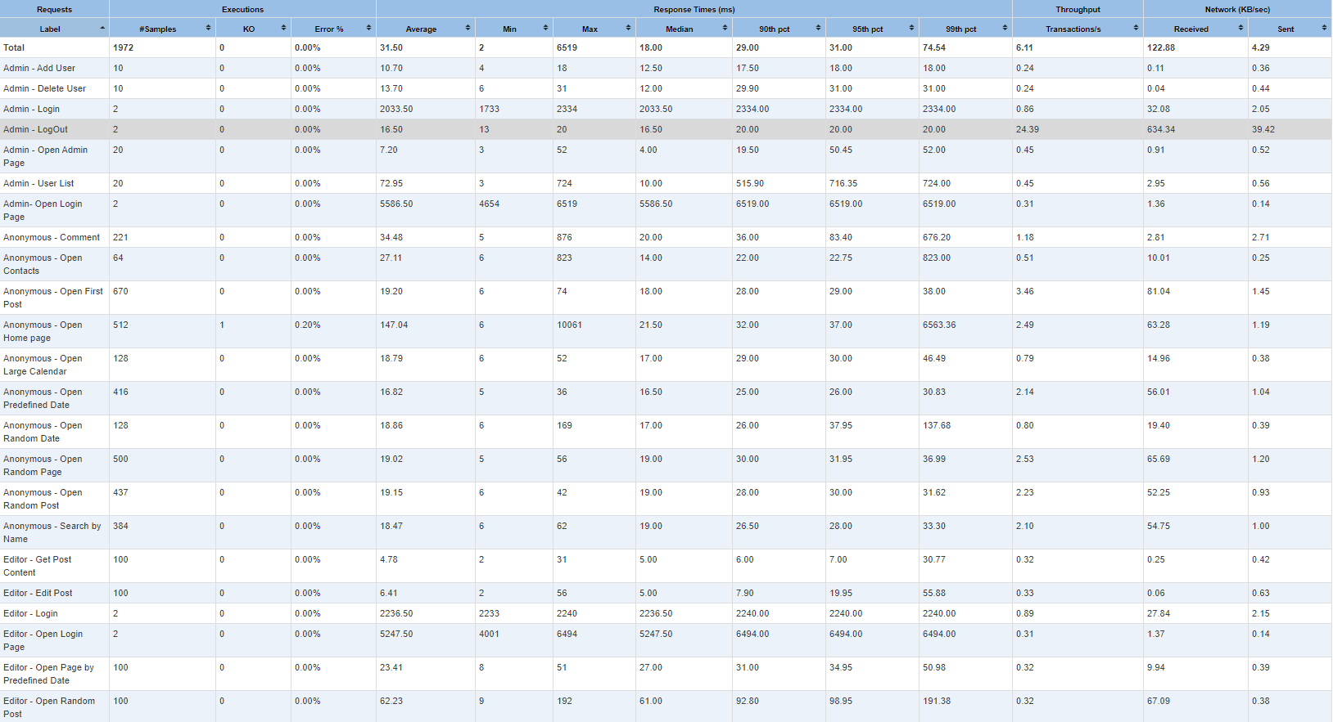

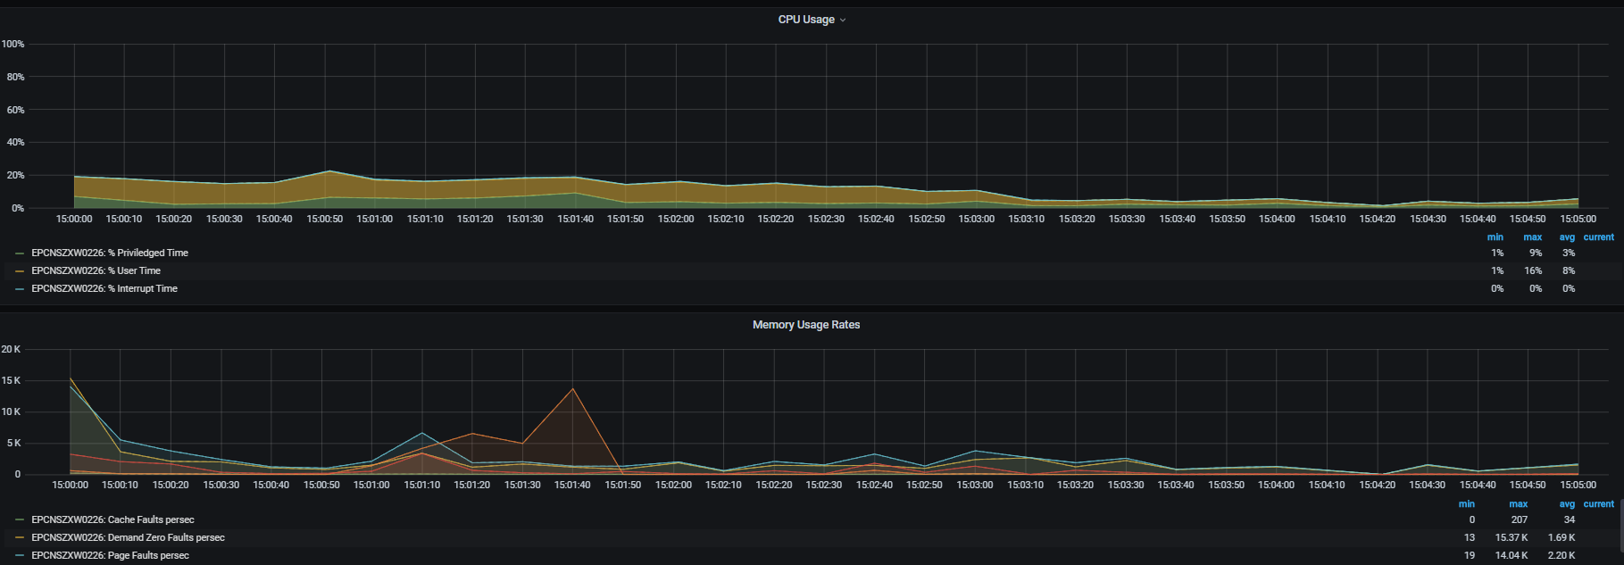

<https://snapshot.raintank.io/dashboard/snapshot/JFDhVskbA3iqgY3zqBC1arlG58KeOb2n>

**Memory Scaling Comparison**

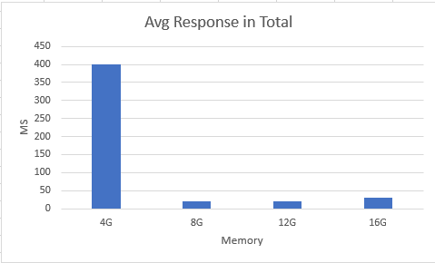 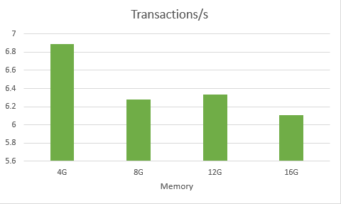

* 3.71% error rate when memory size = 4G, that means the application could NOT work properly. The reason is the server itself already need more than 3G to run, the left is not enough for our application.
* The application works properly start with memory size=8G.So this is should be the min size setting in memory.
* There is no significant differ of the application performance during memory size increase from 8-16G