PROJECT REPORT
Heart Disease Risk Analytics System

1. Application Overview
This project builds a small cloud-based system for analysing a medical dataset (heart disease data). I used Hadoop for distributed storage and Hive for SQL queries. The system also includes two web pages: one shows statistics in charts, and another lets users calculate their own risk score.

The system performs the following core tasks:
- Loads heart disease data (1025 records) into Hadoop's distributed file system (HDFS)
- Cleans and processes data using Hive SQL queries
- Calculates risk scores (0-5) for each patient based on five clinical factors
- Groups data by age, sex, and risk level to find patterns
- Exports results as CSV files for visualization
- Shows results in a web dashboard with interactive charts
- Provides a risk calculator where users input their own health data
The project demonstrates how distributed computing tools (Hadoop + Hive) can handle medical data at scale while providing practical tools for doctors and patients.

2. Objectives
The project goals:
- Data ingestion: Successfully upload the dataset (heart.csv) into HDFS.
- Schema creation: Create Hive healthcare_dw database and external tables.
- Data cleaning : Apply Hive SQL preprocessing.
- Risk scoring: Apply a rule-based scoring model (0–5 scale).
- Analytics: Compute statistics by age, sex, and risk level.
- Export results: Save results to CSV for python dashboard
- Web dashboard: Build a dashboard using HTML and Chart.js.
- Interactive calculator: Built risk scoring tool where users input their data
All objectives were completed.

3. Problem Description and Dataset Collection
3.1 Dataset Overview
The medical dataset used in this project is the Heart Disease dataset, containing 1026 patient records with 14 clinical features including demographic, behavioural, and clinical features associated with cardiac health.

Dataset fields:
Field | Description | Type
age | Patient age in years | Integer (29-77)
sex | 1 = male, 0 = female | Binary
cp | Chest pain type (0-3) | Integer
trestbps | Resting blood pressure (mm Hg) | Integer (94-200)
chol | Cholesterol level (mg/dl) | Integer (126-564)
fbs | Fasting blood sugar > 120 mg/dl | Binary
restecg | Resting ECG results (0-2) | Integer
thalach | Maximum heart rate | Integer (71-202)
exang | Exercise-induced angina | Binary
oldpeak | ST depression | Float
slope | ST segment slope | Integer
ca | Number of major vessels (0-3) | Integer
thal | Thalassemia | Integer
target | Heart disease present (0-4) | Integer

Problem being solved:
Medical professionals and researchers often need:
- Storing large clinical datasets: Traditional databases struggle with millions of patient records
- Running complex analyses: Need to find patterns across demographics
- Consistent risk assessment: Manual scoring is slow and inconsistent
- Quick decision support: Doctors need instant risk calculations
- Data visualization: Non-technical staff need charts, not tables

This project shows how cloud data tools can solve these problems. Even though my chosen dataset is small (1025 records), the workflow scales to millions of records because Hadoop distributes work across multiple machines

4. Methodology and Implementation
4.1 Hadoop Cluster Setup
A multi-container Hadoop cluster (NameNode, DataNode, ResourceManager, NodeManager, HistoryServer) was deployed using Docker. This simulates a distributed environment.

Cluster components:
- NameNode: Manages file metadata, coordinates data distribution
- DataNode: Stores actual data blocks
- ResourceManager: Allocates computing resources for jobs
- NodeManager: Runs tasks on worker nodes
- HistoryServer: Tracks completed jobs for debugging
This setup gave me a working Hadoop 3.2.1 cluster running on my laptop:
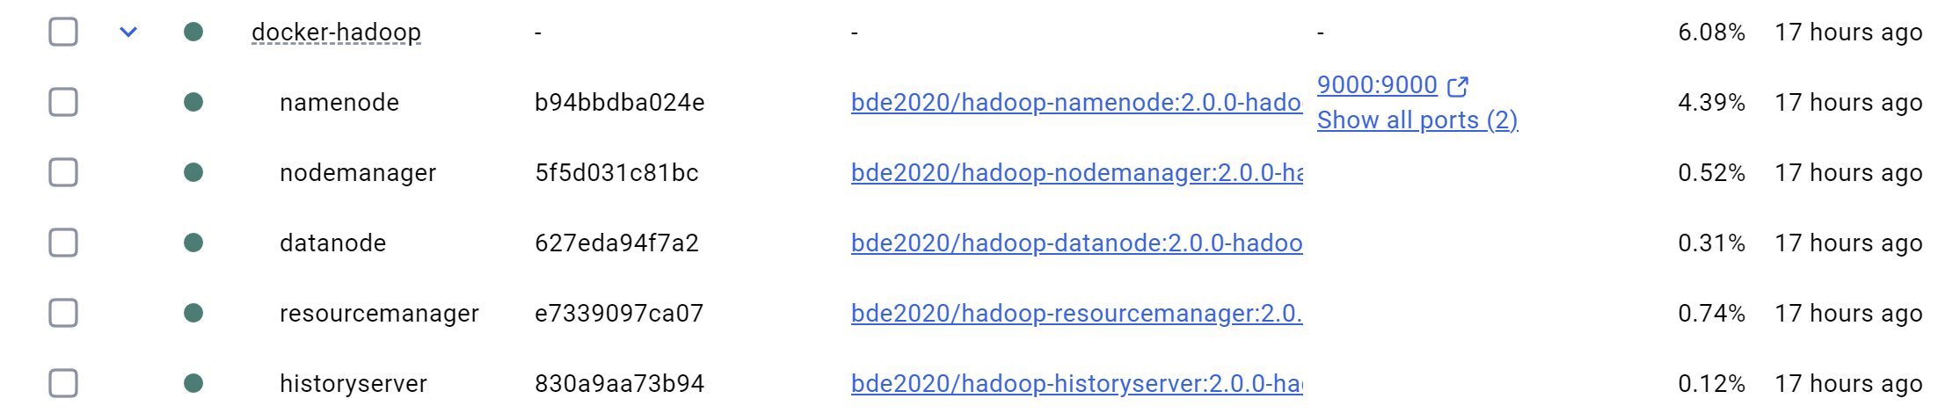

4.2 Data Ingestion into HDFS
The CSV file (heart.csv) was uploaded to HDFS:
# Created directory structure
hdfs dfs -mkdir -p /user/root/healthcare/heart
# Uploaded data file
hdfs dfs -put heart.csv /user/root/healthcare/heart/
HDFS automatically splits the file into blocks (default 128MB). For larger datasets, these blocks get distributed across multiple DataNodes. This enables parallel processing.

4.3 Hive Configuration
Hive lets you query HDFS data using SQL instead of writing MapReduce code. I installed Hive 3.1.2 and configured it to use Derby database for metadata.

# Entered NameNode container
docker exec -it namenode bash

# Initialized metadata database
cd /opt/hive
schematool -dbType derby -initSchema
A new database (healthcare_dw) and an external table were created to read the CSV file.

CREATE DATABASE IF NOT EXISTS healthcare_dw;
USE healthcare_dw;
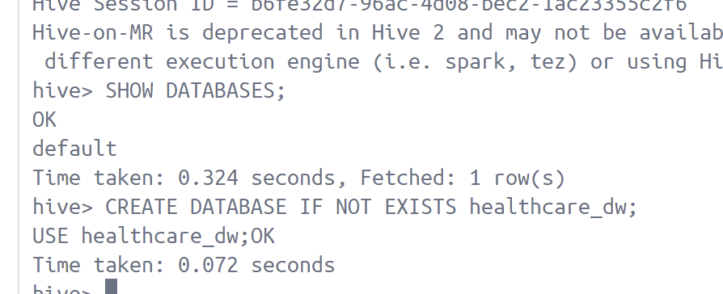

CREATE EXTERNAL TABLE IF NOT EXISTS heart_raw (
age INT,
sex INT,
cp INT,
trestbps INT,
chol INT,
fbs INT,
restecg INT,
thalach INT,
exang INT,
oldpeak DOUBLE,
slope INT,
ca INT,
thal INT,
target INT
)
ROW FORMAT DELIMITED
FIELDS TERMINATED BY ','
STORED AS TEXTFILE
LOCATION '/user/root/healthcare/heart'
TBLPROPERTIES ("skip.header.line.count"="1");
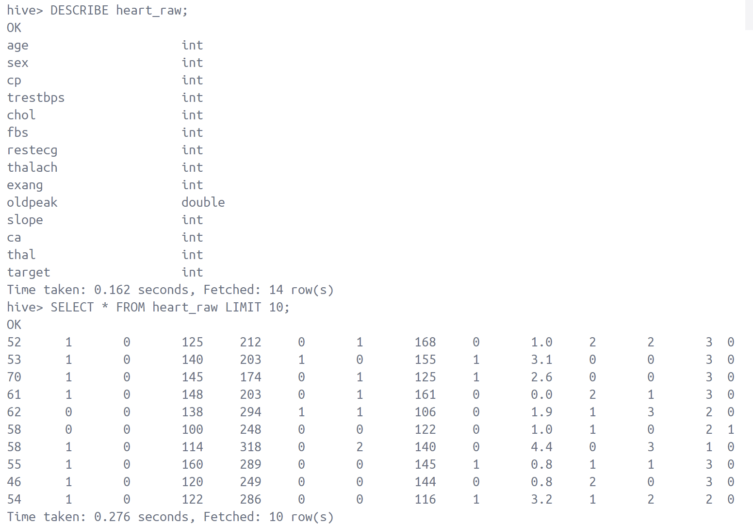

4.4 Data Cleaning and Risk Scoring
I wrote Hive SQL to clean the data and calculate risk scores. The scoring model uses simple clinical thresholds that doctors commonly use for screening.
Risk factors (each worth 1 point):
- age > 55
- resting BP > 130
- cholesterol > 250
- fasting blood sugar > 120
- exercise-induced angina = 1
Total score: 0-5 points
CASE WHEN age > 55 THEN 1 ELSE 0 END +
CASE WHEN rest_bp > 130 THEN 1 ELSE 0 END +
CASE WHEN chol > 250 THEN 1 ELSE 0 END +
CASE WHEN fbs = 1 THEN 1 ELSE 0 END +
CASE WHEN exang = 1 THEN 1 ELSE 0 END AS risk_score

Risk levels are defined as:
- 0-1→ Low
- 2–3 → Medium
- 4–5 → High

CASE
WHEN risk_score <= 1 THEN 'Low'
WHEN risk_score <= 3 THEN 'Medium'
ELSE 'High'
END AS risk_level

These rules are easy to explain and match early-warning checks used in clinical screening.

4.5 Analysis Queries
I ran several SQL queries to find patterns in the data:
Query 1: Disease rate by age group
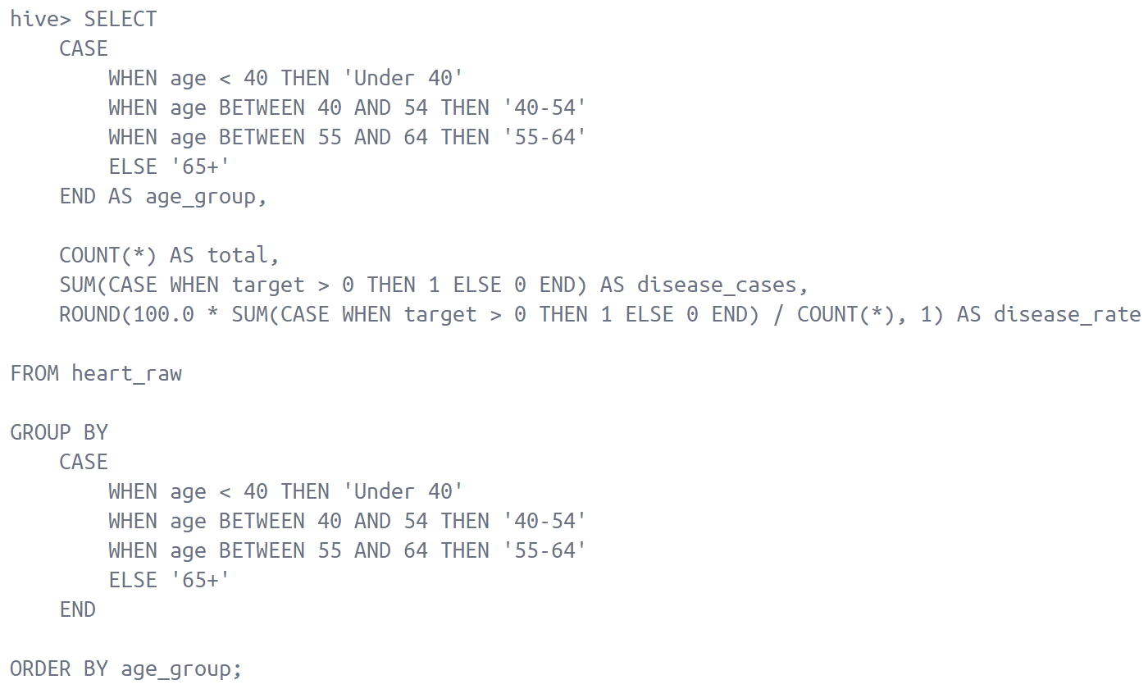
Query result:
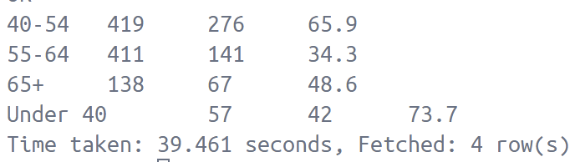
See the file (age_group_stats.csv)

Query 2: Disease rate by sex
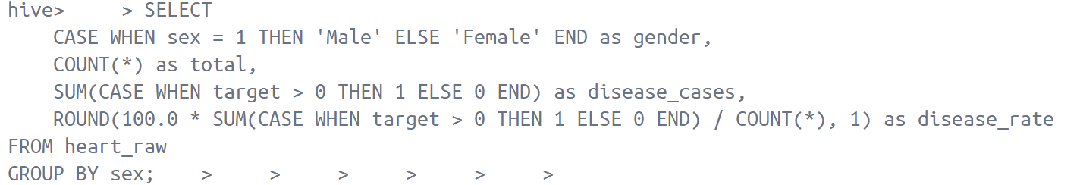

Query result:
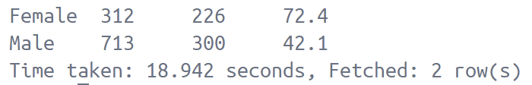
See the file (sex_stats.csv)

Query 3: Disease rate by age group and sex
This query provides a detailed breakdown of heart disease prevalence across different age groups and sexes. This is critical for identifying high-risk demographics.
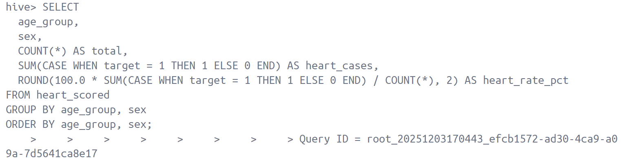

Query result:
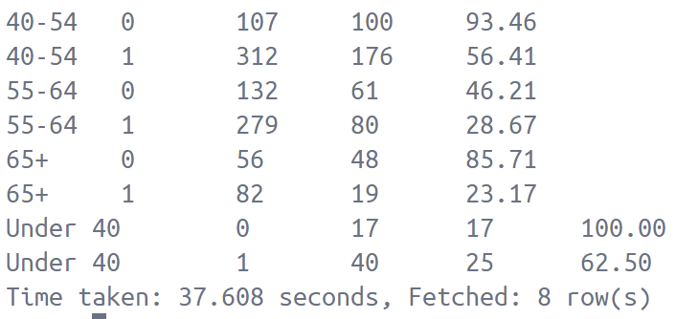
See the file (age_sex_stats.csv)

Query 4: Risk level distribution
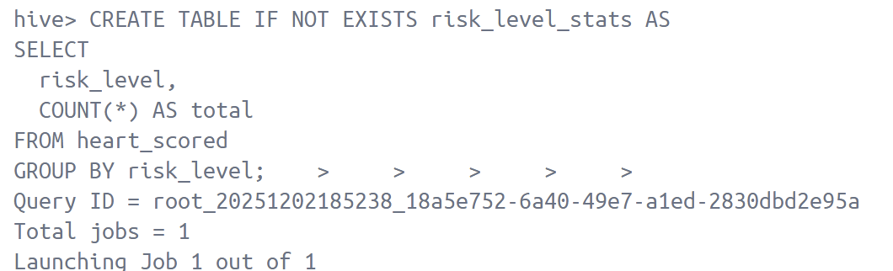

Query result:
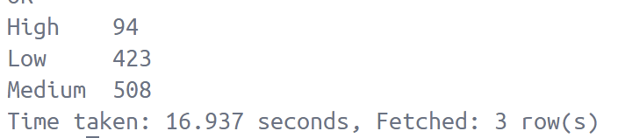
See the file (risk_level_stats.csv)

4.6 Data Visualisation
Two dashboards were created:
- Python Notebook (Matplotlib) - initial exploratory plots based on four csv files.
Bar chart: Heart disease rate by age
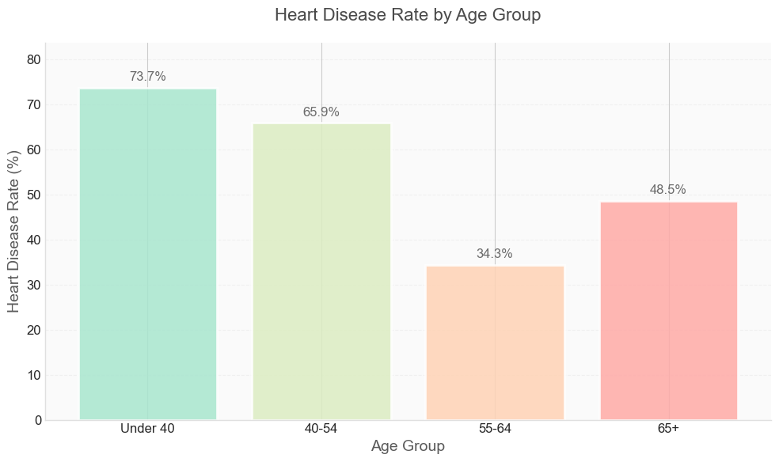
Younger patients show unexpectedly higher disease rates (73.7% for Under 40) compared to older groups (34.3% for 55-64), contradicting typical age-disease patterns.

Bar chart: Heart disease rate by sex
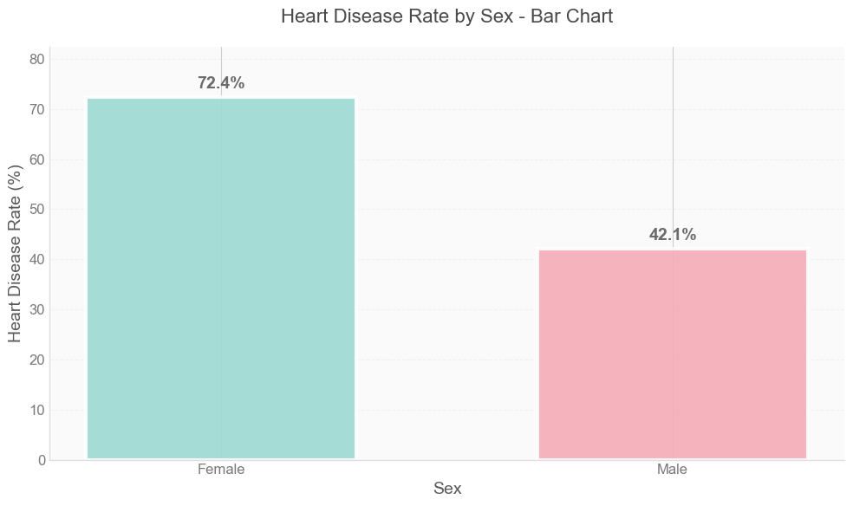
Females demonstrate significantly higher heart disease prevalence (72.4%)
than males (42.1%), representing a 30-percentage-point gender gap.

Grouped bar and line chart: Compare male vs female side-by-side for each age group

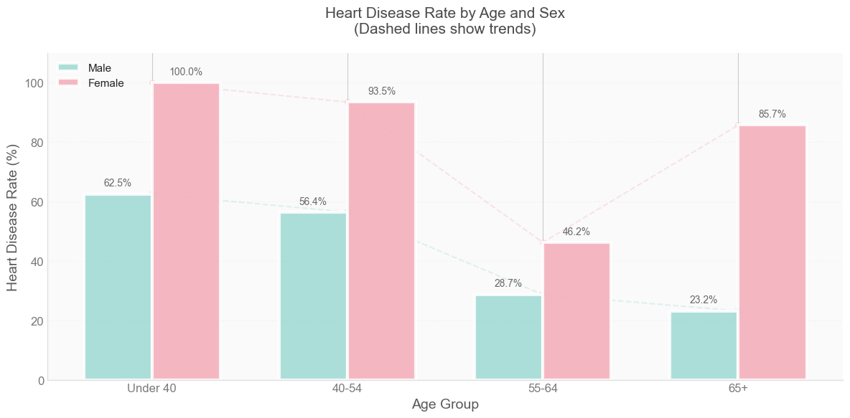
- Females have consistently higher rates in younger ages
- While male rates decline steadily with age (from 62.5% to 23.2%), female rates follow a U-shaped curve, starting very high (100%), dropping in middle age (46.2%), then spiking again in elderly (85.7%). This suggests hormonal or lifestyle factors that change across a woman's life stages.

Doughnut chart: Risk-level distribution

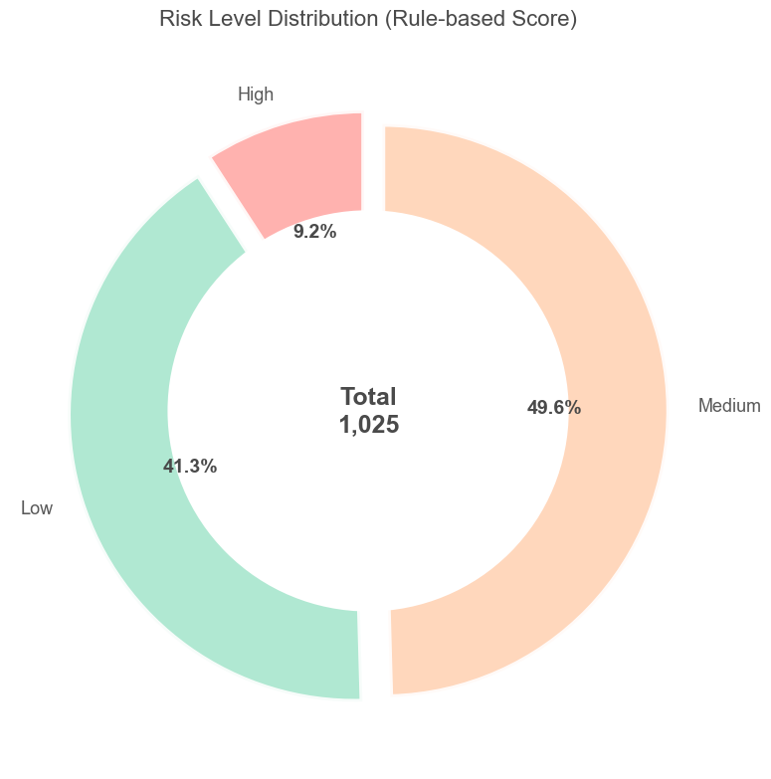
Nearly half of patients (49.6%) fall into medium-risk category, with low-risk (41.3%) and high-risk (9.2%) forming the remaining distribution.

- Web Dashboard (HTML + Chart.js) :
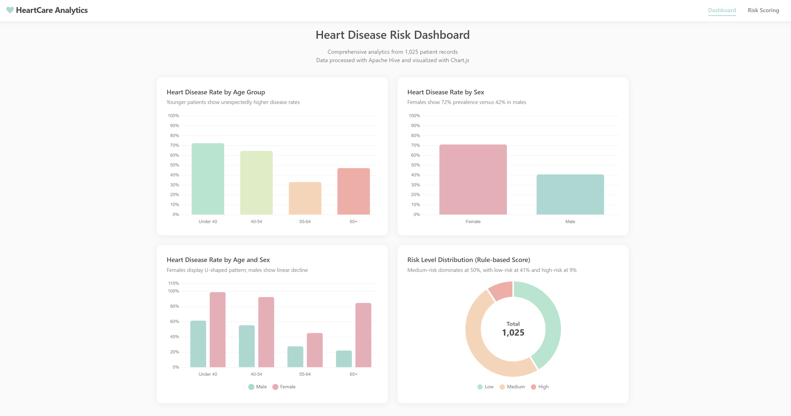

4.7 Interactive Risk Calculator
A second web page allows users to enter their own values, which applies the same rule-based logic as Hive and displays:
Users input:
- age
- blood pressure
- cholesterol
- FBS
- exercise-induced angina
The browser computes the risk score and gives a textual explanation.
This shows how database logic can be reused in a front-end tool.
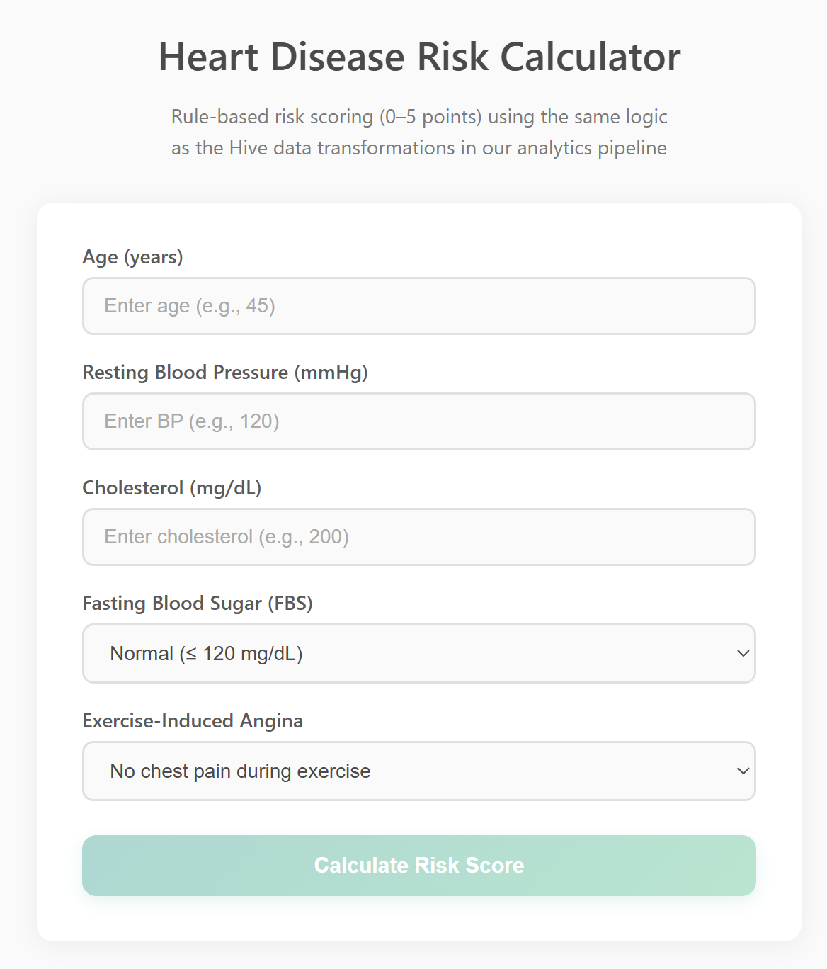

5. Suitability of Hadoop and Hive
Hadoop Advantages
1. Scalability
- The chosen dataset: 1025 records, ~50KB
- Real healthcare dataset: 10+ million records, 100+ GB
- Hadoop handles both by distributing work across nodes
- Adding more machines increases capacity linearly
2. Fault tolerance
- HDFS replicates each block 3 times by default
- If a DataNode fails, data is still available from replicas
- Jobs automatically restart on different nodes if one fails
3. Cost-effective
- Runs on commodity hardware (regular servers, not specialized equipment)
- Open-source
- Can use cloud resources (AWS, Azure) or on-premise servers

Hive Advantages
1. SQL interface
- Healthcare analysts know SQL, not Java MapReduce
- Existing SQL queries can be migrated to Hive with minimal changes
- Faster development than writing custom MapReduce code
2. Schema flexibility
- Can create multiple table views over same data
- Easy to add new columns without restructuring files
- Supports complex data types (arrays, maps, structs)
3. Integration
- Works with BI tools (Tableau, Power BI, Superset)
- Connects to Python, R, Excel via JDBC/ODBC
- Exports to CSV, JSON, Parquet for analysis

For this project, Hadoop + Hive provide a simple and scalable way to:

load the dataset -> clean it -> score each record -> compute statistics

Although the dataset is small, the workflow matches real cloud pipelines. It shows that the Hadoop ecosystem is highly suitable for early-stage medical analytics pipelines and scalable risk scoring.

6. Features of the Software
The system provides:
Backend (Hadoop + Hive)
Data Storage:
- Distributed file storage in HDFS
- Automatic data replication for reliability
- Block-level storage (scales to petabytes)
Data Processing:
- SQL-based data cleaning and transformation
- Automated risk scoring using clinical rules
- Aggregation queries for statistical analysis
- MapReduce execution for distributed computation
Data Management:
- Metadata catalog in Derby database
- External tables (data stays in HDFS)
- Schema versioning and evolution
- Query execution history
Frontend (Web Dashboard)
Visualization:
- Four charts using python matplotlib and interactive Chart.js
- Color-coded risk levels.
- Export charts as PNG images
Risk Calculator:
- Form inputs for patient data
- Real-time risk calculation
- Explanation of risk factors
- Consistent with Hive scoring logic

System Architecture
Data Flow:
heart.csv → HDFS → Hive External Table → SQL Processing →
Scored Table → CSV Export → Web Dashboard

User Flow:
User inputs data → JavaScript calculates → Display risk score →
Show contributing factors

Technical Stack
- Storage: Hadoop HDFS 3.2.1
- Processing: Apache Hive 3.1.2
- Metadata: Derby Database
- Visualization: Chart.js 3.9, python
- Frontend: HTML5, CSS3, JavaScript ES6
- Deployment: Docker Compose
- Development: Python (exploratory analysis)

7. Worked Example
A complete example from data input to risk score:
Input values:
- Age: 63
- Resting BP: 150
- Cholesterol: 260
- Fasting blood sugar: 1
- Exercise angina: 1
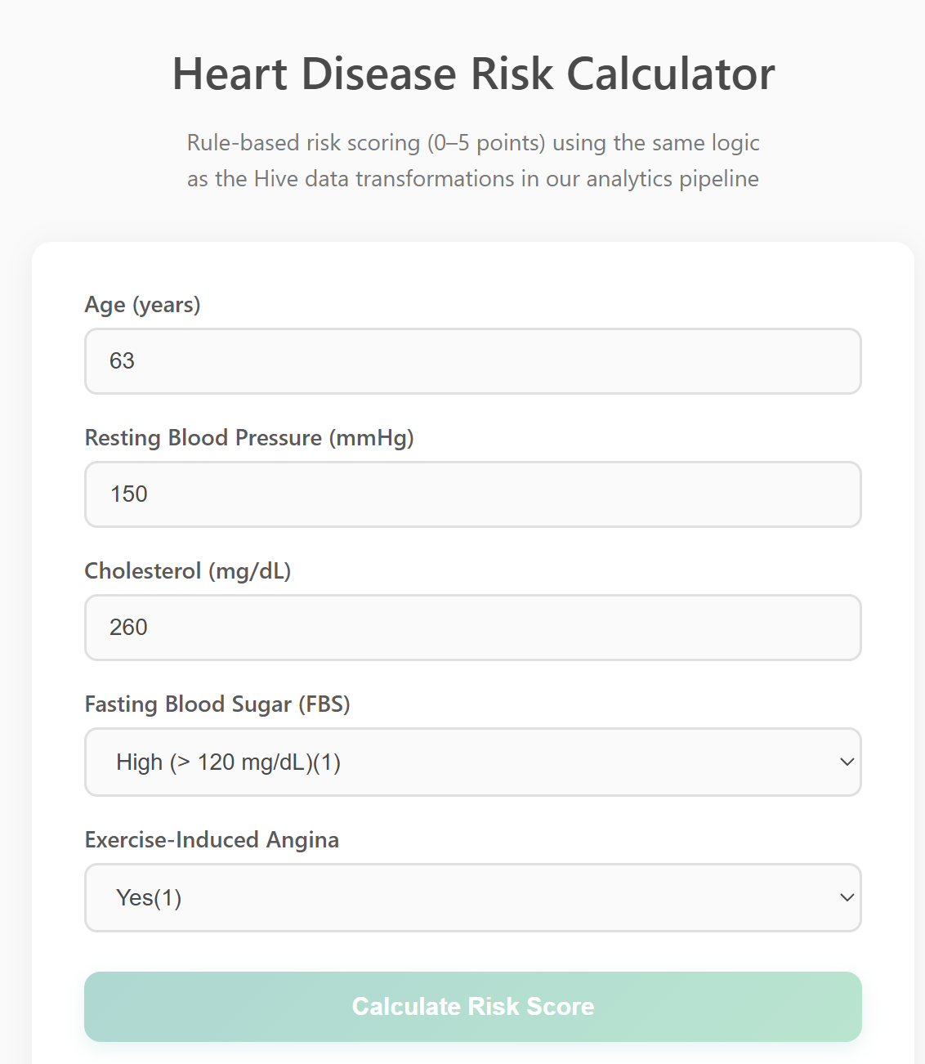

Scoring:
- Age > 55 → +1
- BP > 130 → +1
- Chol > 250 → +1
- FBS high → +1
- Exercise angina → +1
CASE
WHEN 5 <= 1 THEN 'Low'
WHEN 5 <= 3 THEN 'Medium'
ELSE 'High'
END

Total score: 5 → Risk Level: High
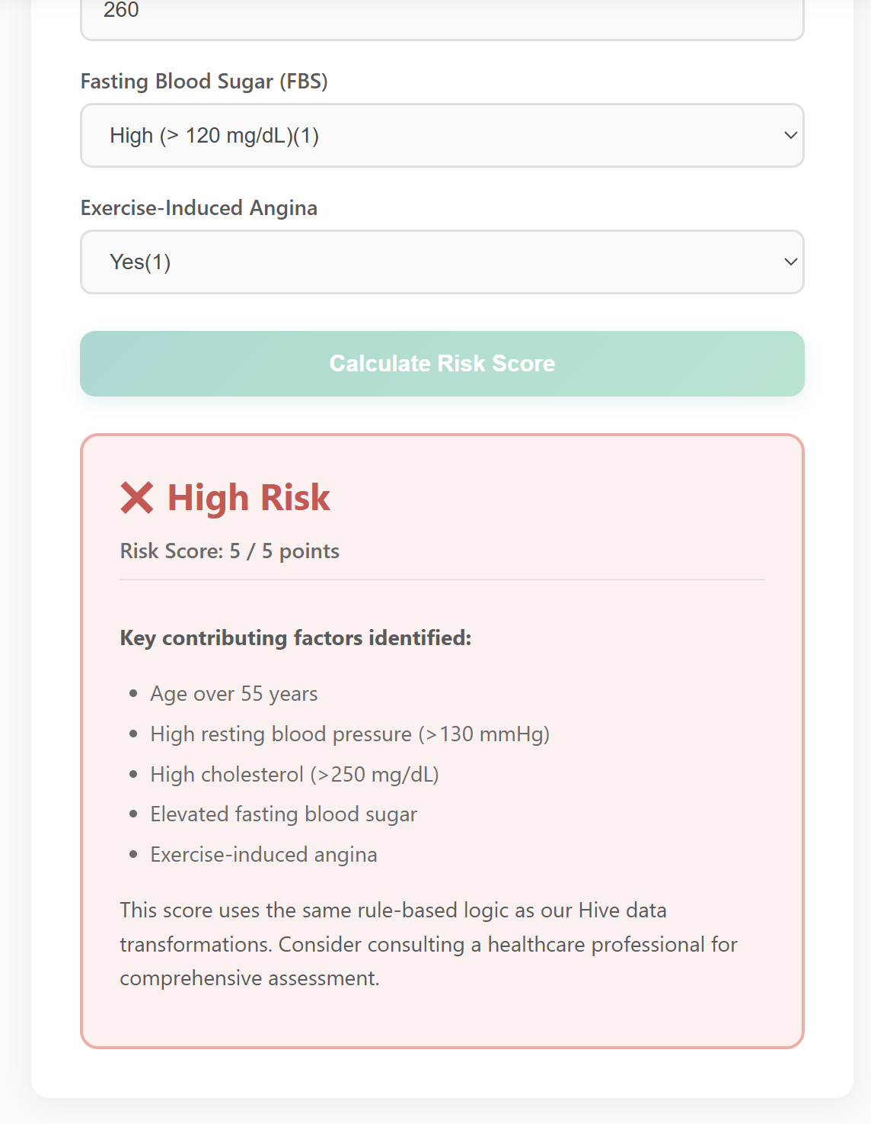
The web tool shows this result along with a short explanation.
This example confirms Hive and the UI produce consistent risk classification.

8. Challenges and Solutions
Challenge 1: Hive Installation Issues
Problem: Initial Hive installation failed with Java classpath errors.
Solution:
- Downloaded correct Hive version (3.1.2) compatible with Hadoop 3.2.1
- Fixed Guava version conflict by replacing jar file
- Set HADOOP_HOME and HIVE_HOME environment variables correctly

Challenge 2: Metastore Connection Failures
Problem: Hive couldn't connect to metastore database.
Solution:
- Reinitialized Derby database: schematool -dbType derby -initSchema
- Removed old metastore_db folder
- Created clean metadata catalog
Challenge 3: Exporting Hive results to CSV
Problem: My first attempt was hive -e "SELECT ..." > /tmp/file.csv. Because Hive had metastore issues in non-interactive mode, the command failed silently and the exported files were empty (size 0 bytes).
Solution: I switched to Hive’s own export mechanism:
INSERT OVERWRITE LOCAL DIRECTORY '/tmp/age_group_export'
ROW FORMAT DELIMITED FIELDS TERMINATED BY ','
SELECT ... FROM age_group_stats;
Hive wrote the data into /tmp/.../000000_0 correctly, and then I used docker cp to copy the files to my local data_processed folder.

Challenge 4: Losing Hive metadata after metastore reset
Problem: After I re-initialised the metastore and environment variables once, all previous databases and tables disappeared from Hive, even though the HDFS data was still there.
Solution: I realised that the Derby metastore stores only metadata, not the raw data. I created a set of Hive scripts (01_create_tables.sql, 02_scoring_rules.sql, 03_aggregate_analysis.sql, 04_export_results.sql) so that I can quickly recreate healthcare_dw, heart_raw, heart_scored and all summary tables from the original heart.csv whenever the metastore is reset.

9. Future Enhancements
- Add more risk factors
  - Smoking status
  - Family history
  - BMI
  - Physical activity level
- Machine learning model
  - Train decision tree or logistic regression
  - Compare ML predictions vs rule-based scores
  - Feature importance analysis
- Real-time data ingestion
  - Use Apache Kafka for streaming patient data
  - Update dashboard in real-time as new data arrives
  - Alert system for high-risk patients
- Cloud deployment
  - Deploy on AWS EMR
  - Use S3 for data storage
  - Auto-scaling based on load

10. Conclusion
This project successfully demonstrates a complete cloud-based analytics pipeline for medical data. I used Hadoop for distributed storage and Hive for SQL analysis, processing 1026 heart disease records. The system includes data ingestion, cleaning, risk scoring, statistical analysis, and visualization.
Key achievements:
- Built working Hadoop cluster with 5 containers
- Loaded and queried data using Hive SQL
- Implemented clinically-relevant risk scoring model
- Created interactive web dashboard with charts
- Built risk calculator tool for patient use
- Maintained consistent logic between database and frontend

The system illustrates how distributed data engineering tools can support clinical decision support, risk assessment, and healthcare analytics in scalable environments.

11. References
Technical Documentation
- Apache Hadoop Documentation
  - Official HDFS Architecture Guide
  - https://hadoop.apache.org/docs/current/
- Apache Hive Documentation
  - Hive Query Language (HiveQL) Reference
  - https://hive.apache.org/
Libraries and Tools
- Chart.js Documentation
  - Interactive JavaScript Charts
  - https://www.chartjs.org/docs/latest/
- Python pandas Documentation
  - Data Analysis Library
  - https://pandas.pydata.org/docs/
Academic References
- Detrano et al. (1989)
  - "International application of a new probability algorithm for the diagnosis of coronary artery disease"
  - American Journal of Cardiology, 64:304-310
Course Materials
- COMP47780 Cloud Computing
  - Lecture notes on Hadoop ecosystem

