Name: Yash Chaudhary

Sap ID: 500122609

Lab Exercise 8- Create POD in Kubernetes

Step-by-Step Guide

Step 1: Create a YAML File for the Pod
We'll create a Pod configuration file named pod-example.yaml
apiVersion: v1
kind: Pod
metadata:
name: my-pod
labels:
app: web
spec:
containers:
- name: my-container
image: nginx:latest
Step 2: Apply the YAML File to Create the Pod

Use the kubectl apply command to create the Pod based on the YAML configuration file.

kubectl apply -f pod-example.yaml

This command tells Kubernetes to create a Pod as specified in the pod-example.yaml file.

Step 3: Verify the Pod Creation

To check the status of the Pod and ensure it's running, use:

kubectl get pods

This command lists all the Pods in the current namespace, showing their status, restart count, and other details.

You can get detailed information about the Pod using:

kubectl describe pod my-pod
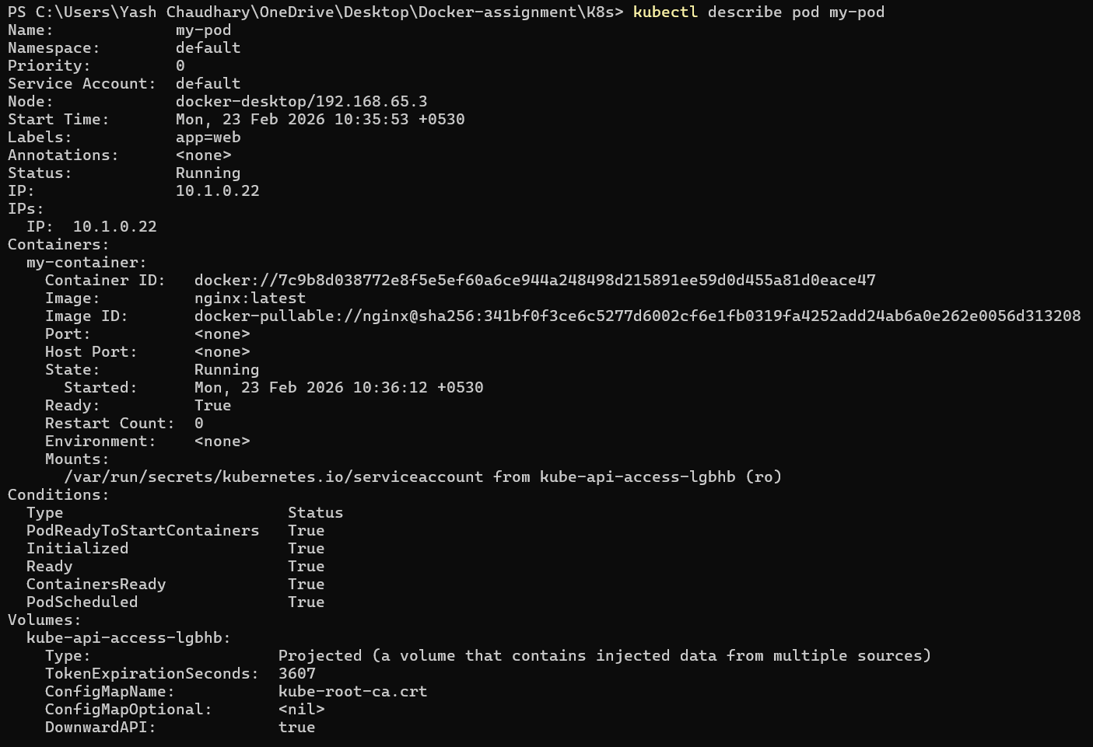

This command provides detailed information about the Pod, including its events, container specifications, and resource usage.

Step 4: Interact with the Pod

You can interact with the running Pod in various ways, such as accessing the logs or executing commands inside the container.

View Logs: To view the logs of the container in the Pod:

kubectl logs my-pod
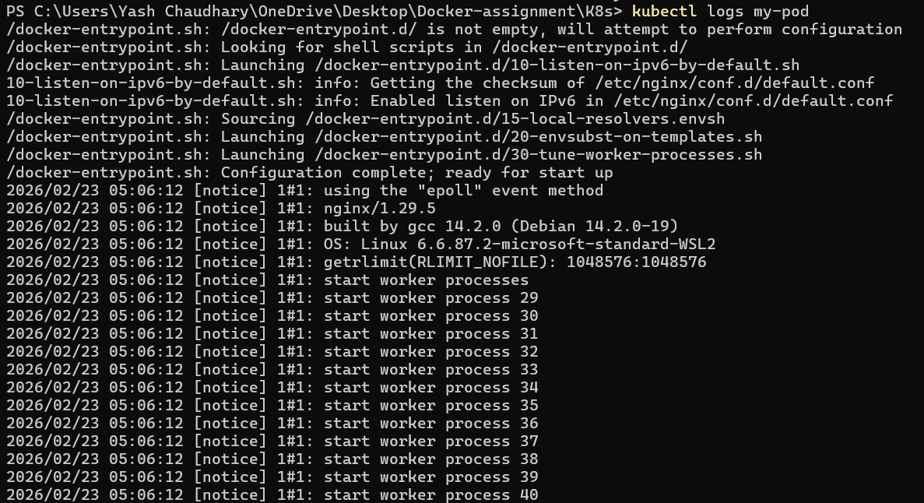

Execute a Command: To run a command inside the container:

kubectl exec -it my-pod -- /bin/bash

The -it flag opens an interactive terminal session inside the container, allowing you to run commands.

Step 5: Delete the Pod

To clean up and remove the Pod when you're done, use the following command:

kubectl delete pod my-pod
This command deletes the specified Pod from the cluster.

