Name: Yash Chaudhary
SAP ID: 500122609
Lab Exercise 9- Create Service in Kubernetes

Step-by-Step Guide

NodePort Service
To expose the Service on a port on each Node in the cluster, modify the Service type to NodePort.

Create a YAML file named service.yaml with the following content:
service.yaml
apiVersion: v1
kind: Service
metadata:
name: nodeport-service
spec:
selector:
app: web
ports:
- protocol: TCP
port: 80
targetPort: 80
nodePort: 30007 # A specific port in the range 30000-32767
type: NodePort
Apply this YAML to create the NodePort Service:

kubectl apply -f nodeport-service.yaml

Verify the Service:

kubectl get services
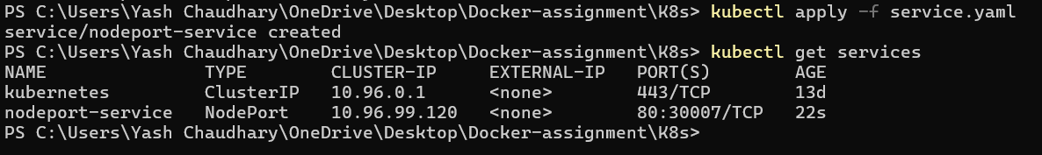

You should see the nodeport-service listed with a NodePort and details about the port exposed.

