

**Introduction to Computer Vision**

**Coursework**

**Submission 1**

**Your name SHELLY SRIVASTAVA**

**Student number 190385633**

**Question 1(a):**



**Rotated images:**









**Skewed images:**







**Your comments:**

**With forward mapping the resulting image was grainy. But forward mapping is easier to implement. The technique used here is reverse mapping. This results in a smoother image.**

**The image is rotated around the first pixel i.e. image(1,1). Image rotation results in cropping of the image. The new pixels position, if outside the image matrix’s size, is cropped off. Thus, rotation of 120 degrees can result in a black image because the new pixel positions are outside the image matrix.**

**In the case for skew, had to change the skew matrix as the x and y coordinates for matlab is different from x-y plane. In skewed image, the resulting image was being cropped off as well.**

**Question 1(b):**

θ2=50 and θ1=20 clockwise



θ1=20 clockwise and θ2=50



**Your comments:**

**Both images are formed by different order of rotation and skew. This shows that the order of the transformation is important. Both the images formed are quite different from each other. The first one has a black band on its right and left side. Whereas, the image on the left has the same band but on its top and bottom.**

**The actual image (white background) of the left figure is more compact than in the right figure, which seems to be stretched out.**

**Question 2(a)**:

**Designed kernel:**

**[1 1 1; 1 1 1; 1 1 1]**

Averaged image

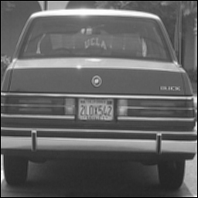

Original image

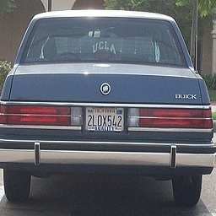

**Your comments:**

**The kernel is normalised by 1/9. The new image has a black border. Those are the pixels which were not computed by the kernel. In the case of a 3x3 kernel only one band of row and column is not computed on both sides.**

**Moreover, the resulting image is blurry. It can be noticed that the number plate of the car in the above image is hazy.**

**Question 2(b):**

**Filtered image with kernel A**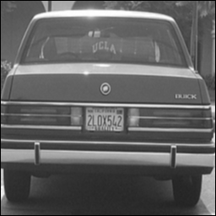

**Filtered image with kernel B**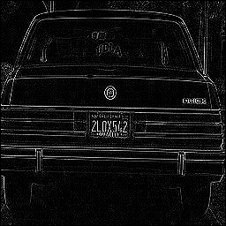

**Your comments:**

**Kernel A is the Gaussian filter and is normalised by 1/16. The image produced is much smoother. It can be noticed that the blur produced by kernel A is lesser than that of the previous image. The black band around the image still exists.**

**Kernel B is the edge detection kernel. It can be observed that the writing on the car (number plate) is clearly visible.**

**Question 2(c):**

A followed by A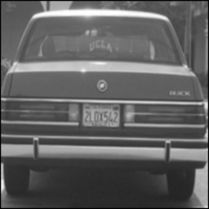

**A followed by B**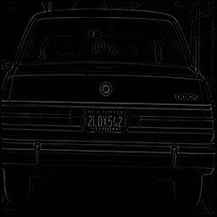

**B followed by A:** 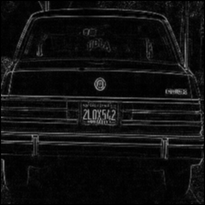

**Your comments:**

**With these operations, the black border has bled into the image when the image is filtered again, which corrupts the image. One way to overcome this would be to remove the border of the resultant image after filtering it the first time.**

**A followed by A : this image looks a bit more washed out than the one filtered only once.**

**A followed by B : it is much difficult for the edge detection filter to figure out the edges as the filter A washes out the edges with the noise.**

**B followed by A: The edges are detected by the kernel B and then it is washed out by the kernel A.**

**Question 2(d):**

**Extended kernels of A and B (5x5):**

**Kernel A: [1 4 7 4 1; 4 16 26 16 4; 7 26 41 26 7; 4 16 26 16 4; 1 4 7 4 1]**

**Kernel B: [0 0 1 0 0; 0 0 1 0 0; 1 1 -8 1 1; 0 0 1 0 0;0 0 1 0 0]**

**Results obtained by applying 5x5 kernel:**

**B followed by A**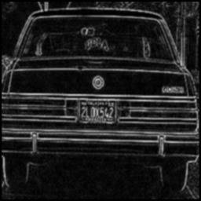

**A followed by B**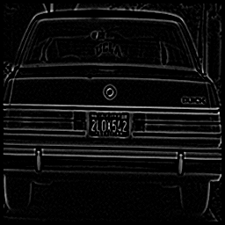

**A followed by A**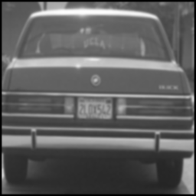

**Extended kernels of A and B (7x7):**

**Kernel A: [0 0 1 2 1 0 0; 0 3 13 22 13 3 0; 1 13 59 97 59 13 1; 2 22 97 159 97 22 2; 1 13 59 97 59 13 1; 0 3 13 22 13 3 0; 0 0 1 2 1 0 0]**

**Kernel B: kernel_B_7 = [0 0 0 1 0 0 0;0 0 0 1 0 0 0; 0 0 0 1 0 0 0; 1 1 1 -12 1 1 1; 0 0 0 1 0 0 0;0 0 0 1 0 0 0;0 0 0 1 0 0 0]**

**Results obtained by applying 7x7 kernel:**

**A followed by A**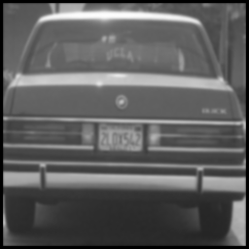

**B followed by A**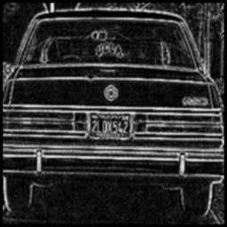

**A followed by B**

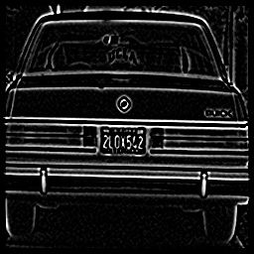

**Your comments:**

**The border of the resulting image is more prominent than that for 3x3 kernel as there are more pixels which are not operated on at the borders. The border as usual, bleeds into the picture after the second round of filtering.**

**The filters are normalised by their sum.**

**A followed by A: the washing out effect increases as the size of the kernel increases**

**A followed by B: As the size of the kernels increase, it can be seen that the edges are preserved. The edges are more prominent with kernels of larger size from 3x3 to 5x5 and finally 7x7.**

**B followed by A: With larger kernels, the edges detected at the end are much brighter. Also, more edges are detected with larger kernels.**

**Question 3(a):**

**Two non-consecutive frames:**

Image 1

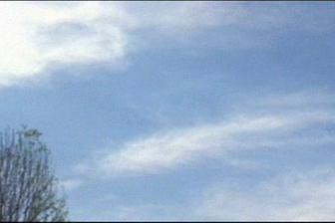

Image 2

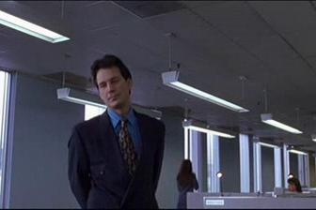

**Corresponding colour histograms:**

Histogram 2

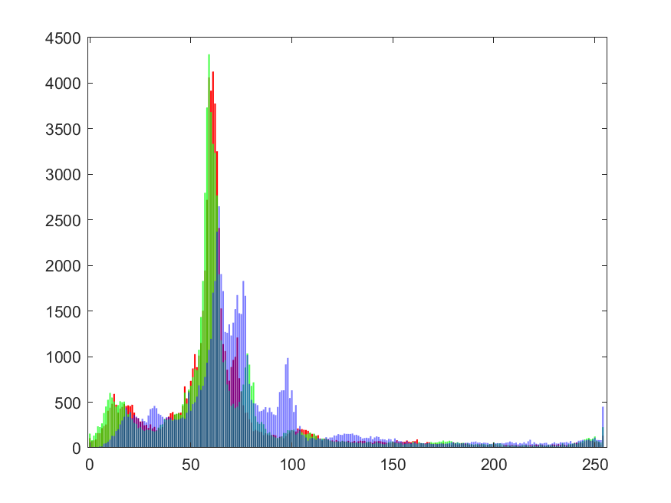

Histogram 1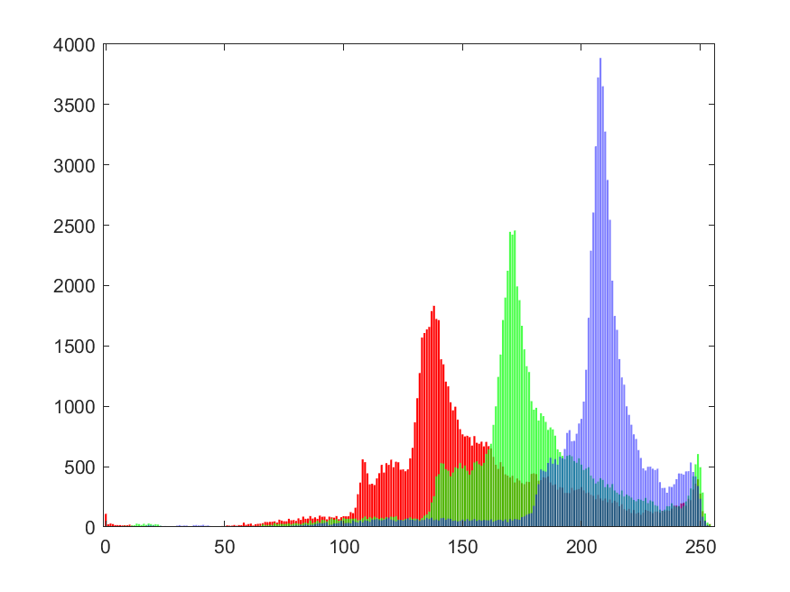

**Your comments:**

**The above histogram represents the color distributions for all the three channels. The two histograms given above are very different from each other. The color distribution for the sky is more on the higher pixel values (more for blue out of the three as well). Whereas, the scene from indoors has the distribution on the lower values of the pixels.**

**The histogram on the left has similar peaks (at different intensities with different values) for all the three channels. For the histogram on the right, the red and green has approximately the same trend, except for blue.**

**Question 3(b):**

**Example 1:**

It

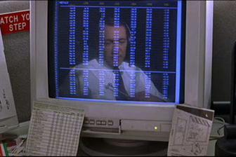

It+1

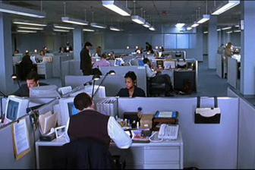

**Histograms:**

Histogram of It

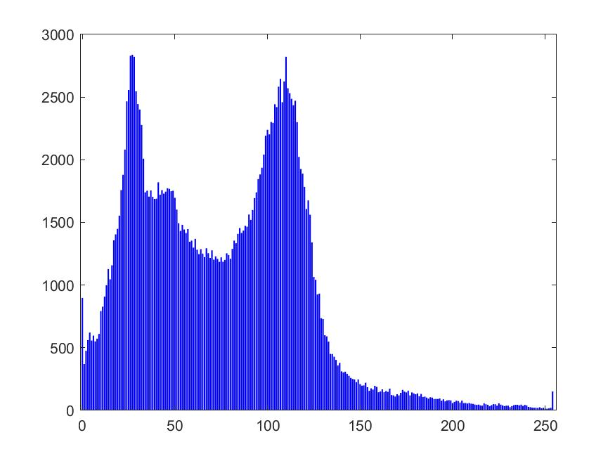

Histogram of It+1

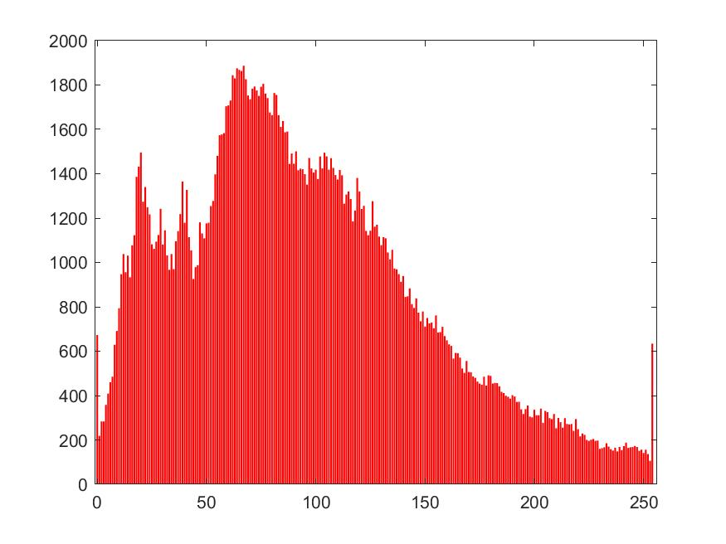

Intersection result

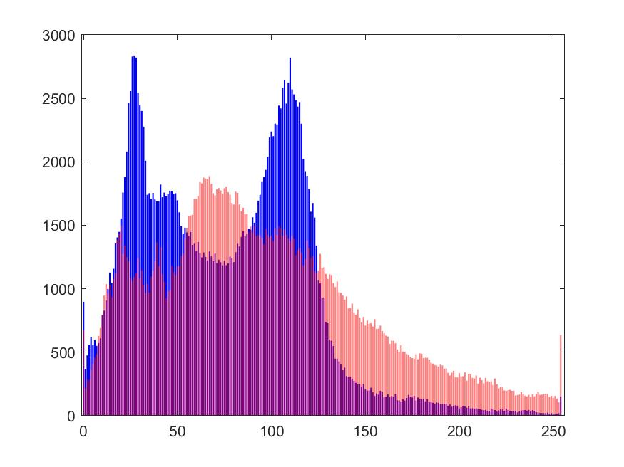

**Example 2:**

It+1

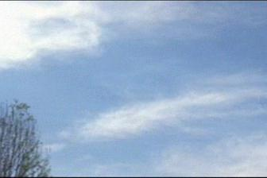

It

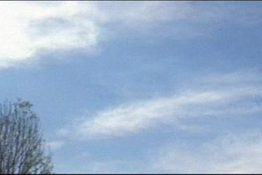

**Histograms:**

Histogram of It

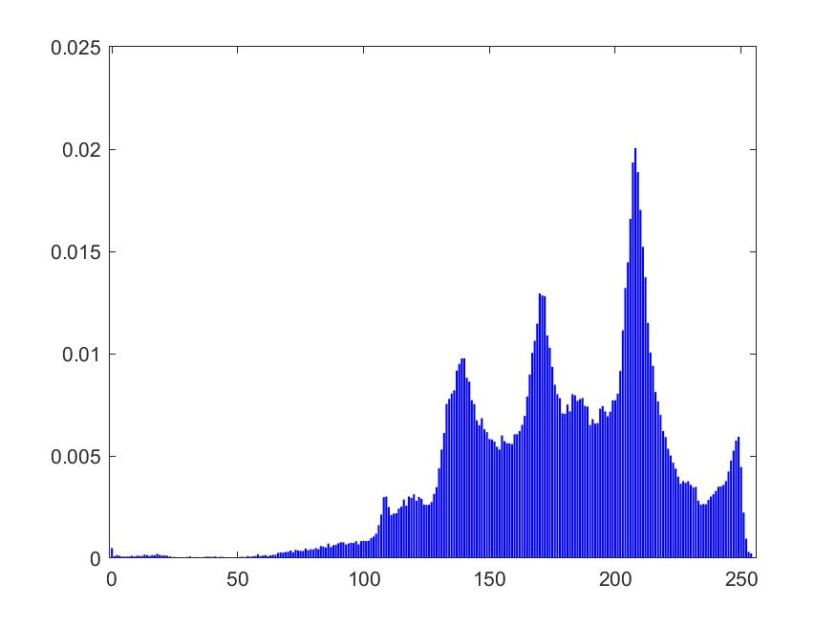

Histogram of It+1

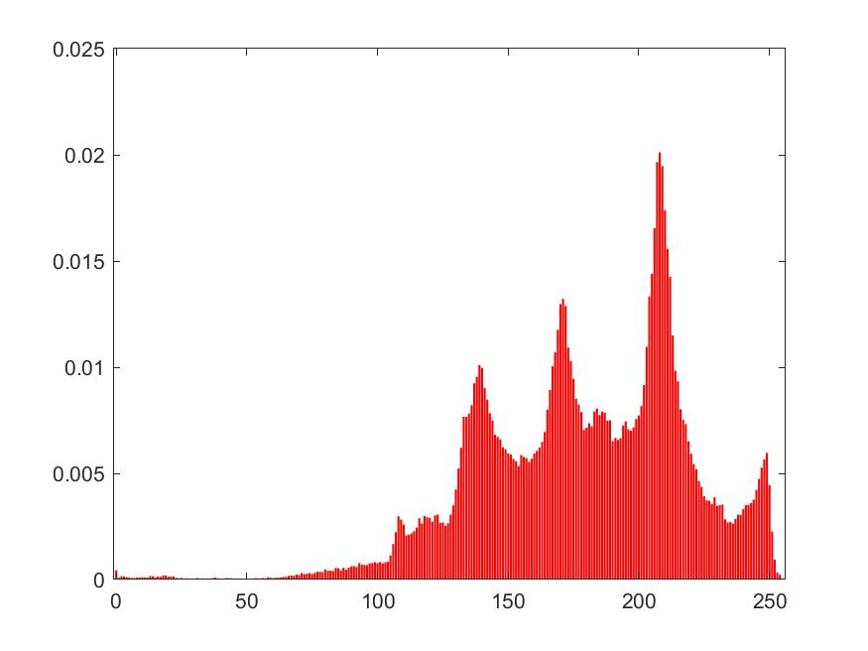

Intersection result

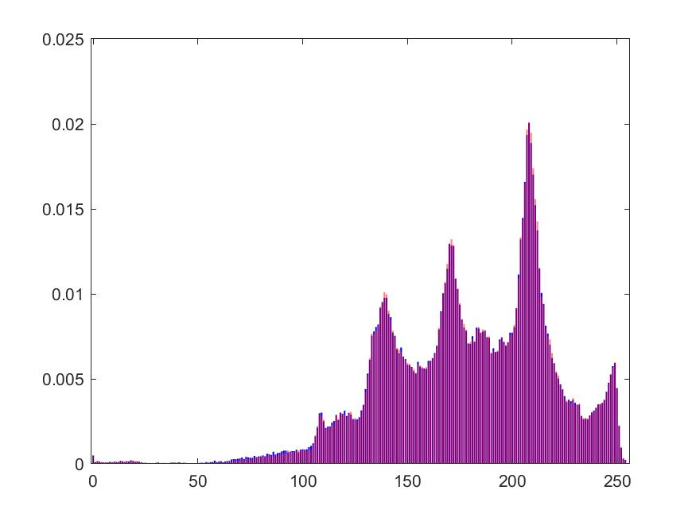

**Your Comments:**

**Example 1 is not normalised. Example 2 has been normalised by the total number of pixels in the frame.**

**It can be seen that the intersection for Ex 1 is less than 1 (0.7 approx). This can be identified as a change of scene in the video. This intersection indicates that the scene has changed and the color distribution has changed with it.**

**For Example two, the intersection is approximately 1, i.e. it overlaps the previous histogram. Thus, it can be inferred that the scene has not changed as it still hold the color distribution.**

**By normalising, images of different sizes can be compared. Over in this example as both the image is form a video sequence, the number of pixels remains the same. Thus no change is observed before and after normalization**

**Question 3(c):**

**Comments:**

**The intersection value represents if the scene has changed or not from the previous frame. The histogram technique is fairly robust when it comes to comparing two images.**

**It fails when the scenes changes but the color distribution is still maintained; as histogram is the representation of the color distribution and not position of the colors in the image.**

**This technique can be used for supervised image classification. Histograms of the new images can be compared with the histograms of the already labelled images to classify them.**