Lab 1. Setting up VSCode and Extensions

Overview
This lab covers all aspects of the download and installation of Visual Studio (VS) Code and the necessary prerequisites. This lab will cover the necessary steps and information to download and install the prerequisites needed for the subsequent labs within this course. This software is needed for one or more of the applications we will be utilizing in our labs throughout the course.

Objectives
- Install node.js
- Install Java SDK
- Install and run Visual Studio Code
- Install Zowe Explorer plugin
- Install IBM Z Open Editor plugin
- Complete registration

Lab instructions

Install node.js:
- Check for node.js installation and verify that the version number is v8 or higher.
Open your workstation's version of the command prompt (called Terminal on Mac OS X). Once the command prompt is open, use the command in Example 1 to check if your workstation currently has a version of node.js installed.
- Node.js version
C:\Users\User> node -v

V12.16.1
If you do not see a version number after you submit the command, you do not have node.js installed, or if it shows a version less than v8, you should continue following these instructions. If you do see a version number and it is v8 or higher, you can move on to section Install Java SDK.
- If node.js version is less than v8, or node isn't installed at all.
Updating node.js to the appropriate version number is a relatively simple process because the installer takes care of most of the "heavy lifting". All you will need to do is visit the Node.js download site, provided below, and follow the download and installation instructions for your specific workstation platform. Do this same process if you do not already have node.js installed.
https://nodejs.org/en/download/
This process will install the latest versions of Node.js and the node package manager (npm) and overwrite any older version files in your system. This removes the step of needing to manually uninstall the previous versions beforehand.
- Once completed, verify the installation and proper version number, as shown previously in Example 1.
Note: The version numbers in our examples are provided purely for reference and may not reflect the latest versions of the software.

Install Java SDK:
- Check for Java installation and verify that the version number is v8 or higher.
Open your workstation's version of the command prompt, if not already open. Once the command prompt is open, use the command in Example 2 to check if your workstation currently has a version of Java installed. Java SDK 8 is the preferred version for these labs, however, any versions higher than that will suffice.
- Java version
C:\Users\User> java -version

java version "1.8.0_241"

Java(TM) SE Runtime Environment (build 1.8.0_241-b07)

Java HotSpot(TM) 64-Bit Server VM (build 25.241-b07, mixed mode)
If you do not see a version number after you submit the command, you do not have Java installed or if it shows a version less than v8, you should continue following these instructions. The display format of the version number for Java is slightly different than what is displayed for node.js. With Java, the second value in the displayed version number, i.e. the "8" in Example 2, is the version number. So, our example is showing Java SDK version 8. If you do see a version number and it is v8 or higher, you can move on to section Install VSCode.
- If your version of Java displayed is less than v8, you need to uninstall the current version on your workstation and reinstall the correct version. Follow the link below to uninstall instructions that represent your workstation operating system (OS).

Linux: https://www.java.com/en/download/help/linux_uninstall.xml

Mac: https://www.java.com/en/download/help/mac_uninstall_java.xml

Windows: https://www.java.com/en/download/help/uninstall_java.xml
- Once Java is uninstalled from your workstation, you can click the Java JDK 8 download link below and follow the installation instructions for your specific OS.
https://www.oracle.com/java/technologies/javase/javase-jdk8-downloads.html
- Verify the installation and proper version number as shown in Example 2.
Note: You will be prompted to register a new Oracle account in order to download the installation file, please do so. If you have an existing account, you may use that to log in and continue.

Install VSCode
If you do not already have VSCode installed on your workstation, please do so now by following the download and installation instructions at the link below:
https://code.visualstudio.com/download
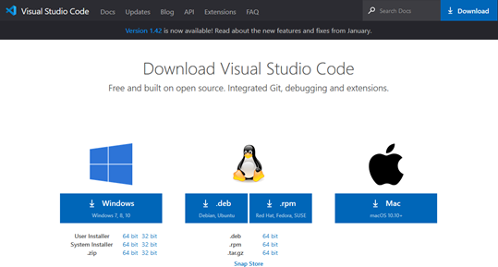
- VSCode download site

Note: Be sure to select the correct installation file for your workstations respective OS, shown in Figure 1.

Install VSCode extensions
This section introduces two VSCode extensions, Zowe Explorer and IBM Z Open Editor, listed in Figure 2, and instructions on how to install them.
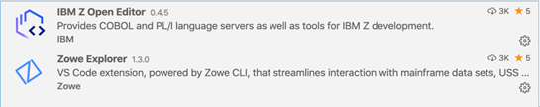
- VSCode required extensions

Zowe Explorer:
Zowe is a new, and the first open source framework for z/OS and provides solutions for development and operations teams to securely manage, control, script and develop on the mainframe like any other cloud platform. Out of the box, the Zowe Explorer provides a lot of functionality allowing z/OS developers access to jobs, datasets and (USS) files on a z/OS server. Backed by the Zowe CLI and z/OSMF, developers now have powerful features that makes it easy to work with z/OS within the familiar VSCode environment. This extension can be used to edit COBOL and PL/I files opened on z/OS MVS™ and USS using the Zowe extension's Data Sets and USS views. It can even run JCL and lets you browse job spool files. For more information on Zowe Explorer and its interaction with z/OS please visit:
https://ibm.github.io/zopeneditor-about/Docs/interact_zos_zowe_explorer.html

Install Zowe Explorer:
Open VSCode and in the left side tool menu select Extensions. From there, in the "Search Extensions in Marketplace" search field, type Zowe Explorer. Search results will begin populating, select "Zowe Explorer" and click install, depicted in Figure 3.
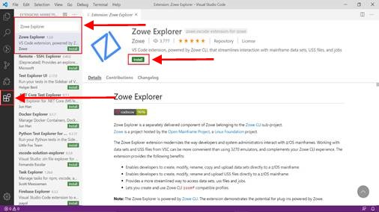
- Install Zowe Explorer in VSCode
The Zowe community has a number of on-line videos that walk through the steps required to install, configure and operate the Zowe Explorer, see: http://www.youtube.com/watch?v=G_WCsFZIWt4&t=0m38s

IBM Z Open Editor:
IBM Z Open Editor brings COBOL and PL/I language support to Microsoft VSCode. It is one of the several next generation capabilities for an open development experience for z/OS®. It also works in association with the Zowe Explorer plugin. For more information on IBM Z Open Editor, please visit:
https://ibm.github.io/zopeneditor-about/Docs/introduction.html#key-capabilities

Install IBM Z Open Editor:
Open VSCode and in the left side tool menu select Extensions. From there, in the "Search Extensions in Marketplace" search field, type IBM Z Open Editor. Search results will begin populating, select " IBM Z Open Editor " and click install, depicted in Figure 4.
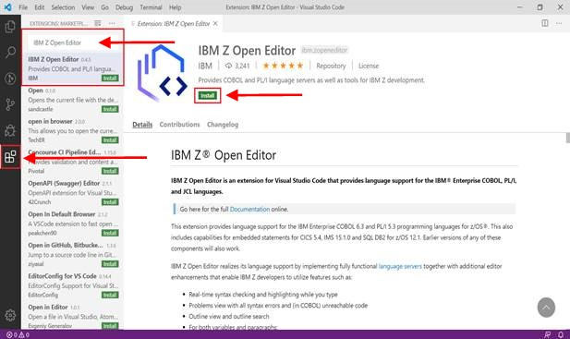
- Install IBM Z Open Editor in VSCode
Note: There may be some limitations with IBM Z Open Editor if running a 32-bit Java version on Windows.

Register for an account:

Follow the link provided below to register for an account with the mainframe. This account registration will provide you with a username, password and z/OSMF URL to establish your connection to the mainframe and must be done before moving on to lab 2.

You will be registered into the IBM Z XPlore learning experience system; you are required to click into the “Open Mainframe Project COBOL Programming Course” section and complete the “Access Resources” challenge.

Registration Link:
https://ibm.biz/cobollabs

Lab 2. Connecting to the Mainframe

Overview
In this lab exercise you will connect to an IBM Z mainframe system, view a simple COBOL hello world program in VSCode, submit JCL to compile the COBOL program, and view the output.

Objectives
- Setup connection profile in Zowe Explorer
- Connect to z/OS through connection profile
- Filter data sets
- Submit “hello world” job
- View jobs output

Lab instructions

- The lab assumes installation of VSCode with Z Open Editor and Zowe Explorer extensions as shown in Figure 1.
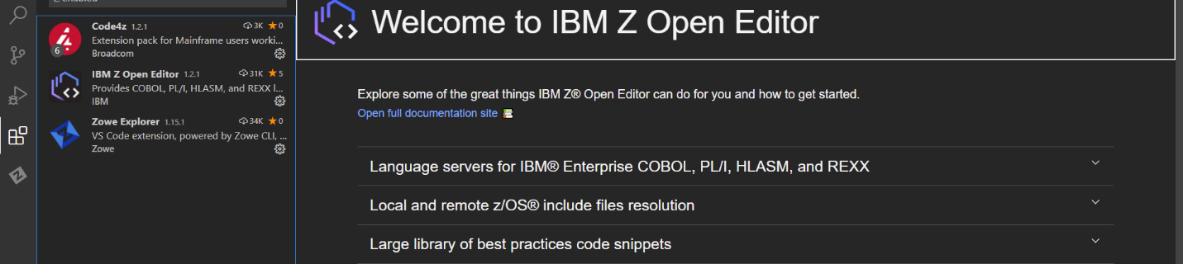
Click Extensions icon
List should include:
1. IBM Z Open Editor
2. Zowe Explorer
- VSCode extensions

- Click the Zowe Explorer icon as shown in Figure 2.
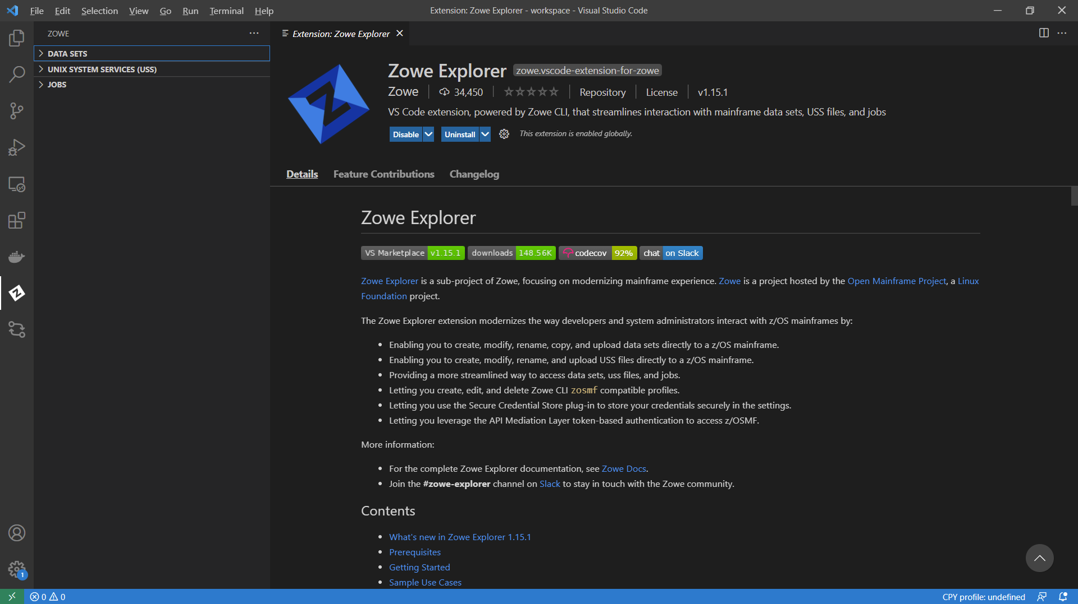
- Zowe Explorer icon
Zowe Explorer

- In order to connect to the lab system, get your team configuration zip file and extract it. You can obtain the team configuration zip file from the .zip file you downloaded along with this document.
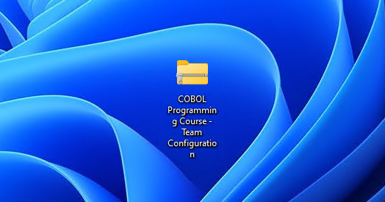
- Team Configuration Zip Folder

- Open the extracted folder. You will find the two configuration files as shown in Figure 4.
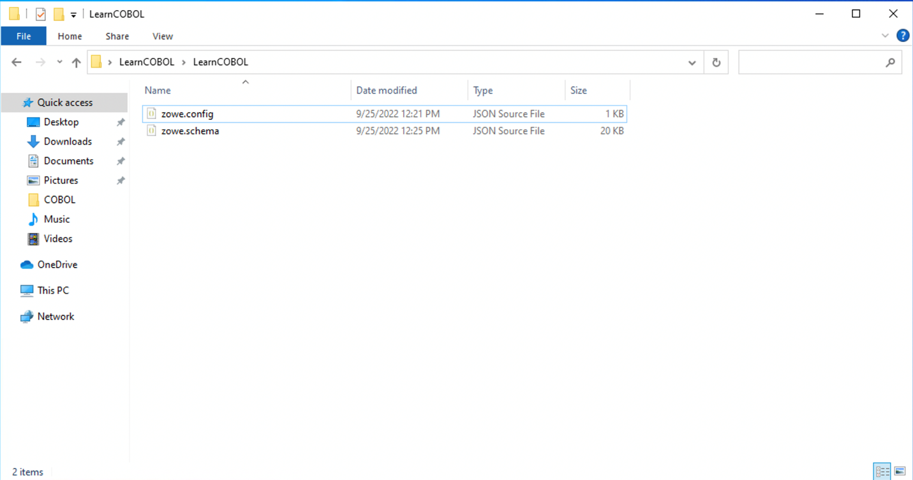
- Inside the Team Configuration folder

- Now back on your VS Code window, select the Explorer tab, and press the "Open folder" button in the left bar.
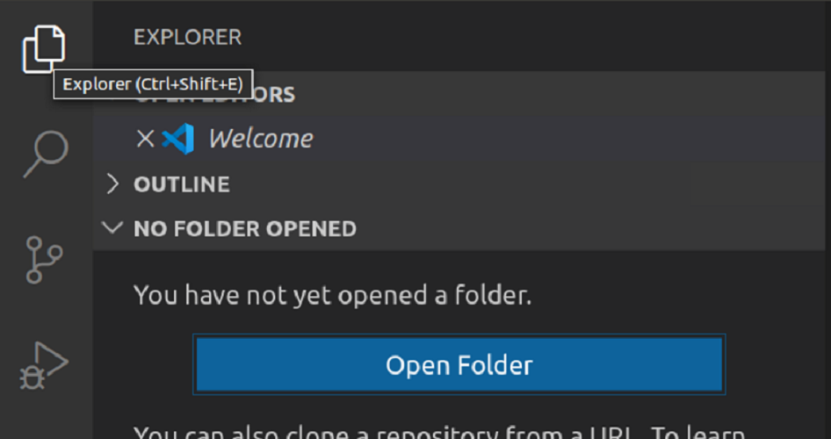
- Click the Open Folder button

- A pop-up window would show up, select the folder containing the team configuration files..
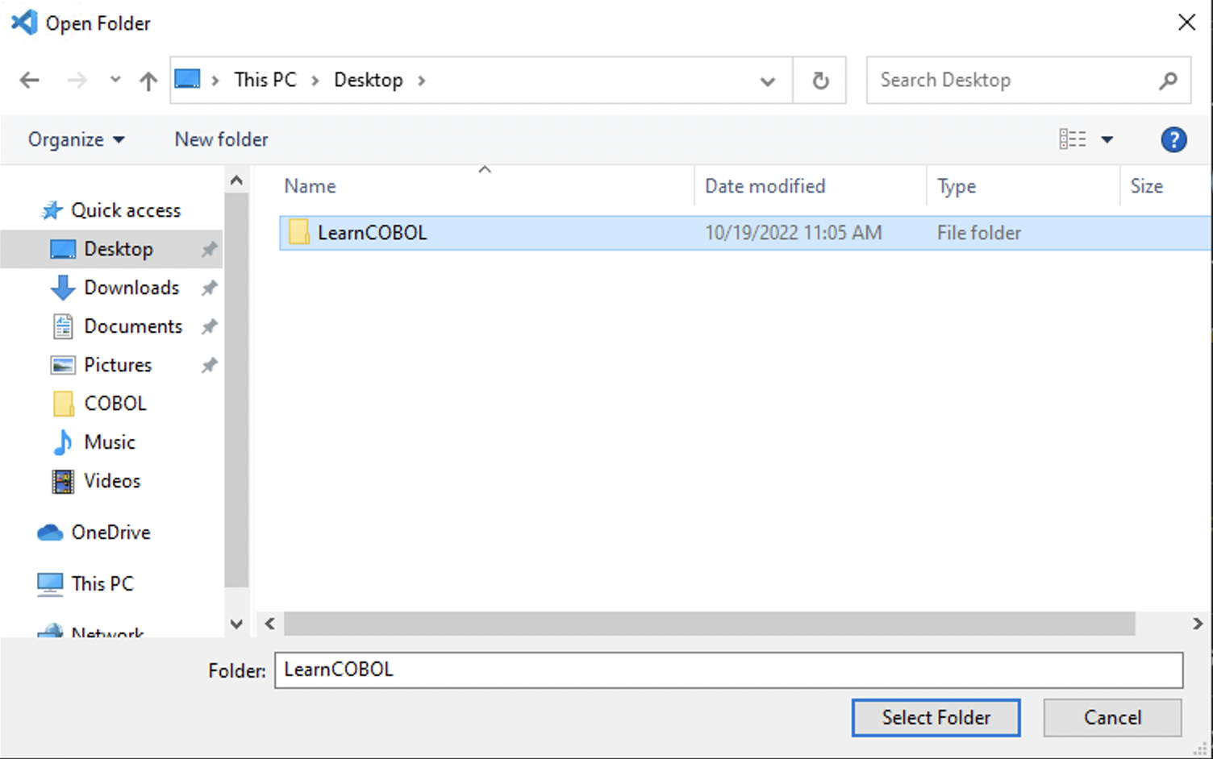
- Select the Team Configuration folder

If you are prompted to trust the authors of the files in the folder as shown in Figure 7, select Yes, I trust the authors.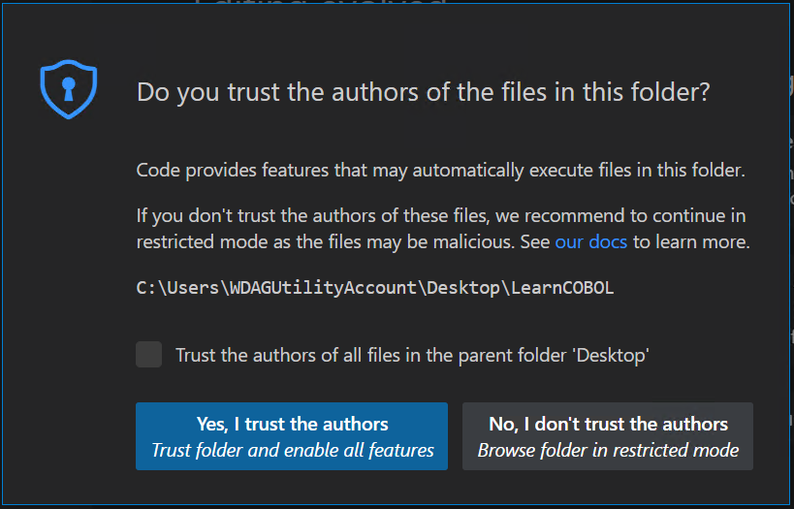
- Trust the Authors of Files in The Folder

- Your connection should be added automatically to the Data Sets list as shown in Figure 8.
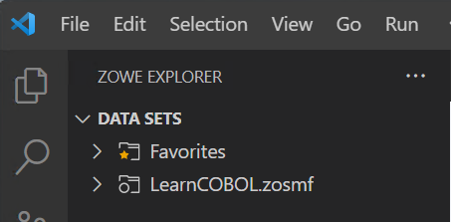
- LearnCOBOL Connection

If the connection does not appear, hover to the far right of the Data Sets line and press the + icon. Afterward, select the LearnCOBOL connection as shown in Figure 9.
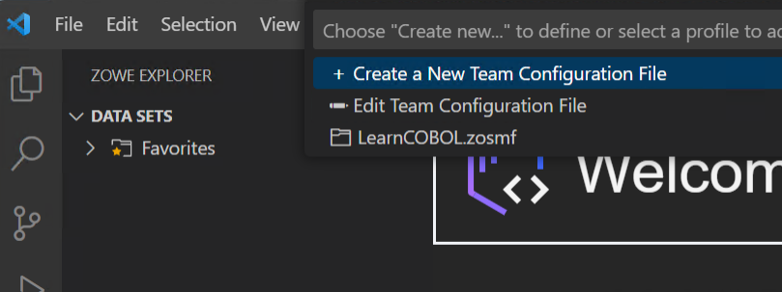
- Adding the Connection manually

- Press the LearnCOBOL connection..
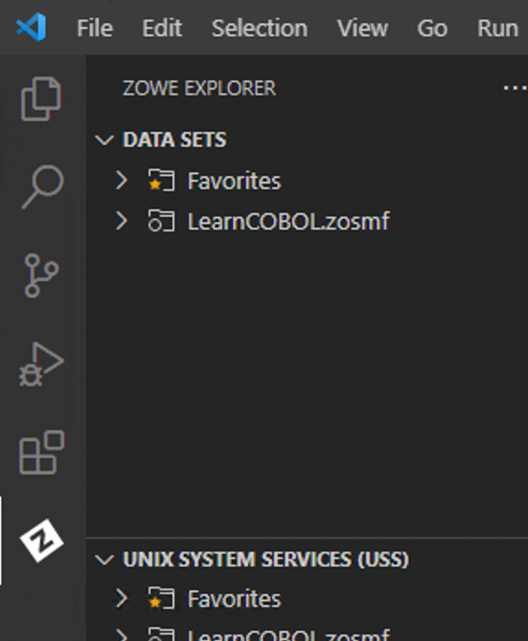
- Password prompt

- The connection prompts for a username as shown in Figure 11. Please enter the username assigned to you! Do not use the sample username of Z99998.
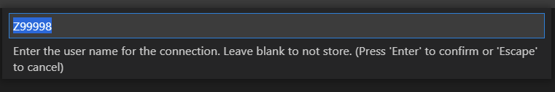
- Enter assigned user name

- Enter your assigned password as shown in Figure 12.
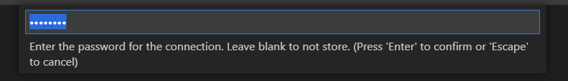
- Accept connections with self-signed certifications

- Expansion of the connection (LearnCOBOL.zosmf) reads “Use the search button to display datasets”. Click the search button as shown in Figure 13.
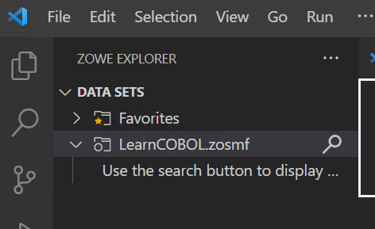
- Search button

- A prompt to "Search Data Sets" will appear as shown in Figure 14. Please enter the username assigned to you! Do not use the sample username of Z99998.
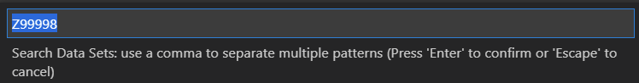
- Select a filter

- A list of data set names beginning with your username will appear as shown in Figure 15. You may have a different list as compared to what is shown in Figure 15.
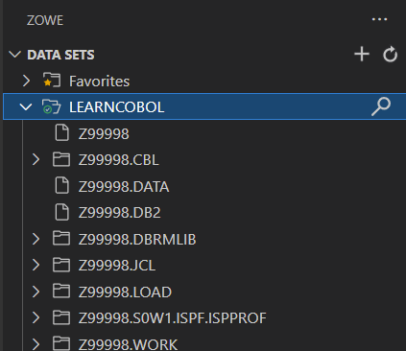
- Filtered data set names

- Expand <USERNAME>.CBL to view COBOL source members, then select member HELLO to see a simple COBOL ‘Hello World!’ program as shown in Figure 16.
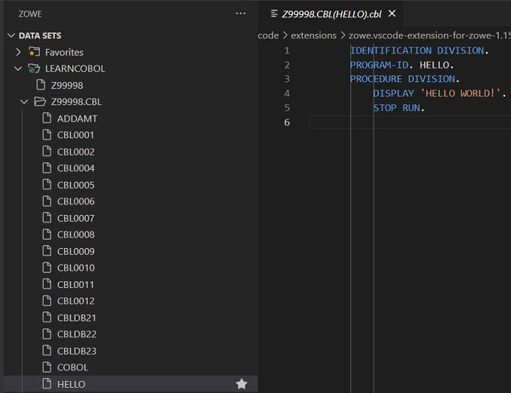
- USERNAME.CBL

- Expand <USERNAME>.JCL to view JCL and select member HELLO which is the JCL to compile and execute simple ‘Hello World!’ COBOL source code as shown in Figure 17.
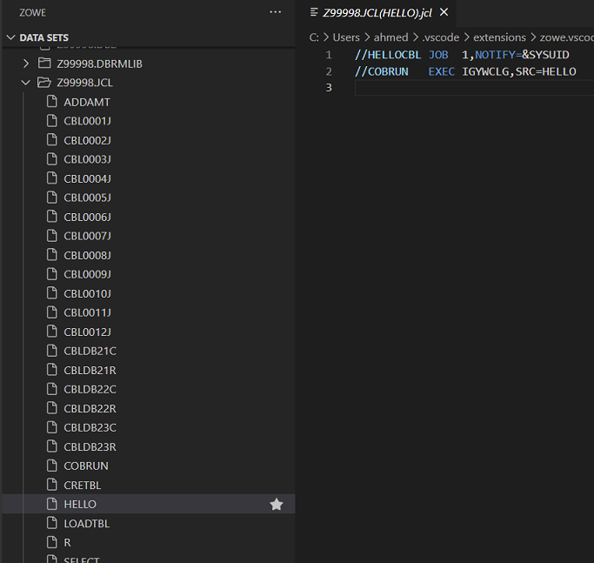
- USERNAME.JCL

- Right click on JCL member HELLO, a section box appears. Select Submit Job for system to process HELLO JCL as shown in Figure 18. The submitted JCL job compiles the COBOL HELLO source code, then executes the COBOL HELLO program.
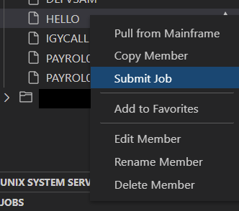
- Submit Job

- Observe the ‘Jobs’ section in Zowe Explorer as shown in Figure 19.
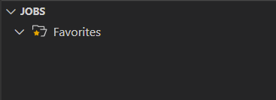
- JOBS section

- Again, click on the + to the far right on the Jobs selection. Result is another prompt to ‘Create new’. Select your connection (LearnCOBOL.zosmf) from the list as shown in Figure 20.
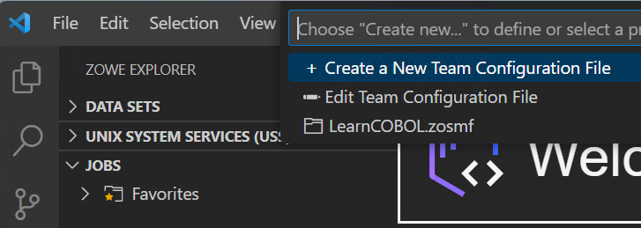
- Select LearnCOBOL connection
+

- As a result, the JCL jobs owned by your username appear. HELLOCBL is the JCL job name previously submitted. Expand HELLOCBL output to view sections of the output as shown in Figure 21.
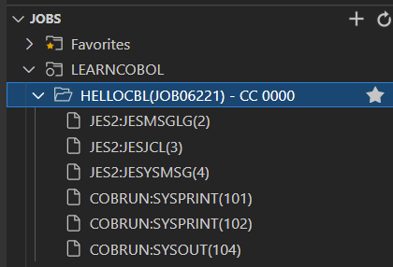
- HELLOCBL output

- Select COBRUN:SYSPRINT(101) to view the COBOL compiler output. Scroll forward in the COBOL compile to locate the COBOL source code compiled into an executable module as shown in Figure 22. Observe the Indicator Area in column 7, A Area beginning in column 8, and B Area beginning in column 12. Also, observe the period (.) scope terminators in the COBOL source.
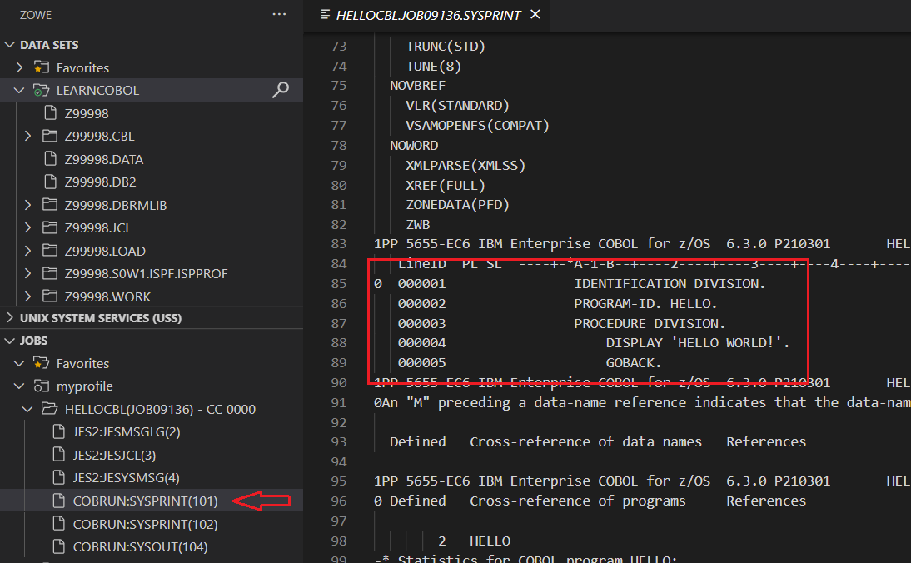
- COBOL compiler output

- View the COBOL program execution by selecting COBRUN:SYSOUT(104) from the LearnCOBOL in the Jobs section of Zowe Explorer as shown in Figure 23.
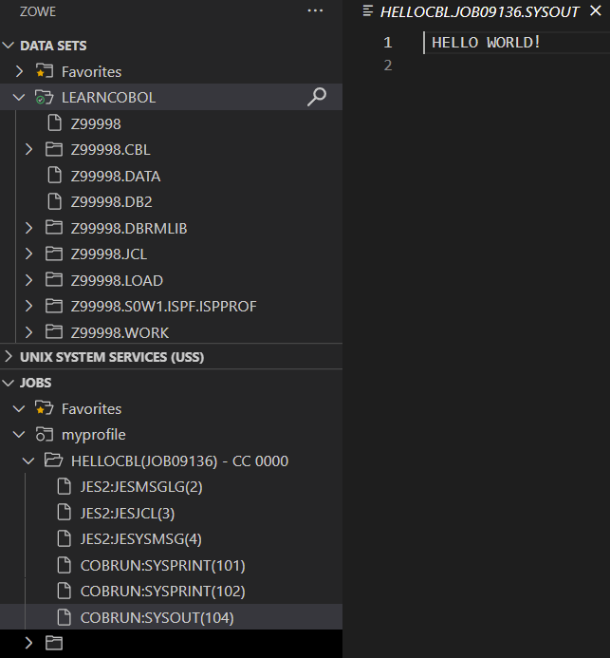
- COBOL program execution

- The following URL is another excellent document describing the above VSCode and Zowe Explorer details with examples:

https://marketplace.visualstudio.com/items?itemName=Zowe.vscode-extension-for-zowe

