SQL Database Code

GB Manufacturing Inventory Management System

Team Members: Alfred Beam, Shelton Adams, and Kenneth Battle

Class: CEIS400 – Week 7 - Group 1

Version: 1.1

Date: February 28, 2025

Revisions

|  |  |  |  |
| --- | --- | --- | --- |
| Version | Author | Description | Date |
| 1.0 | Alfred Beam | Initial Draft | 02/15/2025 |
| 1.1 | Alfred Beam | Added SQL Database Code | 02/28/2025 |
|  |  |  |  |
|  |  |  |  |
|  |  |  |  |

**Contents**

1 Schema Creation 4

1.1 Schema Image 4

1.2 Schema Code 4

2 Employee Table 5

2.1 Employee Table Images 5

2.2 Employee Table Code 6

3 Material Table 7

3.1 Material Table Image 7

3.2 Material Table Code 8

4 Tool Table 9

4.1 Tool Table Image 9

4.2 Tool Table Code 10

# Schema Creation

## Schema Image

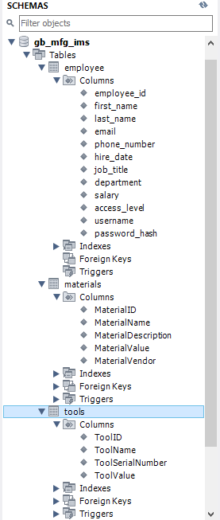

## Schema Code

CREATE SCHEMA `gb_mfg_ims` ;

# Employee Table



## Employee Table Images

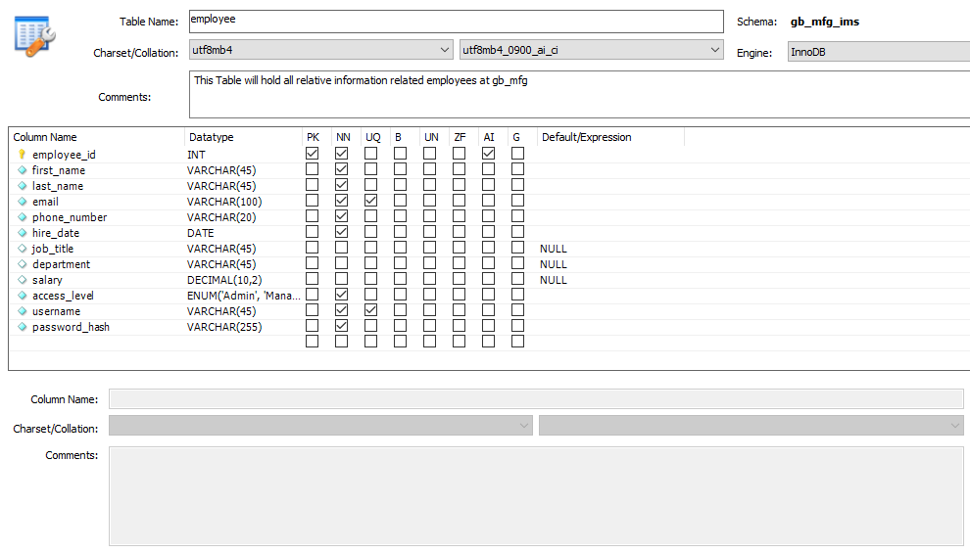

## Employee Table Code

CREATE TABLE `employee` (

`employee_id` int NOT NULL AUTO_INCREMENT,

`first_name` varchar(45) NOT NULL,

`last_name` varchar(45) NOT NULL,

`email` varchar(100) NOT NULL,

`phone_number` varchar(20) NOT NULL,

`hire_date` date NOT NULL,

`job_title` varchar(45) DEFAULT NULL,

`department` varchar(45) DEFAULT NULL,

`salary` decimal(10,2) DEFAULT NULL,

`access_level` enum('Admin','Manager','Staff') NOT NULL,

`username` varchar(45) NOT NULL,

`password_hash` varchar(255) NOT NULL COMMENT 'Store hashed passwords',

PRIMARY KEY (`employee_id`),

UNIQUE KEY `email_UNIQUE` (`email`),

UNIQUE KEY `username_UNIQUE` (`username`)

) ENGINE=InnoDB AUTO_INCREMENT=20 DEFAULT CHARSET=utf8mb4 COLLATE=utf8mb4_0900_ai_ci COMMENT='This Table will hold all relative information related employees at gb_mfg'

# Material Table



## Material Table Image

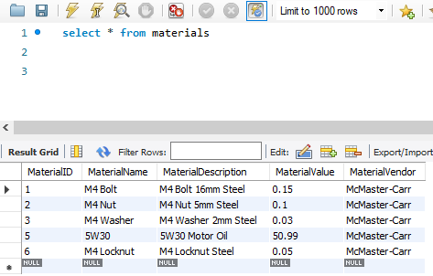

## Material Table Code

CREATE TABLE `materials` (

`MaterialID` int NOT NULL AUTO_INCREMENT,

`MaterialName` varchar(45) NOT NULL,

`MaterialDescription` varchar(45) NOT NULL,

`MaterialValue` double NOT NULL,

`MaterialVendor` varchar(45) NOT NULL,

PRIMARY KEY (`MaterialID`)

) ENGINE=InnoDB AUTO_INCREMENT=7 DEFAULT CHARSET=utf8mb4 COLLATE=utf8mb4_0900_ai_ci

# Tool Table



## Tool Table Image

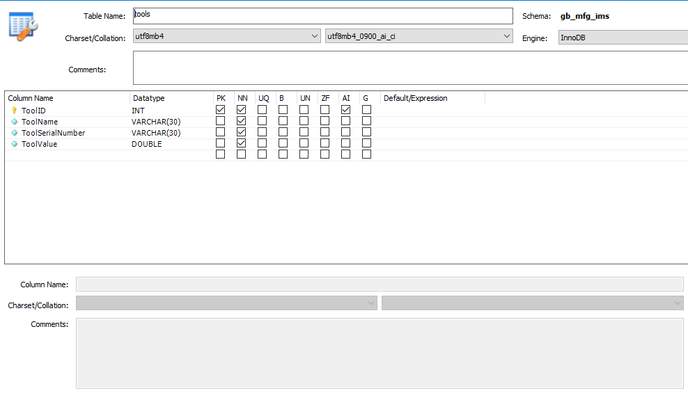

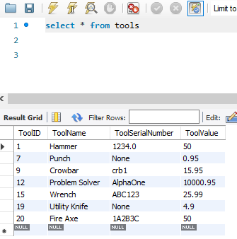

## Tool Table Code

CREATE TABLE `tools` (

`ToolID` int NOT NULL AUTO_INCREMENT,

`ToolName` varchar(30) NOT NULL,

`ToolSerialNumber` varchar(30) NOT NULL,

`ToolValue` double NOT NULL,

PRIMARY KEY (`ToolID`)

) ENGINE=InnoDB AUTO_INCREMENT=21 DEFAULT CHARSET=utf8mb4 COLLATE=utf8mb4_0900_ai_ci