##Exploratory/Descriptive Analsysis

###Shelton Stevens

library("tidyverse")

## ── Attaching packages ─────────────────────────────────────── tidyverse 1.3.1 ──

## ✔ ggplot2 3.3.6 ✔ purrr 0.3.4  
## ✔ tibble 3.1.7 ✔ dplyr 1.0.9  
## ✔ tidyr 1.2.0 ✔ stringr 1.4.0  
## ✔ readr 2.1.2 ✔ forcats 0.5.1

## ── Conflicts ────────────────────────────────────────── tidyverse_conflicts() ──  
## ✖ dplyr::filter() masks stats::filter()  
## ✖ dplyr::lag() masks stats::lag()

library("tidymodels")

## ── Attaching packages ────────────────────────────────────── tidymodels 0.2.0 ──

## ✔ broom 0.8.0 ✔ rsample 0.1.1  
## ✔ dials 0.1.1 ✔ tune 0.2.0  
## ✔ infer 1.0.0 ✔ workflows 0.2.6  
## ✔ modeldata 0.1.1 ✔ workflowsets 0.2.1  
## ✔ parsnip 0.2.1 ✔ yardstick 0.0.9  
## ✔ recipes 0.2.0

## ── Conflicts ───────────────────────────────────────── tidymodels_conflicts() ──  
## ✖ scales::discard() masks purrr::discard()  
## ✖ dplyr::filter() masks stats::filter()  
## ✖ recipes::fixed() masks stringr::fixed()  
## ✖ dplyr::lag() masks stats::lag()  
## ✖ yardstick::spec() masks readr::spec()  
## ✖ recipes::step() masks stats::step()  
## • Search for functions across packages at https://www.tidymodels.org/find/

library("GGally")

## Registered S3 method overwritten by 'GGally':  
## method from   
## +.gg ggplot2

library("ggcorrplot")  
library("gridExtra")

##   
## Attaching package: 'gridExtra'

## The following object is masked from 'package:dplyr':  
##   
## combine

library("dplyr")  
library("skimr")  
library("esquisse")  
library("corrr")

##   
## Attaching package: 'corrr'

## The following object is masked from 'package:skimr':  
##   
## focus

library("ranger")  
library("randomForest")

## randomForest 4.7-1.1

## Type rfNews() to see new features/changes/bug fixes.

##   
## Attaching package: 'randomForest'

## The following object is masked from 'package:ranger':  
##   
## importance

## The following object is masked from 'package:gridExtra':  
##   
## combine

## The following object is masked from 'package:dplyr':  
##   
## combine

## The following object is masked from 'package:ggplot2':  
##   
## margin

library("ggplot2")

HomeSales <- read.csv("ames_student.csv")   
HomeSales <- subset( HomeSales, select = -c(Functional, Garage_Cars, Three_season_porch, Pool_Area, Pool_QC, Misc_Feature, Misc_Val))  
HomeSales = HomeSales %>% mutate_if(is.character,as_factor)

##Graphing Variables

ggplot(data=HomeSales, aes(x=MS_SubClass, y=Above_Median)) +  
 geom_bar(stat="identity")

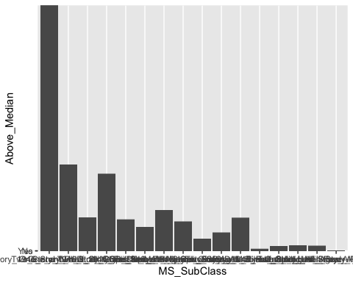

ggplot(data=HomeSales, aes(x=MS_Zoning, y=Above_Median)) +  
 geom_bar(stat="identity") +  
 theme(axis.text.x = element_text(angle=90, hjust=1, size=5))

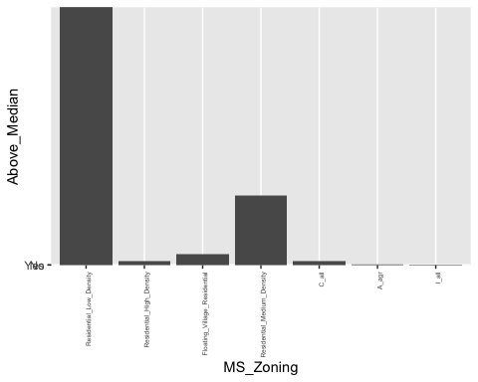

ggplot(HomeSales, aes(x=Lot_Frontage, y=Above_Median)) +   
 geom_boxplot()

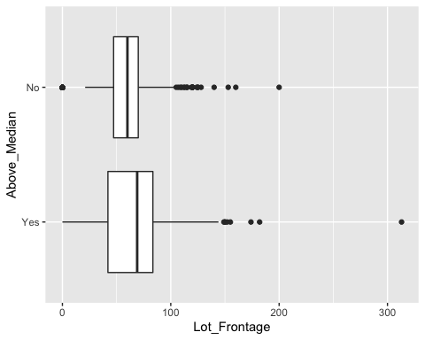

ggplot(HomeSales, aes(x=Lot_Area, y=Above_Median)) +   
 geom_boxplot()

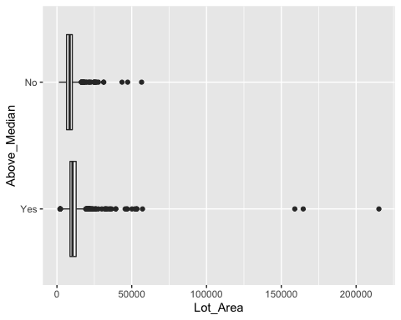

ggplot(data=HomeSales, aes(x=Lot_Shape, y=Above_Median)) +  
 geom_bar(stat="identity")

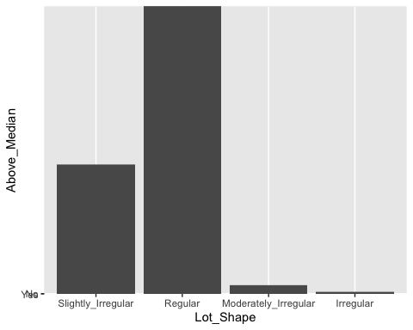

ggplot(data=HomeSales, aes(x=Land_Contour, y=Above_Median)) +  
 geom_bar(stat="identity")

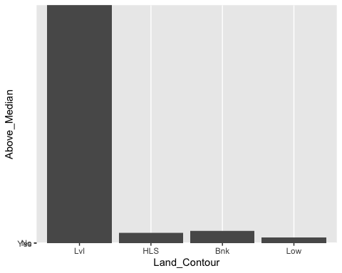

ggplot(data=HomeSales, aes(x=Lot_Config, y=Above_Median)) +  
 geom_bar(stat="identity")

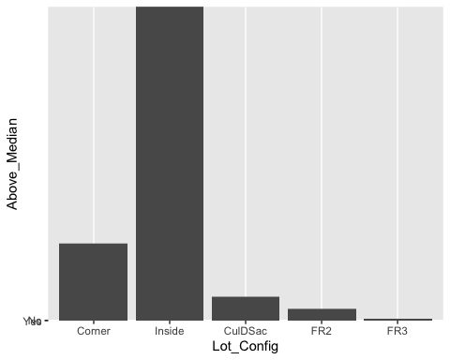

ggplot(data=HomeSales, aes(x=Neighborhood, y=Above_Median, fill= Above_Median)) +  
 geom_bar(stat="identity") +  
 theme(axis.text.x = element_text(angle=90, hjust=1, size=5)) +  
 ggtitle("Neighborhood versus Median Sales Price") +  
 labs(y= "Above Median", x = "Neighborhood") +  
 labs(fill = "Above Median")

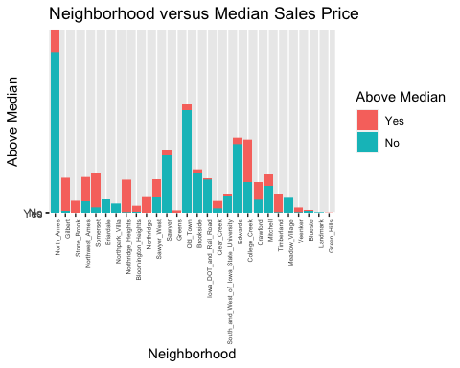

ggplot(data=HomeSales, aes(x=Condition_1, y=Above_Median)) +  
 geom_bar(stat="identity")

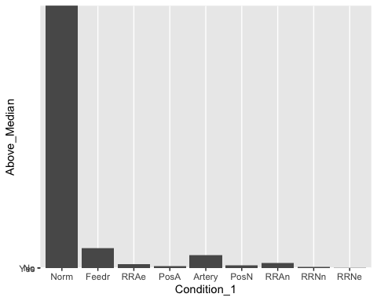

ggplot(data=HomeSales, aes(x=Bldg_Type, y=Above_Median)) +  
 geom_bar(stat="identity")

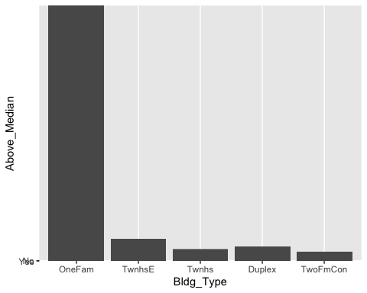

ggplot(data=HomeSales, aes(x=House_Style, y=Above_Median)) +  
 geom_bar(stat="identity") +  
 theme(axis.text.x = element_text(angle=90, hjust=1))

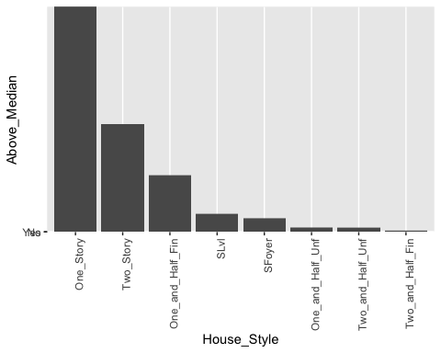

HomeSales$Overall_Qual <-factor(HomeSales$Overall_Qual, levels = c("Very_Excellent", "Excellent", "Very_Good", "Good", "Above_Average", "Average", "Below_Average", "Fair", "Poor", "Very_Poor"))  
ggplot(data=HomeSales, aes(x=Overall_Qual, y=Above_Median, fill=Above_Median)) +  
 geom_bar(stat="identity") +  
 theme(axis.text.x = element_text(angle=90, hjust=1)) +  
 theme(axis.text.y = element_text(angle=90, vjust=.5)) +  
 ggtitle("Overall Quality versus Median Sales Price") +  
 labs(y= "Above Median", x = "Overall Quality") +  
 labs(fill = "Above Median")

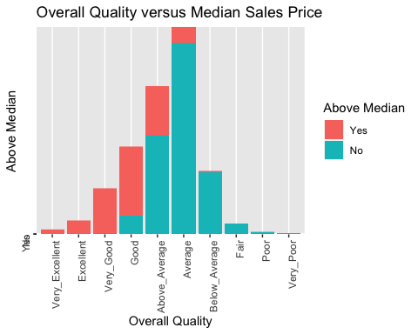

ggplot(data=HomeSales, aes(x=Overall_Cond, y=Above_Median)) +  
 geom_bar(stat="identity") +  
 theme(axis.text.x = element_text(angle=90, hjust=1))

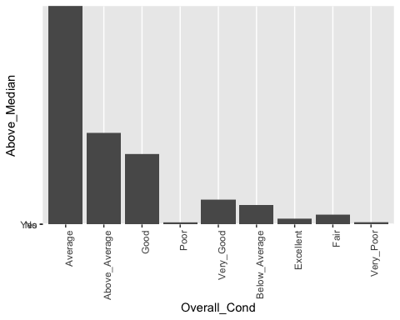

ggplot(HomeSales, aes(x=Year_Built, y=Above_Median)) +   
 geom_boxplot()

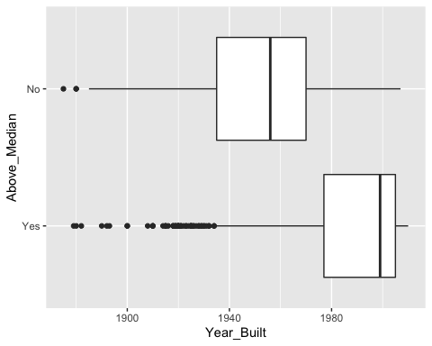

ggplot(HomeSales, aes(x=Year_Remod_Add, y=Above_Median)) +   
 geom_boxplot() +  
 ggtitle("Remodel Year versus Median Sales Price") +  
 labs(y= "Above Median", x = "Remodel Year")

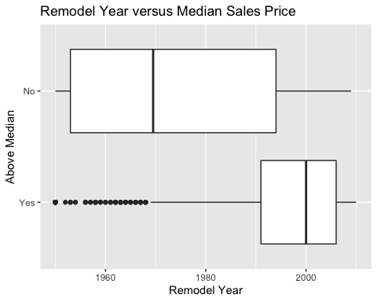

ggplot(data=HomeSales, aes(x=Roof_Style, y=Above_Median)) +  
 geom_bar(stat="identity")

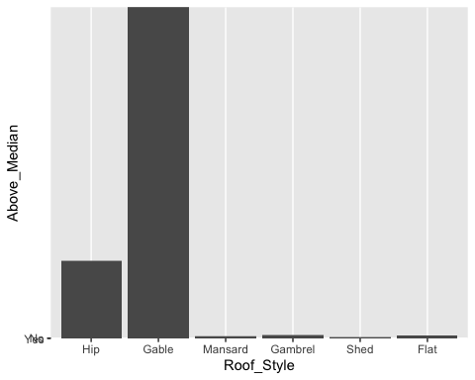

ggplot(data=HomeSales, aes(x=Exterior_1st, y=Above_Median)) +  
 geom_bar(stat="identity") +  
 theme(axis.text.x = element_text(angle=90, hjust=1))

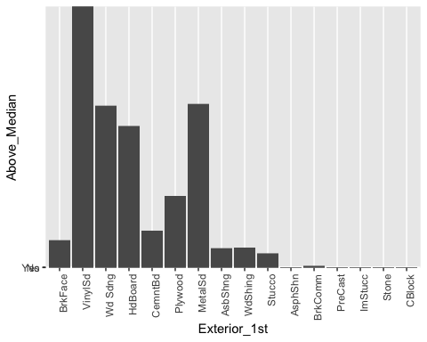

ggplot(data=HomeSales, aes(x=Exterior_2nd, y=Above_Median)) +  
 geom_bar(stat="identity") +  
 theme(axis.text.x = element_text(angle=90, hjust=1))

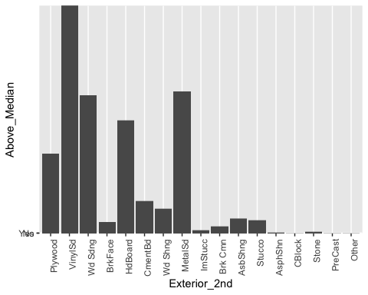

ggplot(data=HomeSales, aes(x=Mas_Vnr_Type, y=Above_Median)) +  
 geom_bar(stat="identity") +  
 theme(axis.text.x = element_text(angle=90, hjust=1))

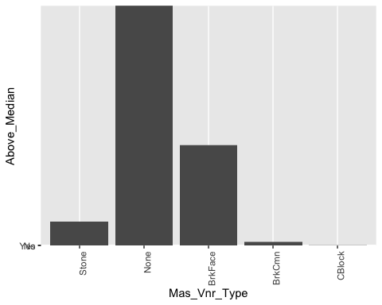

ggplot(HomeSales, aes(x=Mas_Vnr_Area, y=Above_Median)) +   
 geom_boxplot()

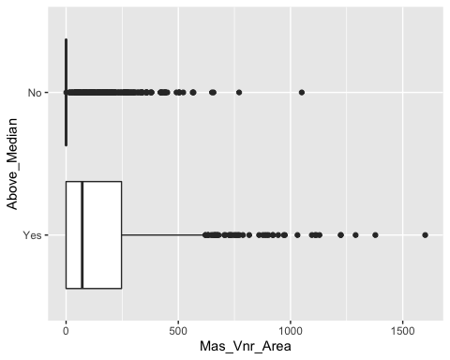

ggplot(data=HomeSales, aes(x=Exter_Cond, y=Above_Median)) +  
 geom_bar(stat="identity") +  
 theme(axis.text.x = element_text(angle=90, hjust=1))

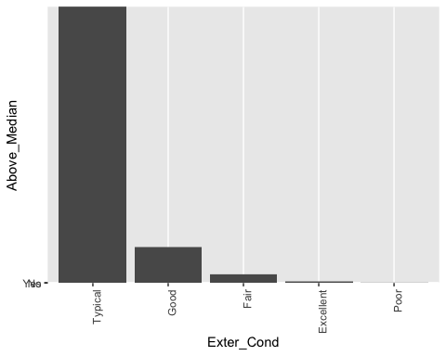

ggplot(data=HomeSales, aes(x=Foundation, y=Above_Median)) +  
 geom_bar(stat="identity") +  
 theme(axis.text.x = element_text(angle=90, hjust=1))

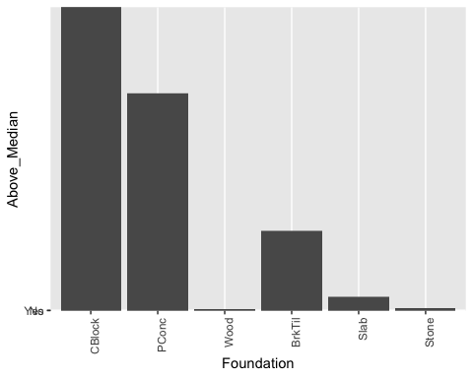

ggplot(data=HomeSales, aes(x=Bsmt_Qual, y=Above_Median)) +  
 geom_bar(stat="identity") +  
 theme(axis.text.x = element_text(angle=90, hjust=1))

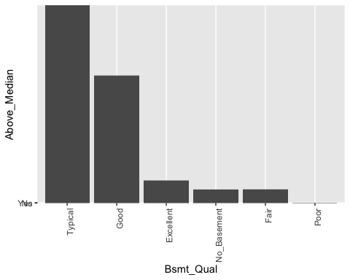

ggplot(data=HomeSales, aes(x=Bsmt_Cond, y=Above_Median)) +  
 geom_bar(stat="identity") +  
 theme(axis.text.x = element_text(angle=90, hjust=1))

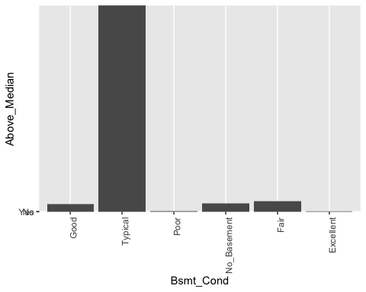

ggplot(data=HomeSales, aes(x=Bsmt_Exposure, y=Above_Median)) +  
 geom_bar(stat="identity") +  
 theme(axis.text.x = element_text(angle=90, hjust=1))

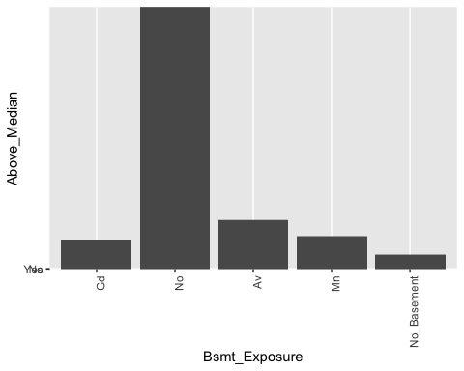

HomeSales$BsmtFin_Type_1 <-factor(HomeSales$BsmtFin_Type_1, levels = c("GLQ", "Unf", "ALQ", "Rec", "BLQ", "LwQ", "No_Basement"))  
ggplot(data=HomeSales, aes(x=BsmtFin_Type_1, y=Above_Median, fill=Above_Median)) +  
 geom_bar(stat="identity") +  
 theme(axis.text.x = element_text(angle=90, hjust=1)) +  
 ggtitle("Basement Finish versus Median Sales Price") +  
 labs(y= "Above Median", x = "Basement Finish Type") +  
 labs(fill = "Above Median")

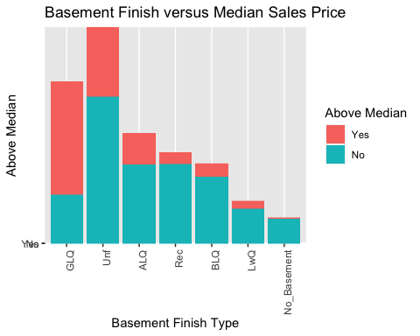

ggplot(HomeSales, aes(x=BsmtFin_SF_1, y=Above_Median)) +   
 geom_boxplot()

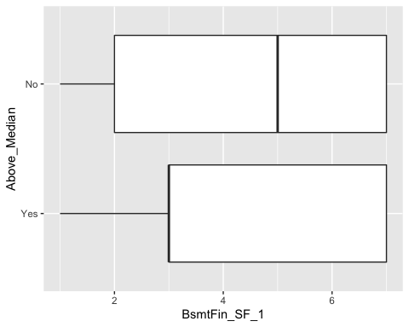

ggplot(data=HomeSales, aes(x=BsmtFin_Type_2, y=Above_Median)) +  
 geom_bar(stat="identity") +  
 theme(axis.text.x = element_text(angle=90, hjust=1))

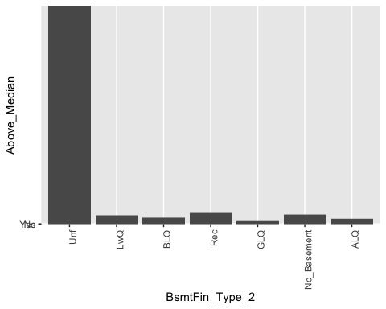

ggplot(HomeSales, aes(x=BsmtFin_SF_2, y=Above_Median)) +   
 geom_boxplot()

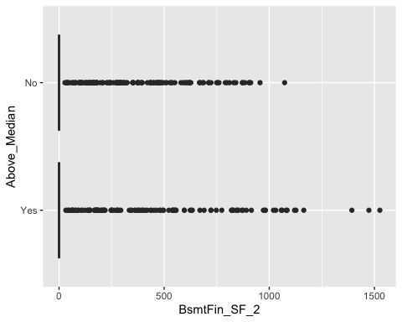

ggplot(HomeSales, aes(x=Bsmt_Unf_SF, y=Above_Median)) +   
 geom_boxplot()

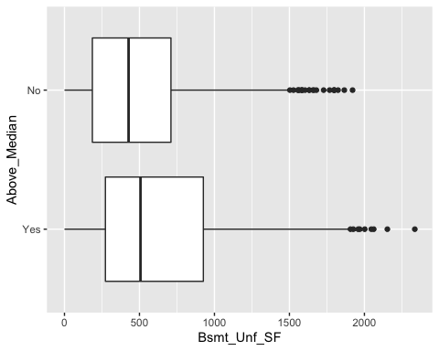

ggplot(HomeSales, aes(x=Total_Bsmt_SF, y=Above_Median)) +   
 geom_boxplot()

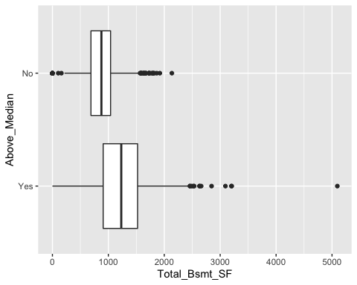

ggplot(data=HomeSales, aes(x=Heating_QC, y=Above_Median)) +  
 geom_bar(stat="identity") +  
 theme(axis.text.x = element_text(angle=90, hjust=1))

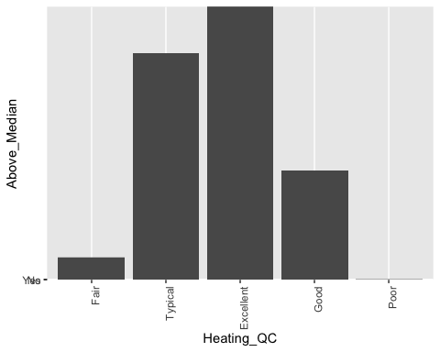

ggplot(HomeSales, aes(x=First_Flr_SF, y=Above_Median)) +   
 geom_boxplot()

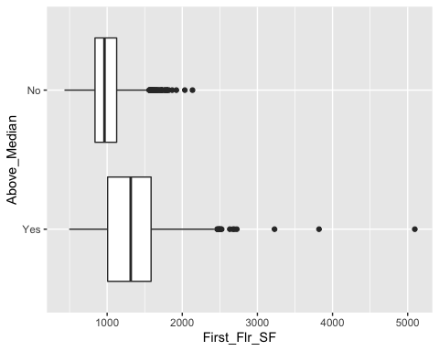

ggplot(HomeSales, aes(x=Second_Flr_SF, y=Above_Median)) +   
 geom_boxplot()

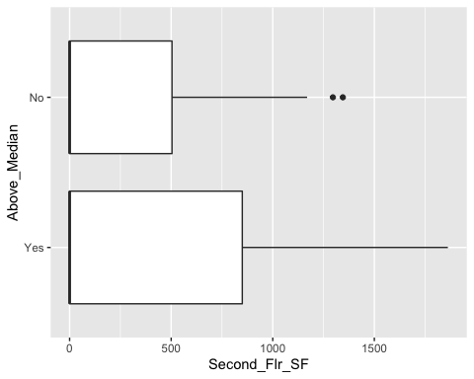

ggplot(HomeSales, aes(x=Gr_Liv_Area, y=Above_Median)) +   
 geom_boxplot()

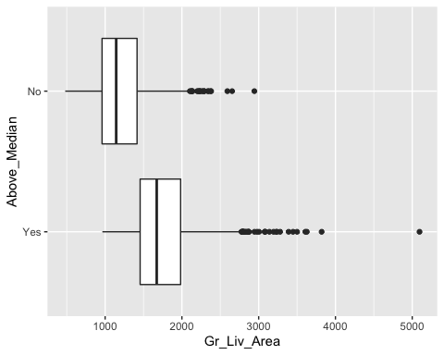

ggplot(HomeSales, aes(x=Bsmt_Full_Bath, y=Above_Median)) +   
 geom_boxplot()

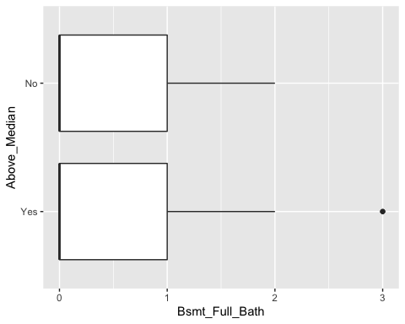

ggplot(HomeSales, aes(x=Bsmt_Half_Bath, y=Above_Median)) +   
 geom_boxplot()

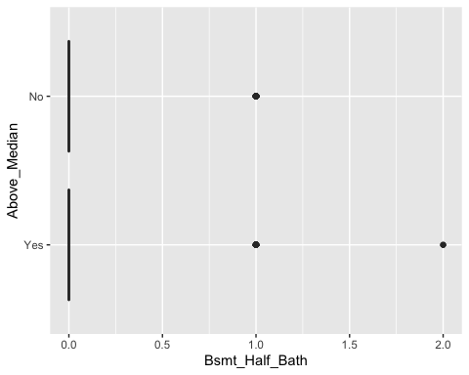

ggplot(HomeSales, aes(x=Full_Bath, y=Above_Median)) +   
 geom_boxplot()

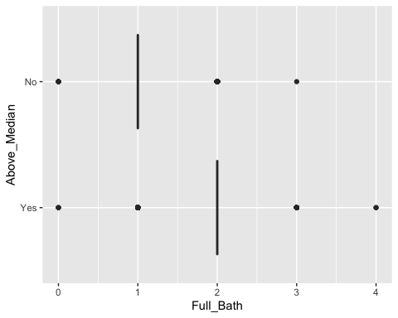

ggplot(HomeSales, aes(x=Half_Bath, y=Above_Median)) +   
 geom_boxplot()

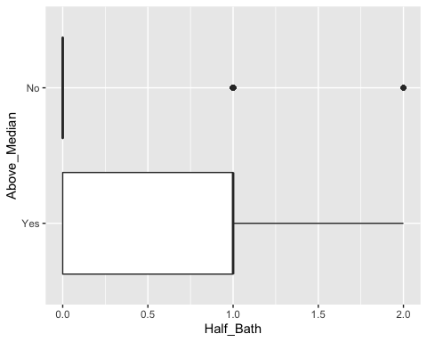

ggplot(HomeSales, aes(x=Bedroom_AbvGr, y=Above_Median)) +   
 geom_boxplot()

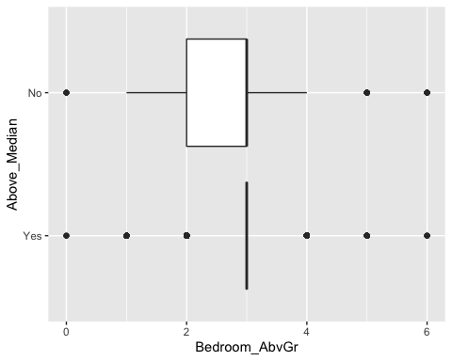

ggplot(HomeSales, aes(x=Kitchen_AbvGr, y=Above_Median)) +   
 geom_boxplot()

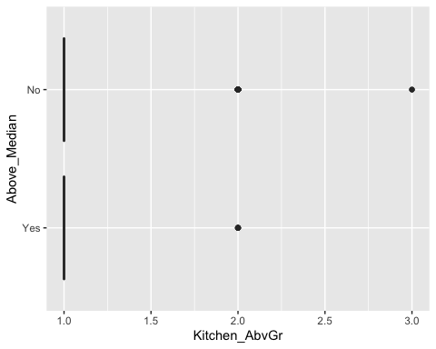

ggplot(data=HomeSales, aes(x=Kitchen_Qual, y=Above_Median)) +  
 geom_bar(stat="identity") +  
 theme(axis.text.x = element_text(angle=90, hjust=1))

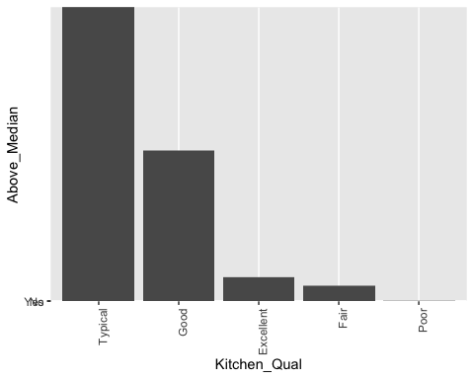

ggplot(HomeSales, aes(x=TotRms_AbvGrd, y=Above_Median)) +   
 geom_boxplot()

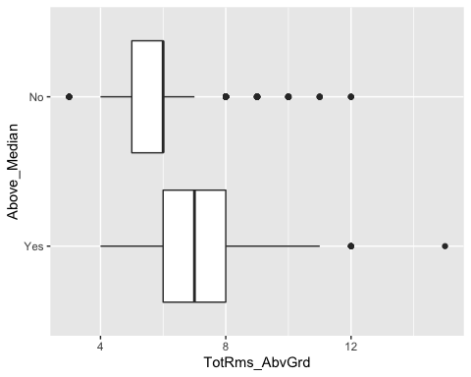

ggplot(HomeSales, aes(x=Fireplaces, y=Above_Median)) +   
 geom_boxplot()

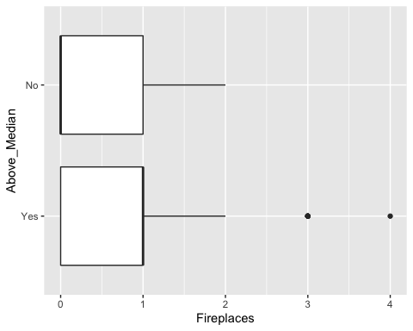

ggplot(data=HomeSales, aes(x=Fireplace_Qu, y=Above_Median)) +  
 geom_bar(stat="identity") +  
 theme(axis.text.x = element_text(angle=90, hjust=1))

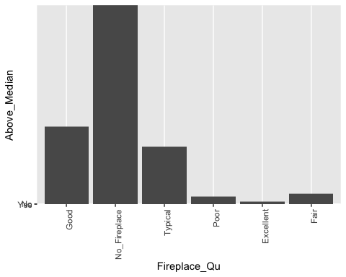

ggplot(data=HomeSales, aes(x=Garage_Type, y=Above_Median)) +  
 geom_bar(stat="identity") +  
 theme(axis.text.x = element_text(angle=90, hjust=1))

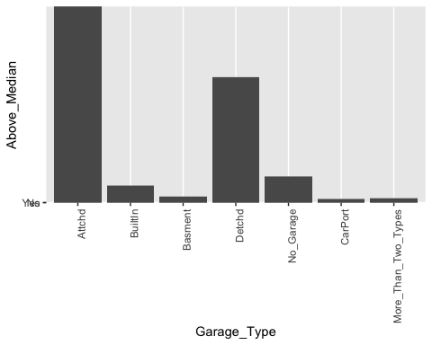

ggplot(data=HomeSales, aes(x=Garage_Finish, y=Above_Median, fill=Above_Median)) +  
 geom_bar(stat="identity") +  
 theme(axis.text.x = element_text(angle=90, hjust=1)) +  
 ggtitle("Garage Finish versus Median Sales Price") +  
 labs(y= "Above Median", x = "Garage Finish Type") +  
 labs(fill = "Above Median")

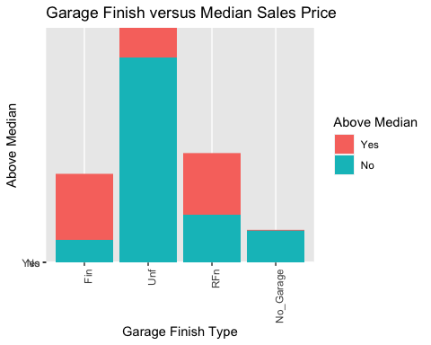

ggplot(HomeSales, aes(x=Garage_Area, y=Above_Median)) +   
 geom_boxplot()

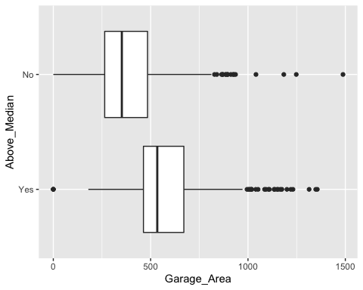

ggplot(data=HomeSales, aes(x=Garage_Qual, y=Above_Median)) +  
 geom_bar(stat="identity") +  
 theme(axis.text.x = element_text(angle=90, hjust=1))

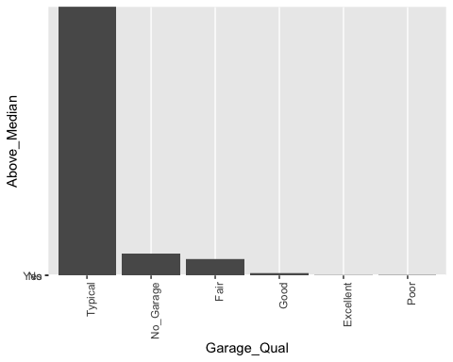

ggplot(data=HomeSales, aes(x=Garage_Cond, y=Above_Median)) +  
 geom_bar(stat="identity") +  
 theme(axis.text.x = element_text(angle=90, hjust=1))

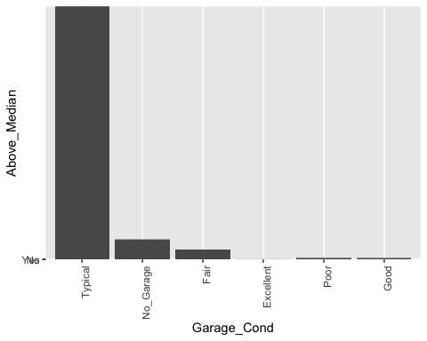

ggplot(data=HomeSales, aes(x=Paved_Drive, y=Above_Median)) +  
 geom_bar(stat="identity") +  
 theme(axis.text.x = element_text(angle=90, hjust=1))

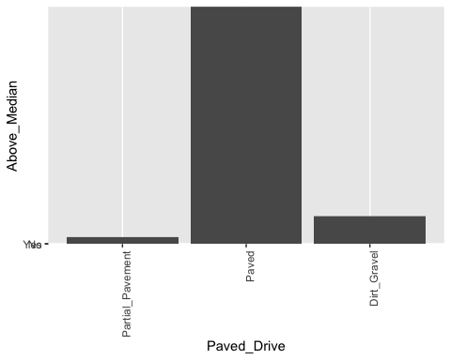

ggplot(HomeSales, aes(x=Wood_Deck_SF, y=Above_Median)) +   
 geom_boxplot()

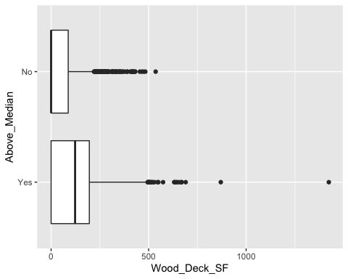

ggplot(HomeSales, aes(x=Open_Porch_SF, y=Above_Median)) +   
 geom_boxplot()

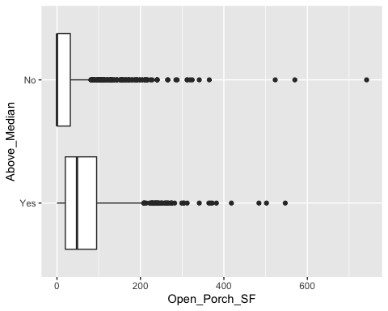

ggplot(HomeSales, aes(x=Enclosed_Porch, y=Above_Median)) +   
 geom_boxplot()

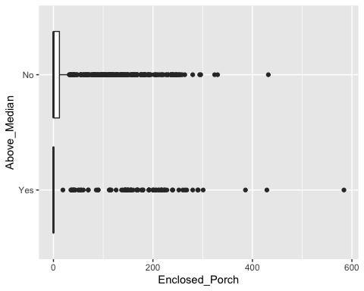

ggplot(HomeSales, aes(x=Screen_Porch, y=Above_Median)) +   
 geom_boxplot()

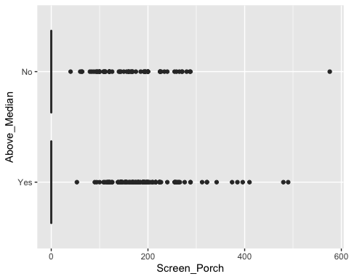

ggplot(data=HomeSales, aes(x=Fence, y=Above_Median)) +  
 geom_bar(stat="identity") +  
 theme(axis.text.x = element_text(angle=90, hjust=1))

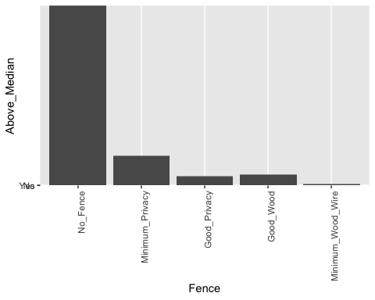

ggplot(HomeSales, aes(x=Mo_Sold, y=Above_Median)) +   
 geom_boxplot()

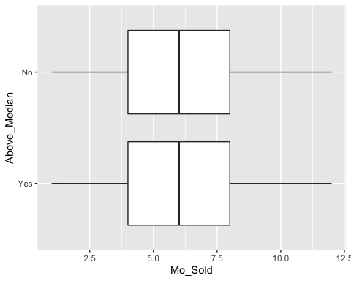

ggplot(HomeSales, aes(x=Year_Sold, y=Above_Median)) +   
 geom_boxplot()

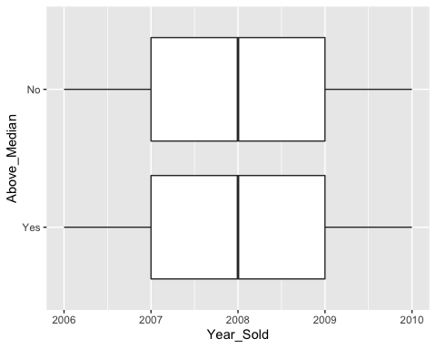

ggplot(data=HomeSales, aes(x=Sale_Type, y=Above_Median)) +  
 geom_bar(stat="identity") +  
 theme(axis.text.x = element_text(angle=90, hjust=1))

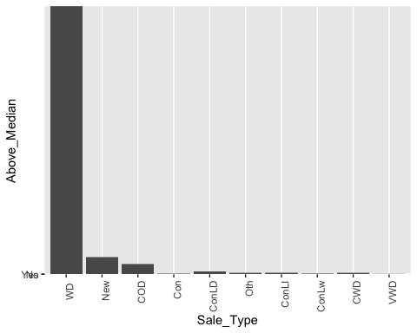

ggplot(data=HomeSales, aes(x=Sale_Condition, y=Above_Median)) +  
 geom_bar(stat="identity") +  
 theme(axis.text.x = element_text(angle=90, hjust=1))

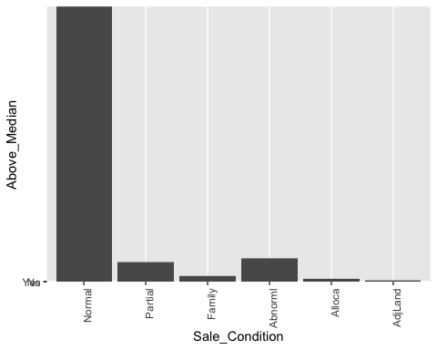

ggplot(HomeSales, aes(x=Longitude, y=Above_Median)) +   
 geom_boxplot()

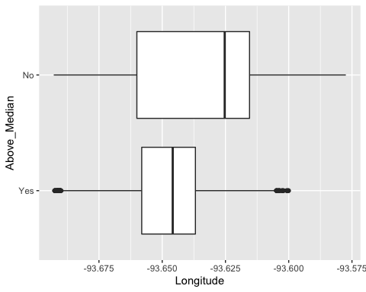

ggplot(HomeSales, aes(x=Latitude, y=Above_Median)) +   
 geom_boxplot()

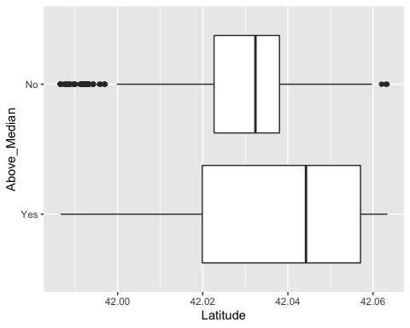

ggplot(data=HomeSales, aes(x=Above_Median, y=Above_Median)) +  
 geom_bar(stat="identity") +  
 theme(axis.text.x = element_text(angle=90, hjust=1))

