ASPECT: A Data-Centric Ambispective Framework for Eligibility Criteria Analysis of Clinical Trials

Konghao Zhao, PhD¹, Ching Ying Lin, MD², Sana Ali, MD², Zhaojin Yin¹, Yahan Li, PhD¹, Yuchen Ge¹, Jorge Nieva, MD², Yong Chen, PhD³, Ruishan Liu, PhD^{1*}

¹Viterbi School of Engineering, University of Southern California, Los Angeles, CA, USA
²Keck School of Medicine, University of Southern California, Los Angeles, CA, USA
³Perelman School of Medicine, University of Pennsylvania, Philadelphia, PA, USA
*Corresponding author: ruishanl@usc.edu

ABSTRACT
Background
More than half of terminated clinical trials fail due to inadequate patient accrual, with eligibility criteria identified as a primary barrier. Current approaches to criteria design either rely on expert consensus or evaluation on real-world patient. No method integrates historical trial analysis and real-world patient evaluation with rules optimization.

Methods
First, we systematically analyzed patterns of individual eligibility criterion (EC) from 285 Phase 3 oncology trials across five cancer types against 1,937 historical trials. Second, we built transformer-based models to predict associations between criteria and trial outcomes. Third, EC was further applied to 20,126 cancer patients from the All of Us Research Program to quantify criterion-level exclusion rates by demographic groups. At last, we implemented a multi-objective genetic algorithm to optimize EC configurations balancing enrollment and safety.

Results
We developed ASPECT (AmbiSPective Eligibility Criteria Analysis for Clinical Trials), a data-centric framework integrating retrospective trial mining with prospective real-world simulation. We provide criterion-level exclusion and frequency rankings along with historical enrollment statistics through an interactive web interface from the retrieved 285 trials. We found out that across cancer types, current eligibility criteria excluded an average of 86% of real-world patients at the trial level caused by overly excluded rules. Elderly patients were disproportionately excluded at both criterion and trial levels in several cancer types. In a case study applying multi-objective optimization to a failed Phase 3 trial, we identified alternative eligibility configurations that increased predicted eligible patients from 69 to 1,408 while reducing predicted adverse event occurrence probability from 0.97 to 0.74.

Conclusions
ASPECT enables systematic, evidence-based evaluation of eligibility criteria by integrating retrospective historical patterns with prospective simulation, providing actionable insights to support more inclusive trial design.

INTRODUCTION

Clinical trials are essential for evaluating new cancer treatments, yet many fail to meet their enrollment targets. Among terminated trials globally, 55% close due to low accrual, and fewer than 5% of adults with cancer participate in clinical research [1, 2]. These pitfalls delay patients’ access to effective treatments, reduce the generalizability of findings to real-world population and increase development costs [3]. A major contributor to this issue is the design of eligibility criteria in the trial protocols which are rules that determine patient inclusion. They are often overly restrictive, inconsistently justified, and difficult to evaluate before a trial begins.

Eligibility criteria design faces three fundamental challenges. First, criteria are often overly restrictive: rules are typically developed through expert consensus, with many inherited from earlier protocols without empirical re-evaluation [4, 5]. As a result, rules have became more complex over time, excluding patients who could safely participate. Second, criteria are decoupled from real-world patient populations. It is difficult to assess how individual rules affect enrollment in diverse demographic groups or to evaluate the combined effects of multiple criteria on scale [6, 7]. Third, criteria design is not goal-oriented in which rules are written to define a study population rather than to optimize for enrollment, safety, or equity simultaneously, with no mechanism to predict outcomes or simulate how proposed criteria would affect actual patient cohorts before a trial begins [8].

Recent efforts have begun to address these challenges through three main approaches. First, consensus guidelines from the American Society of Clinical Oncology and Friends of Cancer Research recommend broadening specific criteria such as laboratory thresholds and performance status requirements, but these qualitative recommendations highlight the need for computational methods that can provide quantitative, patient-level evidence [9, 10, 11]. Second, data-driven approaches and natural language processing based framework have used real-world electronic health records to evaluate how relaxing individual criteria affects trial outcomes [12, 13, 14]. However, these methods assess criteria in isolation without characterizing how rules interact, and they do not provide systematic analysis of historical eligibility patterns across trials to aid future design. Third, patient-trial matching tools have been developed to improve recruitment efficiency by using automation pipeline to determine whether individual patients meet eligibility criteria [15, 16]. While effective for enrollment, these tools are unable to quantify criterion-level exclusionary patterns or demographic disparities that could inform criteria design. A critical methodological gap remains: no existing approach combines large-scale analysis of historical eligibility criteria, data-driven quantification of how rules shape real-world patient inclusion and exclusion, and goal-oriented evaluation of rule interactions to guide more evidence-based eligibility criteria design.

To address this gap, we developed an ambispective computational framework that enables evaluation of eligibility criteria by integrating retrospective trial mining with prospective simulation on real-world patient cohorts, which learns from historical trials while projecting impact on actual patients. The framework extracts and structures eligibility rules from trial protocols, analyzes patterns across trials, simulates exclusion rates in real-world populations, and identifies optimized criteria configurations through multi-objective optimization. We applied this framework to 285 Phase 3 oncology trials across five cancer types, evaluating 25,084 unique eligibility rules against 20,131 patients from the All of Us Research Program.

Using this approach, we computed rule frequency and historical statistics, quantified rule-level exclusion patterns, identified criteria with disproportionate demographic impact, and analyzed threshold sensitivity across laboratory values. In a case study of a failed Phase 3 trial, we demonstrate that alternative rule configurations could increase projected accrual while lowering essential safety constraints. These findings illustrate how ambispective analysis can provide a data-driven foundation for developing more inclusive, evidence-based eligibility criteria.

METHOD

Study Design

We designed an ambispective study to evaluate the historical structure and real-world impact of eligibility criteria used in Phase 3 oncology trials. The study comprised three components: a retrospective assessment of historical trial protocols to evaluate patterns of eligibility rule use and their associations with safety and enrollment outcomes, a prospective simulation applying these criteria to real-world patient cohorts to estimate exclusion rates and demographic disparities, and a multi-objective optimization analysis using a genetic algorithm to identify eligibility configurations that balance patient recruitment and safety.

Clinical Trials Data

To create our primary study cohort, we exhaustively identified Phase 3 oncology trials from ClinicialTrials.gov [17] that met the following criteria (1) studied breast, colorectal, lung, melanoma, or prostate cancer (2) listed as completed and (3) had publicly available study documents containing a comprehensive list of eligibility criteria. From these documents, we extracted individual eligibility rules, and this process yielded 285 trials comprising: 82 breast cancer, 21 colorectal cancer, 110 lung cancer, 20 melanoma, and 52 prostate cancer trials (Suppl. Table 1). Trials had a mean of 24.3 ± 16.2 eligibility criteria per protocol, with enrollment counts ranging from 396 ± 257 (colorectal) to 709 ± 860 (breast) participants. The mean duration of recruitment was 42.3 ± 33.5 months across cancer types. To allow subgroup analyzes by therapeutic mechanism, we further classified trials according to intervention drug categories, including chemotherapy, immunotherapy, targeted therapy, supportive care, hormonal therapy, and placebo-controlled designs.

To establish a comprehensive reference database for retrospective analysis, we used the ClinicalTrial.gov API to retrieve all Phase 3 oncology trials with completed status across the five cancer types, regardless of document availability. This broader database (Suppl. Table 2) comprised 1,937 trials in total and served as the computational backbone for historical frequency analysis, temporal trend assessment, and outcome modeling. The Trial characteristics in this expanded cohort were similar to the primary study cohort, with mean eligibility criteria counts of 20.4 to 25.2 per protocol across cancer types.

Real World Patient Data
We used the National Institutes of Health All of Us Research Program to construct our patient cohorts [18] for real-world simulation. The program is a longitudinal cohort study designed to enroll one million or more participants reflecting the diversity of the United States population, which links survey responses, electronic health records, physical measurements, and so on. All data are de-identified and accessible through a secure research workbench. We selected patients cohorts with incident diagnoses of the five target malignancies using the International Classification of Diseases (ICD). For example, patients who have a malignant breast neoplasm are selected for breast cancer trials. Then, for each patient, we extracted demographic characteristics, procedures, laboratory measurements, survey responses, medical conditions, and drug use to comprise patient features. The final cohort comprised 20,126 patients: 7,689 with breast cancer, 2,435 with colorectal cancer, 2,336 with lung cancer, 2,603 with melanoma, and 5,063 with prostate cancer (Suppl. Table 3). The cohort was predominantly older adults (mean age 70.0–76.4 years across cancer types), with racial composition of approximately 79-98% White, 1.7–18% Black or African American, and 0.3–3% Asian participants. Combined with the 285 trials in our primary study cohort, this yielded 1,253,929 patient-trial pairs for prospective simulation.

Retrospective Trial Mining
To process trials in the historical reference database, we extracted structured features including registration and completion dates, enrollment count, number of study sites, recruitment duration, intervention categories, and eligibility criteria text from the API. Individual eligibility rules were parsed and extracted from each trial protocol. For each trial in the study cohort, we extracted individual criteria and performed semantic similarity matching against rules in the historical database, followed by verification using an agent-based natural language inference system. For each matched rule, we mapped it back to the corresponding trials and computed frequency of use across trials, average historical statistics, and temporal trends in adoption.

To model associations between eligibility criteria and trial outcomes, we trained predictive models using two data sources. For safety outcomes, we used the TrialBench dataset, which contains multimodal data for clinical trial prediction [19]. For enrollment outcomes, we trained models using our historical trial database. These models take inclusion and exclusion eligibility criteria text paired encoded via transformer-based embeddings as input and output four outcomes: (1) adverse event occurrence rate, (2) mortality event occurrence rate, (3) enrollment count, and (4) enrollment count per site-month (EPSM).

Prospective Real-World Simulation
To estimate the real-world impact of eligibility criteria, we performed criterion-level patient-trial matching. For each patient-trial pair, we first aligned patient features, for example, laboratory values, comorbidities, prior treatments, demographics, with the corresponding extracted eligibility rule requirements. We then evaluated each rule independently to determine whether the patient feature satisfied the criterion using an agent-based natural language inference system, which produces a binary eligibility decision across all rules for each patient-trial pair. Trial-level eligibility was then determined using a conservative decision rule that accounts for the incompleteness of real-world data. A patient was classified as eligible for a trial only if no inclusion criteria were unmet, no exclusion criteria were met, and at least one inclusion criterion was met. Importantly, when a patient record lacked information relevant to a specific criterion (e.g., no documented ECOG score), we assumed the patient was not excluded by that criterion, reflecting the clinical reality that patients cannot be excluded based on features that are not documented or assessed. Using these classifications, we computed exclusion rates at two levels: (1) patient-level, representing the proportion of patients excluded from each trial; and (2) rule-level, representing the proportion of patients excluded by each individual criterion. We further stratified exclusion rates by demographic subgroups (age, sex, ethnicity) to identify criteria with disproportionate impact on specific populations.

Multi-objective Genetic Algorithm
While the above analyses characterize how individual criteria shape real-world eligibility and their historical patterns of use, trial designers must ultimately balance safety and enrollment when selecting an overall eligibility configuration. Combining retrospective rule outcome associations with prospective real-world exclusion estimates, we implemented a multi-objective genetic algorithm (MOGA) to optimize eligibility sets. MOGA systematically explores the combinatorial space of possible rule configurations, an extremely large search space of size 2^{n}, where each of the n eligibility criteria may be included or excluded. In contrast to single-objective approaches that require predefined weighting of competing priorities, MOGA simultaneously optimizes multiple objectives without requiring a priori trade-off specifications. In this study, the algorithm jointly minimized (1) predicted exclusion rate to maximize potential enrollment, and (2) predicted adverse event occurrence probability to preserve patient safety. The output of the optimization is a Pareto frontier of non-dominated eligibility configurations, each representing a distinct trade-off between feasibility and safety.

Clinician Annotation
To validate our prospective simulation pipeline, we randomly selected one patient for each trial in our study cohort, yielding 285 patient–trial pairs and a corresponding 6315 criterion-level matches for annotation. Two oncologists cooperated to evaluate all pairs at the criterion-level. Because each trial contains a large number of eligibility rules, we first applied a semantic pre-filtering step to identify criteria pairs that were meaningful using the available patient data, thereby reducing annotation burden while maintaining coverage of clinically meaningful rules. Annotators evaluated each criterion-level decision as eligible, ineligible, or indeterminate. These evaluations were then aggregated using our predefined decision rule to produce a trial-level eligibility determination for each patient–trial pair.

Technical details of retrospective analysis, natural language inference agents, rule matching system, transformer architectures, and optimization hyperparameters are provided in the Technical Implementation Section in Supplementary Appendix.

RESULTS

Overview of framework
We developed a unified framework for ambispective evaluation and optimization of eligibility criteria in Phase 3 oncology trials (Figure 1). Given a draft set of proposed eligibility criteria for a trial, the framework performs two complementary analyses. First, the retrospective trial-mining module maps each criterion to semantically similar rules across 1,937 historical Phase 3 oncology trials. This enables multi-level cross-trial statistics, including (1) frequency of prior use, (2) historical patterns of adoption across cancer types and drug classes, and (3) predicted associations with safety and enrollment outcomes derived from transformer-based predictive models. Second, the prospective real-world simulation module applies the proposed criteria to 20,126 real-world cancer patients from the All of Us Research Program, producing interpretable criterion-level eligibility decisions that are aggregated to derive (4) rule-level and trial-level exclusion rates stratified by demographic groups. Integrating outputs from both modules, the framework employs a multi-objective genetic algorithm to identify (5) Pareto-optimal eligibility configurations that balance enrollment potential against predicted safety, providing trialists with alternative rule sets and their expected trade-offs.

To support clinical use, we developed a publicly accessible website (https://sheltonzhaok.github.io/ASPECT/) that presents historical statistics for all eligibility rules extracted from the 285 fully documentable trials in our primary cohort. Rules are indexed by cancer type and drug category, and each rule displays its frequency of use, associated historical outcomes, and observed exclusionary impact in real-world data. Clinicians designing new trials can use the platform to explore precedent rules, compare alternatives, or examine the empirical behavior of criteria similar to those under consideration without rerunning the entire analysis.

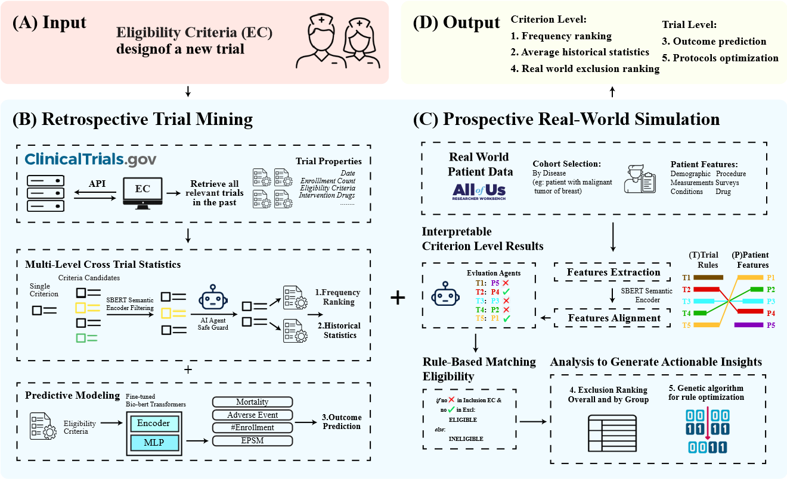

Figure 1: Overview of the ASPECT framework for eligibility criteria analysis. The framework (top) accepts proposed eligibility criteria as input and produces criterion-level and trial-level outputs through two complementary modules. Retrospective Trial Mining (B) extracts and analyzes eligibility criteria from 285 Phase 3 oncology trials against 1,937 historical trials, generating (1) frequency rankings, (2) historical statistics, and (3) outcome predictions from fine-tuned transformer models. Prospective Real-World Simulation (C) applies proposed criteria to 20,126 patients from the All of Us Research Program, producing interpretable criterion-level eligibility decisions, (4) demographic-stratified exclusion rankings, and (5) Pareto-optimal rule configurations via multiobjective optimization.

Performance Benchmark
We evaluated both the predictive models for trial outcomes and the patient-trial matching pipeline. For trial-level outcome prediction, regression models showed strong agreement between predicted and observed values (Supplementary Figure 6). On the full dataset, mean absolute errors were 425.41 for enrollment count, 47.90 for site count, 21.22 months for recruitment duration, and 4.03 for EPSM. When restricted to the lower 95th percentile to reduce outlier influence, performance improved substantially: MAE decreased to 247.13 for enrollment count, 44.23 for site count, 17.89 months for recruitment duration, and 2.68 for EPSM. Classification models for mortality and adverse event prediction achieved F1 scores of 0.94 and 0.92, respectively, compared with 0.68 and 0.93 reported in original study [19] using heterogeneous trial populations.

For patient-trial matching, we surveyed existing paradigms (Figure 2A). However, only open-source models without requiring training data or predefined rule ontologies were suitable to be applied in the private All of US Research Workbench. To validate the matching accuracy, two oncology fellows annotated 285 patient-trial pairs at the criterion level, which were aggregated into trial-level eligibility labels as ground truth. Our NLI-based framework achieved F1 scores of 0.48 to 0.70 across five cancer types, matching or exceeding performance of general-purpose LLMs (Llama-3.1-8B-IT [20], Qwen2.5-7B-IT [21], Mistral-7B-IT [22], and Gemma-7b-IT [23]) and Panacea-7B [24] a T5 model fine-tuned on clinical trial data (Figure 2B).

Computational efficiency was essential for population-scale evaluation. Our NLI-based framework requires less than 1 billion parameters compared with 7–8 billion for alternative architectures (Figure 2C), and achieves inference speeds 11 to 272 times faster than competing methods (Figure 2D). This efficiency gain stems from our criterion-level matching strategy. Rather than processing entire patient records (approximately 300 features) and full trial protocols (approximately 30 eligibility criteria) in a single inference, where such a long a context length undermines LLM capacity, our framework decomposes the task into independent criterion-level decisions. Each patient-trial pair requires approximately 5 seconds to evaluate, compared with nearly 2 minutes for LLM-based approaches processing the complete feature-protocol context. Applied to our evaluation of 1,253,929 patient-trial pairs, our framework completed the full evaluation in one week, whereas LLM-based methods would require a prohibitive amount of computation time on standard GPUs, making large-scale analysis infeasible.

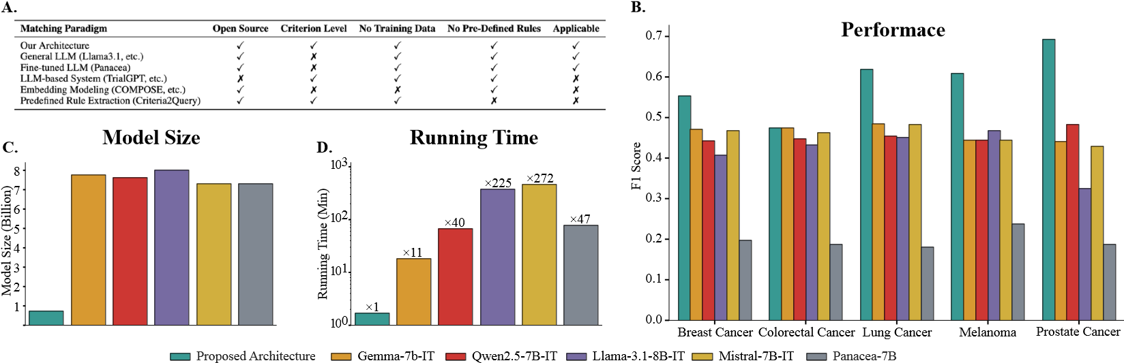

Figure 2: Comparison of key characteristics, performance, model size, and computational efficiency of patient-trial matching paradigms. Panel A summarizes key characteristics of different matching paradigms. Panel B demonstrates F1 performance across five cancer types across baseline and fine-tuned LLMs. Panel C compares model sizes. Panel D displays total running time in log-scale minutes.

Ambispective analysis of clinical trial NCT02566993
The ATLANTIS phase 3 trial (NCT02566993) compared lurbinectedin plus doxorubicin with physician’s choice chemotherapy in relapsed small-cell lung cancer after one prior platinum regimen [25]. The study failed to meet its primary endpoint. Despite fewer hematologic toxicities and treatment-related deaths in the experimental arm, median overall survival having 9.6 against 7.6 months did not reach statistical significance. A contributing factor was the inefficient recruitment, where the trial enrolled 613 of 919 screened patients across 160 sites over 42 months, yielding only 0.09 patients per site per month (EPSM). This low EPSM reflects highly restrictive eligibility criteria that prolonged accrual and may have compromised statistical power. Therefore, we applied our ambispective framework to systematically evaluate this trial’s eligibility criteria, integrating retrospective historical analysis and prospective real-world simulation with rules optimization.

Retrospective analysis. We first computed rule frequency across historical lung cancer trials and mapped each criterion to average historical statistics (Figure 3A, left panel). Among the most frequently used rules, the top five were: written informed consent (24.5%), male contraception
Agreement (17.4%), prior PM01183, topotecan, or anthracycline treatment (14.9%), immunodeficiency including HIV infection (15.7%), and ECOG performance status ≤ 2 (10.2%). These criteria reflect standard ethical, reproductive, treatment history, and functional status prerequisites common across modern oncology protocols. In addition, frequency patterns within chemotherapy-specific trials exhibited similar distributions, confirming that these foundational rules are consistently applied regardless of therapeutic mechanism. Further, historical statistics revealed that trials incorporating these frequent rules had EPSM values ranging from 1.0 to 4.0. The ATLANTIS trial’s EPSM of 0.09 fell substantially below these historical benchmarks despite employing similar eligibility constructs, suggesting that rule frequency alone does not guarantee recruitment efficiency. Notably, the average start dates of trials containing these rules (2000–2017) indicate that many eligibility frameworks were established during a period of conservative design philosophy and have persisted without modernization despite evolving therapeutic standards and patient demographics.

Prospective Simulation. We next applied the trial’s eligibility criteria to real-world lung cancer patients from the All of Us Research Program to quantify criterion-level exclusionary impact (Figure 3A, right panel). The most exclusionary rules were: history of second invasive malignancy treated with chemotherapy or radiotherapy (83.9% excluded), interstitial lung disease or pulmonary fibrosis (71.1%), and active infection or external drainages (33.3%). These criteria alone excluded a vast majority of real-world patients before other rules were applied. Notably, ASCO and Friends of Cancer Research have identified prior or concurrent malignancies as one of the criteria that commonly lead to the over exclusion of specific patient populations from clinical trials [9, 10, 11]. Our findings provide quantitative evidence supporting this recommendation. Interestingly, demographic stratification revealed differential exclusionary patterns. Elderly patients (>65 years) experienced higher exclusion rates than younger cohorts across multiple criteria, including hemoglobin thresholds, interstitial lung disease, and ECOG performance status, and so on. Gender and racial disparities are also evident and presented in the figure.

Predictive Modeling. To examine trial outcomes and quantify the contribution of individual criteria, we applied transformer-based predictive models trained on historical data (Supplementary Figure 7). Predicted outcomes closely approximated actual trial statistics: enrollment duration was predicted at 42 months (actual: 36 months), enrollment count at 351 (actual: 613), and probability of mortality and adverse events at 0.98 and 0.99, respectively where both of which occurred in the trial. We then performed leave-one-out analysis to assess the marginal effect of removing each criterion. EPSM, adverse event rate, and mortality rate remained essentially unchanged across all rule removals, while recruitment duration and site count showed only minor variations. This indicates that individual eligibility criteria exert minimal influence on predicted safety or efficiency outcomes. However, enrollment count exhibited the greatest sensitivity: among exclusion criteria, removing rule 4 (pre-treatment with lurbinectedin, topotecan, or anthracyclines) produced the largest positive shift (+64.97 patients), suggesting this rule eliminated patients with relapsed SCLC who had received standard salvage therapies. Among inclusion criteria, removing rule 6 SCLC of unknow primary (+80.44), rule 7 ECOG≤2 (+43.14), and rule 19 minimum 4 weeks since completion of whole-brain radiotherapy (+24.96) yielded the most pronounced enrollment increases. Conversely, removing hematologic thresholds for absolute neutrophil count (−55.28) and platelets (−30.71) decreased predicted enrollment and does not meaningfully altering predicted safety endpoints, implying that these laboratory are fundamental stabilizing criteria that ensure patients have sufficient marrow reserve to tolerate cytotoxic therapy. These findings demonstrate that optimizing individual rules in isolation might be insufficient to meaningfully improve trial design, motivating combinatorial optimization approaches.

Multi-Objective Optimization. Given that modifying individual rules produced minimal improvement in efficiency or safety, we implemented a multi-objective genetic algorithm (MOGA) to explore combinatorial eligibility configurations that jointly optimize enrollment and predicted adverse event rate (Figure 3B). The algorithm searched the space of 2³² possible eligibility rule subsets, constrained to retain a minimum of 15 active rules to ensure biological and operational validity. Before optimization, the original eligibility set predicted enrollment of 69 patients with an adverse event probability of 0.973. Through iterative search, the MOGA identified Pareto-optimal configurations representing distinct trade-offs between recruitment feasibility and safety. At the selected elbow point, the optimized configuration achieved predicted enrollment of 1,408 patients while reducing the predicted adverse event probability to 0.735. The retained rules formed a clinically coherent subset encompassing fundamental demographic bounds (minimum age), hematologic and biochemical safety thresholds (ANC ≥ 2.0×10⁹/L, platelets ≥ 100×10⁹/L, creatinine clearance ≥ 30 mL/min, ALT/AST ≤ 3×ULN), treatment recovery intervals (≥ 3 weeks since prior anticancer therapy, ≥ 4 weeks since whole-brain radiotherapy), and essential regulatory requirements (confirmed SCLC diagnosis, informed consent, contraceptive safeguards). This optimized configuration preserved core physiological and safety constraints while eliminating redundant or overly restrictive criteria. A comprehensive list of optimized rules could be found in the Supplemental table 4.

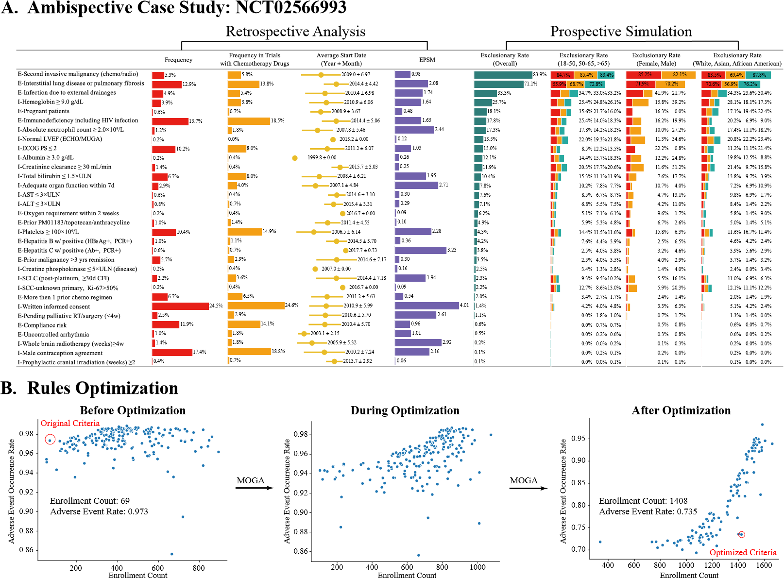

Figure 3: An ambispective case study integrating retrospective analysis, prospective simulation, and eligibility optimization. Panel A presents an ambispective evaluation of trial NCT02566993. The left section shows retrospective findings, including rule frequency across historical trials, frequency within chemotherapy trials, average start year, and enrollment productivity (EPSM). The right section displays prospective simulation results, with criterion-level exclusionary impact overall and across age, sex, and racial subgroups. Panel B illustrates multi-objective rules optimization using a multiobjective genetic algorithm (MOGA). Scatterplots show the distribution of candidate eligibility configurations before optimization, during iterative search, and after convergence.

Retrospective Analysis of Historical Eligibility Criteria in 285 Trials
We performed a large-scale retrospective analysis of eligibility criteria across 285 Phase III oncology trials spanning five cancer types. Each individual criterion was parsed and normalized, and we computed criterion-level statistics including frequency of use across trials, average trial start year, average enrollment count, length, and sites, and average enrollment per site per month (EPSM). The distribution of eligibility rule frequency across therapeutic categories and cancer types is shown in Supplementary Figure 8A, while complete criterion-level statistics are provided through the web interface.

Across all cancer types, eligibility design exhibited striking regularities. A small number of rule classes consistently dominated historical protocols, most notably disease stage definitions, constraints on prior systemic therapy, and exclusions based on a history of other malignancies (Supplementary Figure 9A). These rule types appeared with high frequency despite substantial differences in disease biology and treatment paradigms, indicating that eligibility design has largely followed shared conventions rather than disease-specific optimization.

To assess how historical eligibility design relates to recruitment performance, we examined recruitment efficiency using EPSM in relation to protocol complexity and rule usage patterns (Supplementary Figure 9B). Trials with fewer eligibility criteria consistently demonstrated higher recruitment efficiency, whereas protocols with a larger number of rules rarely achieved efficient accrual (left). Notably, high rule frequency did not correspond to high EPSM where the most commonly adopted eligibility criteria were not associated with efficient recruitment (right). This pattern suggests that widely adopted eligibility rules, though intended to ensure safety and consistency, may not confer recruitment advantages and more evidence-based reassessment is needed.

We further examined longitudinal trends in eligibility design by aligning rule frequency and recruitment statistics by trial start year (Supplementary Figure 9C). Across cancer types, rule usage increased steadily through the early 2000s, peaked between 2007 and 2010, and declined thereafter (left). Despite these temporal shifts in eligibility complexity, recruitment efficiency remained persistently low over time, underscoring the limited impact of incremental protocol modifications on improving accrual (right).

Together, this retrospective analysis demonstrates that contemporary eligibility criteria are shaped by long-standing design patterns that have persisted for more than a decade without meaningful improvements in recruitment efficiency. These findings motivate the need for systematic, data-driven approaches to eligibility criteria design that move beyond historical conventions toward evidence-based optimization.

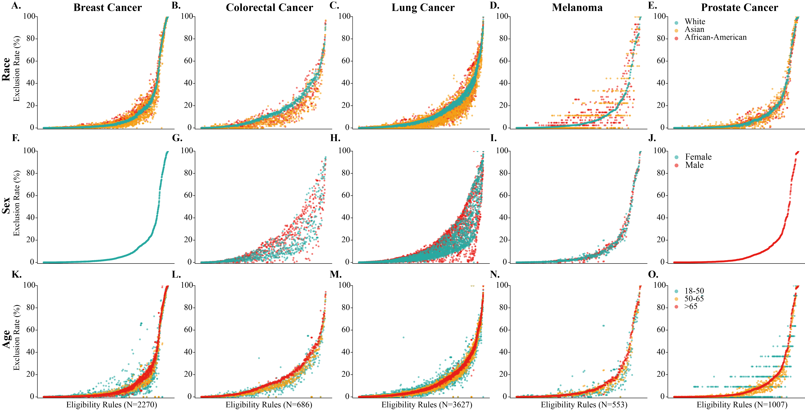

Figure 4: Rule-level exclusion rates by demographic subgroup across five cancer types. Exclusion rates are displayed for all eligibility rules from 285 trial cohorts that excluded at least one patient, stratified by race (Panels A–E), sex (Panels F–J), and age (Panels K–O) for breast, colorectal, lung, melanoma, and prostate cancer. Each point represents a single eligibility criterion, sorted along the x-axis by its overall exclusion rate within the corresponding cancer type. The y-axis shows subgroup-specific exclusion percentages, calculated as the proportion of patients in that subgroup who would be excluded if the rule were applied, where the subgroup is indicated by different colors.

Prospective Simulation of Eligibility Criteria Against Real-World Patients
For the 285 extracted oncology clinical trials across five cancer types, we performed simulated criterion-level patient-trial matching to quantify protocol exclusionary rates and characterize patterns of real-world patient exclusion. Trial-level exclusion rates remained strikingly high across all cancer types (Supplementary Table 5). Colorectal and lung cancer trials exhibited the highest exclusion rates (93.6% and 91.3%, respectively), followed by melanoma (89.0%), while breast and prostate cancer protocols showed comparatively lower rates (81.4% and 72.5%). Collectively, these results indicate that most oncology trials impose highly restrictive eligibility conditions, rendering the majority of real-world patients ineligible for participation. When examining demographic subgroups, patterns remained largely consistent but revealed cancer-specific disparities. Among racial groups, White patients experienced the highest exclusion rates in lung cancer (91.6%) and colorectal cancer (94.0%), while Asian patients experienced the highest exclusion rates in melanoma (92.2%) and prostate cancer (72.9%) but the lowest rates in the others, potentially reflecting differences in biomarker distribution or lifestyle factors. Gender-stratified results indicated that male participants faced higher exclusion than females in colorectal cancer (95.5% vs. 91.9%) and lung cancer (91.8% vs. 91.0%). Age-based trends demonstrated a consistent patterns of increasing exclusion with advancing age: patients older than 65 years showed higher exclusion rates across colorectal (94.0% vs. 92.6% and 92.4%), melanoma (89.1% vs. 89.4% and 88.4%), breast (81.7% vs. 81.2% and 80.7%), and prostate cancer (72.7% vs. 70.6%) compared with younger cohorts. This pattern suggests that age-related comorbidities, laboratory-based physiological thresholds (e.g. renal clearance, hematologic values) and other rules related to symptoms exert a compounding restrictive effect in older adults.

We further computed exclusion rates for each individual eligibility rule, with the overall distribution shown in Supplementary Figure 8B. To identify specific criteria driving demographic disparities, we stratified rule-level exclusion rates by race, sex, and age (Figure 4). Across all cancer types, eligibility rules exhibited a characteristic distribution: most rules excluded relatively few patients, while a subset of highly restrictive criteria drove the majority of exclusions. This indicates that the high overall exclusion rates observed at the trial level are largely attributable to a small proportion of overly restrictive rules rather than broadly distributed exclusionary effects across all criteria. Racial stratification (Panels A–E) revealed that White patients were disproportionately excluded in colorectal and lung cancer, with their scatter distribution consistently positioned above Asian and African-American patients across the exclusion spectrum. Consistent results are also shown for Asian patients in melanoma and prostate cancer. Gender differences (Panels F–J) were relatively modest across cancer types, with overlapping distributions between male and female patients for most eligibility rules, except for colorectal and lung cancer. In contrast, age-based stratification (Panels K–O) demonstrated pronounced disparities: elderly patients (>65 years) were systematically over-excluded in colorectal, melanoma, breast, and prostate cancer, with their scatter distributions consistently elevated above younger age groups across the full range of eligibility criteria. This vertical displacement indicates that older adults face higher exclusion rates not from a few specific rules, but rather from a cumulative burden across multiple criteria, reflecting the higher prevalence of comorbidities and laboratory abnormalities that trigger exclusion thresholds designed around younger, healthier populations.
Laboratory Threshold Sensitivity Analysis
To quantify how specific laboratory cutoffs influence patient exclusion, we extracted, normalized, and harmonized all numerical hematologic and biochemical eligibility thresholds reported in trial protocols across five cancer types (Figure 4). This analysis addresses the incomplete documentation of laboratory criteria frequently observed in ClinicalTrials.gov records, where eligibility summaries often omit the quantitative limits required for patient screening.

Figure 5 illustrates the exclusionary impact of eight commonly used laboratory parameters: absolute neutrophil count (ANC), platelet count, hemoglobin, creatinine clearance, white blood cell count, serum creatinine, total bilirubin, and albumin. Each panel displays an exclusion curve showing the proportion of real-world patients excluded as threshold values become increasingly stringent. Discrete points overlaid on each curve indicate the specific cutoff values actually employed in Phase 3 trials, with their frequency of use shown in parentheses. Complete threshold frequencies and associated trial counts are provided in Supplementary Table 6.

Several consistent patterns emerge. First, exclusion rates vary monotonically with threshold stringency, although the direction of the relationship depends on the parameter type. For hematologic and renal function criteria, including absolute neutrophil count (ANC), platelet count, hemoglobin, and creatinine clearance, patient exclusion increases as thresholds become more stringent (i.e., higher minimum values). For example, increasing the creatinine clearance requirement from 30 to 60 mL/min raises patient exclusion from approximately 5% to more than 30% across most cancer types. In contrast, for serum creatinine and total bilirubin, exclusion decreases as threshold values increase, reflecting that these parameters are defined by upper-limit cutoffs, for which higher thresholds are more permissive. Second, substantial heterogeneity exists in threshold selection across trials evaluating the same laboratory parameter. ANC cutoffs range from 1.0 to 2.0 ×10⁹/L, platelet requirements from 75 to 150 ×10⁹/L, and hemoglobin thresholds from 8 to 11 g/dL. This variability highlights the absence of standardized consensus values in historical protocol design. Notably, breast cancer trials exhibit the greatest diversity in threshold selection across multiple parameters, suggesting less uniformity in eligibility specification for this cancer type.

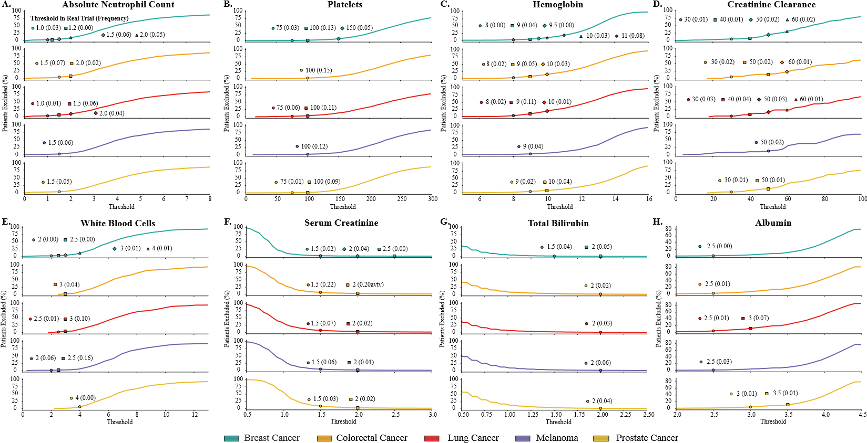

Figure 5: Exclusionary impact of common laboratory thresholds across five cancer types. Panels A–H show the proportion of patients excluded as eligibility thresholds become more restrictive for eight frequently used laboratory criteria: (A) absolute neutrophil count, (B) platelets, (C) hemoglobin, (D) creatinine clearance, (E) white blood cells, (F) serum creatinine, (G) total bilirubin, and (H) albumin. Lines depict exclusion curves for each cancer type, and points indicate thresholds used in real Phase 3 trials, with accompanying frequencies shown in parentheses.

DISCUSSION

In this study, we introduce an ambispective framework for evidence-based eligibility criteria design, combing large-scale retrospective analysis with prospective patient-trial simulation to evaluate how trial rules perform in real-world populations. Using data from 285 oncology trials and more than 20,000 patients across five cancer types, we demonstrate that contemporary protocols frequently exclude over 80% of real-world populations and disproportionately restrict access for older adults. By quantifying rule-level restrictiveness and modeling trade-offs among enrollment and safety, we show that many EC can be relaxed or reweighted without compromising therapeutic intent. Our results indicate that eligibility design, which historically based on expert opinion and convention, can be informed by empirical evidence, providing a systematic pathway toward more inclusive and externally valid trials.

Prior studies have evaluated the impact of EC using real-world data, forming the most direct methodological precedents for this work. For example, TrialPathFinder showed that relaxing certain laboratory and comorbidity rules in non-small cell lung cancer has minimal impact on the trial hazard ratios while expanding the pool of eligible patients [12]. Following this, TRIALSCOPE developed a framework for emulating clinical trials from EMR data to estimate treatment effects, and as a secondary finding, showed that simulations with and without eligibility criteria produced comparable hazard ratios [26]. Another closely related study demonstrated the feasibility of using natural language processing to structure eligibility text and estimated how rule changes affect real-world inclusion [14]. However, these studies share important limitations: they treat eligibility criteria as a binary modifier (applied vs. not applied) or evaluate rules in isolation, without analyzing which specific criteria drive exclusion or investigating interactions between rules. Additionally, they focus on single cancer types and do not quantify demographic disparities or support systematic optimization. Our framework advances this line of research by integrating large-scale retrospective evidence across 285 trials, rule interaction analysis, and multi-objective optimization, enabling comprehensive, empirically grounded criteria evaluation across five cancer types.

Recent developments in LLM-based multi-agent systems further contextualize our study within the emerging landscape of AI-enable trial design. ClinicalAgent [27] demonstrates how GPT-4 based agents can reason about trial efficacy, safety, and enrollment feasibility using structure biomedical knowledge sources, whereas TrialGenie [28], based on virtual Lab [29], employs multiple AI agent from different expertise to automate protocol parsing, cohort construction, and trial emulation using MIMIC-IV. While these systems advance automated reasoning and workflow execution for clinical trial tasks, they do not empirically evaluate the performance of eligibility criteria in real-world populations, quantify their restrictiveness, assess equity implications, or optimize rule sets for multiple objectives. In contrast, our framework directly interrogates how eligibility criteria interact with real-world patient populations, integrates outcome prediction to support trial design decisions, and employs multi-objective optimization to generate evidence-based eligibility configurations that balance enrollment and safety.

A broader range of data-driven and NLP-based methods supports the extraction and optimization of eligibility criteria and downstream applications such as patient–trial matching. Early systems including Criteria2Query [30], ontology-based normalization pipelines [31, 32], and deep learning based extraction model [33, 34] focus on converting free-text eligibility criteria into structured, computable representations, enabling reproducible cohort construction and retrospective rule-level assessment using EHR data. Building on these extraction capabilities, several data-driven approaches have begun to examine how eligibility criteria can be empirically calibrated using real-world data, demonstrating that modernizing or relaxing overly restrictive rules can broaden access, improve representativeness, and reduce inequities in trial enrollment [13, 35, 36, 37]. These methods primarily evaluate individual criteria or propose disease-specific adjustments, but do not integrate multi-dimensional trade-offs or historical evidence at scale. As these methods refine the structure and calibration of the eligibility rules themselves, a parallel line of work focuses on how such rules are applied in practice. Complementary downstream systems in patient–trial matching use machine-learning classifiers, graph-based models, and more recently large language models to determine which patients satisfy existing eligibility definitions [15, 16, 38, 39]. Although these approaches excel at operationalizing and applying eligibility rules, and in some cases offer criterion-level reasoning, they do not quantify the degree to which individual criteria exclude real-world patients or leverage such information to inform eligibility design. Our framework bridges these gaps by using structured criteria representations as inputs, applying patient-trial matching as a simulation engine rather than an endpoint, and aggregating criterion-level outputs to generate actionable insights for trial designers.

Our framework has several practical implications for clinical trial EC design. The comprehensive rule-level statistics and interactive web interface provide trialists with immediate, actionable information about which criteria are most exclusionary or frequent and how they differentially affect demographic subgroups. The threshold sensitivity analyses offer quantitative guidance for calibrating laboratory cutoffs, where adjustments could be made to expand the eligible population. The multi-objective optimization further enables explicit exploration of trade-offs between enrollment potential and predicted safety, allowing investigators to identify criteria configurations that achieve recruitment targets while maintaining acceptable risk bounds. Looking ahead, since the framework is publicly available and reproducible, a clinician could easily reapply the entire ambispective analysis to unforeseen disease type to generate the analysis. Besides, since the framework is also highly modular, the strength of prospective simulation could be further reinforced by the advanced closed-source patient-trial matching paradigm.

Several limitations should be considered in this study. Xxxxxxxxxxxxx

REFERENCES

- Ma S, Wang Y, Wagner J, et al. Predicting accrual success for better clinical trial resource allocation. Sci Rep 2025;15:3879.
- Unger JM, Cook E, Tai E, et al. The role of clinical trial participation in cancer research: Barriers, evidence, and strategies. Am Soc Clin Oncol Educ Book 2016;35:185-198.
- Sertkaya A, Wong HH, Jessup A, et al. Key cost drivers of pharmaceutical clinical trials in the United States. Clin Trials 2016;13:117-126.
- Kim ES, Uldrick TS, Schenkel C, et al. Continuing to broaden eligibility criteria to make clinical trials more representative and inclusive: ASCO-Friends of Cancer Research joint research statement. Clin Cancer Res 2021;27:2394-2399.
- Van Spall HGC, Toren A, Kiss A, et al. Eligibility criteria of randomized controlled trials published in high-impact general medical journals: a systematic sampling review. JAMA 2007;297:1233-1240.
- Hauck CL, Kelechi TJ, Cartmell KB, et al. Trial-level factors affecting accrual and completion of oncology clinical trials: A systematic review. Contemp Clin Trials Commun 2021;24:100843.
- Unger JM, Hershman DL, Till C, et al. "When offered to participate": A systematic review and meta-analysis of patient agreement to participate in cancer clinical trials. J Natl Cancer Inst 2021;113:244-257.
- Beaver JA, Howie LJ, Pelosof L, et al. A 25-year experience of US Food and Drug Administration accelerated approval of malignant hematology and oncology drugs and biologics: A review. JAMA Oncol 2018;4:849-856.
- Kim ES, Bruinooge SS, Roberts S, et al. Broadening eligibility criteria to make clinical trials more representative: American Society of Clinical Oncology and Friends of Cancer Research joint research statement. J Clin Oncol 2017;35:3737-3744.
- Harvey RD, Mileham KF, Bhatnagar V, et al. Modernizing clinical trial eligibility criteria: Recommendations of the ASCO-Friends of Cancer Research washout period and concomitant medication work group. Clin Cancer Res 2021;27:2400-2407.
- Magnuson A, Bruinooge SS, Singh H, et al. Modernizing clinical trial eligibility criteria: Recommendations of the ASCO-Friends of Cancer Research performance status work group. Clin Cancer Res 2021;27:2424-2429.
- Liu R, Rizzo S, Whipple S, et al. Evaluating eligibility criteria of oncology trials using real-world data and AI. Nature 2021;592:629-633.
- Fang Y, Liu H, Idnay B, et al. A data-driven approach to optimizing clinical study eligibility criteria. J Biomed Inform 2023;142:104375.
- Lee K, Liu Z, Mai Y, et al. Optimizing clinical trial eligibility design using natural language processing models and real-world data: Algorithm development and validation. JMIR AI 2024;3:e50800.
- Jin Q, Wang Z, Floudas CS, et al. Matching patients to clinical trials with large language models. Nat Commun 2024;15:9074.
- Gao J, Xiao C, Glass LM, et al. COMPOSE: Cross-modal pseudo-siamese network for patient trial matching. In: Proceedings of the 26th ACM SIGKDD International Conference on Knowledge Discovery & Data Mining. Virtual Event: ACM, 2020:803-812.
- U.S. National Library of Medicine. ClinicalTrials.gov. (https://clinicaltrials.gov/). Accessed 2024.
- All of Us Research Program Investigators, Denny JC, Rutter JL, et al. The "All of Us" research program. N Engl J Med 2019;381:668-676.
- Chen J, Hu Y, Cai M, et al. TrialBench: Multi-modal AI-ready datasets for clinical trial prediction. Sci Data 2025;12:1564.
- Grattafiori A, Dubey A, Jauhri A, et al. The Llama 3 herd of models. arXiv preprint 2024;arXiv:2407.21783.
- Qwen Team, Yang A, Yang B, et al. Qwen2.5 technical report. arXiv preprint 2025;arXiv:2412.15115.
- Jiang AQ, Sablayrolles A, Mensch A, et al. Mistral 7B. arXiv preprint 2023;arXiv:2310.06825.
- Gemma Team, Mesnard T, Hardin C, et al. Gemma: Open models based on Gemini research and technology. arXiv preprint 2024;arXiv:2403.08295.
- Wang Z, Cao L, Jin Q, et al. A foundation model for human-AI collaboration in medical literature mining. Nat Commun 2025;16:8361.
- Ponce Aix S, Ciuleanu TE, Navarro A, et al. Combination lurbinectedin and doxorubicin versus physician’s choice of chemotherapy in patients with relapsed small-cell lung cancer (ATLANTIS): a multicentre, randomised, open-label, phase 3 trial. Lancet Respir Med 2023;11:74-86.
- González J, Ueno R, Wong C, et al. TrialScope — a framework for clinical trial simulation from real-world data. NEJM AI 2025;2(10).
- Yue L, Xing S, Chen J, et al. ClinicalAgent: Clinical trial multi-agent system with large language model-based reasoning. In: Proceedings of the 15th ACM International Conference on Bioinformatics, Computational Biology and Health Informatics. Shenzhen, China: ACM, 2024:1-10.
- Li H, Pan W, Rajendran S, et al. TrialGenie: Empowering clinical trial design with agentic intelligence and real world data. April 2025.
- Swanson K, Wu W, Bulaong NL, et al. The virtual lab of AI agents designs new SARS-CoV-2 nanobodies. Nature 2025;646:716-723.
- Yuan C, Ryan PB, Ta C, et al. Criteria2Query: a natural language interface to clinical databases for cohort definition. J Am Med Inform Assoc 2019;26:294-305.
- Jiang M, Chen Y, Liu M, et al. A study of machine-learning-based approaches to extract clinical entities and their assertions from discharge summaries. J Am Med Inform Assoc 2011;18:601-606.
- Weng C, Tu SW, Sim I, et al. Formal representations of eligibility criteria: A literature review. J Biomed Inform 2010;43:451-467.
- Tian S, Erdengasileng A, Yang X, et al. Transformer-based named entity recognition for parsing clinical trial eligibility criteria. ACM BCB 2021;2021:49.
- Bompelli A, Li J, Xu Y, et al. Deep learning approach to parse eligibility criteria in dietary supplements clinical trials following OMOP common data model. AMIA Annu Symp Proc 2020;2020:243-252.
- Lee EQ, Weller M, Sul J, et al. Optimizing eligibility criteria and clinical trial conduct to enhance clinical trial participation for primary brain tumor patients. Neuro Oncol 2020;22:601-612.
- Royce TJ, Zhao Y, Ryals CA. Improving diversity in clinical trials by using real-world data to define eligibility criteria. JAMA Oncol 2023;9:455.
- Griffith S, Benedum CM, Bozkurt S, et al. Data-driven strategies for enhancing diversity in oncology clinical trials: Optimization of eligibility criteria. J Clin Oncol 2024;42(16suppl):11020.
- Theodorou BP, Xiao C, Sun J. TREEMENT: Interpretable patient-trial matching via personalized dynamic tree-based memory network. In: Proceedings of the 14th ACM International Conference on Bioinformatics, Computational Biology, and Health Informatics. Houston, TX: ACM, 2023:1-9.
- Chang CY, Yuan J, Ding S, et al. Towards fair patient-trial matching via patient-criterion level fairness constraint. AMIA Annu Symp Proc 2023;2023:884-893.

SUPPLEMENTARY MATERIAL

Technical Implementation - Retrospective Trial Mining
Trial Data Retrieval from ClinicalTrials.gov API. We queried the ClinicalTrials.gov API v2 endpoint (https://clinicaltrials.gov/api/v2/studies) to retrieve Phase 3 oncology trials. Separate queries were executed for five cancer types using condition-specific search terms: “breast cancer,” “colorectal cancer,” “lung cancer,” “melanoma,” and “prostate cancer.” Trials were included if: (1) overallStatus was “COMPLETED” and (2) phases contained “PHASE3.” Results were paginated using the nextPageToken parameter with a maximum page size of 1,000 studies per request.

For each trial, we extracted structured fields from the protocolSection modules including: NCT ID, organization name, titles, start date, primary completion date, enrollment count, eligibility criteria text, age and sex restrictions, facility locations, intervention details, and outcome measures. Site count was computed by parsing the semicolon-delimited locations string. Recruitment duration was calculated as the difference between primary completion date and start date. Enrollment per site-month (EPSM) was computed as:

$$EPSM= \frac{Enrollment Count}{Site Count × (Recruitment Duration \left(days\right) / 30.44)}$$

Records with missing enrollment, dates, or zero site count were excluded from EPSM calculations.

Eligibility Criteria Extraction and Parsing. Raw eligibility criteria text was split into inclusion and exclusion sections using regular expression pattern matching that handles common formatting variants including “Key inclusion criteria,” variable delimiters, and line breaks. When no exclusion section was detected, all text was assigned to inclusion criteria. Individual eligibility rules were identified by splitting on newlines within each section.

Semantic Similarity Matching Across Trials. To identify semantically equivalent eligibility rules across trials, we developed a two-stage retrieval pipeline combining dense embedding similarity with natural language inference (NLI) verification.

We used the Sentence-BERT model multi-qa-mpnet-base-cos-v1 to encode eligibility criteria into 768-dimensional dense vectors. Embeddings were computed in batches of 64 using GPU acceleration and cached to disk (keyed by SHA-1 hash of rule texts) to avoid redundant computation. For each query criterion, we computed cosine similarity against all rules in the historical database:

$$sim\left(q,r\right)=\frac{e_{q}∙e_{r}}{\left\|e_{q}\right\|\left\|e_{r}\right\|}$$

where e_{q} and e_{r} denote the embedding vectors for the query and reference rules, respectively. Rules exceeding a similarity threshold of 0.60 were retained as candidates. To avoid redundant matches from the same trial, we retained only the highest-scoring rule per NCT ID.
Candidate matches were verified using SciFive-large (razent/SciFive-large-Pubmed_PMC-MedNLI), a T5-based model fine-tuned on PubMed, PubMed Central, and the MedNLI corpus. For each candidate pair, we performed bidirectional inference with the input format

mednli: sentence1:{rule} sentence2: {query}.

Candidate pairs were retained only if neither inference direction returned “neutral,” ensuring functional equivalence rather than superficial lexical similarity.

Historical Statistics Computation. For each eligibility criterion matched to historical trials, we computed aggregate statistics including: overall frequency (proportion of trials containing a matched rule), enrollment count (mean ± SD), site count (mean ± SD), recruitment duration in months (mean ± SD), and EPSM (mean ± SD). Mean trial start date was computed by converting dates to Unix timestamps, averaging, and converting back to calendar date, with standard deviation reported in years.

Predictive Modeling for Trial Outcomes. We trained transformer-based models to predict associations between eligibility criteria configurations and trial outcomes. For all models, eligibility criteria text was formatted as a sentence pair (inclusion criteria as Sentence A, exclusion criteria as Sentence B) and tokenized using the BioBERT tokenizer (dmis-lab/biobert-v1.1) with maximum sequence length of 512 tokens.

For classification tasks (mortality and adverse event occurrence), training data were obtained from the TrialBench dataset, filtered to include only Phase 3 oncology trials across the five cancer types. We used BioBERT-base with a two-class sequence classification head. Models were trained for 10 epochs with batch size 32, AdamW optimizer, weight decay 0.01, and 500 warmup steps. Early stopping with patience of 10 epochs was applied based on validation loss using an 80/20 train/validation split.

For regression tasks (enrollment count, site count, recruitment duration, EPSM), training data consisted of all Phase 3 oncology trials retrieved from the ClinicalTrials.gov API (the historical reference database described above) with complete enrollment, site, and date information. We used BioBERT-base configured for single-value regression. Target variables were z-score normalized prior to training, with normalization statistics saved for inference-time denormalization. We employed Huber loss with δ = 1.0 to reduce sensitivity to outliers:

$$L_{δ}(y,\hat{y})=\left\{\begin{aligned}\frac{1}{2}{(y-\hat{y})}^{2} if \left|y-\hat{y}\right|≤δ \\ δ∙(\left|y-\hat{y}\right|-\frac{1}{2}δ) otherwise \end{aligned}\right.$$

Regression models were trained for 10 epochs with batch size 128 and otherwise identical optimization settings.

Prospective Real-World Simulation
Patient Cohort Construction from All of Us. We constructed cancer-specific patient cohorts from the National Institutes of Health All of Us Research Program (Registered Tier Dataset v7) using the Researcher Workbench.

Patients were selected using the All of Us cohort builder GUI by specifying disease-specific concept sets. We identified patients with incident diagnoses of five cancer types using SNOMED-CT concept IDs mapped from ICD-10-CM codes: breast cancer (concept ID 4112853, corresponding to malignant neoplasm of breast), colorectal cancer (concept ID 4180790, malignant neoplasm of colon/rectum), lung cancer (concept ID 443388, malignant neoplasm of bronchus and lung), melanoma (concept ID 4095312, malignant melanoma of skin), and prostate cancer (concept ID 4163261, malignant neoplasm of prostate).

For each cohort, we exported patient-level CSV data across six OMOP-CDM domains using auto-generated BigQuery SQL scripts:
- Person: Demographics including gender, race, ethnicity, sex at birth, and date of birth (converted to age in years)
- Survey: Patient-reported outcomes, lifestyle factors, and family history (question-answer pairs)
- Drug: Medication history via standard concept names (RxNorm)
- Procedure: Surgical and diagnostic procedures via standard concept names (CPT/HCPCS)
- Condition: Medical diagnoses via standard concept names (SNOMED-CT), labeled as
- “present”
- Measurement: Laboratory values with numerical results and units (LOINC), or categorical results where applicable

Exported CSV files were processed in chunks (10,000 rows) to manage memory. Demographic records were filtered to exclude responses of “Not male, not female, prefer not to answer, or skipped,” “No matching concept,” “PMI: Skip,” “None Indicated,” or “I prefer not to answer.” Age was computed from date of birth as years elapsed to the current date. Measurement values were extracted as numerical when available; categorical measurement results (e.g., “Positive”/“Negative”) were retained as descriptive features. Laboratory concept names were cleaned by removing bracketed annotations (e.g., “[Mass/volume]”).

All patient features were structured into a unified dictionary per patient with standardized keys:
- demographic: gender, demographic: ethnicity, numerical: age (years)
- numerical: {measurement} ({unit}) for laboratory values
- condition: {concept_name} with value “present” for diagnoses
- Descriptive keys for surveys, drugs, procedures, and categorical measurements

Patient dictionaries were converted to a pandas DataFrame and exported as a CSV file for downstream matching. The final cohorts comprised 7,689 breast cancer, 2,435 colorectal cancer, 2,336 lung cancer, 2,603 melanoma, and 5,063 prostate cancer patients.
Structured Data Extraction from Unstructured Text. To enable automated matching, we parsed unstructured eligibility criteria and patient descriptions into structured representations using a twostep LLM-based pipeline with GPT-4.1 (gpt-4.1-2025-04-14).

Step 1: Atomic Feature Decomposition. Raw text was decomposed into atomic feature descriptions. Each criterion was extracted as a standalone sentence beginning with “the patient.” The prompt for trial criteria extraction was:

You are given a paragraph containing a clinical trial eligibility description. Your task is to extract and organize the criteria into a dictionary format. Each dictionary should have a single key called ’description’ with its value containing a complete and meaningful description of a patient feature. You need to extract each feature as a descriptive sentence. For numerical features, include their units. Ensure all descriptions are semantically meaningful and contextually accurate and state the sentence with ’the patient’.
Example Input: "Criterion: older than 18, younger than 60, pregnancy, insulin-dependent diabetes with dysautonomia, agitation, central or peripheral neurological disease"
Example Output: [{"description": "the patient is aged between 18 and 60 years old"}, {"description": "the patient is pregnant"},
{"description": "the patient has insulin-dependent diabetes with dysautonomia"}, ...]

Step 2: Variable Type Classification. Each feature description was classified into one of four variable types and structured into dictionaries containing type, name, and value fields. The prompt was:

Analyze the provided trial description, identify their variable type, and structure them into a list of dictionaries with three keys: ’type’ the variable type, ’name’ a concise description that includes units if applicable, and ’value’ the corresponding value.
First, analyze the structure of the given trial description, identify whether it has complex structure or modifiers. If the description has complex structure or modifiers which means it cannot be decomposed into simple feature without losing information, for example it may contain severity levels, lab test, durations, pain levels, or detailed descriptions of symptoms or diseases, convert the description to a descriptive variable. Use "descriptive" as the value of ’type’, "n/a" as the value of ’value’, and retain the original feature description as the value of ’name’.

Second, if the description could be decomposed, classify it as either numerical, demographic, disease, or symptom variable. Check whether it is numerical variable first, if it is, include the unit in parentheses in the ’name’. If this numerical feature specifies a minimum threshold, set it as ’min feature name (unit)’ and vice versa. If it specifies a range, break it into a min and a max feature. Also, split blood pressure into systolic and diastolic blood pressure, and convert all age to years and body temperature to celsius. Then, refer to the demographic reference: {cat_reference}, where the ’name’ and ’value’ of demographic variables are predefined. If a trial’s feature and value could be reduced or found in the reference, it is a demographic variable and extract accordingly. If the feature does not appear in the demographic reference, it is a condition variable which represents either disease or symptom. Use "present" or "not present" as the value for condition variable. For any other cases not covered, make it descriptive variable.

The demographic reference ontology included standardized categories for gender (male, female, both), ethnicity (White, Black or African American, Asian, Hispanic or Latino), smoking status, pregnancy status, and functional status. Variable types were assigned as follows:
- Numerical: Laboratory values, vital signs, and age with standardized units. Threshold criteria were annotated with “min” or “max” prefixes (e.g., “min age (years)”). Blood pressure was split into systolic and diastolic components.
- Demographic: Categorical variables matched to the predefined reference ontology.
- Condition: Disease or symptom variables with binary values (“present” or “not present”).
- Descriptive: Complex criteria with modifiers, severity levels, or temporal qualifiers retained verbatim with value “n/a”.

Patient-Criterion Feature Alignment. For each trial criterion, we identified the most relevant patient features using semantic similarity search. Patient and trial feature names were encoded using Sentence-BERT (multi-qa-mpnet-base-cos-v1) into dense vector representations. For each trial criterion embedding, we computed cosine similarity against all patient feature embeddings and selected the top-k matches (default k = 1):
$$sim\left(t,p\right)=\frac{e_{t}∙e_{p}}{\left\|e_{t}\right\|\left\|e_{p}\right\|}$$

where e_{t} and e_{p} denote embeddings for trial criterion and patient feature names, respectively. Similarity scores were retained for downstream filtering, with matches below a threshold (default 0.0) marked as “irrelevant.”

Natural Language Inference Evaluation. Eligibility decisions were determined using a hierarchical evaluation strategy combining rule-based logic with natural language inference (NLI).

For structured variables with exact type matches, deterministic rules were applied:
- Numerical thresholds: Direct comparison after unit normalization. For “min” criteria, patient value ≥ threshold yields “yes”; for “max” criteria, patient value ≤ threshold yields “yes”.
- Categorical matches: Exact match or subset membership (e.g., gender “both” accepts any value).
- Condition variables: Binary comparison of “present”/“not present” values.

For complex or descriptive criteria where rule-based matching was insufficient, we employed SciFivelarge (razent/SciFive-large-Pubmed_PMC-MedNLI) for NLI-based evaluation. The patient feature-value pair was formulated as the premise and the trial criterion as the hypothesis:

mednli:
sentence1: {patient_feature}**{patient_value}
sentence2: {trial_criterion}**{trial_value}

The model output was mapped to eligibility decisions: entailment → “yes” (criterion satisfied), contradiction → “no” (criterion not satisfied), neutral → “not enough info” (indeterminate).

Rule-Based Eligibility Decision. Criterion-level decisions were aggregated to trial-level eligibility using a conservative decision rule:

$$Eligibility = \left\{\begin{aligned}1 if (∄ inclusion with "no")∧(∄ exclusion with "yes") ∧(∃ inclusion with "yes") \\ 0 otherwise\end{aligned}\right.$$

Specifically, a patient was classified as eligible only if: (1) at least one inclusion criterion was satisfied (“yes”), (2) no inclusion criterion was explicitly unmet (“no”), and (3) no exclusion criterion was met (“yes”). Criteria marked “irrelevant,” “not enough info,” or with missing patient data were treated conservatively—assumed satisfied for inclusion criteria and assumed not met for exclusion criteria.

Exclusion Rate Computation. Exclusion rates were computed at both criterion and trial levels. For each criterion c in trial t:
$${Exclusion Rate}_{c,t}=\frac{\left|\left\{p:p excluded by c\right\}\right|}{\left|P\right|}$$

where P denotes the patient cohort. Trial-level exclusion rate was computed as the proportion of patients ineligible for the trial. Rates were stratified by demographic subgroups: age (18–50, 50–65, >65 years), sex (male, female), and race (White, Black or African American, Asian).

Multi-Objective Genetic Algorithm for Eligibility Optimization
Problem Formulation. We formulated eligibility criteria optimization as a multi-objective combinatorial optimization problem. Let x =(x₁,x₂,...,x_{n}) ∈ {0,1}^{n} represent a binary vector where x_{i} = 1 indicates that eligibility criterion i is retained and x_{i} = 0 indicates removal. The total number of decision variables n equals the sum of inclusion and exclusion criteria in the trial protocol.

We simultaneously optimized two competing objectives:
- Maximize enrollment: The number of patients eligible under the modified criteria configuration.
- Minimize predicted adverse event probability: The probability of adverse events predicted by the transformer-based classification model given the active eligibility criteria.

A constraint enforced a minimum number of active rules (default k = 15) to ensure clinical validity:
$$\sum_{i=1}^{n}{x_{i}≥ k}$$

Algorithm Implementation. We implemented the Non-dominated Sorting Genetic Algorithm III (NSGA-III) using the DEAP library. The algorithm was configured with fitness weights (+1.0,−1.0) corresponding to maximizing enrollment and minimizing adverse event probability.

Population Initialization. The initial population of N = 100 individuals was generated by random binary vectors satisfying the minimum rule constraint. The original eligibility configuration (all bits set to 1) was injected into the first generation to ensure the baseline was represented.

Fitness Evaluation. For each candidate configuration x:
- Enrollment count: For each patient in the cohort, criterion-level eligibility decisions were masked according to x. A patient was counted as eligible if: (a) at least one active inclusion criterion was satisfied, (b) no active inclusion criterion was explicitly unmet, and (c) no active exclusion criterion was met.
- Adverse event probability: Active inclusion and exclusion criteria were concatenated into text format and passed through the fine-tuned BioBERT classification model. The softmax probability for the positive class (adverse event occurrence) was extracted.

Genetic Operators.
- Selection: NSGA-III selection with uniform reference points.
- Crossover: Single-point crossover with probability p_{c} = 0.8.
- Mutation: Bit-flip mutation with per-gene probability p_{m} = 0.07 and overall mutation probability 1.0.
- Repair: After mutation, individuals violating the minimum rule constraint were repaired by randomly activating genes until the constraint was satisfied.

Hyperparameters and Convergence. Algorithm hyperparameters were set as follows: population size N = 100, number of generations G = 100, crossover probability p_{c} = 0.8, per-gene mutation probability p_{m} = 0.07, and minimum active rules k = 15. The algorithm was seeded at 1 for reproducibility.

After each generation, the population was reduced to N individuals via NSGA-III selection based on Pareto dominance and reference point association. Generation-level statistics (fitness distributions, active rules, eligible patient counts) were logged for analysis.

Pareto Frontier Extraction. Upon termination, the final non-dominated set was extracted as the Pareto frontier, with each point representing a distinct trade-off between enrollment potential and predicted safety. For presentation, we identified the “elbow point” on the frontier—the configuration achieving the best balance between objectives—using visual inspection of the enrollment vs. adverse event probability scatter plot.

Exclusion Rate Computation by Demographic Group. To quantify demographic disparities, we computed rule-level exclusion rates stratified by patient subgroups. For each rule r in trial t:

$${Exclusion Rate}_{r,g}=\frac{\left|\left\{p:g excluded by r\right\}\right|}{\left|g\right|}$$

where g denotes a demographic subgroup. Subgroups were defined as:
- Race: White, Asian, Black or African American (matched via lowercase string comparison)
- Sex: Female, Male
- Age: 18–50, 50–65, >65 years
Results were aggregated across all trials per cancer type and exported for visualization.

Table 1: Trial (study cohort) statistics and intervention drug category distributions for retrieved Phase 3 completed trials that have study documents across five cancer types.

 | Breast Cancer  (N=82) | Colorectal Cancer  (N=21) | Lung Cancer  (N=110) | Melanoma  (N=20) | Prostate Cancer  (N=52)
Number of Eligibility Criteria | 26.5±14.2 | 30.6±16.7 | 26.4±16.8 | 15.7±14.5 | 22.9±16.1
Enrollment Count | 709.3±859.7 | 396.0±257.1 | 512.2±407.2 | 471.2±444.6 | 501.0±443.2
Site Count | 165.4±174.8 | 97.4±106.1 | 101.2±88.2 | 89.3±72.2 | 109.4±159.5
Recruitment Length (months) | 47.80±37.09 | 49.48±42.65 | 40.37±20.59 | 32.03±14.03 | 42.02±35.94
Enrollment per Site per Month | 1.31±4.49 | 0.77±1.81 | 2.49±12.24 | 0.54±1.28 | 2.19±5.91
Intervention Drug Categories
Chemotherapy | 34 (41.5%) | 14 (66.7%) | 66 (60.0%) | 1 (5.0%) | 9 (17.3%)
Immunotherapy / Biological Therapy | 14 (17.1%) | 4 (19.0%) | 64 (58.2%) | 14 (70.0%) | 9 (17.3%)
Targeted Therapy | 35 (42.7%) | 15 (71.4%) | 35 (31.8%) | 9 (45.0%) | 16 (30.8%)
Supportive Care | 25 (30.5%) | 13 (61.9%) | 17 (15.5%) | 4 (20.0%) | 21 (40.4%)
Hormonal Therapy | 23 (28.0%) | 0 | 0 | 0 | 19 (36.5%)
Placebo | 26 (31.7%) | 3 (14.3%) | 28 (25.5%) | 10 (50.0%) | 13 (25.0%)
Others | 0 | 0 | 1 (0.9%) | 0 | 0

Table 2: Trial (historical reference database) statistics and intervention drug category distributions for retrieved Phase 3 completed trials across five cancer types.

 | Breast Cancer (N=694) | Colorectal Cancer (N=330) | Lung Cancer (N=501) | Melanoma (N=92) | Prostate Cancer (N=320)
Number of Eligibility Criteria | 23.3 ± 19.4 | 24.2 ± 20.9 | 20.4 ± 15.4 | 25.2 ± 19.1 | 21.0 ± 16.1
Enrollment Count | 911.4 ± 1782.1 | 625.2 ± 486.5 | 746.6 ± 3599.8 | 509.7 ± 609.8 | 764.9 ± 2877.0
Site Count | 56.6 ± 106.8 | 29.9 ± 58.1 | 58.9 ± 118.2 | 52.3 ± 75.1 | 57.8 ± 111.6
Recruitment Length (months) | 61.08 ± 38.82 | 76.12 ± 41.41 | 49.60 ± 27.83 | 63.81 ± 37.15 | 60.66 ± 44.91
EPSM | 4.53 ± 11.97 | 2.34 ± 2.85 | 3.16 ± 13.76 | 2.90 ± 7.25 | 2.51 ± 5.66
Intervention Drug Categories
Chemotherapy | 281 (40.5%) | 173 (52.4%) | 276 (55.1%) | 30 (32.6%) | 42 (13.1%)
Immunotherapy | 56 (8.1%) | 41 (12.4%) | 126 (25.1%) | 52 (56.5%) | 23 (7.2%)
Targeted Therapy | 144 (20.7%) | 89 (27.0%) | 177 (35.3%) | 25 (27.2%) | 42 (13.1%)
Supportive Care | 190 (27.4%) | 150 (45.5%) | 87 (17.4%) | 12 (13.0%) | 111 (34.7%)
Hormonal Therapy | 161 (23.2%) | 4 (1.2%) | 1 (0.2%) | 0 | 145 (45.3%)
Placebo | 125 (18.0%) | 57 (17.3%) | 120 (24.0%) | 25 (27.2%) | 73 (22.8%)
Others | 0 | 1 (0.3%) | 1 (0.2%) | 1 (1.1%) | 2 (0.6%)

Table 3: Disease, demographic, socioeconomic, insurance, and family history characteristics of real-world patient cohorts from the All of Us Research Program.

 | Breast Cancer (N=7689) | Colorectal Cancer (N=2435) | Lung Cancer (N=2336) | Melanoma (N=2603) | Prostate Cancer (N=5063)
Cohort Disease | Malignant tumor of breast | Malignant neoplasm of colon and/or rectum | Malignant tumor of lung | Malignant melanoma | Malignant tumor of prostate
Age (average ± std) | 70.0±11.5 | 71.3±11.5 | 71.8±11.1 | 72.2±12.2 | 76.4±7.8
Sex
Female | 7573 (98.5%) | 1317 (54.1%) | 1333 (57.1%) | 1283 (49.3%) | 40 (0.8%)
Male | 116 (1.5%) | 1118 (45.9%) | 1003 (42.9%) | 1320 (50.7%) | 5023 (99.2%)
Ethnicity
White | 6286 (81.8%) | 1947 (80.0%) | 1853 (79.3%) | 2551 (98.0%) | 4133 (81.6%)
Black or African American | 1179 (15.3%) | 427 (17.5%) | 411 (17.6%) | 43 (1.7%) | 873 (17.2%)
Asian | 224 (2.9%) | 61 (2.5%) | 72 (3.1%) | 9 (0.3%) | 57 (1.1%)
Annual Income
<50k | 2206 (28.7%) | 804 (33.0%) | 863 (36.9%) | 530 (20.4%) | 1287 (25.4%)
50k-100k | 1827 (23.8%) | 509 (20.9%) | 471 (20.1%) | 692 (26.6%) | 1258 (24.8%)
100k-150k | 1039 (13.5%) | 290 (11.9%) | 268 (11.5%) | 438 (16.8%) | 748 (14.8%)
150k-200k | 518 (6.7%) | 124 (5.1%) | 93 (4.0%) | 221 (8.5%) | 379 (7.5%)
>200k | 773 (10.1%) | 212 (8.7%) | 159 (6.8%) | 369 (14.2%) | 624 (12.3%)
Unknown Income | 1326 (17.2%) | 496 (20.4%) | 482 (20.6%) | 353 (13.6%) | 767 (15.1%)
Insurance Type
Medicare | 3357 (38.9%) | 1137 (40.1%) | 1178 (42.5%) | 1331 (41.3%) | 3067 (46.2%)
Employer / Union | 3059 (35.4%) | 799 (28.2%) | 667 (24.1%) | 1001 (31.0%) | 1455 (21.9%)
Medicaid | 781 (9.0%) | 363 (12.8%) | 389 (14.0%) | 154 (4.8%) | 418 (6.3%)
Purchased | 1029 (11.9%) | 304 (10.7%) | 283 (10.2%) | 377 (11.7%) | 755 (11.4%)
Veterans Affairs | 86 (1.0%) | 118 (4.2%) | 137 (4.9%) | 219 (6.8%) | 671 (10.1%)
Military | 148 (1.7%) | 52 (1.8%) | 65 (2.3%) | 85 (2.6%) | 194 (2.9%)
Other Health Plan or Unknown | 174 (2%) | 59 (2%) | 53 (1.9%) | 57 (1.7%) | 75 (1.1%)
Family Member Having that Cancer
Father | 34 (0.4%) | 92 (3.3%) | 77 (2.8%) | 231 (7.9%) | 453 (8.2%)
Grandparent | 586 (7.2%) | 108 (3.9%) | 63 (2.3%) | 99 (3.4%) | 126 (2.3%)
Mother | 785 (9.6%) | 70 (2.5%) | 60 (2.2%) | 178 (6.1%) | –
Sibling | 546 (6.7%) | 58 (2.1%) | 53 (2.0%) | 243 (8.3%) | 302 (5.5%)
Daughter | 62 (0.8%) | 3 (0.1%) | 2 (0.1%) | 30 (1.0%) | –
Son | 2 (0.0%) | – | 2 (0.1%) | 22 (0.8%) | 11 (0.2%)
Unknown Family History | 6175 (75.4%) | 2474 (88.2%) | 2452 (90.6%) | 2126 (72.6%) | 4646 (83.9%)

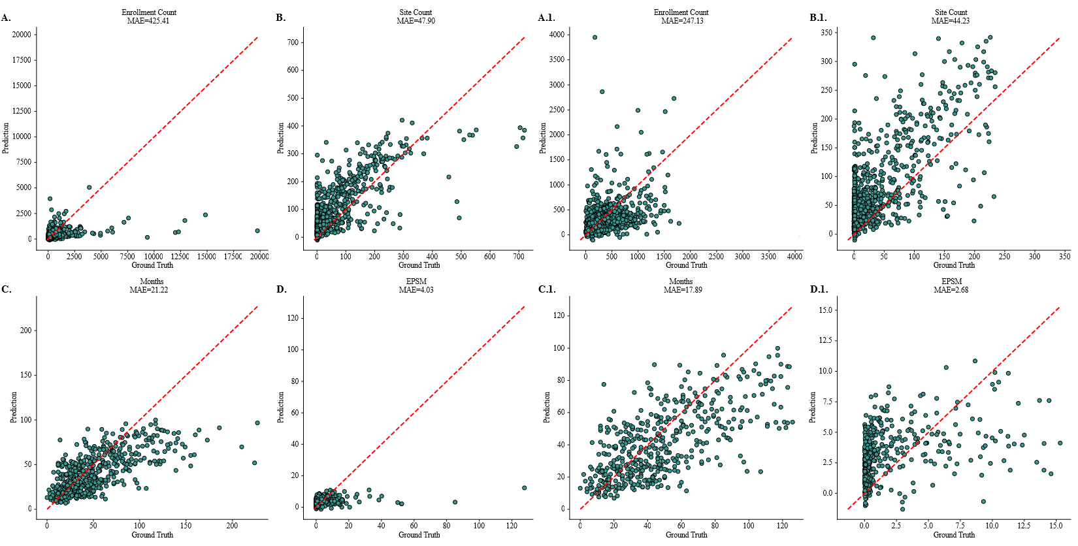

FULL Lower 95% Quantile

Figure 6: Predictive accuracy of trial-level outcome models for enrollment, site count, recruitment duration, and enrollment productivity (EPSM). Panels A–D show predicted versus observed values for all Phase 3 oncology trials in the retrospective cohort (full dataset), with separate scatterplots for (A) enrollment count , (B) site count , (C) recruitment duration in months , and (D) EPSM. Panels A.1–D.1 show corresponding performance restricted to the lower 95% quantile to reduce the influence of extreme outliers. Red dashed lines denote perfect agreement, and mean absolute error (MAE) values are reported for each outcome.

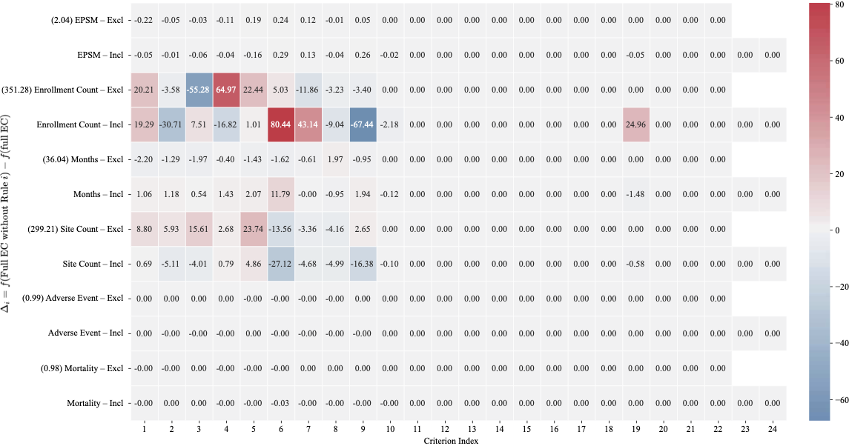

Figure 7: Leave-one-out analysis of eligibility criteria impact on predicted trial outcomes for NCT02566993. Heatmap displays the marginal change in predicted outcomes (f(full EC without rule i) − f(full EC)) when each eligibility criterion is individually removed from the complete eligibility set. Rows represent six predicted outcomes: EPSM, enrollment count, recruitment duration (months), site count, adverse event occurrence, and mortality occurrence, stratified by exclusion (Excl) and inclusion (Incl) criteria. Columns represent individual eligibility criteria indexed 1–24. Values in parentheses on the y-axis indicate baseline predictions using the full eligibility set. Red shading indicates positive change (removal increases predicted value) whereas blue shading indicates negative change (removal decreases predicted value).

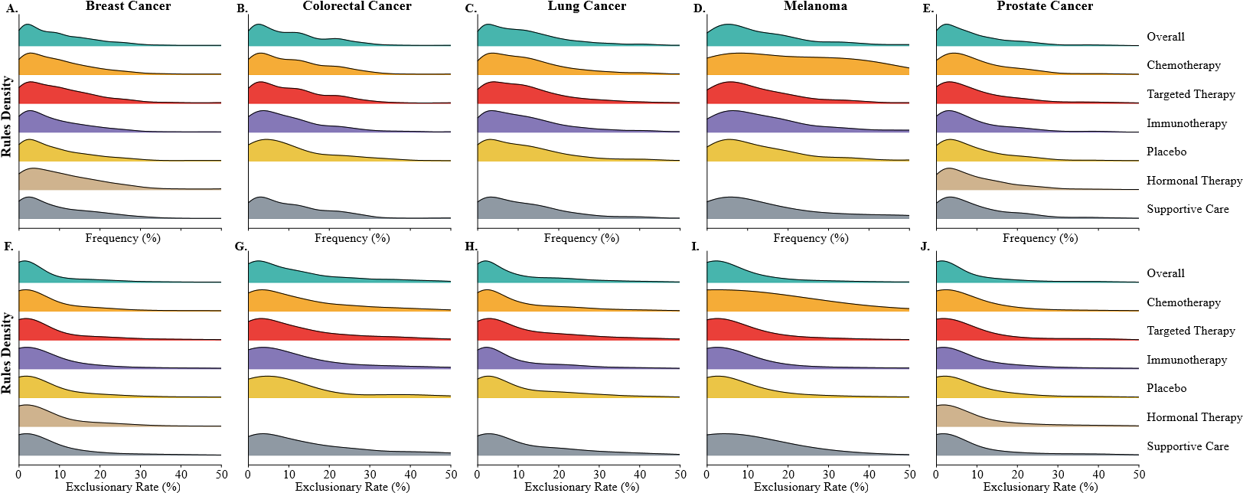

Figure 8: Distributions of eligibility rule frequency and exclusionary impact across therapeutic categories and cancer types. (A–E) Kernel density estimates showing the distribution of rule frequency (%) for seven therapeutic categories across breast, colorectal, lung, melanoma, and prostate cancer trials. (F–J) Corresponding density plots of rule exclusionary rates (%), illustrates how often rules within each therapeutic category exclude real-world patients in prospective simulation.

Table 4: Optimized eligibility criteria for NCT02566993 retained at the selected Pareto-optimal configuration.

Rule Category | Eligibility Criterion
Demographics | Minimum age ≥ 18 years
Disease Characteristics | Histologically or cytologically confirmed diagnosis of limited- or extensivestage small cell lung cancer (SCLC) that has failed one prior platinumcontaining regimen, with a chemotherapy-free interval of at least 30 days
Hematologic Safety | Absolute neutrophil count (ANC) ≥ 2.0×10⁹/L  Platelet count ≥ 100×10⁹/L
Hepatic Function | Alanine aminotransferase (ALT) ≤ 3× upper limit of normal (ULN) Aspartate aminotransferase (AST) ≤ 3× ULN
Renal Function | Calculated creatinine clearance ≥ 30 mL/min
Muscle Enzymes | Creatine phosphokinase (CPK) ≤ 5× ULN if elevation is disease-related
Treatment Recovery | At least 3 weeks since prior anticancer therapy, with recovery to Grade ≤ 1 from treatment-related adverse events, except for sensory neuropathy, anemia, asthenia, and alopecia, which may be Grade ≤ 2 (per NCI CTCAE v4.0)
Radiotherapy Washout | ≥ 4 weeks since completion of whole-brain radiotherapy  ≥ 2 weeks since completion of prophylactic cranial irradiation  ≥ 2 weeks since completion of radiotherapy to any other site
Reproductive Safety | Women of childbearing potential must have documented non-childbearing status or agree to use a highly effective contraceptive method through 6  weeks after treatment discontinuation  Fertile males with partners of childbearing potential must agree to use condoms during treatment and for 4 months after the last investigational product dose
Regulatory | Provision of voluntary written informed consent prior to any study-specific procedure

Table 5: Trial-level exclusionary rates by cancer type and demographic group in prospective simulation
Group | Melanoma | Lung Cancer | Colorectal Cancer | Breast Cancer | Prostate Cancer
Overall Excl rate | 89.0% | 91.3% | 93.6% | 81.4% | 72.5%
White | 89.0% | 91.6% | 94.0% | 81.2% | 72.7%
Asian | 92.2% | 90.0% | 90.1% | 79.9% | 72.9%
African-American | 89.4% | 90.4% | 92.1% | 82.5% | 71.5%
Female | 89.4% | 91.0% | 91.9% | 81.4% | -
Male | 88.6% | 91.8% | 95.5% | - | 72.5%
18–50 | 88.4.% | 91.6% | 92.6% | 81.2% | 70.6%
50–65 | 88.5% | 90.8% | 92.4% | 80.7% | 70.1%
>65 | 89.1% | 91.5% | 94.0% | 81.7% | 72.7%

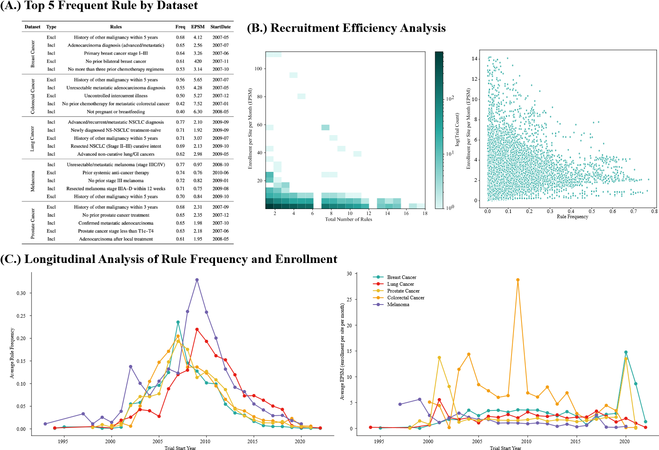
Figure 9: Retrospective analysis of eligibility rules of 285 trial cohorts. (A) The table summarizes the top five most frequent eligibility criteria within each cancer dataset, including rule type, frequency, average exclusion-adjusted productivity (EPSM), and trial start year. (B) Recruitment efficiency analyses demonstrate (left) a heatmap of enrollment productivity (EPSM) as a function of the total number of eligibility rules where color intensity in the heatmap reflects the logarithmic trial count and (right) a scatterplot relating individual rule frequency to EPSM across all trials. (C) Longitudinal analysis of rule frequency and enrollment presents line plots depicting temporal changes in average rule frequency (left) and average EPSM (right) by cancer type, aligned by trial start year.

Table 6: Historical frequency of laboratory eligibility thresholds across five cancer types.

 |  | Breast Cancer |  |  | Colorectal Cancer |  |  | Lung Cancer |  |  | Melanoma |  |  | Prostate
Laboratory Test | Threshold | #Trials | Freq | ER | #Trials | Freq | ER | #Trials | Freq | ER | #Trials | Freq | ER | #Trials | Freq | ER
Absolute Neutrophil Count (×10^9/L) | 1 | 18 | 0.03 | 2.91 | – | – | – | 6 | 0.01 | 3.29 | – | – | – | – | – | –
 | 1.2 | 3 | 0 | 3.55 | – | – | – | – | – | – | – | – | – | – | – | –
 | 1.5 | 45 | 0.06 | 4.93 | 24 | 0.07 | 5.33 | 30 | 0.06 | 5.71 | 5 | 0.06 | 3.05 | 15 | 0.05 | 4.12
 | 2 | 32 | 0.05 | 10.04 | 6 | 0.02 | 9.81 | 18 | 0.04 | 9.89 | – | – | – | – | – | –
Platelets (×10^9/L) | 75 | 20 | 0.03 | 0.69 | – | – | – | 29 | 0.06 | 1.91 | – | – | – | 4 | 0.01 | 0.74
 | 100 | 88 | 0.13 | 1.56 | 49 | 0.15 | 2.21 | 52 | 0.11 | 3.66 | 11 | 0.12 | 1.96 | 29 | 0.09 | 1.73
 | 150 | 37 | 0.05 | 6.56 | – | – | – | – | – | – | – | – | – | – | – | –
Hemoglobin (g/dL) | 8 | 2 | 0 | 3.03 | 6 | 0.02 | 3.68 | 12 | 0.02 | 4.17 | – | – | – | – | – | –
 | 9 | 28 | 0.04 | 5.28 | 18 | 0.05 | 8.15 | 55 | 0.11 | 10.4 | 4 | 0.04 | 3.25 | 5 | 0.02 | 5.08
 | 9.5 | 1 | 0 | 7.4 | – | – | – | – | – | – | – | – | – | – | – | –
 | 10 | 19 | 0.03 | 10.29 | 10 | 0.03 | 15.09 | 4 | 0.01 | 19.84 | – | – | – | 13 | 0.04 | 8.69
 | 11 | 57 | 0.08 | 18.63 | – | – | – | – | – | – | – | – | – | – | – | –
Creatinine Clearance (mL/min) | 30 | 8 | 0.01 | 5.54 | 5 | 0.02 | 6.02 | 14 | 0.03 | 2.27 | – | – | – | 3 | 0.01 | 3.05
 | 40 | 4 | 0.01 | 8.26 | – | – | – | 18 | 0.04 | 7.58 | – | – | – | – | – | –
 | 50 | 11 | 0.02 | 19.91 | 8 | 0.02 | 14.54 | 17 | 0.03 | 15.36 | 2 | 0.02 | 12.82 | 2 | 0.01 | 14.1
 | 60 | 15 | 0.02 | 30.7 | 2 | 0.01 | 23.31 | 7 | 0.01 | 22.73 | – | – | – | – | – | –
White Blood Cells (×10^9/L) | 2 | 1 | 0 | 2.08 | 6 | 0.02 | – | – | – | – | 5 | 0.06 | 1.14 | – | – | –
 | 2.5 | 1 | 0 | 2.6 | – | – | – | 4 | 0.01 | 2.07 | 14 | 0.16 | 1.86 | – | – | –
 | 3 | 5 | 0.01 | 3.89 | 14 | 0.04 | 2.78 | 48 | 0.1 | 4.04 | – | – | – | – | – | –
 | 4 | 4 | 0.01 | 11.61 | – | – | – | – | – | – | – | – | – | 1 | 0 | 6.64
Serum Creatinine (mg/dL) | 1.5 | 16 | 0.02 | 2.2 | 74 | 0.22 | 7.05 | 33 | 0.07 | 7.34 | 5 | 0.06 | 4.8 | 8 | 0.03 | 8.69
 | 2 | 30 | 0.04 | 0.94 | 67 | 0.2 | 3.23 | 9 | 0.02 | 3.24 | 1 | 0.01 | 1.8 | 5 | 0.02 | 3.02
 | 2.5 | 1 | 0 | 0.69 | – | – | – | – | – | – | – | – | – | – | – | –
Total Bilirubin (mg/dL) | 1.5 | 25 | 0.04 | 1.55 | – | – | – | – | – | – | 5 | 0.06 | 1.4 | 14 | 0.04 | –
 | 2 | 32 | 0.05 | 0.69 | 7 | 0.02 | 1.87 | 16 | 0.03 | 1.4 | – | – | – | – | – | 1.48
Albumin (g/dL) | 2.5 | 1 | 0 | 1.25 | 4 | 0.01 | 3.04 | 4 | 0.01 | 4.16 | 3 | 0.03 | 1.04 | – | – | –
 | 3 | – | – | – | – | – | – | 33 | 0.07 | 11.69 | – | – | – | 3 | 0.01 | 4.54
 | 3.5 | – | – | – | – | – | – | – | – | – | – | – | – | 3 | 0.01 | 10.9

