SKILL SWAP HUB - SKILLX

INTRODUCTION

Skill Swap Hub is the skill exchange platform designed to help students share and learn skills from one another. In today’s competitive environment, students often possess different talents such as programming, communication, or design. This platform creates an opportunity for students to collaborate, where one student can teach a skill while learning another in return.

PROBLEM STATEMENT

Students have valuable skills but lack a structured platform to share and learn from peers. Existing systems focus mainly on formal education and do not support peer-to-peer skill exchange efficiently.

OBJECTIVES

- To enable students to share and learn skills easily
- To maintain a centralized database of students and their skills
- To allow students to request skills from others
- To track and manage skill exchanges

SCOPE OF THE PROJECT

The system is designed for students within an institution to:

- Register and manage their profiles
- Add and update their skills
- Request skills from other students
- Participate in skill exchange programs

SYSTEM ARCHITECTURE
- Frontend: HTML,CSS,JavaScript
- Backend: Node.js
- Database:MongoDB

METHODOLOGY

The system is implemented using a Database Management System (DBMS). It includes:

- Designing relational tables (Student, Skill, Requests, Exchanges)
- Establishing relationships using foreign keys
- Performing operations like insertion, retrieval, and updates using SQL queries

EXPECTED OUTCOME

- Efficient skill-sharing among students
- Improved learning through collaboration
- Organized tracking of skills and exchanges
- Better utilization of student talents

DATABASE DESIGN

The system consists of the following main tables:

- Student – stores student details
- Skill – stores different skills
- Student_Skill – maps students with their skills
- Skill_Request – records skill learning requests
- Skill_Exchange – tracks completed exchanges

WORKING OF THE SYSTEM

Step 1: Student Registration

- A student enters their details (Name, USN, Department, Email).
- Data is stored in the Student table.

Step 2: Adding Skills

- Students add skills they possess (e.g., Python, Photoshop).
- Skills are stored in the Skill table.

Their skill level is linked via Student_Skill table. Step 3: Viewing Available Skills
- Students can view all available skills in the system.

They can also see which student offers which skill. Step 4: Requesting a Skill
A student selects a skill they want to learn.

A request is created in the Skill_Request table with status:

- Pending
- Accepted
- Rejected

Step 5: Matching & Approval

- Another student who has the requested skill can accept the request.
- Once accepted, the learning session can be scheduled.
Step 6: Skill Exchange

- Students exchange knowledge (online/offline).

After completion, the exchange is recorded in the Skill_Exchange table. Step 7: Tracking & Management
Admin or system can:

- Track all requests
- Monitor completed exchanges
- Analyze popular skills

ADVANTAGES

- Promotes peer-to-peer learning
- Cost-effective (no external training required)
- Encourages collaboration among students
- Easy tracking and management of skills

ER DIAGRAM

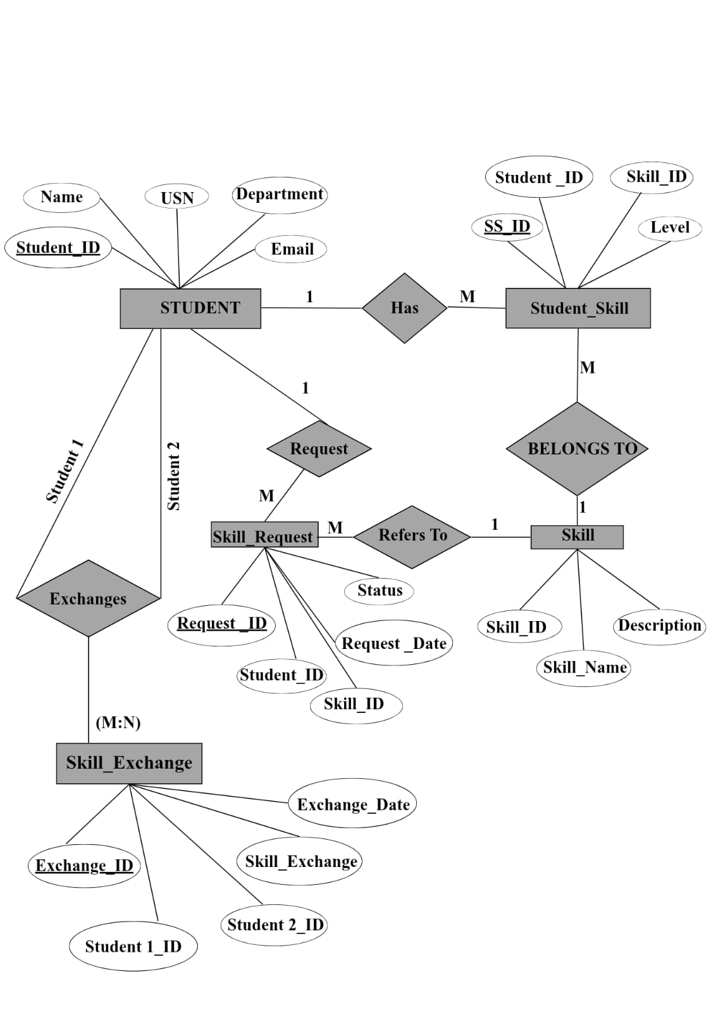

CONCLUSION

The Skill Exchange Platform for Students is an efficient system that bridges the gap between learners and skill providers. By using DBMS, the platform ensures organized data storage, quick retrieval, and smooth management of skill-sharing activities, ultimately enhancing student learning and collaboration

