1. Spec-based testing: We conducted spec-based tests for all features and requirements and all these tests have passed.
2. Usability testing: We find that some features are not so usable and not easy to test. For example, “review paper” feature has too many dependencies. When a PC chair assigns a paper to some reviewers, they should be able to see this paper in their “review paper” page, otherwise they can never see this page. And when they want to update their reviews, review criteria and questions are synchronized with these in the database and might always be updated by PC chair.
3. We are still in the process of being accustomed to agile development. There are always new and changing requirements that are out of expect. We should keep improving the ability to predict future features. But also we should let our code be more flexible to try to handle requirements even we haven’t thought of.
4. We used Trello to assign the work for everyone. Generally, the assignment is based on detailed requirements.

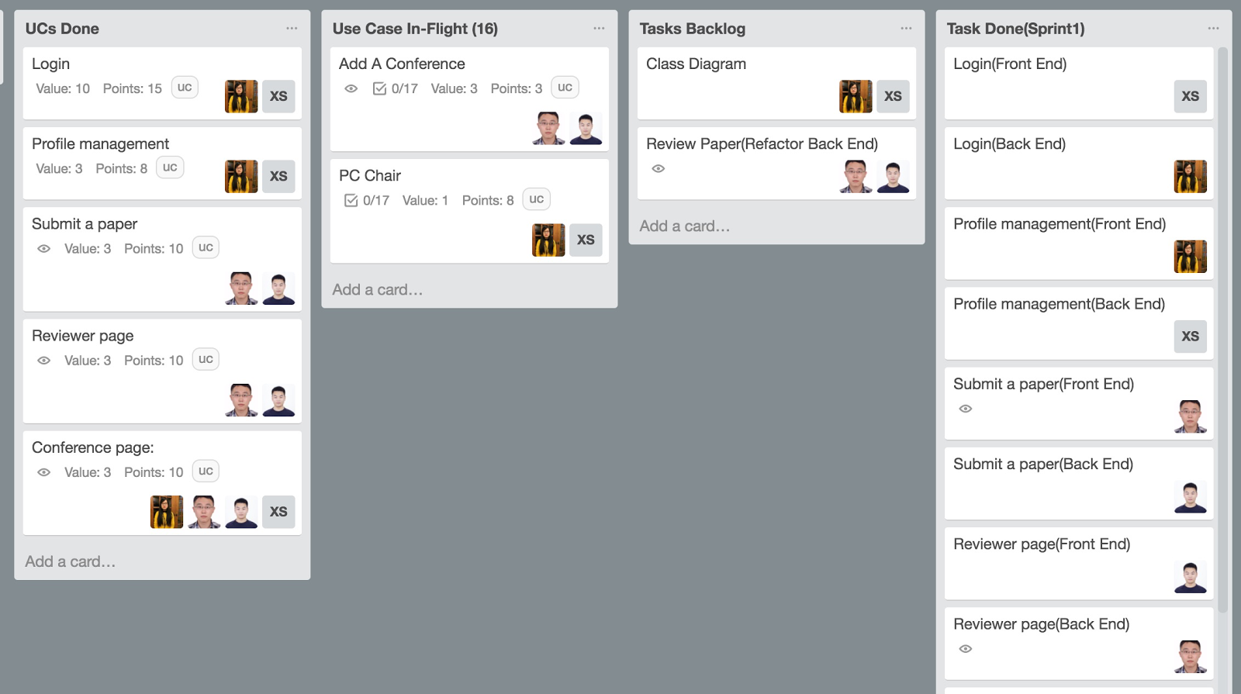

**Figure 4. Trello**

1. We use Github to get our commit distribution and branch tree. Our commit frequency is pretty high in Thursday, almost the sum of all other days because Friday is always deadline. This really reminds us to start early.

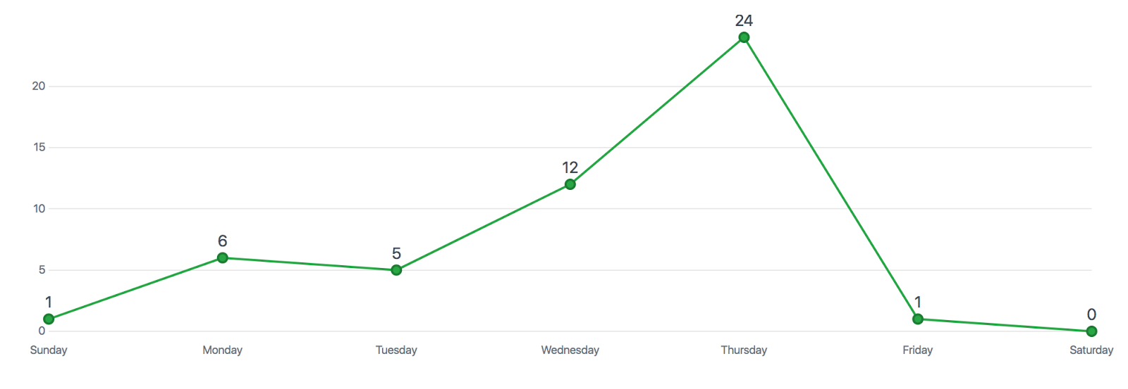

**Figure 5. Github commit distribution**

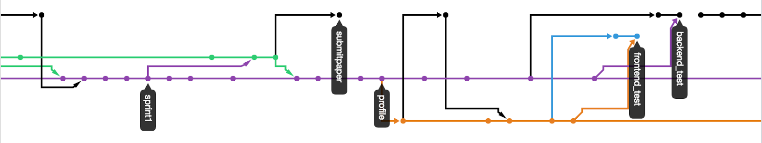

**Figure 6. Github branch tree**