Run docker build . -t dns_app/as or fs or us:latest

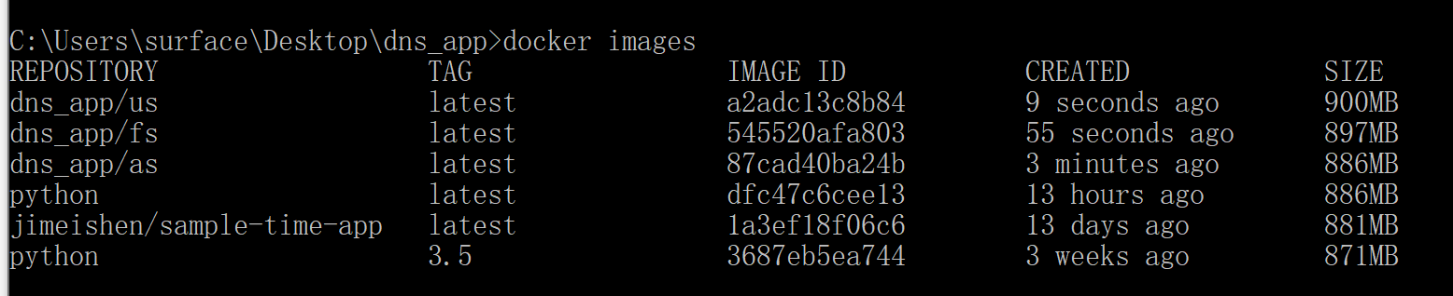

docker run -d -p 53533:53533 dns_app/as python main.py

docker run -d -p 19090:9090 dns_app/fs python main.py

docker run -d -p 8080:8080 dns_app/us python main.py

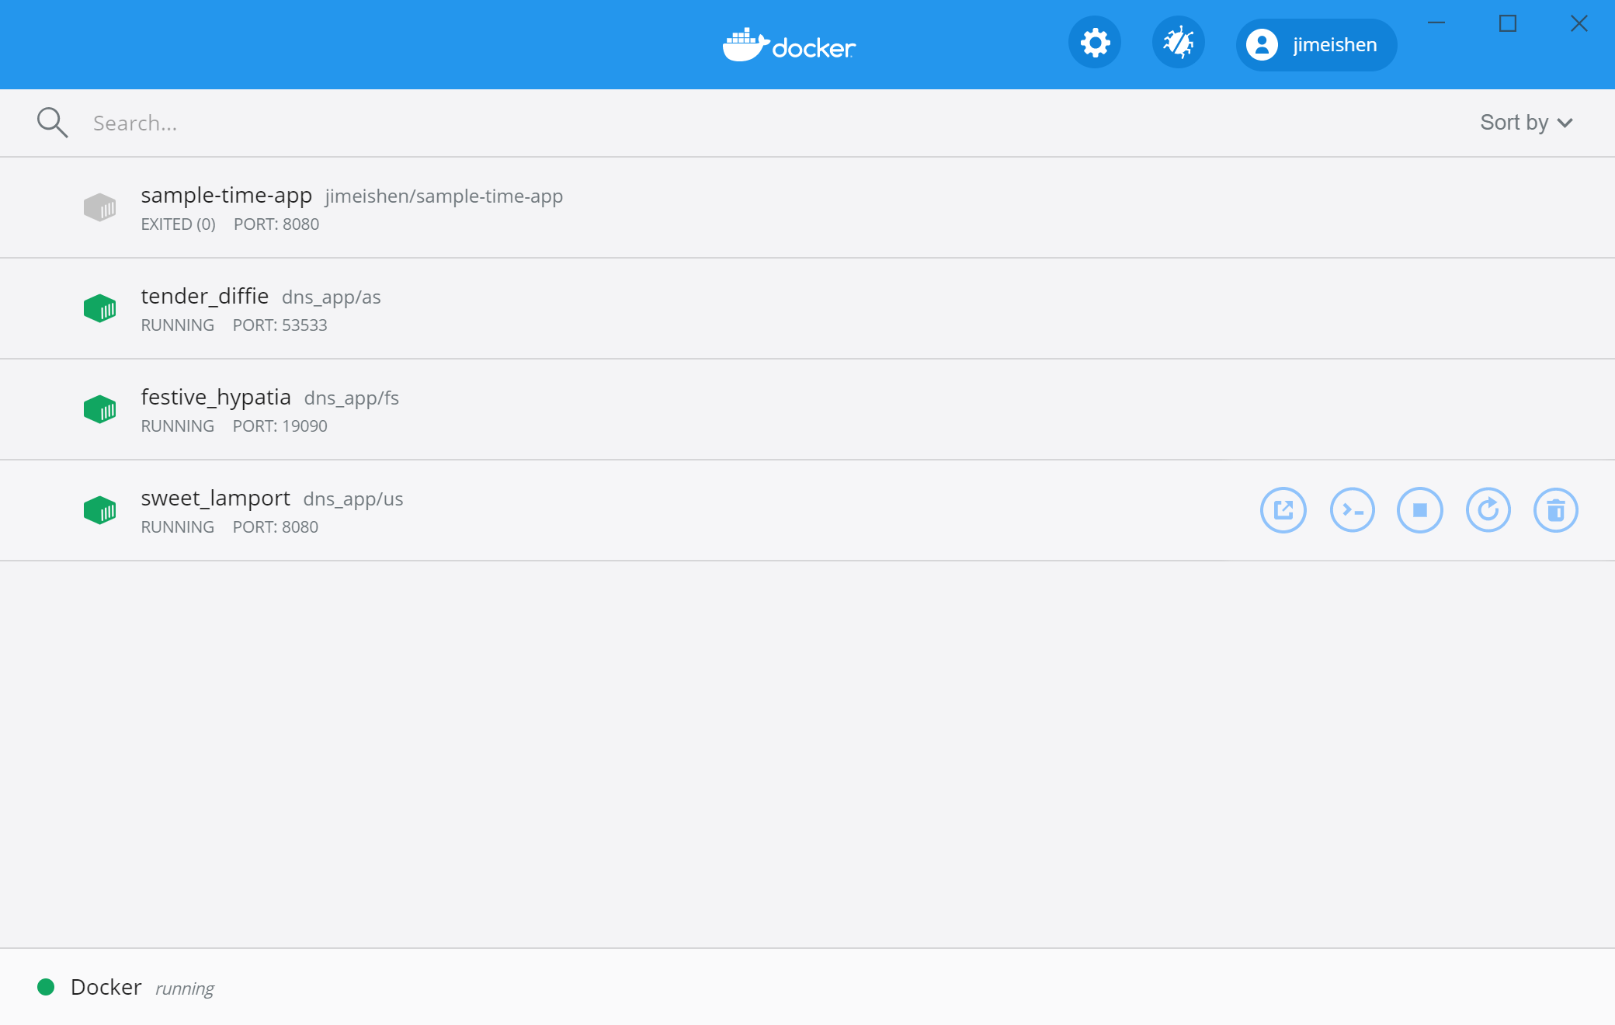

PUT.

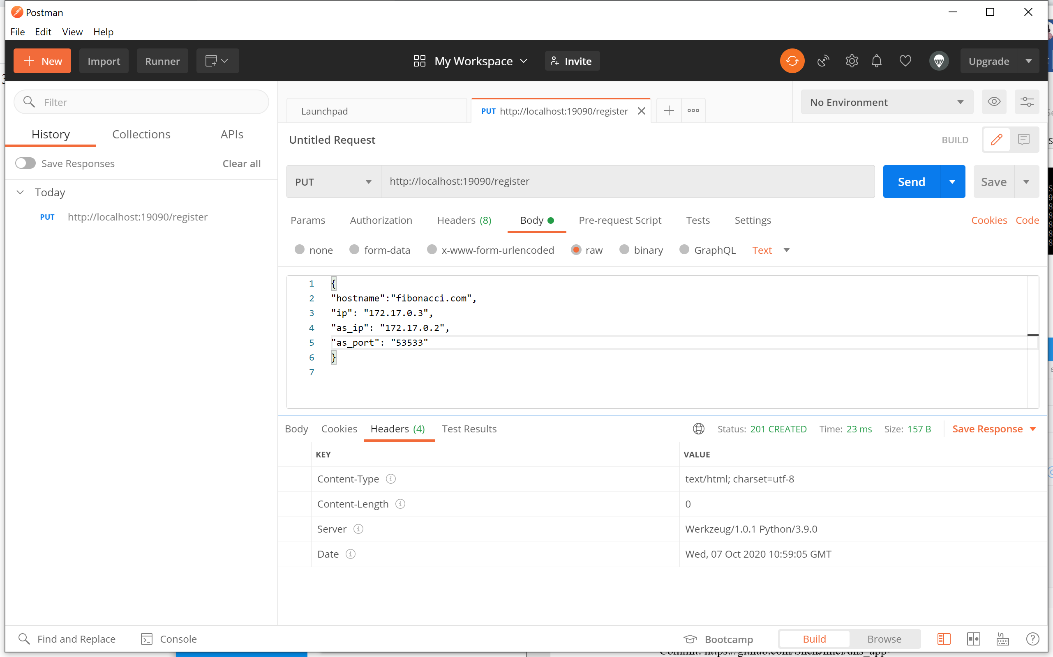

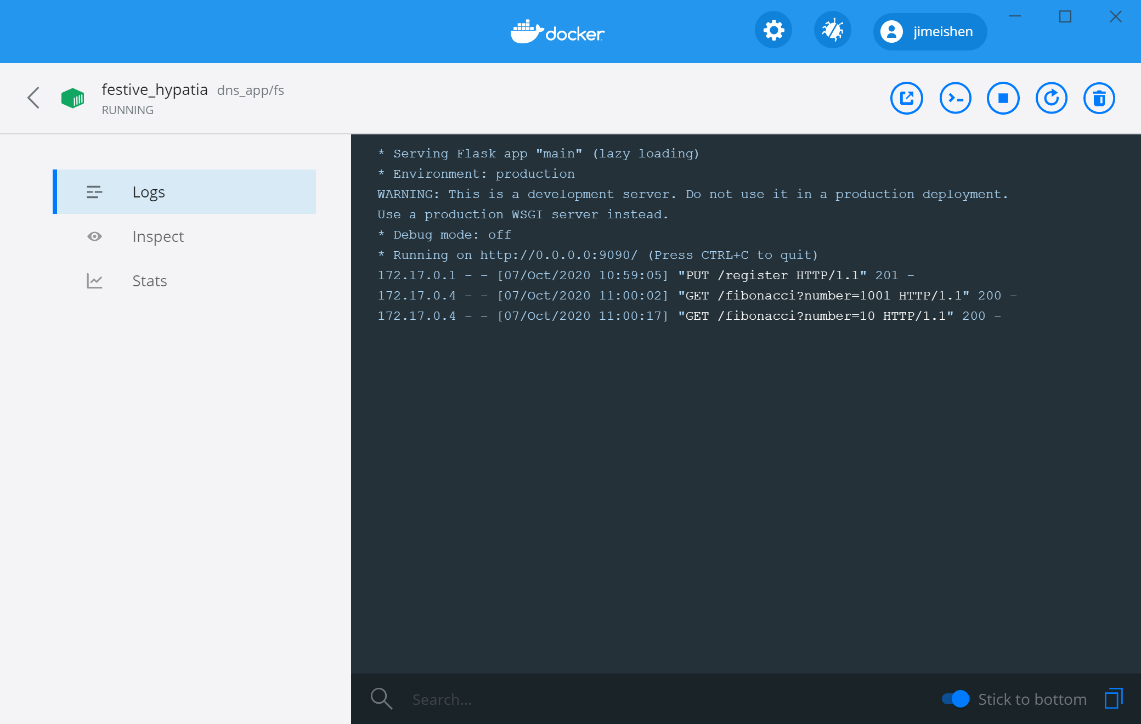

GO http://localhost:8080/fibonacci?hostname=fibonacci.com&fs_port=9090&number=10&as_ip=172.17.0.2&as_port=53533

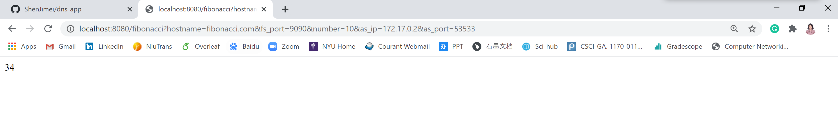

Commit: https://github.com/ShenJimei/dns_app

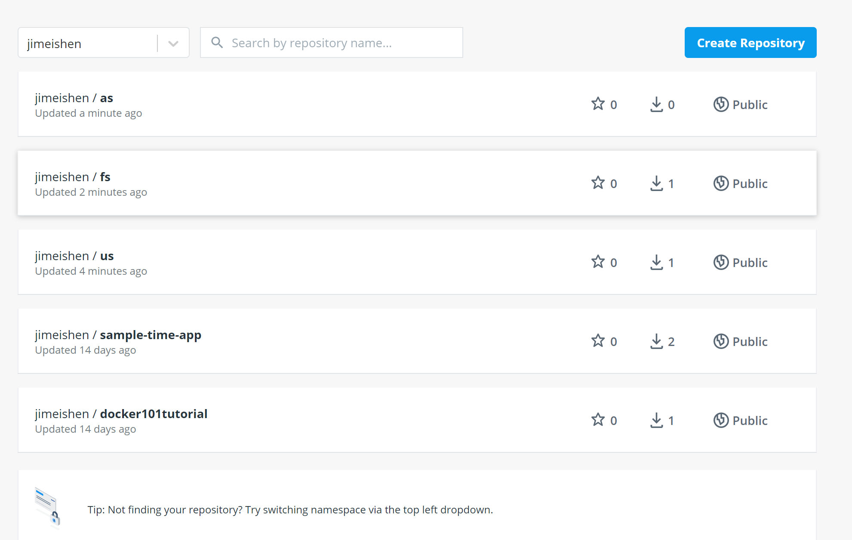

Write deploy_dns.tml

apiVersion: apps/v1

kind: Deployment

metadata:

name: deploy-dns

labels:

app: dns-app

spec:

replicas: 3

selector:

matchLabels:

app: dns-app

template:

metadata:

labels:

app: dns-app

spec:

containers:

- name: as

image: jimeishen/as

ports:

- containerPort: 30001

- name: fs

image: jimeishen/fs

ports:

- containerPort: 30002

- name: us

image: jimeishen/us

ports:

- containerPort: 30003

