April 16 Evening:

I started to do this assignment. The first step I took is to follow the miro board I created last week. I first create many empty functions and let all this function’s relationship became what is showing up on the miro board.

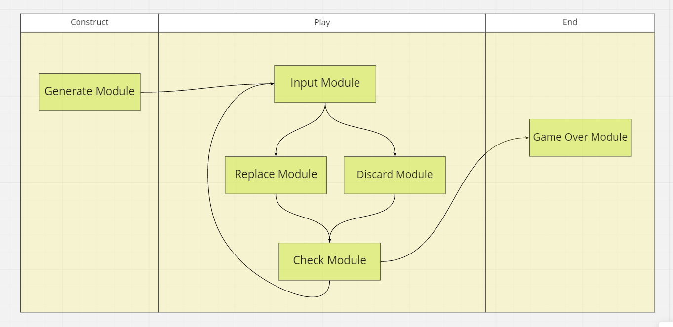

Then, I start do complete the generate module first.