Wilson Sporting Goods



**Project Instructor:**

Miss Sajida Sharmeen

**Curriculum Code:**

6740

Candidates:

Moiz Mansoor

Aizaz Asim Khan

Mudassir Ali

Sameer Ahmed

Mohammad Mudassir

**Project Certification**

This is to certify that Moiz Mansoor, Aizaz Asim Khan, Mudassir Ali, Sameer Ahmed and Muhammad Mudassir has successfully Designed & Developed:

“Wilson Sporting Goods”

Date of Issue: 11/ Jan / 2020

**Introduction**

The thirst for learning, upgrading technical skills and applying the concepts in real life environment at a fast pace is what the industry demands from IT professionals today. However busy work schedules, far-flung locations, unavailability of convenient time-slots pose as major barriers when it comes to applying the concepts into realism. And hence the need to look out for alternative means of implementation in the form of laddered approach.

The above truly pose as constraints especially for our students too! With their busy schedules, it is indeed difficult for our students to keep up with the genuine and constant need for integrated application which can be seen live especially so in the field of IT education where technology can change on the spur of a moment. *Well, technology does come to our rescue at such times!!*

Keeping the above in mind and in tune with our constant endeavour to use Technology in our training model, we at Aptech have thought of revolutionizing the way our students learn and implement the concepts using tools themselves by providing a *live and synchronous eProject learning environment!*

## Customer expectations

**CLIENT:** Wilson Sporting Goods

**Project Objective**

The Objective of this program is to give a sample project to work on real life projects. These applications help you build a larger more robust application.

The objective is not to teach you Dreamweaver but to provide you with a real-life scenario and help you create basic applications using the tools.

You can revise the chapters before you start with the project.

This project is meant for students who have completed the module of ***VISUAL STUDIO CODE*** These programs should be done in the Lab sessions with assistance of the faculty if required.

Kindly get back @ eprojects@aptechfze.ae in case of any doubts regarding the application or its objectives.

**HARDWARE/SOFTWARE REQUIREMENTS**:

**Hardware**

* A minimum computer system that will help you access all the tools in the courses is a Pentium 166 or better
* 64 Megabytes of RAM or better

### Software

* Visual Studio Code
* Chrome / Firefox
* Sigma
* Adobe Premier
* Adobe Photoshop
* Adobe Illustrator

**Task Sheet**

|  |  |  |  |
| --- | --- | --- | --- |
| Task | Start date | Candidates | Status |
| Case Study | 11/Jan/2020 | Moiz Mansoor | **Completed** |
| Graphics Designing | 11/Jan/2020 | Moiz Mansoor  Aizaz Khan | **Completed** |
| Site Interface Designing | 11/Jan/2020 | Moiz Mansoor | **Completed** |
| Material Searching | 11/Jan/2020 | Moiz Mansoor  Aizaz Khan  Sameer Ahmed  Mudassir Khan  Mudassir Ali | **Completed** |
| Site Testing | 11/Jan/2020 | Moiz Mansoor M. | **Completed** |

**List of Validation**

|  |  |
| --- | --- |
| ***Option*** | ***Validation*** |
| Fields in Form should not be Null | Yes |
| Hyperlinks Have Alternating Text | No |
| Search Pages | No |
| Homepage Has Forward Only Link | Yes |
| All Web pages have link back to Homepage | Yes |
| All Functions Are Compatible with Firefox | Yes |
| All Functions Are Compatible with IE | No |

Submission Checklist

|  |  |  |
| --- | --- | --- |
| ***LIST OF ITEMS*** | ***Remarks*** | ***COMMENTS*** |
| Do All Pages Linked together | **Yes** |  |
| All Hyperlinks working | **Yes** |  |
| Page Colors As Per Common Guidelines | **No** | No such Instruction were provided |
| Site Browser Compatible | **Yes\*** | Only tested in Google Chrome and Firefox |
| Feedback Form Included | **No** | Requirements askes for a local mail client instead. |
| Project Zip File | **Yes** |  |

**“Screenshots”**

**HOME PAGE**



**Our Brands**

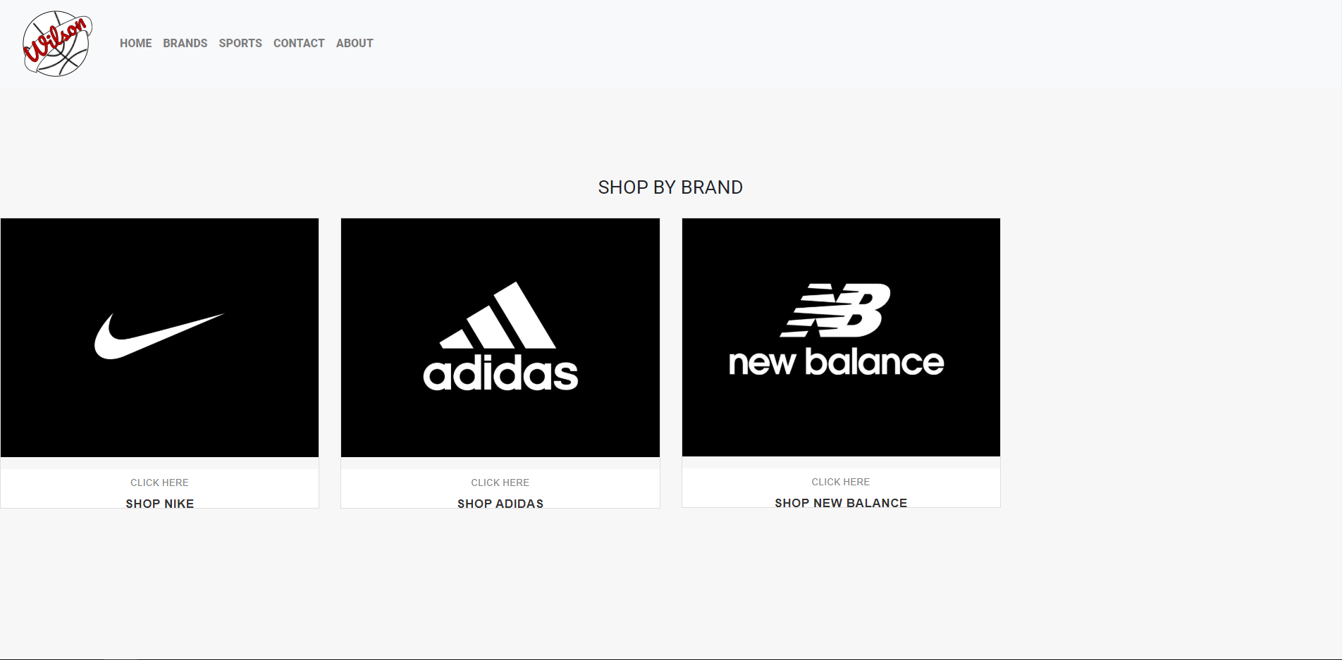

**Our Sports**

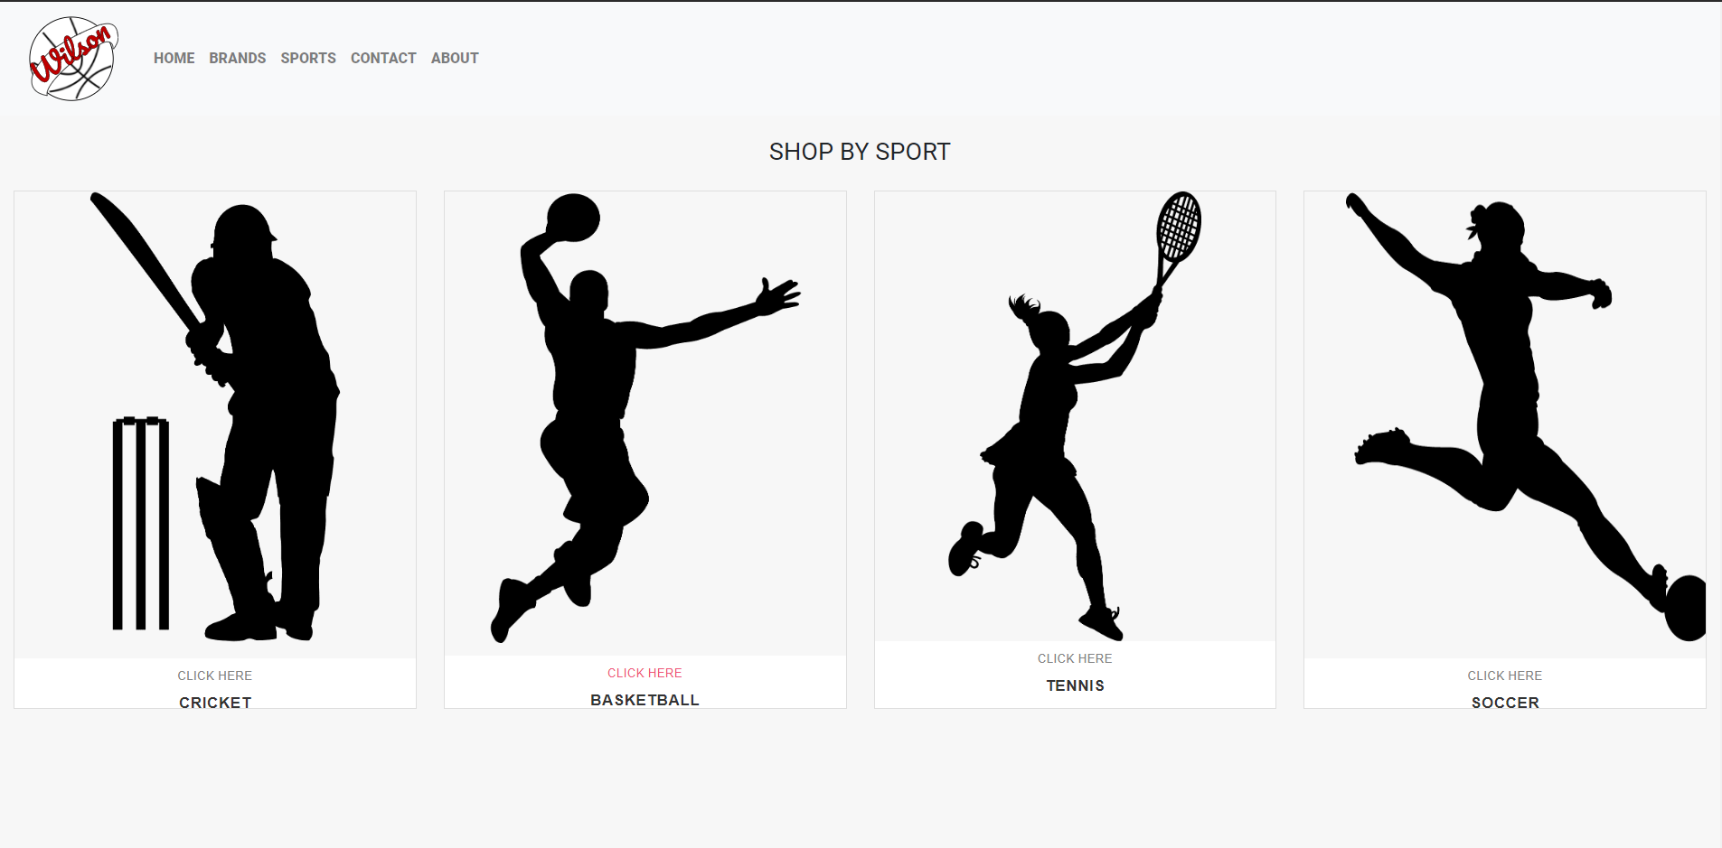

**Contact Us**

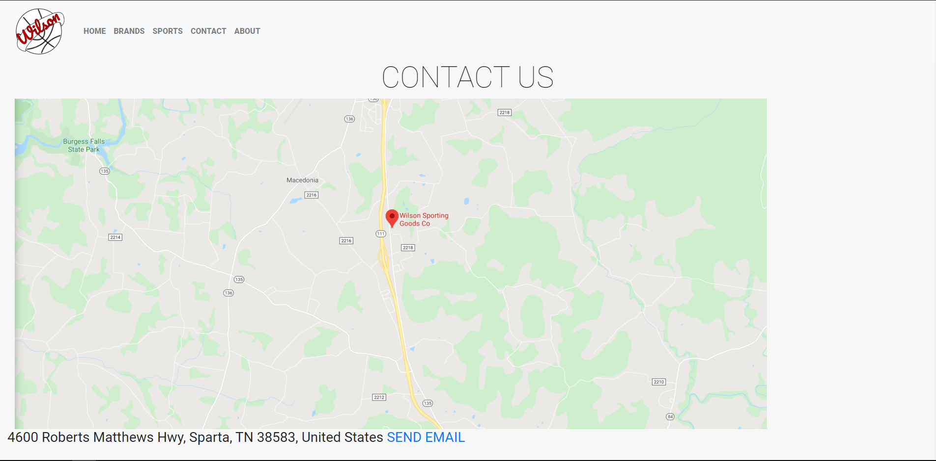

**Footer**

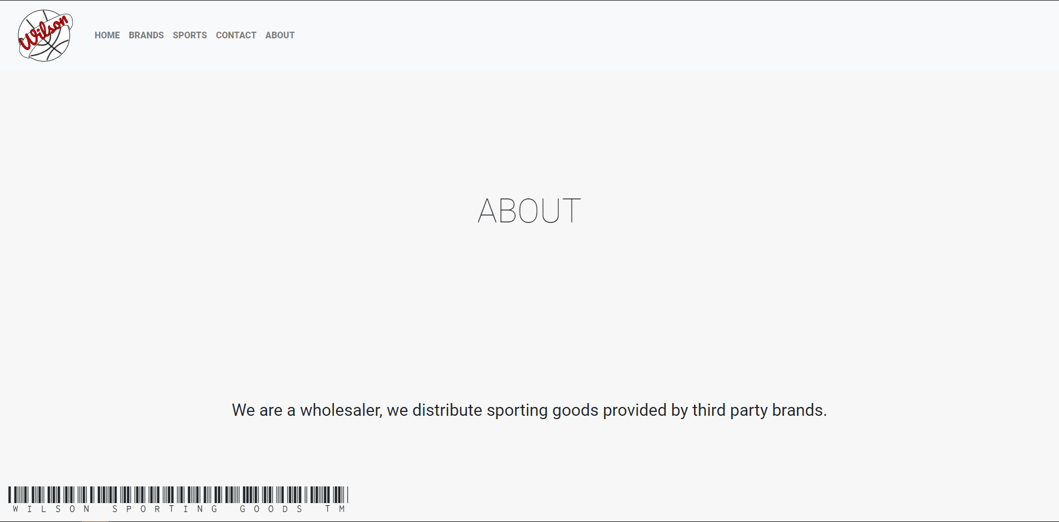

**Comparison Page**

