Shenabeth Jenkins

Professor Alexander

CMSC 204

2/3/2020

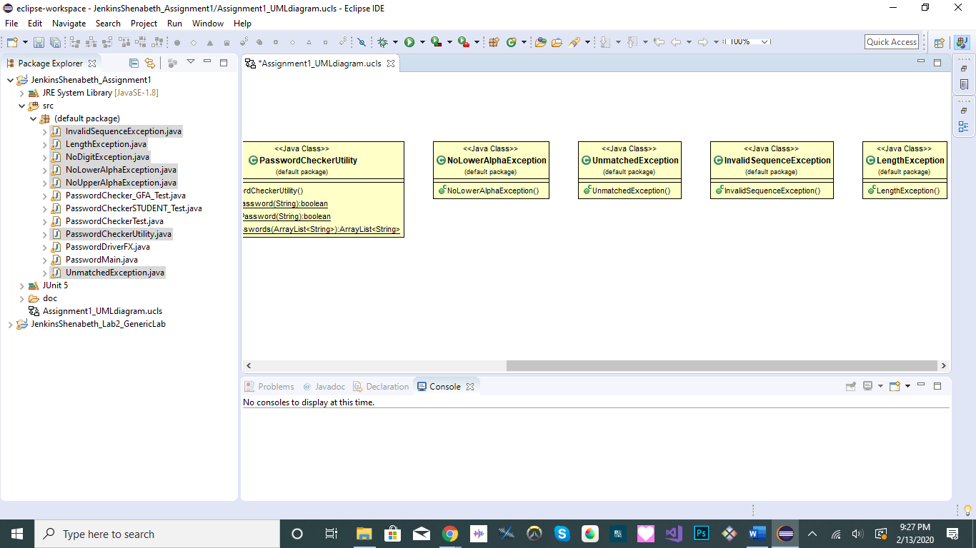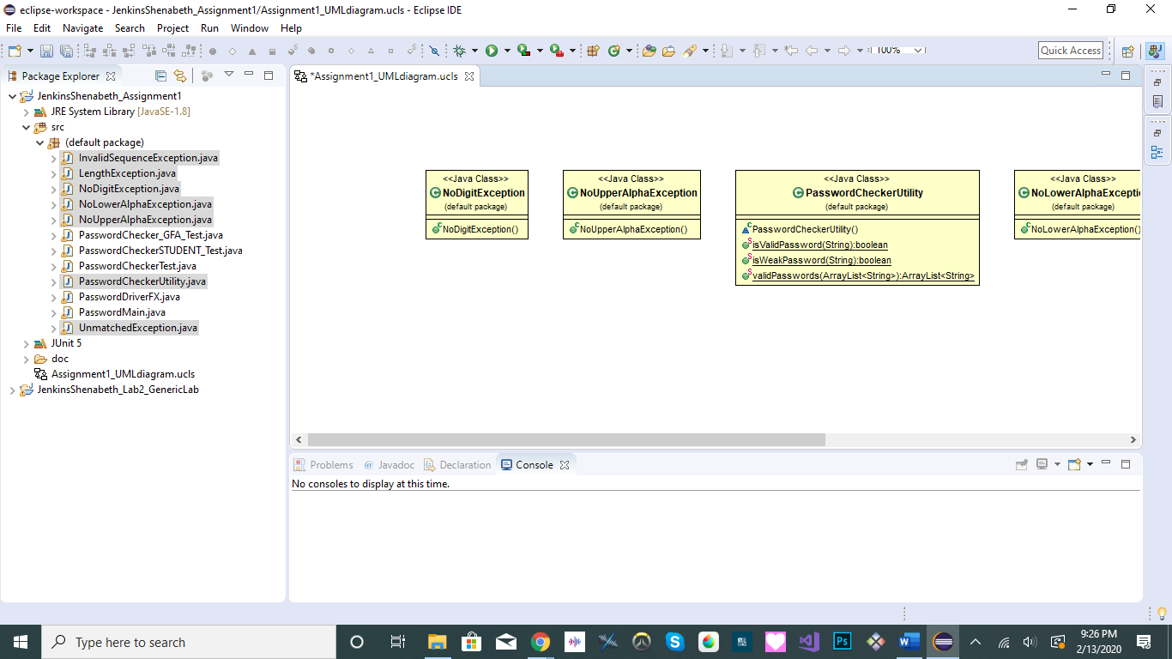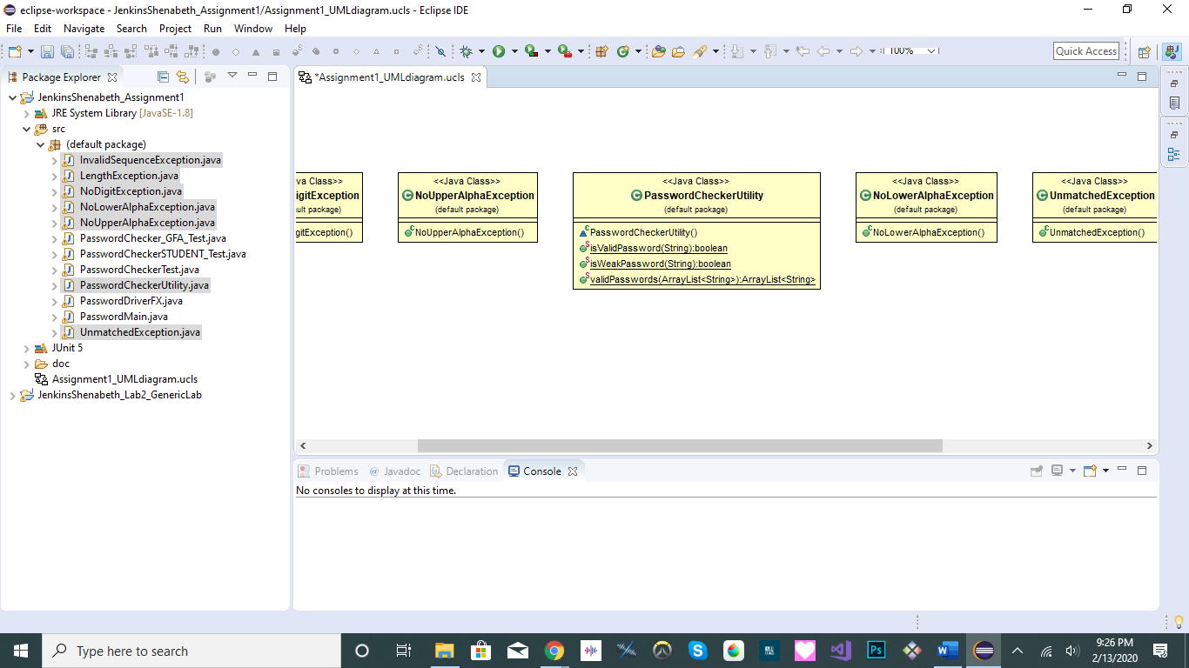**UML Class Diagrams**

**Learning Experience**

Assignment 1 is about creating exceptions in order for a GUI driver to accurately display messages depending on which standards are met. I think this was a good project for introducing how you can create your own exceptions rather than using bound to only using the existing exceptions. Of course because the GUI was provided, it was easier to focus completely on the implementation of exceptions.

The thing that I had the most trouble with for this assignment was with coding the student junit test. It was very confusing as to why the provided junit test passed but my version did not. In the end, it just required a lot of trial and error

Compared to the exception classes, I think they were easy easier to choose than three utility.

If I were to do this project again, I think it would have been easier for me to start with making the exception classes. Because I had started with making the utility class, I had a bunch of red error lines to get confused with because the exceptions hadn't existed yet. Of course the junit tests would help to let you know if your code has the right output, but having the exceptions created would have let me know sooner that the red lines were only caused by the non-existing exceptions that my code was referring to.