**FIT3179 Data Visualisation Week 9 Homework**

**Name: Deelaka Shenal Wijenayaka**

**Student ID: 31938388**

**Lab: Lab 10 Wednesday 6-8pm**

**Tutor: Kadek Satriadi**

**URL:** [**https://shenalcode.github.io/31938388_FIT3179Week9Homework/**](https://shenalcode.github.io/31938388_FIT3179Week9Homework/)

**Map Screenshot:**

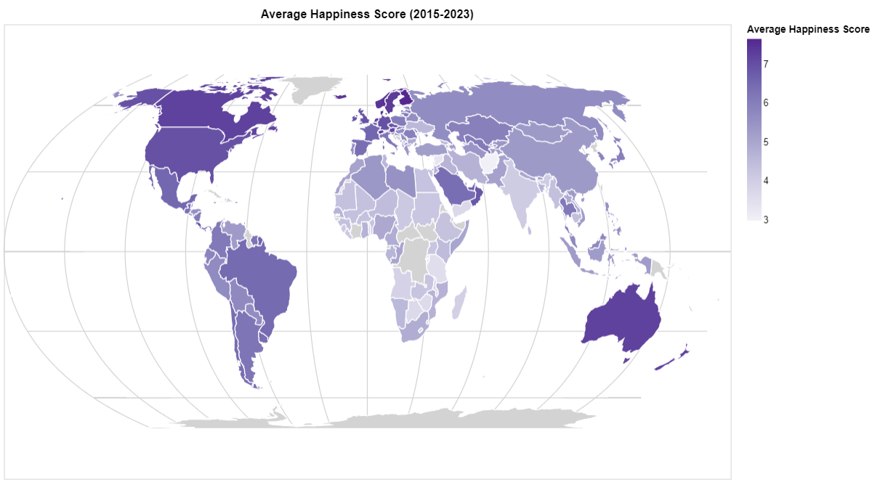

* **Domain:** Anyone who is interested in geopolitical issues such as quality of life and how other factors effect the happiness of a person in a country so they can design their public policies to match to satisfy their people, for example government policy makers.
* **Dataset:** Islam, S. (2023). World Happiness Report up to 2023. Retrieved from <https://www.kaggle.com/datasets/sazidthe1/global-happiness-scores-and-factors>
* **Data transformation:** The data set consisted of data gathered from 2015 to 2023. Therefore, to create this map I have summed up all the scores recorded over the years and found the average happiness score for each country to create this map.
* **Justification:** I have used a choropleth map.The goal of the map was to show the average happiness score of each country; hence I was trying to visualize a quantitative data attribute related to a region. Therefore, in my opinion the choropleth map is more suitable than a proportional symbol map. Symbol maps are used to present data related to an exact position. Dot map is not suitable for this representation at all. For the map projection I have used an equal earth projection. This is because to create a choropleth map, it requires a map projection with area preservation.