《操作系统综合实验》
实 验 报 告 书

学 生 姓 名 xxxxxx
学 号 xxxxxxxxxxx
班 级 xxxxxxx

2020 — 2021 学年 第 2 学期

《操作系统综合实验》实验报告
实验名称 | 系统调用基础 | 实验序号 |  | 1
实验日期 | 2021.6 |  | 实验人 |  | Xxx
一、实验题目
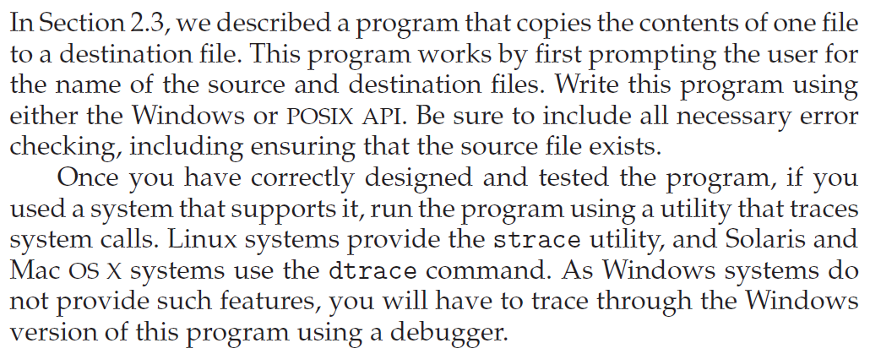

二、相关原理与知识
- 程序编写
  - 拷贝文件功能
  - 模仿cp命令的执行效果
    - 错误检查（参数检查，程序逻辑，函数返回值判断等）
    - 只考虑文件，不考虑目录
- strace
  - 查看所编写程序执行过程中调用的系统调用
  - strace用来判断一个程序执行出错的原因
三、实验过程
创建file1.txt和file2.txt，和源程序operatingSystem1.exe一同放在虚拟机的根目录：
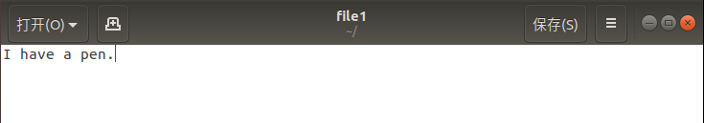

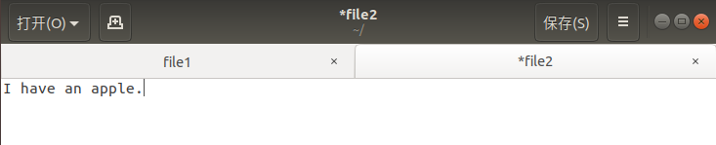

如图，两个文本的内容分别为：I have a pen. 以及 I have an apple.
然后将编译好的源程序在终端通过strace命令运行，输入的命令如下：
Strace -tt -f ./operatingSystem1

四、实验结果与分析

实验结果如下：
20:26:42.507068 execve("./operatingSystem1", ["./operatingSystem1"], 0x7ffe1ed7d030 /* 53 vars */) = 0
20:26:42.508074 brk(NULL) = 0x557403121000
20:26:42.508409 access("/etc/ld.so.nohwcap", F_OK) = -1 ENOENT (No such file or directory)
20:26:42.508754 access("/etc/ld.so.preload", R_OK) = -1 ENOENT (No such file or directory)
20:26:42.509012 openat(AT_FDCWD, "/etc/ld.so.cache", O_RDONLY|O_CLOEXEC) = 3
20:26:42.509295 fstat(3, {st_mode=S_IFREG|0644, st_size=79203, ...}) = 0
20:26:42.509556 mmap(NULL, 79203, PROT_READ, MAP_PRIVATE, 3, 0) = 0x7ff7a51fd000
20:26:42.509810 close(3) = 0
20:26:42.510126 access("/etc/ld.so.nohwcap", F_OK) = -1 ENOENT (No such file or directory)
20:26:42.510399 openat(AT_FDCWD, "/lib/x86_64-linux-gnu/libc.so.6", O_RDONLY|O_CLOEXEC) = 3
20:26:42.510630 read(3, "\177ELF\2\1\1\3\0\0\0\0\0\0\0\0\3\0>\0\1\0\0\0\260\34\2\0\0\0\0\0"..., 832) = 832
20:26:42.510789 fstat(3, {st_mode=S_IFREG|0755, st_size=2030544, ...}) = 0
20:26:42.510950 mmap(NULL, 8192, PROT_READ|PROT_WRITE, MAP_PRIVATE|MAP_ANONYMOUS, -1, 0) = 0x7ff7a51fb000
20:26:42.511147 mmap(NULL, 4131552, PROT_READ|PROT_EXEC, MAP_PRIVATE|MAP_DENYWRITE, 3, 0) = 0x7ff7a4bf9000
20:26:42.511295 mprotect(0x7ff7a4de0000, 2097152, PROT_NONE) = 0
20:26:42.511442 mmap(0x7ff7a4fe0000, 24576, PROT_READ|PROT_WRITE, MAP_PRIVATE|MAP_FIXED|MAP_DENYWRITE, 3, 0x1e7000) = 0x7ff7a4fe0000
20:26:42.511595 mmap(0x7ff7a4fe6000, 15072, PROT_READ|PROT_WRITE, MAP_PRIVATE|MAP_FIXED|MAP_ANONYMOUS, -1, 0) = 0x7ff7a4fe6000
20:26:42.511746 close(3) = 0
20:26:42.511904 arch_prctl(ARCH_SET_FS, 0x7ff7a51fc500) = 0
20:26:42.512115 mprotect(0x7ff7a4fe0000, 16384, PROT_READ) = 0
20:26:42.512262 mprotect(0x557401992000, 4096, PROT_READ) = 0
20:26:42.512406 mprotect(0x7ff7a5211000, 4096, PROT_READ) = 0
20:26:42.512549 munmap(0x7ff7a51fd000, 79203) = 0
20:26:42.512746 fstat(1, {st_mode=S_IFCHR|0620, st_rdev=makedev(136, 0), ...}) = 0
20:26:42.512923 brk(NULL) = 0x557403121000
20:26:42.513068 brk(0x557403142000) = 0x557403142000
20:26:42.513213 write(1, "input the name of file\n", 23input the name of file
) = 23
20:26:42.513363 fstat(0, {st_mode=S_IFCHR|0620, st_rdev=makedev(136, 0), ...}) = 0
20:26:42.513590 read(0, file1（此处是手动输入）
"file1\n", 1024) = 6
20:26:58.053910 read(0, file2（此处是手动输入）
"file2\n", 1024) = 6
20:27:01.319016 openat(AT_FDCWD, "file1", O_RDONLY) = 3
20:27:01.319091 openat(AT_FDCWD, "file2", O_WRONLY|O_CREAT|O_TRUNC, 0666) = 4
20:27:01.319246 fstat(3, {st_mode=S_IFREG|0664, st_size=14, ...}) = 0
20:27:01.319307 read(3, "I have a pen.\n", 4096) = 14
20:27:01.319348 fstat(4, {st_mode=S_IFREG|0664, st_size=0, ...}) = 0
20:27:01.319400 write(1, "I have a pen.\n", 14I have a pen.
) = 14
20:27:01.319715 read(3, "", 4096) = 0
20:27:01.320284 close(3) = 0
20:27:01.321004 write(4, "I have a pen.\n", 14) = 14
20:27:01.321831 close(4) = 0
20:27:01.322782 write(1, "\n", 1
) = 1
20:27:01.323335 lseek(0, -1, SEEK_CUR) = -1 ESPIPE (Illegal seek)
20:27:01.324096 exit_group(0) = ?
20:27:01.324906 +++ exited with 0 +++

上述结果中出现了如下系统调用：
Execve():执行文件
Brk():改变程序间断点的位置
Access():检查调用进程是否可对文件执行某种操作
Openat():作用类似于open()，用于打开文件
Fstat():返回文件信息
Mmap():将文件内容映射进内存
Close():关闭文件
Read(),write():从文件读/向文件写
Mprotect():设置内存的访问权限
Munmap():解除映射
Lseek():改变文件的偏移量（偏移量或指针）
Exit_group():程序的正常结束

五、问题总结
该程序的问题是：不能在不存在目标文件的情况下创建该文件；
除此之外，strace命令的语句格式对实验结果也有影响。该实验使用的命令：
Strace -tt -f ./operatingSystem1
含义是：
在调用信息前加上微秒级时间信息（-tt），并同时跟踪该程序执行时由fork()调用产生的子进程（-f）。

六、源代码
- #include <stdio.h>
- #include <stdlib.h>
- void copyFile()
- {
- FILE *in, *out;
- char ch,iname[10],oname[10] ;
- printf("input the name of file\n");
- scanf("%s",iname);
- scanf("%s",oname);

- if ((in = fopen(iname,"r")) == NULL)
- {
- printf("canot find the in.txt file!\n");
- exit(0);
- }

- if ((out = fopen(oname,"w"))==NULL)
- {
- printf("cannot find the out.txt file!\n");
- exit(0);
- }

- ch = fgetc(in);
- while (ch!=EOF)
- {
- fputc(ch,out);
- putchar(ch);
- ch = fgetc(in);
- }
- fclose(in);
- fclose(out);
- }

- int main()
- {
- copyFile() ;
- puts("");
- return 0;
- }

