《操作系统综合实验》
实 验 报 告 书

学 生 姓 名 XXXXXX
学 号 XXXXXXXXXXX
班 级 XXXXXXX

2020 — 2021 学年 第 2 学期

《操作系统综合实验》实验报告
实验名称 | 文件系统 | 实验序号 |  | 5
实验日期 | 2021.6 |  | 实验人 |  | XXX
一、实验题目
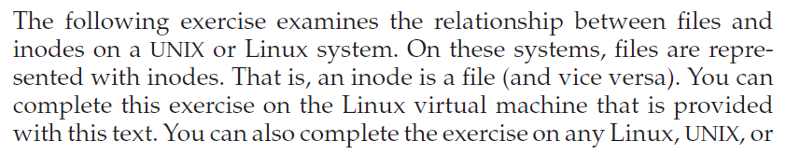

二、相关原理与知识
- 文件系统的结构和实现，包括目录的实现、存储空间和索引的分配、空闲空间的管理、文件系统的性能评估等
三、实验过程
- 输入命令：ls -li file1得到：
2.在file1.txt和file2.txt之间创建硬链接：
硬链接创建完成后，查询file2.txt的inode，发现它的Inode值与file1.txt完全相同，文本的内容也与file1.txt的完全相同。
接下来，在文本编辑器中将file2.txt的内容修改成”I have a pineapple”并保存。然后打开file1.txt发现，file1.txt的内容也随之变成了”I have a pineapple”。
使用命令rm file1删除file1.txt。结果file2.txt仍然存在。
使用命令strace -tt rm file2 删除file2.txt并追踪系统调用。
实验结果如下：
21:57:22.523964 execve("/bin/rm", ["rm", "file2"], 0x7fffc96a3660 /* 53 vars */) = 0
21:57:22.524815 brk(NULL) = 0x55deeaa9f000
21:57:22.525072 access("/etc/ld.so.nohwcap", F_OK) = -1 ENOENT (No such file or directory)
21:57:22.525376 access("/etc/ld.so.preload", R_OK) = -1 ENOENT (No such file or directory)
21:57:22.525653 openat(AT_FDCWD, "/etc/ld.so.cache", O_RDONLY|O_CLOEXEC) = 3
21:57:22.525908 fstat(3, {st_mode=S_IFREG|0644, st_size=79203, ...}) = 0
21:57:22.526136 mmap(NULL, 79203, PROT_READ, MAP_PRIVATE, 3, 0) = 0x7f041618b000
21:57:22.526383 close(3) = 0
21:57:22.526622 access("/etc/ld.so.nohwcap", F_OK) = -1 ENOENT (No such file or directory)
21:57:22.526848 openat(AT_FDCWD, "/lib/x86_64-linux-gnu/libc.so.6", O_RDONLY|O_CLOEXEC) = 3
21:57:22.526994 read(3, "\177ELF\2\1\1\3\0\0\0\0\0\0\0\0\3\0>\0\1\0\0\0\260\34\2\0\0\0\0\0"..., 832) = 832
21:57:22.527226 fstat(3, {st_mode=S_IFREG|0755, st_size=2030544, ...}) = 0
21:57:22.527401 mmap(NULL, 8192, PROT_READ|PROT_WRITE, MAP_PRIVATE|MAP_ANONYMOUS, -1, 0) = 0x7f0416189000
21:57:22.527549 mmap(NULL, 4131552, PROT_READ|PROT_EXEC, MAP_PRIVATE|MAP_DENYWRITE, 3, 0) = 0x7f0415b87000
21:57:22.527692 mprotect(0x7f0415d6e000, 2097152, PROT_NONE) = 0
21:57:22.527837 mmap(0x7f0415f6e000, 24576, PROT_READ|PROT_WRITE, MAP_PRIVATE|MAP_FIXED|MAP_DENYWRITE, 3, 0x1e7000) = 0x7f0415f6e000
21:57:22.527989 mmap(0x7f0415f74000, 15072, PROT_READ|PROT_WRITE, MAP_PRIVATE|MAP_FIXED|MAP_ANONYMOUS, -1, 0) = 0x7f0415f74000
21:57:22.528152 close(3) = 0
21:57:22.528305 arch_prctl(ARCH_SET_FS, 0x7f041618a540) = 0
21:57:22.528503 mprotect(0x7f0415f6e000, 16384, PROT_READ) = 0
21:57:22.528665 mprotect(0x55dee98ca000, 4096, PROT_READ) = 0
21:57:22.528809 mprotect(0x7f041619f000, 4096, PROT_READ) = 0
21:57:22.528952 munmap(0x7f041618b000, 79203) = 0
21:57:22.529209 brk(NULL) = 0x55deeaa9f000
21:57:22.529345 brk(0x55deeaac0000) = 0x55deeaac0000
21:57:22.529490 openat(AT_FDCWD, "/usr/lib/locale/locale-archive", O_RDONLY|O_CLOEXEC) = 3
21:57:22.529637 fstat(3, {st_mode=S_IFREG|0644, st_size=10281936, ...}) = 0
21:57:22.529778 mmap(NULL, 10281936, PROT_READ, MAP_PRIVATE, 3, 0) = 0x7f04151b8000
21:57:22.529926 close(3) = 0
21:57:22.530111 ioctl(0, TCGETS, {B38400 opost isig icanon echo ...}) = 0
21:57:22.530264 newfstatat(AT_FDCWD, "file2", {st_mode=S_IFREG|0664, st_size=21, ...}, AT_SYMLINK_NOFOLLOW) = 0
21:57:22.530413 geteuid() = 1000
21:57:22.530550 newfstatat(AT_FDCWD, "file2", {st_mode=S_IFREG|0664, st_size=21, ...}, AT_SYMLINK_NOFOLLOW) = 0
21:57:22.530696 faccessat(AT_FDCWD, "file2", W_OK) = 0
21:57:22.530909 unlinkat(AT_FDCWD, "file2", 0) = 0
21:57:22.531249 lseek(0, 0, SEEK_CUR) = -1 ESPIPE (Illegal seek)
21:57:22.531416 close(0) = 0
21:57:22.531588 close(1) = 0
21:57:22.531739 close(2) = 0
21:57:22.531999 exit_group(0) = ?
21:57:22.532239 +++ exited with 0 +++
与删除过程相关的特殊系统调用函数有geteuid(),ioctl()和unlinkat()等。
用如下命令创造一个软链接，并查询file3和file4的inode：
Ln -s file3 file4
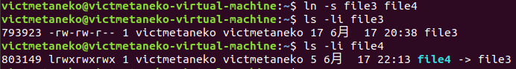
查询结果显示存在链接，但是两个文件的inode并不相同。
然后，将file4.txt的内容更改成”I have a bad apple.”再打开file3.txt，发现file3.txt已经随之改变。
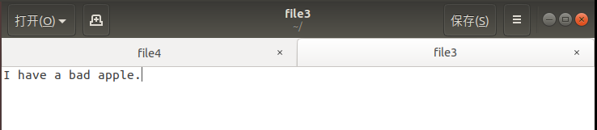
此时，通过终端删除file3.txt。再次试图打开file4.txt时，则显示已经找不到该文件。

四、实验结果与分析
实验结果及分析如上。
五、问题总结
Ubuntu18系统的终端默认只读取文件名而不读取扩展名（同名文件情况除外），所以不能直接使用教材上的指令，而是把.txt等扩展名去掉。

六、源代码
- #include <stdio.h>
- #include <stdlib.h>
- void copyFile()
- {
- FILE *in, *out;
- char ch,iname[10],oname[10] ;
- printf("input the name of file\n");
- scanf("%s",iname);
- scanf("%s",oname);

- if ((in = fopen(iname,"r")) == NULL)
- {
- printf("canot find the in.txt file!\n");
- exit(0);
- }

- if ((out = fopen(oname,"w"))==NULL)
- {
- printf("cannot find the out.txt file!\n");
- exit(0);
- }

- ch = fgetc(in);
- while (ch!=EOF)
- {
- fputc(ch,out);
- putchar(ch);
- ch = fgetc(in);
- }
- fclose(in);
- fclose(out);
- }

- int main()
- {
- copyFile() ;
- puts("");
- return 0;
- }

