**西安电子科技大学**

**微机原理综合实验 课程实验报告**

**实验名称 点阵LED显示设计实验**

xxxxxxxxxxxxx 学院 xxxxxxx 班

成 绩

姓名 xxxxxx 学号 xxxxxxxxxxx

同作者 无

实验日期 2021 年 5 月 28 日

|  |
| --- |
| 指导教师评语：  指导教师：  年 月 日 |
| **实验报告内容基本要求及参考格式**  一、实验目的  二、实验所用仪器（或实验环境）  三、实验基本原理及步骤（或方案设计及理论计算）  四、实验数据记录（或仿真及软件设计）  五、实验结果分析及回答问题（或测试环境及测试结果） |

1. **实验要求**

编写程序，控制点阵向上（或左右）游动显示“西安电子科技大学欢迎您！-姓名”。

实验系统中的16×16 LED点阵由四块8×8 LED点阵组成，如图所示，8×8点阵内部结构图如下。由图可知，当行为“0”，列为“1”，则对应行、列上的LED点亮。

 

**16×16点阵示意图 点阵内部结构图**

 

**点阵外部引脚图 汉字显示示例**

1. **实验目的**

1. 了解LED点阵的基本结构。

2. 学习LED点阵扫描显示程序的设计方法。

1. **实验电路及连线**

参考电路图如下：

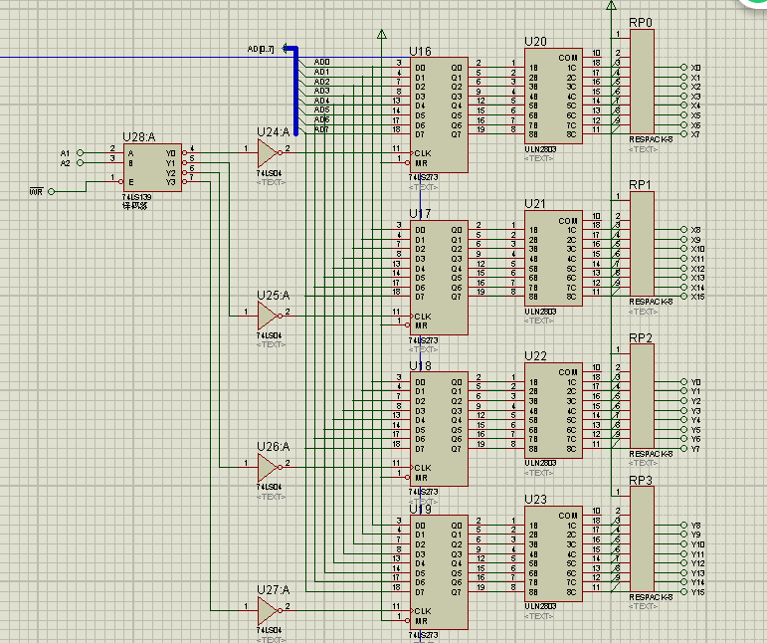

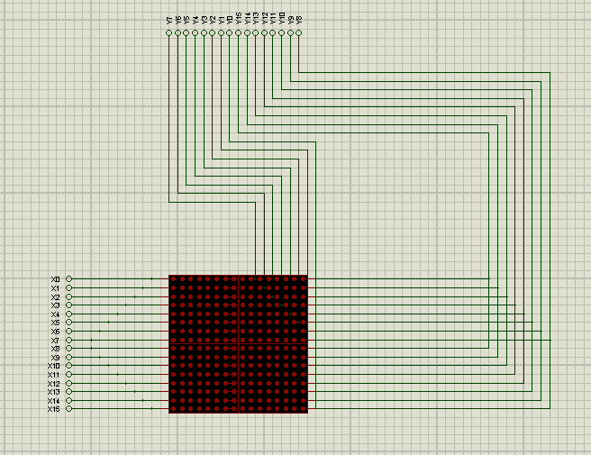

1. **实验内容**

开始

设置行列的高和宽的长度

以矩阵形式定义数据段

首字符移入AX

取下一字符的基址BX

将二者依次移入DX中

Y

DX出栈显示

录入完成？

N

结束

RowLow EQU 9004H

RowHigh EQU 9006H

ColLow EQU 9000H

ColHigh EQU 9002H

CODE SEGMENT

ASSUME CS:CODE,DS:DATA,SS:STACK

START:

MOV AX,DATA

MOV DS,AX

MOV AX,STACK

MOV SS,AX

MOV AX,CODE

MOV SP,AX

main:

MOV AL,0

MOV DX,RowLow

OUT DX,AL

MOV DX,RowHigh

OUT DX,AL

MOV AL,0FFH

MOV DX,ColLow

OUT DX,AL

MOV DX,ColHigh

OUT DX,AL

n123:

MOV CharIndex,0

nextchar:

MOV DelayCNT,20

LOOP1: ;取下一字符的基址BX

MOV BitMask,1

MOV ColCNT,16

MOV BX,CharIndex

MOV AX,2

MUL BX

MOV BX,AX

nextrow:

MOV AL,0FFH

MOV DX,RowLow

OUT DX,AL

MOV DX,RowHigh

OUT DX,AL

MOV AX,[SI+BX]

MOV DX,ColLow

OUT DX,AL

MOV DX,ColHigh

MOV AL,AH

OUT DX,AL

;扫描行

INC BX

INC BX

MOV AX,BitMask

MOV DX,RowLow

NOT AL

OUT DX,AL

MOV DX,RowHigh

MOV AL,AH

NOT AL

OUT DX,AL

MOV AX,BitMask

ROL AX,1 ;循环右移1位

MOV BitMask,AX

NOP

DEC ColCNT

JNZ nextrow

DEC DelayCNT

JNZ LOOP1

INC CharIndex

MOV AX,CharIndex

CMP AX,208 ;字符数

JNZ nextchar

JMP n123

delay:

PUSH CX

MOV CX,1

delay1:

loop delay1

POP CX

RET

CODE ENDS

DATA SEGMENT

Font:

;西 CCEF7

DB 000H,000H,0FFH,0FEH,004H,040H,004H,040H

DB 004H,040H,03FH,0F8H,024H,048H,024H,048H

DB 024H,048H,024H,048H,028H,038H,030H,008H

DB 020H,008H,020H,008H,03FH,0F8H,020H,008H

;安 CB0B2

DB 002H,000H,001H,000H,03FH,0FCH,020H,004H

DB 042H,008H,002H,000H,002H,000H,0FFH,0FEH

DB 004H,020H,008H,020H,018H,040H,006H,040H

DB 001H,080H,002H,060H,00CH,010H,070H,008H

;电 CB5E7

DB 001H,000H,001H,000H,001H,000H,03FH,0F8H

DB 021H,008H,021H,008H,021H,008H,03FH,0F8H

DB 021H,008H,021H,008H,021H,008H,03FH,0F8H

DB 021H,00AH,001H,002H,001H,002H,000H,0FEH

;子 CD7D3

DB 000H,000H,07FH,0F8H,000H,010H,000H,020H

DB 000H,040H,001H,080H,001H,000H,0FFH,0FEH

DB 001H,000H,001H,000H,001H,000H,001H,000H

DB 001H,000H,001H,000H,005H,000H,002H,000H

;科 CBFC6

DB 008H,010H,01DH,010H,0F0H,090H,010H,090H

DB 010H,010H,0FDH,010H,010H,090H,038H,090H

DB 034H,010H,050H,01EH,053H,0F0H,090H,010H

DB 010H,010H,010H,010H,010H,010H,010H,010H

;技 CBCBC

DB 010H,020H,010H,020H,010H,020H,013H,0FEH

DB 0FCH,020H,010H,020H,010H,020H,015H,0FCH

DB 018H,084H,030H,088H,0D0H,048H,010H,050H

DB 010H,020H,010H,050H,051H,088H,026H,006H

;大 CB4F3

DB 001H,000H,001H,000H,001H,000H,001H,000H

DB 001H,000H,0FFH,0FEH,001H,000H,001H,000H

DB 002H,080H,002H,080H,004H,040H,004H,040H

DB 008H,020H,010H,010H,020H,008H,0C0H,006H

;学 CD1A7

DB 022H,008H,011H,008H,011H,010H,000H,020H

DB 07FH,0FEH,040H,002H,080H,004H,01FH,0E0H

DB 000H,040H,001H,080H,0FFH,0FEH,001H,000H

DB 001H,000H,001H,000H,005H,000H,002H,000H

;欢 CBBB6

DB 000H,080H,000H,080H,0FCH,080H,004H,0FCH

DB 005H,004H,049H,008H,02AH,040H,014H,040H

DB 010H,040H,028H,0A0H,024H,0A0H,045H,010H

DB 081H,010H,002H,008H,004H,004H,008H,002H

;迎 CD3AD

DB 000H,000H,020H,080H,013H,03CH,012H,024H

DB 002H,024H,002H,024H,0F2H,024H,012H,024H

DB 012H,024H,012H,0B4H,013H,028H,012H,020H

DB 010H,020H,028H,020H,047H,0FEH,000H,000H

;您 CC4FA

DB 009H,000H,009H,000H,011H,0FCH,032H,004H

DB 054H,048H,099H,050H,011H,048H,012H,044H

DB 014H,044H,011H,040H,010H,080H,002H,000H

DB 051H,004H,051H,012H,090H,012H,00FH,0F0H

;王

DB 010H,004H,008H,004H,008H,004H,0FFH,0A4H

DB 002H,024H,042H,024H,022H,024H,014H,024H

DB 014H,024H,008H,024H,008H,024H,014H,024H

DB 024H,004H,042H,004H,082H,014H,000H,008H

;申

DB 008H,040H,008H,040H,00BH,0FCH,010H,040H

DB 010H,040H,030H,040H,03FH,0FEH,050H,000H

DB 090H,040H,010H,040H,013H,0FCH,010H,040H

DB 010H,040H,010H,040H,01FH,0FEH,010H,000H

;奥

DB 000H,040H,040H,040H,017H,0FCH,010H,040H

DB 083H,0F8H,040H,080H,047H,0FEH,010H,090H

DB 011H,010H,021H,0FEH,0E2H,010H,022H,090H

DB 024H,050H,028H,010H,020H,050H,000H,020H

DB 000H,000H,000H,000H,000H,000H,000H,000H

DB 000H,000H,000H,000H,000H,000H,000H,000H

DB 000H,000H,000H,000H,000H,000H,000H,000H

DB 000H,000H,000H,000H,000H,000H,000H,000H

BitMask DW 1

CharIndex DW 1

DelayCNT DW 1

Colcnt DW 1

DATA ENDS

STACK SEGMENT

STA DB 100 DUP(0)

TOP EQU LENGTH STA

STACK ENDS

END START

1. **运行截图**

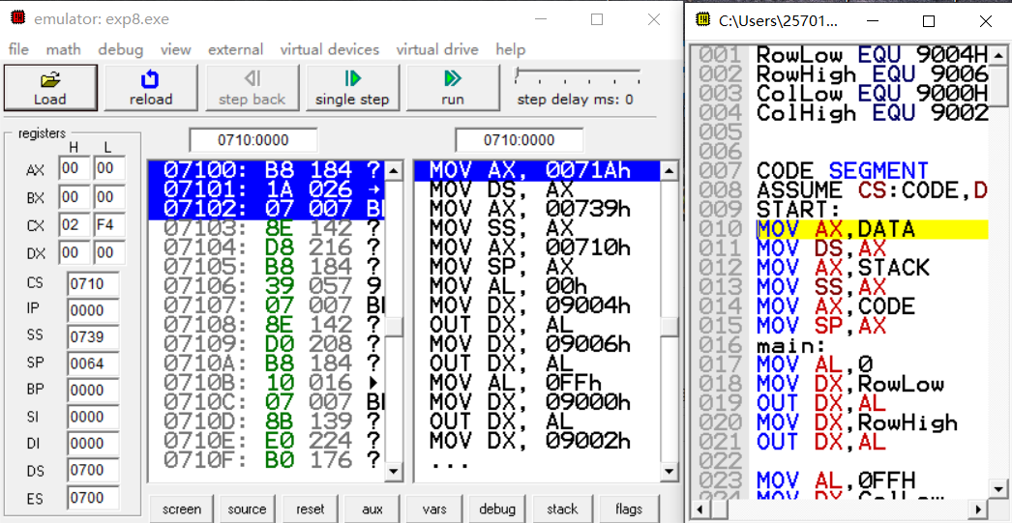

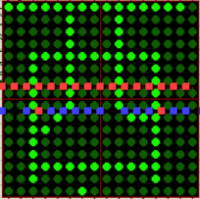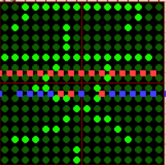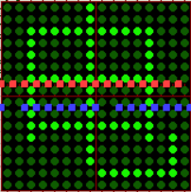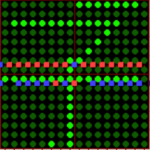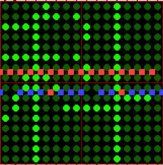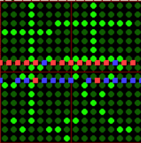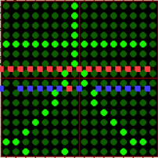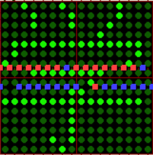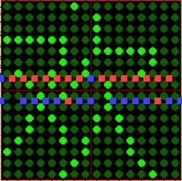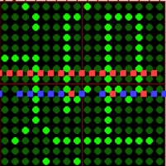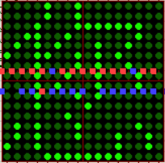

1. **心得体会**

通过这次实验我对proteus和emu8086有了更加深刻的了解，尤其是LED矩阵的使用。