03/25/2024
Household Descriptions
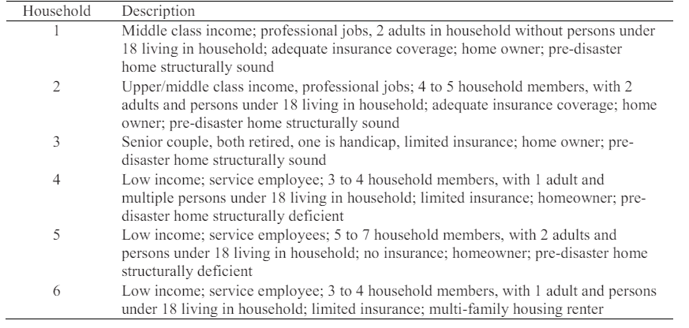
- Demand Assumption (makeup):
  - Assume: 6>4>5>3>1>2
  - Uniform Distribution: 1200/1000/800/600/400/200/0
- House Information:
  - RAPIDO Price
  - Katrina Cottage: Cost per square foot * size of trailer
  - Hotel/Repair/D_Home/Shelter -> makeup
- Attributes and weights

03/29/2024

- Rental Units and funding (no need to store) -> provide the same number in the every beginning of the season.

