|  |  |  |  |
| --- | --- | --- | --- |
| **Team Number** | 05 | **Section** | 03 |
| **Team Members** | 1. Brandon Truong 2. Jason Khy 3. Phong Nguyen | | |
| **Software Name** | Ruminate Self-Study© | | |

## Problem Statement

Pacing oneself properly is difficult when self-studying any topic. However, being able to pace their studying and put the focus on important problems is essential to learning a subject. With this in mind, we need a flashcard software that will take the difficulty of singular items into account, and use special functions to create spaced repetition. This software will allow users to customize their flashcards with text, color, images, and even audio. It will be made user friendly towards all sorts of audiences, seeing as how flashcard studying can be applicable to anyone.

## Functional Requirements

This product has these features:

1. Rename deck
2. Add Card
3. Delete Card
4. Rate Card
5. Change decks
6. Study Cards
7. Review Cards

## References

Thomas Frank. How to Remember More of What You Learn with Spaced Repetition. <https://collegeinfogeek.com/spaced-repetition-memory-technique/>

Brandon Hill. How to Use Spaced Repetition to Remember What You’ve Learned. <https://biznessprofessionals.com/how-to-use-spaced-repetition-to-remember/>

## Use Cases

1.

|  |  |  |  |
| --- | --- | --- | --- |
| **Use Case Name** | | Rename deck | |
| Goal | | | |
| The goal of this use case is for the actor to be able to rename a deck in the system. | | | |
| Participating Actors | | | |
| User and system. | | | |
| Glossary | | | |
| * Deck - A set/grouping of cards created and modified by the user. | | | |
| Primary Flow of Events | | | |
| Trigger | | | |
| User clicks on the make deck button. | | | |
| **Steps** | **Action** | | **System Response** |
| 1 | User clicks on a Deck button | | Selects the Deck ID |
| 2 | User fills in textBox with the new deck name | | System records user’s input |
| 3 | User clicks on the change name button | | System changes Deck Name based on ID |
| Alternate Flow of Events | | | |
| **Alternate Trigger** | | | |
| The user clicks on the Change Name without clicking a deck | | | |
| **Steps** | **Action** | | **System Response** |
| *1* | User clicks on the change name | | Returns nothing |

2.

|  |  |  |  |
| --- | --- | --- | --- |
| **Use Case Name** | | Add Card | |
| Goal | | | |
| This function allows the user to create and insert cards into any deck. | | | |
| Participating Actors | | | |
| User and system. | | | |
| Glossary | | | |
| * Card - An object with two “sides”, one front and one back. Created and customized by the user. | | | |
| Primary Flow of Events | | | |
| Trigger | | | |
| User clicks on the add card button. | | | |
| **Steps** | **Action** | | **System Response** |
| 1 | User clicks on “Add Card” | | Shows the Add Cards window |
| 2 | User inputs information on the card | | System records and saves data |
| 3 | User clicks “Add Card” | | Returns back to the home screen |
| Alternate Flow of Events | | | |
| **Alternate Trigger** | | | |
| User clicks on the close button. | | | |
| **Steps** | **Action** | | **System Response** |
| 1 | User clicks “close” | | Returns back to the home screen |

3.

|  |  |  |  |
| --- | --- | --- | --- |
| **Use Case Name** | | Delete Card | |
| Goal | | | |
| This function allows the user to remove any card from any deck. | | | |
| Participating Actors | | | |
| User and system. | | | |
| Glossary | | | |
| * Delete - To take away something that exists. | | | |
| Primary Flow of Events | | | |
| Trigger | | | |
| User clicks on the remove card button. | | | |
| **Steps** | **Action** | | **System Response** |
| 1 | User clicks on Remove Card | | Pops up a prompt to confirm action |
| 2 | User confirms action | | Removes and deletes the selected card(s) entirely |
| Alternate Flow of Events | | | |
| **Alternate Trigger** | | | |
| User denies action. | | | |
| **Steps** | **Action** | | **System Response** |
| 1 | User clicks on the finish action button | | Returns to previous screen |

4.

|  |  |  |  |
| --- | --- | --- | --- |
| **Use Case Name** | | Rate Card | |
| Goal | | | |
| When studying or reviewing, the user will rate the difficulty of the item. Each difficulty will affect the spaced repetition time to review. For example, rating an item four stars corresponds to “easy,” and will make a card reviewable in 1 days whereas an item rated one star corresponds to “hard” and will make a card reviewable within 1 hour. | | | |
| Participating Actors | | | |
| User and system. | | | |
| Glossary | | | |
| * Rating - A “score” that the user can assign to individual cards in terms of difficulty. * “Easy” - cards will be reviewed again in a very long time frame. * “Normal” - cards will be reviewed again in a longer time frame. * “Hard” - cards will be reviewed again in a shorter time frame. * “Difficult” - cards will be reviewed again in a very short time frame. | | | |
| Primary Flow of Events | | | |
| Trigger | | | |
| The user clicks on the button “Easy”, “Normal”, “Hard”, or “Difficult”. | | | |
| **Steps** | **Action** | | **System Response** |
| 1 | User click on “Easy”, “Normal”, “Hard”, or “Difficult” | | System changes the rating of the card based on the cardID |
| 2 | Users check their comprehension of the item by rating the card from easy to difficult. | | System will mark individual cards by enums corresponding to the difficulty |
| Alternate Flow of Events | | | |
| **Alternate Trigger** | | | |
| The user clicks on Rating with no cards in the deck. | | | |
| **Steps** | **Action** | | **System Response** |
| 1 | User click on a difficulty rating with no cards in Deck | | System does nothing because there are no cards to rate. |

5.

|  |  |  |  |
| --- | --- | --- | --- |
| **Use Case Name** | | Study Card | |
| Goal | | | |
| The user will be able to flip through the cards one-by-one in an order determined by the system. For every card, they will be able to turn the card back and forth on demand, and even show both sides of the card side-by-side. | | | |
| Participating Actors | | | |
| User and system. | | | |
| Glossary | | | |
| * Study - To learn something in depth with the hope of retaining the knowledge. | | | |
| Primary Flow of Events | | | |
| Trigger | | | |
| The user clicks on the study deck button. | | | |
| **Steps** | **Action** | | **System Response** |
| 1 | The user clicks on the study deck button | | The cards are organized into an order determined by the system and shown one-by-one on the screen. |
| 2 | The user clicks on the flip card | | The system “flips” the card and displays the alternate side. |
| 2.5 | The user chooses to display both sides side-by-side | | The system displays both sides of the card. |
| 3 | The user clicks on next arrow | | The system replaces the displayed card(s) with the next card in line. |
| Alternate Flow of Events | | | |
| **Alternate Trigger** | | | |
| The user clicks on the previous card rather than the next card in step 3. | | | |
| **Steps** | **Action** | | **System Response** |
| 3 | The user clicks on previous card | | The system replaces the displayed card(s) with the previous card. |

6.

|  |  |  |  |
| --- | --- | --- | --- |
| **Use Case Name** | | Change Deck | |
| Goal | | | |
| This function allows the user to change a deck of flashcards. | | | |
| Participating Actors | | | |
| User and system. | | | |
| Glossary | | | |
| * Deck - A set/grouping of cards created and modified by the user. | | | |
| Primary Flow of Events | | | |
| Trigger | | | |
| User clicks on the Decks page. | | | |
| **Steps** | **Action** | | **System Response** |
| 1 | User clicks on Decks page | | Shows a list of decks to be selected |
| 2 | User clicks on a deck name | | Change deck to the selected one by displaying new name and the total cards in the screen |
| Alternate Flow of Events | | | |
| **Alternate Trigger** | | | |
| User clicks outside of the Decks | | | |
| **Steps** | **Action** | | **System Response** |
| 1 | User clicks outside the Decks | | Returns to the previous screen without saving changes |

7.

|  |  |  |  |
| --- | --- | --- | --- |
| **Use Case Name** | | Review Card | |
| Goal | | | |
| The user will be able to flip through the cards one-by-one in an order determined by the system. For every card, they will be able to turn the card back and forth on demand, and even show both sides of the card side-by-side. | | | |
| Participating Actors | | | |
| User and system. | | | |
| Glossary | | | |
| * Review - To look at a subject you have already seen again. | | | |
| Primary Flow of Events | | | |
| Trigger | | | |
| User clicks on the review button | | | |
| **Steps** | **Action** | | **System Response** |
| 1 | User clicks on review button | | Change scene to review |
| 2 | User clicks on one of the rating buttons | | Rate card and moves to next card to be reviewed |
| Alternate Flow of Events | | | |
| **Alternate Trigger** | | | |
| User clicks the home button | | | |
| **Steps** | **Action** | | **System Response** |
| 1 | User clicks the home button | | Returns to the previous screen |

## Final Product Pictures

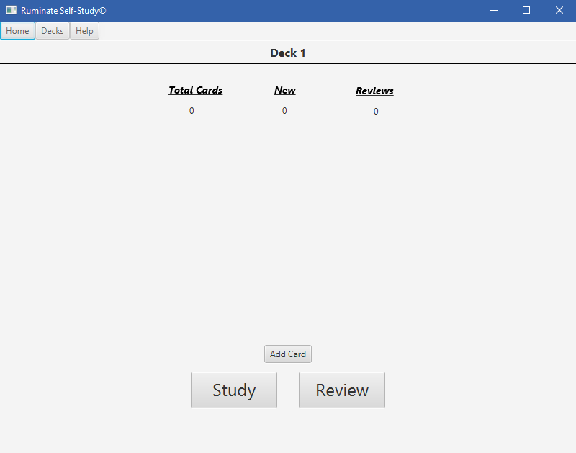

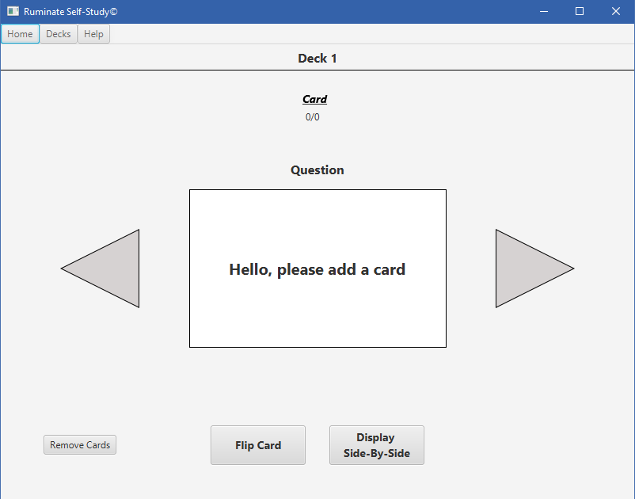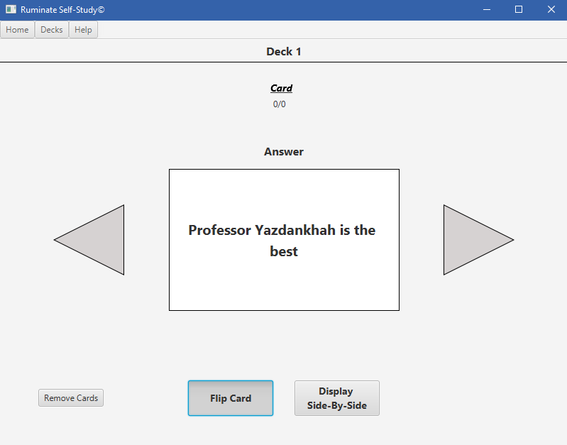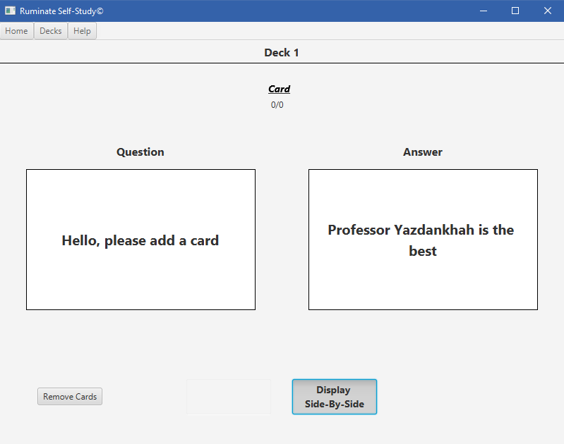

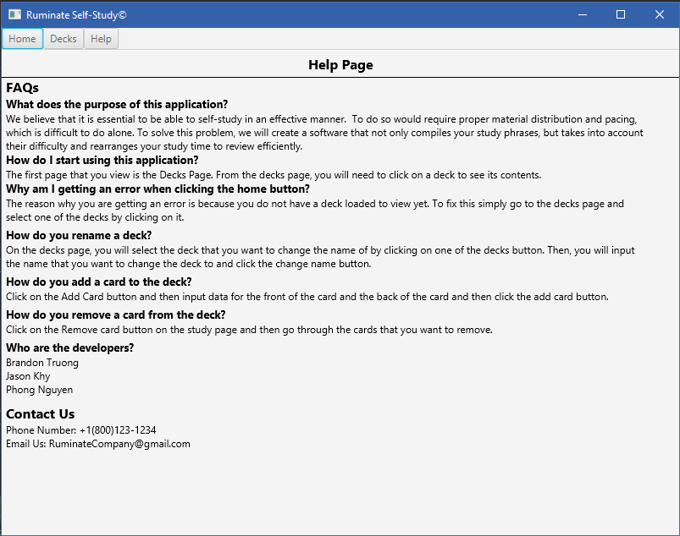

## Glossary

|  |  |
| --- | --- |
| Deck | A set/grouping of cards created and modified by the user. |
| Card | An object with two “sides”, one front and one back. Created and customized by the user. |
| Rating | A “score” that the user can assign to individual cards in terms of difficulty. |
| Four Stars | “Easy” cards will be reviewed again in a very long time frame. |
| Three Stars | “Fair” cards will be reviewed again in longer time frame. |
| Two Stars | “Hard” cards will be reviewed again in a shorter time frame. |
| One Star | “Very Hard” cards will be reviewed again in a very short time frame. |
| No Star | “Skip” will push card later in the deck to be studied/reviewed. |
| Delete | To take away something that exists. |
| Study | To learn something in depth with the hope of retaining the knowledge. |
| Review | To look at a subject you have already seen again. |