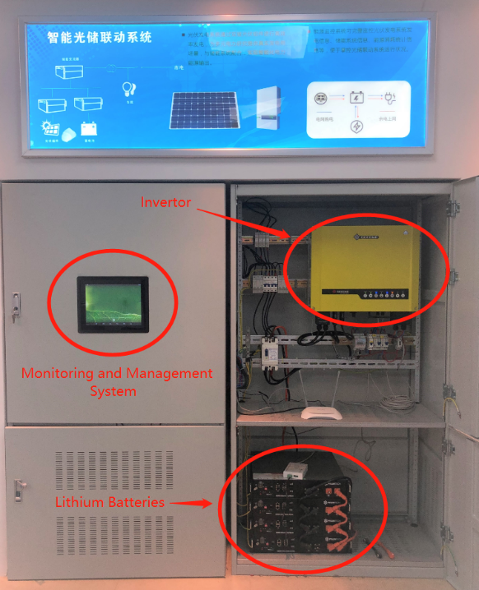**Data-driven multi-energy experiment and simulation platform**

Our lab is a retrofitted semi-basement building in a southeast city - Hangzhou, China, where the weather is humid in summer and cold in winter. In order to maintain users’ comfort, save energies, and even produce surplus electricity to earn money, we did the renovation mainly in three aspects:

**(1) Rooftop PV-battery and public grid interaction system**

We installed two kinds of PV panels, i) one set of panels on the roof (10kW), and ii) the other set on the window (2kW), which appears to be half-transparent glasses. Besides, some lithium batteries (9.6kWh) are installed between the public grid and indoor loads. Based on PV generation and users’ demand, the batteries are scheduled to be charged or discharged to achieve the minimization of energy cost under the premise of guaranteeing users’ comfort.

**(2) Develop smart plugs and wireless controller**

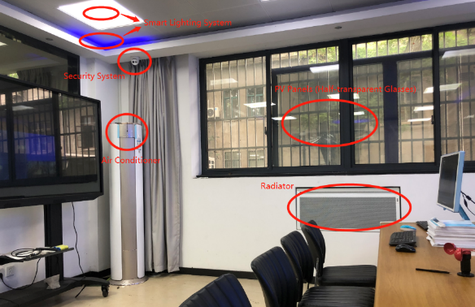**Smart plug:** We developed two kinds of smart plugs for single-phase and three-phase electricity, respectively. The smart plug can monitor voltage, current, power, power factor, and system frequency. Besides, the smart plug integrates contactor relay, WiFi module, and Bluetooth module to upload the monitoring data and execute ON-OFF instruction.

**Wireless controller:** We developed infrared controller, temperature detector and humidity detector for the air conditioning system, radiator, and electric fan. These appliances belong to heating, ventilating, and air-conditioning loads (HVACs), and account for a large share of the total power consumption.

**Based on smart plugs and wireless controller, we achieved four functions:**

* Electricity consumption data acquisition for analyzing users’ behaviors.
* 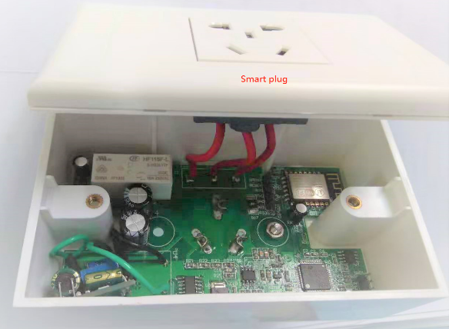Remote monitor and control of appliances by computer and phone APP.
* Flexible loads control to provide regulation services for power systems.
* Information push to suggest users power consumption and cost saving.

**(3) Data-driven power system simulation platform**

The simulation platform mainly includes three modules: dashboard, scenario design, and smart interaction.

* 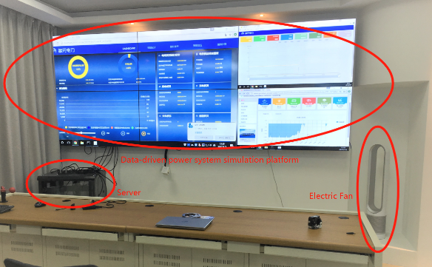The “dashboard” module is used to monitor operating state of power systems for the operator, including thermal generation power, operating state of wind turbines, PV generation, load power, and real-time electricity price. The power systems can be impacted by real outdoor weather and real power consumption in the lab.
* The “scenario design” module is used to design typical power system conditions, including wind turbines, PV, thermal power plants, and various consumers. The corresponding equipment parameters can be customized comprehensively. For example, as for a wind turbine, the name, type, number, node on the system, real location, and height of blades can be set.
* The “smart interaction” module is for smart control of all the appliances in the lab, including curtain, air purifier, air conditioner, radiator and lights. The lab is regarded as one of users in the simulated power system. When electricity price is extremely high, some lights for beauty are turned off, and air conditioner’s set temperature is turned up. Even though we only have one electric unit (i.e., our lab), the users (i.e., students) are some dozens. Their behaviors and demand are various on different days. All these real data are monitored and stored in servers to participate in the simulation. So this platform have massive amounts of real electricity data to achieve the so-called “data-driven”.