***JUSTICE FOR REFUGEES***

***Pointers for an intro:***

* Looking at the objectives of the fast track process and what it inherently aims to achieve for the many thousands of people, displaced and left in collateral limbo
* What needs to be done to meet the unprecedented demand for legal services in the face of political oppression and hostility impinging on their rights and our obligations towards asylum seekers
* Development of readily accessible, low cost and efficient legal services to not only speed up processes but ultimately reshape the way we access legal information – tie this in later with middle class – low income earners and future prospects extending from the service we ultimately would like to achieve

**PURPOSE:**

* Funded by legal aid over 12 months with the support of Immigration Advice and Right Centre
* This program aims to provide assistance to fast track applicant in NSW who:
* Have received a negative decision from the Immigration Assessment Authority (IAA)
* Have been excluded from review in the IAA by the Department of Immigration and Border Protection

**Participants:**

* Relying on support from a network of barristers in NSW who are administrative and immigration specialists, those training in these areas
* They will provide advice on the prospect of advice on the success of an application going to judicial review, and if it is positive provide lawyers to represent them in the Federal circuit

***Background on RACS***

Currently, there are **14** experienced human rights lawyers on their team. However, the **pro bono partners** supporting racs consists of the following: Allen’s Linklaters, Gilbert and Tobin, Herbert Smith Freehills, King and Wood Mallesons, Norton Rose Fulbright, Wotton+ Kearney, JusticeConnect.

**University Programs** from UNSW, USYD, MACQ and Santa Clara

**Auditors;** KPMG

**Website and Fact Sheet Design**; Electric Elephant

**RACS ‘ top strategic goals as outlined in their annual report 2015-2016**

* Provide quality legal advice, case management and representation for financially disadvantaged and vulnerable people seeking asylum and family reunion -- **yes**
* Provide community education on changes to Refugee law
* Provide outreach services to asylum seeker and refugee partner organisations
* Advocate for systemic reform – **yes**
* Maintain an effective and expert staff team - **yes**

**Current funding:**

* Since April 2014, RACS has had its funding slashed
* They receive a capped amount of money from the Department of Immigration and Border Protection – for those people who have come by plane and have sought asylum
* No funding allocated to those who have arrived by boat or to provide family reunion casework
* Main revenue – Public Interest Grants and other grants, Community contracts, Donations and funding

**Changes in law impacting J4R:**

* **15 December 2014**, Asylum seekers arriving by boat can only apply for a Temporary Protection Visa (TPV) or a Safe Haven Visa (SHV) regardless of the date of arrival and cannot access merits review and the RRT. Litigation dealt through with the Immigration office and judicial review through the Federal Circuit Courts
* **16 June 2015,** Asylum seekersseeking an extension of time to lodge their TPV applicationsoutside of the requested 28 days will be threatened with having their bridging visas cancelled and detention for non compliance with the conditions to cooperate with reasonable requests given to them from the department.
* **15 June 2015-**  The processing of the FOI will not take place for maritime arrivals unless they are submitted by people within a certain date range

**Different Partnerships Utilised by RACS and the changing demographics of refugees (LANGUAGES)**

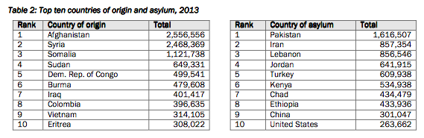

Australia’s primary intakes: Africa, Middle East and Asia

**Current Outreach programs that can also benefit from the website;**

**Auburn Asylum Seeker and Refugee Legal Outreach**

Contributors: Auburn council and Dooley’s Lidcombe

Based: Auburn Centre for community and provides drop in clients as well as people with appointments

Main topics of Advice: From Annual Report

* Bridging visa (e.g. conditions, reporting, expiry, cancellation, Code of Behaviour)
* Protection visa applications (e.g. application process, legal tests, explaining letters and decisions, refusal, appeals)
* Ministerial intervention
* Family reunion (e.g. partner visa, child visa, humanitarian visa)
* Completing forms (e.g. visa application forms, FOI requests for access to documents, applications for AFP certificates)
* Explaining and facilitating correspondence with Department of Immigration
* Referrals for assistance through other RACS services, other legal services and welfare services.

Success of Program; in 50 days, 1196 individuals from 29 nationalities were settled

Similar program; Jesuit Refugee Service

More than 60 education sessions provided in 9 different languages with more than 50 people walking in on a daily basis; **ease of accessibility of the website in this scenario?**

Ease of communication to programs for lawyers; **what we can possibly look at?**

The Asylum Services Centre Legal Service – ASC in Newtown, collaboration of lawyers from Gilbert and Tobin

Innovative collaboration to bring forward justice – how can we effectively impact and better the service provided by the program through our website?

End on Australia’s current contribution to refugee protection and our obligation towards the protection of asylum seekers and their resettlement ---

Contrasting the statistics of how much refugees have been resettled by Racs and how much more they can resettle more efficiently using new innovation – cutting the cost to provide more service

At this stage we can bring about our primary cuts in funding, possible reinstatement to support the advancement of innovative legal aid and further the support RACS can provide

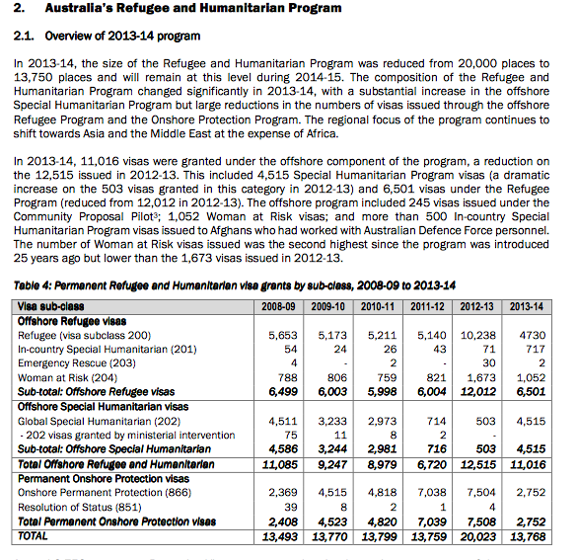

Emotional Hamstrings info to take on:

The new law, introduced in December 2014, established that in exercising the power to remove a non-citizen from Australia, it is irrelevant whether Australian has non- refoulement obligations in relation to that person. This new law explicitly authorises violations of Australia’s international obligations under the Refugee Convention, Convention against Torture (CAT) and the International Covenant on Civil and Political Rights (ICCPR), as it requires removal even where Australia’s non-refoulement obligations have not been considered.

In an environment, where few asylum seekers will be able to access legal advice due to the massive funding cuts organisations, like RACS, have experienced, these changes are terrifying for people facing the prospect of claiming protection under this new Fast Track process.