* XY2-100 (16bit interface to scanhead with X, Y and Z channel)
  + Cambridge DC2000 (16bit DA, state space, DSP, self-tuning)

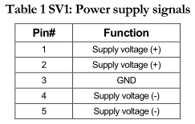 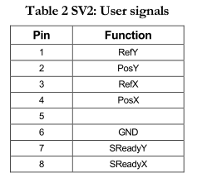

Galvo connectors:

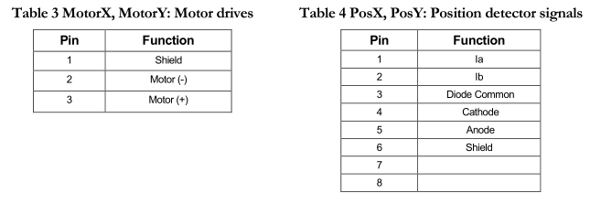

Digital Data Input & Output: RS422 diff. line drivers & receivers, compatible with XY2-100 (SmartDirect) interface. Serial DAC – 3.3V CMOS SPI. Standard internal controller update rate is 20us. Smaller galvanometers update rate is 10us.

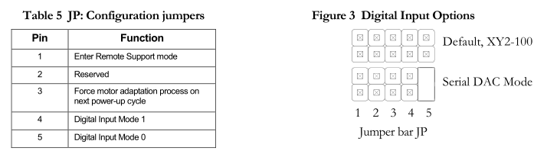

XY2-100:

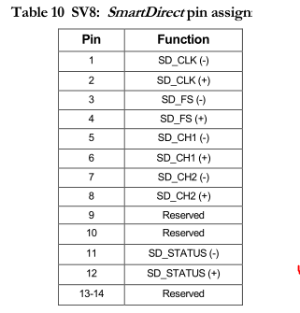

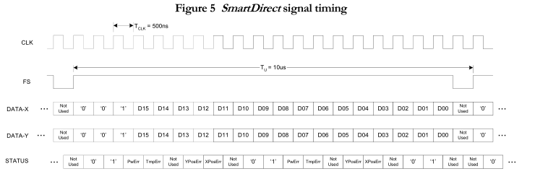

Temperature sensor: 2N3904, LM83.

* Cambridge DC900, XY2-100

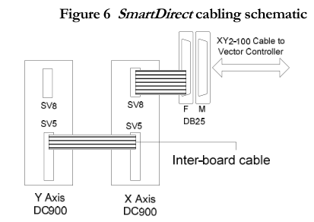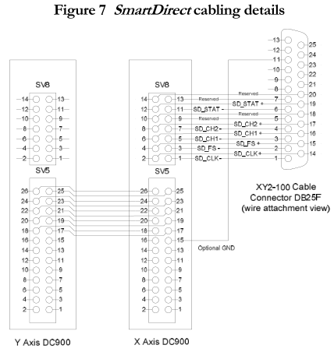

* XY2-100-E (18bit) interface to scanhead with X and Y channel
* HALaser Systems, E1701D

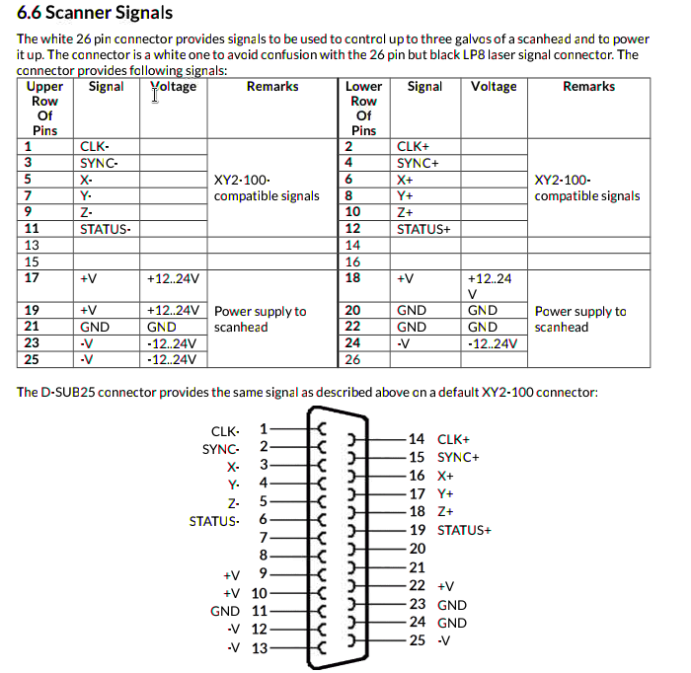

* Robotronix

<http://www.robotronix.it/web/wp-content/uploads/2014/03/cRIO-RX-XY2-100.pdf>

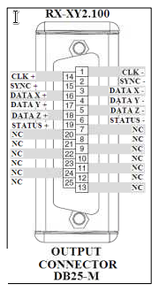 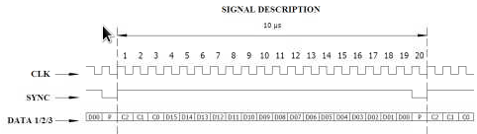

* ScanLab

