ECE 150/251 Assignment 2

Name: Shenghan Gao

App description:

There are two activities in this app. In the first activity, the camera preview is displayed on the screen, the navigation bar is set to be translucent so that we are able to have a preview that is in the same size as the phone screen without compression. If we click the “Take picture” button on the bottom, we can take a picture that is in the same size as the screen, and this picture is shown on the screen, marked with “Picture_From_Mask_Me” and saved in the gallery, then the text on the button will be changed into “Add mask”. If we click the button, we will be brought to the second activity. In this activity, faces (up to 10) in the picture are detected, and a mask with 1 circle, 2 rectangles and 1 triangle in different colors is overlaid on each face. Meanwhile, the confidence values of the faces are shown on the top-left corner in several lines. However, if no faces are detected, there will be a line reading “”No face detected, try again!” shown on the picture. Now the text on the button is changed into “Show preview” and if we click it, we will be brought back to the camera preview mode and are able to take another picture.

Answers to the questions:

1. In the logging system provided by Android, there are 5 commonly used methods, they are Log.v(), Log.d(), Log.i(), Log.w() and Log.e(). Their verbosity is decreasing in this order. Usually, we declare a TAG constant in our class. In the following example, we call these 5 methods in order, and then the log messages will be printed out.

Java code:

public class MainActivity extends Activity {

private static final String ACTIVITY_TAG = "LogDemo";

private Button bt;

public void onCreate(Bundle savedInstanceState)

{

super.onCreate(savedInstanceState);

setContentView(R.layout.activity_main);

bt = (Button)findViewById(R.id.bt);

bt.setOnClickListener(new Button.OnClickListener()

{

@Override

public void onClick(View v)

{

Log.v(MainActivity.ACTIVITY_TAG, "This is Verbose.");

Log.d(MainActivity.ACTIVITY_TAG, "This is Debug.");

Log.i(MainActivity.ACTIVITY_TAG, "This is Information.");

Log.w(MainActivity.ACTIVITY_TAG, "This is Warning.");

Log.e(MainActivity.ACTIVITY_TAG, "This is Error.");

}

});

}

}

If we click the button, the result in the logcat includes these 5 lines:

01-18 16:12:09.248 9807-9807/com.shenghangao.logdemo1 V/LogDemo﹕ This is Verbose.

01-18 16:12:09.248 9807-9807/com.shenghangao.logdemo1 D/LogDemo﹕ This is Debug.

01-18 16:12:09.249 9807-9807/com.shenghangao.logdemo1 I/LogDemo﹕ This is Information.

01-18 16:12:09.249 9807-9807/com.shenghangao.logdemo1 W/LogDemo﹕ This is Warning.

01-18 16:12:09.249 9807-9807/com.shenghangao.logdemo1 E/LogDemo﹕ This is Error.

That is how we can print the messages to logcat.

2.

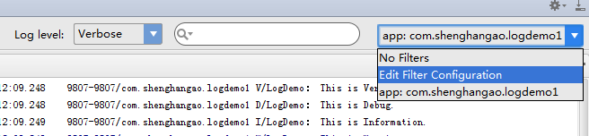

As we can see, there is a choice called Edit Filter Configuration in the drop-down list, if we click it, we are able to find the specified messages in our application. For example, in the case above, we can filter the messages by log tag, and now it is LogDemo here. Then the messages shown to us are exactly what we want.

