**Appendices**

***Figure 2. Dummy Coding Variable: PAY_METHOD_last***

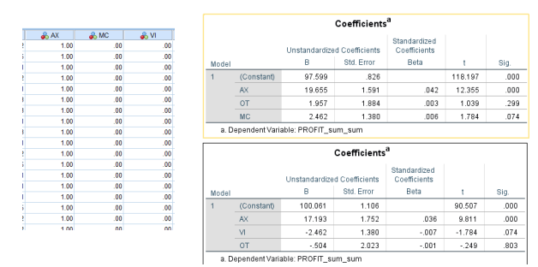

***Figure 3. Segment 1 ANOVA Sig.***

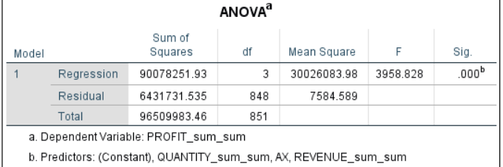

***Figure 4. Segment 5 ANOVA Sig.***

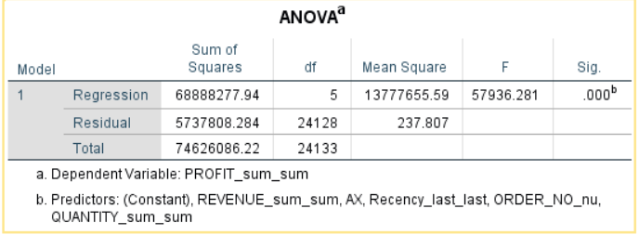

***Figure 5. Segment 1 Regression Model R Squares***

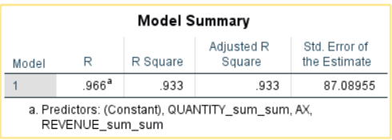

***Figure 6. Segment 5 Regression Model R Squares***

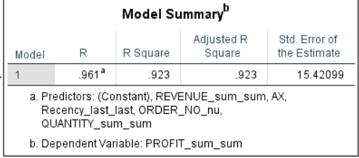

***Figure 7. Segment 1 Insignificant Variables (Without Revenue)***

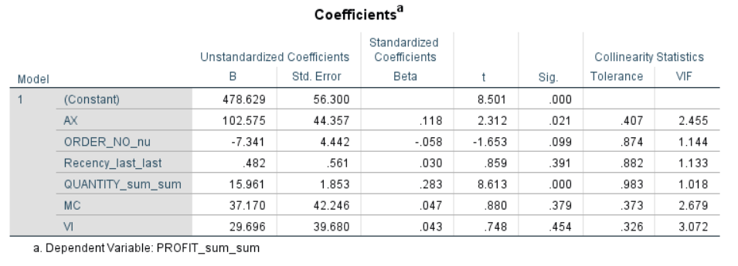

***Figure 8. Segment 1 Residuals Mean***

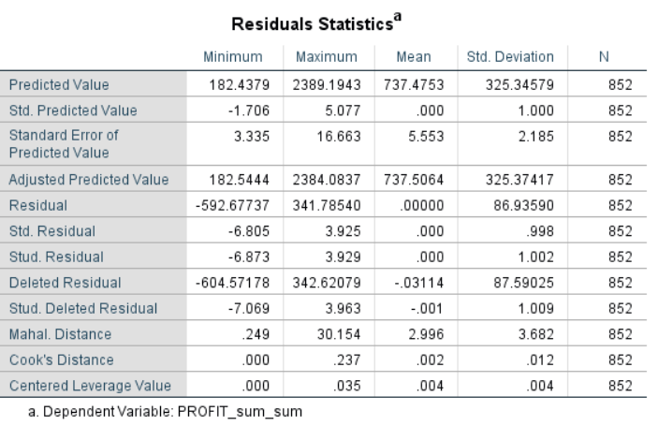

***Figure 9. Segment 5 Residuals Mean***

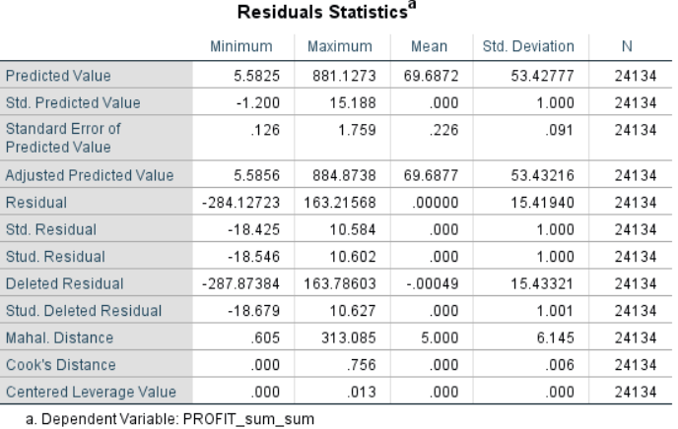

***Figure 10. Segment 1 VIF of Independent Variables***

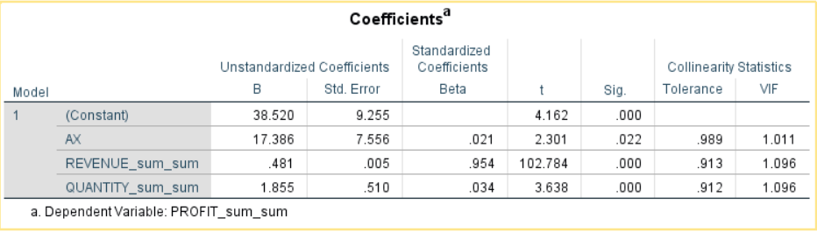

***Figure 11. Segment 5 VIF of Independent Variables***

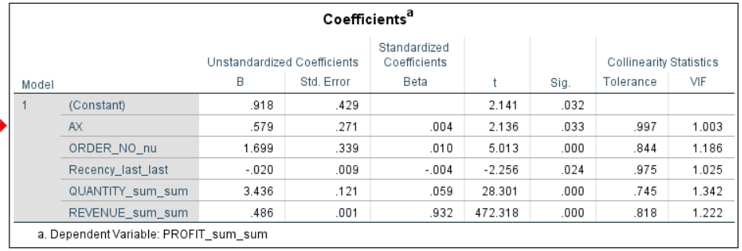

***Figure 12. Segment 1 Leverage Values***

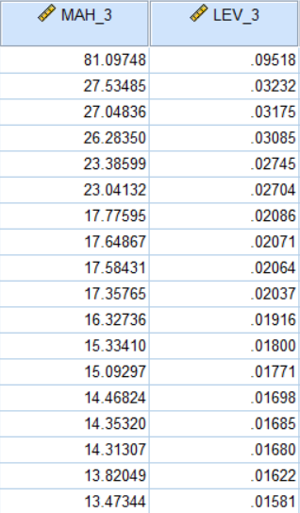

***Figure 13. Segment 5 Leverage Values***

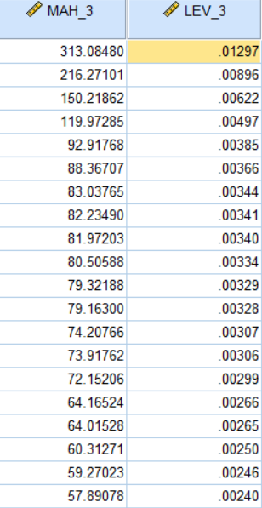

***Figure 14. Segment 1 Final Regression Model Coefficients***

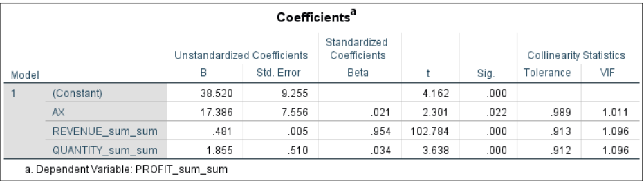

***Figure 15. Segment 5 Final Regression Model Coefficients***

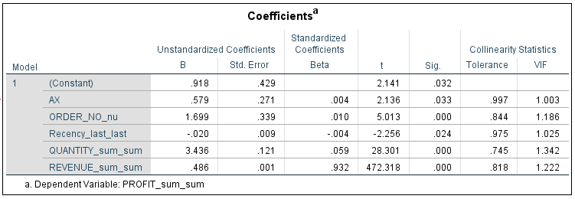

***Figure 16. Segment 1 Predicted and Original Profit Comparison***

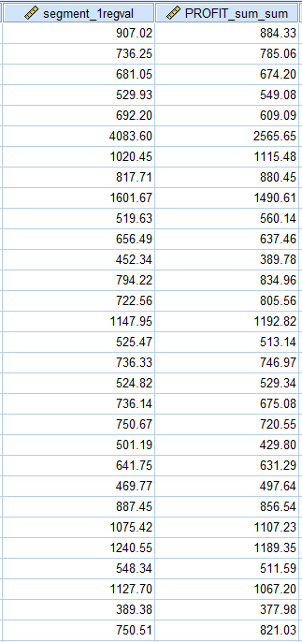

***Figure 17. Segment 5 Predicted and Original Profit Comparison***

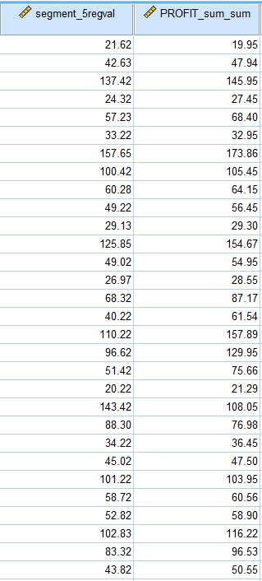

***Figure 18. Predicted and Original Profit R Square***

