max/min: 0.2, -0.2, volatility 0.20/252

Index return: -0.1758

90-day window returns:

MVO without Strategy Return: 0.039

Strategy Absolute Return: 0.8246

Strategy Annualized Return: 0.6022

Strategy VaR Return: -0.0659

Strategy CVaR Return: -0.0886

120-day window returns:

MVO without Strategy Return: 0.6469

Strategy Absolute Return: 1.0343

Strategy Annualized Return: 0.6996

Strategy VaR Return: -0.0667

Strategy CVaR Return: -0.0868

150-day window returns:

MVO without Strategy Return: 0.0144

Strategy Absolute Return: 0.2393

Strategy Annualized Return: 0.3949

Strategy VaR Return: -0.0696

Strategy CVaR Return: -0.0922

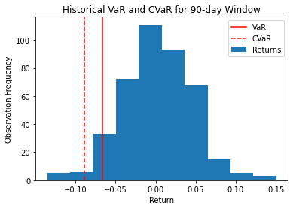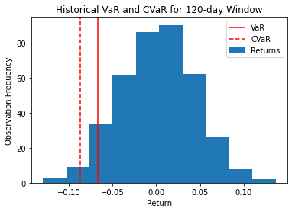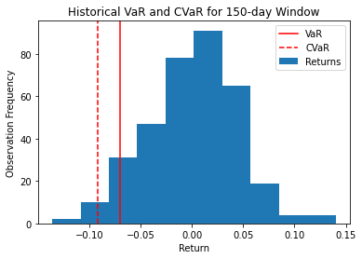

max/min: 0.25, -0.25, volatility 0.25/252

Index return: -0.1758

90-day window returns:

MVO without Strategy Return: -0.0011

Strategy Absolute Return: 1.0033

Strategy Annualized Return: 0.7549

Strategy VaR Return: -0.0773

Strategy CVaR Return: -0.104

120-day window returns:

MVO without Strategy Return: 1.209

Strategy Absolute Return: 1.5173

Strategy Annualized Return: 0.9269

Strategy VaR Return: -0.0739

Strategy CVaR Return: -0.1

150-day window returns:

MVO without Strategy Return: 0.1825

Strategy Absolute Return: 0.442

Strategy Annualized Return: 0.5862

Strategy VaR Return: -0.0806

Strategy CVaR Return: -0.1043

