

Journal of Behavioral and Experimental Finance 36 (2022) 100739
Contents lists available at ScienceDirect

Journal of Behavioral and Experimental Finance
journal homepage: www.elsevier.com/locate/jbef

Full length article

A model of trust in Fintech and trust in Insurtech: How Artificial Intelligence and the context influence it
Alex Zarifis a,b,∗, Xusen Cheng c
a University of Nicosia, Cyprus
b University of Cambridge, UK
c Renmin University of China, China

a r t i c l e i n f o

Article history:
Received 27 June 2022
Received in revised form 11 August 2022 Accepted 24 August 2022
Available online 1 September 2022

Keywords: Fintech Insurtech
Artificial Intelligence Trust
Finance Insurance
a b s t r a c t

Finance and insurance are being transformed by Artificial Intelligence (AI). Nevertheless, the consumer is not passive in this process and there is some inhibition to trust. This research models trust in Fintech and trust in Insurtech. The two models are then compared to evaluate if trust in both is similar. Multigroup Structural Equation Modelling is used to evaluate if the model is equally valid for Fintech and Insurtech. The model presented here shows that trust in both Fintech and Insurtech are formed by (1) Individuals psychological disposition to trust, (2) Sociological factors influencing trust, (3) Trust in either the financial organization or the insurer and (4) Trust in AI and related technologies. The results of the multigroup analysis show that the model is equally valid for Fintech and Insurtech. This is particularly useful as these services are often offered by the same organization, or even the same mobile application.
© 2022 The Authors. Published by Elsevier B.V. This is an open access article under the CC BY license
(http://creativecommons.org/licenses/by/4.0/).

- Introduction

Fintech and Insurtech are offering the consumer many new technology-centric services. Consumers are mostly positive to- wards these new technologies as they offer convenience and new capabilities (Kerényi and Müller, 2019). However, the role of consumer trust in the adoption of these new technologies is not entirely understood. The term Fintech refers to the special- ized technology used in the financial industry while similarly, Insurtech is the specialized technology used in insurance. These terms are gaining popularity because technology is enabling more customized solutions and it has a more decisive role for finance and insurance (Alt et al., 2018; Lee and Shin, 2018). At its core, what is happening is that Artificial Intelligence (AI) is replacing the highly specialized, and highly skilled, human expert (Olivia and Smolnik, 2021). This transformation may be as fundamental to the nature of finance and insurance as the Internet was. The capabilities of AI and automation enable processes to be more scalable and effective. In finance, a loan can be approved in sec- onds based on behavioural data, to someone that was otherwise not creditworthy such as a student, e.g. Klarna (Venkataramakr- ishnan, 2021), while in insurance a consumer can be compensated for a loss they had very recently without them even having to

∗ Corresponding author at: University of Nicosia, Cyprus.
E-mail addresses: zarifis.a@unic.ac.cy (A. Zarifis), xusen.cheng@ruc.edu.cn (X. Cheng).

https://doi.org/10.1016/j.jbef.2022.100739
make the claim, through the use of sensors and Internet of Things (IoT) devices (Krishnakanthan et al., 2021). While these changes are across the supply chain possibly the greatest transformation, at least the most visible one, is in the interaction and relation- ship between the financial organization or the insurer and their consumer. While the time of the travelling insurer going from door to door, often referred to colloquially in England as ‘the man from the ‘Pru’’ (Prudential insurance) has long gone, we are now moving towards no human interaction at all, at least in B2C. As around 75% of Fintech and Insurtech are focused on retail (Catlin et al., 2017), the consumer’s perspective is important. While finance and insurance have some differences in the nature of their relationship with their consumer there are also similarities, including the pivotal role of trust.
Trust is necessary whenever there is an interaction between two sides and at least one faces some kind of risk (McKnight and Chervany, 2002). This means it is more important in some contexts than others. While trust has been researched for many decades, it became a more prominent concern with the intro- duction and expansion of the Internet. The loss of face-to-face interaction raised the perceived risk and the importance of trust (Pavlou, 2003). Once solutions were found to reduce the risk, and build trust, this became a smaller challenge. Consumer trust has emerged as a challenge for new transformative technologies like blockchain, virtual worlds and AI. Organizations want to utilize these technologies in a way that does not reduce consumer trust. The importance of trustworthy AI is so significant that

2214-6350/© 2022 The Authors. Published by Elsevier B.V. This is an open access article under the CC BY license (http://creativecommons.org/licenses/by/4.0/).

international legal frameworks have been created to give some broad guidance on what is, and is not, acceptable (European Commission, 2021).
Fintech and Insurtech, powered by AI, are another transfor- mative phenomenon where concern about trust is important and is influencing adoption. Many Fintech and Insurtech com- panies are startups, while incumbents in finance and insurance may change beyond recognition. For example, chatbots or virtual assistants that utilize AI are widely used to interact with the per- son purchasing insurance or making an insurance claim (Zarifis et al., 2021). From the consumer’s perspective there are some concerns. It is unclear if these AI powered systems are trusted, and how many interactions with the consumer they can replace. Anecdotal evidence of this pushback by some consumers are the many adverts that emphasize that their company will not force you to communicate with AI and will provide a real person to communicate with. Even pioneers of AI like Google are offering more opportunities to talk to a real person, seemingly hedging their bets (Johnson, 2017). Current literature does not sufficiently address trust in Fintech and Insurtech, and if they are sufficiently similar to be covered with one model. Therefore, the research questions are:
RQ1: What is the role of trust in Fintech? RQ2: What is the role of trust in Insurtech?
In this research we outline the possible constituent factors that influence trust in Fintech and trust in Insurtech. We start with the psychology and sociology of trust, then discuss trust in other areas and trust in AI and data technologies. We then draw these issues together to propose a model of trust in Fintech and Insurtech. The model separates trust in a specific organization and trust in a specific technology like AI. This is an important distinction: Consumers have beliefs about the organization they bring with them, and other pre-existing beliefs on AI. Their be- liefs on AI might have been shaped by experiences with other organizations. The validated model shows that trust in Fintech or Insurtech is formed by (1) Individuals psychological disposition to trust, (2) Sociological factors influencing trust, (3) Trust in either the financial organization or the insurer and (4) Trust in AI and related technologies. In addition to validating a model for trust firstly in Fintech and secondly in Insurtech, the two models were compared to see if they were the same, or if they had differences. For example, if one variable was more influential in one of the two models, this would suggest that the model of trust in one of them was not the same as in the other. The results of the multigroup analysis show that the model is equally valid for Fintech and Insurtech. Having a model of trust that is suitable for both Fintech and Insurtech is particularly useful as these services are often offered by the same organization, or even the same mobile application side by side.
The following section outlines the theoretic foundation and develops the research model. This is followed by the methodology section explaining the steps of the quantitative Multigroup Struc- tural Equation Modelling (MGA-SME). The implementation of this analysis is then presented along with the results. Finally, the discussion and conclusion elaborate on the value of the model.

- Theoretical foundation

The theoretic foundation must link trust to Fintech and In- surtech. Given this objective, we approach the literature review by looking at three areas: (1) the influence of psychology, so- ciology and different contexts on trust, (2) trust in financial organizations and insurers and (3) trust in AI and data technolo- gies. These areas support the research model presented at the end of this section.

  - The role of psychology, sociology and context for trust

There is literature on trust spread across many different areas such as business, collaboration and education, but the funda- mental principles they extend are usually from psychology and sociology (Aoki, 2020; McKnight et al., 2002). Each specific con- text such as business, and each specialized implementation like Fintech and Insurtech bring with them some idiosyncratic twists on the common themes from psychology and sociology. Each per- son has a different physiology and experiences that shape their psychological disposition. Therefore, many models of trust start with this variable (Aoki, 2020; McKnight et al., 2002). In most cases, creating a general model of trust that ignores the different individual disposition is hard to support with the data, so this should not be left out. This is because there usually is a range of responses from participants that is hard to fully explain without acknowledging their individualism and psychological differences. The sociological factors influencing trust are not as consistent as the psychological ones because they are influenced by the context to some degree. They are however often similar across similar contexts (McKnight et al., 2017; Schniter et al., 2020).
The influence of the context on trust can be low in some
situations, due to certain factors such as common sociological influence but in other situations the context can be more decisive (Mou et al., 2017; Paolini et al., 2020). One prominent model of trust in e-commerce, widely considered to be the seminal paper bringing trust theory into e-commerce and information systems, showed how dispositions to trust combined with contextual fac- tors created trust (McKnight et al., 2002). After trust was brought into e-commerce and information systems (McKnight and Cher- vany, 2002), it has been adapted to several contexts such as collaborative consumption (Möhlmann, 2015) and habits (Polites and Karahanna, 2012), so that it captures the consumer’s per- spective accurately in each context. Because of the relatively complex interplay of psychology, sociology, the context and trust, an empirically tested model is often the best way to understand and convey what is happening. A new model of trust should therefore build on the principles of psychology and sociology and adapt to the specific context. Because of the important role of the context, if research can focus a specific geographic region that has similar regulation and laws this will be conducive to more accurate results (Paolini et al., 2020).

  - Trust in financial organizations and insurers

The relationship between a consumer and their financial or insurance organization is different to their relationship with other organizations they purchase products or services from. Both fi- nance and insurance usually involve large amounts of money over prolonged periods of time, often a lifetime. They require a higher involvement than the mundane or impulsive daily purchases we make (Johnson, 2017; Pitthan and De Witte, 2021). These more important purchases are therefore referred to as ‘considered pur- chases’ and can be seen as the opposite side of the spectrum from ‘impulse purchases’ (Johnson, 2017). The ability of the consumer to evaluate the service they are receiving is often less compared to simpler products, due to the complexity and volume of the transactions. This high risk, opaqueness and low transparency puts more weight on the importance of trust. This weight to build trust, traditionally fell on (1) staff, (2) technology and (3) institutions such as regulators. (1) Expert staff skilfully build professional relationships and embody professionalism through repeated interactions (Bapna et al., 2017). (2) Technology gives the consumer the ability to check what is happening with their finances and insurance cover on a mobile device. This immediate access a mobile app provides can reduce the uncertainty and

perceived risk. This is, of course, as long as they can understand relatively easily what is happening. (3) Institutions like regulators that build institutional trust are perceived to be independent and fair (Fang et al., 2014).
While finance and insurance have several similarities, they also have some differences. They both involve a high level of risk, but the nature of the risk is different. In finance the primary risks are usually that the value of the consumer’s assets will be reduced, or they will not be given the credit that they request. In insurance the primary risk is that the remedy provided to the consumer when they make a valid claim falls short of their expectations (Pitthan and De Witte, 2021). The remedy provided by the insurer is not always just financial but is often centred on reducing the period of disruption with practical solutions.

  - Trust in AI and data technologies

Research has shown that people trust human-like character- istics when interacting with people, but when interacting with systems, they can trust system-like characteristics that are differ- ent in some ways (Lankton et al., 2015). People’s characteristics like integrity, benevolence, ability and competence are more hu- man like, while reliability, functionality and helpfulness are more associated with technology (McKnight et al., 2017). Trust has these pillars that hold true in most contexts, but it should not be taken for granted that they work in all contexts. For example, in one study when the AI performed better than the human participant, this did not always reinforce the human’s trust in it (Yin et al., 2019).
The consumer engaging in Insurtech already has some expe- rience and beliefs in its constituent technologies (Zarifis et al., 2021). As we have seen in the second section the consumer’s trust evolves depending on what technologies they interact with. For example, while purchasing insurance online with a chatbot may be a new experience, they may have interacted with chatbots before. Someone who uses a virtual assistant in their home and experiences the interaction, and how their data is used, will have some beliefs on this issue. The opaqueness of how AI is often applied is a concern (European Commission, 2021), that compounds the nature of some decisions in finance and insur- ance. While AI dominates the headlines, other data technologies are also important. Each technology raises different issues. For example, blockchain technologies were designed to build trust but there are people that distrust them more than the pre- existing alternatives. For some, blockchain technologies and a decentralized ledger reduce risk, while for others a traditional database controlled by one organization is less risky. The con- sumer’s perspective on each of these transformative technologies may not be immediately obvious.
Therefore, we must understand the consumer’s perspective on the constituent technologies of Fintech and Insurtech. Unfor- tunately, this is made harder by the different transparency of each of these technologies. Some are (1) largely transparent like a chatbot interacting with the consumer, (2) others are not trans- parent, but the consumer has some awareness of what they do, and (3) others are very opaque. The three levels of transparency (transparent, partially transparent and opaque) are illustrated in Fig. 1. The technologies that are transparent to the consumer and understood by them, are a small fraction of what is currently being used in Fintech or Insurtech, in processes like getting a loan or making an insurance claim.

  - Research model of trust in fintech/insurtech

The role of Fintech and Insurtech is increasing. This term only emerged recently but it is now widely used in the finance, insurance and technology sectors. AI driven automation, utiliz- ing additional technologies such as big data, Internet of Things (IoT), blockchain and 5G is making the role of technology even more central than it was before. This research started by asking what the role of trust in Fintech and Insurtech is, and if it is different to other forms of trust. The first step to answering this question is to attempt to identify its constituent parts. The starting point is that trust in Fintech and Insurtech is formed by
(1) Individuals psychological disposition to trust, (2) Sociologi- cal factors influencing trust, (3) Trust in the financial/insurance organization and (4) Trust in AI and related technologies. This relationship is illustrated in Fig. 2. The organization can think, and act independently, this is often referred to as agency. AI is also increasingly showing an ability to act independently and have its own agency. Therefore, the consumer must trust both the organization and AI with their respective independent agency. The hypotheses underpinning the model are presented below. The first two hypotheses cover how psychological disposition influences trust, first in finance and secondly in insurance:
H1: Individual’s psychological disposition to trust, positively influences trust in a financial organization (H1a) and an insurer (H1b).
H2: Individual’s psychological disposition to trust, positively influences trust in AI and related technologies used in finance (H2a) and in insurance (H2b).
The people around an individual and the communities that emerge around a technology often influence the individual’s be- liefs. The next two hypotheses cover how social factors influence trust, first in finance and secondly in insurance:
H3: Sociological factors influencing the individual’s trust, pos- itively influence trust in a financial organization (H3a) and an insurer (H3b).
H4: Sociological factors influencing the individual’s trust, pos- itively influence trust in AI and related technologies used in finance (H4a) and in insurance (H4b).
The literature review showed how trust in a technology is not a monolithic action. The literature shows that the consumer often brings with them some existing beliefs based on their experience. The first part of the fifth hypothesis covers how the consumer’s trust in the financial organization will also influence their trust in the specialized financial technology, Fintech. The second part of the fifth hypothesis asserts the same for insurance:
H5a: Trust in a financial organization positively influences trust in Fintech.
H5b: Trust in an insurer positively influences trust in In- surtech.
The consumer has already heard many things about AI and in most cases interacted with it in some way. Therefore, they have some beliefs on the advantages, disadvantages and risks AI creates. The final hypothesis asserts that trust in AI influences trust, first in Fintech and secondly in Insurtech:
H6: Trust in AI and related technologies positively influence trust in Fintech (H6a) and Insurtech (H6b).
While there are broad procedural frameworks to give software developers some guidance when creating AI systems like CRISP- DM (Martinez-Plumed et al., 2021), this model is focused on the relationship with the consumer. Therefore, it is also suitable for financial organizations and insurers that do not develop AI systems but only apply them with limited customization. This research empirically tests this model in the following sections.

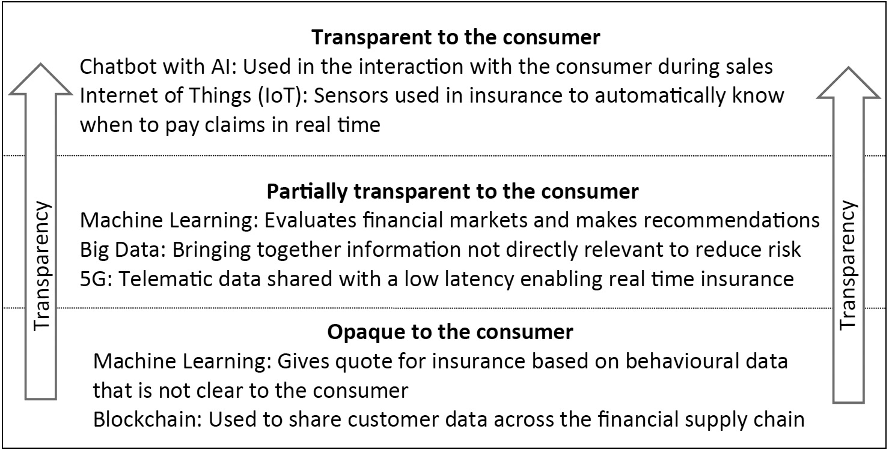

Fig. 1. The 3 levels of transparency of Fintech and Insurtech technologies for the consumer.
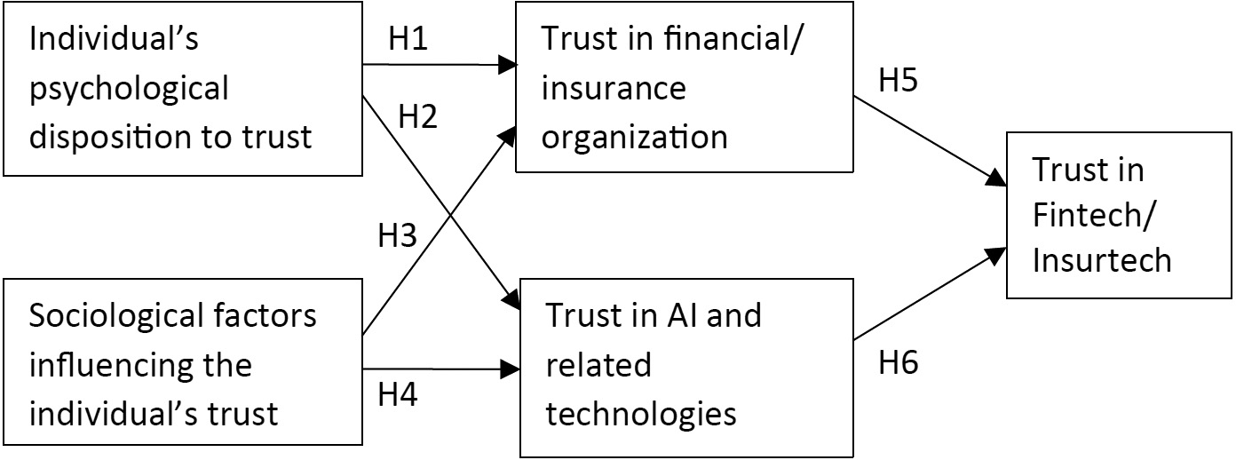

- Methodology
Fig. 2. The model of trust in Fintech and Insurtech.

3.2. Data analysis technique

The methodology section will cover the data collection first and then the data analysis. The model has a strong theoretic foundation, but it is also evaluated with empirical data and a quantitative methodology.
  - Data collection

The data was collected with an online survey administered by SoSci Survey (www.soscisurvey.de). The survey questions are based on the constructs presented in Table 1. For each construct there were three questions in the survey. The first section re- lated the five constructs to typical Fintech scenarios like taking a loan and receiving investment advice. The second section of the survey related the five constructs to typical Insurtech sce- narios like acquiring insurance cover and making an insurance claim. Participants could respond to each question by making a choice on a Likert scale from 1 to 7, with 1 indicating a strong disagreement, and 7 a strong agreement. The participants had to have experience using Fintech and Insurtech. The data collection focused on EU countries as they have similar laws and regulations for finance and insurance. In total 283 responses were received. After the typical checks such as checking that all the questions are answered and removing responses that took an unreasonably short time to complete, the final number of valid and useable sur- vey responses are 236. The participants came from Germany (56), Poland (50), Greece (42), Cyprus (28), France (18), Spain (11), Italy
(8), Hungary (6), Sweden (4), Ireland (3), Netherlands (3), Austria
(2), Malta (1), Romania (1), Bulgaria (1), Croatia (1) and Slovakia
(1). Table 2 gives more detailed demographic information on the sample groups.

The model with five variables was tested with Partial Least Squares-Structural Equation Modelling (PLS-SEM), multi-group analysis (MGA) using SmartPLS 3.3.3, (Hair et al., 2014). This method was used primarily for two reasons: Firstly, variables like trust can be measured more accurately as a latent variable with several measured items. Secondly, MGA enables the comparison of two data sets with the same model. The analysis evaluated the validity of the model first for Fintech, then for Insurtech and lastly, if the model is equally representative for both. The multigroup analysis compared the model with the Fintech sam- ple, to the Insurtech sample, to evaluate if they are sufficiently similar so that we can say the model represents both equally well. This is necessary as this research proposes that despite the differences between Fintech and Insurtech trust plays a similar role. Models of this complexity are usually evaluated in two stages in SmartPLS. First, this research analysed the measurement model that evaluates how well each of the observed variables capture their latent variables. The second stage was the structural model itself, the relationships between the five latent variables.

- Analysis and results

This section starts with the measurement model and con- cludes with the structural model.

  - Measurement model

As PLS-SEM does not have a single measure that captures how well the model fits the data, so several measures were

Constructs and their indicators.
Construct | Item | Source of construct items
Individual’s psychological disposition to trust | PT1, PT2, PT3 | McKnight et al. (2002) and Mou et al. (2017)
Sociological factors influencing the individual’s trust | ST1, ST2, ST3 | McKnight et al. (2002) and Mou et al. (2017)
Trust in financial organization or insurer | TO1, TO2, TO3 | Hwong et al. (2017) and Lankton et al. (2015)
Trust in AI and related technologies | TAI1, TAI2, TAI3 | Aoki (2020) and Zarifis et al. (2021)
Trust in Fintech/Insurtech | TFI1, TFI2, TFI3 | Sleiman et al. (2021) and Zarifis et al. (2021)

Table 2
Demographic information of the survey sample group.

Measure Item Participants
Gender Female | 103  133
Under 18 | 25
18–24 | 88
Age 25–39 | 79
40–59 | 31
60 or older | 13
No high school education | 0
High school graduate | 97
Educational level University bachelor’s degree | 95

Male
Table 3
Results of the measurement model analysis. Items Fintech/Insurtech

Loadings CR AVE Discriminant validity (HTMT)

PT ST TO TAI

PT-1 0.943/0.950 0.911/
0.903
0.773/
0.757

PT PT-2 0.878/0.881 PT-3 0.812/0.770
ST-1 0.852/0.807 0.922/

0.799/

0.823/

University master or doctoral 44
ST ST-2 0.925/0.888 ST-3 0.901/0.854
0.887
0.723
0.840

degree
TO-1 0.853/0.793 0.911/
0.775/
0.780/
0.798/

Income (in Euro per month)
No regular income 14
400–1200 41
1201–3000 92
TO TO-2 0.912/0.876 TO-3 0.934/0.869
0.893
0.736
0.740
0.774

3001–5000 54
>5000 6
TAI
TAI-1 0.866/0.860 0.928/
0.894
TAI-2 0.952/0.940 TAI-3 0.818/0.766
0.810/
0.738
0.670/
0.753
0.647/
0.781
0.690/
0.807

assessed. The reflective measurement model was evaluated by the methods illustrated in Tables 3 and 4, Hair et al. (2014). The reliability and validity of the construct were tested by the Composite Reliability (CR) and Average Variance Extracted (AVE). The Composite Reliability of the observed variables with the

TFI

Table 4
TFI-1 0.853/0.837 0.900/
0.884
TFI-2 0.912/0.860
TFI-3 0.934/0.879
0.749/
0.717
0.842/
0.788
0.820/
0.774
0.801/
0.818
0.759/
0.833

latent variable were all above the required threshold of 0.7, with the lowest at 0.749. The Average Variance Extracted (AVE) was above the required threshold of 0.5, with the lowest at 0.707. The lowest factor loading observed variables was 0.766 so they were all above the recommended level of 0.7. Discriminant validity was measured primarily by the Heterotrait-Monotrait Ratio of Correlations (HTMT), and none of the values exceeded the rec- ommended limit of 0.90. HTMT is now the preferred method for discriminant validity (Hair et al., 2021), but other methods were also used and they returned similar results.

  - Structural model

Firstly, this stage analysed the relationship between the latent variables within the model and secondly it compared the model between the groups of Fintech and Insurtech. The coefficient of determination (R2) evaluated how well the endogenous variables represent the exogenous variables. All the values are moderate or high. For the Fintech group the R2 for TAI is 0.476 that is moderate as it is above 0.33, and for TO it is 0.683 and TFI it is 0.751, that are considered strong as they are above 0.67. For the Insurtech group R2 for TAI is 0.638, TO is 0.627 that are moderate as they are above 0.33 and for TFI it is 0.752 that is strong as it is above 0.67 (Chin, 1998).
The effect sizes on the endogenous latent variables are pre- sented in Table 4. Values above 0.35 are considered strong, be- tween 0.35 and 0.15, moderate, between 0.15 and 0.02 are be- lieved to be weak and below 0.02 there is no effect (Chin, 1998). The effect sizes are significant in all cases.
The final stage of the analysis evaluated if the model applied to both Fintech and Insurtech equally well. The results of the non- parametric multigroup analysis method PLS-MGA are presented
Effect sizes.

Path | Effect size (F2 ) |  |  | Effect
 | Fintech | Insurtech |  | Fintech | Insurtech
PT-TO | 0.158 | 0.083 |  | Medium | Medium
PT-TAI | 0.111 | 0.090 |  | Medium | Medium
ST-TO | 0.232 | 0.208 |  | Medium | Medium
ST-TAI | 0.056 | 0.214 |  | Medium | Medium
TO-TFI | 0.528 | 0.258 |  | Strong | Medium
TAI-TFI | 0.284 | 0.344 |  | Medium | Medium

in Table 5. The multigroup analysis identified the difference be- tween the groups and the probability that this difference is statis- tically significant (p-value). None of the p-values are below 0.05 or above 0.95, so none are statistically significant. This proves that the model does not have significant differences in Fintech or In- surtech. The equality of the two models is not rejected. Therefore, the model can be used in both of these related contexts.
- Discussion and conclusion

This research modelled trust in Fintech and trust in Insurtech. The model of trust in Fintech and trust in Insurtech are then com- pared and it is proved that the model fits these two areas equally well. Therefore, the model can be used in both Fintech, Insurtech or services that include both. Technology is playing an increasing role in finance and insurance (Alt et al., 2018; Lee and Shin, 2018). These two areas involve risk for the consumer and therefore trust is needed. The new decisive role of Fintech and Insurtech is reforming the relationship with the consumer. In this period of digital transformation driven by AI, financial organizations and insurers need their consumers’ trust. The theoretic contribution is discussed next, followed by the practical contribution.

Table 5
Multi-group comparison test results.
Path | Path Coefficient Difference (Fintech vs. Insurtech) | PLS-MGA: p-value (Fintech vs. Insurtech) | Hypotheses | Result
PT-TO | 0.027 | 0.758 | H1: Fintech = Insurtech | Non-rejected equality
PT-TAI | 0.022 | 0.365 | H2: Fintech = Insurtech | Non-rejected equality
ST-TO | 0.020 | 0.830 | H3: Fintech = Insurtech | Non-rejected equality
ST-TAI | 0.120 | 0.365 | H4: Fintech = Insurtech | Non-rejected equality
TO-TFI | 0.066 | 0.312 | H5: Fintech = Insurtech | Non-rejected equality
TAI-TFI | 0.088 | 0.468 | H6: Fintech = Insurtech | Non-rejected equality

  - Theoretic contribution

By extending widely validated models of trust (Lankton et al., 2015; McKnight et al., 2017; McKnight and Chervany, 2002), this research makes four main contributions to theory: (1) firstly it offers a model for trust in Fintech, (2) secondly it offers a model for trust in Insurtech and (3) it brings evidence that the same model is equally valid across Fintech and Insurtech. The third point is particularly important as these services are increasingly being offered together (Konopik et al., 2021). (4) It shows that the consumer brings with them some pre-existing beliefs on AI and related technologies. The consumer therefore does not trust Fintech and Insurtech just based on their direct experience with them, but they are also influenced by their existing beliefs on AI. This model ads to extensive research in other contexts, supporting the influence of pre-existing beliefs on technology use (Polites and Karahanna, 2012). These beliefs or habits can cause an inertia that is hard to change (Polites and Karahanna, 2012).
The model of trust in Fintech and Insurtech shows how an ‘Individual’s psychological disposition to trust’ and ‘Sociological factors influencing the individual’s trust’ influence ‘Trust in fi- nancial or insurance organization’ and ‘Trust in AI and related technologies’. The last two variables then shape trust in Fintech or Insurtech. In addition to validating the model, this research shows how to operationalize the five variables in the context of Fintech and Insurtech.
An additional contribution is developing our understanding of Insurtech and linking it more extensively to the literature in business and information systems. Despite insurance contribut- ing over 10 trillion euro per year to the European economy (Insurance-Europe, 2021), and technology playing an increas- ing role, our literature review indicates that it has not received sufficient attention by scholars. Just as Fintech carved out its own segment of dedicated research and experts in business and information systems (Lee and Shin, 2018), it is now overdue for Insurtech to receive similar attention.

  - Practical contribution

With AI permeating many aspects of our personal and profes- sional lives it can be challenging for organizations to know what to focus on first. Whether the future of finance and insurance is a more efficient version of the model we have today, or more decentralized finance running on blockchains (DeFi), algorithms and AI are taking centre stage. The model this research develops enables an organization in finance or insurance to focus on the four variables that shape consumer trust in Fintech and Insurtech. An organization has more influence on the variable ‘Trust in financial organization/insurer’ than the other three psychological disposition, sociological factors, and trust in AI. The organization should however have an understanding of all four factors and try to compensate weaknesses in factors it has less influence on, by strengthening a factor where it does have more influence. The consumer may perceive these four variables differently in different contexts. Therefore, the organization must use experts in the technology, and business intelligence to optimize their
relationship with AI and their consumers, in their context. The model presented here, can be informed and adapted to each organization’s context with business intelligence utilizing context specific big data and machine learning (Park et al., 2020).
Broader frameworks that are used for AI development like CRISP-DM (Martinez-Plumed et al., 2021) do not focus on the relationship with the consumer directly so they can be supple- mented with the use of this model. Additionally, an organization that is neither developing nor significantly customizing their AI solutions may benefit more by using a model targeted on their relationship with the consumer and the variables they can influ- ence, like trust in their organization, rather than attempting to apply broader models. If an organization is engaged in software development and significant customization, they can use the trust model alongside broader procedural models.
Lastly, this research puts forward the three levels of trans- parency of AI and related technologies from the consumers per- spective, as illustrated in Fig. 1. These are (1) transparent to the consumer, (2) partially transparent to the consumer, and (3) opaque to the consumer. The three levels give those applying Fintech and Insurtech a starting point to evaluate the consumers perspective of the transparency of their specific implementation. A more nuanced understanding will enable the targeted reduction of the opaqueness so that trust is elevated.

- Limitations and future research

The contribution of this research should be seen in the light of some typical limitations that are caused by the topic and research methodology. The participants were from the European Union so this model should also be tested in other geographic regions. Another limitation is that the model is relevant to Fintech and Insurtech as we understand it today and not traditional, less technology-centric, approaches to finance and insurance.
The three levels of transparency of AI from the consumers perspective, can be further developed and evaluated. An exper- iment method could also be applied to further test the model and the causal relationships. The possible role of financial literacy can also be explored in relation to the model presented here. The simple and fast process offered to the consumer by Fintech and Insurtech mask the actual financial dimensions of what is happening to some degree. Despite this, higher financial literacy would probably lead to higher confidence in using Fintech and Insurtech.
This research also argues that more dedicated research on Insurtech is needed in business, information systems and finance. Future research can further clarify the similarities and differences to Fintech, particularly in areas such as the relationship with the consumer, how risk is calculated and how digital transformation is reshaping business models. It can also be explored if additional factors, like law and regulation, act like separate variables or moderate these relationships.

CRediT authorship contribution statement

Alex Zarifis: Ideas, Formulation or evolution of overarching research goals and aims, Development or design of methodology, Creation of models, Application of statistical, mathematical, com- putational, or other formal techniques to analyse or synthesize study data, preparation, creation and/or presentation of the pub- lished work by those from the original research group, specifically critical review, commentary or revision – including pre-or post- publication stages. Xusen Cheng: Ideas, Formulation or evolution of overarching research goals and aims, Development or design of methodology, Creation of models, Application of statistical, math- ematical, computational, or other formal techniques to analyse or synthesize study data, preparation, creation and/or presentation of the published work by those from the original research group, specifically critical review, commentary or revision – including pre-or postpublication stages.

Declaration of competing interest

The authors declare that they have no known competing finan- cial interests or personal relationships that could have appeared to influence the work reported in this paper.

Ethics statement

The paper meets the requirements of the institutions of the authors for empirical papers. All the necessary permissions were taken for the data collection. A committee approval number is not applicable.

References

Alt, R., Beck, R., Smits, M.T., 2018. FinTech and the transformation of the financial industry. Electron. Mark. 28 (3), 235–243. http://dx.doi.org/10.1007/s12525-
018-0310-9.
Aoki, N., 2020. An experimental study of public trust in AI chatbots in the public sector. Gov. Inf. Q. 37 (4), 101490. http://dx.doi.org/10.1016/j.giq.2020.
101490.
Bapna, R., Qiu, L., Rice, S., 2017. Repeated interactions versus social ties: Quantifying the economic value of trust, forgiveness, and reputation using a field experiment. MIS Q. 41 (3), 841–866. http://dx.doi.org/10.25300/MISQ/ 2017/41.3.08.
Catlin, T., Lorenz, J.-T., Münstermann, B., Olesen, P.B., Ricciardi, V., 2017. Insurtech — the Threat that Inspires. McKinsey & Company, March, 12. https://www.mckinsey.com/industries/financial-services/our- insights/insurtech-the-threat-that-inspires%0Awww.mckinsey.com/ clientservice/financial_services.
Chin, W.W., 1998. The partial least squares approach to structural equation modelling. In: Marcoulides, G.A. (Ed.), Modern Methods for Business Research (Issue JANUARY 1998, 295–336). Lawrence Erlbaum Associates.
European Commission, 2021. Proposal for a regulation of the European parliament and of the council laying down harmonised rules on artificial in- telligence (artificial intelligence act) and amending certain Union Legislative Acts. In: European Commission, Vol. 0106.
Fang, Y., Qureshi, I., Sun, H., McCole, P., Ramsey, E., Lim, K.H., 2014. Trust, satisfaction, and online repurchase intention: The moderating role of perceived effectiveness of E-commerce institutional mechanisms. MIS Q. 38 (2), 407–427, http://fesrvsd.fe.unl.pt:2104/ehost/pdfviewer/pdfviewer?vid= 11&sid=38f88484-fa57-403c-b62e-de1caaf6bd9f%40sessionmgr4004&hid= 4104.
Hair, J., Hult, T., Ringle, C., Sarstedt, M., 2014. A primer on partial least squares structural equation modeling (PLS-SEM). In: SAGE Publications (Vol. 46, Issues 1–2). http://dx.doi.org/10.1016/j.lrp.2013.01.002.
Hair, J., Hult, T., Ringle, C., Sarstedt, M., 2021. A Primer on Partial Least Squares Structural Equation Modeling (PLS-SEM), third ed. Sage Publishing.
Hwong, A.R., Sah, S., Lehmann, L.S., 2017. The effects of public disclosure of industry payments to physicians on patient trust: A randomized experiment.
J. Gen. Intern. Med. 32 (11), 1186–1192. http://dx.doi.org/10.1007/s11606- 017-4122-y.
Insurance-Europe, 2021. European insurance: Preliminary figures 2020 (Issue June).

Johnson, G., 2017. Your customers still want to talk to a human being. In: Harvard Business Review, Vol. 1. https://hbr.org/2017/07/your-customers- still-want-to-talk-to-a-human-being.
Kerényi, Á., Müller, J., 2019. Brave New Digital World? – Financial technology and the power of information. Financial Econ. Rev. 18 (1), 5–32. http:
//dx.doi.org/10.33893/fer.18.1.532.
Konopik, J., Jahn, C., Schuster, T., Hozbach, N., Pflaum, A., 2021. Mastering the digital transformation through organizational capabilities: A concep- tual framework. Digit. Bus. 2, 1–13. http://dx.doi.org/10.1016/j.digbus.2021. 100019.
Krishnakanthan, K., McElhaney, D., Milinkovoch, N., Pradhan, A., 2021. How top tech trends will transform insurance. In: McKinsey & Company (Issue September).
Lankton, N., McKnight, H., Tripp, J., 2015. Technology, humanness, and trust: Rethinking trust in technology. J. Assoc. Inf. Technol. 16 (10), 880–918.
Lee, I., Shin, Y.J., 2018. Fintech: Ecosystem, business models, investment deci- sions, and challenges. J. Bus. Horiz. 61 (1), 35–46. http://dx.doi.org/10.1016/ j.bushor.2017.09.003.
Martinez-Plumed, F., Contreras-Ochando, L., Ferri, C., Hernandez-Orallo, J., Kull, M., Lachiche, N., Ramirez-Quintana, M.J., Flach, P., 2021. CRISP-DM twenty years later: From data mining processes to data science trajectories. IEEE Trans. Knowl. Data Eng. 33 (8), 3048–3061. http://dx.doi.org/10.1109/ TKDE.2019.2962680.
McKnight, H., Chervany, N.L., 2002. What trust means in E-commerce customer relationships: An interdisciplinary conceptual Typology. Int. J. Electron. Commer. 6 (2), 35–59.
McKnight, H., Choudhury, V., Kacmar, C., 2002. Developing and validating trust measures for e-commerce: An integrative typology. Inf. Syst. Res. 13 (3), 334–359.
McKnight, H., Lankton, N.K., Nicolaou, A., Price, J., 2017. Distinguishing the effects of B2B information quality, system quality, and service outcome quality on trust and distrust. J. Strateg. Inf. Syst. 26 (2), 118–141. http:
//dx.doi.org/10.1016/j.jsis.2017.01.001.
Möhlmann, M., 2015. Collaborative consumption: determinants of satisfaction and the likelihood of using a sharing economy option again. J. Consum. Behav. 14 (3), 193–207. http://dx.doi.org/10.1002/cb.1512.
Mou, J., Shin, D.H., Cohen, J.F., 2017. Trust and risk in consumer acceptance of e-services. Electron. Commer. Res. 17 (2), 255–288. http://dx.doi.org/10.1007/ s10660-015-9205-4.
Olivia, H., Smolnik, S., 2021. AI invading the workplace: negative emotions towards the organizational use of personal virtual assistants. Electron. Mark. 7 (3), 101–134. http://dx.doi.org/10.1007/s12525-021-00493-0.
Paolini, D., Maricchiolo, F., Pacilli, M.G., Pagliaro, S., 2020. COVID-19 lockdown in Italy: the role of social identification and social and political trust on well-being and distress. Curr. Psychol. http://dx.doi.org/10.1007/s12144-020- 01141-0.
Park, Y., Sawy, O. A. El., Hong, T., 2020. Digital transformation to real-time enterprise to sustain competitive advantage in the digitized world: The role of business intelligence and communication systems. Korea Bus. Rev. 24, 105–130. http://dx.doi.org/10.17287/kbr.2020.24.0.105.
Pavlou, P., 2003. Consumer acceptance of electronic commerce: Integrating trust and risk with the technology acceptance model. Int. J. Electron. Commer. 7 (3), 101–134. http://dx.doi.org/10.1080/10864415.2003.11044275.
Pitthan, F., De Witte, K., 2021. Puzzles of insurance demand and its biases: A survey on the role of behavioural biases and financial literacy on insurance demand. J. Behav. Exp. Finance 30, 100471. http://dx.doi.org/10.1016/j.jbef. 2021.100471.
Polites, G.L., Karahanna, E., 2012. Shackled to the status quo: The inhibiting effects of incumbent system habit, switching costs, and inertia on new system acceptance. MIS Q. 36 (1), 21–42.
Schniter, E., Shields, T.W., Sznycer, D., 2020. Trust in humans and robots: Economically similar but emotionally different. J. Econ. Psychol. 78 (March), 102253. http://dx.doi.org/10.1016/j.joep.2020.102253.
Sleiman, K.A.A., Juanli, L., Lei, H., Liu, R., Ouyang, Y., Rong, W., 2021. User trust levels and adoption of mobile payment systems in China: An empirical analysis. SAGE Open 11 (4), http://dx.doi.org/10.1177/21582440211056599.
Venkataramakrishnan, S., 2021. Klarna and stripe announce ‘buy now, pay later’ partnership tie-up will allow retailers easily to add option for customers to pay in instalments at checkouts. Financ. Times 1, https://www.ft.com/ content/841e0d03-f547-4a1f-b1f4-ef9a8ac7ab1f.
Yin, M., Vaughan, J.W., Wallach, H., 2019. Understanding the effect of accuracy on trust in machine learning models. In: Conference on Human Factors in Computing Systems - Proceedings. pp. 1–12. http://dx.doi.org/10.1145/ 3290605.3300509.
Zarifis, A., Kawalek, P., Azadegan, A., 2021. Evaluating if trust and personal information privacy concerns are barriers to using health insurance that explicitly utilizes AI. J. Internet Commer. 20 (1), 66–83. http://dx.doi.org/ 10.1080/15332861.2020.1832817.



Comparative Analysis of Machine Learning Algorithms For XAU/USD Prediction: Integrating Economic Indicators And Sentiment Analysis

MSc Research Project MSc In Data Analytics

Manoj Crasta
Student ID: x23199156

School of Computing National College of Ireland

Supervisor: Abdul Shahid

2


National College of Ireland Project Submission Sheet School of Computing

Student Name: | Manoj Crasta
Student ID: | x23199156
Programme: | MSc In Data Analytics
Year: | 2024
Module: | MSc Research Project
Supervisor: | Abdul Shahid
Submission Due Date: | 12/12/2024
Project Title: | Comparative Analysis of Machine Learning Algorithms For  XAU/USD Prediction: Integrating Economic Indicators And Sentiment Analysis
Word Count: | 7009
Page Count: | 20
I hereby certify that the information contained in this (my submission) is information pertaining to research I conducted for this project. All information other than my own contribution will be fully referenced and listed in the relevant bibliography section at the rear of the project.
ALL internet material must be referenced in the bibliography section. Students are required to use the Referencing Standard specified in the report template. To use other author’s written or electronic work is illegal (plagiarism) and may result in disciplinary action.

Signature:
Date: | 28th January 2025

PLEASE READ THE FOLLOWING INSTRUCTIONS AND CHECKLIST:

Attach a completed copy of this sheet to each project (including multiple copies). | □
Attach a Moodle submission receipt of the online project submission, to  each project (including multiple copies). | □
You must ensure that you retain a HARD COPY of the project, both for  your own reference and in case a project is lost or mislaid. It is not sufficient to keep a copy on computer. | □

Assignments that are submitted to the Programme Coordinator office must be placed into the assignment box located outside the office.

Office Use Only
Signature:
Date:
Penalty Applied (if applicable):

Comparative Analysis of Machine Learning Algorithms For XAU/USD Prediction: Integrating Economic Indicators And Sentiment Analysis
Manoj Crasta x23199156

Abstract
XAU/USD which is an highly traded forex pair in the financial market, is known for its volatility. Its dependence on diverse factors like economic indicators and sentiment-driven market dynamics, makes it a difficult pair to predict. While exist- ing studies focus on either quantitative data or sentiment data. This study sought to fill this gap by integrating both historical indicators and sentiment scores from news articles to predict XAU/USD hourly rate. The prominent machine learn- ing models were implemented and evaluated using metrics like MAE, MSE and R². Random Forest was found to be the most efficient in terms of accuracy and interoperability with Mean Absolute Error of 7.2035. Deep learning models even though they are designed for sequential data were outperformed by ensemble mod- els. While sentiment score contributed to the predictive capability of models, their influence was limited. This research can help the traders and financial analyst to effectively predict the XAU/USD trends by providing a reliable framework. Nev- ertheless, some additional investigation of sentiment-driven features and real-time analysis tools is necessary to enhance model generalizability and precision.

Introduction
The foreign exchange(forex) market which is the most liquid and dynamic market in the global financial system has a daily trading volume exceeding $2 trillion as of April 2022 (2023). Forex market which facilitates international trade, investment and
Chaboud et al.
speculation acts as a cornerstone of the global economy. Day traders and financial insti- tutions are engaged throughout the day buying, selling and speculating the instruments to earn profit in the forexmarket. Various instruments are traded in the forex market, among these gold, which is traded as XAU/USD, holds a unique position because of its role as a commodity as well as an financial instrument. XAU/USD reflects the price of one ounce of gold in US dollars and gold’s properties like corrosion resistance and durab-
ility has always upheld its value (2023). XAU/USD is currently a critical
Andriani et al.
indicator for policymakers and multinational corporations due to its role of safe haven
asset and hedge against inflation and economic instability (2022). XAU/USD
Kilimci
rate prediction is not as simple as it may seem because this currency pair is sensitive to a number of external factors such as geopolitical occurrences, political and other economic activities and even the sentiment of the market. Although it is a complex job, it is con- sidered as essential for financial decisions. As a result of the technological development,

the participation in the forex market is rising dramatically. On one side the forex market offers a lot of growth opportunities but on the other side it involves high risk due to its volatility. Hence predicting the instruments like XAU/USD requires diverse data sources from historical data to the market sentiments. This complex nature of XAU/USD has led to many studies and research over the years on financial predictive analytics.
Many studies have been conducted on predicting financial instruments like XAU/USD rate, exploring different methods and diverse datasets focusing on improving prediction accuracy. Some researchers implemented traditional time-series models, such as ARIMA, SARIMA and GARCH and effectively captured the seasonal trends but due to the dy- namic nature of financial markets, struggled to learn the non-linear data
Pant and Pant
(2024);Guha and Bandyopadhyay (2016). This issue was addressed by using machine learning models like SVM, Decision trees and ensemble techniques but temporal depend-
encies were not caught by these models (2021);Mahajan et al. (2023).
Sudimanto et al.
Deep learning models were also studied and models like LSTM, GRU performed well for
XAU/USD prediction (2024);Birdi et al. (2023). Some previous studies also em-
Gong
phasized on the effects of economic indicators and market sentiment on the instruments. The majority of the studies use either economic indicators or sentiment data, which limits the robustness and comprehensiveness of these models.
The multifaceted nature of affecting factors, such as economic indicators and senti- ment data, makes the XAU/USD rate prediction a complex task. Current studies are either focused on quantitative data or sentiment analysis, which fails to capture the com- plementary nature between these data sources. Moreover, there are very few published works with comparison of different types of machine learning models that uses both eco- nomic indicators and sentiment analysis which further can give a better understanding of the effective techniques for forecasting of the XAU/USD rates. These limitations highlight the need of using multiple data sources in the analysis that could include quantitative and qualitative data to build predictive models for XAU/USD rates.

  - Research Question
This study addresses the following research question:
How do different machine learning models compare in their ability to pre- dict the XAU/USD exchange rate using a combination of textual sentiment data and various economic indicators?

  - Research Objectives
To address the research question, the following specific research objectives were derived:
- To develop a comprehensive dataset which consists of hourly sentiment scores de- rived from news articles related to XAU/USD rates, economic indicators and the historical XAU/USD data.
- To build different machine learning and deep learning models to predict the hourly rates of XAU/USD and evaluating each of those with metrics such as Mean Absolute Error (MAE), Mean Absolute Error (MAE) and R² value.
- To compare different machine learning models based on the performance, robust- ness and operational efficiency in predicting XAU/USD rates and identifying the best technique.

Hence this study aims to contribute to the field of financial predictive analytics by using integrated data consisting of economic indicators and sentiment analysis to improve robustness and accuracy of XAU/USD forecasting models.

  - Proposing Research Model
In this study financial news articles are collected from Perigon API and sentiment ana- lysis is applied to calculate the sentiment scores. Then these hourly sentiment scores are aligned with historical XAU/USD data as well as economic indicators like S&P 500, Crude Oil price, and volatility index to create a comprehensive dataset. Various machine learning and deep learning models including Random forest, XGBoost, LSTM will be trained on this dataset. Best performing model will be identified by evaluating all the models based on the performance metrics. Hence this study will offer valuable insights for traders, investors and policymakers by combining quantitative economic indicators with qualitative sentiment analysis.

  - Document Structure
This thesis is structured in a way to provide a logical and clear progression of the re- search. The first chapter gives an introduction to the research outlining the objectives of the research and motivation. A comprehensive literature review will be presented in chapter 2 which summarizes the traditional methods, , machine learning techniques, and the integration of economic and sentiment data in financial forecasting. In the chapter 3 the methodology which will be followed in the study will be discussed in detail. Data min- ing techniques followed in data collection, preprocessing, sentiment analysis and model building will be discussed. In the chapter 4 on Results and discussions includes all the in- terpretations and comparative analysis of the models employed. Chapter 5 concludes the thesis by summarizing the key findings, contributions, and recommendations for future research efforts.

- Related Work
The related work section examines and discusses various studies on forex market pre- diction. These studies are organized onto distinct categories. The studies involving traditional forecasting techniques are discussed in the first segment. The subsequent sec- tions discuss the use of machine learning and deep learning techniques in financial market predictions, highlighting their growing relevance in the field. The fourth section explores the studies where economic indicators were included in the financial prediction. It also investigates the influence of sentiment analysis, showing how market sentiments derived from the news impacts the forex trends. In the final section, the gaps in the existing studies will be identified and research niche is outlined. This systematic approach will build a comprehensive foundation on financial predictions while positioning the proposed research to address the current gaps effectively.

  - Evolution of Forecasting Techniques
The techniques used for predicting financial markets have been evolved over time from traditional methods to modern machine learning techniques due to the ongoing research in the field. During initial days traders were using fundamental analysis and technical
analysis for financial forecasting. (2015) explored in depth on fundamental
Wafi et al.
analysis methods for predicting stock prices. They focused on models that assess factors like market trends, financial statements and competitive positioning. However, significant drawbacks were identified, which included availability of quality data, dependence highly on market efficiency and rapidly changing market conditions. Also, fundamental analysis proved to be time consuming. Another widely used method for financial predictions is technical analysis which depends on historical price pattern and trading volumes.
Neely
(2011) explored the evolution of technical trading rules (TTRs) in forex market and they found that over the time its effectiveness declines due to market dynamics. Their findings also pointed out the need to continuously enhance the forecasting methods.
and Weller
Similarly, (1997) discussed the application of technical analysis in forex market
Neely
and the demonstrated that although forex traders could earn profits, the ability to do so declines as other traders adopt the same strategies.
To address the challenges of fundamental analysis in short-term variations, along with the declining effectiveness of technical analysis led to the adoption of time-series forecast-
ing methods. (2024)) used the ARIMA(1,1,2) model to predict gold futures prices.
Bai
Data between 2020 to 2024 was used. The model established a constant R² of 0.313 as well as an R² of 0.748, and the residual tests did not reveal autocorrelation, indicating white noise. The Ljung-Box statistics (12.286 with p=0.657) also supported validity of the model. The study forecasted gold prices to remain relatively constant in the first half of the year and to rise sharply in the second half of the year and it emphasized the importance of ARIMA models to capture short-term trends. One of the studies
by (2023) experimented with ARIMA, ARIMA-GARCH and ARIMA-TGARCH
Bunnag
models for forecasting daily gold prices. The hybrid model ARIMA(2,1,3)-GARCH(1,1) outperformed other models achieving the lowest MAE of 106.712 and RMSE of 126.788. This demonstrated the effectiveness of ARIMA-GARCH models in forecasting gold prices
under volatile market conditions. (2016) employed the AR-
Guha and Bandyopadhyay
IMA model to predict gold prices in India ranged from 2003 to 2014. They implemented six ARIMA model combinations and the best performing model was ARIMA(1,1,1) with R-squared of 0.993 and MAE of 477.33. This study highlighted the limitations of ARIMA in capturing sudden changes caused by economic instability. This research therefore em- phasizes use of time-series modeling in prediction of the gold price, while acknowledging
its constraints in volatile market conditions. (2021) checked the per-
Syrris and Shenai
formance of ARIMA and hybrid ARIMA-GARCH models for gold prices for the period of 2018 to 2019. The ARIMA(4,0,15)-GARCH(1,1) model with normal error distribution (NED) was identified as the most efficient model with the lowest AIC (-7.4459) and the best Theil coefficients. It also explained the combined effect of ARIMA-GARCH where GARCH captured volatility clustering, while ARIMA handled autoregressive processes.
While fundamental and technical analysis showed great results in earlier stages, due to markets dynamic nature its effectiveness declined. Likewise, the time-series models like ARIMA, GARCH and hybrid models failed to address the non-linearity present in the data. This highlights the necessity for employing advanced machine learning models.

  - Machine Learning and Deep Learning
This below section explores various studies undertaken in the field of financial prediction using machine learning and deep learning techniques.
(2021) performed a comparison analysis of SVM and ARIMA in pre- dicting the gold prices, with SVM emerging as best one. The study used daily gold price data, from the World Gold Council for 41 years (1979–2019), and imputed missing values by calculating the average of gold price for three consecutive days. The dataset was then split into the training set up to year 2014 and test data from the year 2015 onward. SVM achieved an RMSE of 0.027 and R-squared of 99% where as ARIMA registered RMSE
Makala and Li
of 36.2. The study (2023) employed ensemble techniques for gold price
Mahajan et al.
prediction by combining models like decision trees, SVM and gradient boosting. Daily gold price data from 2011 to 2019 was used and compared to individual model’s ensemble model performed better. The results showed an MAE of 0.5227, R-squared of 0.8877 and RMSE of 0.7107. This study shed lights on the potential of ensemble models.
A similar study that used ensemble regression models for the prediction of XAU/USD
is (2022), where data from July 2019 up to July 2020 was used. Technical indicat-
Kilimci
ors were also included like moving averages, Bollinger bands etc. The study experimented with the help of different regression models, such as linear regression, decision tree regres- sion, random forest regression, and support vector regression, and some specific ensemble methods voting and stacking regression. The stacking regression model achieved the best results with a MAPE of 2.2036, outperforming other models in predicting gold prices. (2021) compares the performance of SVM, K-Nearest Neighbors, De-
Sudimanto et al.
cision Trees and Ensemble models for the prediction of XAU/USD prices using data from 2019 to 2021. Models were trained on data from 2019-2020 and tested on the 2021 data. It included technical indicators like Moving Average Convergence/Divergence (MACD) for prediction. Coarse Gaussian SVM and 10-NN models showed highest accuracy of 88.9%.
The comparison study (2021) Linear regression was compared with different
N et al.
types of LSTM (Long Short Term Memory) models such as Vanilla LSTM, Stacked LSTM, and Bidirectional LSTM for global gold prediction from year 1978 to 2018. Study demonstrated that linear regression showed higher errors, with a MAPE of 10.94 and RMSE of 0.153. Vanilla and Stacked LSTM models were the best among all the models that were developed as they yielded the lowest MAPE of 2.649 and RMSE of 0.0292 and 0.0291 respectively. The study highlighted that potential of LSTM in forecasting gold prices, which outperforms linear regression.
Another study (2020) employed LSTM-based deep learning model to predict
S and S
daily gold prices using data from January 1979 to July 2020. LSTM model performed bril- liantly achieving RSME of 7.385 on test data, demonstrating strong alignment between predicted and actual prices. It demonstrated the ability of LSTM over conventional methods such as ARIMA, SVR and CNN for analyzing golds non-linear price fluctu- ations. Gated Recurrent Unit (GRU) is also evaluated in order to predict gold prices by (2024). K-fold cross-validation was performed with several combina-
Sudiatmika et al.
tions of timesteps, batch sizes and epochs. The model with best parameters achieved the lowest MSE of 0.0000324, MAE of 0.012846 with batch size of 64 and 100 epochs. This study showed the potential of GRU for gold prediction.

  - Role of Economic Indicators AND Sentiment Analysis
The studies which have used economic indicators and sentiment analysis in predicting financial markets are discussed below.
The study (2018) artificial neural networks and linear regression to
Sami and Nazir
predict daily gold prices. It used a broader features like 22 market variables like oil prices, S&P 500 index along with daily gold prices from 2005 to 2016. ANN achieved an RMSE as low as 19 outperforming linear regression. This study is notable for incorporating eco- nomic indicators, including gold-producing companies’ stock values and Russia’s interest
rates, for forecasting. Another study (2023) explored the application of
Cohen and Aiche
Random Forest, GBRT and XGBoost to predict gold price fluctuations using data from February 2011 to February 2023. Feature set included global stock indices, commodity futures, VIX volatility and bond yields. Also lagged values up to day 10 was used. The result shows that XGBoost model has the highest accuracy with test MSE of 0.0000186 among other models. The study also pointed out that the three day moving average of gold, lagged stock indices and VIX scores with one day lag significantly affected the prices.
To explore the relationship between gold prices and economic indicators like stock market indices, crude oil prices, exchange rates, inflation and interest rates
Manjula and
(2019) performed an regression analysis on gold prices. The study divided the dataset into two distinct periods: January 2000–October 2011 (rising trend) and November 2011–December 2018 (horizontal trend). Out of the three models random forest achieved the best prediction accuracy for entire period with R-Square of 0.9802. The study was also able to establish that the correlation between gold price and its influencing
Karthikeyan
factors was higher during the rising trend period. (2024) utilized machine
Rakshitha et al.
learning models, including decision trees, regression and ensemble methods for gold prices from December 2016 to December 2023. It also included economic indicators like crude oil prices, metal indices with Adjusted Close price as the dependent variable. Gradient Boosting achieved the lowest RMSE of 0.8433 after feature selection and with R-square of 0.881. It highlighted the influence of cross-validation in enhancing models accuracy.
The effects of financial news sentiment on gold price prediction was discussed by (2020). The study compared 5-days news sentiment with 1-day news sen-
and Mengoni
Junjie
timent and 5-days news sentiment had better prediction accuracy of 78.43% and a lower L2 loss at 0.0044. Results from this study showed that there was a negative correlation between positive news sentiment and gold prices to underscore the role of the precious metal as a safe haven or hedge against financial risk. This study demonstrated that using sentiment analysis can enhance the prediction ability of machine learning models. The
study (2022) utilized both sentiment analysis and macroeconomic in-
Darapaneni et al.
dicators to predict Indian companies stocks and it resulted in accurate prediction. LSTM and Random Forest was used with historical prices of Reliance, HDFC Bank, TCS and SBI companies. Economic indicators like gold prices, Brent Crude, USD-INR exchange rates were included in the dataset along with sentiment analysis of financial news head- lines. The LSTM model showed a lowest RMSE of 7.89 for SBI stock with only historical data. While random forest fed with the integrated data and it showed similar RMSEs with the LSTM model. This study therefore establishes the need for the inclusion of financial news sentiment as well as macroeconomic factors in order to improve market forecasting.

  - Research Niche
After a comprehensive review of previous studies, a gap was identified in the integration of economic indicators and sentiment analysis for predicting the hourly rate XAU/USD. A Figure 1 in table format summarizes existing studies with remarks.Although there are many studies that focus on either economic indicators or sentiment analysis inde- pendently, only a limited number of works that use both qualitative and quantitative data for the prediction of the financial market. In addition, most of the prior research employ daily price data which fails to capture the finer, real-time market fluctuations. Furthermore, there is no prior study which investigates the combined impact of sentiment analysis and economic indicators on XAU/USD despite the significance of this index in the global financial system. This research seeks to fill this gap, by using modern ma- chine learning models that incorporate both economic variables and sentiment analysis providing a comprehensive and robust framework for predicting the XAU/USD rate.
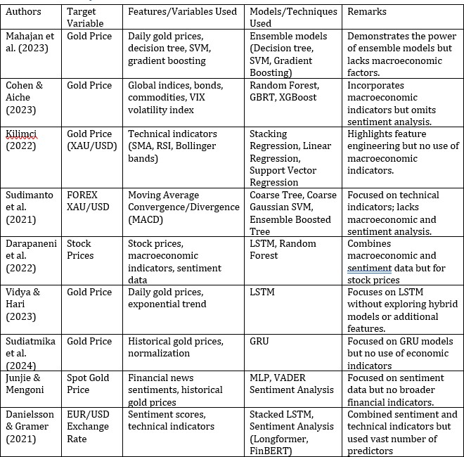

Figure 1: Existing Studies Summary

- Methodology
This section explains in detail the methodology undertaken in the study. CRISP-DM approach is employed in this study covering all the steps from data collection and data preprocessing and visualization, feature engineering, as well as model selection and model assessment. To make accurate predictions on XAU/USD rates this study leverages both time series economic indicators and sentiment analysis. Hence steps taken to calculate the sentiment scores have also been discussed in this section. This methodology follows a systematic approach first by understand, preparing and analyzing the diverse datasets and then employs different machine learning models to derive actionable insights.

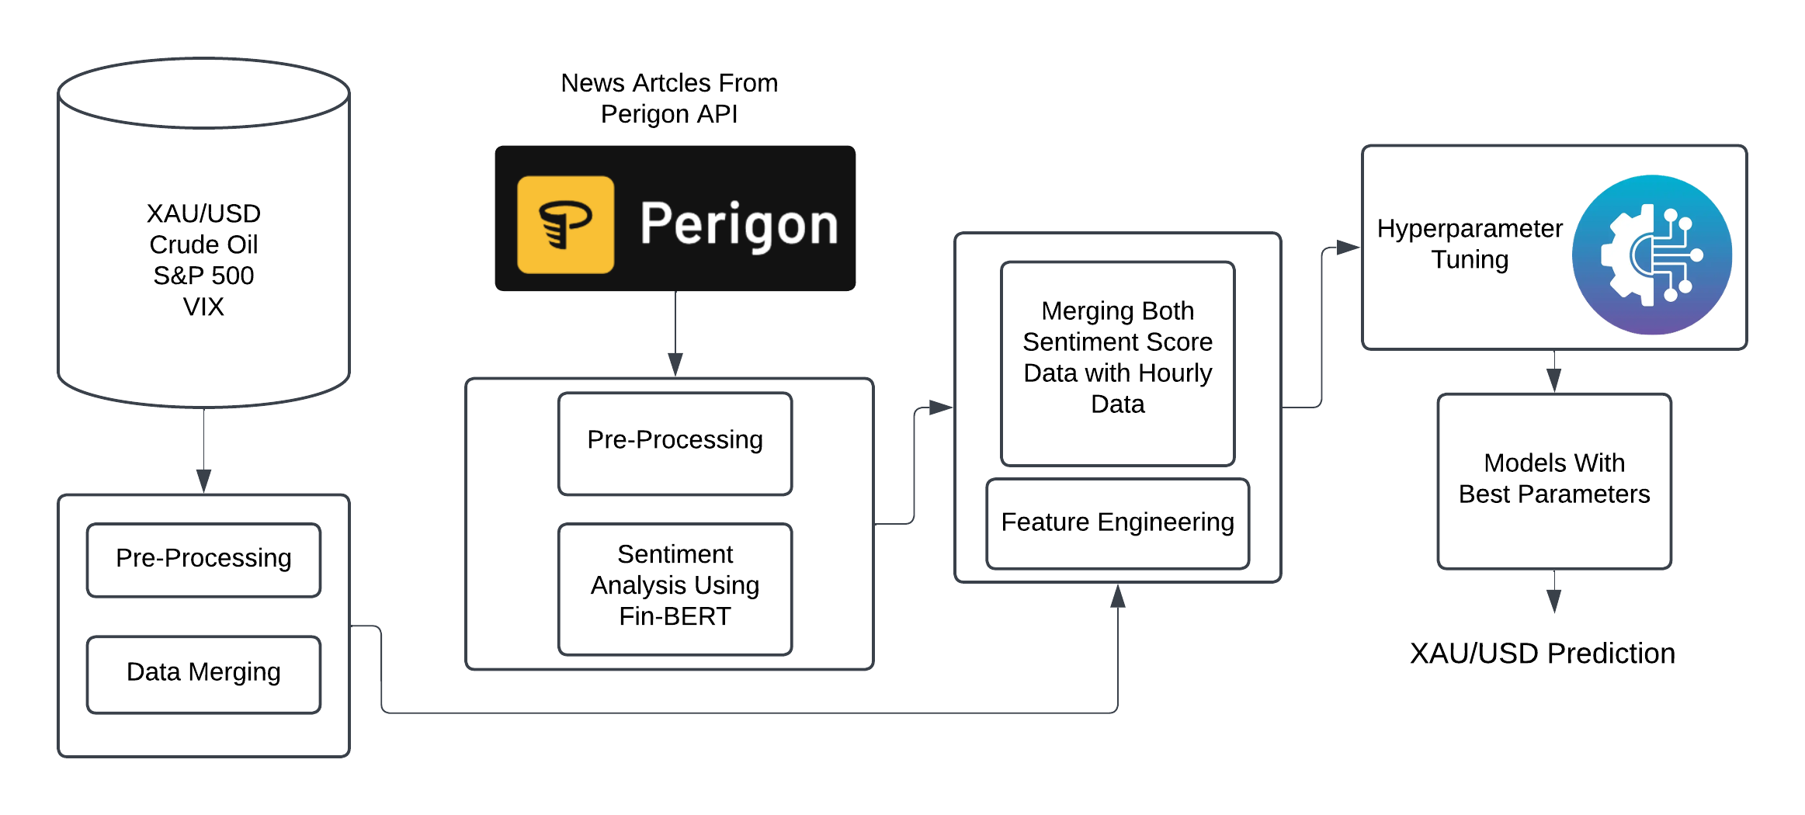
Figure 2: Architecture For XAUUSD Prediction

  - Data Collection
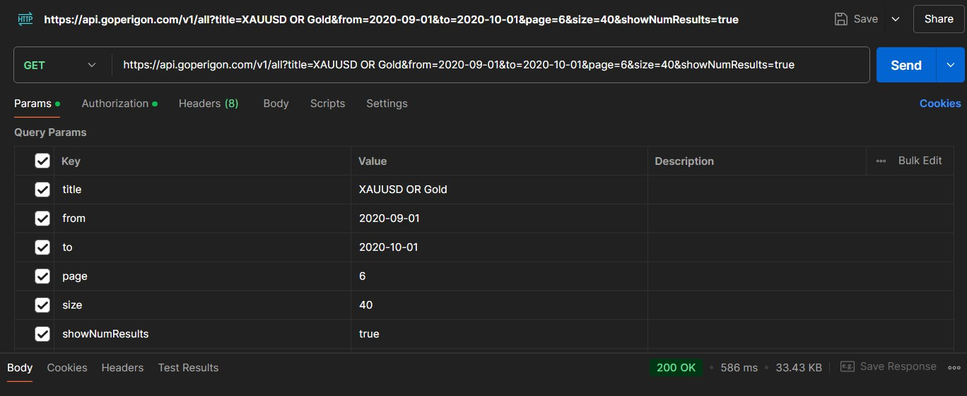
The first step in this research involved in collecting the necessary data essential for mod- elling and analysis. For this study, news articles related to XAU/USD were sourced from Perigon API, which is an HTTP REST API built to fetch news articles and web content. This API delivers responses in JSON format while employing response codes of standard HTTP to provide the status of each request. As Perigon provides data only from July 2020, for this study our datasets are ranged from July 2020 to December 2023. There JSONs containing the news articles were fetched using Postman. All the JSON files were stored systematically in an folder for further processing.

Figure 3: API request in Postman for fetching XAU/USD-related articles Besides the news articles, hourly historical rate of XAU/USD for same duration was
collected from MetaTrader5, which is an recognized trading platform. Along with this hourly data of Crude Oil, S&P500 index and VIX (CBOE Volatility Index) were obtained from the site BacktestMarket.com, which is a reliable source for financial historical data. These historical datasets collected in CSV format and included primary features like Date/Time, Open, Close, Low, High and Volume. These economic indicators were selec- ted on based on their influence on XAU/USD rate.

  - Data Pre-processing
In every data mining project preparing the data plays a pivotal role. Similarly in our research various data preprocessing steps undertaken. It involved in handling the news articles for sentiment analysis and then aligning the sentiment scores with the historical financial datasets for robust modelling.
The first step in the data processing phase is extracting and cleaning the news articles which are encoded in JSON files. These files were accessed one by one and two features were extracted with JSON key “pub date” and “description”. The pub date date has published date and description has article description. The format of pub date was changed from ISO to standardized date-time format and rounded to the nearest hour for easy calculation of hourly sentiment score in later steps. Furthermore, the duplicates records were removed based on both published date and description. Also the missing or invalid values were replaced with NaN values which were then dropped from the dataset. This cleaned data containing features pub date and description was then exported from the Pandas dataframe to excel file for further analysis.
In the next step sentiment analysis was performed on the cleaned news data using FinBERT (Financial BERT) model. FinBERT is a pre-trained natural language pro- cessing model trained mainly on financial data and designed for financial text analysis. The description of each articles is then fed to the FinBERT pipeline, which generates a sentiment label with a confidence score. FinBERT classifies text into three sentiment categories: positive, negative or neutral.
To make the representation of sentiment simple, a single sentiment score was obtained by consolidating individual scores of positive, negative and neutral. Neutral scores were replaced by 0, positive scores were kept unchanged and negative score were multiplied by
-1 to create an unified column named Sentiment Score.
To align with the hourly historical data of XAU/USD the Sentiment Score values are aggregated on hourly basis. The date column pub date values were rounded to the nearest hour and sentiment scores of all articles published within the same hour are summed. This step provides a summarized score for each hour and this data will be saved in excel for further modelling process.
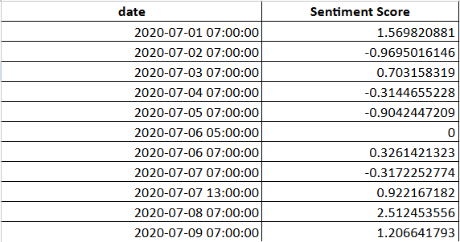
Figure 4: Hourly aggregated sentiment scores

The next steps individual hourly datasets such as XAU/USD, Crude Oil, S&P500 and VIX will be handled. The XAU/USD CSV file has two columns for date and time, which is merged into a single column named TIMESTAMP for easy integration with Sentiment

score dataset. Unwanted columns such as OPEN, LOW, HIGH, VOL,SPREAD and TICKVOL were dropped. As the next step datasets XAU/USD and hourly sentiment score dataset are merged using the TIMESTAMP column in the XAU/USD and date column in the Sentiment Score dataset. After merging the dataset there were some missing values in the sentiment score column because no articles were published during those hours. Forward-filling technique was used to handle these missing values. This merged dataset then saved in excel for further process.
Same as XAU/USD the hourly historical data of Crude Oil, VIX and S&P500 were also preprocessed. Date and time column are merged into the single column. All the unwanted columns are dropped retaining only datetime and close columns. To match the date range of XAU/USD, these datasets were filtered to include data between July 2020 and December 2023. There is a column named CLOSE in all the datasets, so this column in each of the datasets is renamed to crude close, vix close and sp close. Next the all three datasets were merged sequentially with the XAU/USD-Sentiment Score integrated dataset using the datetime column as key. This will ensure that all datasets were aligned with each row representing the hourly observation for all variables. After merging missing values are checked and addressed. The final merged dataset provides a unified view of economic indicators and sentiment scores and is shown in the figure below.
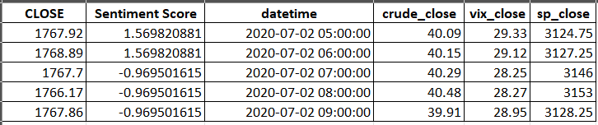
Figure 5: Final Dataset

  - Exploratory Data Analysis
To understand more about the selected features and their relationship with the XAU/USD closing price, exploratory data analysis(EDA) was performed. The correlation analysis
in Figure showed a negative correlation between the VIX index and XAU/USD, which
6
was contrary to the traditional safe-heaven narrative. This is because during the time between 2020 and 2023, market was recovering from the Covid-19 pandemic effects and also interest rate hikes also might have influenced the relationship. Crude oil showed a weak negative correlation and sentiment score also demonstrated a isolated impact of XAU/USD. S&P 500 demonstrated a slightly positive correlation reflecting a nuanced interplay between gold and equity market trends during the period.
To understand the XAU/USD rate trend and pattern, a time-series graph was plotted Figure 7. It revealed significant fluctuations with sharp increases and decreases. It high- lighted the volatility of the gold prices influenced by economic, geopolitical and market factors. There is a long-term upward movement shows the consolidation and correction.

  - Feature Engineering
Feature engineering was essential for this study to ensure the data was effectively prepared for predictive modelling. As discussed during the preprocessing all the datasets were formatted into date-time format to easily merge the datasets. Since scaling features

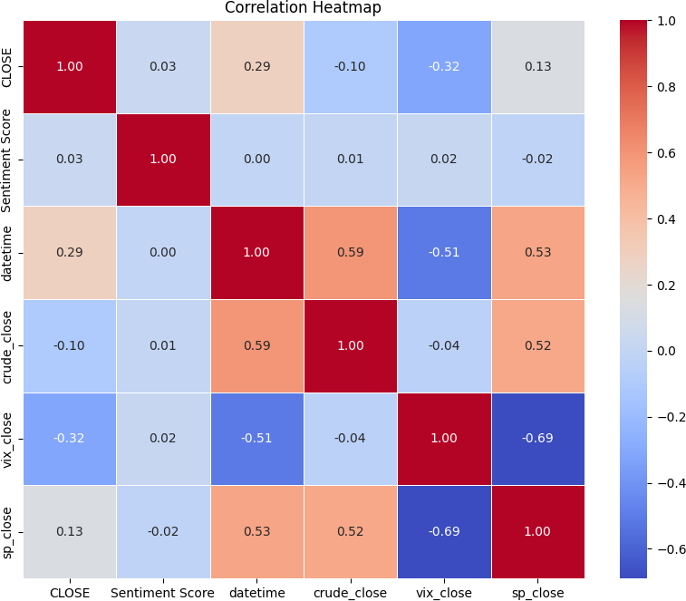

Figure 6: Correlation Heatmap

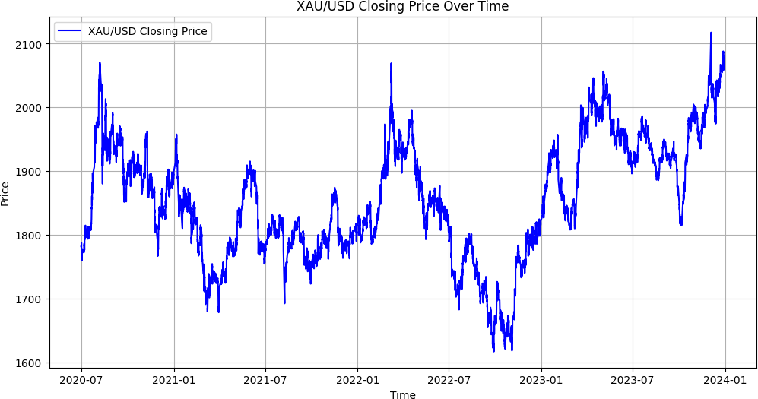

Figure 7: XAU/USD Historical Rates Over Time

facilitates consistency in the data, StandardScaler was applied to transform the data to a standard scale with a mean of zero and a standard deviation of one. The feature CLOSE which represents the hourly closing rate of XAU/USD is selected as target variable, while features such as as sentiment scores, crude oil closing prices, VIX closing values, and S&P 500 closing prices were selected as independent variables. By following these steps the data consistency and suitability for modelling was ensured.

  - Modelling
This phase involved in building and training variety of machine learning algorithms to predict the XAU/USD rate. The dataset was split into 80% for training and 20% for test- ing to evaluate model performance. The algorithms used in this study are Decision Tree, Random Forest, XGBoost, GradientBoost, Supprt Vector Regressor, LSTM and GRU. Each algorithm were selected for its unique strengths ensuring comprehensive modelling and each of these models are described briefly below:

    - Decision Tree Regressor:
Decision Tree is a basic and yet effective algorithm which divides the data based on a feature thresholds and creates a tree structure to take decisions. Every split thus reduces the variance within the data subsets.

    - Random Forest Regressor:
Random Forest is a meta algorithm that works on random sample of the data and builds multiple decision trees. The final output will be obtained through an average of the results of the predictions made by each tree. It is also very useful for decreasing overfitting and for increasing the model accuracy.

    - Support Vector Regressor:
Support Vector Regressor (SVR) was also selected as a kernel-based machine learning model that can detect non-linear structure in financial data. It maps input features to the space of high dimensionality and it determines the correct hyperplane for accurate predictions. Because of its mathematical property and versatility makes it suitable for modeling complicated dependencies between XAU/USD rates.

    - Gradient Boost Regressor:
Gradient Boosting is a type of ensemble technique which will build weak learners iterat- ively. Each of the weak learners corrects the errors of its predecessors. It uses gradient descent function to minimize the errors and optimize the performance. It minimizes the errors by using gradient descent function and performs effectively.

    - XGBoost Regressor:
XGBoost is an optimized version of Gradient Boosting framework which is designed for speed and efficiency. It is well suited to large datasets as it supports parallel computation and it uses regularization techniques to prevent overfitting.

    - Long Short-Term Memory:
LSTM is a type of RNN which is tailored for sequential data to capture long term de- pendencies. It achieves through the use of input, forget and output gates to either retain or discard data selectively. LSTMs are known to be superior in time series analysis makes them a suitable for XAU/USD prediction.

    - Gated Recurrent Unit:
GRU is a simplified LSTM that has less number of parameters yet its performance effect- ively by capturing the temporal dependencies. GRU simplifies its working by eliminating the complication of multiple gates by as it uses gating mechanisms in order to control the flow of information.

    - Hyperparameter Tuning:
In our model building phase we have used different methods for hyperparameter tuning as suitable for each type of model. This study employs GridSearch with 5-fold cross- validation for the traditional models such as Random Forest, Decision Tree, Gradient Boosting Regressor, SVR and XGBoost. All the important parameters of each model was explored such as learning rate, maximum depth and number of estimators.
On the other hand for deep learning models LSTM and GRU, we have applied ran- dom search to explore hyperparameter space. Here Keras Tuner Library was used for hyperparameters like GRU/LSTM units, activation functions, and learning rate were op- timized. Validation loss was used to identify the best hyperparameters. The reason to use distinct approaches here is to ensure the computational efficiency and optimal per- formance across all model types. The table Table 1 contains all the parameters checked for each models.

- Evaluation
In this comparative study, standard regression metrics like Mean Squared Error(MSE), Mean Absolute Error (MAE) and R-Squared (R2) were used to evaluate the predictive models to assess their accuracy, error and ability to explain data variability.
- Mean Squared Error (MSE): It is the square of differences between predicted and actual values. It explains the model’s ability to avoid deviations. A lower value indicates high model accuracy and less prediction errors.
- Mean Absolute Error (MAE): MAE is the average absolute differences between predicted and actual values, , thus providing a clear understanding of prediction accuracy. This is because unlike MSE, it is not skewed by outliers and can therefore be used to determine general trends in error. MAE is an assessment of a model’s capability to provide consistent predictions, which means a low MAE is desirable.
- R-Squared (R²): R2 represents to what extent the model explains the variance in the target variable. It helps assess the model’s ability in capturing the variability in the data.

Table 1: Hyperparameter values for different models.

Model | Parameter | Values
LSTM | lstm units 1 | 50, 100, 150, 200
 | lstm units 2 | 50, 100, 150, 200
 | activation | ’relu’, ’tanh’
 | dropout rate | 0.1, 0.2, 0.3, 0.4, 0.5 (step = 0.1)
 | learning rate | 1e-4, 1e-3, ..., 1e-2 (log sampling)
 | loss | ’mse’ (Mean Squared Error)
GRU | gru units 1 | 50, 100, 150, 200
 | gru units 2 | 50, 100, 150, 200
 | activation | ’relu’, ’tanh’
 | dropout rate | 0.1, 0.2, 0.3, 0.4, 0.5 (step = 0.1)
 | learning rate | 1e-4, 1e-3, ..., 1e-2 (log sampling)
 | loss | ’mse’ (Mean Squared Error)
Gradient Boosting | n estimators | 50, 100, 150
 | learning rate | 0.01, 0.1, 0.5, 1.0
 | max depth | 3, 5, 7
Random Forest | n estimators | 50, 100, 150
 | max depth | None, 10, 20, 30
 | min samples split | 2, 5, 10
 | min samples leaf | 1, 2, 4
Decision Tree | max depth | 3, 5, 10, 20
 | min samples split | 2, 5, 10
 | min samples leaf | 1, 2, 4
XGBoost | n estimators | 50, 100, 200
 | max depth | 4, 6, 8
 | learning rate | 0.01, 0.1, 0.2
 | subsample | 0.7, 0.8, 1.0
 | colsample bytree | 0.7, 0.8, 1.0
SVR | C | 0.1, 1, 10, 100
 | kernel | ’linear’, ’rbf’
 | gamma | ’scale’, ’auto’, 0.1, 1, 10

  - Experiment 1: Decision Tree Regressor
The Decision Tree Regressor model with best parameters performed reasonably with MSE of 354.7371, MAE of 7.9344 and R² of 0.9587. Further feature importance analysis showed that crude oil prices and S&P 500 closing prices were the most significant predictors. The model effectively captured of the significant trends of the data but had some discrepancies, pointing to the fact that even deeper or ensemble based kinds of models may help more due to the data complexity.

  - Experiment 2: Random Forest Regressor
Random Forest Regressor performed better than any other model with MSE of 186.9992, an MAE of 7.2035, and an R² score of 0.9782. Due to the ensemble capabilities model

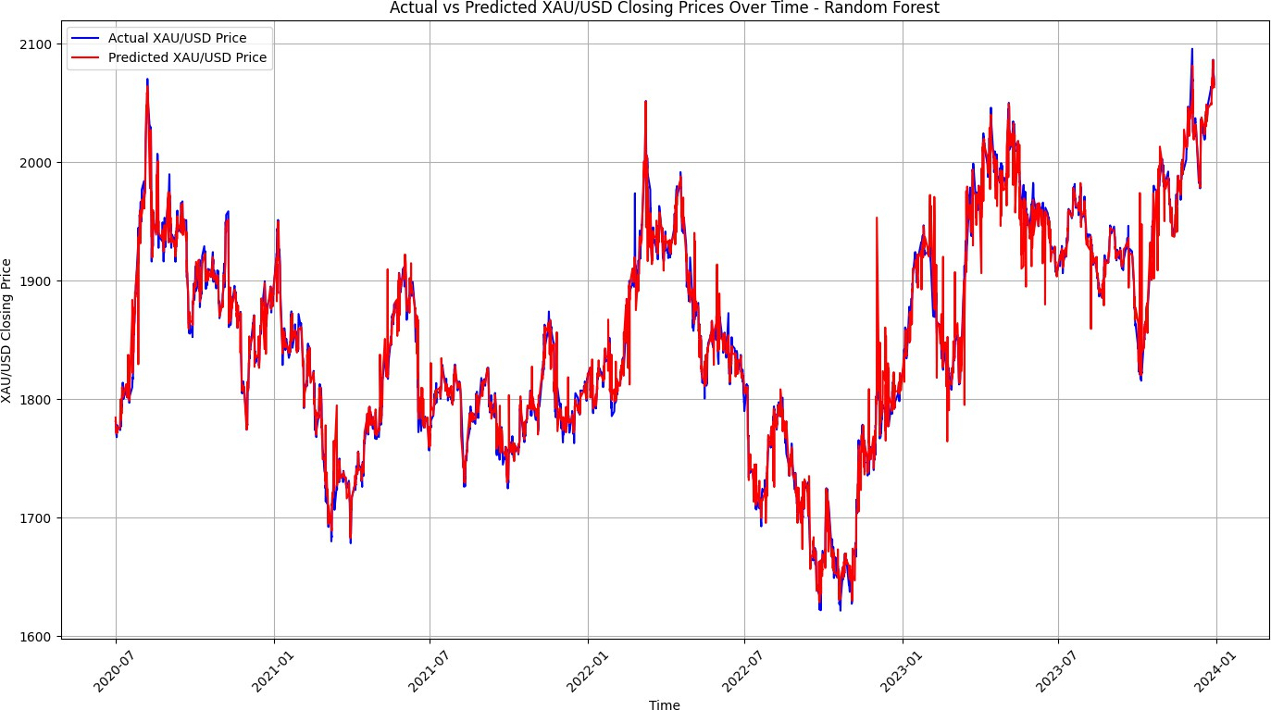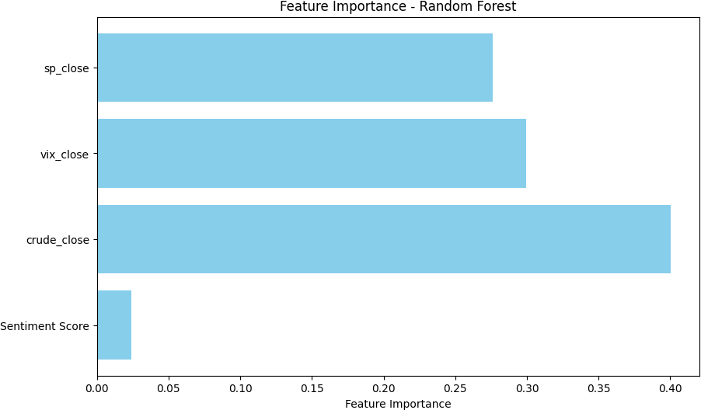

Figure 8: Actual vs Predicted XAU/USD Closing Prices Using Random Forest Model Over Time
Figure 9: Feature importance plot of the model

improved its ability to generalize and reduced overfitting. Because of its high accuracy and less sensitivity to noise, this model would be suitable for financial forecasting.
The feature importance plot in Figure 9 shows that the features ’crude close’ and ’sp close’ are the most significant predictors, while the ’sentiment score’ has a relatively smaller influence on the prediction. Also time-series plot in Figure 8 which compares the actual and the predicted XAUUSD rates shows the capability of the random forest to closely follow the trends and fluctuations.

  - Experiment 3: Gradient Boosting Regressor
Gradient Boosting resulted in MSE of 311.2950, MAE of 10.5101 and R² of 0.9637. This model was able to progressively rectify its mistakes with the help of the boosting mech- anism and therefore performed well. Thus, somewhat higher error metrics compared to Random Forest indicate that some dynamics can be missed due to the choice of hyper- parameters or interactions with features.

  - Experiment 4: XGBoost Regressor
The XGBoost model achieved a R² score of 0.9760 with an MSE of 205.9491 and MAE of 8.5170. The feature importance plot showed that crude oil prices and VIX close prices are the key predictors. This is likely due to the ability of XGBoost to handle non-linearity relationships and interactions which has been suggested in existing studies Cohen and Aiche (2023) where XGBoost models have outperformed other models when dealing with similar financial datasets.

  - Experiment 5: Support Vector Regressor
The performance of SVR was moderate in this study, achieving an MSE of 452.8473, an MAE of 11.4575, and an R² score of 0.9472. However, SVR, which is known for its performance in non-linear data, struggled with scale of the dataset, which may be due to its to its sensitivity to parameter tuning.

  - Experiment 7: Long Short-Term Memory (LSTM)
The LSTM model, which is designed for sequential data, achieved an MSE of 587.2744, an MAE of 17.2771, and an R² score of 0.9316. Even though it has temporal capabilities, its performance lagged behind the ensemble models, which implies that feature-level interactions may overpowered the temporal dependencies in this dataset. The Figure 11 shows the training and validation loss curves for LSTM model over the epochs. We can see that the steep decline in both curves reflects the capability of LSTM model to train effectively on our dataset. Also from the plot we can see that LSTM exibits strong generalization and minimized overfitting.
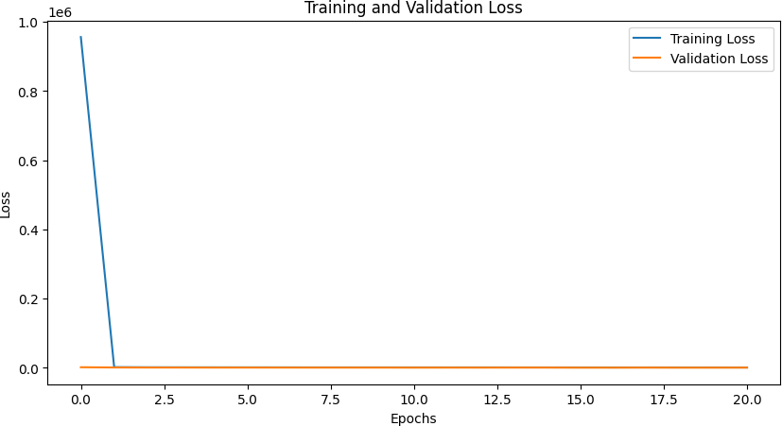
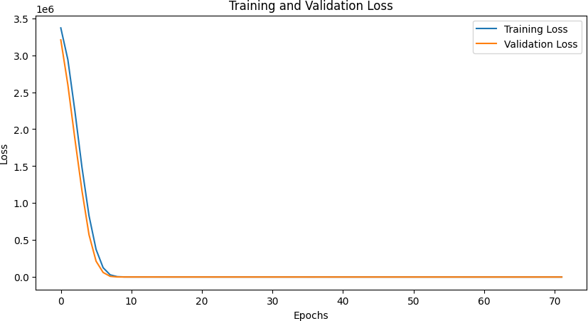

Figure 10: Training and Validation Loss Over Epochs for GRU
Figure 11: Training and Validation Loss Over Epochs for LSTM

  - Experiment 7: Gated Recurrent Unit (GRU)
GRU was the lowest performed model in this study. Even though it was a computationally efficient alternative to LSTM, it achieved MSE of 697.5075, an MAE of 18.9500, and an R² score of 0.9187. Despite doing the hyperparameter tuning using RandomSearch, its rapid convergence in the plot Figure 11 suggests the chances of overfitting.
However, these metrics fall short compared to other models like Random Forest, suggesting that GRU’s performance may have been affected by dataset constraints or limitations in the hyperparameter tuning process. The model’s rapid convergence also suggests potential overfitting or limited learning capacity, emphasizing the need for fur- ther experimentation with larger, more diverse datasets and alternative tuning methods to enhance its predictive accuracy.

  - Best Performing Model
Out of all the models Random Fores Regressor emerged as the best performing model in terms of both metrics and simplicity. It achieved the lowest MSE and highest R-squared score while maintaining interpretability. The second ranked model was XGBoost because of its strong performance metrics and its capability to handle non-linearity in the data. These results are consistent with previous studies, where ensemble models have shown their capability in similar financial forecasting tasks. This evaluation confirms the use of ensemble models in capturing complex patterns and interactions in the financial datasets. While deep learning models like LSTM and GRU are well suited for sequential data tasks they were outperformed in this study by ensemble methods probably because of the kind

of features employed. The table Table 2 shows the best parameters for each model and their metrics.

Table 2: Best Parameters of Models And Their Metrics
Model | Best Parameters | R² Score | MSE | MAE
LSTM | lstm units 1: 200, lstm units 2: 150, activation: relu, dro- pout rate: 0.3, learning rate: 0.00086 | 0.9316 | 587.27 | 17.28
GRU | gru units 1: 150, gru units 2: 200, activation: tanh, dro- pout rate: 0.4, learning rate: 0.00922 | 0.9187 | 697.51 | 18.95
Gradient Boosting | n estimators: 150, learning rate: 0.5, max depth: 7 | 0.9637 | 311.3 | 10.51
Random Forest | n estimators: 150, max depth: 30, min samples split: 2, min samples leaf: 1 | 0.9782 | 187 | 7.2
Decision Tree | max depth: 20,  min samples split: 2, min samples leaf: 1 | 0.9587 | 354.74 | 7.93
XGBoost | colsample bytree: 1.0, learn- ing rate: 0.2, max depth: 8, n estimators: 200, subsample: 0.7 | 0.976 | 205.95 | 8.52
SVR | C: 100, gamma: 10, kernel: rbf | 0.9472 | 452.85 | 11.46

  - Discussion
In this study I have implemented popular machine learning models for the prediction of XAU/USD hourly rate using economic indicators and sentiment analysis. The results showed that most models demonstrated significant predictive capabilities but limitations and ways to enhance the results became apparent during the analysis.
After tuning all the models with the best parameters, Random Forest emerged as the most effective model in this study. It showed an balance between metrics and in- terpretability, proving it to be a robust choice for XAU/USD rate prediction. LSTM was able to capture temporal dependencies well, but due to high computational require- ment and extensive tuning makes it unsuitable for real-world, time-sensitive applications. GRU showed overfitting and failed to exhibit generalization. Other ensemble models like XGBoost and Gradient Boosting also showed their capabilities in handling non-linear conditions making them ideal for financial problems. While these models performed well in predicting XAUUSD, but the feature importance plot Figure 9 of all models revealed that impact of sentiment score feature was limited. One of the reasons can be that, in

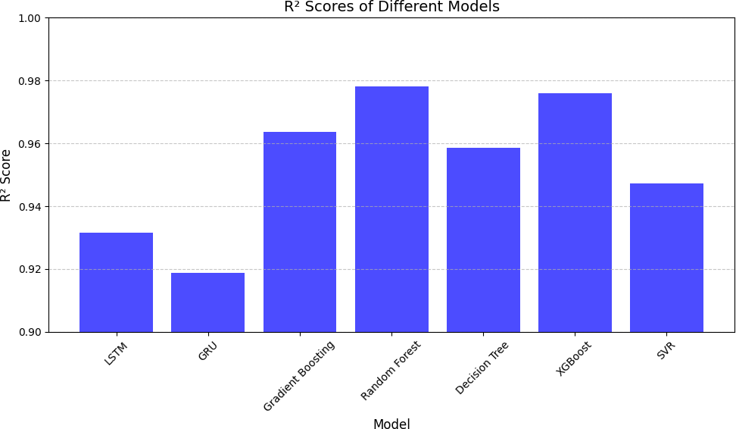

Figure 12: R² Scores of All Models

this project Perigon API was used for the news articles collection and this API only had the access to news articles from July 2020. Another reason can be sentiment scores inability to accurately reflect the markets’s reaction to news headlines. Because not all news will have direct or proportional impact on financial decisions. The major limitation of this study is the dataset size, due to the dependency on Perigon API as discussed earlier. Although the models performed well, having a larger and more diverse dataset would increase generalization and model reliability. Other features based on sentiments like polarity scores and keywords-based sentiments were not explored due to time con- straint. Perhaps, the use of domain specific insights and high frequency financial data could better capture relationships between sentiment and gold prices.
The results of this study aligns with the previous studies that ensemble models have always been superior in compared to other standalone models or deep learning models in the field of financial prediction. This study has contributed valuable insights to the financial field by demonstrating how machine learning models can be employed to pre- dict XAU/USD rates integrating sentiment analysis and economic indicators. Although the study’s exhibited limitations due to the limited sentiment data and small data size, it revealed strong predictive capabilities of various machine learning models, especially ensemble models.

- Conclusion and Future Work
In this study, the primary goal was to perform a comparison analysis of predictive capab- ilities of various popular machine learning models in predicting XAUUSD rate integrating economic indicators and sentiment from the news articles. To meet these objectives, a comprehensive dataset was developed. It included historical hourly rates of XAUUSD, hourly sentiment scores derived from the news articles and economic indicators namely crude oil, VIX index and S&P 500. Different machine learning models were implemented

and compared based on the evaluation metrics such as Mean Absolute Error (MAE), Root Mean Squared Error (RMSE), and R² Score.
Out of all the models implemented Random Forest Regressor emerged as the effective model due to its interpretability and computational efficiency. XGBoost and Gradient Boost Regressor also performed similarly revealing that ensemble models perform best for the similar financial prediction applications.
Although the performance of models in predicting the XAU/USD rate was great, it was observed that sentiment scores had relatively limited influence on the predictions. Future work can be carried out with a broader dataset like including more economic indicators related to XAU/USD and larger number of articles of wider timeframe. Besides these other sentiment features like polarity scores or keyword-specific sentiment score techniques can be explored.

References
Andriani, W., Gunawan and Prayoga, A. (2023). Prediksi nilai emas menggunakan al- goritma regresi linear, Jurnal Ilmiah Informatika Komputer 28: 27–35.
Bai, Y. (2024). Research on gold price prediction based on arima model, Theoretical and Natural Science 52: 41–48.
Birdi, N., Sarangi, P. K., Singla, T., Sahoo, A. K. and Subudhi, G. B. (2023). Forex trend analysis using rnn and lstm models: Predictive analytics through neural networks, 2023 International Conference on Computational Intelligence and Sustainable Engineering Solutions (CISES), pp. 206–210.
Bunnag, T. (2023). The importance of gold and forecasting of the gold price using arima, arima-garch, and arima-tgarch model.
Chaboud, A., Rime, D. and Sushko, V. (2023). The foreign exchange market, Technical Report BIS Working Papers No. 1094, Monetary and Economic Department. JEL classification: F31, G15.
URL: https://www.bis.org/publ/work1094.html
Cohen, G. and Aiche, A. (2023). Forecasting gold price using machine learning method- ologies, Chaos, Solitons Fractals 175: 114079.
URL: https://www.sciencedirect.com/science/article/pii/S0960077923009803
Darapaneni, N., Paduri, A., Sharma, H., Manjrekar, M., Hindlekar, N., Bhagat, P., Aiyer,
U. and Agarwal, Y. (2022). Stock price prediction using sentiment analysis and deep learning for indian markets.
Gong, W. (2024). Research on gold price forecasting based on lstm and linear regression,
HS Web of Conferences 181: 02005. ICDEBA 2023.
Guha, B. and Bandyopadhyay, G. (2016). Gold price forecasting using arima model,
Journal of Advanced Management 4(2): 117–121.
Junjie, Z. and Mengoni, P. (2020). Spot gold price prediction using financial news senti- ment analysis, 2020 IEEE/WIC/ACM International Joint Conference on Web Intelli- gence and Intelligent Agent Technology (WI-IAT), pp. 758–763.

Kilimci, Z. (2022). Ensemble regression-based gold price (xau/usd) prediction, Journal of Emerging Market Finance 2: 7.
Mahajan, R., Patil, P., Chikmurge, D. and Barve, S. (2023). Forecasting gold price using ensemble based machine learning approach.
Makala, D. and Li, Z. (2021). Prediction of gold price with arima and svm, Journal of Physics: Conference Series 1767: 012022.
Manjula, K. A. and Karthikeyan, P. (2019). Gold price prediction using ensemble based machine learning techniques, 2019 3rd International Conference on Trends in Electron- ics and Informatics (ICOEI), pp. 1360–1364.
N, D., Prajapati, P. R., M, R., Ramesh, R., Kodipalli, A. and Joy Martis, R. (2021). Prediction of gold price using deep learning, 2021 IEEE 9th Region 10 Humanitarian Technology Conference (R10-HTC), pp. 1–5.
Neely, C. (1997). Technical analysis in the foreign exchange market: A layman’s guide,
Review 79: 23–38.
Neely, C. and Weller, P. (2011). Technical analysis in the foreign exchange market, Tech- nical Report Working Paper 2011-001B, Federal Reserve Bank of St. Louis Research Division. Accessed: 1 August 2024.
Pant, K. and Pant, A. (2024). Exchange rate prediction using time series approach, Title of the Journal or Conference Proceedings . Accessed: 2 August 2024.
Rakshitha, Y., Divya Sri, K., Swetha, B., Alajangi, S. and Kavitha, D. (2024). Data mining strategies for gold price prediction using multi-factorial influences, International Journal for Multidisciplinary Research (IJFMR) 6: 1. M.TECH. Integrated CSE with specialization in Business Analytics, VIT Chennai.
URL: https://www.ijfmr.com
S, V. G. and S, H. V. (2020). Gold price prediction and modelling using deep learning techniques, 2020 IEEE Recent Advances in Intelligent Computational Systems (RA- ICS), pp. 28–31.
Sami, I. and Nazir, K. (2018). Predicting future gold rates using machine learning ap- proach, International Journal of Advanced Computer Science and Applications 8: 92– 99.
Sudiatmika, I., Putra, I. and Artana, W. (2024). The implementation of gated recurrent unit (gru) for gold price prediction using yahoo finance data: A case study and analysis, Brilliance: Research of Artificial Intelligence 4: 176–184.
Sudimanto, Y., Heryadi, L. and Wibowo, A. (2021). Foreign exchange prediction us- ing machine learning approach: A pilot study, 2021 4th International Conference on Information and Communications Technology (ICOIACT), IEEE, pp. 239–242.
Syrris, I. and Shenai, V. (2021). Forecasting gold prices with arima and garch models.
Wafi, A. S., Hassan, H. and Mabrouk, A. (2015). Fundamental analysis models in financial markets – review study, Procedia Economics and Finance 30: 939–947. Available at: https://doi.org/10.1016/S2212-5671(15)01344-1 (Accessed: 1 August 2024).

JOURNAL OF BEHAVIORAL AND EXPERIMENTAL FINANCE

Editors-in-Chief
STEFAN PALAN, University of Graz
ELENA N. ASPAROUHOVA, University of Utah, UT

Associate Editors
MICHAEL DOWLING, Dublin City University
YAOYAO FAN, Dongwu Business School, Soochow University ANDREAS HELLMANN, Macquarie University Sydney
FELIX HOLZMEISTER, University of Innsbruck ANAND JHA, Wayne State University
TIM KAISER, Koblenz University XIAO LI, Nankai University
DEBRAH MELOSO, Toulouse Business School CHRISTOPH MERKLE, Aarhus University

ROLAND MESTEL, University of Graz
SOPHIE MOINAS, Toulouse School of Economics YIHUI PAN, University of Utah
E´ LISE PAYZAN-LENESTOUR, University of New South Wales ORLY SADE, Hebrew University of Jerusalem
XUAN VINH VO, University of Economics, Ho Chi Minh City MEI WANG, WHU, Vallendar
WENHAO YANG, Chinese University of Hong Kong, Shenzhen

Founding Editor
BRYAN M. LUCEY, Trinity College

Editorial Board
LUCY ACKERT, Kennesaw State University RAJ AGGARWAL, University of Akron, OH GREG DAVIES, Oxford Risk, London
LIAM DELANEY, University College Dublin JOHN W. GOODELL, University of Akron, OH COLM HARMON, University of Sydney JULIA HENKER, Bond University
HA˚ KAN HOLM, Lund University
JU¨ RGEN HUBER, University of Innsbruck KENNETH A. KIM, Tongji University MICHAEL KIRCHLER, University of Innsbruck LISA KRAMER, University of Toronto
CATHERINE KYRTSOU, University of Macedonia, University of Paris 10, University of Strasbourg
MORTEN LAU, Copenhagen Business School PATRICK L. LEONI, Kedge Business School, Marseille IGOR LONCARSKI, University of Ljubljana
PETE LUNN, Economic and Social Research Institute, Dublin RYAN O. MURPHY, Morningstar, Inc.

DAVID NAWROCKI, Villanova University CHARLES NOUSSAIR, University of Arizona
MICHAEL M. POMPIAN, Mercer Investment Consulting RACHEL A.J. POWNALL, Maastricht University VICTOR RICCIARDI, Goucher College, Baltimore, MD PATRICK ROGER, Universite´ de Strasbourg
ASTRID SALZMANN, RWTH Aachen University ALESSANDRO SANTONI, European Central Bank MICHAEL DAVID SEBASTIAN, Hewitt EnnisKnupp, Inc.
MICHAEL J. SEILER, College of William and Mary, Williamsburg, VA
DEHUA SHEN, School of Finance, Nankai University OLIVER SPALT, Tilburg University
MEIR STATMAN, Santa Clara University, CA STEFAN TRAUTMANN, University of Heidelberg UTZ WEITZEL, Utrecht University
NING ZHU, UC Davis and Shanghai Advanced Institute for Finance

Scientific Transfer Manager
KENNETH KIM, Tongji University

Received: 2022-04-08 | Reviewing: 2022-04-08 & 2022-05-20| Accepted: 2022-05-21 | Online: 2022-05-22 | Issue Date: 2022-06-30
Ensemble Regression-Based Gold Price (XAU/USD) Prediction
Zeynep Hilal Kilimci
Department of Information Systems Engineering Kocaeli University
Kocaeli, 41001, Turkey zeynep.kilimci@kocaeli.edu.tr 0000-0003-1497-305X

Abstract—The prediction of any commodities such as cryptocurrency, stocks, silver, gold is a challenging task for the investors, researchers, and analysts. In this work, we propose a model that forecasts the value of 1 ounce of gold in dollars by using regression ensemble-based approaches. To our knowledge, this is the very first study in terms of combining regression models for the prediction of XAU/USD index although there are plenty of methods employed in the literature to forecast the price of gold. The contributions of this study are fivefold. First, the dataset is gathered between July 2019 and July 2020 from global financial websites in the world, and cleaned for modeling. Then, feature space is extended with technical and statistical indicators in addition to opening, closing, highest, lowest prices of gold index. Next, different regression and ensemble-based regression models are carried out. These are linear regression, polynomial regression, decision tree regression, random forest regression, support vector regression, voting regressor, stacking regressor. Experiment results demonstrate that the usage of stacking regression combination model exhibits considerable results with 2.2036 of MAPE for forecasting the price of XAU/USD index.
Keywords—Gold price prediction, XAU/USD index forecast, ensemble regression, stacking regressor
- Introduction
Gold, a precious metal, has maintained its popularity among societies for thousands of dec as a barter, reserve unit, and jewelry. Considering the durability of the gold mine due to its structure, the convenience it ensures in terms of its workability and other benefits, it is significant for the business in production and for the financial markets as a commodity. For this reason, the price of gold is widely followed in the world financial markets. If the gold index is the price of an ounce of gold traded in US dollars (XAU/USD), that is, it refers to how many US dollars it takes to buy an ounce of gold. Gold, as a commodity, is considered one of the most important investment instruments not only for companies that are in close contact with the outside world, but also for any country. Countries and multinational companies use the exchange rate, which is one of the most important economic variables, as well as gold reserves as variables to ensure their connection with the outside world. This makes the gold index and the gold market one of the largest and most important financial markets in the world. For this reason, the gold index can be quickly affected in a positive or negative way by many developments that may occur in the markets, the economy and political policies. Taking into account external factors, it becomes almost impossible to control the future level of the gold index and its market. This makes gold index forecasting a more attractive and active research area for researchers, and investors. Within the scope of this study, it is proposed to construct a model that predicts the price of the gold index based on the regression ensemble-based approach.
Regression analysis is known as a collection of statistical procedures for predicting the relations between a dependent argument and one or more independent arguments. Regression analysis is especially employed for two conceptively different objectives. Firstly, regression analysis is evaluated to conclude causal relations between the independent and dependent arguments. Second, regression analysis is commonly utilized for forecasting, where its use has drastically coincided with the area of machine learning. The second usage of regression analysis is the main focus of this work. The most used kinds of regression analysis are linear regression, logistic regression ridge regression, etc. In this study, linear regressor, decision tree regressor, random forest regressor, and support vector regressor are evaluated as base regressors on the other hand voting regressor, and stacking regressor are assessed as ensemble regression models to predict the gold price.
In this study, it is proposed to forecast the price of gold index (XAU/USD). Movements in XAU/USD are analyzed between July 2019 and July 2020 by gathering data from global financial websites. In order to compose feature set is, opening, closing, the highest, and the lowest gold prices are included to the dataset. The same variables of the dollar index that have an effect on gold have been added to the dataset. In order to extend feature space, technical indicators are also included namely, simple moving average, relative strength index, and Bollinger band. Then, five different regression models are constructed namely, linear regression, polynomial regression, decision tree regression, random forest regression, support vector regression. Finally, voting regressor and stacking regressor models are employed by consolidating previous four regression models to get more robust prediction of gold price. There are plenty of methods employed by academic circumferences to evaluate and forecast the price of gold, such models are based on linear regression (MLR), support vector machine (SVM), artificial neural network (ANN), etc. To our knowledge, this is the very first attempt in terms of combining regression models for the prediction of XAU/USD index. Experiment results demonstrate that the combining of regression models is an effective method to acquire more robust results for forecasting the gold price instead of employing individual estimates.
The rest of the article is organized as follows: Section 2 presents a summary of studies that analyze predict direction on financial investment instruments. Section 3 contains the architecture of the proposed model and the methods used for the construction of the system. The results of the experiment and the conclusions are presented in Section 4 and Section 5.
- Related Work
This part provides a summary of the literature studies on regression analysis to estimate the price or direction of

Cite (APA): Kilimci, Z.H. (2022). Ensemble Regression-Based Gold Price (XAU/USD) Prediction. Journal of Emerging Computer Technologies, 2(1), 7-12.
Volume:2, No:1, Year: 2022, Pages: 7-12, June 2022, Journal of Emerging Computer Technologies

different instruments such as digital currencies, stocks, mineral commodities such as gold, silver, bonds, funds and such products.
In a study [1], authors propose to forecast gold prices using multiple regression method (MLR). Various parameters which have an impact on the gold prices are employed to construct feature set such as Commodity Research Bureau future index (CRB), USD/Euro Foreign Exchange Rate (EUROUSD), Inflation rate (INF), Money Supply (M1), New York Stock Exchange (NYSE), Standard and Poor 500 (SPX), Treasury Bill (T-BILL), and US Dollar index (USDX). Authors report that the success of proposed model is competitive for forecasting the price of gold with 85.2% of sample variations in monthly described by the model. In another study [2], authors aim to predict price of gold employing multiple linear regression with principal component analysis (PCA). In order to eliminate the problem of presence of multicollinearity of the explanatory variables, PCA is employed in the experiments. The usage of PCA contributes to the performance of the proposed system by improving prediction accuracy from
0.572 to 0.625. In other study [3], a new consolidated approach (ICA- GRUNN) based on independent component analysis (ICA) and gate recurrent unit neural network (GRUNN) is presented on the estimation of gold price. Authors conclude the paper that ICA-GRUNN outperforms the traditional techniques such as autoregressive integrated moving average (ARIMA), radial basis function neural network (RBFNN), long short-term memory neural network (LSTM), GRUNN, and ICA-LSTM in terms of accuracy.
In a study [4], authors investigate the impact of Chicago Board Options Exchange (CBOE) gold and silver implied volatility on gold futures volatility in China using heterogeneous autoregressive (HAR) and Ridge regression methods. To demonstrate the effectiveness of the proposed models, data is gathered between March 18, 2011 and June 29, 2018. Authors report that HAR and Ridge regression-based models perform better predictive performance compared to the benchmark models. Pierdzioch et al. present a real-time approach based on quantile-regression in order to assess forecast out-of-sample gold returns with the help of macroeconomic and financial parameters [5]. With the usage of real-time quantile-regression technique, model instability, uncertainty, and the possibility that a forecaster has an asymmetric loss function is provided. Authors inform that the forecasts calculated employing the real-time quantile- regression model performs better than an autoregressive model. In a study [6], Suranart et al. focus on the various models namely, neural network, radial basis function network and support vector regression (SVR) to forecast the price of gold. The dataset is collected between June 2008 and April 2013 and evaluated as monthly and weekly. Experiment results indicate that SVR exhibits superior performance on both weekly and monthly data by performing 1.140 of MAPE and 0.908 of MAPE, respectively. In a study [7], authors investigate the effect of decision tree and support vector regression models on the prediction of gold price. The decision tree technique is utilized for the feature selection task while the regression is performed for the purpose of gold index estimation. Experiment results show that the consolidation of decision tree and support vector regression models boost the prediction performance compared to the techniques namely, linear regression and neural network. Sadorsky proposes tree- based classifiers to forecast the direction of gold and silver price [8]. For this purpose, bagging, stochastic gradient
boosting, and random forests are employed. The prediction performance of tree-based methods that ranges from 85% and 90% excels when compared to the logit models for 20-day and 10-day estimates. In another study [9], Mithu et. al propose to estimate the gold price employing regression methods for stock market inconsistency and settling economic. For this purpose, authors evaluate support vector regression (SVR), random forest regressor (RFR), decision tree, gradient boosting, and XGBoost methods separately to estimate the daily gold price. The paper is concluded the superior performance of RFR algorithm with 99% of accuracy score. In [10], authors focus on estimating artificial neural networks of gold prices using multiple linear regression models. Experiment results demonstrate that MRL analysis in an effective way to compose the network pattern and get more accurate estimation score with 0.004264% of MSE.
- Methods
In this part, regression and ensemble regression-based models are introduced used in this work.
- Linear Regression (LR)
In statistics, linear regression is a linear model for constructing the relation between a scalar answer (dependent) and one or more expository parameters (independent). The state of one expository parameter is named as simple linear regression while the situation is named as multiple linear regression for more than one variable [11]. However, this is rather different from multivariate linear regression, where multiple related dependent parameters are estimated, rather than a one scalar parameter [12]. The correlations are composed of employing linear estimator functions whose unknown model variables are predicted from the data in linear regression. These are called as linear models [13]. Linear regression is the first and broadly employed type of regression analysis in various applications [14]. These are trend estimation in time series data, epidemiology, finance, economics, environmental science, machine learning, etc. Because linear regression is extensively applied in social, behavioral, biological and sciences to define possible relations between parameters, it is as one of the most significant tools employed in these fields.
- Polynomial Regression (PR)
Polynomial regression is a form of Linear regression employed as a specific version of multiple linear regression which forecasts the relation between independent and dependent variables as an nth degree polynomial [15]. Even though polynomial regression complies a nonlinear model to the data, as a statistical forecast problem it is linear, that is the regression method is linear in the unknown variables that are forecasted from the data. That is why polynomial regression is accepted to be a specific situation of multiple linear regression.
- Decision Tree Regression (DTR)
This approach is also known as decision tree learning or induction of decision trees which is one of the predictive modelling techniques used in machine learning, data mining, and statistics. It utilizes a decision tree as a predictive model to move from samples about an item demonstrated in the branches to outcomes about the item's goal value indicated in the leaves. In tree models, if the goal parameter will take a discrete set of values are named as classification trees while

goal variable will get continuous values are entitled as regression trees [16]. Decision trees are assessed as intelligibly and simple among the other widely-used machine learning techniques [17].
- Random Forest Regression (RFR)
Random decision forests or random forests are supervised learning techniques that are utilized for both classification and regression. The term forest stands for lots of decision trees. The model builds an ensemble of decision trees at training phase and blends their decisions by making inferences about the goal category (classification) that is the highly voted by the community of decision trees or average estimation (regression) of the base trees. Random forest approach ensures superior predictive accuracy, and do not enable overfitting if there are adequate trees in the forest [18], is proposed by Breiman [19]. In this work, random forest algorithm is employed with 100 estimators.
- Support Vector Regression (SVR)
Support vector machine (SVM) is initially presented by Vapnik [20]. Support vector classification (SVC) and support vector regression (SVR) are two major categories for SVMs. SVM is a learning framework employing a high dimensional feature space. It provides functions of prediction that are enlarged on a sub set of support vectors. A variant of a SVM for regression model is asserted in 1997 by Vapnik et al. [21]. This model is named as support vector regression (SVR). The method generated by SVC just bounds up with a sub set of the training data, for the cost function for constructing the method does not attach importance to training data that reach out further the margin. Likewise, the model generated by SVR solely is contingent on a subset of the training data, inasmuch as the cost function for establishing the system disregards any training data that is near to the model estimation. SVR is the widely applied version of SVMs. One of the basic properties of SVR is that in place of reducing the error of observed training, SVR proposes to decrease the generalized error bound so as to accomplish generalized success. The generalization error is composed of the consolidation of a regularization term that checks the complexity of the hypothesis space and the error of training.
- Voting Regressor (VR)
A voting ensemble or majority voting is an ensemble machine learning technique that consolidates the estimations from a lot other method. This generally is employed to develop the success of the system by integrating various models instead of using any single learning technique. In other words, majority voting is utilized for both classification or regression, is performed by consolidating the decisions from multiple methods. In the event of regression [22], it is calculated by taking average of the estimations of all models, while the predictions for each class are aggregated and the final decision on class with the majority vote is estimated in classification [23]. In summary, a voting regressor used in this work is an ensemble meta-predictor that conforms distinct individual regressors, each on the entire dataset. Then, the average of individual forecasts is ensured to decide a final estimation.
- Stacking Regressor (SR)
Stacking is an ensemble technique that employs a meta- learning method to learn how to best consolidate the
estimations from two or more individual machine learning techniques [24]. The advantage of stacking approach is that it can benefit the abilities of a set of well-performed methods on a regression or classification task and make estimations that have better success than any individual method in the ensemble. The meta-model is frequently basic, maintaining a smooth explication of the estimations performed by the individual models. For this reason, linear methods are constantly utilized as the meta-model. For instance, linear regression is employed for regression tasks while logistic regression used for classification tasks for the purpose of forecasting a label of class.
- Proposed Framework
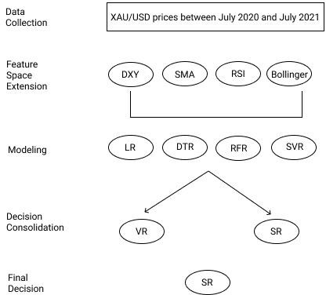
Fig. 1. The architecture of proposed model.
In this work, the prediction of gold price index (XAU/USD) is proposed. First, data collection process is performed between July 2019 and July 2020. Due to weekends and public holidays, 252 days of data were collected from the financial website. Missing 113 days of data is completed with a quadratic decal calculation method. Prices of opening, closing, highest, and lowest XAU/USD index are collected via the investing.com website with the help of Selenium library. The feature space of the data set is extended by collecting different features that may affect the direction and price of the gold index in the same date range. These are simple moving average (SMA) for 20, 50, and 100 days, opening, closing, highest and lowest dollar index (DXY) prices, 14-day relative strength index (RSI), the upper, middle and lower values of the Bollinger band (BB). SMA- 20, SMA-50, SMA-100 mean 20-day, 50-day, 100-day simple moving averages of 1 ounce of gold, respectively. RSI-14 represents the 14-day relative strength index of 1 ounce of gold. BB-upper, BB-middle, BB-lower value symbolize the upper, middle, and lower band values of the Bollinger band of 1 ounce of gold. Historical indicator values are calculated using the technical analysis library named TA- lib. After extending feature space, modelling stage is implemented by utilizing various regression models namely, linear regressor (LR), decision tree regressor (DTR), random forest regressor (RFR), support vector regressor (SVR). To consolidate decisions of each regression model, voting (VR) and stacking regressors (SR) employed for the purpose of

acquiring more robust decision on predicting XAU/USD index. Figure 1 demonstrates major stages of tasks carried out along this work.
- Experiment Results
In this section, we propose to forecast the value of 1 ounce of gold in dollars with the help of regression ensemble-based approaches. Experiment results of base regression models and ensemble regression methods are presented to demonstrate the impact of ensemble-based regression models on estimating XAU/USD index. Voting regressor (VR) and stacking Regressor (SR) are utilized as decision integration approach while linear regression (LR), polynomial regression (PR), decision tree regressor (DTR), random forest regressor (RFR), and support vector regressor (SVR) are evaluated as individual learners. The dataset is randomly splitted into 80% training and 20% test sets. To assess the performance of the proposed model, various evaluation metrics are employed namely, mean absolute percentage error (MAPE), mean absolute error (MAE), mean squared error (MSE), and R- squared (R²) as below:

𝑁  1 𝑦_{𝑎} − 𝑦_{𝑓}  𝑀𝐴𝑃𝐸 = ∑ | | × 100  𝑁 𝑦𝑎  𝑖=1 | (1)
𝑁  1  𝑀𝐴𝐸 = ∑|𝑦𝑎 − 𝑦𝑓|  𝑁  𝑖=1 | (2)
𝑁  1 ₂  𝑀𝑆𝐸 = ∑(𝑦𝑎 − 𝑦𝑓)  𝑁  𝑖=1 | (3)
2  ∑(𝑦_{𝑎} − 𝑦_{𝑓})  𝑅² = 1 −  ∑(𝑦𝑎 − 𝑦𝑚)² | (4)
where N is the size of test set, ya and yf are the actual and forecasted observations, respectively. In R-squared calculation, numerator corresponds to sum squared regression that is the sum of residuals squared while denominator corresponds to total sum of squares which the sum of the distance the data is away from the mean all squared. The statistical characteristics of the data are given followingly: The minimum value of data is 1404.00, the maximum value is 1810.78, the mean is 1574.508, and median of the data is 1547.00.
In Table I, experiment results of individual and ensemble- based regression techniques are presented in terms of different evaluation metrics. It is obviously observed that stacking regressor with 2.2036 of MAPE outperforms both the other ensemble-based regression model and base regression approaches. It is followed by SVR, PR, and LR with 2.2745, 2.3042, and 2.3816 of MAPE results. In this case, the usage of SVR, PR, or LR as an individual learner is more meaningful rather than the utilization of voting ensemble model in terms of both predict performance and time. On the other hand, voting regressor as an ensemble- based approach exhibits poor MAPE result compared to LR, PR, and SVR techniques. Moreover, it is clearly observed that the utilization of both DTR with 5.1923 of MAPE and RFR with 4.2544 of MAPE is not convenient to forecast the price
of XAU/USD index. SVR as an individual method with 2.2745 of MAPE is competitive for forecasting of XAUSD index when compared to the proposed decision consolidation method, namely SR. Also, the utilization of decision tree- based models namely, decision tree and random forest regressors are not convenient to predict the price of XAUUSD when considering both system success and time.
TABLE I. Experiment Results of Individual and Ensemble-
based Regression Models
 | Evaluation Metrics
Models | MAPE | MAE | MSE | R2
LR | 2.3816 | 0.0198 | 0.0022 | 0.9975
PR | 2.3042 | 0.0182 | 0.0021 | 0.9977
DTR | 5.1923 | 0.1396 | 0.1275 | 0.9861
RFR | 4.2544 | 0.0213 | 0.1065 | 0.9905
SVR | 2.2745 | 0.0116 | 0.0018 | 0.9980
VR | 3.1004 | 0.0174 | 0.0043 | 0.9969
SR | 2.2036 | 0.0109 | 0.0011 | 0.9986
Avg. | 3.1016 | 0.0341 | 0.0350 | 0.9950
The inclusion of stacking regressor model ensures roughly 3% improvement while voting regressor provides nearly 2% enhancement in terms of mean absolute percentage error compared to the poorest technique, namely DTR. As a result of Table I, the performance order of models can be summarized as: SR> SVR> PR> LR> VR> RFR> DTR. The success order of all models is similar compared to the other evaluation metrics. In Figure 2, the forecasts of seven different regression models for XAUUSD price are presented. Figure 2 demonstrates actual and predicted prices of XAUUSD employing different regression models. In each model, scatter plot is employed to observe the performance of different models for shuffled train and test data sets. It is obviously seen that the points estimated by the SR model for the test data almost completely coincide with the actual price.
- Discussion and Conclusion
In this work, regression ensemble-based model is proposed to estimate the value of 1 ounce of gold in dollars (XAU/USD index). To demonstrate the effect of proposed regression ensemble-based model, seven different regression models namely, linear regression, polynomial regression, decision tree regression, random forest regression, support vector regression, voting regressor, stacking regressor are evaluated. For this purpose, the dataset is collected between July 2019 and July 2020 from financial websites, and enhanced with various indicators such as simple moving average (SMA) for 20, 50, and 100 days, opening, closing, highest and lowest dollar index (DXY) prices, 14-day relative strength index (RSI), the upper, middle and lower values of the Bollinger band (BB), and prepared for model construction. To the best of our knowledge, this is the very first attempt considering the consolidation of regression models for the estimation of XAU/USD index. Experiment results indicate that the utilization of stacking regression combination model demonstrates remarkable score with 2.2036 of MAPE for predicting the price of XAU/USD index. In future research, we plan to design a framework which blends both the results of time series analysis and regression models by adding various technical and statistical indicators into dataset.

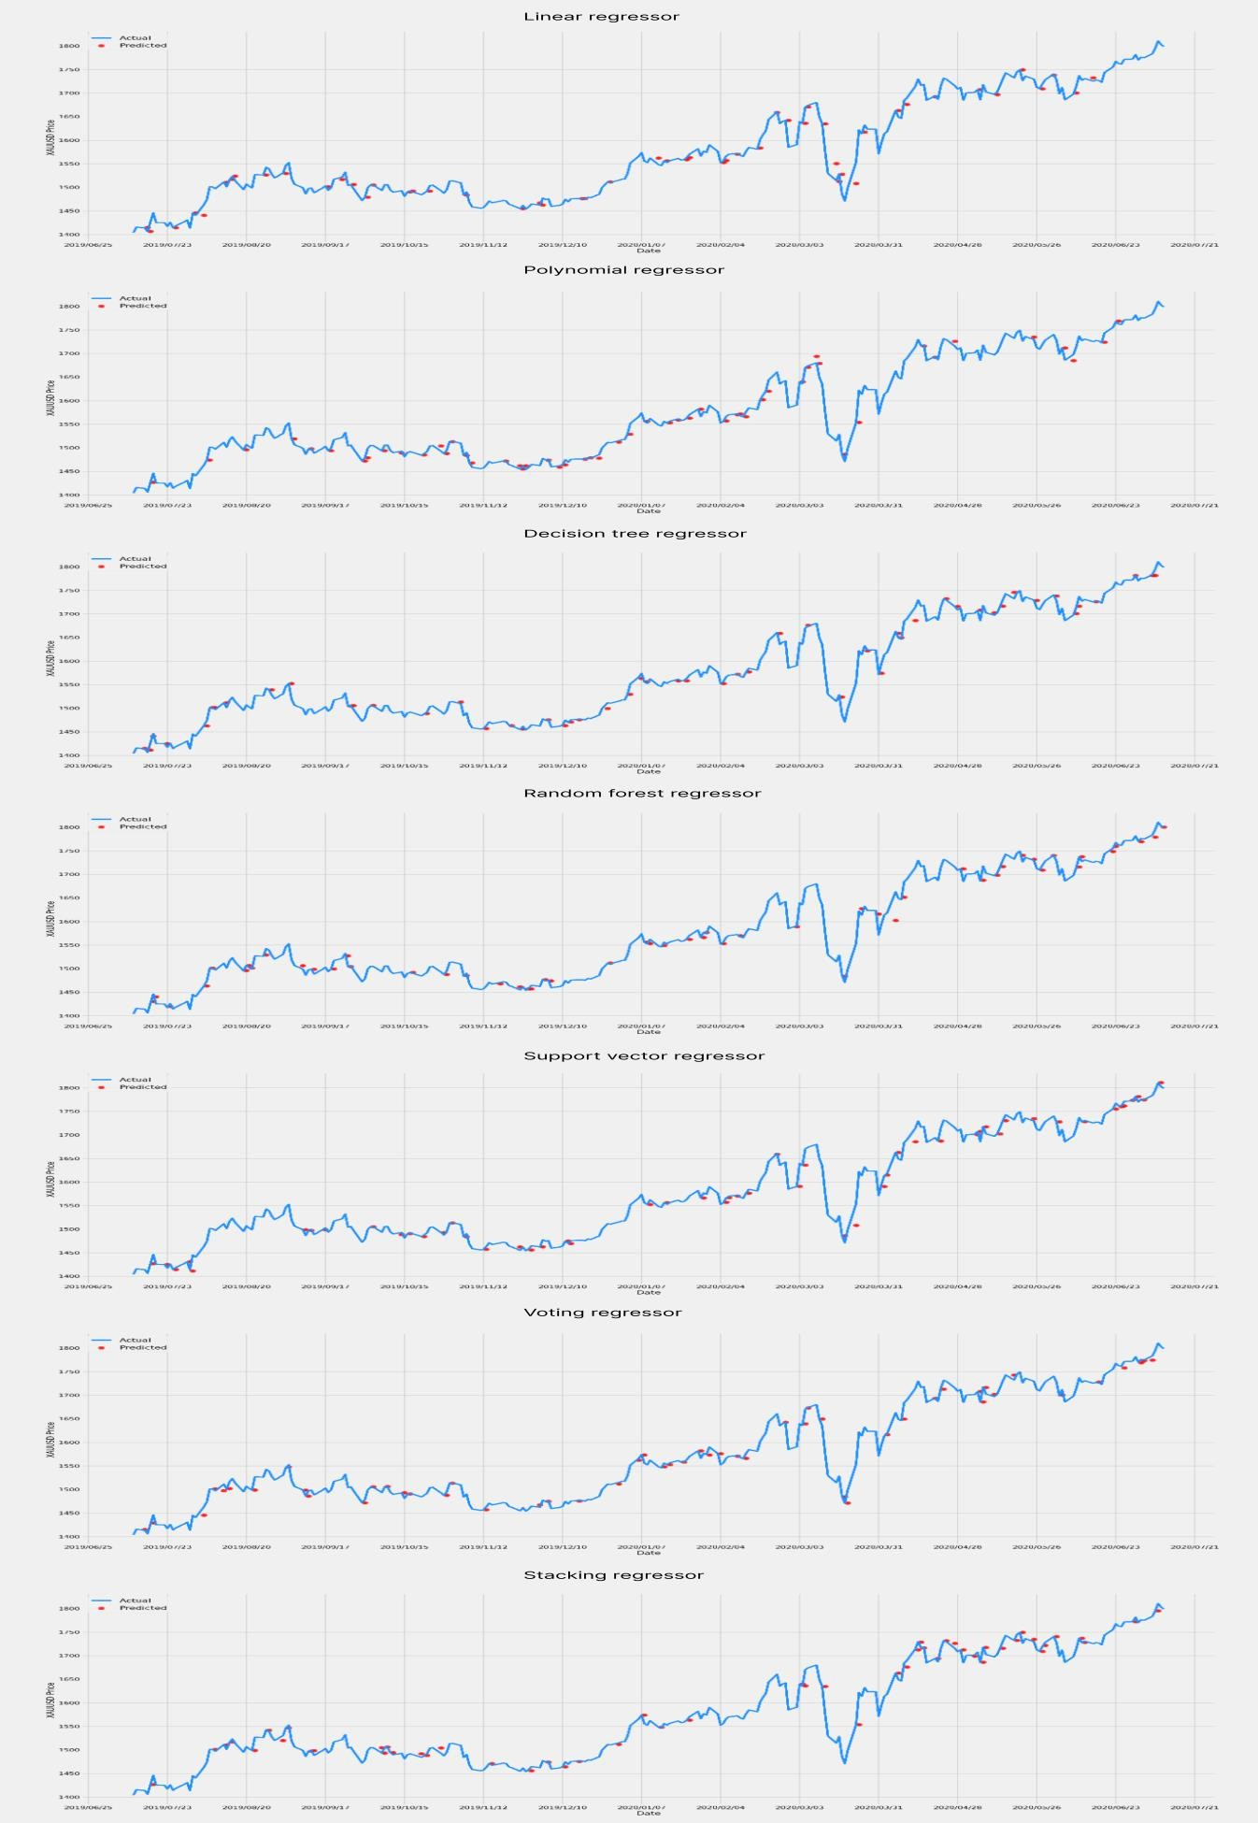
Fig. 2. The forecasts of seven different regression models for XAUUSD price

References
[1]. Ismail, Z., Yahya, A., & Shabri, A. (2009). Forecasting gold prices using multiple linear regression method. American Journal of Applied Sciences, 6(8), 1509.
[2]. Manoj, J., & Suresh, K. K. (2019). Forecast Model for Price of Gold: Multiple Linear Regression with Principal Component Analysis. Thailand Statistician, 17(1), 125-131.
[3]. Jianwei, E., Ye, J., & Jin, H. (2019). A novel hybrid model on the prediction of time series and its application for the gold price analysis and forecasting. Physica A: Statistical Mechanics and Its Applications, 527, 121454.
[4]. Wei, Y., Liang, C., Li, Y., Zhang, X., & Wei, G. (2020). Can CBOE gold and silver implied volatility help to forecast gold futures volatility in China? Evidence based on HAR and Ridge regression models. Finance Research Letters, 35, 101287.
[5]. Pierdzioch, C., Risse, M., & Rohloff, S. (2015). A real-time quantile- regression approach to forecasting gold returns under asymmetric loss. Resources Policy, 45, 299-306.
[6]. Suranart, K., Kiattisin, S., & Leelasantitham, A. (2014, March). Analysis of comparisons for forecasting gold price using neural network, radial basis function network and support vector regression. In The 4th Joint International Conference on Information and Communication Technology, Electronic and Electrical Engineering (JICTEE) (pp. 1-5). IEEE.
[7]. Ongsritrakul, P., & Soonthornphisaj, N. (2003, July). Apply decision tree and support vector regression to predict the gold price. In Proceedings of the International Joint Conference on Neural Networks, 2003. (Vol. 4, pp. 2488-2492). IEEE.
[8]. Sadorsky, P. (2021). Predicting gold and silver price direction using tree- based classifiers. Journal of Risk and Financial Management, 14(5), 198.
[9]. M. A. Mithu, K. M. Rahman, R. A. Razu, M. Riajuliislam, S. I. Momo and A. Sattar. (2021, July). Gold price forecasting using regression techniques for settling economic and stock market inconsistency. In 12th International Conference on Computing Communication and Networking Technologies (ICCCNT), pp. 1-4, IEEE.
[10]. Yanto, M., Sanjaya, S., Yulasmi, Y., Guswandi, D., & Arlis, S. (2021). Implementation multiple linear regresion in neural network predict gold price. Indonesian Journal of Electrical Engineering and Computer Science, 22(3), 1635-1642.
[11]. Freedman, D. A. (2009). Statistical models: theory and practice. cambridge university press.
[12]. Rencher, A. C., & Christensen, W. F. (2012). Chapter 10, Multivariate regression–Section 10.1, Introduction. Methods of multivariate analysis, Wiley Series in Probability and Statistics, 709, 19.
[13]. Hilary, L. (1967). Seal. Studies in the history of probability and statistics. XV: The historical development of the Gauss linear model. Biometrika, 1-24.
[14]. Yan, X., & Su, X. (2009). Linear regression analysis: theory and computing. World Scientific.
[15]. Ostertagová, E. (2012). Modelling using polynomial regression.
Procedia Engineering, 48, 500-506.
[16]. Quinlan, J. R. (1990). Decision trees and decision-making. IEEE Transactions on Systems, Man, and Cybernetics, 20(2), 339-346.
[17]. Wu, X., Kumar, V., Ross Quinlan, J., Ghosh, J., Yang, Q.,
Motoda, H., McLachlan, G. J., Angus, L. B., Yu, P. S., Zhou, Z., Steinberg, D. (2008). Top 10 algorithms in data mining. Knowledge and information systems, 14(1), 1-37.
[18]. Breiman, L. (2001). Random forests. Machine learning, 45(1), 5-
32.
[19]. Korting, T. S. (2006). C4. 5 algorithm and multivariate decision trees. Image Processing Division, National Institute for Space Research– INPE Sao Jose dos Campos–SP, Brazil, 22.
[20]. Vapnik, V. N. (1999). An overview of statistical learning theory.
IEEE transactions on neural networks, 10(5), 988-999.
[21]. Vapnik, V., Golowich, S., & Smola, A. (1996). Support vector method for function approximation, regression estimation and signal processing. Advances in neural information processing systems, 9.
[22]. An, K., & Meng, J. (2010, August). Voting-averaged combination method for regressor ensemble. In International Conference on Intelligent Computing (pp. 540-546). Springer, Berlin, Heidelberg.
[23]. Ruta, D., & Gabrys, B. (2005). Classifier selection for majority voting. Information fusion, 6(1), 63-81.
[24]. Džeroski, S., & Ženko, B. (2004). Is combining classifiers with stacking better than selecting the best one?. Machine learning, 54(3), 255-273.



Forecasting Gold Price Movements Using Alternative Data and
Machine Learning Techniques

Abdelrahman Zewin Master’s Thesis Paper Spring 2026
Master of Business Administration in Data Analytics and Project Management Oulu University of Applied Sciences

Oulu University of Applied Sciences
Degree Programme in Data Analytics and Project Management
Author: Abdelrahman Zewin
Title of thesis: Forecasting Gold Price Movements Using Alternative Data and Machine Learning Techniques
Thesis supervisor: Jari Kiiskinen
Term and year of completion: Fall 2026 Pages: 53 + 2 appendices

Gold is an extremely important commodity as a store of value and a hedge against inflation. Its importance runs deep throughout history, to institutions as well as individuals alike. However, it is a notoriously volatile commodity, one that is easily impacted by geopolitical tensions and macroeconomic factors. Due to its importance, the ability to accurately predict its price movements would constitute immense value to governments, banks, and retail traders. This thesis explores the impact of incorporating alternative data such as google search trends, news sentiments and nontraditional financial metrics like the VIX and DXY indices into machine learning models for the purpose of forecasting short term gold price movements.

A probabilistic forecasting approach was adopted, focused on predicting price ranges rather than point values. Three models were used in this research: Prophet as a baseline linear time series models, and two tree-based machine learning models, Quantile Regression Forest (QQRF) and XGBoost with a quantile objective. A multi-horizon approach was used to forecast the price of gold over a ten trading day period. Four evaluation metrics were used to evaluate model performance. Continuous Ranked Probability Score (CRPS), Prediction Interval Coverage Probability (PICP), Average Interval width (AIW) and RMSE

The results show that the integration of alternative data led to an approximate 2% decline in predictive performance based on average CRPS scores. Upon deeper analysis into feature importance, it was discovered that traditional price based indicators largely dominated model performance, while alternative data features had a very limited and minimal impact on forecasting outcomes.

These findings indicate that alternative data, within the scope of this study, does not provide a statistically meaningful improvement in short term gold price forecasting. Despite the lack of forecasting improvement, the results highlight that not all forms of alternative data are equally useful for predicting gold prices, and that careful feature engineering and data selection remain critical.

ABSTRACT 2
CONTENTS 3
GLOSSARY 5
- INTRODUCTION 6
- BACKGROUND 8
  - Importance of Predicting Gold Prices 8
  - Current Limitations 8
  - Aim of Thesis 10
  - Research Questions 10
- LITERATURE REVIEW 11
  - Early Research and Challenges 11
  - Traditional Approaches to Gold Price Prediction 12
  - Machine Learning in Gold Price Predictions 13
  - Alternative Data in Financial Forecasting 14
  - Sentiment Analysis 15
  - Model Evaluation 16
  - Research Gaps 17
- DATA DESCRIPTION 19
  - Data Collection 19
    - Gold Historical Data 19
    - Google Trends Data 20
    - News Sentiment Data 21
    - Volatility Index (VIX) Data 23
    - USD Index (DXY) 24
  - Data Processing 25
    - Data Cleaning 25
    - Data Transformation 26
- METHODOLOGY 27
  - Forecasting Framework 27
  - Machine Learning Models 29
    - Prophet 29

    - Quantile Regression Forest (QRF) 30
    - XGBoost 30
  - Evaluation Methods 31
    - Continuous Ranked Probability Score (CRPS) 32
    - Prediction Interval Coverage Probability (PICP) 32
    - Average Interval Width 33
- ANALYSIS AND RESULTS 34
  - Prophet Model 34
  - Quantile Regression Forest Model 38
  - XGBoost Model 41
- DISCUSSION 46
- CONCLUSION 52
- AI DECLARATION 53
REFERENCES 54
APPENDICES 57

Concept | Definition
AIW | Average Interval Width
ARIMA | Autoregressive Integrated Moving Average
CRPS | Continuous Ranked Probability Score
DXY | US Dollar Index
LSTM | Long Short-Term Memory
MAE | Mean Absolute Error
MAPE | Mean Absolute Percentage Error
ML | Machine Learning
NLP | Natural Language Processing
PICP | Prediction Interval Coverage Probability
QRF | Quantile Regression Forest
RMSE | Root Mean Square Error
RNN | Recurrent Neural Network
S&P | Standard and Poor’s
USD | United States Dollar
VIX | Volatility Index

Gold is a commodity of great historical importance. For thousands of years, it has been used as a medium of exchange, a store of value, and a hedge against inflation and other risks (Taneva-Angelova, Raychev and Ilieva, 2025). Although it has been a valuable commodity for thousands of years dating back to before ancient Egyptian times and despite its relatively high liquidity, it remains incredibly difficult to predict its price movements due to its high volatility and the many complex factors that drive its price behaviour. Experts typically tend to focus on geopolitical tensions, interest rates, inflation, macroeconomic factors, and currency exchange rate fluctuations to explain gold price movements (Taneva- Angelova, Raychev and Ilieva, 2025). However, the interactions between these factors are difficult to quantify and frequently lead to unpredictable short-term price movements. For that reason, understanding the dynamics and moving parts of gold price movements is extremely important for informed decision-making in international trade and investment strategies (John and Nidhina, 2025).
It is a well-known fact that gold price movements are influenced by many factors beyond simple supply and demand. Factors such as investor behaviour, collective sentiment, market expectations, media narratives and many others all have a significant, however indirect and subtle, effect on how gold moves, especially in the short term. In this context, public attention and market sentiment, exposed through search trends and news headlines, can act as early signals of evolving market conditions leading to a change in trajectory or an acceleration thereof when it comes to price movements. For example, a spike in search interest of terms relating to gold, safe-haven assets, or economic uncertainty may be a significant indicator of increased market fear, investor concern, and a potential bias towards safe-haven assets such as gold before these factors are actually reflected in gold’s price action.
In recent years, advancements in big data and computational techniques have given rise to the availability of digital, behavioural, and unconventional economic indicators, otherwise known as alternative data. This presents an incredible

opportunity to improve financial forecasting by integrating unconventional datasets, such as public sentiment, news articles, and search query trends, to uncover hidden patterns and correlations that traditional financial indicators might overlook (Cohen and Aiche, 2023). These data sources have been increasingly explored in the context of stock markets and cryptocurrencies, but there is comparatively limited research on applying them to commodity markets, especially gold.
Alternative data is often too large, too multidimensional, and too complex for traditional linear models to handle well. These models do not have the necessary complexity to take into account subtle nuances that may otherwise be significant. However, machine learning models are built to work with nonlinear patterns, variable interrelations, and added external features which allows them to be especially useful in detecting predictive signals. In recent years, machine learning methods have significantly advanced and become increasingly more accessible, and are now widely used in predictive modelling, pattern detection, and handling nonlinear relationships between datasets. When combined with alternative data, machine learning models might have the opportunity to uncover concealed correlations and interactions that traditional econometric models might have missed. This fusion of alternative data with sophisticated machine learning techniques offers a promising avenue for developing more robust and accurate gold price forecasting models (Sarvaiya and Ramchandani, 2022, p. 169).
This thesis places itself at the intersection of these developments by exploring whether alternative datasets, once processed through machine learning models, can contribute worthwhile improvements to short term gold price forecasts. To clarify, the purpose here is not to replace traditional financial and macroeconomic indicators or to claim an absolute method of forecasting but rather to offer more value in complementing existing information and predictive methods. In doing so, the research aims to contribute to the growing literature on data-driven forecasting and predictive analytics while maintaining a practical focus on interpretability and real-world relevance.

- BACKGROUND

  - Importance of Predicting Gold Prices

Forecasting gold accurately is extremely important for various stakeholders, including retail investors, financial institutions, fund managers, as well as national economies, since gold serves both as a key investment asset and a vital industrial raw material (Trivedi, Somvanshi and J, 2022; Kumar, 2024). In addition to its investment and industrial capacity, gold's role as a safe-haven asset during periods of economic uncertainty highlights the importance of accurate forecasting for hedging against market volatility and preserving capital (Taneva-Angelova, Raychev and Ilieva, 2025). It is for these reasons that even marginal improvements in predictive accuracy can have major implications for decision- making, hedging, and risk exposure.
The issue however is that predicting fluctuations in the price of gold in the short term can be extremely challenging due to the fact that it reacts very quickly to changing market conditions. Unlike stocks and other financial instruments, gold does not produce any earnings or cash flow, therefore traditional valuation models would not apply. Its value is rather determined by opportunity cost, investors’ risk appetite, and market expectations. Other factors such as central bank interest rates, inflation outlook, currency strength, especially that of the USD, as well as market volatility also have a significant, complex effect on the price of gold which makes forecasting the price of gold all the more difficult.

  - Current Limitations

Despite its significance, the field of gold price prediction still exhibits notable research gaps, particularly concerning the comprehensive integration of diverse influencing factors (Taneva-Angelova, Raychev and Ilieva, 2025). While extensive research has focused on traditional economic indicators, there remains a deficiency in studies that systematically incorporate alternative data sources

and advanced machine learning techniques to capture the multifaceted dynamics influencing gold prices (John and Nidhina, 2025; Taneva-Angelova, Raychev and Ilieva, 2025). A lot of the existing research focuses mostly on historical price data and traditional technical indicators. Although these approaches have naturally had some success, it is our view that they fail to capture a holistic enough overview of the situation, leading to an oversight of potential signals stemming out of behavioural data. Furthermore, the research studies that do take into account alternative datasets, quite often incorporate them within the context of predicting movements in cryptocurrency or equity markets, while ignoring the world’s oldest store of value, gold.
Another limitation in existing research is the tendency to prioritise forecasting accuracy without considering the value in marginal contributions. Small improvements in forecasting performance are sometimes ignored and judged as insignificant, despite their potential importance in financial decision-making contexts where even modest gains can translate into meaningful economic value. It is our view that even a small improvement in forecasting accuracy can have rippling effects on people’s abilities to plan ahead, and make better financial decisions, at least in the short term. In a world where the future is always uncertain, one would greatly benefit from being even one percent more confident in what will happen in the future. This thesis addresses this issue specifically by exploring whether the integration of alternative data provides a meaningful impact on predictive performance, even when improvements are minor or incremental. This will be done by focusing strictly on short term forecasts, within a range of two to 4 weeks in the future, as well as comparing forecasting machine learning models with and without the inclusion of alternative datasets in an effort to better understand more clearly the practical value, if any exists, of these alternative datasets on predicting the price of gold. This background section outlines the rationale and motivation behind using a machine learning based approach on this research, as well as the need to provide empirical evidence of the role and value of incorporating alternative datasets into predicting commodity markets.

The overall aim of the thesis is to explore whether alternative data that has been processed and analysed by machine learning models can enhance the prediction of short term (2 - 4 weeks) gold price movements.
This aim focuses on the predictive value of alternative data, not on building a deployable trading system.

  - Research Questions

Specifically, this research will address the following key questions:

    - Which machine learning models perform best when incorporating alternative data for predicting gold price movements?
    - Which types of alternative data, such as Google Trends data or sentiment analysis from financial news, have the strongest predictive relationship with gold price movements?
    - Does the inclusion of alternative data improve forecasting accuracy, even when the improvement in predictive accuracy is small?

As previously mentioned, there have been many studies conducted that explain the importance of forecasting the price of gold for a multitude of reasons. Those same studies have explored various methodologies for achieving this purpose such as using ML models, deep learning models, classical forecasting methods, feature engineering, single and multifactored forecasting to name a few. The vast majority of which, however, have mostly focused on historical price data and traditional economic metrics as their data sources, very few have touched base on the integration of alternative datasets and their role in improving the precious metal’s price forecasting such as Taneva-Angelova et al. (2025). This section will dive deeper into those studies, the data they used, their findings and accomplishments, the limitations they faced, and how they all synthesize and relate both to each other as well as to this research.

  - Early Research and Challenges

The concept of attempting to forecast the price of gold is not new. Researchers have been attempting to find the perfect recipe for accurate and sustainable gold price prediction for years considering the overwhelming benefits that it would entail. Early research has focused mostly on traditional econometric and statistical techniques such as linear regression and autoregressive models. These approaches have had some success, especially in periods of economic and geopolitical stability. However, they have often struggled to adapt to the nonlinear and volatile nature of gold price action during periods of volatility, structural breaks, geopolitical tension, and regime changes (Sarvaiya and Ramchandani, 2022). This limitation was a main driver of shifting towards a more adaptable and flexible forecasting approach capable of capturing the dynamic trends and complex variable interactions affecting gold price movements.
Despite this pivot, forecasting the price of gold accurately, especially in the short term, continued to be elusive. Masud et al. (2025) interestingly noted that gold’s sensitivity to influencing factors such as inflation, market risk outlook, and interest

rates, makes short term forecasts inherently difficult due to the rapidly changing nature of those factors. The challenge of finding the right balance between choosing which variables to consider while avoiding too much unnecessary noise continues to be a work in progress for many researchers as is evident by the continuous interest and research done around this topic. It is for this reason that this thesis believes that any incremental improvement in forecasting accuracy presents incredible value not only to the academic community but also within a practical context to investors and financial advisors alike.

  - Traditional Approaches to Gold Price Prediction

As previously mentioned, many early research studies have approached forecasting the price of gold using traditional econometric and classical forecasting models such as ARIMA and deep learning models like LSTM. ARIMA models, which stands for Autoregressive Integrated Moving Average, are powerful statistical models that are commonly used for analysing and forecasting time series based datasets. They achieve this by combining 3 main parts:
    - Autoregressive, which refers to past values. Auto, meaning self, regression analysis.
    - Integrated, which refers to the order of differencing applied to a non- stationary time series dataset to make it stationary. Stationary here means statistical properties, such as mean and variance, do not change over time. This is a core requirement of working with ARIMA models as they need to cancel out trends and seasonality in order to work properly.
    - Moving Average, representing the number of past forecast errors. To simplify, predictions by nature are never perfectly accurate. The errors made in previous predictions are captured by the moving average and used to enhance the accuracy of future predictions.
ARIMA models are a very common tool to linearly predict time series data, which means within the context of gold forecast, they perform somewhat well under stable conditions and periods of predictability. Their performance declines however in periods of high volatility or unexpected changes.

The second type of model is LSTM, or Long Short-Term Memory. LSTM is a kind of recurrent neural network (RNN) which is designed to learn long term dependencies in sequences of data such as text, speech, or time series. Essentially, it is able to remember important information for a long period of time while also forgetting what isn’t important or useful.
Trivedi, Somvanshi and J (2022) were some of the researchers who have approached forecasting the price of gold using classical forecasting models such as ARIMA. They have found, unsurprisingly, that linear models only do somewhat well in forecasting gold price action in periods of stability and predictable growth. However, they fail to capture the nonlinear characteristics of a volatile, unstable market. Sarvaiya and Ramchandani (2022) took this research a step further by comparing ARIMA and LSTM models. Their findings were similar to that of Trivedi et al. in the limitations of ARIMA predictions of gold, but they were able to discover that LSTM is a far better model to use in gold price predictions. They used RMSE, or root mean square error, as an evaluation method and found that LSTM scored a value of 0.038 compared to ARIMA’s 4.043. RMSE is a standard metric used to measure how far off predicted values are from actual values. In simpler terms, it is a “score” of how accurate a forecasting model is. The lower the score, the more accurate the predictions.

  - Machine Learning in Gold Price Predictions

The application of machine learning (ML) in time series forecasts, especially in predicting the price of gold, have increased drastically over the past few years. As mentioned in the previous paragraph, many studies find that ML models far outperform classical statistical methods when it comes to forecasting accuracy, especially when dealing with nonlinear, complex, timeseries. Cohen and Aiche (2023) explored multiple machine learning methodologies for gold price prediction and have concluded that models such as Random Forests and neural networks have a much better performance compared to linear models. They were able to discover that ML models are particularly suited to capturing hidden correlations between variables, especially when multiple market affecting factors are at play simultaneously. To clarify, we have briefly covered a subset of neural

networks when we described RNNs such as LSTM. In a nutshell, neural networks are a type of machine learning technology that mimics the human brain. They use interconnected layers of nodes (neurons in the brain) to process and analyse data, recognize patterns and trends, and make predictions. Neural networks are the basis for deep learning models and have a wide array of applications such as visual recognition software, chatbots, and predictive analytics. Random Forests is another machine learning method used to make predictions by combining the results of many decision trees. It works by training each decision tree on a random subset of the data and flows through decisions until it makes a prediction. It then combines the results of all the trees, meaning the forest, by averaging the results for regression analysis or taking majority votes for classification to produce the final prediction. Hence the name, Random Forests.
Alharbi (2024) conducted a similar study where he utilized machine learning techniques to forecast the price of precious metals, specifically gold, silver, palladium, and platinum, from 2017 to 2023. He echoed prior findings that ML models are able to adapt to fast moving market dynamics which is further proof that machine learning can be employed not only as a predictive tool but also as a way of understanding underlying market correlations.
Despite these optimistic findings, many authors warn against treating advanced machine learning models as a “black box” solution. Although these models may have better performance and produce more accurate results, they must be evaluated and interpreted carefully especially in investment and financial market contexts where contexts and data reliability are crucial for trust and informed decision-making (Masud et al., 2025).

  - Alternative Data in Financial Forecasting

Beyond advancements in predictive analytics using machine learning and modelling techniques, many studies increasingly highlight the importance of considering alternative data in financial predictions. As previously mentioned, alternative data refers to unconventional datasets. In the context of this specific research, these include public sentiment, news articles, and search query trends

that may shine a light on market expectations and investors’ risk appetite (Cohen and Aiche, 2023).
Several studies such as that of Preis, Moat and Stanley (2013), have shown that sentiment data and search trends can act as strong influencing factors to market movements. These signals often come before noticeable changes in price, structure, or volatility in financial markets which makes them especially relevant for short term predictions. Taneva-Angelova, Raychev and Ilieva (2025) noted that alternative data factors can capture hidden market behaviour changes that traditional indicators often miss.
Despite this finding, research on incorporating alternative data factors into gold price prediction remains largely under researched. Divya Sri et al. (2024) came closest by integrating multiple factors, beyond historical gold prices, such as oil prices, the Standard and Poor’s (S&P) 500 index, Dow Jones Index, US Bond rates (10 years), Euro to USD exchange rates, and prices of precious metals such as silver, platinum, palladium, and rhodium into their prediction model. However, the primary focus continued to be on conventional financial indicators. Studies that take into account behavioural or sentiment-based data as a primary input remain limited and few, which is a noticeable research gap that this thesis aims to address.

  - Sentiment Analysis

In order for news headlines and articles to be used for sentiment analysis, their qualitative information must first be quantified into numerical values that machine learning models would be able to process and understand, typically through the use of natural language processing (NLP) techniques.
NLP is a subset of artificial intelligence that allows computers to understand, generate, interpret and generally work with human language. NLP models have a wide variety of applications in daily life, from autocorrect and voice assistants like Siri on your phone to translators and chatbots such as ChatGPT. In this context, NLP models are able to process text in news headlines and articles, extract relevant information and determine their sentiment polarity (positive or

negative), then assign a numerical sentiment score that can then be correlated to the price of an asset, such as gold. To clarify with an example, a news article headline talking about geopolitical instability in some part of the world would likely be assigned a negative sentiment score. This would infer increased market fear and could very well correlate to an increase in the price of gold since investors would flock towards safe haven assets. One would naturally expect that integrating such sentiment metrics into forecasting models, would enrich the prediction to allow a better understanding of market psychology and investor expectations, which would consequently capture the impact of such alternative data on price movements that traditional price-based models might miss.
This was the opinion of Masud et al. (2025) as they note that sentiment metrics can improve the accuracy of forecasts when combined with traditional time series techniques, especially during times of market instability. However, using sentiment data is not without its own challenges. Differences in data sources, preprocessing methods, and sentiment scoring techniques make study comparisons difficult. Furthermore, context matters, as many studies focus mainly on employing such alternative data to predict equity or cryptocurrency markets, leaving commodities such as gold under researched.

  - Model Evaluation

To ensure the reliability of machine learning models used in forecasting, it is crucial to have some evaluation metrics that would measure the performance of said models in terms of predictive accuracy. Metrics such as mean absolute error (MAE), mean absolute percentage error (MAPE), and RMSE are commonly used and provide a straightforward assessment of model performance by measuring the average magnitude of errors and their significance versus actual price values (John and K. Nidhina, 2025; Kumar, 2024; Trivedi, Somvanshi and J, 2022). RMSE was previously discussed, below is a brief explanation of MAE and MAPE.
Mean Absolute Error (MAE): this is a measure of how far off predictions are from actual values using the average of absolute differences. For example, if a predicted value is 8 and the actual value is 10, the absolute difference would be

2, represented by the formula: (abs(8-10)=2). This process would be done to all prediction points and then averaged to get the MAE.
Mean Absolute Percentage Error: following the same concept of MAE with the slight difference that the measure is in percentages. Absolute difference values are turned into percentages and then averaged.
Moreover, it is occasionally sufficient, and arguably more important, to measure directional predictive accuracy rather than absolute forecasted values. This is where directional performance metrics such Hit Rate or Sign Accuracy come in. These are metrics that are commonly used to determine whether a model correctly predicts the direction of price movement (up or down) which can be of great importance to traders specifically.
While all these metrics are crucial for model comparison and assessment, they overlook the importance of small forecast improvement, which is a recurrent issue across the literature. Trivedi et al. (2025) noted that marginal gains, or small improvements, in predictive performance can have an important effect on decision making, especially in financial contexts where decisions are often made with uncertainty and have significant impact. This perspective is more relevant in short term gold price forecasting. Given market volatility and sensitivity to world events, expecting perfect or large improvements in predictive accuracy would be unrealistic, whereas exploring whether alternative data provides incremental improvements may be a lot more appropriate as a research goal.

  - Research Gaps

The compiled literature revealed many interesting insights as well as some significant research gaps. This section will briefly outline the relevant research gaps that have been identified.
    - Despite the comprehensive research done on employing machine learning techniques in forecasting financial markets, a clear gap was identified in incorporating alternative datasets into forecasting the price of commodities, particularly gold.

    - When considering alternative data sources for forecasting, sentiment data was often overlooked. This is a clear gap given gold’s sensitivity to world news and investors’ risk tolerance.
    - Most research focus on extremely narrow forecasting horizons such as next day predictions, whereas none have considered a broader short-term forecast covering multiple weeks.
    - There is limited consideration of the importance of marginal improvements in forecasting accuracy.

- DATA DESCRIPTION

For the purpose of conducting this research, certain datasets needed to be attained. This section will discuss each of the five datasets used, how they were collected, how they were pre-processed and cleaned, as well as a data dictionary describing each dataset’s fields.

  - Data Collection

There was a total of five publicly available, free, datasets that were collected for the purpose of this research. All of these datasets were collected for the time period starting on the first of January 2008, and ending on the thirty first of December 2017, covering a total period of ten years.

    - Gold Historical Data

The first data set is historical values of the price of gold. This dataset was manually downloaded in the form of a csv file from investing.com, a leading financial data platform founded in 2007. The dataset contains daily historical XAU/USD opening, closing, daily high, and daily low prices from the period of 2008-01-01 to 2017-12-31. This dataset contains 2607 rows and 7 columns. Table 1 shows a data dictionary describing the dataset’s different fields. This table shows the dataset’s original fields and the number of records corresponds to the number of trading days in the above mentioned 10 year period. It is worth noting that not all fields are relevant for the purposes of this research, specifically the volume and percent change fields.
Table 1. Data dictionary of historical gold values dataset.

Field | Data Type | Description
Date | datetime | The date of the observed values

Price | float64 | The closing price for that date
Open | float64 | The opening price for that date
High | float64 | The highest price of gold on that date
Low | float64 | The lowest price of gold on that date
Vol. | float64 | The volume traded in USD
Change % | float64 | The percentage change in price from previous day closing

    - Google Trends Data

Google trends and keyword interest over time was accessed and collected through a python library called “pytrends”. The values extracted represent the popularity of each term on any given day. This popularity value is normalized on a scale of 0 to 100, 100 being peak popularity and 0 being insufficient data.
Pytrends is an unofficial Python library that automates the downloading and extraction of search trend data from Google Trends. It is widely used by data scientists, researchers, marketers, and analysts to access, analyse, and visualize public search data programmatically.
The list of keywords that are observed includes ‘gold price’, ‘gold forecast’, ‘buy gold’, ‘inflation’, ‘safe haven’.
Since Pytrends is an unofficial python library, its use comes with certain limitations. Specifically, sending a request to the google API with too many keywords will result in an error. Simultaneously, if we attempt to extract daily data for too large of a time period, Google's API will only return the data for the first of every month, which is not the granularity needed here. A potential work around is to use a loop to fetch the data for each keyword individually and break apart the time period over many requests to avoid time granularity degradation. This

approach is demonstrated in appendix 1. The output of this data fetching is a popularity score for each term that is a measure of how popular this term was during that period, relative to its peak. For example, a score of 100 means peak popularity, signifying the most searches for this term during this period. A score of 50 means on that day, that term was half as popular compared to its peak, and 0 meaning insufficient data. This dataset contains 3654 rows and 6 columns. The number of records in this dataset corresponds to the number of days in the chosen 10 year period. Table 2 below shows a data dictionary describing the dataset’s different fields.

Table 2. Data dictionary of google trends dataset.

Field | Data Type | Description
date | datetime | The date of the observed values
gold price | Int64 | Popularity score for that term on that day from 0 - 100
gold forecast | Int64 | Popularity score for that term on that day from 0 - 100
buy gold | Int64 | Popularity score for that term on that day from 0 - 100
inflation | Int64 | Popularity score for that term on that day from 0 - 100
safe haven | Int64 | Popularity score for that term on that day from 0 - 100

    - News Sentiment Data

This is a news dataset for the commodity market, specifically gold, where over 10,000+ news headlines across multiple dimensions were manually annotated into various classes. The original dataset has been sampled from a period of 20+ years (2000-2021). The news sentiment data was downloaded from Kaggle.com

(Sinha and Khandait, 2021), which is the world's largest online community and platform for data science and machine learning, owned by Google.
According to the original authors, the dataset has been collected from various news sources and annotated by three human annotators who were subject matter experts. Each news headline was evaluated on various dimensions, for instance
- if a headline is a price related news, then what is the direction of price movements it is talking about; whether the news headline is talking about the past or future; whether the news item is talking about asset comparison; etc. This dataset contains 10570 rows and 10 columns; each record corresponds to one news headline on any given day. Table 3 below shows a data dictionary describing the dataset’s different fields.
Table 3. Data dictionary of news sentiment dataset.

Field | Data Type | Description
Dates | datetime | The date of the news headline
URL | object | URL of the news headline
News | object | News headline
Price Direction Up | int64 | Does the news headline imply price direction up? Integer between 0 meaning no, and 1 meaning yes.
Price Direction Constant | int64 | Does the news headline imply price direction sideways (no change)?  Integer between 0 meaning no, and 1 meaning yes.
Price Direction Down | int64 | Does the news headline imply price direction down? Integer between 0 meaning no, and 1 meaning yes.

Asset Comparison | int64 | Are assets being compared?  Integer between 0 meaning no, and 1 meaning yes.
Past Information | int64 | Is the news headline talking about past events? Integer between 0 meaning no, and 1 meaning yes.
Future Information | int64 | Is the news headline talking about future?  Integer between 0 meaning no, and 1 meaning yes.
Price Sentiment | object | Price sentiment of gold commodity based on headline (positive, negative, neutral)

    - Volatility Index (VIX) Data

The volatility Index, also known as the VIX index, measures the market's expectation of future volatility, representing the expected speed and magnitude of price changes over the next 30 days. It is a commonly used index to gauge market fear, when investors’ fear and anxiety increase due to market downturns or geopolitical instability, the VIX increases. This dataset was used as the market fear factor of the data collected and was downloaded from Yahoo Finance in the form of CSV. This dataset contains 2518 rows and 7 columns. Each record corresponds to an active trading day on the US market, which is where the VIX values are based on. Table 4 below shows a data dictionary describing the dataset’s different fields.
Table 4. Data dictionary of historical gold values dataset.

Field | Data Type | Description
Date | datetime | The date of the observed values
Price | float64 | The closing value for that date
Open | float64 | The opening value for that date

High | float64 | The highest value of VIX index on that date
Low | float64 | The lowest value of VIX index on that date
Vol. | float64 | The volume traded
Change % | object | The percentage change in value from previous day closing

    - USD Index (DXY)

The final dataset consists of historical values of the United States Dollar Index (DXY) for the stated time period. The DXY is a measure of the value or strength of the USD against a basket of six other international currencies. Specifically, these currencies are the euro, Japanese yen, British pound sterling, Canadian dollar, Swedish krona, and Swiss franc. This index is relevant due to its inverse relationship to the price of gold. When the value or strength of the USD decreases, gold becomes cheaper for foreign investors since its value is usually measured in USD, this typically leads to an increase in gold demand, driving the price of gold up. This dataset contains 2590 rows and 7 columns. Each record corresponds to an active trading day on the foreign exchange markets. Table 5 below shows a data dictionary describing the dataset’s different fields.
Table 5. Data dictionary of historical gold values dataset.

Field | Data Type | Description
Date | datetime | The date of the observed values
Price | float64 | The closing value for that date
Open | float64 | The opening value for that date
High | float64 | The highest value of DXY index on that date

Low | float64 | The lowest value of DXY index on that date
Vol. | object | The volume traded
Change % | object | The percentage change in value from previous day closing

  - Data Processing

In order for the above-mentioned datasets to be readily processable for our purposes, they first need to go through certain preprocessing stages. Namely, the datasets need to be cleaned, data quality issues need to be addressed, and feature engineering needs to take place. These steps will be discussed in the following sections.

    - Data Cleaning

The primary data quality issue that needed to be addressed was with the news sentiment dataset obtained from Kaggle. An issue was discovered with the values in the “Dates” column, wherein date strings had inconsistent, and sometimes erroneous formats. For example, “0200-04-23” instead of “2007-04-23”. To address this critical issue, a python script was developed (Appendix 2). This script looped over the data and reformatted the values in the “dates” column into YYYY- MM-DD format as well as fixed data quality issues like the one mentioned above by scanning the news headline’s URL for a date and replacing the faulty value in the “dates” column. This approach fixed the vast majority of the data quality cases; the few remaining edge cases were fixed manually.
Furthermore, the following measures were also taken as part of the data cleaning phase:
      - All date columns were converted into datetime data type and sorted in ascending values.

      - All commas and percentage signs were removed from numeric columns.
      - Numeric columns were converted to float data type.
      - Sentiment data was filtered to the relevant period (2008-2017).
      - Datasets were merged together using the date columns.

    - Data Transformation

After cleaning the data, it was transformed to prepare it for usage by the ML models. For this purpose, the following measures were taken:
      - News sentiment data was aggregated to daily level.
      - Daily net sentiment score was calculated
      - Created various rolling features such as moving averages and standard deviations, which will act as inputs to the ML models
      - Created lagged features to prevent data leaks. Data leakage is when future data that should not yet be available is used to train an ML model that will predict future values.
      - Created multi-horizon targets for the next 10 trading days
      - Produced two datasets, one with and one without alternative data such as google trends and news sentiment data.

This branching of source data into two separate datasets allows for a clear comparison between different models as well as highlighting the incremental value, if any, that alternative data potentially provides when predicting gold price movements.

- METHODOLOGY

Once the data has been thoroughly cleaned and pre-processed, the next stage would be to utilize it to attempt to answer the previously stated research questions. The figure below visualizes the flow of data at different stages throughout this research in a simplified manner.
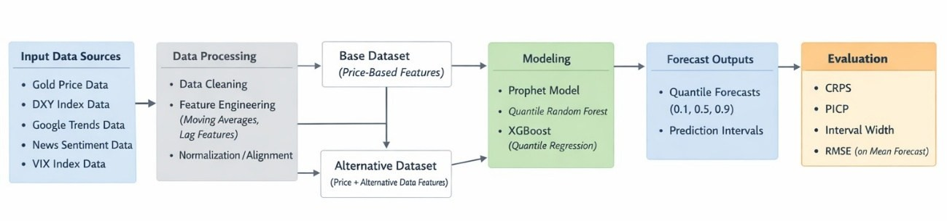

Figure 1. Gold forecasting data flow

This section will discuss in detail the chosen strategies and methodologies, describe the machine learning models as well as the evaluation criteria applied to the pre-processed data for gold price forecasting.

  - Forecasting Framework

This study uses a supervised machine learning framework to predict gold price movements over short term time horizons, ranging from 1 to 10 trading days in the future.
Supervised machine learning is a common machine learning training methodology used to train models. In simple terms, it is the equivalent of teaching a computer using examples, where models are trained using labelled data, meaning each input (feature) is mapped to an output (target). The machine learning model learns the relationship between these inputs and outputs and uses that knowledge to predict future values.
Instead of focusing primarily on forecasting point predictions, meaning specific price levels, this research adopted the probabilistic forecasting approach, with an

emphasis on predicting price ranges. This approach allows for a more realistic evaluation of forecast accuracy as well as a more concrete assessment of future price trajectories by taking into account the inherent uncertainties, which is particularly relevant in volatile financial markets.
Furthermore, since the focus is on predicting short-term price movements in the next 1 to 10 trading days, it was decided to employ a direct multi-horizon approach. A direct multi-horizon approach is a forecasting method where a separate machine learning model is trained for each relevant future time step. In practical terms, this study will train 10 models to forecast each of the future 10 trading days, each model would learn the relationship between current day’s features and its assigned horizon target. This approach was preferred for a couple of reasons:
- Unlike many of the approaches mentioned in the literature review studies, this study will be focusing on a slightly longer time horizon, 10 trading days, as opposed to just one day in the future. Despite this still being classified as short term forecasting, the longer horizon increases the risk of imprecision. Training a separate model for each separate time horizon reduces that risk, resulting in a more accurate future prediction.
- The alternative would have been rolling forecasts, wherein one model predicts the next future value, and then rolling it forward to predict the next future value after that. This approach would result in accumulated mistakes and compounding errors, which this research would ideally like to avoid.
As previously mentioned, two feature configurations are evaluated:

  - Base model, which includes traditional financial indicators such as price- based features, VIX, USD index
  - Alternative model, which includes all the base features with the addition of Google Trends and sentiment data variables
This setup enables controlled comparison of the potential incremental predictive value of alternative data. However, in order to preserve the temporal structure of

the data and the integrity of this study, a chronological 80-20 split with lagged features was implemented to prevent look ahead bias and data leakage.

  - Machine Learning Models

To evaluate predictive performance, the following models are implemented:

- Prophet (baseline model)
- Quantile Regression Forest (QRF)
- XGBoost with quantile objective

This section will briefly describe each model and why it was chosen.

    - Prophet

Prophet is an open source, additive regression forecasting model developed by Meta, formerly Facebook (Taylor and Letham, 2018). This model was developed specifically to forecast time series in a simple and intuitive way. It works by breaking down a time series dataset into three parts:
      - Trend, meaning the overall long-term direction.
      - Seasonality, meaning repeating daily, weekly, or yearly patterns.
      - Events, meaning special dates that could have an effect on the forecast such as holidays or economic or political announcements.
It then uses all three parts to provide a forecast.

This model was chosen for multiple reasons, the first of which is its ease of use. It does not require deep statistical or technical expertise and has a sort of “plug and play” architecture. The second reason is its ability to handle non-linear trends, seasonalities, and global events well, making especially suitable for forecasting financial markets or commodities such as gold.
This model will be used as the benchmark against which other models will be evaluated.

Due to this study’s focus on probabilistic forecasting, choosing a quantile regression forest model was a natural inevitability. Simply stated, QRFs are a subset of random forest models that predict a range of possible outcomes rather than a single average value. It works by estimating any chosen quantile, in this case an upper and lower bound which serve as the prediction intervals, or conditional quantiles (Meinshausen, 2006).
This model was chosen for its ability to model non-linear relationship and interactions between multiple variables, making it ideal for the purposes of this research.

    - XGBoost

XGBoost, otherwise known as Extreme Gradient Boosting, is another tree-based powerful, open source, machine learning algorithm designed to handle structured, tabular data (Chen and Guestrin, 2016).
It is commonly used for both classification and regression predictions and preferred by experts due to its graceful handling of missing values, its efficiency and speed, and the fact that it provides feature importance scores, allowing researchers to see which inputs have the most impact.
It works by building a collection of decision trees, each acting as a mini model that cooperates with its peers. Each new tree attempts to fix the mistakes of its predecessors, this is the “boosting” part. The “gradient” part refers to the use of trial and error to optimize predictions step by step, making the model more accurate with each iteration. Finally, it uses regularization, or penalties, to prevent overfitting, thus ensuring the model doesn’t just memorize the training data.
Unliked QRF, XGBoost is normally designed for point predictions, however in this case, its objective function is changed to quantile loss in order to predict quantile intervals. The quantiles used for both XGBoost and QRF will be 10th and 90th percentile resulting in an 80% prediction interval.

As previously mentioned, this research is implementing a probabilistic forecasting approach in order to predict the future price of gold while incorporating alternative data features. To re-iterate and keep the research questions in focus, the objectives here are:
      - Determine whether alternative data can improve accuracy.
      - Determine which machine learning model performs best at predicting gold price movements.
      - Determine which alternative data has the strongest predictive value.
      - Determine whether the inclusion of alternative data, provides at least incremental forecasting improvements.
In order to achieve these objectives and answer this study’s research questions, certain metrics must be measured to evaluate predictive performance. These metrics must measure the following:
      - Coverage: whether actual prices fall within the predicted intervals ranges
      - Sharpness: whether predicted ranges are sufficiently tight to be useful
      - Accuracy: how close the predicted cumulative distribution is to the actual values
Based on these criteria, the following metrics have been chosen:

      - Continuous Ranked Probability Score (CRPS) as a primary metric of accuracy
      - Prediction Interval Coverage Probability (PICP) to measure coverage
      - Average Interval Width to measure sharpness
      - Root Mean Squared Error (RMSE) as a secondary metric

Forecast performance will be evaluated separately for each of the 10-day horizons using a walk forward method wherein models are trained on past data and tested against unseen future values, if a walk forward approach is not a viable option, a simple chronological 80-20 split will be used. The following sections will describe each metric in more detail.

CRPS is a measure of how good a probabilistic forecast is. It compares the predicted distribution to the actual observed value and produces a single score (Gneiting and Raftery, 2007). The lower the CRPS score is, the better the forecasting accuracy of the model. It is worth noting that this method rewards accuracy, calibrated uncertainty and appropriate spreads. Simultaneously, it penalizes overconfidence, which is when the intervals are too narrow, as well as excessive uncertainty, which is when the intervals are too wide. In this case, CRPS is approximated using discrete quantiles due to model constraints.
To put this in practical terms, for example, if a probabilistic weather forecasting model produces a forecast which indicates a 70% change of rain and it does rain, this will result in a lower CRPS score, which is good. Whereas if the same model forecasts a 50% chance of rain, the score will be higher, or worse, due to the increased uncertainty and lack of confidence.

    - Prediction Interval Coverage Probability (PICP)

PICP is a common measure of coverage in probabilistic forecasting. It measures how often actual values fall within predicted intervals (Khosravi, Nahavandi and Creighton, 2011). For example, suppose a model is forecasting 100 days of rain with 80% prediction intervals, if the forecast was true for 85 days out of the 100, the PICP is then 85%. Ideally the PICP should be as close as possible to the chosen prediction interval. For this experiment a PICP of 80% will be used.
It is important to note here that measuring coverage alone is not enough. Models can achieve 100% coverage simply by using unreasonably wide intervals such as “the price of gold tomorrow will be between $100 and $10000”, the probability of such a statement being accurate is almost always 100%. However, this sort of prediction has no predictive or practical value, which brings us to the next metric, average interval width.

As one can infer from the name, average interval width (AIW) is a measure of how wide the prediction intervals are. This is a measure of sharpness that refers to the average width of the predicted interval, or the distance between the upper bound and the lower bound (Khosravi, Nahavandi and Creighton, 2011). For example, if a model forecasts that the price of gold tomorrow will be between
$1900 and $2100, the interval width would be $200. The average interval width metric can be calculated using the following formula:

𝑁
1

𝐼𝑛𝑡𝑒𝑟𝑣𝑎𝑙 𝑊𝑖𝑑𝑡ℎ =
𝑁 ∑(𝑈𝑝𝑝𝑒𝑟_{𝑡} − 𝐿𝑜𝑤𝑒𝑟_{𝑡})
𝑡=1

The lower the interval width, the more precise and confident a model is, however precision comes with the risk of missing coverage, meaning the actual value does not fall within predicted intervals. Therefore, is it important to balance between coverage and sharpness when designing a probability forecasting model.

Following the guidelines outlines in the methodology section, a python notebook “thesis_modeling.ipynb” was created. Within this notebook, the thesis experiment was conducted with the following criteria:
- 3 models were used: Prophet, Quantile Regression Forest, and XGBoost Quantile.
- 80-20 chronological train-test split, with an 80% prediction interval.
- RMSE, CRPS, PICP, and AIW were used as evaluation metrics over a 10 day horizon.
The results of this experiment will be discussed for each model.

  - Prophet Model

As previously mentioned, prophet is a linear time series forecasting model, as such, it does not take into account any engineered features. The inputs are simply dates and values. The outputs would be a lower bound forecast, an upper bound forecast, and a mean point forecast. Naturally, since features are inherently not considered this means that there would be no difference in forecasted values between the base dataset and the alternative dataset. The following chart shows the model’s forecast vs actual gold prices in the last 10 days of both datasets.

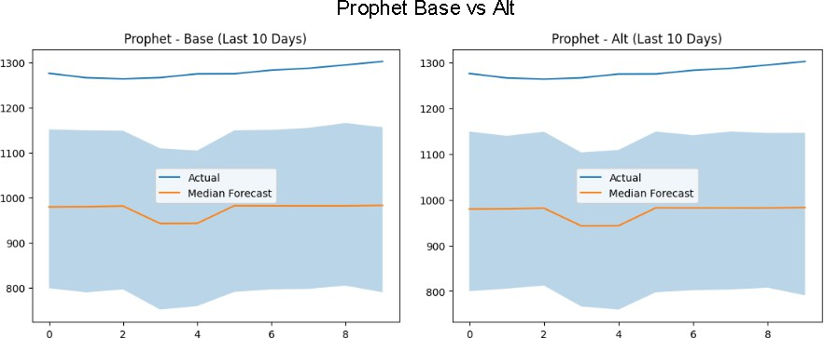

Figure 2. Prophet forecast base vs alternative datasets, last 10 days

In the above charts, The X-axis represents trading days while the Y-axis represents gold prices. The blue line represents the actual values of gold price during the 10 trading day period between the 20th of November 2017 and the 15th of December 2017. The actual values fluctuated between $1240 to $1280 per gold ounce. The lightly blue shaded area represents the upper and lower bound of the model’s forecast, while the orange line represents the median or 50th percentile forecast.
The model had a wide average interval width of around $192 across the whole dataset, and an even larger ~$350 across the subset of the last 10 days shown in the figure above.
This wide gap between actual prices and forecasted range shown is to be expected considering 1. This model works best with linear values, while gold price movements are notoriously volatile and 2. Forecasts are known to be less accurate as the time horizon expands, the figure above shows the forecast of the last 10 days over a 10 year period. To further validate this reasoning Figure 3 below shows the forecast of the first 10 days which shows accurate forecasts for the begning of the forecasting horizon.

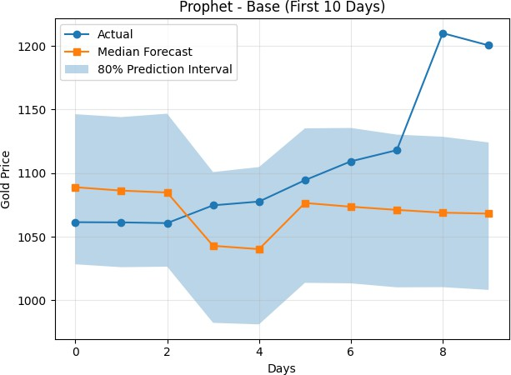

Figure 3. Prophet forecast, first 10 days

Beyond the average interval width, other metrics were measured such as the PICP measuring coverage, the CRPS measuring overall accuracy, and the RMSE measuring how far off the forecast is from actual values. As a contextual reminder, for the CRPS and RMSE metrics, the lower the score, the better the performance. Conversely, a higher PICP score is better as it means actual values fell within the forecasted range more often. The following figure showcases two tables showing all the metrics for the Prophet model across both base and alternative datasets for each of the 10 horizons on average.

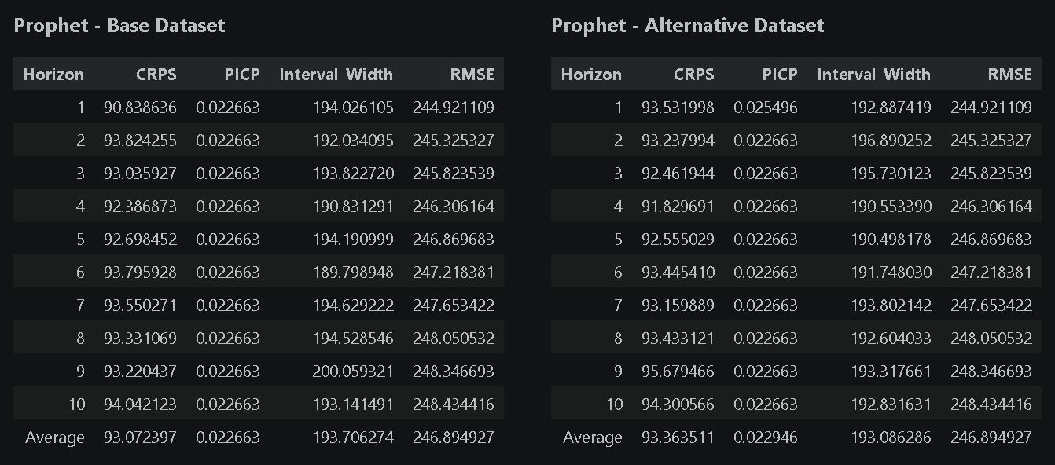

Figure 4. Prophet model avg evaluation metrics per daily horizon of the test data subset (last 20% of 2007-2017 dataset). Base vs Alternative datasets

We can observe from the above figure that on average, the PICP, measuring coverage, only has a value of around 0.023. This means that on average, actual values fell within the forecast range only 2.3% of the time. Consequently, the RMSE shows a very high value of around 247 points while the CRPS also has a high score of approximately 93 points. All of these metrics can be visualized in a bar graph for comparison in figure 5 below.

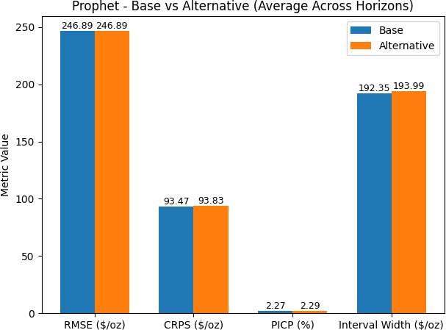

Figure 5. Bar graph of Prophet model metric values

  - Quantile Regression Forest Model

The next model trained was the QRF model, a tree-based model previously mentioned in this thesis. This model was created with the following configurations:
    - n_estimators=300,
    - min_samples_leaf=5
    - random_seed=42

The n_estimators parameter refers to the number of decision trees the model will build. In this case, 300 decision trees were built, this number was chosen as a suitable balance between forecasting accuracy and computational resource usage. Typically, increasing the number of trees leads to higher accuracy and stability, however it does also increase computation time and load. The

samples_leaf parameter refers to the number of samples a leaf can split into. In this case, this means that each decision path must have at least 5 samples. This was chosen to prevent the model from creating overly specific rules for a small subset of the dataset, which would otherwise lead to overfitting. The last parameter refers to the random seed for reproducibility. Having a fixed seed means that this experiment would always be reproduceable and have consistent results which is essential for experimentation and comparisons. The value 42 is common convention and standard practice.
Figure 6 below shows a comparison of the model’s probabilistic forecast of the value of gold for the last 10 trading days of the datasets. From the charts, we can observe that the model had an interval width of around $70 using the base dataset for the subset of those last 10 days, whereas using the alternative dataset resulted in a slightly wider interval width of approximately $90. This increased interval width is likely the driving force behind the increased coverage in the alternative dataset, meaning more of the actual values fall within the forecasted range. Interestingly, it is very clear that there appears to be a clear directional mismatch between the forecasted values and actual values, specifically around the 2nd trading day horizon where the forecasted values drop, while the actual values increase. This phenomenon is later corrected in later daily horizons with the alternative dataset model producing a sharp upward correction around the 6th trading day horizon.
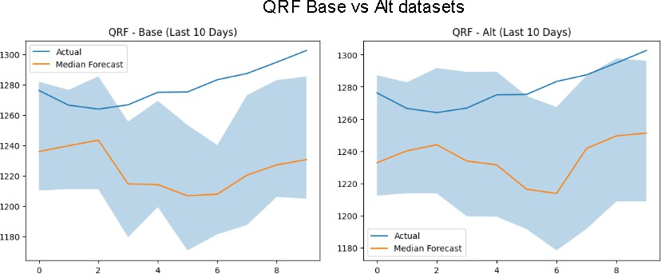

Figure 6. QRF forecast range of t+10 horizon, base vs. alternative dataset, last 10 trading days

For more detailed information on the performance of the QRF model, we dive deeper into the actual metric values across the entire datasets. Figure 7 below shows two tables comparing the model’s values for each metric, for each daily horizon, between the base and alternative datasets.
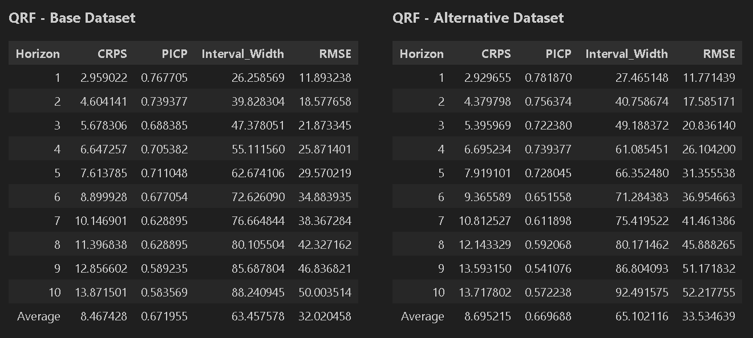

Figure 7. QRF model avg evaluation metrics per daily horizon of the test data subset (last 20% of 2007-2017 dataset). Base vs Alternative datasets

We can observe from the above figure that on average, the PICP, measuring coverage, has a value of around 0.6719 when using the base dataset while the alternative dataset resulted in a value of 0.6696. This means that on average, actual values fell within the forecast range around 67% of the time, a significant improvement from the results of the baseline prophet model. This is also a much closer result to the 80% prediction interval used in the research design. Consequently, the RMSE shows a lower value of around 32 and 33.5 points for the base and alternative datasets respectively, while the CRPS also has a low score of approximately 8.47 points in the base dataset and 8.70 in the alternative dataset. It is also worth noting that the RMSE progressively increases across both datasets as the daily horizon increases. This is expected behaviour since uncertainty and in conjunction, the margin of error compounds overtime in financial forecasting. All of these metrics can be visualized in a bar graph for comparison in figure 8 below.

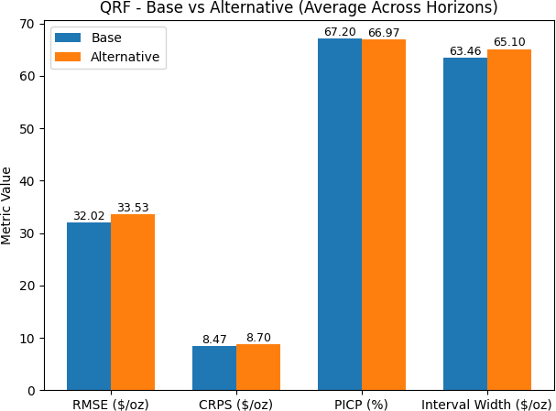

Figure 8. Bar graph of QRF model metric values

  - XGBoost Model

The final model trained and tested was the XGBoost model. This model was designed with the following configurations:
    - objective="reg:quantileerror"
    - quantile_alpha= [0.1, 0.5, 0.9]
    - n_estimators=300,
    - learning_rate=0.05,
    - max_depth=4,
    - random_state=42

While there aren’t optimal values for these configurations, it is important to keep the bigger picture and the objective of the research in mind. These values were chosen as they constitute the right balance between complexity, computational feasibility, and a balanced bias-variance tradeoff.

As previously mentioned, the XGBoost model is another tree-based model originally optimized for point value predictions, however in this case, its objective function is changed to quantile loss or quantile error to predict quantile intervals. This tells XGBoost to optimize for quantile regression in order to estimate conditional quantiles of the target distribution. For simplicity, “conditional quantiles” means producing quantiles or intervals on the condition of the provided features.
Quantile alpha simply refers to the quantiles that will be estimated, in this case the 10th, 50th (mean), and 90th percentiles, leading to an 80% prediction interval as was stated in the methodologies section.
“N estimators” refers to the number of trees built similar to the QRF model, in this case that value was set to 300 in order to balance between forecasting accuracy and resource overhead as well as to make the models comparable to each other.
The learning rate here is essentially the impact of each tree’s prediction which means how much each new tree contributes to the overall prediction. The higher this number, the bigger the impact each tree has on the overall prediction, this means the model learns faster but risks overfitting. Conversely, a lower learning rate means the model learns slower but more carefully, resulting in a more thoughtful output. This number was chosen to ensure gradual learning and to decrease the risk of overfitting. Furthermore, a lower learning rate requires a higher number of trees to obtain a good performance, which was the strategy adopted in this case.
Max depth limits how deep each tree can grow. Lower max depth leads to high bias or underfitting while higher max depth leads to high variance or overfitting. A delicate balance between the two is important to prevent either extreme fitting of data, which is why a value of 4 was chosen. Finally, random state refers to the same concept discussed in QRF for reproducibility.

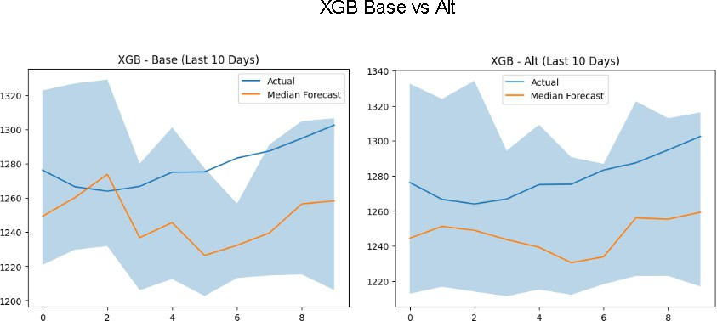

Figure 9. XGBoost forecast range of t+10 horizon, base vs. alternative dataset, last 10 trading days.

The figure above showcases a comparison between the predicted intervals of the XGBoost model while using the base dataset vs the alternative dataset for the last 10 trading days. Immediately the difference in interval width is very apparent, with the base dataset starting out with an interval width of around $100, while the alternative dataset consistently has a wider interval width of around $120, signalling more uncertainty. As a result of the wider interval width, one can observe that the alternative dataset model has a much better coverage of actual values falling within prediction ranges compared to the base dataset. While normally a wider interval width results in a less useful forecast, even if the coverage is better, in this case, the forecast still shows promise despite the increased interval width. In order to get a clearer understanding of the model’s performance, we must first analyse each metrics average results across the entire dataset. Figure 10 below shows a tabular comparison between the metric values of the XGBoost model when trained on the base dataset vs the alternative dataset, across each of the 10 daily horizons.

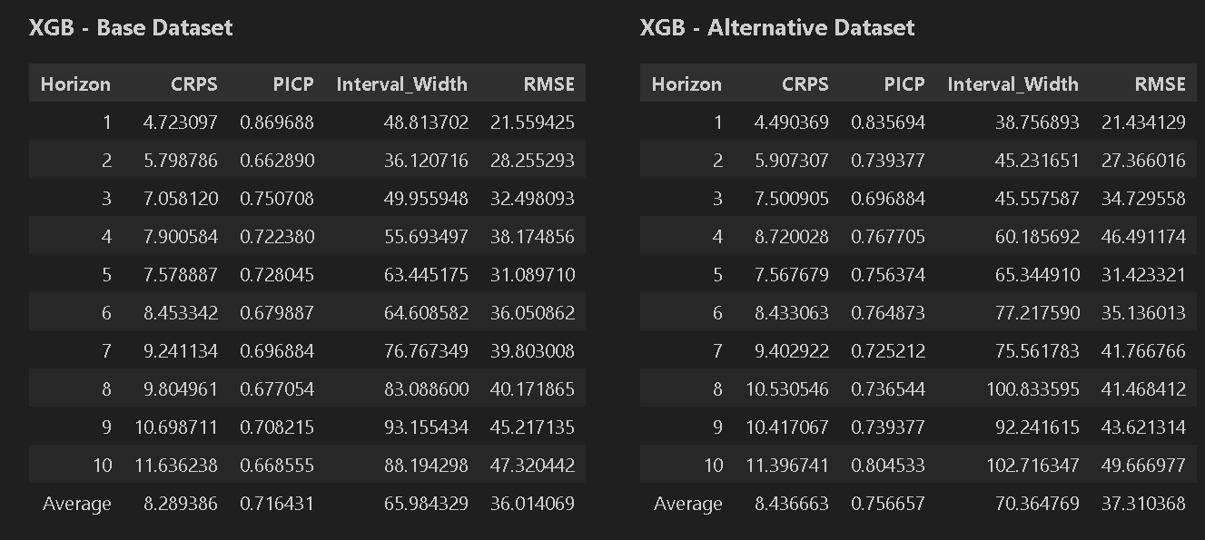

Figure 10. XGBoost model avg evaluation metrics per daily horizon of the test data subset (last 20% of 2007-2017 dataset). Base vs Alternative datasets

We can observe from the above figure that on average, the PICP, measuring coverage, has a value of around 0.7164 when using the base dataset while the alternative dataset resulted in a slightly higher value of 0.7566. This means that on average, actual values fell within the forecast range around 72% of the time while using the base dataset vs 76% of the time while using the alternative dataset, a slight improvement from the reported 67% results of the QRF model. This is the highest result and the closest to the 80% prediction interval used in the research design, out of all models trained. The RMSE shows a value of around 36 and 37.3 $/oz for the base and alternative datasets respectively, while the CRPS also has a low score of approximately 8.29 points in the base dataset and 8.43 in the alternative dataset. It is also worth noting that similarly to the QRF model results, the RMSE of the XGBoost models progressively increases across both datasets as the daily horizon increases. All of these metrics can be visualized in a bar graph for comparison in figure 11 below.

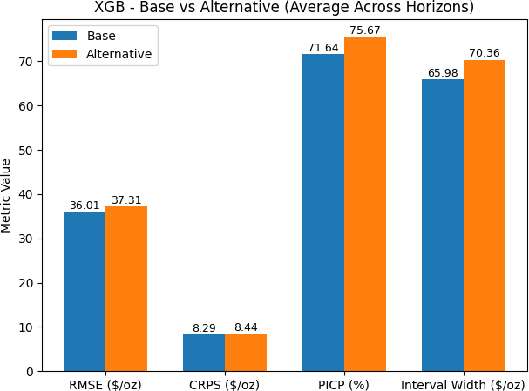

Figure 11. Bar graph of XGBoost model metric values

While other models showed relatively similar results between the metric values produced by using the base dataset vs the alternative dataset, the results of the XGBoost model evaluations tell a slightly different story with the interval width in particular being noticeably higher with the alternative dataset.
A further detailed interpretation and comparative analysis will be discussed in the next section.

7 DISCUSSION

The results outlined in the previous section show a clear hierarchical ranking of performance between the three models employed in this research. It was evident that the tree-based machine learning models, Quantile Regression Forest and XGBoost, significantly outperformed the linear Prophet model across all evaluation metrics. Prophet produced significantly higher RMSE scores and very poor prediction interval coverage, indicating that it struggled to accurately model the dynamics of gold price movements across each of the 10 evaluation daily horizons. In contract, the tree-based machine learning models produced not only more accurate point forecasts and more reliable probabilistic predictions but also a tighter interval width and far better coverage as is summarized in Figure 12 below.
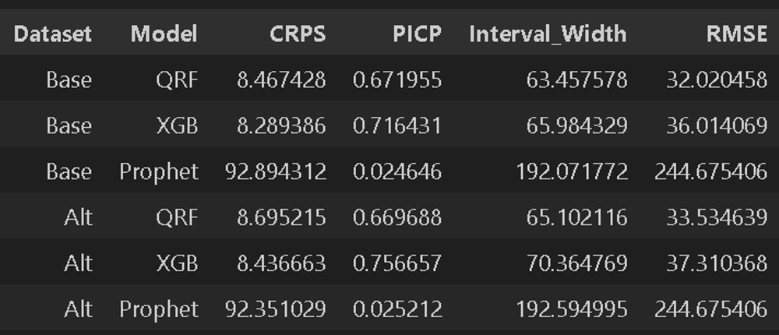

Figure 12. Comparison of model performance across metrics

The higher performance of tree-based ensemble methods come as no surprise as it is well documented in existing financial forecasting literature such as Gu et al. (2020). Random forest and gradient boosting models are well known for their ability to capture nonlinear relationships and complex interactions between variables. It is worth re-iterating once more than predicting financial markets is an extremely difficult endeavour as they are influenced by a wide range of factors that affect each other such as macroeconomic indicators, market volatility, and investor sentiment.

Since Prophet relies on additive trends and seasonalities, it is an extremely effective tool in business forecasting contexts such as predicting retail sales or web traffic. However, it fails to capture the complexities of financial markets and their stochastic, or random, behaviour. Gold prices are characterized by extreme sensitivity to macroeconomic factors which lead to sudden volatility, but because Prophet assumes a relatively smooth underlying trend structure, it is less capable of adapting to abrupt changes in market conditions. This likely explains the significantly higher forecasting errors observed for the Prophet model.
If we look at previously reported evaluation metrics from other experiments, reported RMSE values in the literature vary significantly depending on dataset and methodology. For example, studies such as Cohen, G. and Aiche, A. (2023). and Alharbi, M.H. (2024) report lower RMSE values for tree-based models compared to baseline approaches. This is consistent with our own findings in this research, where the tree-based models (QRF and XGBoost) also achieved lower RMSE values, 32 and 36 $/oz respectively, compared to the Prophet model which had an average value of approximately 248 $/oz. Although a direct comparison is not realistic due to differences in data preprocessing, forecasting horizons, and evaluation frameworks.
If we switch focus to comparing the two tree-based machine learning models, we can observe that there is a relatively small difference in performance between them. Both models resulted in very similar values across the evaluated metrics, with only slight differences depending on the forecasting horizon. The Quantile Regression Forest typically resulted in lower RMSE and average interval width values, suggesting it is slightly better at forecasting point values with higher confidence. XGBoost on the other hand often produced higher PICP or coverage scores closer to the expected prediction interval and marginally better CRPS scores, indicating it is more suited to probabilistic forecasting with decent accuracy. If we consider CRPS as the primary evaluation metric as was mentioned in the methodologies section, then we can surmise that out of the three models, on average, XGBoost performs the best in this specific scenario. In general, both tree-based models are well suited to the task of gold price

forecasting. The choice between them may depend on practical considerations such as computational efficiency, interpretability, or ease of implementation.
This brings us to the other comparative aspect of this research, whether alternative datasets improve forecasting accuracy or not. We will dissect the results for each Model. The results in Figure 10 show that for the QRF, using alternative dataset has actually resulted in worse scores across all metrics. The RMSE score was 33.5 using alternative dataset compared to 32 in the base dataset. The interval width was higher at 65.1 signalling less confidence using the alternative dataset compared to 63.4 using the base dataset. The CRPS had a result of 8.69 using the alternative dataset compared to 8.46 with the base dataset, a decline of approximately 2.6% in performance. Similarly, the results for the XGB model were slightly better using the base dataset than the alternative dataset, with the RMSE scoring 36 vs 37.3 and the CRPS scoring 8.28 vs 8.43 respectively. Interestingly, XGB had a noticeably better PICP or coverage score of 0.756 using the alternative dataset than the base dataset at 0.716. However, this is primarily due to the increased interval width from 65 to 70, signalling a wider net and decreased forecasting confidence. Overall, XGB’s forecasting performance declined by around 1.75% when using alternative dataset compared with the evaluation results of the base dataset. The results of the prophet model were not relevant in this section since the model does not take features into account. Any slight differences in results between alternative and base dataset usage is purely stochastic and does not carry any scientific relevance.
It is worth noting that for all metrics and models, the difference is very minimal and hardly impactful, however the author of this research felt the need to still acknowledge it given the emphasis placed on incremental improvements earlier in the research paper.
There are several possible explanations to these outcomes. First, there may be a high level of noise in alternative data variables compared to the predictive value they bring. Search trends and news sentiment may capture general public interest in gold markets, but this information may not translate directly into short-term price movements as price action is more highly influenced by macroeconomic indicators, trading activity, and geopolitical events.

Second, the time horizon used in this study may influence the usefulness of alternative data. Sentiment and search activity may have predictive value over longer time horizons causing gradual changes in investor behaviour or macroeconomic expectations. However, within a ten day forecasting window, these signals may not have enough weight to meaningfully affect model predictions.
Third, the transformation and aggregation of the sentiment data may have reduced the informational content of the original dataset. In order to align the data temporally and avoid data leakage, the sentiment data were aggregated to daily values and lagged before being integrated into the model features. While this step is necessary for methodological correctness, it may also reduce the granularity and value of the information available to the models.
At this stage, it is worth mentioning some limitations that were encountered while conducting this research. Firstly, it was not feasible to conduct the research in a true walk-forward approach due to computational resource limitations, walk- forward would have meant re-training each of the three models for every time step around the 10 year datasets, two times for each dataset (base and alternative). This would have resulted in several thousand model re-trainings which exceed the computational capacity available. Instead, a simple chronological split was used while ensuring no data leakage. This setup was significantly simpler and is a common approach to forecasting among predictive analytics researchers. Another limitation that was unavoidable was the simplification of the news sentiment dataset by aggregating and reducing the data to a simple net sentiment score and headline count. This was a necessary step in order to be able to align the datasets on dates. However, in doing so, one could argue that sentiment data loses a lot of its context and intensity or impact. Based on the above reported limitations and constraints, it is the opinion of this author that future research should endeavour to 1. Implement true walk-forward validation to mimic real world performance 2. Decrease the forecasting horizon to focus on hours instead of days and 3. Increase the granularity of the alternative datasets in order to match it to price data on an hourly or 10 minute basis.

Finally, to dive deeper into the meaning behind the results it was necessary to compare the importance of the features used. Starting off the feature analysis with the QRF model features, figure 13 below shows that the two primarily dominant features are the gold price 10 day moving average (Gold_MA_10) and the daily gold price closing (Gold_Close), accounting for approximately 72% of the total feature importance. Signalling that traditional financial metrics are still the biggest drivers of financial asset price forecasting, considering that all the features from alternative data such as the VIX, DXY, Google Trends, and news sentiment score significantly lower on the feature importance scale. In simple terms, this means that alternative data metrics have little to no impact on the predictive model’s decision making when it comes to forecasting gold price movements over a 10 day horizon.
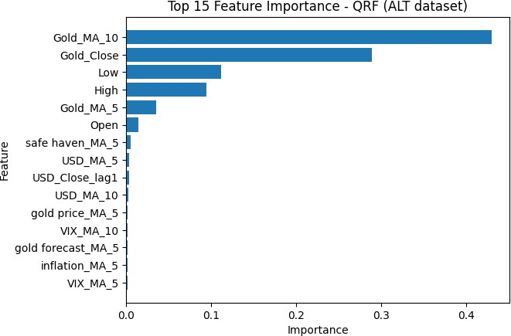

Figure 13. QRF model features importance

Similar results we discovered in the XGB model’s feature analysis as is show in Figure 14 below. The two primarily dominant features were the daily price high and low, jointly making up around 61% of the total feature importance across all features. This aligns with expectations given the model’s probabilistic forecasting superiority. Another interesting find is that the next two most important features

are the gold price 10 day moving average (Gold_MA_10) and the daily gold price closing (Gold_Close), which were the top two features in the QRF model. While the daily gold price low and high, which are the top two features in the XGB model, were the 3rd and 4th most important features in the QRF model. Between both models, these 4 features make up around 92% of the total feature importance in the QRF model and around 78% of the total feature importance in the XGB model. An overwhelming majority in both cases, further emphasising the lack of impact of the alternative dataset features.
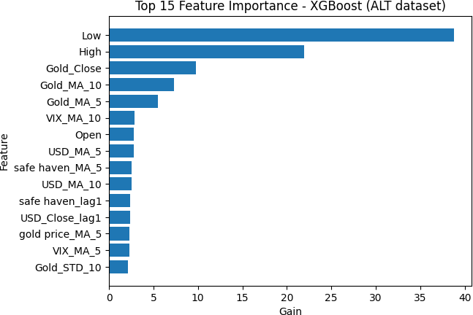

Figure 14. XGBoost model feature importance

Despite the lack of improvement from using alternative data, these results remain extremely valuable. Negative findings are important in scientific research, particularly in the context of financial forecasting where accurate prediction methodologies and tools that provide consistent results continue to be elusive. The results suggest that not all forms of alternative data are equally useful for predicting gold prices, and that careful feature engineering and data selection remain critical.

In conclusion, this research has attempted to explore the impact of utilizing alternative datasets along with machine learning models for the purpose of forecasting the price of one of the world’s oldest stores of value, gold. The aim of this endeavour was to explore whether alternative data that has been processed and analysed by machine learning models, can enhance the prediction of short term (2 - 4 weeks) gold price movements. The primary focus was on the predictive value of alternative data, not on building a deployable trading system. Three types of machine learning models were employed: Prophet, a linear time series forecasting model, and two tree-based models, QRF and XGBoost.
The results of the analysis have shown that on average there was an approximate 2% decline in predictive performance based on average CRPS scores, when using alternative datasets versus relying solely on traditional financial metrics. This was largely due to the increased noise introduced by those metrics as well as the length of the forecasting horizon, spanning over 10 trading days. Since the prediction performance decreased, one can directly address the research question of meaningful impact by stating that alternative data did not provide a statistically meaningful improvement to predictive performance.
These results have answered the remaining research questions of this thesis by showing that, in this case, alternative data has not improved the accuracy of short-term gold price forecasts when compared to using price-based indicators alone. Out of the three models used, and if we consider CRPS as the primary evaluation metric, it would be clear that XGBoost performs best when incorporating alternative data for predicting gold price movements.
As for the importance of alternative dataset features, results have revealed that alternative data, such as Google Trends data or sentiment analysis from financial news, have limited importance and a weak relationship with gold price movements as the vast majority of feature importance was driven by traditional financial metrics such as moving average, daily price lows, highs, and closing.

Generative AI was used to brainstorm ideas for topics for the purpose of writing this paper. Specifically, the AI model “GPT-5.1”. Generative AI was also used to brainstorm ideas on the content, flow, and sentence structure in this paper. It was consulted on the feasibility of the proposed thesis and its relevance.
All content in the final version has been written and evaluated by the author to ensure accuracy, clarity, and academic integrity.

Alharbi, M.H. (2024). Applying Machine Learning Techniques to Analyze and Explore Precious Metals. Technology and Investment, 15(04), pp.183–197. doi:https://doi.org/10.4236/ti.2024.154011.
Chen, T. and Guestrin, C. (2016). XGBoost: a Scalable Tree Boosting System. Proceedings of the 22nd ACM SIGKDD International Conference on Knowledge Discovery and Data Mining - KDD ’16, 1(1), pp.785–794. doi:https://dl.acm.org/doi/epdf/10.1145/2939672.2939785.
Cohen, G. and Aiche, A. (2023). Forecasting gold price using machine learning methodologies. Chaos, Solitons & Fractals, [online] 175, p.114079. doi:https://doi.org/10.1016/j.chaos.2023.114079.
Divya Sri K, Swetha B, Rakshitha Y, Alajangi Shreya and D Kavitha (2024). Data Mining Strategies for Gold Price Prediction Using Multi-Factorial Influences. International Journal For Multidisciplinary Research, [online] 6(3). doi:https://doi.org/10.36948/ijfmr.2024.v06i03.18567.
Gneiting, T. and Raftery, A.E. (2007). Strictly Proper Scoring Rules, Prediction, and Estimation. Journal of the American Statistical Association, 102(477), pp.359–378. doi:https://doi.org/10.1198/016214506000001437.
Gu, S., Kelly, B. and Xiu, D. (2020). Empirical Asset Pricing via Machine Learning. The Review of Financial Studies, [online] 33(5), pp.2223–2273. doi:https://doi.org/10.1093/rfs/hhaa009.
John, B. and K. Nidhina (2025). Gold Price Forecasting Using Machine Learning Techniques. In: Communications in computer and information science. [online] Springer, Cham, pp.286–297. doi:https://doi.org/10.1007/978-3-031- 82383-1_22.
Khosravi, A., Nahavandi, S. and Creighton, D. (2011). Prediction Interval Construction and Optimization for Adaptive Neurofuzzy Inference Systems.

IEEE Transactions on Fuzzy Systems, [online] 19(5), pp.983–988. doi:https://doi.org/10.1109/TFUZZ.2011.2130529.
Kumar, P. (2024). Gold Price Prediction Using Machine Learning Techniques. International Journal for Research in Applied Science and Engineering Technology, [online] 12(5), pp.3692–3696. doi:https://doi.org/10.22214/ijraset.2024.62251.
Masud, S.R., Imtiaz, A., Hossain, S.M. and Ullah, S. (2025). A Comprehensive Approach to Gold Price Prediction Using Machine Learning and Time Series Models. In: Interdisciplinary Approaches in Technology and Management for Social Innovation (IATMSI). 2025 IEEE International Conference on Interdisciplinary Approaches in Technology and Management for Social Innovation (IATMSI). IEEE, pp.1–6. doi:https://doi.org/10.1109/iatmsi64286.2025.10984927.
Nicolai Meinshausen (2006). Quantile Regression Forests. Journal of Machine Learning Research, [online] 7(35), pp.983–999. Available at: https://www.jmlr.org/papers/volume7/meinshausen06a/meinshausen06a.pdf.
Preis, T., Moat, H.S. and Stanley, H.E. (2013). Quantifying Trading Behavior in Financial Markets Using Google Trends. Scientific Reports, 3(1). doi:https://doi.org/10.1038/srep01684.
Sarvaiya, D. and Ramchandani, D. (2022). Time Series Analysis and Forecasting of Gold Price using ARIMA and LSTM Model. International Journal for Research in Applied Science and Engineering Technology, 10(9), pp.168–
173. doi:https://doi.org/10.22214/ijraset.2022.46555.

Taneva-Angelova, G., Raychev, S. and Ilieva, G. (2025). A Framework for Gold Price Prediction Combining Classical and Intelligent Methods with Financial, Economic, and Sentiment Data Fusion. International Journal of Financial Studies, [online] 13(2), p.102. doi:https://doi.org/10.3390/ijfs13020102.
Taylor, S.J. and Letham, B. (2017). Forecasting at scale. Forecasting at scale, [online] 71(1). doi:https://doi.org/10.7287/peerj.preprints.3190v2.

Trivedi, U.B., Somvanshi, T.V.S. and J, S.P. (2022). Gold prices prediction: Comparative study of multiple forecasting models. YMER Digital, 21(07), pp.745–764. doi:https://doi.org/10.37896/ymer21.07/60.
Sinha, A. and Khandait, T. (2021). Sentiment Analysis of Commodity News (Gold). [online] Kaggle.com. Available at: https://www.kaggle.com/datasets/ankurzing/sentiment-analysis-in-commodity- market-gold [Accessed 20 Dec. 2025].

APPENDICES

Appendix 1

from pytrends.request import TrendReq
import pandas as pd
import time
import random
from datetime import datetime, timedelta
import os

start_time = datetime.now() print(f"Starting at {start_time}")

#
# CONFIG #

keywords = [ 'gold price', 'gold forecast', 'buy gold', 'inflation', 'safe haven'
]
start_date = datetime(2008, 1, 1)
end_date = datetime(2017, 12, 31) window_size = 180 # ~6 months
OUTPUT_FILE = 'google_trends_gold_keywords_daily_2008_2017.csv' BASE_SLEEP = 10
RATE_LIMIT_SLEEP_MIN = 120
RATE_LIMIT_SLEEP_MAX = 300
#
# INIT PYTRENDS #
pytrend = TrendReq( hl='en-US',
tz=360,
timeout=(10, 25)
)
#
# LOAD EXISTING DATA (if any) #
if os.path.exists(OUTPUT_FILE):
final_df = pd.read_csv(OUTPUT_FILE, parse_dates=['date']) completed_keywords = set(final_df.columns) - {'date'} print(f"Resuming. Found existing keywords: {completed_keywords}")
else:

final_df = None completed_keywords = set() print("Starting fresh run.")
#
# MAIN LOOP #
for kw in keywords:
if kw in completed_keywords:
print(f"Skipping already completed keyword: {kw}")
continue
print(f"\nProcessing keyword: {kw}") all_dfs = []
current_start = start_date
while current_start < end_date:
current_end = min(current_start + timedelta(days=window_size), end_date)
timeframe = f"{current_start.strftime('%Y-%m-%d')} {current_end.strftime('%Y-%m-%d')}" print(f" Fetching {timeframe}")
try:
pytrend.build_payload( kw_list=[kw], timeframe=timeframe, geo=''
)
df = pytrend.interest_over_time()

if not df.empty:
df = df[[kw]] all_dfs.append(df)
time.sleep(BASE_SLEEP)

except Exception as e:
if "429" in str(e):
wait = random.randint(RATE_LIMIT_SLEEP_MIN, RATE_LIMIT_SLEEP_MAX) print(f"⛔ Rate limited. Sleeping for {wait} seconds...")
time.sleep(wait)
continue else:
print(f"⚠️ Error: {e}. Retrying in 10s...") time.sleep(10)
continue

current_start = current_end + timedelta(days=1)
#
# MERGE & SAVE CHECKPOINT #
if not all_dfs:
print(f"No data collected for keyword: {kw}")
continue

kw_df = pd.concat(all_dfs)
kw_df = kw_df[~kw_df.index.duplicated(keep='first')] kw_df.reset_index(inplace=True)
if final_df is None:
final_df = kw_df
else:
final_df = final_df.merge(kw_df, on='date', how='outer') final_df.sort_values('date', inplace=True)
# SAVE AFTER EACH KEYWORD
final_df.to_csv(OUTPUT_FILE, index=False) print(f"✅ Saved progress after keyword: {kw}")
#
# DONE #
end_time = datetime.now() print(f"Ending at {end_time}")

elapsed = end_time - start_time

print("\nAll keywords processed.") print(f"Final dataset saved to: {OUTPUT_FILE}")
print(f"Script took (hh:mm:ss) {elapsed} to run") print(final_df.head())
Starting at 2026-01-29 13:54:26.967318
Starting fresh run.

Processing keyword: gold price Fetching 2008-01-01 2008-06-29
Fetching 2008-06-30 2008-12-27
Fetching 2008-12-28 2009-06-26
Fetching 2009-06-27 2009-12-24
Fetching 2009-12-25 2010-06-23
Fetching 2010-06-24 2010-12-21
Fetching 2010-12-22 2011-06-20
Fetching 2011-06-21 2011-12-18
Fetching 2011-12-19 2012-06-16
Fetching 2012-06-17 2012-12-14
Fetching 2012-12-15 2013-06-13
Fetching 2013-06-14 2013-12-11
Fetching 2013-12-12 2014-06-10
Fetching 2014-06-11 2014-12-08
Fetching 2014-12-09 2015-06-07
Fetching 2015-06-08 2015-12-05
Fetching 2015-12-06 2016-06-03
Fetching 2016-06-04 2016-12-01
Fetching 2016-12-02 2017-05-31
Fetching 2017-06-01 2017-11-28
Fetching 2017-11-29 2017-12-31
⬛ Saved progress after keyword: gold price

Processing keyword: gold forecast Fetching 2008-01-01 2008-06-29

Fetching 2008-12-28 2009-06-26
Fetching 2009-06-27 2009-12-24
Fetching 2009-12-25 2010-06-23
Fetching 2010-06-24 2010-12-21
Fetching 2010-12-22 2011-06-20
Fetching 2011-06-21 2011-12-18
Fetching 2011-12-19 2012-06-16
Fetching 2012-06-17 2012-12-14
Fetching 2012-12-15 2013-06-13
Fetching 2013-06-14 2013-12-11
Fetching 2013-12-12 2014-06-10
Fetching 2014-06-11 2014-12-08
Fetching 2014-12-09 2015-06-07
Fetching 2015-06-08 2015-12-05
Fetching 2015-12-06 2016-06-03
Fetching 2016-06-04 2016-12-01
—● Rate limited. Sleeping for 197 seconds... Fetching 2016-06-04 2016-12-01
Fetching 2016-12-02 2017-05-31
Fetching 2017-06-01 2017-11-28
Fetching 2017-11-29 2017-12-31
⬛ Saved progress after keyword: gold forecast

Processing keyword: buy gold Fetching 2008-01-01 2008-06-29
Fetching 2008-06-30 2008-12-27
Fetching 2008-12-28 2009-06-26
Fetching 2009-06-27 2009-12-24
Fetching 2009-12-25 2010-06-23
Fetching 2010-06-24 2010-12-21
Fetching 2010-12-22 2011-06-20
Fetching 2011-06-21 2011-12-18
Fetching 2011-12-19 2012-06-16
Fetching 2012-06-17 2012-12-14
Fetching 2012-12-15 2013-06-13
Fetching 2013-06-14 2013-12-11
Fetching 2013-12-12 2014-06-10
Fetching 2014-06-11 2014-12-08
Fetching 2014-12-09 2015-06-07
Fetching 2015-06-08 2015-12-05
Fetching 2015-12-06 2016-06-03
Fetching 2016-06-04 2016-12-01
Fetching 2016-12-02 2017-05-31
Fetching 2017-06-01 2017-11-28
Fetching 2017-11-29 2017-12-31
⬛ Saved progress after keyword: buy gold
Processing keyword: inflation Fetching 2008-01-01 2008-06-29
Fetching 2008-06-30 2008-12-27
Fetching 2008-12-28 2009-06-26
Fetching 2009-06-27 2009-12-24
Fetching 2009-12-25 2010-06-23
Fetching 2010-06-24 2010-12-21
Fetching 2010-12-22 2011-06-20
Fetching 2011-06-21 2011-12-18
Fetching 2011-12-19 2012-06-16
Fetching 2012-06-17 2012-12-14

Fetching 2013-06-14 2013-12-11
Fetching 2013-12-12 2014-06-10
Fetching 2014-06-11 2014-12-08
Fetching 2014-12-09 2015-06-07
Fetching 2015-06-08 2015-12-05
Fetching 2015-12-06 2016-06-03
Fetching 2016-06-04 2016-12-01
Fetching 2016-12-02 2017-05-31
Fetching 2017-06-01 2017-11-28
Fetching 2017-11-29 2017-12-31
⬛ Saved progress after keyword: inflation

Processing keyword: safe haven Fetching 2008-01-01 2008-06-29
Fetching 2008-06-30 2008-12-27
Fetching 2008-12-28 2009-06-26
Fetching 2009-06-27 2009-12-24
Fetching 2009-12-25 2010-06-23
Fetching 2010-06-24 2010-12-21
Fetching 2010-12-22 2011-06-20
Fetching 2011-06-21 2011-12-18
Fetching 2011-12-19 2012-06-16
Fetching 2012-06-17 2012-12-14
Fetching 2012-12-15 2013-06-13
Fetching 2013-06-14 2013-12-11
Fetching 2013-12-12 2014-06-10
Fetching 2014-06-11 2014-12-08
Fetching 2014-12-09 2015-06-07
Fetching 2015-06-08 2015-12-05
Fetching 2015-12-06 2016-06-03
Fetching 2016-06-04 2016-12-01
Fetching 2016-12-02 2017-05-31
Fetching 2017-06-01 2017-11-28
Fetching 2017-11-29 2017-12-31
⬛ Saved progress after keyword: safe haven Ending at 2026-01-29 14:16:55.767603
All keywords processed.
Final dataset saved to: google_trends_gold_keywords_daily_2008_2017.csv Script took (hh:mm:ss) 0:22:28.800285 to run
date gold price gold forecast buy gold inflation safe haven
0 2008-01-01 | 27 | 100 | 58 | 41 | 0
1 2008-01-02 | 45 | 49 | 44 | 55 | 0
2 2008-01-03 | 54 | 76 | 43 | 55 | 0
3 2008-01-04 | 45 | 83 | 49 | 60 | 45
4 2008-01-05 | 34 | 47 | 62 | 50 | 0

Appendix 2

import pandas as pd
from datetime import datetime
import re

# Load dataset
df = pd.read_csv("gold-dataset-sinha-khandait.csv")

# Regex pattern to find YYYY-MM-DD in URLs
date_pattern = re.compile(r"\d{4}-\d{2}-\d{2}")
def fix_date(row):
original_date = str(row["Dates"]) url = str(row["URL"])

# Regex pattern for YYYY-MM-DD
valid_pattern = re.compile(r"\d{4}-\d{2}-\d{2}") url_pattern = re.compile(r"\d{4}-\d{2}-\d{2}")

# Try to extract a valid date from the URL
match = url_pattern.search(url)
extracted_date = match.group(0) if match else None
def normalize(date_str):
try:
return pd.to_datetime(date_str, errors="coerce").strftime("%Y-%m-%d")
except Exception:
return None

normalized = normalize(original_date)
# Check if normalized year is reasonable
if normalized:
year = int(normalized[:4])
if 1900 <= year <= datetime.now().year:
# Valid year, keep it
return pd.Series([normalized, False]) else:
# Year out of range, replace with URL date if available
if extracted_date:
return pd.Series([extracted_date, True]) else:
return pd.Series([normalized, False])
else:
# If normalization failed, try URL
if extracted_date:
return pd.Series([extracted_date, True]) else:
return pd.Series([original_date, False])
# Apply function to each row
df[["new_date", "date_modified"]] = df.apply(fix_date, axis=1) df.drop(columns=['Dates'], inplace=True) df.rename(columns={"new_date": "date"}, inplace=True)
# Save cleaned dataset
df.to_csv("gold-sentiment-dataset-cleaned.csv", index=False)

print("✅ Cleaning complete. Saved as gold-dataset-cleaned.csv") print(df[["date", "date_modified"]].head())
C:\Users\AbdoZ\AppData\Local\Temp\ipykernel_27520\1942584045.py:25: UserWarning: Parsi ng dates in %d-%m-%Y format when dayfirst=False (the default) was specified. Pass `dayfirst=True
` or specify a format to silence this warning.
return pd.to_datetime(date_str, errors="coerce").strftime("%Y-%m-%d")
⬛ Cleaning complete. Saved as gold-dataset-cleaned.csv date date_modified
0 2016-01-28 False
1 2017-09-13 False
2 2016-07-26 False
3 2018-02-28 False
4 2017-06-09 False

Forex Trend Prediction: Can Machine Learning Algorithms Forecast Short Timeframe Movements?

Alireza Behjoee University of Groningen BA Thesis, Data Science Noman Haleem
June, 13 2025

Abstract
The Foreign Exchange (FOREX) market is the largest and most liquid financial market in the world. Its worldwide 24-hour accessibility, coupled with its dynamic nature, makes it very attractive to traders and investors. Therefore, numerous deep learning algorithms have been developed to forecast market trends, but they face challenges such as overfitting, long training times, and limited interpretability. Additionally, most prior research has focused on longer timeframes, such as daily, which may not be optimal for capturing the frequent fluctuations in Forex prices.
This study attempts to bridge these gaps by developing machine learning models using the 13 most commonly used technical indicators, in addition to OHLCV (Open, High, Low, Close, Volume) data. The models are trained on shorter timeframes, specifically the 5-minute, 15-minute, 30-minute, 1-hour, and 4-hour intervals, for the EUR/USD currency pair and the XAU/USD commodity pair. Then, they are evaluated not only based on accuracy but also through profitability analysis in order to assess their performance under real-world trading conditions and how much net profit they could generate.
Overall, our proposed model achieves an accuracy of 82.10% and a profit of 9.2% for XAU/USD on the 5-minute timeframe, based on backtesting from April 25, 2025, to May 1, 2025.

- Introduction 2
- Literature Review 7
- Methodology 9
  - Data 9
  - Technical Indicators 12
  - Data labeling 13
  - Data Preprocessing 14
    - Mutual Information (MI) 15
    - Recursive Feature Elimination with Cross-Validation (RFECV) 16
  - Model training 16
  - Model Evaluation and Profitability Analysis 17
    - Accuracy Evaluation 18
    - Profitability Analysis (Backtesting) 18
- Results 23
  - XAU/USD 23
  - EUR/USD 29
- Discussion 34
5.2. Limitations 37
- Conclusion 38
References 41

The Foreign Exchange (FOREX or FX) market is a global marketplace where currencies are traded, with an average daily volume of $6.6 trillion, making it the largest financial market in the world (Guyard & Deriaz, 2024; Mabrouk et al., 2021; Ayitey Junior et al., 2023). It is a decentralized market that operates 24 hours a day, except on weekends, across major financial centers such as London, New York, Tokyo, and Sydney.
The core of Forex trading is the exchange between two different assets, typically currencies traded in pairs such as EUR/USD, where one is bought and the other is sold. Profit or loss is based on fluctuations in the exchange rate. For instance, buying EUR/USD results in a profit if the value of the euro increases against the dollar, and a loss if it decreases. Some pairs, like XAU/USD, represent commodities (such as gold) traded against currencies, but they follow a similar trading mechanism. Participants in the Forex market include central banks, commercial banks, financial institutions, hedge funds, multinational corporations, and individual retail traders.
The Forex market offers several advantages that make it more attractive and profitable than other financial markets. These include no commissions or middlemen, flexible lot sizes, high liquidity, fast transactions, high leverage with low margin, 24-hour access, protection from insider trading, limited regulation, and extensive online trading options (Ayitey Junior et al., 2023).
Despite its attractive potential for profit, predicting price movements in the Forex market has long been a challenging task due to the influence of various factors. These include interest rate changes, inflation, geopolitical events, market sentiment, central bank decisions, economic indicators such as GDP and employment data, and human behavior (Ayitey Junior et al., 2023).

Because of these challenges, “only 2% of traders are successful in predicting Forex market movements correctly” (Ayitey Junior et al., 2023).
There are two main types of techniques used to predict price movements which are fundamental analysis and technical analysis. Fundamental analysis focuses on evaluating economic, political, and social factors that can affect prices. In contrast, technical analysis focuses on analyzing historical price data and technical indicators to understand market patterns. Numerous studies have demonstrated that technical analysis plays a crucial role in Forex trading and can be effective in forecasting future price movements (Abbad et al., 2014; Saadati & Manthouri, 2024). However, another approach that has gained increasing attention in recent years is the combination of technical analysis, which includes technical indicators, price, and volume data, with Artificial Intelligence (AI) to predict market trends, due to AI's ability to analyze complex data and detect hidden patterns.
In line with this growing focus on trend prediction, numerous deep learning (DL) algorithms have been developed to forecast price direction in the Forex market. While these models have shown some promising results, they also face some limitations. As Guyard and Deriaz (2024) point out, many publications in Forex trading that have focused on neural network models rely on relatively small datasets, which poses a significant challenge for deep learning models. This is because “deep learning models require large and diverse datasets to effectively train and generalize their learnings” (Taherdoost, 2023). Moreover, most DL studies in the Forex market have focused on daily or longer timeframes, which further reduces the amount of data. At these timeframes, even several years of historical records may result in only a small number of data points, which is often not enough to train deep learning models effectively. This lack of data can

lead to overfitting and unreliable predictions, ultimately resulting in financial losses for traders who depend on such models for decision-making.
As mentioned, most studies have focused on longer timeframes when developing deep learning models, which presents another issue. The Forex market is known for its high volatility and frequent price fluctuations throughout the day, often caused by news or the release of economic indicators (Dakalbab et al., 2025; Eddelbuttel & McCurdy, 1998; Guyard & Deriaz, 2024). Therefore, models trained on longer timeframes may fail to capture price changes that occur over short periods, resulting in inaccurate predictions during times of high volatility.
Another major concern is the lack of interpretability in deep learning models, as deep learning algorithms that generate predictions are often regarded as a black box, making their decisions difficult to interpret (Lam et al., 2025). In the context of financial market prediction, this poses a significant challenge, because it is unclear which features drive the final prediction. This lack of transparency creates uncertainty for both researchers and traders, since it becomes difficult to determine whether the model’s predictions are based on meaningful patterns or statistical noise.
A further limitation is that even the most accurate deep learning models may not be suitable for live signal generation in the Forex market due to their high computational demands and slow processing times. A study by Zafeiriou et al. (2024) found that while standard neural networks like LSTM can predict the Forex market, their complexity and latency make them impractical for real-time use. In live trading, especially in the Forex market where prices can change within seconds, timing is critical. If a model is too slow, the market may move before a signal is generated. As a result, delays in signal generation, even by a few seconds, can cause missed opportunities or financial losses because accurate entry timing is essential for achieving profit.

Given these limitations, machine learning (ML) models may offer a more practical and effective alternative, especially in scenarios where processing time is critical and data is limited. To begin with, ML models are generally simpler, faster to train, and more efficient, which enables quicker signal generation and makes them more suitable for algorithmic trading. Additionally, studies outside the financial domain have shown that ML models often outperform DL models when working with smaller datasets (Gill et al., 2022; Xu, Kinfu, Levine, et al., 2021; Guyard & Deriaz, 2024). Furthermore, machine learning models are more interpretable, as they provide feature importance metrics that help traders and researchers understand how and why the model makes specific predictions. Finally, little research has focused on developing models specifically for shorter timeframes, which may be more effective in capturing the high volatility that frequently occurs in the Forex market throughout the day. Therefore, this study aims to address these gaps by evaluating whether machine learning classification algorithms can effectively predict short-term trends (5-minute, 15-minute, 30-minute, 1-hour, and 4-hour), not only for EUR/USD, the most widely studied and traded currency pair (Mabrouk et al., 2021), but also for XAU/USD, a popular commodity pair, in order to assess whether such models generalize well across different asset types. To evaluate model performance, this study will consider not only accuracy but also conduct a profitability analysis by implementing a trading strategy based on the model’s predictions to measure how much net profit each model could generate under realistic trading conditions on Otet Markets broker. Hence, the main research question is: Can machine learning classification algorithms predict short-term Forex market trends? The sub-questions are:
- Which machine learning classification algorithms perform best in predicting EUR/USD and XAU/USD?

- How does the choice of timeframe impact the accuracy and profitability of machine learning models?
- To what extent does higher accuracy translate into higher profitability in real trading scenarios?
- Which technical indicators most influence the profitability of the models?

This paper is structured as follows. The Literature Review section provides an overview of related work on the use of ML and DL models in the Forex market. The Methodology section explains the data collection process, the technical indicators used, the model development steps, and the trading strategy used for profitability analysis. The Results section presents model performance based on both accuray and profitability outcomes. The Discussion interprets the results across different timeframes and assets, highlights the limitations, and the Conclusion summarizes the key findings and outlines possible directions for future research.

Literature Review

Most existing research on the Forex market frames the task as a classification problem, where the goal is to determine the direction of market trends. In addition, these studies use technical indicators as input features and preserve the temporal order of the data during modeling.
Galeshchuk and Mukherjee (2017), for instance, analyzed the performance of Convolutional Neural Networks (CNNs), Artificial Neural Networks (ANN), Artificial Neural Networks with Moving Average input (ANN-MA), and other models for predicting price movements of the EUR/USD, GBP/USD, and USD/JPY currency pairs using daily data from 2010 to 2015, while preserving the chronological order of the data during training. Their findings showed that the CNN model outperformed all other methods, achieving an average accuracy of 75.28%.
Guyard and Deriaz (2024) tested various machine learning algorithms to predict the direction of the EUR/USD currency pair using daily data. Among all the models evaluated, Histogram-Based Gradient Boosting achieved the highest accuracy (58%) and profit (29.5%).
Yildirim et al. (2021) explored the prediction of price direction for the EUR/USD currency pair using Long Short-Term Memory (LSTM) models from January 2013 to January 2018, based on daily data. The task was framed as a binary classification problem (increase vs. decrease), and the models were trained using technical indicators as input features. Moreover, no shuffling was applied during training in order to preserve the chronological order of the data points. Their proposed hybrid LSTM model achieved an accuracy of 73.61%.
Baasher and Fakhr (2010) conducted a study to predict the price direction of the USD/JPY, USD/EGP, and EUR/EGP currency pairs using daily data over a period of 1852 days, from April

2003 to August 2010. They evaluated three models, which were Radial Basis Function Neural Network (RBF), Multilayer Perceptron Neural Network (MLP), and Support Vector Machine (SVM). The models were trained using 11 technical indicators as input features. Among them, the MLP model achieved the highest accuracy, reaching 79.2%.
Mabrouk et al. (2021) experimented with linear and non-linear machine learning algorithms to predict the EUR/USD currency pair using daily data from January 2014 to January 2021. The models were trained using technical indicators as input features, and the chronological order of the data was preserved during training. Their best model was an SVM, which achieved an accuracy of 72% and generated 62% profit.
Fisichella and Garolla (2021) developed a CNN model trained on 4-hour interval data from six currency pairs (GBP/USD, EUR/USD, USD/CHF, USD/JPY, EUR/GBP, and GBP/JPY) ranging from January 1, 2010, to April 30, 2021. Their proposed model achieved an accuracy of 60.7%.
Phuong Dong Nguyen et al. (2024) developed a hybrid deep learning model by combining two convolutional layers and one LSTM layer. The dataset included currency pairs such as AUD/USD, CAD/JPY, and EUR/USD. It coverd the period from April 1, 2012, to April 13, 2022, spanning a total of 10 years. The first eight years of data were used for training the model, while the final two years were used for simulation. The task was designed as a trend classification problem with three categories, where each day was labeled as either an uptrend, a downtrend, or an unknown trend. They trained the model using 14 technical indicators along with OHLCV data. The proposed hybrid model achieved a monthly profit of 15%.
Someswari Perla et al. (2023) conducted a study using five currency pairs, including MYR/USD, MXN/USD, EUR/JPY, EUR/GBP, and EUR/HKD, on a daily timeframe, to predict the next

day’s exchange rates and classify the trends as either up or down, based on six technical indicators. For the regression task, the authors used data from January 3, 2012, to August 5, 2015, with a total of 900 daily records for each currency pair. For the classification task, they used a slightly longer dataset, which was from January 3, 2012, to December 31, 2015, which included 1044 records per pair. The authors proposed a model called Deep Kernel Random Vector Functional Link Network Autoencoder (DKRVFLN-AE). In the regression task, this model achieved the best overall performance, with a MAPE of 1.17%, MAE of 0.0081, and RMSE of 0.0126 on the EUR/JPY test set. In the classification task, this model again outperformed all other classifiers, achieving an accuracy of 84.66% and an F-measure of 0.83 on the MXN/USD pair.

Methodology

Data

The data used in this study was collected using MetaTrader 5 (MT5). It was obtained through OTET Markets, a regulated Forex broker that enables users to execute trades and access both real-time and historical data for various currency pairs and commodities. In order to retrieve the historical data, a live trading account was created with OTET Markets and linked to the MT5 platform. Using the official MT5 Python library, a direct connection was established to the MT5 terminal, which allowed historical data to be retrieved for the selected symbols and timeframes. The retrieved data includes the standard OHLCV format (Open, High, Low, Close, Volume) along with the Timestamp. These components represent the following:
- Timestamp: The date and time when the candle (time interval) starts.
- Open: The price at the beginning of the time interval.
- High: The highest price reached during the interval.
- Low: The lowest price during the interval.
- Close: The final price at the end of the interval.
- Volume: The total number of transactions traded during the interval.

Two trading instruments were selected for analysis: EUR/USD and XAU/USD. EUR/USD represents the Euro to the U.S. Dollar currency pair, and is the most heavily traded pair in the Forex market (Mabrouk et al., 2021). XAU/USD, on the other hand, represents the value of gold measured in the U.S. Dollars. As a commodity instrument, it often behaves differently from currency pairs as it reacts strongly to news, geopolitical events, etc. These two instruments were chosen to compare model performance across both a major currency pair and a commodity pair

in order to provide broader insights into the generalizability of the machine learning algorithms. For both symbols, OHLCV data was collected across five commonly used short-term timeframes:
- 5-minute (5M): Suitable for high-frequency trading, capturing rapid market fluctuations.
- 15-minute (15M): Also used for high-frequency strategies, offering slightly more stability than 5M.
- 30-minute (30M): Helps identify short-term intraday trends while reducing noise.
- 1-hour (1H): Commonly used for analyzing clearer intraday movements.
- 4-hour (4H): Captures broader market moves within a single trading day without overlapping into long-term timeframes.
To ensure a fair comparison across instruments and timeframes, the same start and end dates were selected for each timeframe for both EUR/USD and XAU/USD. However, despite using identical time ranges, the number of data points differs between the two instruments. This difference is due to variations in trading hours and weekend gaps. While the Forex market for EUR/USD operates almost continuously from Sunday 22:00 GMT to Friday 22:00 GMT, the gold market (XAU/USD) pauses for one hour daily between 21:00 and 22:00 GMT. Additionally, although both instruments are inactive over the weekend, gold typically stops trading slightly earlier on Fridays and resumes slightly later on Sundays, further reducing the number of available candles. Full details of the timeframes, date ranges, and data point counts are provided in Table 1.

Symbol | Timeframe | Time Range | Data Count
XAU/USD | 5M | 2025-03-28 to 2025-05-01 | 6221
XAU/USD | 15M | 2025-01-16 to 2025-05-01 | 6762
XAU/USD | 30M | 2024-10-03 to 2025-05-01 | 6727
XAU/USD | 1H | 2024-05-07 to 2025-05-01 | 5812
XAU/USD | 4H | 2023-04-13 to 2025-05-01 | 3171
EUR/USD | 5M | 2025-03-28 to 2025-05-01 | 6796
EUR/USD | 15M | 2025-01-16 to 2025-05-01 | 7191
EUR/USD | 30M | 2024-10-03 to 2025-05-01 | 7097
EUR/USD | 1H | 2024-05-07 to 2025-05-01 | 6113
EUR/USD | 4H | 2023-04-13 to 2025-05-01 | 3195
Table 1. Time Range and Data Count for Each Symbol and Timeframe.

Technical Indicators

After collecting the data, the most commonly used technical indicators were calculated to serve as input features for training the machine learning models. Technical indicators are mathematical formulas derived from price data, including open, high, low, close (OHLC), and trading volume
(V). They have proven useful in helping traders identify market trends (Ghanem et al., 2024;

Yong et al., 2015). Therefore, by including them as input features, we aim to provide the models with additional context about recent market behavior to improve predictions. Additionally, to provide the models with a broader and more informative feature set, some indicators were calculated using different periods. This approach allows the machine learning algorithms to learn from various market conditions and automatically identify the most effective combinations of indicators and period values for each symbol and timeframe. Table 2 presents a detailed overview of all technical indicators used in this study, along with their corresponding periods.

Technical Indicator | Parameters
Relative Strength Index (RSI) | Period = 7, 14, 21
Moving Average Convergence Divergence (MACD) | Short Term = 12, Long Term = 26, Signal = 9
Weighted Moving Average (WMA) | Period = 10, 20, 50
Exponential Moving Average (EMA) | Periods = 10, 20, 50, 100
Simple Moving Average (SMA) | Period = 10, 20, 50, 100
Ichimoku | Standard settings (9, 26, 52)
Average Directional Index (ADX) | Period = 7, 14, 21
Bollinger Bands (BB) | Period = 10, 20, 50; Standard Deviation = 2 (for band width)

Momentum | Period = 10, 14, 21
Williams %R | Period = 10, 14, 21
Rate of Change (ROC) | Period = 10, 14, 21
Stochastic Oscillator | %K = 14, D = 3; %K = 10, D = 3
Commodity Channel Index (CCI) | Period = 10, 20, 50
Table 2. List of the technical indicators and their corresponding periods.

Data labeling

To label the data, we framed the problem as a binary classification task. The reason for focusing on classification rather than predicting exact prices is the inherent randomness and volatility of financial data, which make it challenging to accurately forecast specific price values (Nguyen et al., 2024). Therefore, as in many previous studies on the Forex market, this study focuses on a binary classification approach, where the model aims to predict whether the price will increase (label = 1) or decrease (label = 0). To do this, we compared the closing prices at two consecutive time steps which are time t and time t-1. If the closing price at time t is greater than the closing price at time t−1, it indicates an upward movement, so we assign a label of 1 to time t+1, as we aim to predict the future direction. In contrast, if the closing price at time t is lower or equal than at time t−1, it indicates a downward trend, so we assign a label of 0 to time t+1.

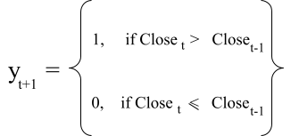

Formula 1. Labeling rule for trend prediction.

Data Preprocessing

After labeling the data and calculating the technical indicators, the dataset was split into three parts. The first 70% was used for training, the next 15% for validation, and the remaining 15% for testing and profitability analysis. This chronological split was done to ensure that the model is always trained on past data and evaluated on more recent data.. The test set was also kept completely unseen during both training and tuning phases to ensure an accurate evaluation of the models’ performance. The specific date ranges used for the training, validation, and test sets are provided in Table 3.

Symbol | Timeframe | Training Set (70%) | Validation Set (15%) | Test Set (15%)
XAU/USD | 5M | 2025-03-28 to  2025-04-22 | 2025-04-22 to  2025-04-25 | 2025-04-25 to  2025-05-01
XAU/USD | 15M | 2025-01-16 to  2025-03-31 | 2025-03-31 to  2025-04-15 | 2025-04-15 to  2025-05-01
XAU/USD | 30M | 2024-10-03 to  2025-02-27 | 2025-02-27 to  2025-03-31 | 2025-03-31 to  2025-05-01

XAU/USD | 1H | 2024-05-07 to  2025-01-14 | 2025-01-14 to  2025-03-07 | 2025-03-07 to  2025-05-01
XAU/USD | 4H | 2023-04-13 to  2024-09-17 | 2024-09-17 to  2025-01-08 | 2025-01-08 to  2025-05-01
EUR/USD | 5M | 2025-03-28 to  2025-04-22 | 2025-04-22 to  2025-04-25 | 2025-04-25 to  2025-05-01
EUR/USD | 15M | 2025-01-16 to  2025-03-31 | 2025-03-31 to  2025-04-15 | 2025-04-15 to  2025-05-01
EUR/USD | 30M | 2024-10-03 to  2025-02-27 | 2025-02-27 to  2025-03-31 | 2025-03-31 to  2025-05-01
EUR/USD | 1H | 2024-05-07 to  2025-01-14 | 2025-01-14 to  2025-03-07 | 2025-03-07 to  2025-05-01
EUR/USD | 4H | 2023-04-12 to  2024-09-17 | 2024-09-17 to  2025-01-09 | 2025-01-09 to  2025-05-01
Table 3. Date ranges used for the training, validation, and test sets for each symbol and timeframe.

Before applying any preprocessing techniques, we first trained the models using all calculated features and OHLCV data. This initial run served as a baseline, allowing us to compare the performance of later models after applying different preprocessing methods. To explore whether such methods could enhance performance, we implemented three different data preprocessing strategies.

    - Correlation Thresholding (CT)

The first method was Correlation Thresholding (CT), which involved calculating the Pearson correlation coefficients between all pairs of features. If two features had a correlation higher than 0.90, one of them was removed. The rationale behind this approach is that highly correlated features often carry redundant information, which can lead to overfitting or unnecessarily

complex models. By keeping only one feature from each correlated group, we aimed to simplify the feature set without information loss.

Mutual Information (MI)

The second technique used was Mutual Information (MI), a measure that captures the amount of information shared between each feature and the target variable. Unlike correlation, MI can detect non-linear relationships, making it especially useful in financial datasets where patterns are often non-linear. We ranked all features by their MI scores and selected the top 10 most important features for each dataset.

Recursive Feature Elimination with Cross-Validation (RFECV)

Finally, we applied Recursive Feature Elimination with Cross-Validation (RFECV) using a Random Forest classifier. This method recursively removes the least important features based on the model’s internal feature importance scores, and evaluates performance using cross-validation at each step. The process continues until the model identifies the optimal subset of features that leads to the highest accuracy.

As a result, for each instrument (EUR/USD and XAU/USD) and each timeframe (5M, 15M, 30M, 1H, 4H), we generated four different versions of the dataset:
      - All technical indocatrs + OHLCV (baseline)

      - Correlation thresholding

      - Mutual Information top 10 features

      - RFECV

This setup allowed us to compare model performance across different data preprocessing strategies and evaluate which method produced the best results for each instrument and timeframe.

Model training

In our study, we evaluated a variety of machine learning models, including:
- Random Forest Classifier (RF)
- Support Vector Machine (SVM)
- K-Nearest Neighbors (KNN)
- Extreme Gradient Boosting (XGBoost)
- Light Gradient Boosting Machine (LightGBM)
- Logistic Regression (LR)
- Histogram Gradient Boosting Classifier
- Gradient Boosting Classifier (GBC)
- Extra Trees Classifier (ETC)
- CatBoost Classifier

To ensure an accurate evaluation, we performed cross-validation while preserving the time order of the data. Hyperparameter tuning was also conducted for all models to optimize their performance. In addition, for non-tree models, specifically SVM, KNN, and Logistic Regression, we applied feature scaling to standardize the data, as these algorithms are sensitive to feature scale and may underperform without normalization. However, for tree-based models including

Random Forest, XGBoost, LightGBM, Gradient Boosting, Extra Trees, HistGradientBoosting, and CatBoost, we did not apply feature scaling, as these models are not affected by the size or scale of the input values.

Model Evaluation and Profitability Analysis

To evaluate the models studied in this research, we used two metrics: accuracy and profitability.

Accuracy Evaluation

We first measured the accuracy of each model using the unseen test set. This allowed us to assess how well the model could correctly classify upward or downward trends on data it had not been trained on.

Profitability Analysis (Backtesting)

In addition to evaluating accuracy, we conducted a profitability analysis to simulate real trades based on the model's predictions and assess its practical effectiveness in real-world trading. This is important because accuracy alone is insufficient for fully assessing a model’s effectiveness, and several studies have shown that models achieving higher accuracy do not necessarily result in higher profitability (Mabrouk et al., 2021; Nguyen et al., 2024).
In our backtest, we applied a realistic trading strategy with the following steps:

- Filtering by Confidence Threshold
In practice, traders often choose to trade only when the signal is strong and reliable. Therefore, to simulate this behavior, we only acted on predictions with confidence levels above 70%. This filtering step was done in order to focus on high-confidence predictions.

- Initial Setup and Broker Assumptions
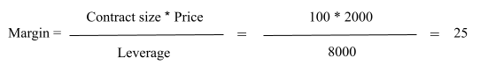
We assumed an initial balance of $1000 per symbol (EUR/USD and XAU/USD) and opened positions using 0.01 lot, which is the minimum tradable lot size on OTET Markets for both instruments. For XAU/USD, a 0.01 lot position requires approximately $25 margin. This is because the margin is calculated as:

Formula 2. Margin Calculation for XAU/USD.

  - Contract size: 100 (standard for 0.01 lot of gold)
  - Price: ~$2000
  - Leverage: 1:8000

For EUR/USD, a 0.01 lot position requires approximately $10 margin:

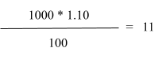

Formula 3. Margin Calculation for EUR/USD.

  - Contract size: 1000 units (0.01 lot)
  - Price: ~$1.10
  - Leverage: 1:100 (common for major forex pairs in OTET)

Note: These values may vary depending on the broker.

- Opening a Trade

When the first high-confidence prediction occurs:
  - If the prediction is 1, we open a buy position at the closing price of that candle.
  - If the prediction is 0, we open a sell position at the closing price.

For example:
  - If the signal is for XAU/USD, we open a 0.01 lot trade, which requires approximately

$25 margin. Given an initial balance of $1000, this means:
    - $25 of the balance is locked as margin
    - $975 remains available
    - The trade size is based on 100 units of gold, and each $1 price movement results in a $1 profit or loss for 0.01 lot.

  - If the signal is for EUR/USD, a 0.01 lot trade requires approximately $10 margin. So:
    - $10 is reserved as margin
    - $990 remains free

    - Since EUR/USD is priced around $1.10, each 10 pip ($0.0010) movement results in a $1 profit or loss for a 0.01 lot trade.
Note: Margin requirements vary between brokers. The above values are based on OTET Markets.

Importantly, once a position is opened, we do not open new trades until the current position is closed, even if more high-confidence signals are generated. This rule helps us:
  - Minimize risk
  - Avoid over-leveraging
  - Prevent margin calls, which can occur when the market moves significantly against open positions, reducing account equity below the required margin and forcing the broker to automatically close trades to limit losses.

- Closing a Trade

A trade is closed when it hits either the Take Profit (TP) or Stop Loss (SL) level. The exact TP and SL values for each symbol and timeframe are provided in Table 4.

Symbol | Timeframe | Take Profit (TP) | Stop Loss (SL)
XAU/USD | 5M | $20 | $10
XAU/USD | 15M | $30 | $15
XAU/USD | 30M | $60 | $25

XAU/USD | 1H | $70 | $40
XAU/USD | 4H | $80 | $50
EUR/USD | 5M | $5 | $2.5
EUR/USD | 15M | $10 | $10
EUR/USD | 30M | $50 | $20
EUR/USD | 1H | $50 | $20
EUR/USD | 4H | $70 | $40
Table 4. Take Profit (TP) and Stop Loss (SL) targets defined for each symbol and timeframe used in the backtesting strategy.

The TP/SL values differ between symbols due to differences in their price scales and movements. XAU/USD is typically priced around $2000, where a $1 move results in a $1 profit or loss per 0.01 lot. In contrast, EUR/USD is priced around $1.10, and moving 10 pips ($0.0010) results in a $1 profit or loss per 0.01 lot. Therefore, TP and SL values were adjusted to reflect each asset’s typical price range and volatility. Moreover, for shorter timeframes, smaller TP/SL targets were used due to limited price movement, in order to avoid holding positions for too long.

- Profit/Loss Calculation

When a position is closed the profit is calculated as follows :
  - For a buy position:
    - Profit = (Close Price − Open Price) - Commission

  - For a sell position:
    - Profit = (Open Price − Close Price) - Commission

We also accounted for trading commissions, which in OTET Markets are approximately $1 per round trade (opening + closing). After a position is closed, the profit or loss, along with the commission, is applied to the current balance. The strategy then waits for the next high-confidence signal to place a new trade based on the updated balance.

- Force-Closing at the End

Finally, if a trade remains open at the end of the dataset, for example, if it hasn’t reached TP or SL, we close the position at the closing price of the last candle. This is a common practice in backtesting to ensure that all trades are closed and accounted for in the final balance.

Results

As described in the methodology, four datasets were created using four data preprocessing strategies for each symbol and timeframe: the full feature set (all technical indicators and OHLCV), Correlation Thresholding (CT), Mutual Information (MI), and Recursive Feature Elimination with Cross-Validation (RFECV). For each of these datasets, a total of 10 machine learning models were trained and evaluated. Given 2 instruments (XAU/USD and EUR/USD) and 5 timeframes (5M, 15M, 30M, 1H, 4H), this resulted in 40 models per symbol and per timeframe, 200 models per symbol across all timeframes, and in total 400 models. However, for each combination of symbol, timeframe, and data preprocessing strategy, only the model with the highest accuracy was selected for reporting and profitability analysis. The results are organized by symbol and timeframe, focusing on metrics including accuracy on unseen data, number of high-confidence predictions (confidence > 70%), number of incorrect predictions, total number of trades, and net profit. Additionally, we present the results of the feature importance analysis for the most profitable models in order to demonstrate which technical indicators or OHLCV features contributed most to generating profitable trades.

XAU/USD

For XAU/USD, the dataset containing all features resulted in high accuracy, particularly when trained with Logistic Regression. At the 5-minute timeframe, this combination not only achieved the highest accuracy (82%) but also resulted in a profit of $92 from 28 trades. Among the reduced feature sets, RFECV with SVM and CT with Random Forest reached similar accuracies

(71.9% and 70%, respectively), though profitability varied. SVM generated a profit of $27, while Random Forest generated a profit of $54.
Moving to the 15-minute timeframe, all four datasets led to profitable outcomes. The full feature set again performed well with Logistic Regression, producing 734 confident predictions and a
$209 profit. Interestingly, the CT dataset, despite having fewer confident predictions (229), achieved the highest profit of $295 using Histogram Gradient Boosting. RFECV with SVM and MI with LightGBM also showed solid performance, returning $247 and $150, respectively.
At the 30-minute timeframe, the dataset with all features trained with Logistic Regression achieved the highest net profit, reaching $456 from 39 trades. Moreover, MI with SVM and RFECV with Random Forest also showed strong profitability, generating $331 and $305, respectively.
In the 1-hour timeframe, the full feature set with Logistic Regression was the most accurate (82.5%) and resulted in a $213 profit. However, other configurations outperformed it in terms of profit, despite having fewer trades and lower accuracy. The MI dataset with CatBoost had the highest return of $446, while CT with Extra Trees and RFECV with CatBoost returned $322 and
$156, respectively.

At the 4-hour timeframe, the MI dataset combined with CatBoost achieved the highest profit among all configurations, earning $902 from 18 trades with an accuracy of 73%. Logistic Regression on the full feature set again achieved the highest accuracy at 78%, generated the most confident predictions (322), and produced a profit of $540. In addition, CT with Histogram Gradient Boosting and RFECV with XGBoost also performed well at this interval, generating

profits of $665 and $614, respectively. The detailed results are provided in Tables 5, 6, 7, 8, and 9.

Data  Preprocessing | Best model | Accuracy | Correct Predictions (>70%) | Incorrect Predictions | Net Profit | Number of Trades
All Features | Logistic Regression | 82% | 574 (92.73%) | 45 (7.27%) | $92 | 28
CT | RF | 70% | 271 (82.12%) | 59 (17.88%) | $54 | 26
MI | CatBoost | 71.90% | 379 (83.30%) | 76 (16.70%) | $-119 | 26
RFECV | SVM | 71.90% | 413 (81.46%) | 94 (18.54%) | $27 | 31
Table 5. Results for XAU/USD at 5-minute timeframe

Data  Preprocessing | Best model | Accuracy | Correct Predictions (>70%) | Incorrect Predictions | Net Profit | Number of Trades
All Features | Logistic Regression | 81% | 734 (85.45%) | 125 (14.55%) | $209 | 61
CT | Histogram Gradient Boosting | 72.80% | 229 (87.07%) | I34 (12.93%) | $295 | 50
MI | LightGBM | 73.80% | 193 (88.94%) | 24 (11.06%) | $150 | 45

RFECV | SVM | 73.50% | 497 (81.61%) | 112 (18.39%) | $247 | 53

Data  Preprocessing | Best model | Accuracy | Correct Predictions (>70%) | Incorrect Predictions | Net Profit | Number of Trades
All Features | Logistic Regression | 81.30% | 606 (90.31%) | 65 (9.69%) | $456 | 39
CT | LightGBM | 68.90% | 192 (87.67%) | 27 (12.33%) | $102 | 33
MI | SVM | 69.90% | 453 (79.75%) | 115 (20.25%) | $331 | 34
RFECV | RF | 69.70% | 346 (79.18%) | 91 (20.82%) | $305 | 35
Table 7. Results for XAU/USD at 30-minute timeframe

Data  Preprocessing | Best model | Accuracy | Correct Predictions (>70%) | Incorrect Predictions | Net Profit | Number of Trades
All Features | Logistic Regression | 82.5% | 629 (87.12%) | 93 (12.88%) | $213 | 27
CT | Extra Trees | 71.10% | 256 (84.21%) | 48 (15.79%) | $322 | 28
MI | CatBoost | 71.50% | 305 (82.43%) | 65 (17.57%) | $446 | 24

RFECV | CatBoost | 72.30% | 338 (82.84%) | 70 (17.16%) | $156 | 24

Data  Preprocessing | Best model | Accuracy | Correct Predictions (>70%) | Incorrect Predictions | Net Profit | Number of Trades
All Features | Logistic Regression | 78% | 322 (82.56%) | 68 (17.44%) | $540 | 20
CT | Histogram Gradient Boosting | 72.30% | 121 (88.97%) | 15 (11.03%) | $665 | 15
MI | CatBoost | 73% | 165 (83.76%) | 32 (16.24%) | $902 | 18
RFECV | XGBoost | 73.20% | 156 (84.78%) | 28 (15.22%) | $614 | 16
Table 9. Results for XAU/USD at 4-hour timeframe

To better understand which input features contributed most to generating higher profits, feature importance was analyzed for the five models with the highest profitability in the XAU/USD timeframes. These included Logistic Regression (5M and 30M) trained on the full feature set, Histogram Gradient Boosting (15M) trained on the CT dataset, and CatBoost trained on the MI dataset for both 1H and 4H. Among these models, the Commodity Channel Index (CCI), MACD and its Signal line component, the Open price, and Tenkan-sen from the Ichimoku indicator were among the most influential features. Additionally, EMA, WMA, ADX, and Stochastic Oscillator

components with different periods also ranked highly in several cases. Figures 1, 2, 3, 4, and 5 show the top 10 features identified for each selected model.

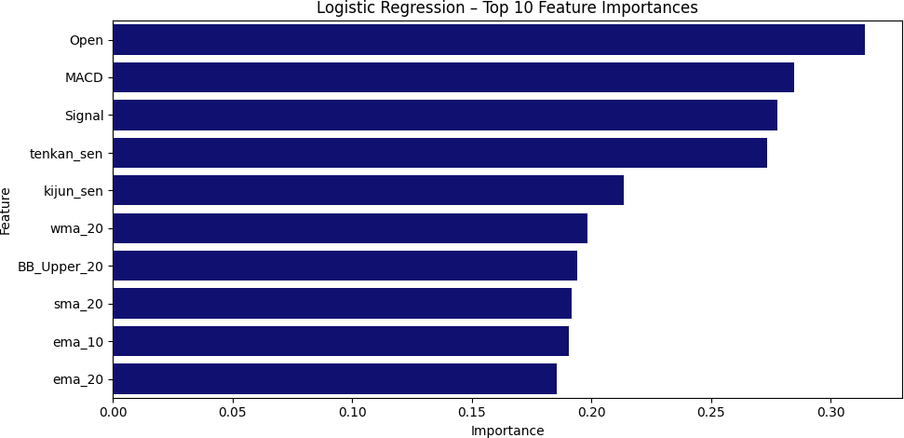

Image 1. Feature importance for XAU/USD – Logistic Regression (5M) on the full feature set
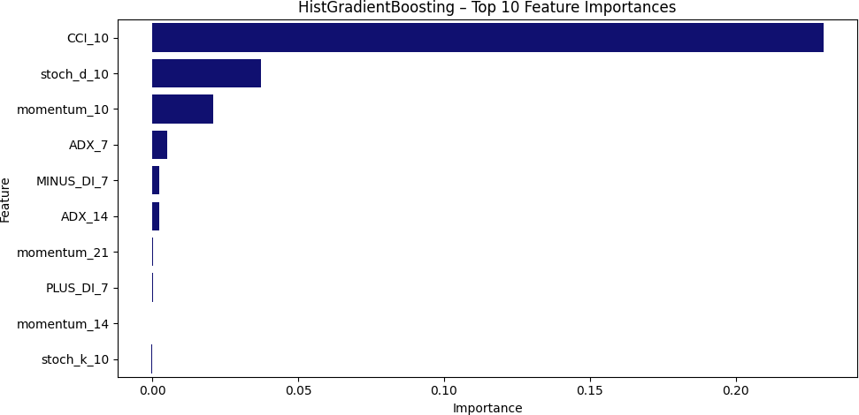

Image 2. Feature importance for XAU/USD – Histogram Gradient Boosting (15M) on the CT dataset

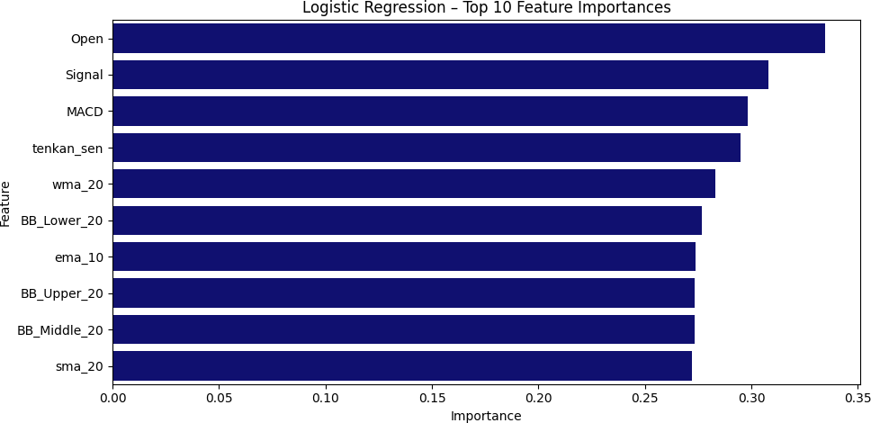

Image 3. Feature importance for XAU/USD – Logistic Regression (30M) on the full feature set

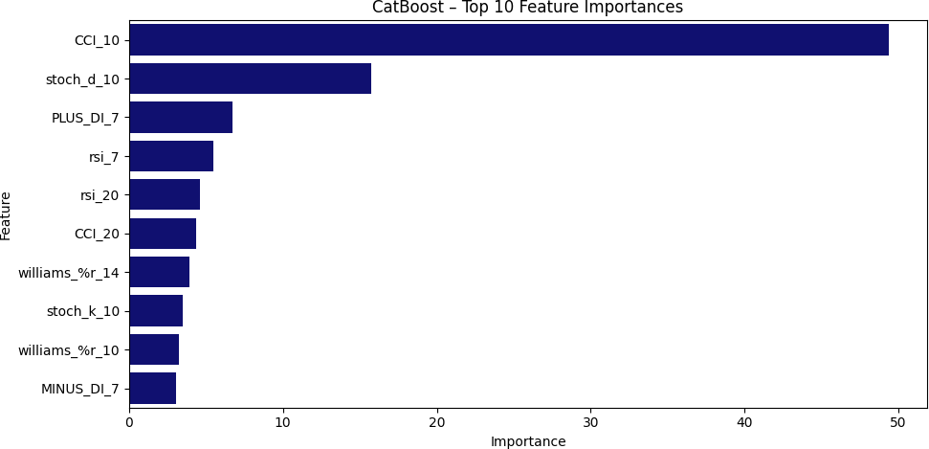

Image 4. Feature importance for XAU/USD – CatBoost (1H) on the MI dataset

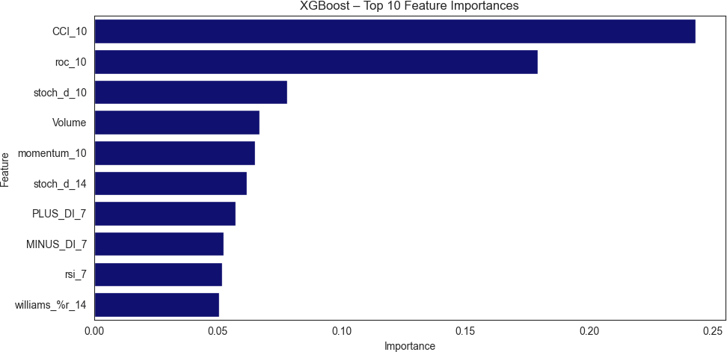

Image 5. Feature importance for XAU/USD – CatBoost (4H) on the RFECV dataset

EUR/USD

The results for EUR/USD are significantly different from those of XAU/USD in terms of profitability and trade frequency. At the 5-minute timeframe, none of the data preprocessing methods and model combinations produced a positive return. Although Logistic Regression on the full feature set had the highest accuracy (82.1%) and produced 605 confident predictions, it still resulted in a -$17.93 loss. Moreover, other models including CT with CatBoost, MI with SVM, and RFECV with Extra Trees delivered larger losses.
For the 15-minute timeframe, only one configuration yielded a positive profit. Logistic Regression on the full dataset achieved both the highest accuracy (81.9%) and the highest profit ($20). CT with LightGBM resulted in a negligible loss (–$0.67), while MI with Gradient Boosting and RFECV with SVM underperformed significantly in terms of profitability.

Unlike the previous timeframes, the 30-minute timeframe showed only marginal profits across all datasets. The best performer, once again, was Logistic Regression on the full dataset, achieving 81.1% accuracy and generating a $6 profit from 4 trades. The other configurations, regardless of data preprocessing method or model choice, yielded similar profits, either $5.30 or
$6.

Starting from the 1-hour timeframe, profitability began to improve overall. Histogram Gradient Boosting on the RFECV dataset outperformed others by generating the highest net profit ($10.87), despite having lower accuracy compared to Logistic Regression on the full feature dataset, which generated a profit of $6.
Finally, at the 4-hour timeframe, all configurations were profitable, but differences were minimal. CT with Random Forest slightly outperformed the others with a profit of $30.36, despite achieving the lowest accuracy (66.2%). All other combinations including Logistic Regression on the full feature set, Gradient Boosting on the MI dataset, and XGBoost on the RFECV dataset resulted in a $27 profit, and accuracies ranged from 67.5% to 80.2%. Tables 10 through 14 present the detailed results for EUR/USD.

Data  Preprocessing | Best model | Accuracy | Correct Predictions (>70%) | Incorrect Predictions | Net Profit | Number of Trades
All Features | Logistic Regression | 82.10% | 605 (91.81%) | 54 (8.19%) | $-17.93 | 8
CT | CatBoost | 69.20% | 322 (79.70%) | 82 (20.30%) | $-31.33 | 12

MI | SVM | 72.20% | 481 (82.08%) | 105 (17.92%) | $-31.93 | 12
RFECV | Extra Trees | 71.60% | 402 (83.40%) | 80 (16.60%) | $-32.17 | 14
Table 10. Results for EUR/USD at 5-minute timeframe

Data  Preprocessing | Best model | Accuracy | Correct Predictions (>70%) | Incorrect Predictions | Net Profit | Number of Trades
All Features | Logistic Regression | 81.90% | 734 (89.51%) | 86 (10.49%) | $20 | 10
CT | LightGBM | 69.50% | 260 (86.67%) | 40 (13.33%) | $-0.67 | 10
MI | Gradient Boosting | 69.40% | 227 (88.67%) | I29 (11.33%) | $-38.67 | 8
RFECV | SVM | 69.20% | 471  (77.85%) | 134  (22.15%) | $-40 | 10
Table 11. Results for EUR/USD at 15-minute timeframe

Data  Preprocessing | Best model | Accuracy | Correct Predictions (>70%) | Incorrect Predictions | Net Profit | Number of Trades
All Features | Logistic Regression | 81.10% | 739 (86.23%) | 118 (13.77%) | $6 | 4

CT | ExtraTrees | 68.10% | 266 (81.10%) | 62 (18.90%) | $6 | 4
MI | SVM | 67.80% | 424 (77.94%) | 120 (22.06%) | $5.30 | 4
RFECV | RF | 68.20% | 336 (80.77%) | 80 (19.23%) | $5.30 | 4
Table 12. Results for XAU/USD at 30-minute timeframe

Data  Preprocessing | Best model | Accuracy | Correct Predictions (>70%) | Incorrect Predictions | Net Profit | Number of Trades
All Features | Logistic Regression | 80.09% | 617 (86.17%) | 99 (13.83%) | $6 | 4
CT | RF | 68.60% | 226 (82.18%) | 49 (17.82%) | -$14.69 | 5
MI | CatBoost | 68.50% | 290 (79.02%) | 77 (20.98%) | $6.31 | 4
RFECV | Histogram Gradient Boosting | 68.70% | 97 (84.35%) | 18 (15.65%) | $10.87 | 4
Table 13. Results for EUR/USD at 1-hour timeframe

Data  Preprocessing | Best model | Accuracy | Correct Predictions (>70%) | Incorrect Predictions | Net Profit | Number of Trades
All Features | Logistic | 80.20% | 336 (85.28%) | 58 (14.72%) | $27 | 3

 | Regression
CT | RF | 66.20% | 63 (75.90%) | 20 (24.10%) | $30.36 | 3
MI | Gradient Boosting | 69.40% | 98 (83.76%) | 19 (16.24%) | $27 | 3
RFECV | XGBoost | 67.50% | 134 (81.21%) | 31 (18.79%) | $27 | 3
Table 14. Results for EUR/USD at 4-hour timeframe

For feature importance analysis, since the 5-minute and 30-minute had either negative or marginal profits, we focused only on Logistic Regression trained on the full feature set for the 15-minute timeframe, Histogram Gradient Boosting trained on the RFECV dataset for the 1-hour timeframe, and Random Forest trained on the CT dataset for the 4-hour timeframe, as these were the top performers in terms of profitability. While for Histogram Gradient Boosting on the 1-hour timeframe and Random Forest on the 4-hour timeframe, the Commodity Channel Index (CCI) and Stochastic Oscillator components such as stoch_k_10 and stoch_d_10 were among the top features, for Logistic Regression on the 15-minute timeframe, the most influential features included the Open price, MACD and its Signal line component, and Tenkan-sen from the Ichimoku indicator. Figures 6, 7, and 8 show the top 10 features for the selected models and timeframes.

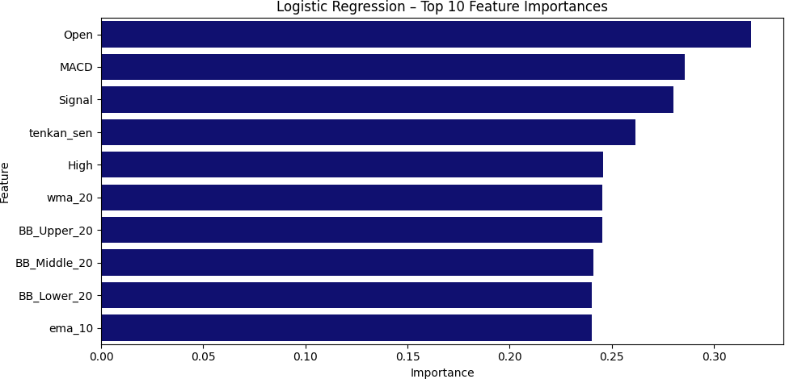

Image 6. Feature importance for EUR/USD – Logistic Regression (15M) on the full feature set

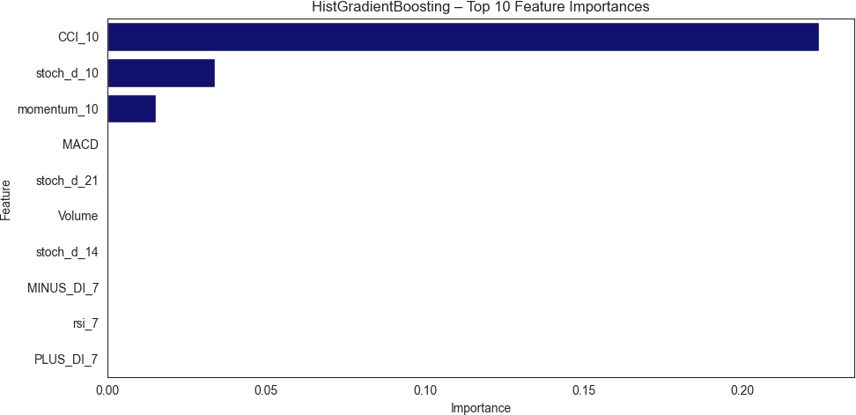

Image 7. Feature importance for EUR/USD – Histogram Gradient Boosting (1H) on the RFECV dataset

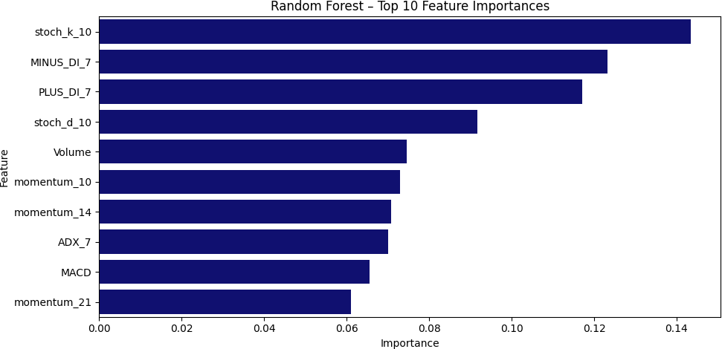

Image 8. Feature importance for EUR/USD – Random Forest (4H) on the CT dataset

Discussion

This section provides a detailed interpretation of the results, including model performance in terms of accuracy and profitability, the impact of different timeframes and data preprocessing methods, and the behavior of the trading instruments. The goal is to examine how these elements interact and to evaluate the practical effectiveness and generalizability of machine learning models in real-world trading scenarios.
One of the most notable observations is that across all timeframes and instruments, Logistic Regression without any data preprocessing achieved the highest accuracy. In several cases, such as XAU/USD at 5-minute, XAU/USD at 30-minute, EUR/USD at 5-minute, and EUR/USD at 15-minute, it was also the most profitable model. Even when it wasn’t profitable, as in the case of EUR/USD at 5M, the loss was smaller compared to other models and datasets evaluated for the same instrument and timeframe. This suggests that Logistic Regression, when applied to the full feature set, performs well in terms of accuracy and generalizes well without requiring additional feature selection methods.
However, it was observed that higher accuracy does not necessarily lead to greater profitability. For instance, in the XAU/USD 4-hour timeframe, CatBoost trained on the MI dataset achieved 73% accuracy but generated a $902 profit, whereas Logistic Regression without data preprocessing reached a higher accuracy of 78% but yielded a profit of $540. Similarly, in the XAU/USD 1-hour timeframe, CatBoost with MI (71.5% accuracy) outperformed Logistic Regression (82.5% accuracy) in profitability, delivering $446 compared to $212. This trend was also observed in the EUR/USD 4-hour timeframe, where Random Forest with the CT dataset generated a slightly higher profit of $30 compared to $27 from Logistic Regression without data

preprocessing, despite having a lower accuracy (66.2% vs. 80.2%). This is because for trading strategies, profitability depends not only on accuracy but also on how strong the price moves when the model is correct. A model with lower accuracy might still generate higher profits if it captures larger trends, while a model with higher accuracy could underperform if its correct predictions only catch small price movements. Therefore, when applying these models in live markets, focusing solely on accuracy is misleading, and traders must also consider trend strength.
In terms of accuracy, the choice of instrument did not significantly affect model performance, as all models showed solid results for both XAU/USD and EUR/USD. This is due to the wide range of technical indicators calculated across multiple periods which helped the models learn different market behaviors and perform well regardless of the specific instrument. However, when it comes to profitability, XAU/USD outperformed EUR/USD by a large margin. All timeframes for XAU/USD produced positive and often substantial profits, whereas most configurations for EUR/USD resulted in negative or marginal profits. This difference is mainly due to the higher price volatility and stronger trend patterns in XAU/USD. Gold often shows larger and more frequent price swings, which makes it easier to reach take-profit targets. On the other hand, EUR/USD usually has smaller price movements, making it harder for models to hit take-profit levels, especially in shorter timeframes. Since the trading strategy developed in this study relies on take-profit and stop-loss levels, and both of which depend on price movement, this resulted in EUR/USD having both lower profits and fewer trades, even though smaller take-profit and stop-loss levels were used compared to XAU/USD. These findings suggest that while using multiple technical indicators with different periods can improve model accuracy, profitability depends on developing a strategy tailored to each instrument. Hence, for this strategy selecting

an asset with stronger trends and higher price volatility is crucial for turning predictions into profitable trades.
In addition, the analysis shows that longer timeframes generally produced higher net profits for both XAU/USD and EUR/USD. For both instruments, the most profitable outcomes were achieved in descending order from the 4-hour timeframe down to the 5-minute timeframe. However, it is important to note that although shorter timeframes appear to generate smaller total profits, they do so over significantly shorter periods. When adjusted for time, their profitability can actually exceed that of longer timeframes. For instance, the most profitable model seemed to come from the 4-hour configuration for XAU/USD, which generated $902 and represents 90.2 percent of the initial balance, from January 8, 2025 to May 1, 2025. However, the 5-minute XAU/USD configuration generated $92 in less than a week, which is 9.2 percent of the initial balance, between April 25, 2025 and May 1, 2025. Meanwhile, the 15-minute configuration produced $295 from April 15, 2025 to May 1, 2025, and the 30-minute configuration made $456 from March 31, 2025 to May 1, 2025. These results indicate that while longer timeframes capture more substantial trends and generate higher profits, shorter timeframes offer better returns relative to the time invested. This is particularly true in the Forex market, where traders can profit from short-term trends, which contrasts with the stock market, where profits often require buying and holding assets over longer periods. Therefore, our findings support the idea that shorter timeframes are more profitable and better aligned with the dynamics of the forex market.
Apart from accuracy and profitability, the feature importance analysis revealed several patterns regarding which technical indicators and OHLCV components contributed most to higher profitability. At the 1-hour and 4-hour timeframes, the Commodity Channel Index (CCI) and

Stochastic Oscillator components (such as stoch_k_10 and stoch_d_10) frequently ranked among the top features. These indicators are commonly used to detect short- to medium-term momentum and identify overbought or oversold conditions, which may explain why they appeared frequently in longer timeframes for both instruments. In contrast, for shorter timeframes, the most influential features included the MACD and its Signal line, and Tenkan-sen from the Ichimoku indicator. These indicators are generally more responsive to short-term price movements and adapt quickly to recent changes, which aligns well with shorter timeframes where trades are more sensitive to immediate price behavior. Interestingly, the open price also emerged as an important feature, suggesting that it has a significant influence on predictions in shorter timeframes. Finally, the frequent appearance of EMA, WMA, and ADX indicates that combining momentum, trend strength, and price fluctuation signals is crucial for making better predictions and decisions in short-term trading.

Limitations

While this study offers useful insights, it also has some limitations that should be considered. One limitation is that the classification models used are only capable of predicting the direction of the trend, for example, whether the price will go up or down, but not the magnitude of that movement. As mentioned, this is problematic in real trading scenarios because profitability depends not only on the direction of trends, but also on how far the price moves. For instance, some models achieved high accuracy but still resulted in low profits, because the profits from correct predictions were smaller than the losses from incorrect ones. In such cases, the imbalance between the magnitude of profitable and unprofitable trades makes the model less effective in real trading.

Another limitation of this study is that the profits calculated in backtesting may not fully reflect real-world trading performance, even though efforts were made to simulate realistic conditions. In backtesting, trades are executed at the closing price of the candle during which the signal is generated. However, in real trading, if algorithmic trading is implemented, there are often slight delays in execution due to factors such as internet latency, system processing time, or platform response speed. These factors can reduce the actual profit compared to our results. On the other hand, if the strategy is executed manually, additional delays or missed opportunities may occur, as it is not feasible for a human to monitor the market continuously throughout the day, which might also reduce profitability. Even though this study used machine learning models instead of deep learning models to allow faster signal generation, this limitation should still be taken into account.
A final limitation to consider is that the trading strategy developed in this study allows only one open position at a time. This design choice is logical, as it helps avoid the risk of opening multiple positions simultaneously, which could lead to margin calls. However, this also means the model might miss other high-confidence trading opportunities that appear while a trade is already active. This constraint was used because we assumed an initial balance of $1000 and preferred to minimize risk in order to make the profitability analysis as realistic as possible. With such a balance, it is reasonable to limit trading to one position at a time to stay within safe margin requirements. In real-world scenarios, however, traders with larger capital and a higher risk tolerance may choose to open multiple positions simultaneously. Even then, it is crucial to set a clear limit on the number of open positions. Therefore, the development of a trading strategy depends heavily on the initial capital available, the type of instrument, model

predictions, and the level of risk a trader is willing to take, and there is no single strategy that fits all situations.

This paper evaluated various machine learning algorithms with different settings to assess their ability to predict short-term trends in the Forex market for two instruments, EUR/USD and XAU/USD using technical indicators and OHLCV data. In addition to evaluating model accuracy, a profitability analysis was conducted by developing a trading strategy to measure how much profit each model could generate under realistic trading conditions.
Overall, the models demonstrated strong accuracy for both instruments. However, XAU/USD was significantly more profitable than EUR/USD, due to differences in instrument behavior and the effectiveness of the trading strategy applied. The results also indicated that shorter timeframes provide better returns relative to the time invested and have greater potential than longer timeframes for generating profit in the Forex market. Moreover, our proposed Logistic Regression model on the 5-minute timeframe achieved both the highest accuracy at 82.10 percent and the highest profit of $92 within 5 trading days, excluding weekends.
Given the results of this study, there are several opportunities for future exploration. One potential direction for future research is to develop a strategy specifically tailored to EUR/USD, as the models achieved high accuracy and produced many confident predictions. This is a promising path, as these predictions have the potential to be used for generating profit from EUR/USD. Another promising path is to incorporate the magnitude of price movement along with trend direction, since profitability depends on both factors. This could make the models even more effective in real-world trading scenarios. Finally, developing an automated trading bot based on the most profitable model could help turn model predictions into real-time trading signals and generate profit in live market conditions.

- Guyard, K. C., & Deriaz, M. (2024). Predicting Foreign Exchange EUR/USD Direction Using Machine Learning. Proceedings of the 2024 7th International Conference on Machine Learning and Machine Intelligence (MLMI), 1–9. https://doi.org/10.1145/3696271.3696272
- Mabrouk, N., Chihab, M., & Chihab, Y. (2021). Trading Strategy in the Forex Market based on Linear and Non-linear Machine Learning Algorithms: Proceedings of the 2nd International Conference on Big Data, Modelling and Machine Learning, 81–85. https://doi.org/10.5220/0010728800003101
- Ayitey Junior, M., Appiahene, P., Appiah, O., & Bombie, C. N. (2023). Forex market forecasting using machine learning: Systematic Literature Review and meta-analysis. Journal of Big Data, 10(1), 9. https://doi.org/10.1186/s40537-022-00676-2
- Abbad, J., Fardousi, B., & Abbad, M. (2014). Advantages of Using Technical Analysis to Predict Future Prices on the Amman Stock Exchange. International Journal of Business and Management, 9(2), p1. https://doi.org/10.5539/ijbm.v9n2p1
- Galeshchuk, S., & Mukherjee, S. (2017). Deep networks for predicting direction of change in foreign exchange rates. Intelligent Systems in Accounting, Finance and Management, 24(4), 100–110. https://doi.org/10.1002/isaf.1404
- Yıldırım, D. C., Toroslu, I. H., & Fiore, U. (2021). Forecasting directional movement of Forex data using LSTM with technical and macroeconomic indicators. Financial Innovation, 7(1), 1. https://doi.org/10.1186/s40854-020-00220-2
- Baasher, A. A., & Fakhr, M. W. (2010). FOREX Trend Classification using Machine Learning Techniques.

- Taherdoost, H. (2023). Deep Learning and Neural Networks: Decision-Making Implications. Symmetry, 15(9), 1723. https://doi.org/10.3390/sym15091723
- Gill, M., Anderson, R., Hu, H., Bennamoun, M., Petereit, J., Valliyodan, B., Nguyen, H. T., Batley, J., Bayer, P. E., & Edwards, D. (2022). Machine learning models outperform deep learning models, provide interpretation and facilitate feature selection for soybean trait prediction. BMC Plant Biology, 22(1), 180.
https://doi.org/10.1186/s12870-022-03559-z
- XU, Haoyin, KINFU, Kaleab A., LEVINE, Will, et al. When are deep networks really better than decision forests at small sample sizes, and how?. https://doi.org/10.48550/arXiv.2108.13637
- Nguyen, P. D., Thao, N. N., Kim Chi, D. T., Nguyen, H.-Cuc., Mach, B.-Ngoc., & Nguyen, T. Q. (2024). Deep learning-based predictive models for forex market trends: Practical implementation and performance evaluation. Science Progress, 107(3), 00368504241275370. https://doi.org/10.1177/00368504241275370
- Fisichella, M., & Garolla, F. (2021). Can Deep Learning Improve Technical Analysis of Forex Data to Predict Future Price Movements? IEEE Access, 9, 153083–153101. https://doi.org/10.1109/ACCESS.2021.3127570
- Saadati, S., & Manthouri, M. (2024). Forecasting Foreign Exchange Market Prices Using Technical Indicators with Deep Learning and Attention Mechanism. https://doi.org/10.48550/arXiv.2411.19763
- Dakalbab, F., Kumar, A., Talib, M. A., & Nasir, Q. (2025). Advancing Forex prediction through multimodal text-driven model and attention mechanisms. Intelligent Systems with Applications, 26, 200518. https://doi.org/10.1016/j.iswa.2025.200518

- Eddelbuttel, D., & McCurdy, T. H. (1998). The Impact of News on Foreign Exchange Rates: Evidence from High Frequency Data.
- Lam, S., Liu, Y., Broers, M., Van Der Vos, J., Frasincar, F., Boekestijn, D., & Van Der Knaap, F. (2025). Local interpretation of deep learning models for Aspect-Based Sentiment Analysis. Engineering Applications of Artificial Intelligence, 143, 109947. https://doi.org/10.1016/j.engappai.2024.109947
- PERLA, Someswari, BISOI, Ranjeeta, et DASH, P. K. A hybrid neural network and optimization algorithm for forecasting and trend detection of Forex market indices. Decision Analytics Journal, 2023, vol. 6, p. 100193.
https://doi.org/10.1016/j.dajour.2023.100193

- Yong, Y.L., Ngo, D.C., & Lee, Y. (2015). Technical Indicators for Forex Forecasting: A Preliminary Study. ICSI.
- Ghanem, S., Harasheh, M., Sbaih, Q., & Ajmal, T. K. (2024). The predictability of technical analysis in foreign exchange market using forward return: Evidence from developed and emerging currencies. Cogent Business & Management, 11(1), 2428781. https://doi.org/10.1080/23311975.2024.2428781
- Zafeiriou, T., & Kalles, D. (2024). Off-the-Shelf Neural Network Architectures for Forex Time Series Prediction come at a Cost. Proceedings of the 13th Hellenic Conference on Artificial Intelligence, 1–7. https://doi.org/10.1145/3688671.3688791



Predicting Forex Pair Movements: Integrating Sentiment Analysis, Technical, and Fundamental Indicators using Machine Learning and Deep Learning Models

Student Name: Yash Dave Supervisor: Dr. Soheil Varastehpour Co-supervisor: Dr. Masoud Shakiba

A Thesis Presented to the School of Computing In Partial Fulfilment of the Requirements
for the Degree of Master of Applied Technologies-Computing

School of Computing, Electrical and Applied, Technology New Zealand

September 9, 2024

Abstract
The foreign exchange (forex) market is one of the largest and most liquid financial markets globally, making accurate price prediction crucial for traders, policymakers, and financial in- stitutions. This research focuses on improving forex price prediction by integrating sentiment analysis with technical and fundamental indicators. Historical forex data, economic indicators, and sentiment data extracted from financial news were employed to develop predictive models. The primary models used include Long Short-Term Memory (LSTM) networks, Extreme Gra- dient Boosting (XGBoost), ensemble models combining these approaches, and Transformer models. Large Language Models (LLMs), such as GPT-4 and GEMINI Advanced, were also utilised for sentiment analysis. The performance of these models was evaluated using compre- hensive metrics, including Mean Absolute Error, Mean Absolute Percentage Error, Root Mean Square Error, and R-squared. The analysis was conducted on two different time frames: Four- hour and one-day data for forex pairs EUR/USD, NZD/USD, EUR/NZD, and AUD/NZD. Key findings indicate that integrating sentiment analysis improves the predictive accuracy of mod- els, particularly in the Four-hour time frame. The XGBoost model, when combined with tech- nical, fundamental, and sentiment data, achieved the lowest Root Mean Square Error across various currency pairs, outperforming other configurations. In contrast, technical indicators alone delivered the most accurate predictions for the one-day time frame, although combining technical and fundamental indicators also resulted in solid performance. These results high- light the importance of integrating diverse data types, particularly sentiment analysis, for ac- curate and timely forex price prediction. The findings have important implications for traders, analysts, and policymakers, suggesting that incorporating sentiment analysis into forecasting models can enhance accuracy. Future research should explore further refinements of these mod- els and investigate the integration of additional data sources to continue improving predictive capabilities.

I want to express my deepest gratitude to my supervisor, Dr. Soheil Varastehpour, for his continuous support, invaluable guidance, and encouragement throughout this research. His in- sights and expertise were crucial in shaping this thesis from inception to completion. I am also profoundly grateful to my co-supervisor, Dr. Masoud Shakiba, for sharing his valuable experi- ence and guiding me through preparing and submitting my conference papers. His mentorship significantly contributed to the quality of this research.
Additionally, I would like to thank Dr. Iman Ardekani for his guidance and for steer- ing me in the right direction during the critical stages of my research. His advice and support were instrumental in overcoming various challenges encountered during this study. I extend my heartfelt gratitude to Mr. Ali Keivanmarz for his exceptional teaching in the machine learn- ing class, which laid the foundation for the advanced methodologies employed in this thesis. His teachings significantly improved my understanding and application of machine learning techniques, which were pivotal to the success of this research.
I am eternally grateful to my wife, Shaily, for her unwavering support, patience, and encouragement. Her belief in me provided the motivation and strength needed to persevere through the challenges of this research. Finally, I thank my brother, Jagat, for his invaluable guidance and motivation. His encouragement and advice were crucial in helping me stay fo- cused and determined throughout this journey.

ii iii vi viii ix 1
Abstract
List of Tables
1 Introduction
3 Methodology
2.6 Summary
2.4 Ensemble
1.3 Goals
1.2 Motivation
1.1 Background Information
Glossary
List of Figures
Acknowledgments
. 1
. 2
. 3
2 Literature Review
3.2.1 LSTM
3.1 Data Collection
2.3 Deep Learning
1.6 Structure of the Thesis
1.5 Research Challenges
1.4 Research Questions
. 3
. 3
. 4

5
. 5
. 5
2.1 Literature Review Approach
. 9
. 11
2.5 Related Research
2.2 Machine Learning
. 14
. 21
3.3 Evaluation Metrics
3.2.2 XGBoost

24
. 24
3.1.2 Technical Analysis
3.1.1 Sentiment Analysis
. 25
. 28
. 31
. 34
3.1.3 Fundamental Analysis
. 34
3.2 Model Development
. 36
3.2.3 Ensemble Model
. 37
3.2.4 Transformer Model(TRANSFORMER EN DE)
. 39
. 41
. 43
3.4 Addressing Key Research Challenges
3.2.5 Transformer Model(TRANSFORMER DE)
. 44

46
5 Conclusion
Appendix
Bibliography
4.5 Analysis and Discussion
4.2 Fundamental Models (FM)
4.1 Technical Models (TM)
4 Results and Analysis
. 46
. 50
4.3 Technical and Fundamental Models (TM FM)
. 55
4.4 Technical, Fundamental, and Sentiment Models (TM FM SA)
. 60
. 64
4.5.1 Addressing the Research Questions
. 68

70

73

81

List of Figures

. . . . . 6
4 Process of Prediction System
3 LSTM Cell Architecture
2 Framework of Forex Prediction Model
1 Framework combining PCA, DWT, and XGBoost for financial trading
. 7
. 9
. 10
. 12
. 13
. 15
12 Decoder Architecture of the Transformer Model.
8 Proposed Methodology by Adegboye and Kampouridis
6 CNN-LSTM Network Structure
5 Hybrid Model Architecture
. 18
9 The Sentiment Analysis Workflow for Forex News Headlines.
. 25
10 Heatmap showing Spearman correlation coefficients for EUR/USD data.
. . . . 27
. . . . . 38
. 41
20 Performance of the XGBoost FM model on AUD/NZD Test Data.
19 Performance of the XGBoost FM model on EUR/NZD Test Data.
16 Performance of the XGBoost TM model on AUD/NZD Test Data.
15 Performance of the XGBoost TM model on EUR/NZD Test Data.
13 Performance of the Ensemble-LSTM-XGB TM model on EUR/USD Test Data.
11 Architecture of the Ensemble Model Combining LSTM and XGBoost.
48
49
. 49
14 Performance of the Ensemble-LSTM-XGB TM model on NZD/USD Test Data.
. 50
17 Performance of the Ensemble-LSTM-XGB FM model on EUR/USD Test Data.
52
53
. 54
18 Performance of the Ensemble-LSTM-XGB FM model on NZD/USD Test Data.
. 54
21 Performance of the Ensemble-LSTM-XGB TM FM model on EUR/USD Test

. 57
Data.
7 RMSE Comparison
22 Performance of the Ensemble-LSTM-XGB TM FM model on NZD/USD Test
. 58
. . . . . 58
23 Performance of the XGBoost TM FM model on EUR/NZD Test Data.
Data.
. . . . . 59
24 Performance of the XGBoost TM FM model on AUD/NZD Test Data.
. . . 62
25 Performance of the XGBoost TM FM SA model on EUR/USD Test Data.
. . . 63
26 Performance of the XGBoost TM FM SA model on NZD/USD Test Data.
. . . 63
27 Performance of the XGBoost TM FM SA model on EUR/NZD Test Data.
. . . 64
29 Comparative Analysis of RMSE Values Across Forex Currency Pairs Using
28 Performance of the XGBoost TM FM SA model on AUD/NZD Test Data.
. 65
Hour Time Frame Data
30 ROC 9 Spearman Correlation of Sentiment Analysis on Forex Pairs Using Four-
Different Prediction Models for One Day Time Frame.
. 66
33 Code for the split and scale of the data.
31 Performance of the XGB TM model on EUR/USD Test Data.
. 67
. 68
. 82
32 Performance of the LSTM TM model on EUR/USD Test Data.

82
35 Code for the implementation of the XGBoost model used for predicting forex
34 Code for the implementation of the LSTM model used for time series forecasting
. 83
36 Code for the implementation of the Transformer Encoder and Decoder model
prices.
. 84
37 Code for the implementation of the Transformer Encoder and Decoder model
used for sequence modeling part-1.
. 85
38 Code for the implementation of the Transformer Decoder model used for se-
used for sequence modeling part-2.
. 86
39 Code for the implementation of the Transformer Decoder model used for se-
quence modeling part-1.
. 87
40 Code for the implementation of the Ensemble model combining LSTM and
quence modeling part-2.
. 88
41 Code for the implementation of the Ensemble model combining LSTM and
XGBoost part-1.
. 89
42 Training and validation loss over epochs for the LSTM TM FM model for
XGBoost part-2.
. 89
43 Training and validation loss over epochs for the TRANSFORMER EN DE TM FM
EUR/USD.
. 90
44 Training and validation loss over epochs for the TRANSFORMER DE TM FM
model for EUR/USD.
. 90
model for EUR/USD.

. 31
2 Model Performance on Test Data Using Technical Indicators with OHLC One-
1 Fundamental Indicators Used for Each Currency Pair in the Research
. 47
3 Model Performance on Test Data Using Fundamental Indicators with OHLC
Day Time Frame
. 51
4 Model Performance on Test Data Using Technical and Fundamental Indicators
One-Day Time Frame
. 56
5 Model Performance on Test Data with Technical, Fundamental, and Sentiment
with OHLC One-Day Time Frame
. 61
Analysis on a 4H Timeframe

Adam: An optimisation algorithm for training machine learning models
ASX200: Australian Securities Exchange 200 Index
ATR: Average True Range
AUD/NZD: Australian Dollar to New Zealand Dollar
AUBOT: Australian Balance of Trade AUUR: Australian Unemployment Rate BOT: Balance of Trade
CNN: Convolutional Neural Network
DXY: US Dollar Index
EMA: Exponential Moving Average
Ensemble-LSTM-XGB FM: Ensemble model combining LSTM and XGBoost with Funda- mental Indicators
Euro 50: Euro Stoxx 50 Index
EUGDP: Eurozone Gross Domestic Product EUR/NZD: Euro to New Zealand Dollar EUR/USD: Euro to United States Dollar EURBOT: Eurozone Balance of Trade EUM2: Eurozone Money Supply M2 EUM3: Eurozone Money Supply M3 EUUR: Eurozone Unemployment Rate
FA-LSTM: Fractional-Order Adaptive Long Short-Term Memory FLF-LSTM: Forex Loss Function Long Short-Term Memory FM: Fundamental Model
Forex: Foreign Exchange
GDP: Gross Domestic Product

GEMINI Advanced: A state-of-the-art language model from Google
GOLD CLOSE: Gold Close Price
GPT-4: Generative Pre-trained Transformer 4
GRU: Gated Recurrent Unit
GridSearchCV: A tool for hyperparameter tuning using cross-validation
LLM: Large Language Model LLMs: Large Language Models LSTM: Long Short-Term Memory
LSTM FM: Long Short-Term Memory with Fundamental Indicators
L2 regularisation: A technique to prevent overfitting by penalising large weights
MACD: Moving Average Convergence Divergence, a trend-following momentum indicator that shows the relationship between two moving averages of a security’s price.
MAE: Mean Absolute Error
MAPE: Mean Absolute Percentage Error
ML: Machine Learning MLP: Multilayer Perceptron MSE: Mean Squared Error NN: Neural Network
NLP: Natural Language Processing
NZBOT: New Zealand Balance of Trade
NZD/USD: New Zealand Dollar to United States Dollar NZGDTPI: New Zealand Global Dairy Trade Price Index NZGDP: New Zealand Gross Domestic Product
NZM3: New Zealand Money Supply M3 NZTA: New Zealand Tourist Arrivals NZUR: New Zealand Unemployment Rate

NZX50: New Zealand Stock Exchange 50 Index
OHLC: Open, High, Low, Close PSO: Particle Swarm Optimisation R²: Coefficient of Determination
ReduceLROnPlateau: A callback in machine learning to reduce the learning rate when vali- dation loss plateaus
RMSE: Root Mean Square Error
ROC: Rate of Change
RSI: Relative Strength Index SA: Sentiment Analysis S&P: Standard & Poor’s
SMA: Simple Moving Average
sklearn: A machine learning library for Python
Spearman: A measure of rank correlation
StandardScaler: A standardisation tool from the sklearn library
SVM: Support Vector Machine
TensorFlow Keras: A deep learning library for Python
TM: Technical Model
train test split: A function from sklearn to split data into training and test sets
TRANSFORMER DE: Transformer Decoder
TRANSFORMER DE FM: Transformer Decoder with Fundamental Indicators
TRANSFORMER EN DE: Transformer Encoder-Decoder
TRANSFORMER EN DE FM: Transformer Encoder-Decoder with Fundamental Indicators
USD: United States Dollar
USD/IDR: United States Dollar to Indonesian Rupiah
USD/JPY: United States Dollar to Japanese Yen

USD Inflation Rate: United States Inflation Rate USD Interest Rate: United States Interest Rate USBOAT: United States Balance of Trade USBOT: United States Balance of Trade
USM2: United States Money Supply M2
USUR: United States Unemployment Rate
XGBRegressor: A regression model from the XGBoost library
XGBoost: Extreme Gradient Boosting
XGBoost FM: Extreme Gradient Boosting with Fundamental Indicators

- Introduction
  - Background Information
The foreign exchange (forex) market is one of the world’s largest and most liquid financial markets, with immense daily trading activity. This market facilitates the global exchange of currencies, enabling businesses, governments, and individuals to conduct international trade and investment. The forex market’s significance extends beyond currency transactions; it plays a crucial role in global economic stability, influencing everything from import and export prices to inflation rates and monetary policies. Forex trading operates around the clock, five days a week, allowing for constant participation from global financial centers such as London, New York, Tokyo, and Sydney. This continuous trading environment contributes to the market’s high liquidity and volatility, presenting opportunities and risks for market participants. The decen- tralised nature of the forex market, without a centralised exchange, allows for a vast and diverse range of participants, including central banks, financial institutions, corporations, hedge funds, and individual investors. Accurate forecasting of forex prices is paramount for various stake- holders. For traders, precise predictions offer opportunities to maximise profits and minimise risks in a highly volatile market. Effective forex forecasting allows traders to make informed decisions about buying or selling currencies, leveraging anticipated price movements to their advantage. Policymakers rely on forex predictions to formulate economic policies that can sta- bilise their domestic economies. By understanding potential currency fluctuations, they can implement measures to mitigate adverse economic impacts, such as adjusting interest rates or intervening in the currency markets.
Financial institutions use these forecasts to manage their currency exposure and hedge against potential losses. Banks, investment firms, and multinational corporations often engage in forex transactions to protect their investments and operations from unfavorable currency movements. Precise forex predictions enable these institutions to devise strategies that safe- guard their assets and ensure financial stability. Overall, precise forex predictions contribute to more informed decision-making and economic stability. The integration of advanced machine learning (ML) and deep learning (DL) models, combined with traditional economic indica- tors and sentiment analysis, enhances the ability to predict forex price movements accurately. These technological advancements provide a deeper understanding of market dynamics, allow- ing for more reliable forecasts and better financial planning. Furthermore, adopting sentiment analysis using large language models (LLMs) like GPT-4 and GEMINI Advanced represents a significant leap in forex forecasting. These models analyse vast amounts of unstructured data from financial news and social media, capturing market sentiment and its potential impact on currency prices. This holistic approach to forex prediction underscores the importance of integrating various data sources and analytical techniques to achieve a comprehensive and ac- curate forecasting model, ultimately benefiting traders, policymakers, and financial institutions

alike. The importance of accurate forex price predictions must be balanced. Integrating so- phisticated ML and DL models and advanced sentiment analysis techniques can significantly enhance forecasting accuracy, supporting more effective decision-making and global economic stability. The ability to anticipate market movements with greater precision not only aids indi- vidual traders and financial institutions but also supports broader economic policy-making and financial stability efforts.

  - Motivation
Forex price forecasting has witnessed significant advancements in recent years, with researchers exploring the integration of fundamental and technical analysis techniques. This has led to the development of various ML and DL models to improve the understanding and forecast- ing of market trends[1], [2]. Forex price forecasting has seen notable progress recently, with researchers integrating fundamental and technical analysis techniques. For instance, a study presented a deep recurrent neural network model incorporating technical indicators for forex exchange rate forecasting[3]. Another research proposed a deep learning ensemble model for financial time series forecasting that integrates fundamental data[4]. Despite these advance- ments, challenges in forex price forecasting still need to be addressed, such as inherent noise and volatility in forex data, robust and adaptable models, and the necessity to produce accurate predictions under diverse market conditions. The primary motivation for this research is to tackle these challenges. These studies highlight the growing interest in merging fundamental and technical analysis to improve forex price predictions. This research seeks to address the limitations of using either fundamental or technical analysis alone for forex price forecasting. The hybrid LSTM ensemble model is developed to capture a more complete view of mar- ket dynamics and provide more accurate predictions by integrating fundamental and technical analysis. One study employed a hybrid LSTM model with technical and macroeconomic in- dicators to forecast the directional movement of forex data[5]. Ahmed et al.[6], introduced an innovative prediction system using a Forex Loss Function to integrate fundamental and tech- nical factors. These studies highlight the potential benefits of combining multiple elements to improve forecasting accuracy.
Despite extensive research in forex prediction, there still needs to be more, particularly in integrating multiple data sources such as technical indicators, fundamental analysis, and sentiment analysis. Existing studies often focus on more than one type of data, which limits their predictive accuracy and comprehensiveness. Predicting forex prices is inherently complex due to the market’s high volatility and sensitivity to various economic indicators. Traditional methods often need to capture the nuanced influences of market sentiment and fundamental economic conditions. Integrating sentiment analysis adds another layer of complexity and holds the potential for more accurate and holistic predictions.

  - Goals
This research aims to improve forex price prediction by developing and assessing models that incorporate different data types: technical, fundamental, and sentiment data. The study seeks to evaluate the performance of machine learning (ML) and deep learning (DL) models using these data types both individually and in combination. By analysing how each data type af- fects prediction accuracy, this research will provide insights into the optimal way to integrate multiple data sources for better forex price prediction.

  - Research Questions
The primary research questions guiding this study are:
- How do technical indicators compare with models, including fundamental indicators and sentiment analysis, in predicting forex prices?
- How does sentiment analysis affect the accuracy of forex price predictions?
- Which machine learning or deep learning models most effectively integrate these differ- ent data types for forex prediction?

  - Research Challenges
Predicting forex prices involves several challenges due to the market’s high volatility, the in- fluence of various economic indicators, and the integration of sentiment analysis. The inherent noise and volatility in forex data make it difficult to generate accurate predictions. Robust and adaptable models are required to handle diverse market conditions and integrate multiple data sources effectively. One significant challenge is overfitting, where models perform well on training data but fail to generalise to unseen data. Overfitting is especially problematic in finan- cial markets due to its dynamic nature and the potential for models to learn noise rather than signal. Additionally, advanced natural language processing (NLP) techniques are necessary to derive meaningful sentiment scores from unlabelled financial news data. Addressing these challenges is crucial for developing reliable and accurate forex prediction models.

Key research challenges include:
- High Volatility: Forex markets are highly volatile, making it difficult to predict price movements accurately.
- Economic Indicators: Various economic indicators influence forex prices, and their integration into predictive models can be complex.

- Sentiment Analysis Integration: Combining sentiment analysis with traditional indica- tors poses challenges in data integration and model accuracy.
- Noise in Data: The inherent noise in financial data can obscure significant patterns, complicating model training and prediction.
- Overfitting: Ensuring models generalise well to new data is crucial, as overfitting can lead to poor performance on unseen data.
By addressing these challenges, developing more robust and accurate forex prediction models becomes achievable.

  - Structure of the Thesis
This thesis is structured as follows:
- Chapter 1: Introduction - Provides an overview of the research, outlining the objec- tives, significance, and methodology. It introduces integrating sentiment analysis, tech- nical indicators, and fundamental analysis in forex prediction.
- Chapter 2: Literature Review - Reviews relevant literature to frame the research within the existing academic discourse. It covers previous studies on forex prediction, sentiment analysis, and the application of machine learning and deep learning models in financial forecasting.
- Chapter 3: Methodology - Details the methodology, including data collection, senti- ment analysis using large language models (LLMs) such as GPT-4 and GEMINI Ad- vanced, and the development of predictive models. It describes the preprocessing steps, model architectures, and evaluation metrics used.
- Chapter 4: Results and Analysis - Presents the results of the models on various forex pairs and timeframes. It includes performance metrics and comparative analysis, high- lighting the effectiveness of different model configurations.
- Chapter 5: Conclusion - Summarises the findings, discusses the results implications, and suggests future research directions.

- Literature Review
This section provides an in-depth review of the literature relevant to forex price prediction. It covers the foundational concepts and recent advancements in machine learning, deep learning, and ensemble methods, all critical to developing robust predictive models. The first subsec- tion is into machine learning techniques, highlighting key algorithms and their applications in financial forecasting. The subsequent subsection focuses on deep learning, exploring various neural network architectures and their efficacy in handling complex time series data. The third subsection discusses ensemble methods, highlighting the benefits of combining multiple mod- els to enhance predictive accuracy and robustness. Finally, the section on related works reviews significant studies in the field, summarising methodologies, findings, and the current state of research, thus setting the stage for the proposed methods in this study.

  - Literature Review Approach
- The literature was selected using a systematic approach from databases such as IEEE Xplore and Google Scholar.
- Keywords such as “forex prediction,” “machine learning in financial markets,” “deep learning for financial forecasting,” and “ensemble models in trading” were used to iden- tify relevant studies.
- Inclusion criteria: Peer-reviewed articles published between 2016 and 2024, focusing on forex prediction using ML and DL, and studies that integrate technical, fundamental, and sentiment data.
- Exclusion criteria: Studies focusing exclusively on commodities markets, articles lack- ing quantitative evaluation metrics, or non-peer-reviewed sources were excluded from the review.

  - Machine Learning
The application of machine learning techniques in forex prediction has gained substantial at- tention due to their potential in handling complex and high-dimensional financial data. Various ML algorithms have been employed to enhance the accuracy of forex price forecasts, leveraging their ability to model non-linear relationships and patterns that traditional statistical methods may miss. This section reviews critical studies that have utilised machine learning approaches in the context of forex and other financial product prediction, highlighting their methodologies, results, and contributions to the field.

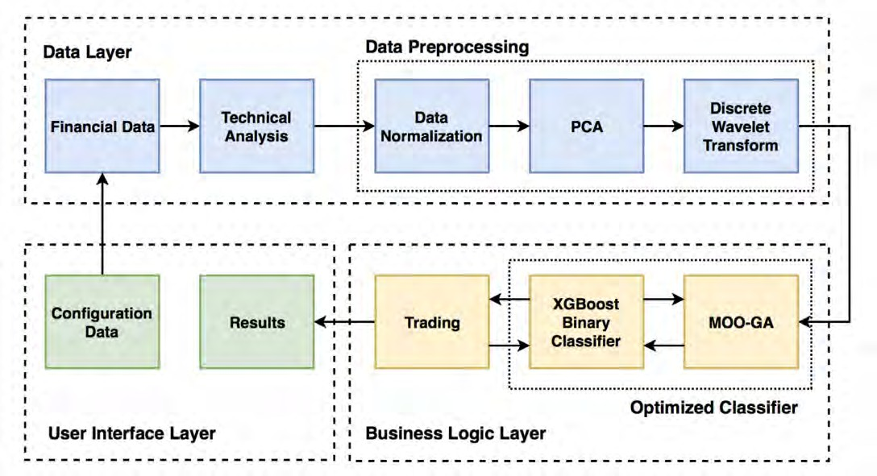
Figure 1: Framework combining PCA, DWT, and XGBoost for financial trading used by Nobre and Neves[7]).

Nobre and Neves present an innovative approach to financial trading by combining Principal Component Analysis (PCA), Discrete Wavelet Transform (DWT), and the XGBoost algorithm to create a robust trading strategy [7]. Their study focuses on optimizing trading per- formance in financial markets through systematic integration of these advanced data processing and machine learning techniques. By applying PCA, the authors reduce the dimensionality of market data, enhancing the model’s efficiency. The DWT decomposes financial time series into a form that captures both frequency and location in time, providing a more precise signal for predictive modeling. The XGBoost algorithm, known for its high performance in classification tasks, is employed as a binary classifier to predict market trends. Their results demonstrate sig- nificant improvements in trading outcomes, suggesting that this combined approach can lead to more informed and strategic trading decisions in volatile financial environments.
Sudimanto et al. [8] conducted a pilot study demonstrating the effectiveness of ML al- gorithms in predicting exchange rates. Their study employed several ML techniques to forecast forex prices, including SVM and random forests. While their findings suggested significant en- hancements in prediction accuracy compared to conventional methods, a notable disadvantage was the model’s complexity and computational intensity, which can be challenging to imple- ment in real-time trading environments. The framework used in their study, as depicted in Fig- ure 2, includes several key steps: starting with foreign exchange data for XAU/USD, followed by data preprocessing and the application of the MACD indicator, and finally, the deployment of various machine learning models (TREE, SVM, Ensemble Tree, K-NN) for prediction and evaluation.

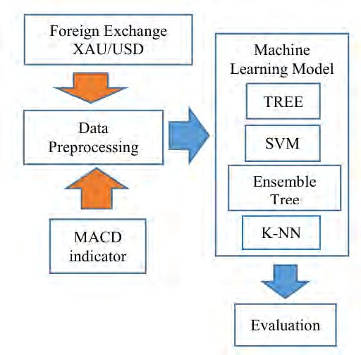
Figure 2: Framework of Forex Prediction Model Employed from Sudimanto et al. [8]

In another study, McNally et al. [9] explored the use of ML for predicting Bitcoin prices, offering insights into the applicability of ML techniques in financial forecasting be- yond traditional forex markets. They utilised a range of algorithms, such as linear regression, decision trees, and neural networks, to predict Bitcoin prices. Their results indicated that ma- chine learning models outperformed standard forecasting methods, especially those combining multiple algorithms. However, the study faced limitations in terms of overfitting and the need for extensive parameter tuning, which could limit the model’s robustness in volatile market conditions.
Basak et al. [10] examined the direction of stock market prices using tree-based classi- fiers. Although their focus was on stock markets, their methodologies and findings are relevant to forex prediction. The study employed decision trees, random forests, and gradient boost- ing machines (GBM) to classify the direction of price movements. The results highlighted the robustness of tree-based classifiers in capturing market trends and making accurate predic- tions. Despite these strengths, the primary disadvantage was the model’s sensitivity to noisy data and tendency to overfit when applied to highly volatile financial markets like forex. Thu and Xuan [11] investigated the use of SVM in forex prediction. Their research demonstrated that SVM could effectively handle forex data’s non-linear and high-dimensional nature, im- proving prediction accuracy. The study emphasised the importance of selecting appropriate

kernel functions and tuning hyperparameters to enhance the model’s performance. However, a significant drawback was the SVM’s computational expense and the complexity of optimising hyperparameters, which can hinder its practicality for high-frequency trading applications.
Neghab et al. [12] integrated macroeconomic fundamentals with machine learning to explain exchange rate forecasts. The study provided a deeper understanding of how macroe- conomic indicators influence exchange rates by employing interpretive ML techniques. Their research underscored the potential of combining fundamental analysis with machine learning to improve the interpretability and accuracy of forex predictions. Despite the promising results, the main disadvantage was the reliance on accurate and timely macroeconomic data, which can be challenging to obtain and may introduce latency in prediction updates.
Chantarakasemchit and Nuchitprasitchai [13] enhanced forex rate prediction by inte- grating machine learning with moving average methods and financial factors. Their research demonstrated improved predictive accuracy for the EUR/USD pair, highlighting the effective- ness of combining technical analysis with ML. However, the study’s limitation was the poten- tial for overfitting due to the complex model configurations required.Chen et al. [14] applied machine learning models to predict the Japanese Yen to US Dollar exchange rate. They used various techniques, including neural networks and support vector machines, demonstrating that these models could effectively forecast forex rates. The primary disadvantage noted was the high computational cost associated with training and validating these models.
De Prado [15] discussed advances in financial machine learning, highlighting various sophisticated techniques for improving predictive performance in financial markets. His work emphasises the importance of feature engineering, model selection, and validation techniques to enhance the robustness and accuracy of machine learning models. De Prado introduced novel methodologies, such as fractional differentiation, to make financial time series stationary while preserving memory, which is crucial for practical model training. He also explored ensemble methods and advanced techniques like meta-labeling to improve the predictive power of trading strategies.
The research consistently shows that XGBoost models deliver promising results com- pared to other machine learning models due to their ability to handle large datasets and capture complex patterns effectively. However, machine learning models can need help with captur- ing long-term dependencies and non-linear relationships inherent in financial time series data. Moreover, ML models often require extensive feature engineering and can be prone to over- fitting, especially in highly volatile markets. To overcome these limitations, deep learning techniques offer several advantages. Deep learning models, particularly neural networks like LSTM and GRU, excel in handling sequential data and can automatically learn complex fea- tures without manual feature engineering. These models can more effectively capture long-term dependencies and temporal patterns, providing better predictive accuracy for financial time se- ries. Additionally, deep learning models can integrate various types of data, such as technical indicators, fundamental factors, and sentiment analysis, to provide a more comprehensive forex

market analysis. The following section is on deep learning techniques and their application in forex prediction.

  - Deep Learning
Deep learning has become a potent tool in financial forecasting, especially for predicting forex prices. Its ability to model complex, non-linear relationships and capture long-term dependen- cies makes it ideal for managing the volatile and dynamic nature of financial markets. This section reviews significant studies that have utilised deep learning techniques for forex pre- diction, detailing their methodologies, results, and contributions. A comprehensive survey on forex and stock price prediction using deep learning techniques highlighted various DL mod- els, such as Convolutional Neural Networks (CNNs) and Recurrent Neural Networks (RNNs), including LSTM and Gated Recurrent Unit (GRU) networks [16]. The advantages of deep learning over traditional machine learning methods, particularly in capturing temporal depen- dencies and complex patterns in financial time series data, were discussed. Another study demonstrated the application of LSTM networks for financial market predictions, explicitly targeting the forex market. The research revealed that LSTMs could effectively learn from sequential data, providing superior prediction accuracy compared to traditional models [17].
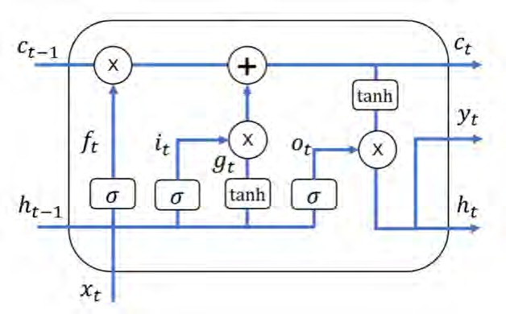
Figure 3: LSTM Cell Architecture (obtained from [18]).

The LSTM was trained on historical forex data and performed well in forecasting future price movements, validating the model’s robustness and effectiveness in financial predictions. Research exploring the use of GRU networks for financial sequence predictions, including forex

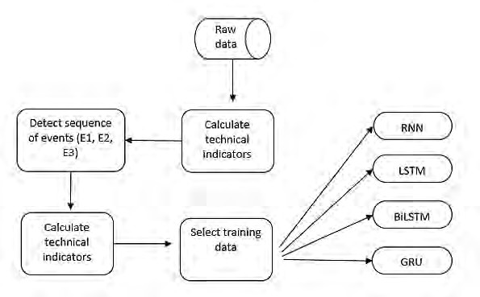
prices, showed that GRU networks, with their simplified architecture compared to LSTM, could still capture essential temporal dependencies and deliver high prediction accuracy [19]. The study highlighted the efficiency of GRUs in training time and computational resources while maintaining predictive performance, making them a valuable alternative in financial forecast- ing. Another study focused on share price prediction using time-series data and deep learning approaches, extending the methodology to the forex market. The LSTM networks employed in this research demonstrated the model’s capability to handle financial data’s noisy and volatile nature, outperforming traditional forecasting techniques in terms of accuracy and robustness
[20].

Figure 4: Process of prediction system from Qi et al. [21]

As Figure 4 shows, an Event-Driven LSTM model for forex price prediction was in- troduced, incorporating external events into the prediction process. The study highlighted the importance of considering market-moving events in forex forecasting, such as economic an- nouncements and geopolitical developments [21]. The Event-Driven LSTM model showed improved prediction accuracy by integrating these external factors, showcasing the adaptability of deep learning models to incorporate diverse data sources for enhanced financial predictions. Researchers have significantly improved prediction accuracy by leveraging advanced neural network architectures such as LSTM and GRU. These models capture the intricate patterns and long-term dependencies in financial time series data. Moreover, integrating event-driven data further enhances the model’s ability to respond to external market influences, providing a more comprehensive and nuanced approach to forex price prediction.
The research by Bilokon et al. compares the performance of Transformer models and LSTM networks in predicting financial time series data [22]. The study focuses on three pri-

mary tasks: mid-price prediction, mid-price difference prediction, and mid-price movement prediction using Limit Order Book (LOB) data. The results indicate that while LSTMs have been widely used and tested across various datasets, Transformers show promising potential in financial applications due to their ability to handle longer sequences and capture complex patterns more effectively. Another study by Fisichella et al. examines the application of deep learning models, specifically LSTMs, in enhancing the accuracy of forex price predictions [23]. The study demonstrates that LSTMs can effectively capture the temporal dependencies and complex patterns inherent in forex data, resulting in superior predictive performance com- pared to traditional technical analysis methods. This research underscores the importance of incorporating advanced neural network architectures to improve the reliability and accuracy of financial forecasting.
Markova [24] explored using CNNs for forex time series forecasting. The study found that CNNs could capture intricate patterns in financial data, leading to accurate predictions. However, the significant drawback was the substantial data preprocessing required, which can be time-consuming and complex. Zhao and Khushi [25] proposed a method combining wavelet denoised-ResNet CNN and LightGBM to predict forex rate changes. Their approach showed substantial improvements in prediction accuracy. However, integrating these complex models required extensive computational resources and fine-tuning, which could limit practical appli- cations. Naeem et al. [26] used sentiment analysis of Twitter data to forecast the USD/PKR exchange rate with machine learning. The study demonstrated that incorporating sentiment analysis could enhance prediction accuracy. The main disadvantage was the reliance on social media data, which can be noisy and may only sometimes reflect actual market conditions.
The following section will explore the Ensemble models, discussing their methodolo- gies, applications, and advantages in improving predictive accuracy in forex price forecasting.

  - Ensemble
The integration of multiple ML and DL models into an ensemble has shown promising results in financial forecasting. Ensemble models combine the strengths of different algorithms to enhance predictive performance and generalisability, addressing the limitations of individual models. Ji et al. [27] introduced a novel hybrid model combining Particle Swarm Optimisation (PSO) with LSTM networks to forecast stock indices. The PSO algorithm optimises the LSTM hyperparameters, improving the model’s predictive capabilities. This hybrid approach lever- ages PSO’s efficiency in searching the solution space and LSTM’s ability to capture temporal dependencies in financial time series data. Their findings demonstrated that the PSO-LSTM model significantly outperforms traditional and standalone LSTM networks, indicating its po- tential for superior accuracy in stock market predictions.
Ghosh et al. [28] investigate the effectiveness of using a hybrid model that combines LSTM networks and random forests for predicting the directional movements of stock prices in

intraday trading. The authors developed a model that leverages the sequential learning capabili- ties of LSTM networks to capture temporal dependencies in stock price data and the robustness of random forests to handle non-linear relationships and interactions between features. This hybrid approach aims to improve the accuracy and reliability of stock price direction predic- tions. The study found that the hybrid LSTM-random forest model outperformed traditional methods in predicting the direction of stock price movements. This improvement is attributed to the model’s ability to capture temporal patterns and complex feature interactions. The model is particularly suited for intraday trading, where accurate short-term predictions are crucial for profitable trading decisions.
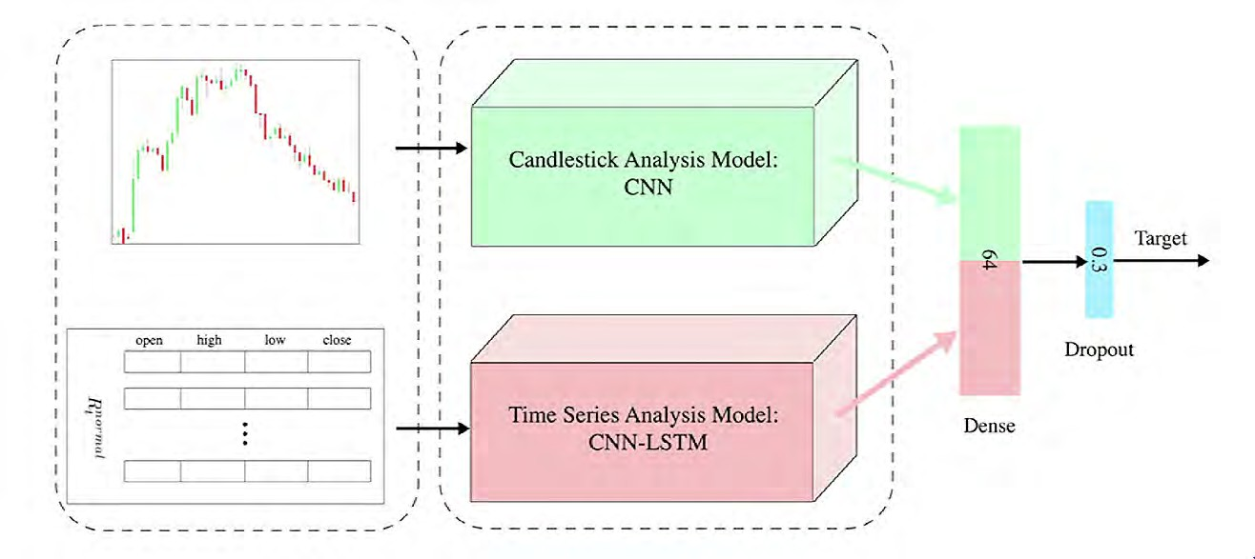
Figure 5: The architecture of the proposed hybrid model by Moghaddam et al. [29]

Moghaddam and Momtazi [29] proposed a hybrid model that integrates image process- ing techniques with time series analysis to predict profitable technical pattern positions in the forex market. Their approach leverages the strengths of both CNNs and LSTM networks. The CNN analyses candlestick chart patterns, while the CNN-LSTM combination captures tempo- ral dependencies in the time series data. The architecture of this hybrid model is depicted in Figure 5. In the model, raw data is preprocessed and then fed into two separate analysis paths. The candlestick analysis model uses CNN to extract features from the candlestick charts. Si- multaneously, the time series analysis model, which combines CNN and LSTM, processes the sequential data. Both model’s outputs are concatenated and passed through a dense layer fol- lowed by a dropout layer to prevent overfitting, ultimately providing the target predictions. This innovative approach demonstrates the potential of combining image processing with deep learning for enhanced predictive accuracy in financial markets.
Escudero et al. [18] compared RNN and Autoregressive Integrated Moving Average

(ARIMA) models for forecasting the Euro/Dollar exchange rate. They developed a hybrid model integrating ARIMA for trend and seasonality detection with RNN to capture non-linear temporal dynamics. The combined ARIMA-RNN model exhibited enhanced predictive accu- racy over standalone models, suggesting its effectiveness in forex exchange rate forecasting. Wang and Guo [30] proposed a mixed model combining ARIMA and XGBoost to forecast stock market volatility. The ARIMA component captures linear trends, while XGBoost models the non-linear aspects of the time series data. Their hybrid approach demonstrated superior forecasting accuracy and robustness compared to traditional models, highlighting its potential for improved stock market volatility predictions.
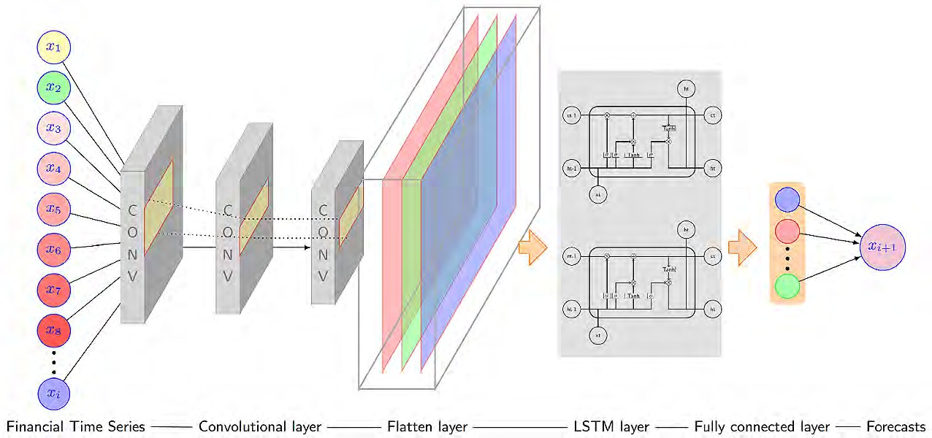
Figure 6: CNN-LSTM network structure used by He et al. [4]

He et al. [4] propose a deep learning ensemble model for financial time series forecast- ing, integrating fundamental and technical data. The authors use a dataset comprising historical financial time series data, including forex pairs like EUR/USD and GBP/USD, sourced from financial databases and market data providers. The ensemble approach combines multiple deep- learning techniques to enhance predictive accuracy and robustness. The study shows that the ensemble model outperforms individual models regarding prediction accuracy and generalisa- tion to various market conditions. The research validates the effectiveness of using ensemble strategies in financial forecasting by leveraging diverse data sources and model architectures. The network structure used by the authors involves a CNN-LSTM architecture shown in FIgure 6, where the CNN layers extract features from the input data, and the LSTM layers capture the temporal dependencies. This combination leverages the strengths of CNNs in handling spatial features and LSTMs in modeling sequential data, leading to improved forecasting performance. These studies underscore the advantages of using ensemble models in financial fore-

casting. By integrating the strengths of different algorithms, ensemble models can achieve higher accuracy and better generalisation than individual models.

  - Related Research
Forex prediction has seen extensive research efforts to improve the forecasting model’s accu- racy and reliability. These efforts span various methodologies, including technical analysis, fundamental analysis, and the integration of sentiment analysis. By utilising ML and DL tech- niques, researchers have aim to identify complex patterns and dependencies in financial data. This offers an overview of important related research, emphasising key studies that have ad- vanced forex prediction. The review covers works employing machine learning algorithms, deep learning models, ensemble methods, and hybrid approaches, illustrating the diverse strate- gies used to address the challenges in forex forecasting. The studies reviewed here highlight the importance of combining different analytical methods to enhance the predictive performance of forex models, reflecting the multi-faceted nature of financial markets.
Dautel et al. [3] explore the application of deep RNNs, such as LSTM networks and GRUs, for forecasting foreign exchange rates. The authors systematically compare these ad- vanced architectures with traditional recurrent and feedforward networks. The dataset includes historical forex data for major currency pairs like EUR/USD, GBP/USD, and USD/JPY, col- lected from reputable financial databases. The study finds that deep learning models, particu- larly LSTMs and GRUs, show superior directional forecasting accuracy and trading profitabil- ity performance. However, the authors note the challenges in implementing and tuning these complex architectures, suggesting that simpler neural networks can sometimes achieve compa- rable results. The research underscores the potential of deep learning in forex forecasting while acknowledging the practical difficulties in model deployment.
This paper by Ahmed et al. [6] introduces a novel prediction system called FLF-LSTM, which incorporates a specialised Forex Loss Function to improve the accuracy of Forex price predictions. The dataset includes historical forex data for pairs like EUR/USD, GBP/USD, and AUD/USD obtained from financial data providers. By integrating fundamental and technical indicators, the model leverages the strengths of LSTM networks in handling sequential data and capturing complex temporal dependencies. The Forex Loss Function is designed to enhance the model’s sensitivity to forex market dynamics, resulting in improved predictive performance compared to traditional loss functions.
Qi et al. [21] present an Event-Driven LSTM model for forex price prediction that in- corporates external market-moving events into the forecasting process. The dataset includes historical forex price data for pairs such as EUR/USD and USD/JPY and event data like eco- nomic announcements and geopolitical developments sourced from financial news outlets and economic calendars. By integrating these event data into the LSTM framework, the model en- hances its ability to predict forex price movements. The study demonstrates that considering

external events dramatically improves the prediction accuracy of LSTM models, highlighting the importance of incorporating diverse data sources in financial forecasting.
Sudimanto et al. [8] conducted a pilot study demonstrating the effectiveness of machine learning algorithms in predicting exchange rates. Their study employed machine learning tech- niques to forecast forex prices, including SVM and random forests. The findings indicated that these models could significantly enhance prediction accuracy compared to conventional methods.
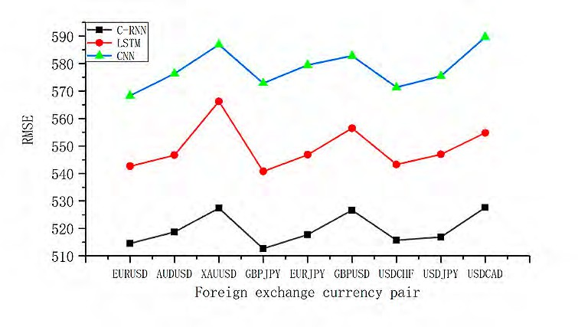
Figure 7: Comparison of RMSE of predicted values by different forecasting algorithms [31].

Ni et al. [31] explore the application of deep learning techniques for forecasting forex time series data. The study specifically focuses on using LSTM networks to predict future forex prices. The researchers collected historical data for major forex pairs and utilised the LSTM model to capture temporal dependencies in the data. Their findings indicate that LSTM networks significantly outperform traditional statistical models regarding predictive accuracy and the ability to handle non-linear relationships in the data. However, the primary limita- tion of this study is the computational complexity associated with training LSTM networks, which requires extensive hyperparameter tuning and significant computational resources. The image in Figure 7 provides a visual comparison of the RMSE values for different forecasting algorithms—C-RNN, LSTM, and CNN—across various foreign exchange currency pairs, in- cluding EUR/USD, AUD/USD, XAU/USD, GBP/JPY, EUR/JPY, GBP/USD, USD/CHF, USD
/JPY, and USD/CAD. The RMSE values for each algorithm are plotted on the y-axis, with lower RMSE values indicating better predictive performance. The LSTM model (represented by red dots) consistently demonstrates lower RMSE values compared to CNN (green triangles) and C-RNN (black squares), highlighting its superior accuracy in forecasting forex prices. In the

research conducted by Vuong et al. [32], the authors investigate the combination of XGBoost and LSTM models for stock price forecasting. The study leverages the strengths of XGBoost in handling structured data and the sequential learning capabilities of LSTM networks. The hy- brid model aims to improve the accuracy of stock price predictions by capturing both linear and non-linear relationships in the data. The results show that the hybrid XGBoost-LSTM model outperforms the individual model’s prediction accuracy and robustness. However, one of the main limitations is the increased complexity and computational cost associated with combining two different machine learning models, which requires careful parameter tuning and significant computational resources.
Islam and Hossain [33] propose a hybrid network combining GRU and LSTM networks for predicting foreign exchange currency rates. The study aims to leverage the strengths of both GRU and LSTM in capturing temporal dependencies and non-linear patterns in the data. The hybrid GRU-LSTM network is trained on historical forex data, and the results indicate significant improvements in prediction accuracy compared to traditional models. The main limitation is the increased computational complexity and training time due to combining two deep learning models, necessitating extensive hyperparameter tuning. Wang et al. [34] develop a prediction model using a combination of CNN and TLSTM (Time-variant LSTM) for fore- casting the USD/CNY exchange rate. The CNN component extracts features from the input data, while the TLSTM network captures temporal dependencies. The study demonstrates that the CNN-TLSTM model outperforms traditional and standalone deep learning models in terms of predictive accuracy. The main limitation of the CNN-TLSTM model is its complexity and the computational resources required for training, which necessitates extensive hyperparameter tuning and careful selection of input features.
Tripathi et al. [35] examine the use of ensemble modeling for exchange rate forecast- ing. The study combines multiple machine learning models to improve prediction accuracy and robustness. The ensemble approach leverages the strengths of different models and mit- igates individual model weaknesses. The results indicate that the ensemble model provides better predictive performance and is more resilient to market volatility. The primary limita- tion of ensemble modeling is the increased computational cost and complexity associated with combining multiple models, which requires significant computational resources and time for training and validation. Meanwhile, Alonso-Monsalve et al. [36] investigate using CNN for high-frequency trend prediction of cryptocurrency exchange rates using technical indicators. The study leverages the feature extraction capabilities of CNNs to identify patterns in high- frequency trading data. The results show that the CNN model outperforms traditional models and provides accurate predictions for cryptocurrency trends. The main limitation of the CNN model is the computational complexity and resources required for training, especially for high- frequency data, necessitating extensive hyperparameter tuning.
The paper by Peng and Lee [37] focuses on mitigating overfitting in forex trading mod- els. The authors propose a data selection strategy to enhance model robustness by carefully

choosing relevant data points that reflect genuine market conditions rather than noise. This approach aims to improve the predictive performance of machine learning models in the highly volatile forex market. Their methodology was tested using intraday trading data, demonstrat- ing significant model accuracy and reliability improvements. The paper by Dassanayake [38] provides an in-depth analysis of different forecasting models. Dassanayake compares tradi- tional statistical methods with modern deep learning techniques to predict the movements of the New Zealand Stock Market Index. The study highlights the strengths and weaknesses of each approach, showing that deep learning models, especially those designed to capture tem- poral dependencies, outperform statistical models in terms of accuracy and handling market volatility. The research uses historical stock market data from New Zealand to validate the models, underscoring the practical applications of advanced forecasting techniques in financial markets.
A survey conducted by Hu et al. [39] explores various deep learning models applied to forex and stock price prediction. The study analyses deep learning techniques, including CNNs, LSTM networks, Deep Neural Networks (DNNs), RNNs, and Reinforcement Learning. The survey classifies these models based on their methodologies and performance metrics such as RMSE, MAPE, MAE, MSE, accuracy, Sharpe ratio, and return rate. The findings indicate that combining LSTM with other models, such as DNN, shows promising results. Reinforce- ment learning also demonstrated substantial returns and performance in financial modeling, reflecting an increasing trend in employing deep learning methods for financial predictions. The paper by Lu [40] examines the application of LSTM networks to forecast the GBP/CNY exchange rate. The study highlights the advantages of LSTM in capturing long-term depen- dencies and non-linear relationships in financial time series data. By training the LSTM model on historical exchange rate data, the research demonstrates its ability to produce accurate and reliable forecasts, emphasising its robustness in handling the volatile nature of forex markets.
Research by Mesleh and Kiranyaz [41] compares the effectiveness of Multilayer Per- ceptron (MLP) and LSTM models in predicting future forex prices. The study involves training both models on historical forex data and evaluating their performance based on prediction ac- curacy. The findings suggest that LSTM models, with their capability to understand sequential data, outperform MLP models, providing more accurate forecasts for forex price movements. The paper by Ulina et al. [42] explores the use of Complementary Ensemble Empirical Mode Decomposition with Adaptive Noise (CEEMDAN) and an Improved Fractional-Order Adaptive LSTM (FA-LSTM) model for forex prediction. The study focuses on the USD/IDR currency pair and demonstrates that integrating CEEMDAN with FA-LSTM enhances the model’s abil- ity to handle non-stationary and noisy financial data, leading to improved prediction accuracy. The study by Ranjit et al. [43] compares various algorithms for predicting foreign exchange rates, including traditional statistical methods and advanced machine learning models. The research evaluates the performance of these algorithms based on their accuracy and compu- tational efficiency, highlighting the strengths and weaknesses of each approach. The findings

provide valuable insights into selecting appropriate models for forex prediction under different market conditions.
Ni et al. [44] explored the effectiveness of deep learning models for forecasting forex time series data. Their study utilised LSTM networks to capture the intricate patterns in fi- nancial time series data. The researchers collected data from various forex pairs, including EUR/USD and GBP/USD, and demonstrated that LSTM models significantly outperformed traditional forecasting methods, providing more accurate and reliable predictions of future forex prices. Shiao et al. [45] conducted a case study using various machine learning mod- els to predict forex prices. They compared the performance of Multiple Linear Regression (MLR), Decision Trees (DT), and Neural Networks (NN) using forex data from multiple cur- rency pairs. The study concluded that neural networks, particularly LSTM models, provided the best predictive accuracy due to their ability to model complex temporal dependencies in the data. Neghab et al. [46] investigated using machine learning models to explain exchange rate forecasts with macroeconomic fundamentals. The study applied interpretive machine learning techniques to a dataset comprising key macroeconomic indicators from significant economies. The findings highlighted the importance of incorporating economic fundamentals into predic- tive models to improve the accuracy and interpretability of forex forecasts.
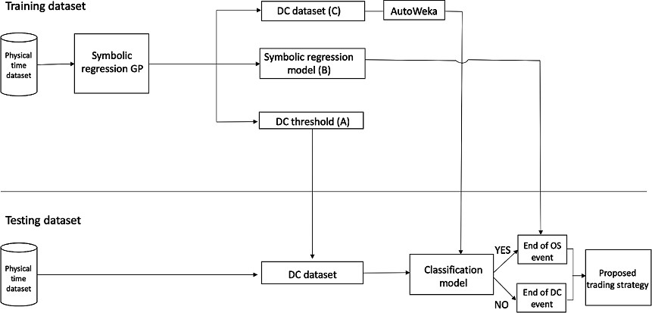

Figure 8: Proposed methodology by Adegboye and Kampouridis [47].

Figure 8 describes the proposed methodology used by Adegboye and Kampouridis for their forex prediction model. The methodology is divided into two main phases: training and testing. The physical time dataset is first input into a symbolic regression genetic program- ming (GP) model in the training phase. This model generates a symbolic regression model
(B) and determines the directional change (DC) threshold (A). The physical time dataset is

also transformed into a DC dataset (C). AutoWeka is then employed to optimize the param- eters and select the best classification model. The physical time dataset is again transformed into a DC dataset in the testing phase. This dataset is fed into the optimized classification model. The model predicts whether the end of an overshoot (OS) event or a DC event has been reached. Based on these predictions, a proposed trading strategy is developed, guiding trading decisions. Adegboye and Kampouridis [47] examined various machine learning mod- els, including classification and regression techniques, to predict directional changes and trend reversals in forex markets. Their research focused on identifying key features that influence market movements and demonstrated that ensemble learning methods, such as Random Forests and Gradient Boosting, significantly enhanced predictive performance compared to individual models. Filippou et al. [48] analysed the impact of media sentiment on currency reversals. The study utilised sentiment analysis on a vast corpus of financial news articles and correlated the sentiment scores with currency exchange rate movements. The results indicated that neg- ative media sentiment often preceded currency reversals, suggesting that integrating sentiment analysis into forex prediction models can improve their accuracy and responsiveness to market events.
The study by Rognone et al. [49] examines the impact of news sentiment on the cryp- tocurrency market compared to the forex market. Using sentiment analysis on news articles, they discovered significant differences in how sentiment affects these markets. The research highlighted that while news sentiment strongly influences both markets, the cryptocurrency market showed higher sensitivity due to its speculative nature. Farimani et al. [50] delved into leveraging latent economic concepts and news sentiments for market prediction. They employed advanced sentiment analysis and machine learning techniques to forecast market movements. Their findings indicated that incorporating latent economic concepts alongside sentiment scores significantly improved predictive accuracy across various financial markets, including forex. Semiromi et al. [51] analysed the predictive power of news story events listed in economic calendars on forex rates. This research utilised a dataset of economic news events and applied machine learning models to forecast forex rates. The results demonstrated that news story events have substantial predictive power, particularly when unexpected or eco- nomically significant. Song and Choi [52] compared various hybrid models for forecasting stock market indices, including CNN-LSTM, GRU-CNN, and ensemble models. Their study revealed that these hybrid models, which combine CNNs and RNNs, outperformed traditional models in capturing complex patterns and temporal dependencies in financial time series data.
In their research, Livieris et al. [53] proposed a CNN-LSTM model for forecasting gold prices. This model integrates CNN’s feature extraction capabilities with LSTM’s sequence modeling strengths, demonstrating superior performance in predicting gold price movements compared to traditional forecasting methods. The study utilised historical gold price data and validated the model’s effectiveness in forecasting financial time series. Paliari et al. [54] con- ducted a comparison of optimised LSTM, XGBoost, and ARIMA models in time series fore-

casting. Using various datasets, including forex data, they found that LSTM and XGBoost models generally outperformed ARIMA in capturing complex temporal dependencies, with LSTM showing particular strength in long-term predictions. This study highlights the advan- tages of using advanced machine learning techniques over traditional statistical models for time series forecasting. Pornwattanavichai et al. [55] introduced BERTFOREX, a cascading model for forex market forecasting that integrates fundamental and technical indicators using the Bidirectional Encoder Representations from Transformers (BERT) framework. The study demonstrated that BERTFOREX effectively captures contextual dependencies within the data, improving prediction accuracy for forex markets. The model outperformed traditional meth- ods, showcasing the potential of transformer-based architectures in financial forecasting. Wood et al. [56] presented the Momentum Transformer, an intelligent and interpretable architecture for trading. This model leverages the transformer framework to capture momentum signals in financial time series, providing enhanced interpretability and performance in trading applica- tions. The study highlighted the model’s ability to learn complex patterns and its applicability across financial instruments, including forex. The Momentum Transformer demonstrated su- perior predictive capabilities compared to traditional models.
Tsantekidis et al. [57] explore the application of deep learning for price prediction by exploiting stationary limit order book features. Their study employs a deep learning model to capture complex patterns in the limit order book data, which are then used to predict future price movements. The results demonstrate that the deep learning approach significantly out- performs traditional methods regarding predictive accuracy. However, the high computational cost associated with processing and training on large volumes of order book data remains a notable limitation, which may only be feasible for some trading environments.
Weerathunga and Silva [58] introduce a hybrid DRNN-ARIMA approach for short- term trend forecasting in the forex market. The model combines DRNN with the ARIMA model to enhance short-term prediction accuracy. Leveraging the strengths of both methods, the hybrid model shows improved forecasting performance. Despite these advantages, the model’s complexity and the need for extensive parameter tuning are significant drawbacks, making
it time-consuming and computationally expensive. Mate´ [59] investigates forecasting forex
spot price intervals using a linear regression model based on interval arithmetic. This study analyses seven major currency pairs and employs interval arithmetic to predict price ranges for the following day. Although the approach offers a unique perspective on interval prediction, its main limitation lies in the simplistic linear regression model, which may not effectively capture the complexities and non-linear relationships inherent in forex data. Talebi et al. [60] present a multi-scale ensemble model designed for classifying trends in the forex market. The model combines predictions from multiple scales to improve trend classification accuracy. Findings indicate that the multi-scale ensemble approach enhances predictive performance compared to single-scale models. Nevertheless, the increased computational complexity and the challenge of integrating multiple scales effectively are significant limitations.

Panda et al. [61] conduct a systematic review of exchange rate prediction using ANN and deep learning methodologies. This review highlights various ANN and deep learning mod- els applied to forex prediction, discussing their advantages and limitations. A significant limi- tation noted is the overfitting problem commonly encountered in deep learning models, which can negatively impact their generalisability to new data. Juszczuk and Krus´ [62] develop a soft multicriteria computing approach to support decision-making in the forex market. Their model integrates multiple criteria to improve decision-making accuracy. While the approach is innovative, its primary limitation is the complexity of accurately weighting and integrating multiple criteria, which can be subjective and challenging to implement effectively. Rundo [63] investigates the integration of a deep LSTM with a reinforcement learning layer for financial trend prediction in high-frequency trading systems. The model combines the sequence mod- eling capabilities of LSTM with reinforcement learning to enhance predictive accuracy and decision-making. Despite the promising results, the computational intensity and the need for substantial data to train the reinforcement learning component are significant challenges.

  - Summary
This subsection summarises the problems and challenges identified in the reviewed literature, explaining the selection of XGBoost, LSTM, Transformer, and ensemble models for this re- search.
- Problems and Challenges in ML Models:

  - Sudimanto et al. [8] highlighted the complexity and computational intensity of ML models like SVM and random forests, which limit their efficiency in financial forecasting.
  - McNally et al. [9] noted issues of overfitting and the extensive parameter tuning required for ML models, reducing robustness in volatile market conditions.
  - Basak et al. [10] discussed the sensitivity of tree-based classifiers to noisy data and their tendency to overfit in highly volatile markets.
  - Thu and Xuan [11] emphasised the computational expense and complexity of opti- mising SVMs, making them less practical for frequent prediction updates.
  - Neghab et al. [12] highlighted the reliance on accurate and timely macroeconomic data, which can cause delays in prediction updates.
- Selection of XGBoost:

  - XGBoost models deliver promising results due to their ability to handle large datasets and capture complex patterns effectively [8].

  - They offer robust performance by integrating technical, fundamental, and sentiment data for comprehensive market analysis.
- Problems and Challenges in DL Models:

  - Ni et al. [31] found that LSTM models outperform traditional statistical models but require extensive hyperparameter tuning and significant computational resources.
  - Vuong et al. [32] highlighted the increased complexity and computational cost of combining models like XGBoost and LSTM.
  - Islam and Hossain [33] discussed the increased training time and computational complexity due to combining GRU and LSTM models.
  - Wang et al. [34] demonstrated that CNN-TLSTM models outperform traditional models but require substantial computational resources for training.
- Selection of LSTM and Transformer Models:

  - LSTM models excel in capturing long-term dependencies and temporal patterns, providing better predictive accuracy for financial time series [31].
  - Transformer models are effective in handling longer sequences and capturing com- plex patterns, making them promising for financial applications [22].
- Advantages of Ensemble Models:

  - Ensemble models combine the strengths of various algorithms to enhance predictive performance and generalisability, addressing the limitations of individual models
[27].
  - Ghosh et al. [28] showed that hybrid models combining LSTM networks and ran- dom forests improve the accuracy and reliability of stock price direction predictions.
  - He et al. [4] validated the effectiveness of using ensemble strategies in financial forecasting by leveraging diverse data sources and model architectures.
- Combining LSTM and XGBoost:

  - LSTM and XGBoost models were combined in this research to leverage their com- plementary strengths in time-series forecasting. LSTM is well-suited for capturing long-term temporal dependencies in sequential data, while XGBoost is effective in modeling non-linear relationships and feature interactions within structured data.
  - The novelty of this approach lies in using LSTM to model long-term trends in forex data and XGBoost to capture short-term fluctuations by integrating technical, fun- damental, and sentiment indicators.

  - By combining these models, the research addresses limitations of existing approaches where single models either focus solely on time-series patterns (LSTM) or feature- based prediction (XGBoost). This hybrid model enhances predictive accuracy by capturing both sequential dependencies and complex relationships between fea- tures.
  - This research also stands out by applying the hybrid model to multiple currency pairs and two different time intervals (four-hour and one-day), making the approach more robust and generalizable across different market conditions.
- Identified Gaps in the Literature:

  - While significant progress has been made in applying ML and DL models to fi- nancial forecasting, the integration of sentiment analysis with technical and funda- mental indicators remains underexplored. Most studies focus solely on technical indicators, overlooking the potential benefits of using multiple data sources for im- proving prediction accuracy.
  - Many of the existing studies, such as Ghosh et al. [28], focus on a single currency pair, limiting the generalisability of their findings. This research expands on previ- ous work by using multiple currency pairs and two different time intervals, thereby providing a broader and more comprehensive analysis of forex market prediction.
  - Few studies systematically compare the performance of ML, DL, and hybrid en- semble models in forex prediction using diverse data types. This leaves a gap in understanding which models offer the best predictive accuracy and robustness in financial markets.
- Conclusion:

  - The challenges and gaps identified in the literature support the selection of XG- Boost, LSTM, Transformer, and ensemble models in this research. By addressing the limitations of traditional ML and DL models and focusing on the integration of diverse data sources, including multiple currency pairs and time intervals, this study aims to enhance the predictive accuracy and robustness of forex price forecasts.

- Methodology
This chapter outlines the comprehensive methodologies employed to investigate forex price predictions utilising a multi-modal approach that integrates technical indicators, fundamental analysis, and sentiment analysis derived from financial news. It meticulously describes the data collection process, detailing the types and sources used, including historical forex rates, economic indicators, and sentiment data. Furthermore, it elaborates on the model development process, illustrating the deployment of various advanced machine learning and deep learning models tailored to analyse and predict forex market movements. Additionally, this section specifies the evaluation metrics used to assess the models’ accuracy and efficacy, ensuring the research findings’ validity and reliability. Through a clear exposition of these methods, this chapter aims to provide a robust framework supporting replicability and scrutiny of the research outcomes.

  - Data Collection
The data collection phase of this research forms the foundation upon which the predictive mod- els are built, encompassing a diverse array of datasets to ensure a comprehensive analysis of forex market dynamics. This section delineates the methodologies employed to gather and prepare three distinct types of data: sentiment analysis data, technical trading data, and fun- damental economic indicators. Each data type uniquely contributes to the model’s ability to predict forex price movements, providing a multifaceted view of the factors influencing cur- rency values. The sources from which data was collected, the criteria for its selection, and the processes involved in its preparation are detailed, aiming to furnish a robust dataset that supports the sophisticated analytical techniques used in this study.
Significantly, two different timeframes of market data were utilised to capture varying market dynamics: One-Day OHLC data, and Four-Hour OHLC data. The Four-hour data was paired explicitly with sentiment analysis data and technical and fundamental indicators, aiming to capture the immediate impact of market sentiment on forex prices within shorter intervals. This combination was mainly selected to assess the influence of rapidly changing market sentiments alongside economic and technical indicators, providing a detailed temporal resolution suitable for high-frequency trading strategies.
Conversely, the One-Day OHLC data was used exclusively with technical and funda- mental indicators. This broader timeframe allowed for examining longer-term trends and eco- nomic impacts without the immediate noise of market sentiment, offering insights into the more stable, underlying movements in forex prices. This strategic differentiation in data utilisation enabled a comparative analysis of model performance across four key forex pairs (EUR/USD, NZD/USD, EUR/NZD, and AUD/NZD) under different architectural setups for each dataset. This approach highlights each model configuration’s relative strengths and weaknesses and

showcases how different data integrations can impact predictive accuracy in forex market pre- diction.

    - Sentiment Analysis
Sentiment analysis is crucial in understanding market trends and predicting forex price move- ments. This section details the methodology employed to collect and process sentiment data from financial news headlines, highlighting the tools and techniques used to ensure a compre- hensive and accurate dataset.
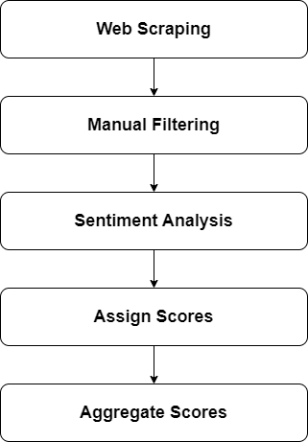
Figure 9: The Sentiment Analysis Workflow for Forex News Headlines.

Advanced web scraping tools and libraries were utilised to collect sentiment data. Se- lenium, an automation tool that simulates user interactions with web pages, was essential for navigating dynamic content. BeautifulSoup, a Python library for parsing HTML and XML doc- uments, was used to extract specific elements such as news headlines and publication dates[64], [65]. Pandas, a data manipulation and analysis library, organised and stored the extracted data in structured formats. These tools were chosen for their robustness and ability to handle com- plex web scraping tasks, ensuring the reliability and comprehensiveness of the collected data.

The sentiment data was sourced from three prominent financial news websites, each known for its extensive coverage of forex-related news. Investing.com is a widely used platform that offers real-time data, news, and analysis on financial markets. It is popular among traders and investors for its comprehensive coverage of market trends and events [66]. This platform provided a substantial portion of the sentiment data used in this study.
DailyForex.com focuses on forex news, analysis, and educational content. It offers in-depth market insights and trading strategies, making it a valuable resource for novice and experienced traders [67]. The site’s detailed analysis and up-to-date information on market movements contributed significantly to the sentiment data collected for this research.
Interest.co.nz is a New Zealand-based financial news website covering various eco- nomic and market topics. It provides localised news and analysis on the NZD currency, offering unique insights into the New Zealand forex market [68]. This site was beneficial for gathering sentiment data related to the NZD currency pairs.
From these sources, a total of 2048 news headlines were collected over the period from January 1, 2023, to January 31, 2024. The distribution of headlines among the different forex pairs was as follows: EUR/NZD with 246 headlines, NZD/USD with 585 headlines, EUR/USD with 466 headlines, and AUD/NZD with 192 headlines. This diverse data set from multiple rep- utable sources ensured a comprehensive analysis of market sentiment, improving the robustness of the predictive models.
The process involved several steps. First, web scraping with Selenium automated the opening of web pages and waited for dynamic content to load, which is crucial for handling websites with JavaScript-driven content. BeautifulSoup then parsed the HTML content of the web pages and extracted necessary elements, such as news titles and publication dates, ensuring only relevant information was captured. After collecting data from each website, the datasets were combined into a single comprehensive dataset using Pandas, ensuring consistency in the data format.
Once collected, the news headlines were processed using state-of-the-art Large Lan- guage Models (LLMs): GPT-4, and GEMINI Advanced. GPT-4, utilised for its advanced zero- shot learning capabilities, interprets context-rich financial news without explicit prior training on financial sentiment. GEMINI Advanced, designed for complex narrative understanding, provides deep insights from financial texts even without labeled data. Each headline was as- signed a sentiment score (positive, neutral, or negative) based on the output of these models.

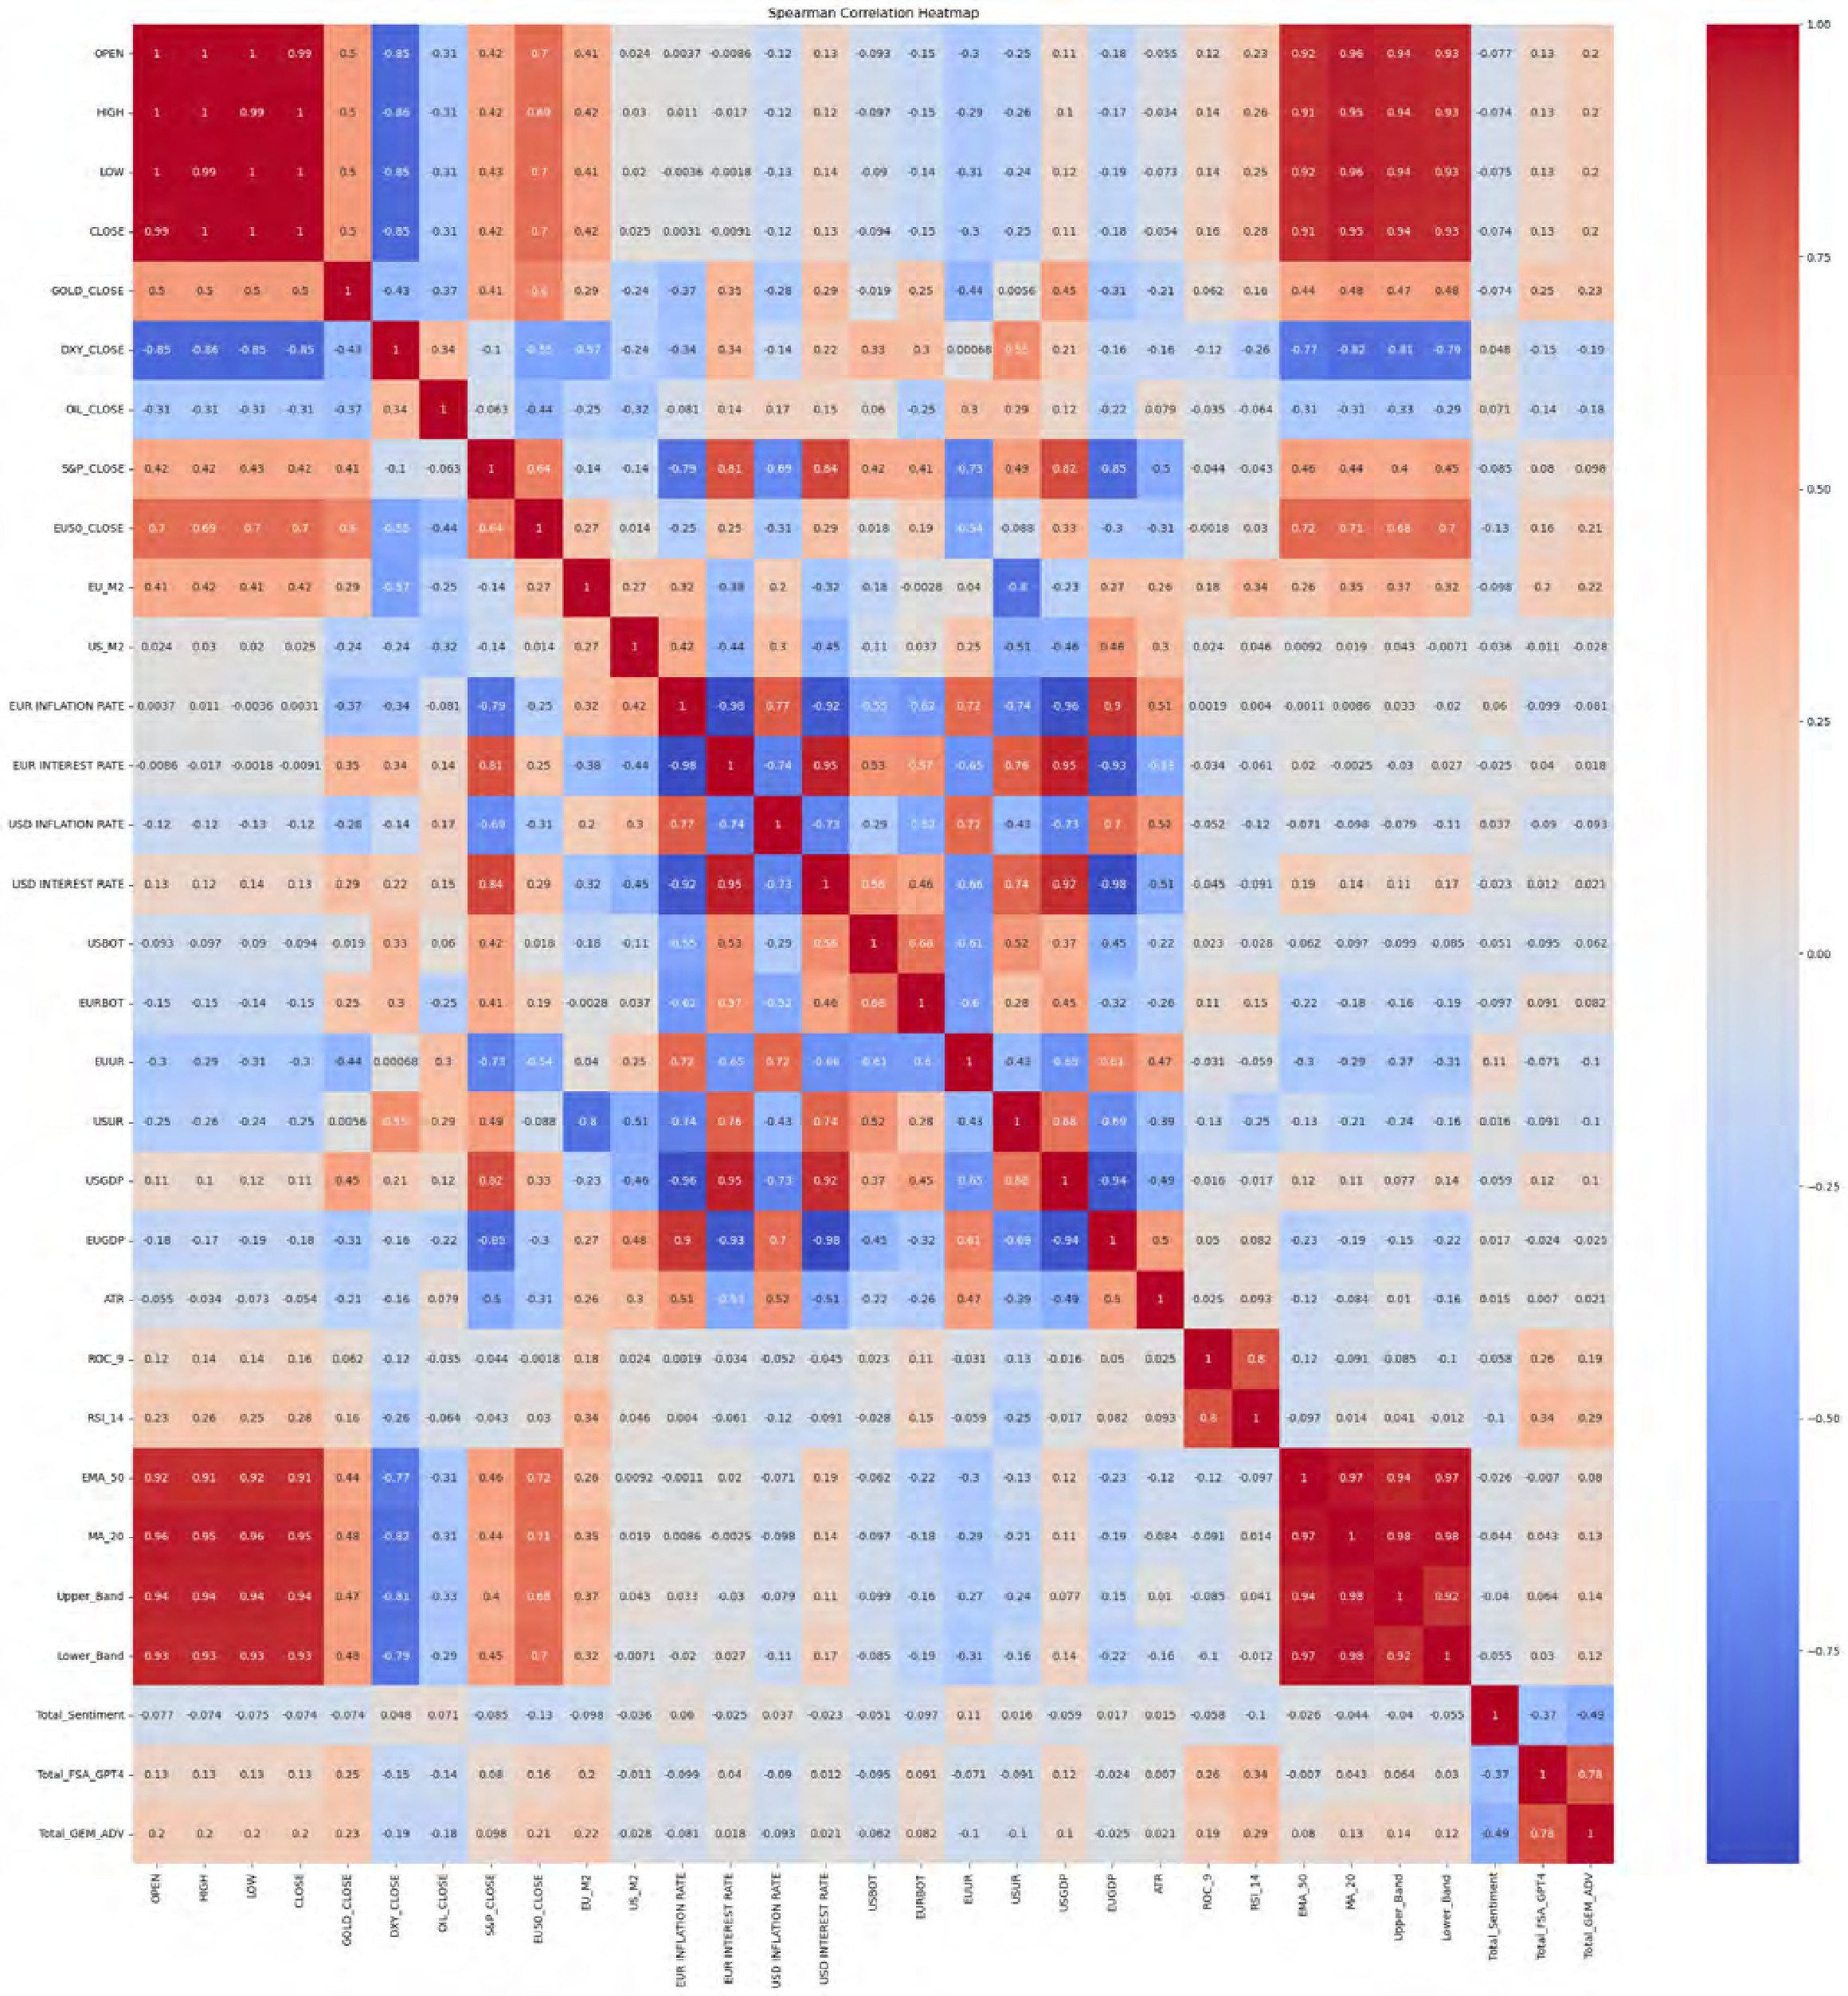
Figure 10: Heatmap showing Spearman correlation coefficients for EUR/USD data.

The sentiment classification process involved assigning scores of 1 for positive senti- ment, 0 for neutral sentiment, and -1 for negative sentiment to each headline. These daily senti- ment scores were aggregated to derive a comprehensive sentiment analysis score for each day. Given that the primary dataset operates on a Fourhour timeframe, Figure 10 shows the ROC 9 indicator—which represents the rate of change over a one-and-a-half-day period—provides a meaningful way to correlate the aggregated daily sentiment scores with forex price movements. This methodology allows for a nuanced understanding of how daily market sentiment influ- ences price trends over subsequent days, capturing the temporal dynamics between sentiment shifts and their market effects. The comprehensive sentiment analysis process is illustrated in Figure 9, which outlines the sequential steps from web scraping to data extraction, sentiment classification, and sentiment score aggregation. This structured approach ensures that the sen- timent data collected is relevant, timely, and accurately reflects market conditions, providing a solid foundation for subsequent predictive modeling.For the sentiment analysis, the following zero-shot prompt was used: ”Provide a sentiment analysis for the following headlines regard- ing the specified currency pair. Indicate whether each headline is positive, negative, or neutral for the specified currency pair.” This approach enabled us to effectively categorise the head- lines without the need for pre-labeled data, leveraging the advanced capabilities of the LLMs [69], [70]. As shown in Figure 10, the Spearman correlation heatmap indicates that the GPT-4 sentiment score has a higher correlation with the close price compared to other sentiment mod- els. Therefore, for the EUR/USD pair, the GPT-4 sentiment analysis score is used for model training to enhance the predictive accuracy of the EUR/USD models.
Following these steps, a robust dataset of financial news headlines was prepared for
sentiment analysis, offering valuable insights into market sentiment and its impact on forex price movements. This comprehensive approach ensures that the sentiment analysis component is grounded in a well-curated and diverse dataset, enhancing the overall reliability and accuracy of the predictive models[71].

    - Technical Analysis
Technical analysis is critical in forex market prediction, as it utilises historical price data and statistical indicators to forecast future price movements. This section delves into the various types of technical indicators used in this research, the rationale behind their selection, and the formulas used for their calculation. The primary indicators included in the dataset are derived from the Open, High, Low, and Close (OHLC) prices, calculated using the TA-Lib library, a comprehensive library for technical analysis [72, 73].
Open, High, Low, and Close (OHLC) Prices: OHLC prices form the foundational data from which various technical indicators are computed. Each of these prices represents different aspects of market behavior within a specific timeframe, providing a granular view of price action:

      - Open Price: The price at which the forex pair begins trading at the start of a given period.
      - High Price: The maximum price reached during the trading period.
      - Low Price: The minimum price reached during the trading period.
      - Close Price: The price at which trading ends for the period.
Average True Range (ATR): ATR measures market volatility by considering the range of price movements. It is calculated based on the greatest of the following: the current high minus the current low, the absolute value of the current high minus the previous close, and the absolute value of the current low minus the previous close. The formula is presented below (Eq. 1):

ATR = 1
n
n
True Range
(1)

∑ i
i=1

Here, True Range is the maximum of (Eq. 2):

True Range = max(High − Low, |High − Close_{prev}|, |Low − Close_{prev}|) (2)

Rate of Change (ROC): ROC is a momentum oscillator that measures the percentage change in price between the current price and a price n periods ago. It indicates the speed at which the price is changing, which helps in identifying overbought or oversold conditions (Eq. 3):
ROCn = Close − Close_{n} _{periods} _{ago} × 100 (3) Closen periods ago
      - ROC 7: Used in the One-day timeframe, it calculates the rate of change over seven days.
      - ROC 9: Used in the Four-hour timeframe, it calculates the rate of change over 36 hours (nine Four-hour periods).
Relative Strength Index (RSI): RSI is a momentum oscillator that measures the speed and change of price movements. It oscillates between 0 and 100 and is typically used to identify overbought or oversold conditions. The formula is presented below (Eq. 4):

where:
RSI = 100 − 100
1 + RS

RS = Average Gain over n periods Average Loss over n periods

(4)

(5)

      - RSI 14: Calculated using 14 days, it helps understand the momentum of price changes and potential reversal points.

Exponential Moving Average (EMA): EMA is a moving average with greater weight and significance on the most recent data points. It reacts more quickly to recent price changes than the simple moving average (SMA). The formula is given in (Eq. 6):

EMA_{t} = α × Price_{t} +(1 −α) × EMA_{t−1} (6)

where:

α = 2
n + 1

(7)

      - EMA 50: A 50-period EMA that smooths out price data to identify the trend direction over a medium-term period.
Bollinger Bands: Bollinger Bands consist of a middle band (usually a 20-period SMA) and two outer bands (upper and lower), standard deviations from the middle band. They measure market volatility and identify potential overbought or oversold conditions. The formulas are shown below (Eq. 8, 9, 10):
Middle Band = MA₂₀ (8)
Upper Band = MA₂₀ +(2 × Standard Deviation₂₀) (9)
Lower Band = MA₂₀ − (2 × Standard Deviation₂₀) (10)
Selection of Technical Indicators
The selection of the above technical indicators is rooted in their proven effectiveness in capturing various aspects of market behavior:
      - ATR (Eq. 1) is essential for understanding market volatility, helping traders adjust their strategies based on the extent of price movements.
      - ROC indicators (ROC 7 and ROC 9) (Eq. 3) are crucial for identifying the momentum of price changes over different timeframes, which is critical for short-term and medium- term trading strategies.
      - RSI (Eq. 4) provides insights into the momentum and potential reversal points, which are critical for timing entries and exits in the market.
      - EMA (Eq. 6) helps smooth out price data to identify trends more accurately, reducing the noise from random price fluctuations.
      - Bollinger Bands (Eq. 8, 9, 10) are invaluable for assessing market volatility and identi- fying overbought or oversold conditions, which can signal potential reversals.
These indicators offer a comprehensive view of market dynamics, enabling a nuanced analysis of price movements. By integrating these technical indicators, the models developed in this research aim to leverage the strengths of each indicator to enhance the accuracy of

forex price predictions. The combination of these indicators provides a robust framework for understanding and forecasting market behaviour across different timeframes, as detailed in subsequent sections of this research.

    - Fundamental Analysis
As the previous section shows, technical analysis indicators provide a robust framework for understanding market dynamics based on historical price data. This section focuses on fun- damental analysis, which complements technical analysis by incorporating economic and fi- nancial indicators that reflect the broader economic environment. Fundamental indicators offer deeper insights into the factors influencing currency values, providing a comprehensive under- standing of market movements. This section details the fundamental indicators used in this research, explaining their significance and impact on forex trading.
Table 1: Fundamental Indicators Used for Each Currency Pair in the Research [74, 75, 76, 77, 78, 79,
80, 81].

Currency Pair | Fundamental Indicators
EUR/USD | GOLD CLOSE, DXY CLOSE, OIL CLOSE, S&P CLOSE, EU50 CLOSE, EU M2, US M2, EUR INFLATION RATE, EUR INTEREST RATE, USD INFLATION RATE, USD INTEREST RATE,  USBOAT, EURBOT, EUUR, USUR, USGDP, EUGDP
NZD/USD | GOLD CLOSE, DXY CLOSE, OIL CLOSE, NZX50 CLOSE, S&P CLOSE, USD INFLATION RATE, USD INTEREST RATE, NZD INFLATION RATE, NZD INTEREST RATE, NZGDTPI, NZTA,  USBOT, NZBOT, NZUR, USUR, USGDP, NZGDP
EUR/NZD | GOLD CLOSE, DXY CLOSE, OIL CLOSE, NZX50 CLOSE, EU50 CLOSE, EU M3, NZD M3, EUR INFLATION RATE, EUR INTEREST RATE, NZD INFLATION RATE, NZD INTEREST RATE,  NZTA, NZBOT, EURBOT, NZUR, EUUR, NZGDP, EUGDP
AUD/NZD | GOLD CLOSE, DXY CLOSE, OIL CLOSE, NZX50 CLOSE, ASX200 CLOSE, AUD M3, NZD M3, AU INFLATION RATE, AU INTEREST RATE, NZD INFLATION RATE, NZD INTEREST  RATE, NZTA, NZBOT, AUBOT, NZUR, AUUR, NZGDP, AUGDP

Gold (GOLD CLOSE): Gold prices are often considered a safe-haven asset, meaning they tend to hold or increase in value during economic uncertainty. Investors flock to gold during fi- nancial instability, leading to price increases. Rising gold prices indicate a lack of confidence in fiat currencies, as gold is seen as a more stable store of value. This can impact forex pairs such as EUR/USD and NZD/USD, as movements in gold prices reflect broader economic sentiments that can influence currency valuations.

US Dollar Index (DXY CLOSE): The US Dollar Index (DXY) measures the value of the USD against a basket of foreign currencies, including the euro, Japanese yen, British pound, Canadian dollar, Swedish krona, and Swiss franc. Movements in the DXY can have significant implications for currency pairs involving the USD. A rising DXY indicates a strengthening USD, which can affect the EUR/USD and NZD/USD pairs by making the USD more valuable relative to these currencies.
Oil (OIL CLOSE): Oil prices influence many aspects of the global economy, including in- flation and trade balances. Countries that are major oil exporters or importers are particularly affected by fluctuations in oil prices. For example, higher oil prices can increase inflationary pressures in oil-importing countries, impacting their currency value. Conversely, oil-exporting countries may see their currency strengthen with rising oil prices. Therefore, oil price move- ments can affect forex pairs like EUR/USD and NZD/USD.
S&P 500 (S&P CLOSE): The S&P 500 is a broad measure of the US stock market’s perfor- mance and is an essential indicator of US economic health. A strong S&P 500 typically signals a robust economy, which can strengthen the USD. Consequently, currency pairs tied to the USD, such as EUR/USD and NZD/USD, are influenced by the performance of the S&P 500. Euro 50 (EU50 CLOSE): The Euro Stoxx 50 Index represents 50 of the Eurozone’s most extensive and most liquid stocks. It serves as a critical indicator for the EUR, reflecting the Eurozone’s economic health and investor sentiment. Movements in the Euro Stoxx 50 can impact pairs like EUR/USD and EUR/NZD, as changes in the index reflect shifts in economic stability and investor confidence.
NZX 50 (NZX50 CLOSE): The NZX 50 Index includes the top 50 companies listed on the New Zealand Stock Exchange, serving as a barometer for the New Zealand economy. The performance of the NZX 50 affects the NZD, influencing currency pairs such as NZD/USD and EUR/NZD. A strong NZX 50 indicates economic growth and investor confidence in New Zealand, leading to a stronger NZD.
ASX 200 (ASX200 CLOSE): The ASX 200 Index is a benchmark for the Australian equity market. It provides insights into the Australian economy, influencing the AUD. The perfor- mance of the ASX 200 affects the AUD/NZD pair, as it reflects Australia’s economic conditions and investor sentiment.
Money Supply (M2 and M3): Money supply measures like M2 and M3 reflect the liquid- ity in the economy. M2 includes cash, checking deposits, and easily convertible near money, while M3 includes M2 plus large-time deposits, institutional money market funds, and other more considerable liquid assets. Changes in money supply can influence inflation and eco- nomic growth. For instance: EU M2 and US M2: These indicators reflect the Eurozone and US money supply, impacting EUR/USD. An increasing money supply can lead to inflationary pressures, affecting currency value. NZD M3 and AUD M3: These measures are crucial for understanding monetary conditions in New Zealand and Australia, influencing NZD/USD and AUD/NZD pairs.

Inflation Rates (EUR, USD, NZD, AU): Inflation rates indicate the rate at which the general price level of goods and services rises, eroding purchasing power. High inflation typically leads to higher interest rates as central banks try to control inflation, affecting currency value. For example: EUR Inflation Rate: Understanding Eurozone inflation is vital for predicting EUR movements. High inflation may lead to higher interest rates, strengthening the EUR. USD Inflation Rate: US inflation impacts the USD’s value against the NZD in the NZD/USD pair. NZD and AU Inflation Rates: These rates affect the NZD and AUD, influencing pairs like NZD/USD and AUD/NZD. Central New Zealand and Australian banks may adjust interest rates in response to inflation, impacting currency value.
Interest Rates (EUR, USD, NZD, AU): Central banks use interest rates to control inflation and stabilise the currency. Changes in interest rates impact currency value by affecting investment flows. Higher interest rates attract foreign investment, strengthening the currency. For instance: EUR and USD Interest Rates: These rates affect the EUR/USD pair. Higher Eurozone or US interest rates can attract investment, strengthening the EUR or USD. NZD Interest Rates: Influence the NZD/USD pair. Higher interest rates in New Zealand can attract investment, strengthening the NZD. AU Interest Rates: Affect the AUD/NZD pair. Changes in Australian interest rates influence the AUD, impacting the pair.
Gross Domestic Product (GDP): GDP measures a country’s economic performance. Higher GDP growth typically strengthens a currency by signaling economic stability and growth. For example: US GDP and EUR/USD: US economic performance influences the USD. Strong GDP growth in the US can strengthen the USD, affecting the EUR/USD pair. NZ GDP and NZD/USD: New Zealand’s economic health affects the NZD. Strong GDP growth in New Zealand can strengthen the NZD, impacting the pair. EU GDP and EUR/USD: Eurozone eco- nomic performance impacts the EUR. Strong GDP growth in the Eurozone can strengthen the EUR, affecting the EUR/USD pair. AU GDP and AUD/NZD: Australia’s GDP influences the AUD. Strong GDP growth in Australia can strengthen the AUD, impacting the AUD/NZD pair. Unemployment Rates (EUUR, USUR, NZUR, AUUR): Unemployment rates indicate eco- nomic health. Lower unemployment generally strengthens a currency by signaling economic stability. For example: US Unemployment Rate (USUR): Affects the USD in EUR/USD and NZD/USD pairs. Lower unemployment in the US can strengthen the USD. EU Unemployment Rate (EUUR): Impacts the EUR in EUR/USD and EUR/NZD pairs. Lower unemployment in the Eurozone can strengthen the EUR. NZ Unemployment Rate (NZUR): Influences the NZD in NZD/USD and EUR/NZD pairs. Lower unemployment in New Zealand can strengthen the NZD. AU Unemployment Rate (AUUR): Affects the AUD in AUD/NZD pairs. Lower unem- ployment in Australia can strengthen the AUD.
Balance of Trade (BOT): The balance of trade (BOT) is the difference between a country’s exports and imports. A positive BOT (trade surplus) typically strengthens the currency, while a negative BOT (trade deficit) can weaken it. For example: USBOAT and EURBOT: Reflect trade balances for the US and Eurozone, impacting EUR/USD. A trade surplus in the US or

Eurozone can strengthen the USD or EUR. USBOT and NZBOT: Influence the USD and NZD in NZD/USD. A US or New Zealand trade surplus can strengthen the USD or NZD. AUBOT: Affects the AUD in AUD/NZD. A trade surplus in Australia can strengthen the AUD.
Trade Indicators (NZGDTPI and NZTA): Specific to New Zealand, these indicators reflect trade terms and agreements, influencing the NZD. For example: NZGDTPI: The Global Dairy Trade Price Index affects the NZD in NZD/USD. Changes in dairy prices can influence New Zealand’s export revenues, impacting the NZD. NZTA: New Zealand Tourist Arrivals impact the NZD in NZD/USD and EUR/NZD. Tourist arrivals can affect trade flows and economic stability, influencing the NZD.
These fundamental indicators comprehensively overview the economic factors influ- encing forex markets. The research aims to leverage the broader economic context to enhance forex price prediction accuracy by integrating these indicators into predictive models. The combination of technical and fundamental analysis offers a holistic approach to understanding and forecasting market movements.

  - Model Development
In the previous section, we discussed the detailed data collection process, encompassing senti- ment analysis and technical and fundamental indicators. This comprehensive dataset forms the backbone of our research, providing the essential inputs needed for accurate forex price pre- diction. In this section, we will delve into the detailed structure of the five models employed in this study, illustrating how each model integrates the diverse data types to analyse and predict forex market movements. The models include LSTM, XGBoost, Transformer architectures, and Ensemble Models.

    - LSTM
The LSTM networks were employed to leverage their strength in capturing temporal patterns and dependencies in sequential data. The LSTM models were used with both One-day and Four-hour OHLC data, combined with technical indicators (TM), fundamental indicators (FM), and sentiment analysis (SA) scores. To ensure the data was suitable for LSTM input, prepro- cessing steps included standardizing the features and targets. The StandardScaler from the sklearn library was utilised for this purpose. Standardising the data ensured that all features had a mean of zero and a standard deviation of one, which is crucial for achieving stable and efficient training of the LSTM model. The data was structured into sequences using a time step, aligning with the chosen temporal resolution for the LSTM model. This involved creating sliding windows of data to capture the temporal dependencies effectively. Each window con- sisted of consecutive time steps of input features, with the target being the forex price at the subsequent time step.

The LSTM model was constructed using the TensorFlow Keras library. The archi- tecture included two LSTM layers with Dropout and BatchNormalisation layers to improve generalisation and model stability. The first LSTM layer was followed by a Dropout layer and a BatchNormalisation layer. The second LSTM layer was followed by another Dropout layer and another BatchNormalisation layer. The final output layer was a Dense layer with a single unit, representing the predicted forex price. L2 regularisation was applied to all lay- ers to prevent overfitting, which penalises large weights and encourages the model to learn simpler patterns. The Adam optimiser was employed with an initial learning rate. Adam is an adaptive learning rate optimisation algorithm well-suited for training deep learning mod- els. Learning rate scheduling was also implemented using the ReduceLROnPlateau callback, which reduces the learning rate when the validation loss plateaued, ensuring that the model continued learning even when improvements slowed. Early stopping was also employed using the EarlyStopping callback, which monitored the validation loss and stopped training if there was no improvement for a specified number of epochs, restoring the best weights observed during training. The model was trained for up to many epochs with a moderate batch size. The training process included validation data to monitor the model’s performance and prevent over- fitting. The ReduceLROnPlateau and EarlyStopping callbacks ensured efficient training by dynamically adjusting the learning rate and preventing overfitting.
LSTM with Technical Indicators (LSTM TM): This configuration utilises technical in- dicators derived from One-day OHLC data to predict forex prices. The technical indicators included are ATR, ROC 7, RSI 14, EMA 50, and Bollinger Bands.
LSTM with Fundamental Indicators (LSTM FM): This model focuses on fundamental economic indicators such as GDP, inflation rates, interest rates, and trade balances to forecast forex price movements.
LSTM with Technical and Fundamental Indicators (LSTM TM FM): This comprehen- sive model combines technical and fundamental indicators, providing a holistic view of the market dynamics influencing forex prices.
LSTM with Technical, Fundamental, and Sentiment Analysis (LSTM TM FM SA): This configuration integrates technical and fundamental indicators with sentiment scores de- rived from financial news headlines. This model captures the immediate impact of market sentiment on forex prices within shorter intervals, aiming to enhance predictive accuracy by leveraging real-time market sentiment. Each configuration was tested on the respective datasets for the four key forex pairs (EUR/USD, NZD/USD, EUR/NZD, and AUD/NZD). The perfor- mance of these models was assessed using a comprehensive suite of metrics, including MAE, MAPE, RMSE, R², and the Spearman correlation coefficient. These metrics provided a quanti- tative assessment of the model’s accuracy and the value added by integrating sentiment analysis with technical and fundamental indicators.

    - XGBoost
The XGBoost model was implemented to leverage its robust gradient-boosting framework, which effectively handles structured data and captures complex patterns. The model’s capabil- ity to handle large datasets and its flexibility in tuning parameters made it an ideal choice for this research. The XGBoost models were trained and evaluated using both One-day and Four- hour OHLC data, combined with technical indicators (TM), fundamental indicators (FM), and sentiment analysis (SA) scores.
To prepare the data for the XGBoost model, it was essential to standardise the features and targets to ensure that all features had a mean of zero and a standard deviation of one. This standardisation was performed using the StandardScaler from the sklearn library. Standardising the data helps achieve stable and efficient training of the XGBoost model by ensuring that the features are on a comparable scale.
The data was split into training and test sets using an 80-20 split, ensuring that 20% of the data was reserved for testing. This split was performed using the train test split function from sklearn, with the shuffle parameter set to False to maintain the time series order of the data. The target variable (CLOSE price) was also scaled to ensure consistent scaling across all features.
The XGBoost model was constructed using the XGBRegressor from the XGBoost li- brary, with the objective function set to reg:squarederror, which is suitable for regression tasks. A comprehensive hyperparameter tuning process was undertaken using GridSearchCV to identify the optimal hyperparameters for the model. The hyperparameter grid included a
range of values for max depth, learning rate, n estimators, subsample, colsample bytree, gamma, and reg lambda. The GridSearchCV approach involved performing an exhaustive search over specified parameter values for the XGBoost estimator. This search was evaluated using 5-fold cross-validation to ensure robustness and generalisability of the results. The scor-
ing metric used was neg mean squared error, which minimises the squared error between the predicted and actual values.
The training process for the XGBoost model involved fitting the model on the scaled training data and validating it using cross-validation to prevent overfitting. The best hyperpa- rameters identified from the grid search were used to fit the final model, ensuring that the model was optimised for predictive performance.
The XGBoost model’s architecture included the following key parameters:
- Max Depth: This parameter controls the maximum depth of the trees. A higher value can increase the model’s capacity to learn complex patterns but may also lead to overfitting.
- Learning Rate: This parameter determines the step size at each iteration while moving toward a minimum of the loss function. A lower learning rate requires more trees but can improve the model’s performance.

- Number of Estimators: This parameter defines the number of boosting rounds. More rounds can lead to better performance but may also increase the risk of overfitting.
- Subsample: This parameter controls the sample fraction to fit the individual base learn- ers. Subsampling can prevent overfitting by introducing randomness.
- Colsample bytree: This parameter controls the fraction of features used for fitting each tree. Similar to the subsample, it helps reduce overfitting by adding randomness.
- Gamma: This parameter specifies the minimum loss reduction required to partition a leaf node further. A higher value leads to more conservative algorithms.
- Reg lambda: This parameter adds a regularisation term to the loss function, which helps in preventing overfitting.
These parameters were fine-tuned to optimise the performance of the XGBoost model, ensur- ing that it effectively captured the underlying patterns in the forex data.

    - Ensemble Model
The ensemble model was developed to combine the strengths of LSTM and XGBoost models, aiming to improve predictive accuracy by leveraging the unique capabilities of each model. The ensemble approach involved training LSTM and XGBoost models separately and then combining their predictions using a weighted averaging technique.

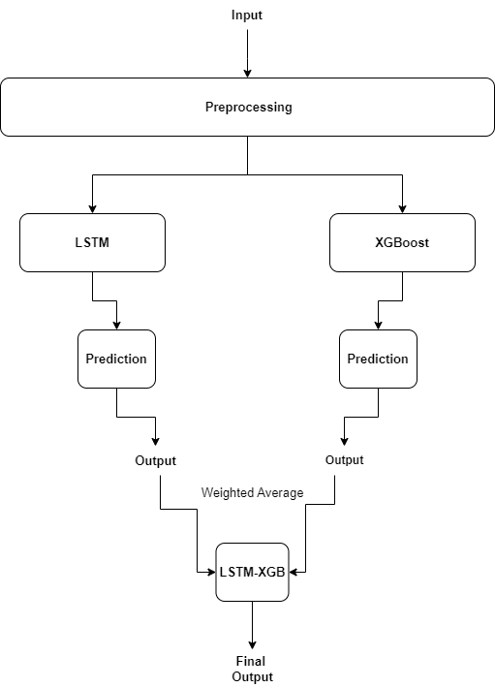
Figure 11: Architecture of the Ensemble Model Combining LSTM and XGBoost.

The LSTM model was trained using standardised One-day and Four-hour OHLC data and technical, fundamental, and sentiment indicators. The preprocessing steps involved stan- dardising the features and targets using the StandardScaler from the sklearn library, ensur- ing that all features had a mean of zero and a standard deviation of one. The data was structured into sequences using a time step, capturing temporal dependencies effectively.
The XGBoost model was trained on the same standardised data, using a comprehensive hyperparameter tuning process with GridSearchCV to identify the optimal hyperparameters. The best hyperparameters were used to fit the final XGBoost model, ensuring it was optimised for predictive performance.

Once both models were trained, their predictions were combined using a weighted av- eraging technique. The weights were determined based on the performance of each model, with the LSTM model generally receiving a higher weight due to its superior performance in capturing temporal patterns. The ensemble model’s predictions were then evaluated using a comprehensive suite of metrics, including MAE, MAPE, RMSE, R², and the Spearman corre- lation coefficient.
As shown in Figure 11, the detailed architecture of the ensemble model combines LSTM and XGBoost. The ensemble model’s architecture included the following steps:
- Training LSTM and XGBoost Models: Both models were trained separately using standardised data and optimised hyperparameters.
- Making Predictions: Each model made predictions on the test data, which were stan- dardised to ensure consistency.
- Combining Predictions: The predictions from both models were combined using a weighted averaging technique, with weights assigned based on each model’s perfor- mance.
- Evaluating Performance: The ensemble model’s predictions were evaluated using a comprehensive suite of metrics to assess its predictive accuracy and the value added by combining LSTM and XGBoost models.
By integrating the strengths of LSTM and XGBoost models, the ensemble model aimed to provide more accurate and robust forex price predictions, leveraging the temporal patterns captured by LSTM and the complex patterns identified by XGBoost.

    - Transformer Model(TRANSFORMER EN DE)
The Transformer model captured complex dependencies within sequential forex data, lever- aging its architecture’s strengths in handling long-range dependencies and parallel process- ing capabilities. The Transformer model used in this research included encoder and decoder components designed to process historical forex data and predict future price movements. To prepare the data for the Transformer model, preprocessing steps involved standardising the fea- tures and targets to ensure all features had a mean of zero and a standard deviation of one. This standardisation was performed using the StandardScaler from the sklearn library. Standar- dising the data is crucial for achieving stable and efficient training of the Transformer model by ensuring that the features are on a comparable scale.
The data was structured into sequences using a sequence length of 10, aligning with the chosen temporal resolution for the Transformer model. This involved creating sliding windows of data to capture temporal dependencies effectively. Each window consisted of ten consecutive

time steps of input features, with the target being the forex price at the subsequent time step. The Transformer model was constructed using the TensorFlow Keras library, with an architec- ture that included both encoder and decoder layers. The encoder processed the input sequences, capturing dependencies within the data. The decoder used these processed sequences to predict future prices, considering the historical context provided by the encoder.
The architecture of the Transformer model included several key components:
      - Transformer Block: Each block consisted of a multi-head attention mechanism, fol- lowed by a feed-forward network. Multi-head attention allowed the model to focus on different parts of the input sequence simultaneously, capturing various aspects of the temporal dependencies. Layer normalisation and dropout were applied to improve gen- eralisation and stability.
      - Encoder: The encoder comprises multiple Transformer blocks, processing the input se- quences to extract meaningful representations. Each block in the encoder included multi- head attention and feed-forward layers.
      - Decoder: The decoder also comprised multiple Transformer blocks, with each block fo- cusing on the encoder outputs and the previous decoder outputs. The decoder’s attention mechanism allowed it to focus on relevant parts of the encoder’s output while generating predictions.
      - Output Layer: A time-distributed dense layer was used as the final output layer, apply- ing a linear activation function to predict the forex price at each time step.
L2 regularisation was applied to all dense layers to prevent overfitting, which penalises large weights and encourages the model to learn simpler patterns. The Adam optimiser was employed with an initial learning rate, and learning rate scheduling was implemented using the ReduceLROnPlateau callback. This callback reduced the learning rate by 0.5 when the validation loss plateaued, ensuring that the model continued learning even when improvements slowed. Early stopping was also employed using the EarlyStopping callback, which monitored the validation loss and stopped training if there was no improvement for 60 epochs, restoring the best weights observed during training. The training process for the Transformer model involved fitting the model on the training data and validating it using validation data to mon- itor the model’s performance and prevent overfitting. The model was trained for up to 1000 epochs with a batch size tailored to the dataset. The performance of the Transformer model was assessed using a comprehensive suite of metrics, including MAE, MAPE, RMSE, R², and the Spearman correlation coefficient. These metrics provided a quantitative assessment of the model’s accuracy and the value added by integrating sentiment analysis with technical and fun- damental indicators.

    - Transformer Model(TRANSFORMER DE)
The Transformer Decoder model captured complex dependencies within sequential forex data, leveraging its architecture’s strengths in handling long-range dependencies and parallel pro- cessing capabilities. This research utilised a Transformer model with a decoder-only architec- ture to process historical forex data and predict future price movements.
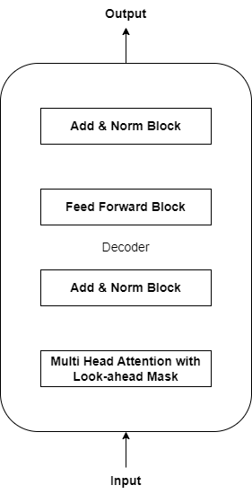
Figure 12: Decoder Architecture of the Transformer Model.

To prepare the data for the Transformer model, preprocessing steps involved standardis- ing the features and targets to ensure all features had a mean of zero and a standard deviation of one. This standardisation was performed using the StandardScaler from the sklearn library. Standardising the data is crucial for achieving stable and efficient training of the Transformer model by ensuring that the features are on a comparable scale. The data was structured into sequences using a sequence length of 8, aligning with the chosen temporal resolution for the Transformer model. This involved creating sliding windows of data to capture temporal depen- dencies effectively. Each window consisted of eight consecutive time steps of input features, with the target being the forex price at the subsequent time step.
The architecture of the Transformer model included several key components, as illus- trated in Figure 12:

      - Transformer Block: Each block consisted of a multi-head attention mechanism with a look-ahead mask, followed by a feed-forward network. Multi-head attention allowed the model to focus on different parts of the input sequence simultaneously, capturing various aspects of the temporal dependencies. Layer normalisation and dropout were applied to improve generalisation and stability.
      - Decoder: The decoder is comprised of multiple transformer blocks. Each block focused on the decoder’s attention mechanism, allowing it to concentrate on relevant parts of the input sequence while generating predictions.
      - Output Layer: A time-distributed dense layer was used as the final output layer, apply- ing a linear activation function to predict the forex price at each time step.
The model’s architecture included the following layers:
      - Input Layer: Accepting the standardised input sequences.
      - Transformer Blocks: Processing the input sequences through multiple layers containing multi-head attention and feed-forward layers.
      - Output Layer: A dense layer with a linear activation function that produces the final price predictions.
The look-ahead mask was used in the attention mechanism to ensure that the model could only attend to previous and current positions in the sequence, preventing it from using future information during training. This is crucial for time-series forecasting tasks, which aim to predict future values based on past and current observations. The look-ahead mask cre- ates a triangular matrix that masks out future time steps, allowing the model to maintain the autoregressive property necessary for sequential data prediction.
L2 regularisation was applied to all dense layers to prevent overfitting, which penalises large weights and encourages the model to learn simpler patterns. The Adam optimiser was employed with an initial learning rate, and learning rate scheduling was implemented using the ReduceLROnPlateau callback. This callback reduced the learning rate by a factor of 0.5 when the validation loss plateaued, ensuring that the model continued to learn even when improve- ments slowed down. Early stopping was also employed using the EarlyStopping callback, which monitored the validation loss and stopped training if there was no improvement for 60 epochs, restoring the best weights observed during training. The training process for the Trans- former model involved fitting the model on the training data and validating it using validation data to monitor the model’s performance and prevent overfitting. The model was trained for up to 1000 epochs with a batch size tailored to the dataset.

  - Evaluation Metrics
This section discusses various statistical measures to assess the predictive models efficacy. Each metric provides unique insights into the models performance during testing, allowing for a comprehensive evaluation of accuracy and reliability.
Mean Absolute Error (MAE): The MAE measures the average magnitude of the errors be- tween the model’s predictions and the actual values, disregarding the direction of the errors. It provides a straightforward interpretation of the average prediction error. The formula for calculating MAE is presented below (Eq. 11):
1 n
MAE = ∑ |y_{i} − yˆ_{i}| (11)
n
i=1

Here, y_{i} represents the true value, yˆ_{i} the predicted value, and n the total count of data points. A lower MAE indicates a more accurate model, as it reflects smaller average errors.
Root Mean Square Error (RMSE): The RMSE estimates the error magnitude, emphasising larger errors due to the squaring of each error term. This metric is beneficial for understanding the model’s performance in scenarios with significant outliers. The calculation for RMSE is as
follows (Eq. 12):
RMSE s1 n y yˆ 2 (12)
= ∑( _{i} − _{i}) i=1
n
The RMSE penalises more significant errors than smaller ones, making it sensitive to outliers. A lower RMSE value indicates better predictive accuracy.
R-squared (R²): The R² metric offers a statistical measure of the fit, indicating how much of the variability in the dependent variable is explained by the model. It measures how well the observed outcomes are replicated by the model based on the proportion of total variation. It is
calculated using (Eq. 13):
∑

R² = 1 −
n i=1
∑n
(y_{i} − yˆ_{i})²
(y_{i} − y¯)2
(13)

i=1
In this equation, y¯ denotes the average of actual values. An R² value closer to 1 indicates that the model explains a higher proportion of the variance in the dependent variable, thus demonstrating a better fit.
Mean Absolute Percentage Error (MAPE): The MAPE quantifies the precision of the model as a percentage of error, making the performance easily interpretable in relative terms. It is advantageous when comparing prediction accuracy across different datasets. The MAPE is
defined as (Eq. 14):
y − yˆ
∑
i=1

MAPE
=
100 n

n
_{i} _{i}
y_{i}

(14)

MAPE expresses the error as a percentage, making understanding the average magni- tude of errors about the actual values easier. A lower MAPE indicates better model accuracy,

especially in a business context with more meaningful percentage errors.
Spearman Correlation Coefficient: The Spearman correlation coefficient assessed the mono- tonic relationship between the predicted and actual values. This non-parametric measure helps determine how well the predictions preserve the rank order of the data. Given the absence of labeled sentiment data, the Spearman correlation was beneficial for evaluating the relationship between sentiment scores and forex price movements. Using the Spearman correlation coeffi- cient, the study determined which large language model (LLM) for sentiment analysis had the highest correlation with forex price movements, thereby selecting the most effective sentiment analysis model for the predictive models.
The models performance on the testing data can be comprehensively evaluated by em- ploying these metrics, encapsulated from Eq. 11 to Eq. 14. Each metric provides a differ- ent perspective on the models accuracy, robustness, and practical utility, enabling a thorough comparison to identify the most precise and reliable model configurations. The combination of these metrics ensures a well-rounded assessment of the predictive models, facilitating informed decisions on model improvements and future applications.

  - Addressing Key Research Challenges
This section outlines how the key challenges identified in predicting forex prices such as volatility, integration of economic indicators, sentiment analysis, noise in data, and overfitting were addressed in the research.
- High Volatility: Forex markets are known for their high volatility, which complicates accurate predictions. To address this, the research uses LSTM and Transformer models, which excel in capturing long-term dependencies and patterns in sequential data. Addi- tionally, the models are trained on both short-term (four-hour) and long-term (one-day) time frames, ensuring that they can adapt to varying market conditions.
- Economic Indicators Integration: The integration of various economic indicators into predictive models can be complex due to the diverse nature of the data. In this research, XGBoost is used to handle structured data, such as economic indicators, by efficiently managing non-linear relationships between multiple features. By combining technical and fundamental data, the model captures both short-term and long-term factors influ- encing forex prices.
- Sentiment Analysis Integration: Sentiment analysis provides valuable insights into market sentiment but poses challenges in integrating unstructured data with traditional technical and fundamental indicators. This research employs LLMs such as GPT-4 and GEMINI Advanced for sentiment extraction from financial news. These sentiment scores are then incorporated into the prediction models, allowing the model to consider market sentiment alongside traditional indicators.

- Noise in Data: Financial data is often noisy, which can obscure meaningful patterns and lead to inaccurate predictions. To reduce the impact of noise, this research employs pre- processing techniques such as feature selection and data smoothing. Ensemble methods, such as the combination of XGBoost and LSTM, also help mitigate the effects of noisy data by leveraging multiple models for more robust predictions.
- Overfitting: Overfitting is a common issue in financial forecasting, where models per- form well on training data but fail to generalize to unseen data. In this study, overfitting is mitigated through the use of regularization techniques, cross-validation, dropout and early stopping during model training. These techniques ensure that the model generalizes well to new data.
By addressing these challenges systematically, the research develops more robust and accurate forex prediction models, capable of adapting to the volatile and complex nature of the forex market.

- Results and Analysis
This section presents the results and analysis of the predictive models, focusing on their perfor- mance across different configurations and forex pairs. Specifically, the analysis covers models that utilise only technical indicators, models based on fundamental indicators, models integrat- ing both technical and fundamental indicators, and models that incorporate sentiment analysis alongside technical and fundamental indicators. For each pair, the predictive accuracy of the models is assessed using a comprehensive suite of evaluation metrics. This section aims to determine the most effective combination of indicators and model configurations for accurate forex price prediction, providing insights into each approach’s practical applicability and ro- bustness.

  - Technical Models (TM)
The performance of the technical models (TM) on test data using the OHLC one-day time- frame is summarised in Table 2. This table highlights the results for various models, includ- ing LSTM TM, XGBoost TM, Ensemble-LSTM-XGB TM, TRANSFORMER EN DE TM,
and TRANSFORMER DE TM, evaluated across four currency pairs: EUR/USD, NZD/USD, EUR/NZD, and AUD/NZD.
The LSTM TM model shows strong performance across all currency pairs, particularly with AUD/NZD, which achieved an RMSE of 0.0037. The XGBoost TM model demonstrated exceptional accuracy, especially for EUR/NZD and AUD/NZD, with RMSE values of 0.0048 and 0.0017, respectively, indicating a very high level of precision. The Ensemble-LSTM- XGB TM model combines the strengths of both LSTM and XGBoost, resulting in improved performance metrics for EUR/USD and NZD/USD, achieving RMSE values of 0.0064 and 0.0039, respectively.
The Transformer-based models, both the encoder-decoder (TRANSFORMER EN DE TM) and the decoder-only (TRANSFORMER DE TM) architectures, showed varied performance.
While they did not outperform the LSTM or XGBoost models overall, they still provided valuable insights, particularly for EUR/NZD and AUD/NZD, with the encoder-decoder model achieving an RMSE of 0.0148 for EUR/NZD and the decoder-only model achieving an RMSE of 0.0051 for AUD/NZD.

Table 2: Model Performance on Test Data Using Technical Indicators with OHLC One-Day Time Frame

Model | Currency  Pair | MAE | MAPE | RMSE | R2
LSTM TM | EUR/USD | 0.0415 | 0.4635% | 0.0065 | 0.9888
 | NZD/USD | 0.0592 | 0.6291% | 0.0050 | 0.9738
 | EUR/NZD | 0.0341 | 0.4273% | 0.0092 | 0.9531
 | AUD/NZD | 0.0318 | 0.2619% | 0.0037 | 0.9796
XGBoost TM | EUR/USD | 0.0077 | 0.7379% | 0.0157 | 0.9363
 | NZD/USD | 0.0025 | 0.4079% | 0.0048 | 0.9872
 | EUR/NZD | 0.0032 | 0.1846% | 0.0048 | 0.9920
 | AUD/NZD | 0.0013 | 0.1258% | 0.0017 | 0.9943
Ensemble-LSTM-  XGB TM | EUR/USD | 0.0045 | 0.4184% | 0.0064 | 0.9893
 | NZD/USD | 0.0030 | 0.4605% | 0.0039 | 0.9917
 | EUR/NZD | 0.0037 | 0.2154% | 0.0051 | 0.9913
 | AUD/NZD | 0.0016 | 0.1519% | 0.0021 | 0.9917
TRANSFORMER  EN DE TM | EUR/USD | 0.0222 | 2.0422% | 0.0255 | 0.8295
 | NZD/USD | 0.0121 | 2.0033% | 0.0181 | 0.6555
 | EUR/NZD | 0.0114 | 0.6832% | 0.0148 | 0.8771
 | AUD/NZD | 0.0039 | 0.3565% | 0.0049 | 0.9644
TRANSFORMER  DE TM | EUR/USD | 0.0172 | 1.6682% | 0.0259 | 0.8246
 | NZD/USD | 0.0126 | 2.0856% | 0.0176 | 0.6757
 | EUR/NZD | 0.0103 | 0.6152% | 0.0132 | 0.9032
 | AUD/NZD | 0.0041 | 0.3741% | 0.0051 | 0.9615

In this section, the four top-performing models, as highlighted in Table 2, will be further analysed using figures that compare predicted and actual prices. These visualisations provide a deeper understanding of how each model performs over time and across different market con- ditions, highlighting the strengths and areas for improvement in forex price prediction.

EUR/USD: The performance of the Ensemble-LSTM-XGB TM model on EUR/USD test data is displayed in Figure 13. This figure shows the close price predictions generated by the ensem- ble model compared to the actual close prices over a specified period. The green line represents the actual close prices, while the red dashed line indicates the predicted close prices.

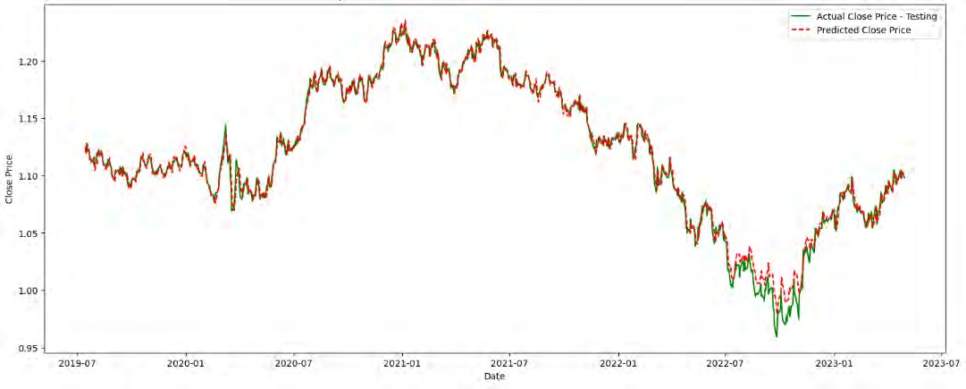
Figure 13: Performance of the Ensemble-LSTM-XGB TM model on EUR/USD Test Data.

The figure shows the ensemble model’s ability to closely follow market trends, with minimal deviations between the predicted and actual values. This alignment underscores the model’s robustness in capturing the underlying patterns and movements in the EUR/USD forex pair, providing high predictive accuracy. The close correspondence between the predicted and actual prices indicates the efficacy of integrating LSTM and XGBoost models, leveraging both temporal dependencies and gradient-boosting techniques to enhance predictive performance.

NZD/USD: The performance of the Ensemble-LSTM-XGB TM model on NZD/USD test data is displayed in Figure 14. The figure shows the predicted close prices in the red dashed line against the actual close prices in the green line over the testing period. The close alignment between the two lines demonstrates the model’s strong predictive capability, accurately captur- ing the market trends and price movements for the NZD/USD pair. This indicates the model’s effectiveness in leveraging LSTM and XGBoost techniques to enhance forex price prediction accuracy.

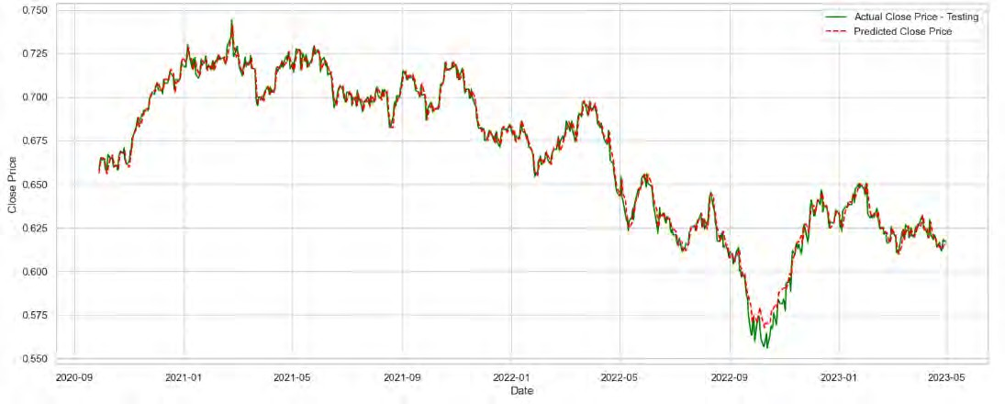
Figure 14: Performance of the Ensemble-LSTM-XGB TM model on NZD/USD Test Data.

EUR/NZD:
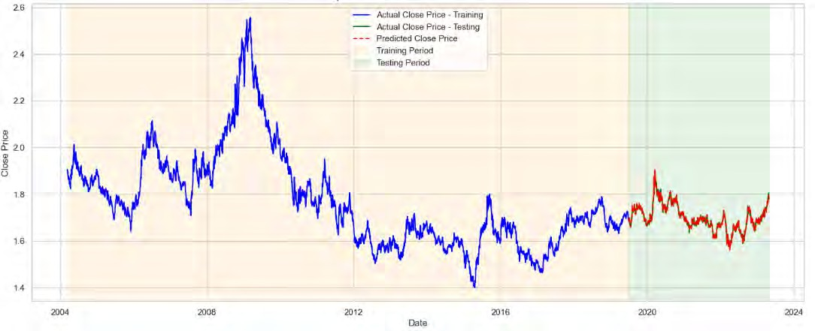
Figure 15: Performance of the XGBoost TM model on EUR/NZD Test Data.

Figure 15 displays the performance of the XGBoost TM model on EUR/NZD test data. Cross-validation helps prevent overfitting by validating the model’s performance on multiple

subsets of the data. As a result, only the train and test periods are displayed in the figure, re- flecting the model’s application to previously unseen data. The close alignment of the predicted and actual prices during the testing phase demonstrates the XGBoost TM model’s proficiency in forecasting forex price movements. This accuracy indicates that the model effectively utilises technical indicators to capture market trends and predict future prices for the EUR/NZD pair.

AUD/NZD:
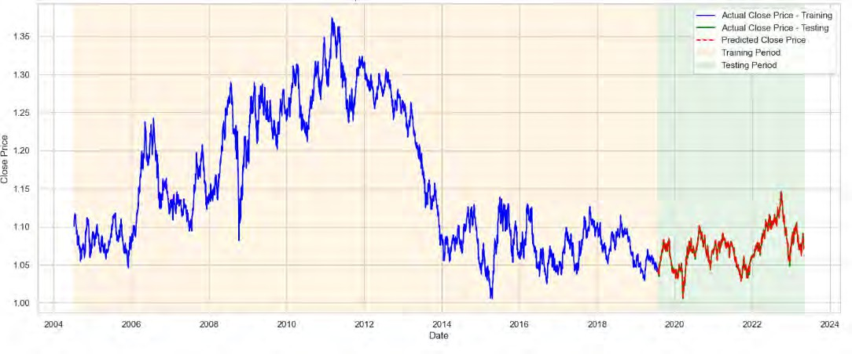
Figure 16: Performance of the XGBoost TM model on AUD/NZD Test Data.

Figure 16 displays the performance of the XGBoost TM model on the AUD/NZD test data. The model parameters were optimised using cross-validation to avoid overfitting. The close match between the predicted and actual prices during the testing phase indicates the model’s efficacy in predicting AUD/NZD price movements based on technical indicators. The following section will examine the performance of the fundamental models. This will include evaluating how well these models predict forex price movements based on fundamental eco- nomic indicators for each currency pair.

  - Fundamental Models (FM)
This section assesses the performance of various models that leverage fundamental economic indicators to predict forex price movements. These fundamental indicators include GDP, infla- tion rates, interest rates, and trade balances, which provide insights into the broader economic conditions influencing currency values.

Table 3: Model Performance on Test Data Using Fundamental Indicators with OHLC One-Day Time Frame

Model | Currency  Pair | MAE | MAPE | RMSE | R2
LSTM FM | EUR/USD | 0.1097 | 1.2457% | 0.0190 | 0.9079
 | NZD/USD | 0.0705 | 0.7480% | 0.0059 | 0.9630
 | EUR/NZD | 0.0647 | 0.8150% | 0.0165 | 0.8485
 | AUD/NZD | 0.0715 | 0.5889% | 0.0075 | 0.9165
XGBoost FM | EUR/USD | 0.0077 | 0.7379% | 0.0157 | 0.9363
 | NZD/USD | 0.0068 | 1.0679% | 0.0093 | 0.9525
 | EUR/NZD | 0.0051 | 0.2982% | 0.0068 | 0.9844
 | AUD/NZD | 0.0023 | 0.2124% | 0.0029 | 0.9845
Ensemble-LSTM-  XGB FM | EUR/USD | 0.0101 | 0.9396% | 0.0155 | 0.9384
 | NZD/USD | 0.0046 | 0.7017% | 0.0057 | 0.9825
 | EUR/NZD | 0.0061 | 0.3566% | 0.0078 | 0.9796
 | AUD/NZD | 0.0029 | 0.2688% | 0.0036 | 0.9751
TRANSFORMER  EN DE FM | EUR/USD | 0.0290 | 2.7551% | 0.0379 | 0.6250
 | NZD/USD | 0.0176 | 2.8499% | 0.0226 | 0.4642
 | EUR/NZD | 0.0268 | 1.5957% | 0.0345 | 0.3354
 | AUD/NZD | 0.0169 | 1.5886% | 0.0204 | 0.3792
TRANSFORMER  DE FM | EUR/USD | 0.0253 | 2.3743% | 0.0292 | 0.7794
 | NZD/USD | 0.0139 | 2.2515% | 0.0178 | 0.6694
 | EUR/NZD | 0.0228 | 1.3748% | 0.0293 | 0.5187
 | AUD/NZD | 0.0135 | 1.2685% | 0.0171 | 0.5614

The LSTM FM model demonstrated varied performance across different currency pairs, with the lowest RMSE observed for the NZD/USD pair. This suggests that the LSTM FM model is particularly effective at capturing the fundamental economic factors influencing the NZD/USD exchange rate. The XGBoost model, when applied to fundamental indicators, out- performed the LSTM model in terms of RMSE for the EUR/NZD and AUD/NZD pairs. This indicates that the XGBoost model can capture the complex relationships inherent in the fun- damental economic data of these pairs. Notably, the XGBoost FM model achieved the lowest RMSE for EUR/NZD and AUD/NZD pairs, showcasing its robustness in handling fundamental data.

The Ensemble-LSTM-XGB FM model, which combines the strengths of both LSTM and XGBoost, provided the best overall performance for EUR/USD and NZD/USD pairs. This ensemble approach leverages the temporal dependencies captured by LSTM and the gradient- boosting capabilities of XGBoost, resulting in superior predictive accuracy. Specifically, the Ensemble-LSTM-XGB FM model achieved the lowest RMSE for EUR/USD and NZD/USD pairs, highlighting its effectiveness in integrating multiple data types. The Transformer models, including the encoder-decoder (TRANSFORMER EN DE FM) and decoder-only (TRANS- FORMER DE FM) architectures, showed lower performance than LSTM and XGBoost mod- els. This suggests that while Transformer models excel in natural language processing tasks, they may be less effective for time series forecasting with fundamental economic indicators in this context. Evaluating these models highlights the importance of selecting appropriate model architectures and integrating various data types to improve predictive accuracy. The re- sults indicate that combining different models and data types, such as in the Ensemble-LSTM- XGB FM model, can significantly enhance forex price predictions based on fundamental indi- cators. The detailed performance metrics for these models are presented in Table 3.

EUR/USD:
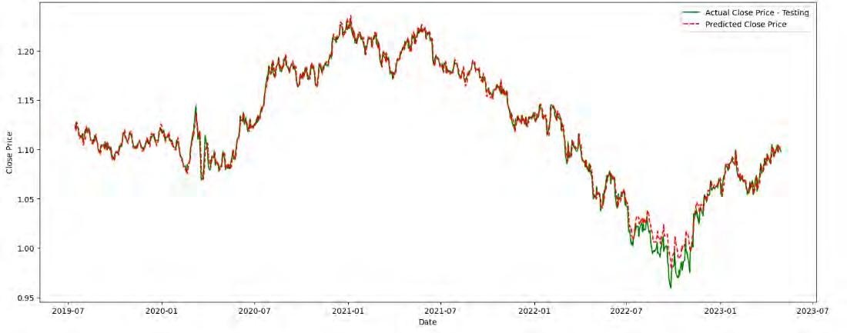
Figure 17: Performance of the Ensemble-LSTM-XGB FM model on EUR/USD Test Data.

The performance of the Ensemble-LSTM-XGB FM model on the EUR/USD test data is displayed in Figure 17. The green line represents the close prices, while the red dashed line indicates the predicted prices. The plot demonstrates the model’s ability to closely follow the actual price movements, capturing trends and fluctuations over the testing period. Using a

weighted averaging technique, the ensemble model integrates the predictions from both LSTM and XGBoost, improving the accuracy and reliability of the predictions. This approach allows the model to utilise the complementary strengths of each method, leading to improved predic- tive performance for the EUR/USD currency pair.

NZD/USD: Figure 18 shows the performance of the Ensemble-LSTM-XGB FM model on NZD/USD test data. The model effectively tracks actual market movements, accurately cap- turing trends and fluctuations during testing. By employing weighted averaging, this ensemble technique combines predictions from LSTM and XGBoost models, leveraging their strengths to enhance overall forecasting performance for the NZD/USD currency pair.
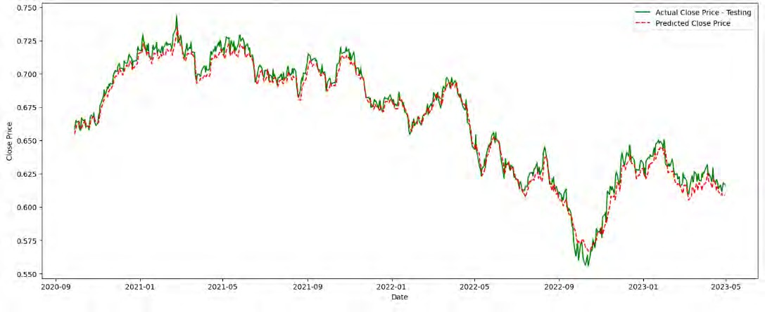
Figure 18: Performance of the Ensemble-LSTM-XGB FM model on NZD/USD Test Data.

EUR/NZD: The performance of the XGBoost FM model on the EUR/NZD test data is depicted in Figure 19. This figure shows how the model predicts the closing prices of the EUR/NZD currency pair based on fundamental indicators.
The model was trained on data from 2004 to 2019 and tested on data from 2020 to 2024. The separation between the training and testing periods is visually marked, highlighting the model’s performance in the unseen data during the testing phase. The figure illustrates the model’s ability to capture the general trend and significant turning points in the EUR/NZD currency pair, showcasing its effectiveness in leveraging fundamental indicators to forecast price movements. Cross-validation during the training phase ensured the model was robust and generalised well to the testing data. The figure demonstrates the model’s ability to predict close prices accurately, indicating that the fundamental indicators used were relevant and provided

valuable information for forecasting the EUR/NZD currency pair.
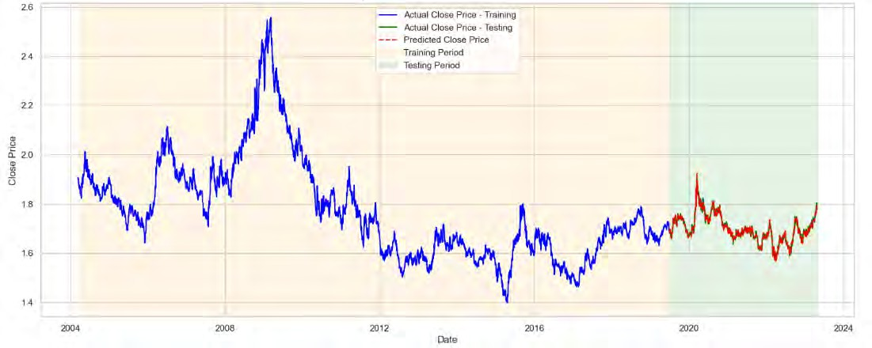
Figure 19: Performance of the XGBoost FM model on EUR/NZD Test Data.

AUD/NZD:
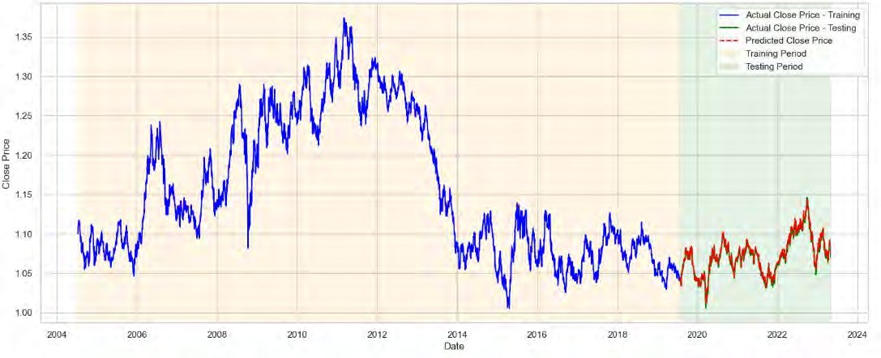
Figure 20: Performance of the XGBoost FM model on AUD/NZD Test Data.

The performance of the XGBoost FM model on the AUD/NZD test data is shown in

Figure 20. This figure exhibits the model’s ability to predict the closing prices of the AUD/NZD currency pair using fundamental indicators. The blue line represents the closing prices during the training period, while the green line shows the closing prices during the testing period. The red dashed line indicates the predicted closing prices during the testing period.
Up to this stage, we have assessed the performances of the technical and fundamental models separately. The evaluation metrics and visualisations have offered insights into the con- tributions of each approach in predicting forex price movements. The technical models utilised indicators derived from OHLC data to capture market trends and price dynamics, while the fundamental models integrated economic indicators to reflect broader market influences and economic conditions. In the next section, we will explore the results of models that integrate both technical and fundamental indicators. By combining these two approaches, the models aim to harness the strengths of each methodology, providing a more comprehensive analysis of market behavior and improving predictive accuracy. This integrated approach offers a holis- tic view of the factors influencing forex prices, enhancing our understanding and forecasting capabilities.

  - Technical and Fundamental Models (TM FM)
This section evaluates models combining technical and fundamental indicators (TM FM) over a one-day timeframe. Table 4 presents the results for four forex pairs: EUR/USD, NZD/USD, EUR/NZD, and AUD/NZD. The LSTM TM FM model performs well, especially for EUR/NZD, with an MAE of 0.0476 and an RMSE of 0.0123. For EUR/USD, this model achieves an MAE of 0.1140, a MAPE of 1.2640%, and an RMSE of 0.0159. Although it performs adequately for NZD/USD and AUD/NZD, its accuracy is somewhat lower than for EUR/NZD, indicating varying model performance across different currency pairs. The XGBoost TM FM often out- performs the LSTM model, particularly for EUR/NZD and AUD/NZD pairs. For EUR/NZD, it achieves an MAE of 0.0046, a MAPE of 0.2708%, and an RMSE of 0.0061, showing high ac- curacy. The XGBoost model also excels for AUD/NZD, with an MAE of 0.0020 and an RMSE of 0.0025, demonstrating its robustness in incorporating technical and fundamental indicators.
The Ensemble model, which combines LSTM and XGBoost (Ensemble-LSTM-XGB TM FM), best performs for EUR/USD and NZD/USD pairs. Using a weighted average of predictions from both models, an MAE of 0.0092 and an RMSE of 0.0118 for EUR/USD are achieved. For NZD/USD, it records an MAE of 0.0037 and an RMSE of 0.0052, highlight- ing the advantage of integrating multiple model architectures to improve predictive accuracy. Transformer models, TRANSFORMER EN DE TM FM, and TRANSFORMER DE TM FM architectures perform less effectively than LSTM and XGBoost models. The TRANSFORMER EN DE TM FM model has an RMSE of 0.0306 for EUR/USD and 0.0184 for NZD/USD, in- dicating that while Transformer models can capture complex dependencies in sequential data, they are not as effective in this context as LSTM and XGBoost models.

Table 4: Model Performance on Test Data Using Technical and Fundamental Indicators with OHLC One-Day Time Frame

Model | Currency  Pair | MAE | MAPE | RMSE | R2
LSTM TM FM | EUR/USD | 0.1140 | 1.2640% | 0.0159 | 0.9341
 | NZD/USD | 0.0931 | 1.0096% | 0.0081 | 0.9306
 | EUR/NZD | 0.0476 | 0.5979% | 0.0123 | 0.9153
 | AUD/NZD | 0.0788 | 0.6518% | 0.0082 | 0.9004
XGBoost TM FM | EUR/USD | 0.0077 | 0.7379% | 0.0157 | 0.9363
 | NZD/USD | 0.0042 | 0.6703% | 0.0062 | 0.9794
 | EUR/NZD | 0.0046 | 0.2708% | 0.0061 | 0.9868
 | AUD/NZD | 0.0020 | 0.1888% | 0.0025 | 0.9879
Ensemble-LSTM-  XGB TM FM | EUR/USD | 0.0092 | 0.8477% | 0.0118 | 0.9641
 | NZD/USD | 0.0037 | 0.5701% | 0.0052 | 0.9856
 | EUR/NZD | 0.0049 | 0.2899% | 0.0064 | 0.9859
 | AUD/NZD | 0.0026 | 0.2420% | 0.0032 | 0.9805
TRANSFORMER  EN DE TM FM | EUR/USD | 0.0229 | 2.1760% | 0.0306 | 0.7547
 | NZD/USD | 0.0127 | 2.0954% | 0.0184 | 0.6440
 | EUR/NZD | 0.0280 | 1.6832% | 0.0333 | 0.3814
 | AUD/NZD | 0.0126 | 1.1768% | 0.0161 | 0.6108
TRANSFORMER  DE TM FM | EUR/USD | 0.0201 | 1.8884% | 0.0264 | 0.8200
 | NZD/USD | 0.0145 | 2.3681% | 0.0179 | 0.6677
 | EUR/NZD | 0.0208 | 1.2425% | 0.0250 | 0.6494
 | AUD/NZD | 0.0095 | 0.8929% | 0.0130 | 0.7493

Table 4 shows that combining technical and fundamental indicators improves the model’s predictive abilities, with XGBoost and ensemble models leading in accuracy. This combined approach effectively captures the complexity of forex market movements, offering valuable in- sights for forex price prediction.

EUR/USD: The performance of the Ensemble-LSTM-XGB TM FM model on EUR/USD test data is illustrated in Figure 21. This model combines the LSTM and XGBoost models’ predic- tive strengths, leveraging technical and fundamental indicators. The green line represents the closing prices, while the red dashed line shows the predicted closing prices.

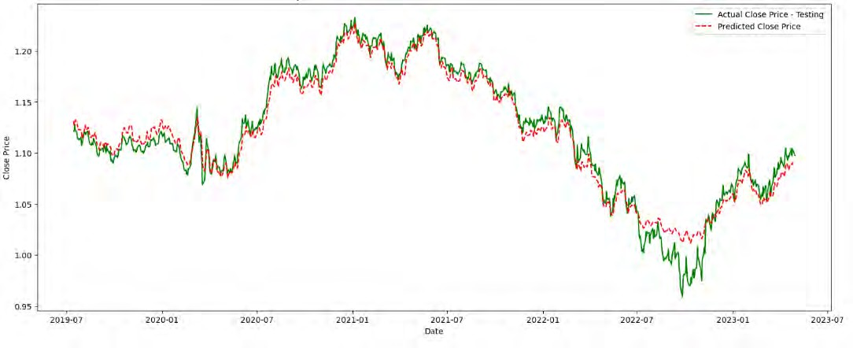
Figure 21: Performance of the Ensemble-LSTM-XGB TM FM model on EUR/USD Test Data.

The chart demonstrates the model’s robust capability to capture the general trend and fluctuations in the EUR/USD closing prices over time. Notably, the ensemble model effectively tracks the peaks and troughs of the actual prices, indicating its strength in forecasting both up- ward and downward movements. By incorporating a weighted average technique, the ensemble model enhances prediction accuracy, balancing the LSTM’s ability to capture temporal depen- dencies with XGBoost’s proficiency in handling structured data. The close alignment between the actual and predicted prices underscores the model’s effectiveness, particularly in capturing complex market dynamics and interactions between various technical and fundamental indica- tors.

NZD/USD: Figure 22 displays the performance of the Ensemble-LSTM-XGB TM FM model on the NZD/USD test data. This ensemble model synergistically combines the temporal pattern recognition of LSTM with the structured data handling capabilities of XGBoost, utilising both technical and fundamental indicators. The chart highlights the model’s proficiency in accu- rately predicting price movements, especially during significant market shifts. This combined approach ensures a more robust and reliable forecast, as evidenced by the close tracking of the actual prices by the predicted values.

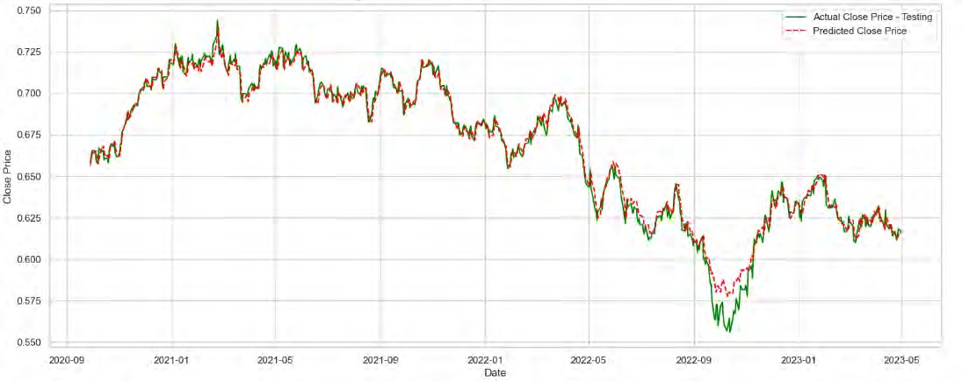
Figure 22: Performance of the Ensemble-LSTM-XGB TM FM model on NZD/USD Test Data.

EUR/NZD:
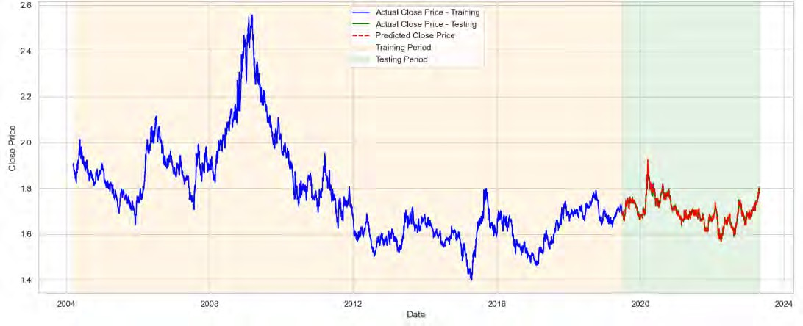
Figure 23: Performance of the XGBoost TM FM model on EUR/NZD Test Data.

Figure 23 showcases the performance of the XGBoost TM FM model on the EUR/NZD test data. This model combines technical and fundamental indicators using the robust gradient- boosting framework of XGBoost. The blue line represents the closing prices during the training

period, while the red line indicates the actual prices during the testing period. The dashed red line shows the model’s predicted closing prices. The model effectively captures the price move- ments and trends in the EUR/NZD pair, closely aligning with the actual data.

AUD/NZD: Figure 24 displays the performance of the XGBoost TM FM model on the AUD/NZD test data, spanning from 2004 to 2024. In this figure, the model combines both technical and fundamental indicators using the XGBoost framework to predict the closing prices of the AUD/NZD pair.
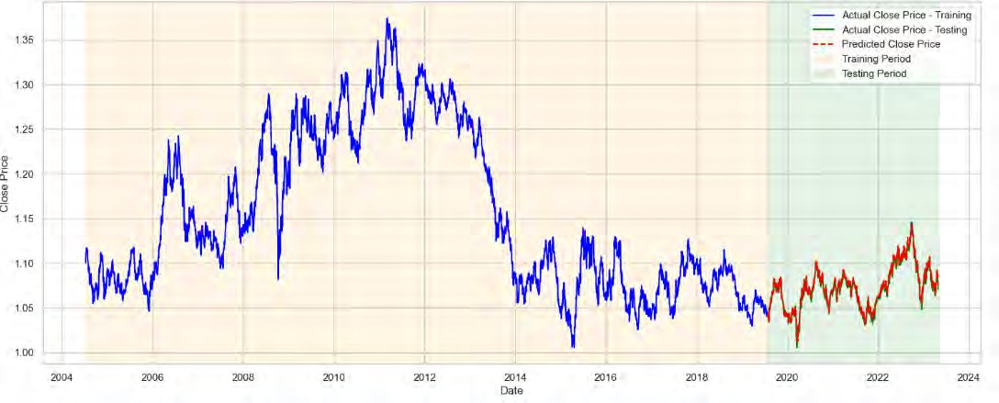
Figure 24: Performance of the XGBoost TM FM model on AUD/NZD Test Data.

This close tracking of the actual prices by the predicted values highlights the robustness and reliability of the XGBoost TM FM model in forecasting forex prices. The training and testing periods are distinctly separated to ensure the model’s performance is thoroughly eval- uated on unseen data, thus preventing data leakage. Furthermore, cross-validation during the training phase optimised the model’s parameters. This method ensures that the model’s per- formance is not overly dependent on a particular subset of the data, promoting generalisability and robustness across different market conditions. The figure underscores the effectiveness of integrating both technical and fundamental indicators to improve the predictive accuracy of the AUD/NZD currency pair over an extended timeframe.

  - Technical, Fundamental, and Sentiment Models (TM FM SA)
This section presents the performance evaluation of models that integrate technical indicators, fundamental indicators, and sentiment analysis (TM FM SA) in a Four-hour timeframe. Table 5 summarises the results of these models across the four forex pairs. The LSTM TM FM SA model shows varying performance across currency pairs. For EUR/USD, it achieves an MAE of 0.0906, a MAPE of 0.1364%, and an RMSE of 0.0020, with an R² of 0.8967. The model per- forms similarly well for EUR/NZD with an MAE of 0.0811 and an RMSE of 0.0043. However, the model’s performance on NZD/USD and AUD/NZD pairs is comparatively lower, indicating that while LSTM can effectively integrate multiple data types, its accuracy can vary depending on the currency pair.
The XGBoost TM FM SA model significantly outperforms other models in this inte- grated approach, particularly for EUR/USD and NZD/USD pairs. For EUR/USD, the model achieves a remarkably low MAE of 0.0007, a MAPE of 0.0707%, and an RMSE of 0.0010, with an R² of 0.9897. The performance is similarly vital for NZD/USD, EUR/NZD, and AUD/NZD, indicating that XGBoost excels in leveraging technical, fundamental, and sentiment data to en- hance predictive accuracy. The Ensemble-LSTM-XGB TM FM SA model also shows robust performance, particularly for EUR/USD and NZD/USD pairs. The ensemble approach, which uses weighted averaging to combine the predictions of both models, achieves a good balance between the strengths of LSTM and XGBoost. For EUR/USD, it achieves an MAE of 0.0008, a MAPE of 0.0759%, and an RMSE of 0.0010, with an R² of 0.9873.
The Transformer models, both TRANSFORMER EN DE TM FM SA and TRANS- FORMER DE TM FM SA architectures, exhibit lower performance compared to LSTM and XGBoost models. For instance, the TRANSFORMER EN DE TM FM SA model achieves an RMSE of 0.0042 for EUR/USD, significantly higher than the XGBoost model. This suggests that while Transformer models are powerful in capturing complex dependencies in sequential data, their performance in this context is less effective than LSTM and XGBoost.
Table 5 clearly shows that integrating technical indicators, fundamental indicators, and sentiment analysis data enhances the predictive capabilities of the models, with XGBoost lead- ing in accuracy and the ensemble model providing a balanced performance across different currency pairs. This comprehensive integration approach effectively captures the multifaceted nature of forex market movements, offering valuable insights for forex price prediction.

Table 5: Model Performance on Test Data with Technical, Fundamental, and Sentiment Analysis on a 4H Timeframe

Model | Currency  Pair | MAE | MAPE | RMSE | R2
LSTM TM FM SA | EUR/USD | 0.0906 | 0.1364% | 0.0020 | 0.8967
 | NZD/USD | 0.2492 | 0.6308% | 0.0042 | 0.6833
 | EUR/NZD | 0.0811 | 0.2015% | 0.0043 | 0.8896
 | AUD/NZD | 0.1403 | 0.1334% | 0.0017 | 0.6719
XGBoost TM FM SA | EUR/USD | 0.0007 | 0.0707% | 0.0010 | 0.9897
 | NZD/USD | 0.0007 | 0.1199% | 0.0009 | 0.9942
 | EUR/NZD | 0.0017 | 0.0990% | 0.0021 | 0.9922
 | AUD/NZD | 0.0004 | 0.0434% | 0.0005 | 0.9837
Ensemble-LSTM-  XGB TM FM SA | EUR/USD | 0.0008 | 0.0759% | 0.0010 | 0.9873
 | NZD/USD | 0.0013 | 0.2155% | 0.0016 | 0.9811
 | EUR/NZD | 0.0019 | 0.1086% | 0.0024 | 0.9895
 | AUD/NZD | 0.0005 | 0.0524% | 0.0007 | 0.9761
TRANSFORMER  EN DE TM FM SA | EUR/USD | 0.0034 | 0.3117% | 0.0042 | 0.5254
 | NZD/USD | 0.0030 | 0.4805% | 0.0036 | 0.7657
 | EUR/NZD | 0.0080 | 0.4546% | 0.0093 | 0.4854
 | AUD/NZD | 0.0019 | 0.1726% | 0.0023 | 0.4068
TRANSFORMER  DE TM FM SA | EUR/USD | 0.0022 | 0.2015% | 0.0028 | 0.7878
 | NZD/USD | 0.0019 | 0.3095% | 0.0024 | 0.8936
 | EUR/NZD | 0.0058 | 0.3328% | 0.0070 | 0.7075
 | AUD/NZD | 0.0016 | 0.1459% | 0.0019 | 0.5935

EUR/USD: Bellow Figure 25 shows the performance of the XGBoost TM FM SA model on the EUR/USD test data. This model integrates technical, fundamental, and sentiment analysis indicators using the XGBoost framework to predict the closing prices of the EUR/USD cur- rency pair. The blue line in the figure represents the actual closing prices during the training period from January 2023 to October 2023, while the red line denotes the actual closing prices during the testing period from October 2023 to January 2024. The dashed red line signifies the predicted closing prices by the model during the testing phase.
The close alignment between the predicted and actual prices in the testing period high- lights the model’s strong predictive capabilities, accurately reflecting the market trends and

price movements. The use of cross-validation in the training phase ensured that the model was not overfitted to any specific subset of data, enhancing its generalisability and robustness across different periods and market conditions. The shaded areas distinguish the training pe- riod (light blue) and the testing period (light green), indicating that the model was evaluated on unseen data to validate its predictive performance. This separation ensures the reliabil- ity and robustness of the model’s predictions. By incorporating sentiment analysis, the XG- Boost TM FM SA model leverages real-time market sentiment, further refining the predictive accuracy for the EUR/USD currency pair.
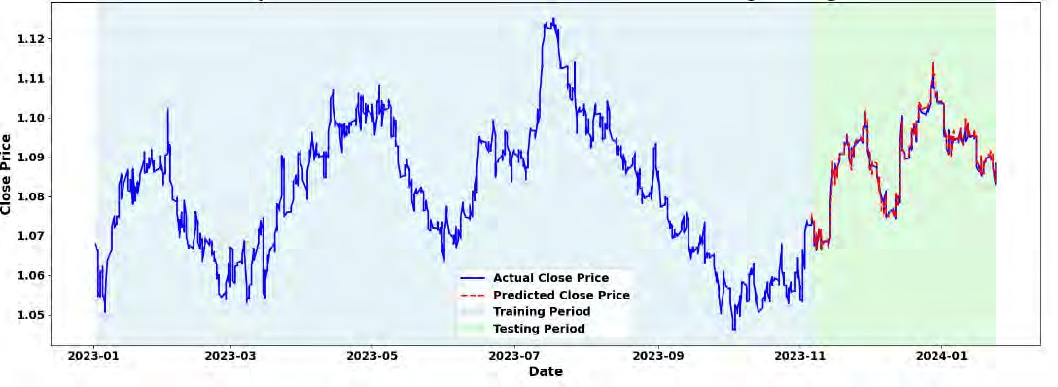
Figure 25: Performance of the XGBoost TM FM SA model on EUR/USD Test Data.

NZD/USD: Figure 26 illustrates the performance of the XGBoost TM FM SA on the NZD/USD test data. This model employs a combination of technical, fundamental, and sentiment anal- ysis indicators within the XGBoost framework to predict the closing prices of the NZD/USD currency pair. The alignment between the predicted and actual prices during the testing pe- riod underscores the model’s robust predictive capabilities, effectively capturing the trends and fluctuations in the market. Cross-validation was used during the training phase to prevent over- fitting, ensuring the model’s performance was consistent across various subsets of the data, thereby enhancing its generalisability.

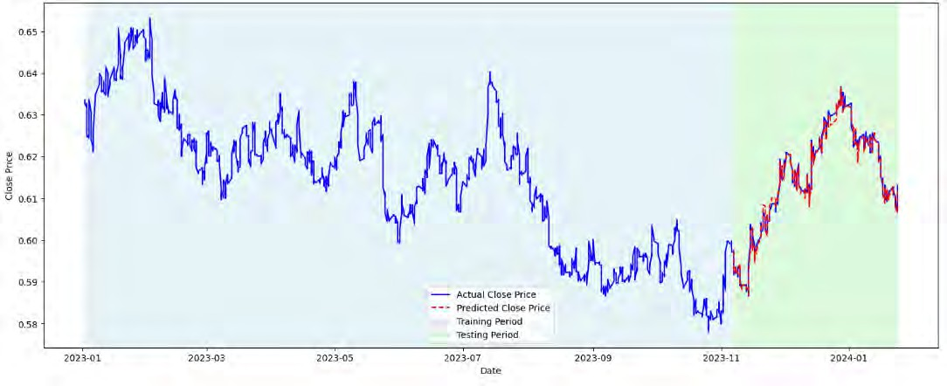
Figure 26: Performance of the XGBoost TM FM SA model on NZD/USD Test Data.

EUR/NZD:
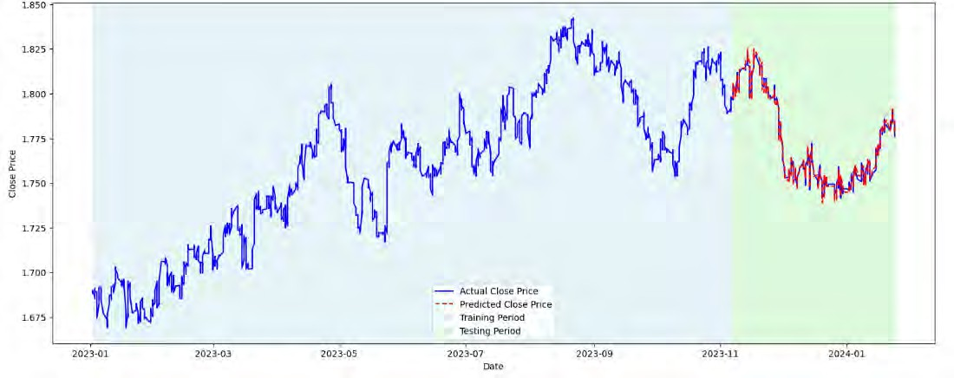
Figure 27: Performance of the XGBoost TM FM SA model on EUR/NZD Test Data.

Figure 27 illustrates the performance of the XGBoost TM FM SA model on EUR/NZD test data. This model combines technical indicators, fundamental data, and sentiment analysis

to predict closing prices. The blue line represents actual prices during the training period (Jan- uary 2023 to October 2023), while the red line shows actual prices during the testing period (October 2023 to January 2024). The dashed red line indicates the model’s predictions. The high alignment between predicted and actual prices in the testing period highlights the model’s effectiveness. Cross-validation during training ensures a robust performance.

AUD/NZD:Figure 28 shows how the XGBoost TM FM SA model performs on AUD/NZD test data. This model uses a combination of technical, fundamental, and sentiment analysis indicators to predict closing prices. In the figure, the blue line represents the actual closing prices during the training period, while the solid red line shows the actual prices during the testing period. The shaded regions distinguish between the training period (light blue) and the testing period (light green), showing that the model’s effectiveness was validated on new, unseen data. The dashed red line indicates the prices predicted by the model during the testing period.
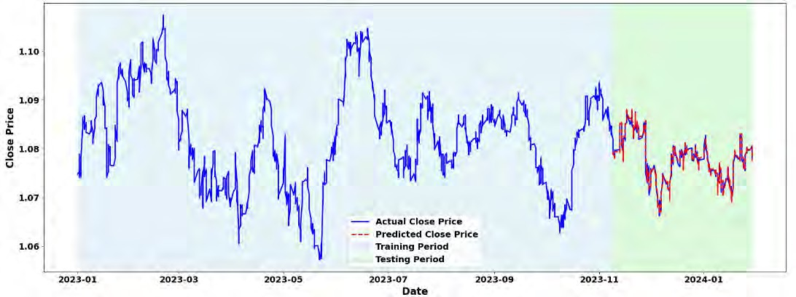
Figure 28: Performance of the XGBoost TM FM SA model on AUD/NZD Test Data.

  - Analysis and Discussion
In the previous section, the performance results of various predictive models were presented, highlighting their effectiveness in forecasting forex prices based on technical, fundamental, and combined indicators. This section is a detailed analysis of these results. This analysis will help to identify the most effective approaches for forex price prediction and provide insights into how these models can be further improved for better generalisation and practical application in

real-world scenarios.
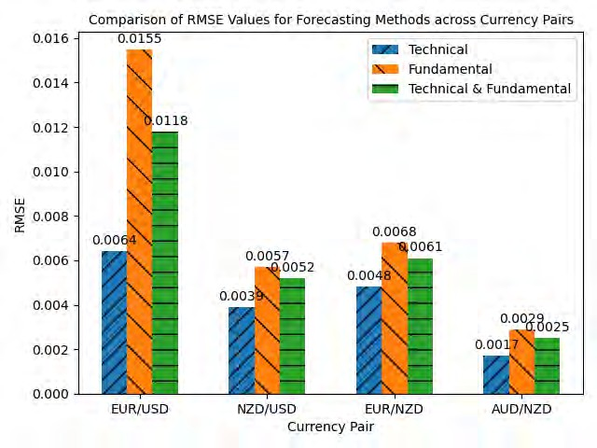
Figure 29: Comparative Analysis of RMSE Values Across Forex Currency Pairs Using Different Pre- diction Models for One Day Time Frame.

Figure 29 reveals that models using technical indicators alone consistently achieved the lowest RMSE values across all currency pairs when compared to models using fundamental indicators and those combining both types of indicators.
For the EUR/USD pair, the technical model attained an RMSE of 0.0064, which is significantly lower than the RMSE values for the fundamental model (0.0155) and the com- bined model (0.0118). Similarly, the technical model for NZD/USD had an RMSE of 0.0039, outperforming both the fundamental model (0.0057) and the combined model (0.0052). The EUR/NZD pair followed the same pattern, with the technical model achieving the lowest RMSE of 0.0048, compared to 0.0068 for the fundamental model and 0.0061 for the combined model. The AUD/NZD pair also demonstrated the superior performance of the technical model, with an RMSE of 0.0017, lower than both the fundamental model (0.0029) and the combined model (0.0025).
These results indicate that technical indicators alone provide the most accurate forecasts for forex prices in these scenarios. The technical indicators are derived directly from the OHLC data, which might explain their superior performance. The inclusion of fundamental indicators did not significantly improve the predictive accuracy and, in some cases, slightly increased

the RMSE. However, while the technical models show the lowest RMSE, the combined use of technical and fundamental indicators could still be valuable. Combining both approaches might help generalise the model better, potentially offering robustness against different market conditions and reducing overfitting. Therefore, while technical indicators appear to be the most effective for minimising RMSE in this study, the integration of both technical and fundamental indicators may provide a more generalised and potentially more resilient forecasting model in the long run.
Next, the discussion will focus on analysing the Four-hour time frame data, integrating technical, fundamental, and sentiment indicators to assess the performance of different models. By examining the correlation between sentiment scores and the ROC 9 indicator and evaluating the predictive accuracy through various metrics, the aim is to determine the most effective model configurations for short-term forex market forecasting.
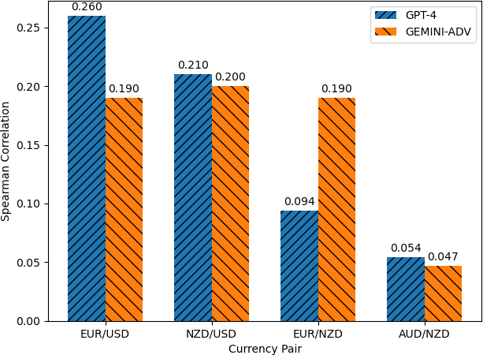

Figure 30: ROC 9 Spearman Correlation of Sentiment Analysis on Forex Pairs Using Four-Hour Time Frame Data

Figure 30 shows the Spearman correlation coefficients between sentiment scores and the ROC 9 indicator for the EUR/USD, NZD/USD, EUR/NZD, and AUD/NZD currency pairs. The GPT-4 model demonstrated a higher correlation for EUR/USD (0.260) and NZD/USD (0.210) than the GEMINI Advanced model. Conversely, GEMINI Advanced showed a stronger correlation for EUR/NZD (0.190), while both models performed similarly for AUD/NZD. These results guided the selection of sentiment analysis models, with GPT-4 chosen for EUR/USD and NZD/USD and GEMINI Advanced for EUR/NZD, enhancing the predictive accuracy of our models.
A key observation from the results is the consistently superior performance of the XG- Boost models, particularly noted for their lower RMSE values across most currency pairs. This

exceptional performance is detailed in Table 5:

- The XGBoost model combined with technical, fundamental, and sentiment analysis (XG- Boost TM FM SA) achieved the lowest RMSE of 0.001022 for the EUR/USD pair, in- dicating high predictive accuracy, as visually represented in Figure 25.
- Similarly, for the NZD/USD and EUR/NZD pairs, the same XGBoost configuration re- ported RMSE values of 0.000924 and 0.002145, respectively, outperforming other model setups.
- For the AUD/NZD pair, the XGBoost TM FM SA model also demonstrated superior performance with the lowest RMSE of 0.000594, further confirming its robustness across different forex markets, as shown in Figure 28.
These results underscore the effectiveness of XGBoost in handling complex datasets where multiple data streams are integrated. The analysis also reveals varying levels of perfor- mance across different models and currency pairs, illustrating the complexity of forex market forecasting. The R² values complement the RMSE results by providing insights into the vari- ance the models explain, with higher R² indicating better model fit to the data.
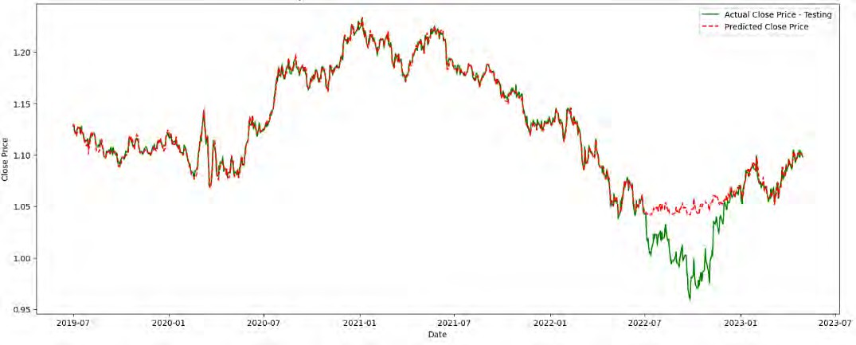
Figure 31: Performance of the XGB TM model on EUR/USD Test Data.

The use of ensemble models in forex price prediction highlights the significant improve- ment in performance and generalisation of test data. As illustrated in Figure 31 and Figure 32, both XGBoost and LSTM models individually demonstrate robust predictive capabilities. The XGBoost model excels in handling complex datasets and capturing non-linear relationships,

while the LSTM model effectively leverages its sequential memory structure to model tempo- ral dependencies.
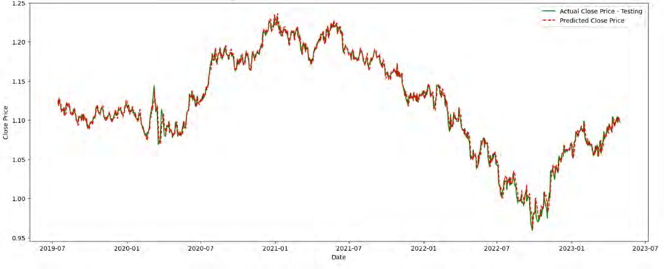
Figure 32: Performance of the LSTM TM model on EUR/USD Test Data.

However, the ensemble model, which combines the strengths of both XGBoost and LSTM, further enhances predictive accuracy and generalisation, as shown in Figure 13. By integrating these models through a weighted average technique, the ensemble model mitigates the individual weaknesses of each model, leading to more accurate and reliable predictions. This approach harnesses the superior generalisation capability of ensemble learning, reducing overfitting and improving performance across various market conditions.

    - Addressing the Research Questions
Research Question 1: How do technical indicators compare with models, including fun- damental indicators and sentiment analysis, in predicting forex prices?
As demonstrated in Figure 29, models using technical indicators alone consistently out- performed those incorporating both fundamental and sentiment indicators, particularly for the one-day time frame. For example, the technical model for EUR/USD achieved the lowest RMSE, indicating the effectiveness of technical models in capturing immediate market move- ments. Although combined models integrating fundamental and sentiment indicators offer broader market insights, their inclusion did not lead to lower RMSE values, suggesting that technical indicators are better suited for short-term forex price predictions.
Research Question 2: How does sentiment analysis affect the accuracy of forex price predictions?

The analysis in Figure 30 demonstrates how sentiment analysis improves prediction ac- curacy, particularly for the four-hour time frame. The positive correlation between sentiment scores and the ROC 9 indicator, especially for EUR/USD and NZD/USD pairs, suggests that sentiment analysis significantly enhances short-term model performance. The results indicate that sentiment analysis plays an important role in improving the accuracy of forex price predic- tions when combined with technical indicators.
Research Question 3: Which machine learning or deep learning models most effectively integrate these different data types for forex prediction?
The findings, as shown in Table 5, highlight the superior performance of XGBoost and Ensemble-LSTM-XGB models in integrating technical, fundamental, and sentiment data. XGBoost consistently delivered the lowest RMSE values across most currency pairs, demon- strating its ability to handle complex datasets with multiple data sources. Additionally, the Ensemble-LSTM-XGB model enhanced accuracy by leveraging the strengths of both LSTM and XGBoost, making it a robust approach for integrating diverse data types in forex predic- tion.

- Conclusion
This research effectively demonstrated the improvement of forex prediction accuracy by inte- grating sentiment analysis derived from LLMs with technical and fundamental data analyses. By employing LLMs such as GPT-4 and GEMINI Advanced, this study could leverage unla- belled financial news data to generate sentiment scores combined with traditional forex market data. Using Spearman correlation coefficients to assess the alignment between sentiment scores and the Rate of Change (ROC 9) indicators was pivotal. This analysis helped determine the most effective LLM for each currency pair based on how closely sentiment changes mirrored market movements. For instance, the selected LLMs exhibited varying degrees of correlation with the ROC 9, guiding the choice of sentiment analysis model for integration into the forex prediction framework, as shown in Figure 30.
The findings, as evidenced in Tables 2, 3, 4, and 5, indicate that the decoder-only ar- chitecture of Transformers exhibits promising results in forex prediction, outperforming the encoder-decoder framework. Moreover, our comparative analysis, as depicted in Figure 29, has demonstrated that technical models outperform those based on fundamental indicators or a combination of both. This could be attributed to the direct reflection of market sentiments and patterns captured in technical data, which these models distill and interpret.
The Ensemble-LSTM-XGB model combined with technical indicators achieved the best RMSE values for most currency pairs for the one-hour data analysis. Specifically, the best-performing models and their RMSE values are as follows: For the EUR/USD pair, the Ensemble-LSTM-XGB with technical indicators had an RMSE of 0.0064, while the Trans- former with an encoder-decoder architecture was the worst, with an RMSE of 0.0259, as seen in Table 2. For the NZD/USD pair, the Ensemble-LSTM-XGB with technical indicators had an RMSE of 0.0039, and the Transformer with an encoder-decoder architecture performed the worst with an RMSE of 0.0176. The EUR/NZD pair showed the XGBoost with techni- cal indicators as the best performer with an RMSE of 0.0048, while the Transformer with an encoder-decoder architecture had the highest RMSE of 0.0148. For the AUD/NZD pair, the XGBoost with technical indicators was the best, with an RMSE of 0.0017, and the Transformer with an encoder-decoder architecture was the worst, with an RMSE of 0.0051, as detailed in Table 2.
For the four-hour data analysis, the XGBoost model combined with technical, funda- mental, and sentiment indicators showed the lowest RMSE values across various currency pairs. For the EUR/USD pair, the XGBoost with technical, fundamental, and sentiment analysis had an RMSE of 0.0010, while the LSTM with technical, fundamental, and sentiment analysis had the highest RMSE of 0.0020, as shown in Table 5. For the NZD/USD pair, the XGBoost with technical, fundamental, and sentiment analysis had an RMSE of 0.0009, with the LSTM model performing the worst with an RMSE of 0.0042. The EUR/NZD pair performed best with the XGBoost model with an RMSE of 0.0021 and worst with the LSTM model with an RMSE

of 0.0043. For the AUD/NZD pair, the XGBoost with technical, fundamental, and sentiment analysis had the lowest RMSE of 0.0005, while the LSTM model had the highest RMSE of 0.0017.
Most compelling is the revelation from Figure 11 that employing ensemble methods, integrating the strengths of XGBoost and LSTM models through a weighted average tech- nique, significantly improves model robustness and generalisability. Such ensemble models have shown superior performance in our study, underpinning their potential as a robust frame- work for future forex market analysis. The use of ensemble models in forex price prediction highlights the significant improvement in performance and generalisation of test data. As illus- trated in Figure 31 and Figure 32, both XGBoost and LSTM models individually demonstrate robust predictive capabilities. The XGBoost model excels in handling complex datasets and capturing non-linear relationships, while the LSTM model effectively leverages its sequential memory structure to model temporal dependencies.
However, the ensemble model, which combines the strengths of both XGBoost and LSTM, further enhances predictive accuracy and generalisation, as shown in Figure 13. By integrating these models through a weighted average technique, the ensemble model mitigates the individual weaknesses of each model, leading to more accurate and reliable predictions. This approach harnesses the superior generalisation capability of ensemble learning, reducing overfitting and improving performance across various market conditions.
Research and Practical Implications
The results of this study have important implications for both academic research and fi- nancial practice. The significant improvement in forex prediction accuracy, particularly through the use of ensemble methods, adds to the growing body of evidence supporting the integration of machine learning and deep learning models in financial forecasting. For researchers, this study presents a robust framework for further exploration of hybrid and ensemble approaches in financial time-series prediction, highlighting the potential for advanced models like LSTM and XGBoost to work in concert for enhanced accuracy.
In practice, the integration of sentiment analysis with technical and fundamental indica- tors offers traders and financial institutions a more comprehensive toolkit for predicting forex market movements. The demonstrated effectiveness of combining these data sources can help practitioners develop more reliable models that better capture market complexities, enabling them to make more informed trading decisions. Additionally, the demonstrated robustness of ensemble models suggests their use in developing automated trading algorithms that can adapt to diverse market conditions and reduce the risks associated with overfitting.
Future Research Directions
While this study produced promising results, several avenues for future research re- main. One area of interest is the inclusion of real-time data processing to assess how these models perform under dynamic market conditions. Furthermore, exploring more advanced sentiment analysis techniques such as those derived from social media or geopolitical analysis

could further enhance prediction accuracy. Future studies could also delve into the potential of combining more sophisticated ensemble techniques, such as stacking or blending, to improve performance.
Expanding the range of economic and geopolitical factors considered in the models would offer additional insights into forex price movements, potentially leading to even more precise predictions. This research lays the groundwork for future advancements in the field of financial forecasting, pushing the boundaries of machine learning and deep learning applica- tions in trading and decision-making.

Bibliography
- Z. Hu, Y. Zhao, and M. Khushi, “A survey of forex and stock price prediction us- ing deep learning,” Applied System Innovation, vol. 4, no. 1, p. 9, Feb. 2021, doi: 10.3390/asi4010009.
- N. Rundo, N. Trenta, N. Di Stallo, and N. Battiato, “Machine Learning for Quantitative Finance Applications: A survey,” Applied Sciences, vol. 9, no. 24, p. 5574, Dec. 2019, doi: 10.3390/app9245574.
- A. J. Dautel, W. K. Ha¨rdle, S. Lessmann, and H.-V. Seow, “Forex exchange rate forecast- ing using deep recurrent neural networks,” Digital Finance/Digital Finance, vol. 2, no. 1–2, pp. 69–96, Mar. 2020, doi: 10.1007/s42521-020-00019-x.
- K. He, Q. Yang, L. Ji, J. Pan, and Y. Zou, “Financial Time Series Forecasting with the Deep Learning Ensemble Model,” Mathematics, vol. 11, no. 4, p. 1054, Feb. 2023, doi: 10.3390/math11041054.
- D. C. Yıldırım, I. H. Toroslu, and U. Fiore, “Forecasting directional movement of Forex data using LSTM with technical and macroeconomic indicators,” Financial Innovation, vol. 7, no. 1, Jan. 2021, doi: 10.1186/s40854-020-00220-2.
- S. Ahmed, S.-U. Hassan, N. R. Aljohani, and R. Nawaz, “FLF-LSTM: A novel prediction system using Forex Loss Function,” Applied Soft Computing, vol. 97, p. 106780, Dec. 2020, doi: 10.1016/j.asoc.2020.106780.
- J. Nobre and R. F. Neves, “Combining Principal Component Analysis, Discrete Wavelet Transform and XGBoost to trade in the financial markets,” Expert Systems With Appli- cations, vol. 125, pp. 181–194, Jul. 2019, doi: 10.1016/j.eswa.2019.01.083.
- Sudimanto, Y. Heryadi, Lukas and A. Wibowo, ”Foreign Exchange Prediction Using Ma- chine Learning Approach: A Pilot Study,” 2021 4th International Conference on Infor- mation and Communications Technology (ICOIACT), Yogyakarta, Indonesia, 2021, pp. 239-242, doi: 10.1109/ICOIACT53268.2021.9563998
- S. McNally, J. Roche and S. Caton, ”Predicting the Price of Bitcoin Using Ma- chine Learning,” 2018 26th Euromicro International Conference on Parallel, Dis- tributed and Network-based Processing (PDP), Cambridge, UK, 2018, pp. 339-343, doi: 10.1109/PDP2018.2018.00
- Suryoday Basak, Saibal Kar, Snehanshu Saha, Luckyson Khaidem, Sudeepa Roy Dey,Predicting the direction of stock market prices using tree-based classifiers, The North American Journal of Economics and Finance,Volume 47,2019,Pages 552-567,ISSN 1062- 9408,https://doi.org/10.1016/j.najef.2018.06.013.

- T. N. T. Thu and V. D. Xuan, ”Using support vector machine in FoRex predicting,” 2018 IEEE International Conference on Innovative Research and Development (ICIRD), Bangkok, Thailand, 2018, pp. 1-5, doi: 10.1109/ICIRD.2018.8376303.
- D. P. Neghab, M. Cevik, M. I. M. Wahab, and A. Basar, “Explaining exchange rate fore- casts with macroeconomic fundamentals using interpretive machine learning,” Computa- tional Economics, May 2024, doi: 10.1007/s10614-024-10617-1.
- O. Chantarakasemchit and S. Nuchitprasitchai, “Enhancing Forex Rates Prediction with Machine Learning on EUR to USD with Moving Average Methods and Financial Fac- tors,” in Lecture notes in networks and systems, 2021, pp. 44–54. doi: 10.1007/978-3- 030-79757-7 5.
- R. -C. Chen, Y. C. Shiao, C. Dewi and Q. -E. Liu, ”Predicting the Japanese Yen to US Dollar Exchange Rate Based on Machine Learning Models,” 2020 In- ternational Computer Symposium (ICS), Tainan, Taiwan, 2020, pp. 141-146, doi: 10.1109/ICS51289.2020.00037.
- M. L. De Prado, Advances in financial machine learning. 2018. [Online]. Available: https://dl.mehralborz.ac.ir/handle/Hannan/3238
- Z. Hu, Y. Zhao, and M. Khushi, “A survey of forex and stock price prediction us- ing deep learning,” Applied System Innovation, vol. 4, no. 1, p. 9, Feb. 2021, doi: 10.3390/asi4010009.
- T. Fischer and C. Krauss, “Deep learning with long short-term memory networks for financial market predictions,” European Journal of Operational Research, vol. 270, no. 2,
pp. 654–669, Oct. 2018, doi: 10.1016/j.ejor.2017.11.054.
- P. Escudero, W. Alcocer, and J. Paredes, “Recurrent neural networks and ARIMA models for Euro/Dollar exchange rate forecasting,” Applied Sciences, vol. 11, no. 12, p. 5658, Jun. 2021, doi: 10.3390/app11125658.
- G. Shen, Q. Tan, H. Zhang, P. Zeng, and J. Xu, “Deep Learning with Gated Recurrent Unit Networks for Financial Sequence Predictions,” Procedia Computer Science, vol. 131, pp. 895–903, Jan. 2018, doi: 10.1016/j.procs.2018.04.298.
- S. Raviraj, M. P. M M and K. M. Pai, ”Share price prediction of Indian Stock Markets us- ing timeseries data - A Deep Learning Approach,” 2021 IEEE Mysore Sub Section Inter- national Conference (MysuruCon), Hassan, India, 2021, pp. 744-751, doi: 10.1109/My- suruCon52639.2021.9641726.

- L. Qi, M. Khushi, and J. Poon, “Event-Driven LSTM for forex price prediction,” 2020 IEEE Asia-Pacific Conference on Computer Science and Data Engineering (CSDE), Dec. 2020, doi: 10.1109/csde50874.2020.9411540.
- P. Bilokon and Y. Qiu, “Transformers versus LSTMs for Electronic trading,” Social Sci- ence Research Network, Jan. 2023, doi: 10.2139/ssrn.4577922.
- M. Fisichella and F. Garolla, ”Can Deep Learning Improve Technical Analysis of Forex Data to Predict Future Price Movements?,” in IEEE Access, vol. 9, pp. 153083-153101, 2021, doi: 10.1109/ACCESS.2021.3127570.
- M. Markova, “Convolutional neural networks for forex time series forecasting,” AIP Con- ference Proceedings, Jan. 2022, doi: 10.1063/5.0083533.
- Y. Zhao and M. Khushi, ”Wavelet Denoised-ResNet CNN and LightGBM Method to Pre- dict Forex Rate of Change,” 2020 International Conference on Data Mining Workshops (ICDMW), Sorrento, Italy, 2020, pp. 385-391, doi: 10.1109/ICDMW51313.2020.00060.
- S. Naeem et al., “Machine learning-based USD/PKR exchange rate forecasting us- ing sentiment analysis of Twitter data,” Computers, Materials & Continua/Computers, Materials & Continua (Print), vol. 67, no. 3, pp. 3451–3461, Jan. 2021, doi: 10.32604/cmc.2021.015872.
- Y. Ji, A. W.-C. Liew, and L. Yang, “A novel improved particle swarm optimization with Long-Short Term Memory hybrid model for stock indices forecast,” IEEE Access, vol. 9,
pp. 23660–23671, Jan. 2021, doi: 10.1109/access.2021.3056713.
- P. Ghosh, A. Neufeld, and J. K. Sahoo, “Forecasting directional movements of stock prices for intraday trading using LSTM and random forests,” Finance Research Letters, vol. 46, p. 102280, May 2022, doi: 10.1016/j.frl.2021.102280.
- A. H. Moghaddam and S. Momtazi, “Image processing meets time series analysis: Pre- dicting Forex profitable technical pattern positions,” Applied Soft Computing, vol. 108,
p. 107460, Sep. 2021, doi: 10.1016/j.asoc.2021.107460.
- Y. Wang and Y. Guo, “Forecasting method of stock market volatility in time series data based on mixed model of ARIMA and XGBoost,” China Communications, vol. 17, no. 3,
pp. 205–221, Mar. 2020, doi: 10.23919/jcc.2020.03.017.
- L. Ni, Y. Li, X. Wang, J. Zhang, J. Yu, and C. Qi, “Forecasting of Forex Time Series data based on deep learning,” Procedia Computer Science, vol. 147, pp. 647–652, Jan. 2019, doi: 10.1016/j.procs.2019.01.189.

- P. H. Vuong, T. T. Dat, T. K. Mai, P. H. Uyen, and P. Bao, “Stock-Price forecasting based on XGBOOST and LSTM,” Computer Systems Science and Engineering, vol. 40, no. 1,
pp. 237–246, Jan. 2022, doi: 10.32604/csse.2022.017685.
- Islam and E. Hossain, “Foreign exchange currency rate prediction using a GRU- LSTM hybrid network,” Soft Computing Letters, vol. 3, p. 100009, Dec. 2021, doi: 10.1016/j.socl.2020.100009.
- J. Wang, X. Wang, J. Li, and H. Wang, “A prediction model of CNN-TLSTM for USD/CNY exchange rate prediction,” IEEE Access, vol. 9, pp. 73346–73354, Jan. 2021, doi: 10.1109/access.2021.3080459.
- M. Tripathi, S. Kumar, and S. K. Inani, “Exchange rate forecasting using ensemble mod- eling for better policy implications,” Journal of Time Series Econometrics, vol. 13, no. 1,
pp. 43–71, Dec. 2020, doi: 10.1515/jtse-2020-0013.
- S. Alonso-Monsalve, A. L. Sua´rez-Cetrulo, A. Cervantes, and D. Quintana, “Convolution on neural networks for high-frequency trend prediction of cryptocurrency exchange rates using technical indicators,” Expert Systems With Applications, vol. 149, p. 113250, Jul. 2020, doi: 10.1016/j.eswa.2020.113250.
- Y.-L. Peng and W.-P. Lee, “Data selection to avoid overfitting for foreign exchange intra- day trading with machine learning,” Applied Soft Computing, vol. 108, p. 107461, Sep. 2021, doi: 10.1016/j.asoc.2021.107461.
- W. Dassanayake, “Critical comparison of statistical and deep learning models applied to the New Zealand Stock Market Index.,” 2022
- Z. Hu, Y. Zhao, and M. Khushi, “A survey of forex and stock price prediction us- ing deep learning,” Applied System Innovation, vol. 4, no. 1, p. 9, Feb. 2021, doi: 10.3390/asi4010009.
- C. Lu, “The Long Short-Term Memory of GBP/CNY exchange rate forecasts,” Advances in Economics, Business and Management Research/Advances in Economics, Business and Management Research, Jan. 2022, doi: 10.2991/aebmr.k.220405.196.
- M. Mesleh and M. Kiranyaz, “Case study: Predicting future forex prices using MLP and LSTM models,” 2021 2nd International Conference on Electronics, Communications and Information Technology (CECIT), Dec. 2021, doi: 10.1109/cecit53797.2021.00067.
- M. Ulina, R. Purba, and A. Halim, “Foreign Exchange Prediction using CEEMDAN and Improved FA-LSTM,” 2020 Fifth International Conference on Informatics and Comput- ing (ICIC), Nov. 2020, doi: 10.1109/icic50835.2020.9288615.

- S. Ranjit, S. Shrestha, S. Subedi and S. Shakya, ”Comparison of algorithms in For- eign Exchange Rate Prediction,” 2018 IEEE 3rd International Conference on Comput- ing, Communication and Security (ICCCS), Kathmandu, Nepal, 2018, pp. 9-13, doi: 10.1109/CCCS.2018.8586826.
- L. Ni, Y. Li, X. Wang, J. Zhang, J. Yu, and C. Qi, “Forecasting of Forex Time Series data based on deep learning,” Procedia Computer Science, vol. 147, pp. 647–652, Jan. 2019, doi: 10.1016/j.procs.2019.01.189.
- Y. C. Shiao, G. Chakraborty, S. F. Chen, L. Hua Li and R. C. Chen, ”Modeling and Prediction of Time-Series-A Case Study with Forex Data,” 2019 IEEE 10th International Conference on Awareness Science and Technology (iCAST), Morioka, Japan, 2019, pp. 1-5, doi: 10.1109/ICAwST.2019.8923188.
- D. P. Neghab, M. Cevik, M. I. M. Wahab, and A. Basar, “Explaining Exchange Rate Fore- casts with Macroeconomic Fundamentals Using Interpretive Machine Learning,” Compu- tational Economics, May 2024, doi: 10.1007/s10614-024-10617-1.
- A. Adegboye and M. Kampouridis, “Machine learning classification and regression mod- els for predicting directional changes trend reversal in FX markets,” Expert Systems With Applications, vol. 173, p. 114645, Jul. 2021, doi: 10.1016/j.eswa.2021.114645.
- I. Filippou, M. P. Taylor, and Z. Wang, “Media sentiment and currency rever- sals,” Journal of Financial and Quantitative Analysis, pp. 1–47, Jun. 2023, doi: 10.1017/s0022109023000534.
- L. Rognone, S. Hyde, and S. S. Zhang, “News sentiment in the cryptocurrency mar- ket: An empirical comparison with Forex,” International Review of Financial Analysis (Online)/International Review of Financial Analysis, vol. 69, p. 101462, May 2020, doi: 10.1016/j.irfa.2020.101462.
- S. A. Farimani, M. V. Jahan, A. M. Fard and G. Haffari, ”Leveraging Latent Economic Concepts and Sentiments in the News for Market Prediction,” 2021 IEEE 8th International Conference on Data Science and Advanced Analytics (DSAA), Porto, Portugal, 2021, pp. 1-10, doi: 10.1109/DSAA53316.2021.9564122.
- H. N. Semiromi, S. Lessmann, and W. Peters, “News will tell: Forecasting for- eign exchange rates based on news story events in the economy calendar,” The North American Journal of Economics and Finance, vol. 52, p. 101181, Apr. 2020, doi: 10.1016/j.najef.2020.101181.
- H. Song and H. Choi, “Forecasting stock market indices using the recurrent neural net- work based hybrid models: CNN-LSTM, GRU-CNN, and ensemble models,” Applied Sciences, vol. 13, no. 7, p. 4644, Apr. 2023, doi: 10.3390/app13074644.

- I. E. Livieris, E. Pintelas, and P. Pintelas, “A CNN–LSTM model for gold price time- series forecasting,” Neural Computing & Applications, vol. 32, no. 23, pp. 17351–17360, Apr. 2020, doi: 10.1007/s00521-020-04867-x.
- I. Paliari, A. Karanikola, and S. Kotsiantis, ”A comparison of the optimized LSTM, XG- BOOST and ARIMA in Time Series forecasting,” 2021 12th International Conference on Information, Intelligence, Systems & Applications (IISA), Chania, Crete, Greece, 2021,
pp. 1-7, doi: 10.1109/IISA52424.2021.9555520.
- A. Pornwattanavichai, S. Maneeroj and S. Boonsiri, ”BERTFOREX: Cascading Model for Forex Market Forecasting Using Fundamental and Technical Indicator Data Based on BERT,” in IEEE Access, vol. 10, pp. 23425-23437, 2022, doi: 10.1109/AC- CESS.2022.3152152.
- K. Wood, S. Giegerich, S. Roberts, and S. Zohren, ”Trading with the momentum trans- former: An intelligent and interpretable architecture,” arXiv preprint arXiv:2112.08534, 2021.
- A. Tsantekidis, N. Passalis, A. Tefas, J. Kanniainen, M. Gabbouj, and A. Iosifidis, “Using Deep Learning for price prediction by exploiting stationary limit order book features,” Ap- plied Soft Computing, vol. 93, p. 106401, Aug. 2020, doi: 10.1016/j.asoc.2020.106401.
- H. P. S. D. Weerathunga and A. T. P. Silva, ”DRNN-ARIMA Approach to Short-term Trend Forecasting in Forex Market,” 2018 18th International Conference on Advances in ICT for Emerging Regions (ICTer), Colombo, Sri Lanka, 2018, pp. 287-293, doi: 10.1109/ICTER.2018.8615580.
- C. G. Mate´, “Forecasting in FOREX the spot price interval of tomorrow with the same information of today. An analysis of the seven majors using a linear regression model based on interval arithmetic,” Knowledge-based Systems, vol. 258, p. 109923, Dec. 2022, doi: 10.1016/j.knosys.2022.109923.
- H. Talebi, W. Hoang, and M. L. Gavrilova, “Multi-scale foreign exchange rates ensemble for classification of trends in forex market,” Procedia Computer Science, vol. 29, pp. 2065–2075, Jan. 2014, doi: 10.1016/j.procs.2014.05.190.
- M. M. Panda, S. N. Panda and P. K. Pattnaik, ”Exchange Rate Prediction using ANN and Deep Learning Methodologies: A Systematic Review,” 2020 Indo – Taiwan 2nd Interna- tional Conference on Computing, Analytics and Networks (Indo-Taiwan ICAN), Rajpura, India, 2020, pp. 86-90, doi: 10.1109/Indo-TaiwanICAN48429.2020.9181351.
- P. Juszczuk and L. Krus´, “Soft multicriteria computing supporting decisions on the Forex market,” Applied Soft Computing, vol. 96, p. 106654, Nov. 2020, doi: 10.1016/j.asoc.2020.106654.

- F. Rundo, “Deep LSTM with Reinforcement Learning Layer for Financial Trend Predic- tion in FX High Frequency Trading Systems,” Applied Sciences, vol. 9, no. 20, p. 4460, Oct. 2019, doi: 10.3390/app9204460.
- G. Fatouros, J. Soldatos, K. Kouroumali, G. Makridis, and D. Kyriazis, “Transforming Sentiment Analysis in the Financial Domain with ChatGPT,” Machine Learning With Applications, vol. 14, p. 100508, Dec. 2023, doi: 10.1016/j.mlwa.2023.100508.
- C. M. Liapis, A. Karanikola, and S. Kotsiantis, “A Multi-Method Survey on the Use of Sentiment Analysis in Multivariate Financial Time Series Forecasting,” Entropy, vol. 23, no. 12, p. 1603, Nov. 2021, doi: 10.3390/e23121603.
- Investing.com, “Forex and Currency News,” available at
https://www.investing.
.
com/news/forex-news
- DailyForex, “Currency Exchange Rates - Currency Trading Rates — DailyForex.com,” available at https://www.dailyforex.com/currencies.
- Interest.co.nz, “Currencies,” available at https://www.interest.co.nz/currencies.
- S. A. Farimani, M. V. Jahan, A. M. Fard, and S. R. K. Tabbakh, “Investigating the Informativeness of Technical Indicators and News Sentiment in Financial Mar- ket Price Prediction,” Knowledge-based Systems, vol. 247, p. 108742, Jul. 2022, doi: 10.1016/j.knosys.2022.108742.
- C.-I. Lee, C. Chang, and F. N. Hwang, “Currency Exchange Rate Prediction with Long Short-Term Memory Networks Based on Attention and News Sentiment Analysis,” 2019 International Conference on Technologies and Applications of Artificial Intelligence (TAAI), Nov. 2019, doi: 10.1109/TAAI48200.2019.8959884.
- W. Souma, I. Vodenska, and H. Aoyama, “Enhanced News Sentiment Analysis Using Deep Learning Methods,” Journal of Computational Social Science, vol. 2, no. 1, pp. 33–46, Jan. 2019, doi: 10.1007/s42001-019-00035-x.
- TradingView, “Comprehensive Financial Charts for Analysis,” available at
https://
www.tradingview.com/, accessed January 16, 2024.
- TA-Lib, “Technical Analysis Library,” available at https://ta-lib.org/, accessed September 28, 2023.
- Federal Reserve Economic Data, “Economic Data,” available at
https://fred.
stlouisfed.org/, accessed July 26, 2023.
- Federal Reserve, “Federal Reserve,” available at https://www.federalreserve.gov/, accessed July 19, 2023.

- European Central Bank, “Statistics,” available at
https://www.ecb.europa.eu/
stats/policy_and_exchange_rates, accessed July 19, 2023.
- Eurostat, “Data and Statistics,” available at https://ec.europa.eu/eurostat, ac- cessed July 26, 2023.
- Reserve Bank of New Zealand, “Statistics,” available at
https://www.rbnz.govt.nz/
statistics, accessed July 24, 2023.
- Statistics New Zealand, “Data and Statistics,” available at
https://www.stats.govt.
nz/, accessed July 25, 2023.
- Reserve Bank of Australia, “Statistics,” available at
https://www.rba.gov.au/
statistics/, accessed March 12, 2024.
- “Statistics,” available at https://www.rba.gov.au/statistics/, accessed March 12, 2024.

Appendix
This section provides detailed code snippets used in the study to implement machine learning and deep learning models for predicting forex prices. These code snippets offer a compre- hensive view of the technical implementation processes, including data preprocessing, model training, and evaluation.
Firstly, Figure 33 shows the code for splitting and scaling the data, which is crucial in preparing the dataset for model training. This is followed by implementing the LSTM model for time series forecasting, illustrated in Figure 34. The subsequent figure, Figure 35, details the code for implementing the XGBoost model for predicting forex prices.
The implementation of the Transformer Encoder and Decoder model, which is used for sequence modeling, is divided into two parts. Part one of the code is shown in Figure 36, and part two in Figure 37. Similarly, the Transformer Decoder model code is also split into two parts, with part one presented in Figure 38 and part two in Figure 39.
In addition, the appendix includes the code for the Ensemble model that combines
40

LSTM and XGBoost. This implementation is also divided into two parts: Figure part one, and Figure 41 shows part two.
shows

Furthermore, the appendix contains figures that depict the training and validation loss over epochs for various models applied to the EUR/USD currency pair. Specifically, Figure 42 describes the training and validation loss for the LSTM TM FM model, Figure 43 shows the
44

loss for the TRANSFORMER EN DE TM FM model, and Figure TRANSFORMER DE TM FM model.
presents the loss for the

These figures collectively provide a clear and detailed overview of this study’s coding processes and model performance evaluation metrics, demonstrating the robust methodologies applied in predicting forex prices.

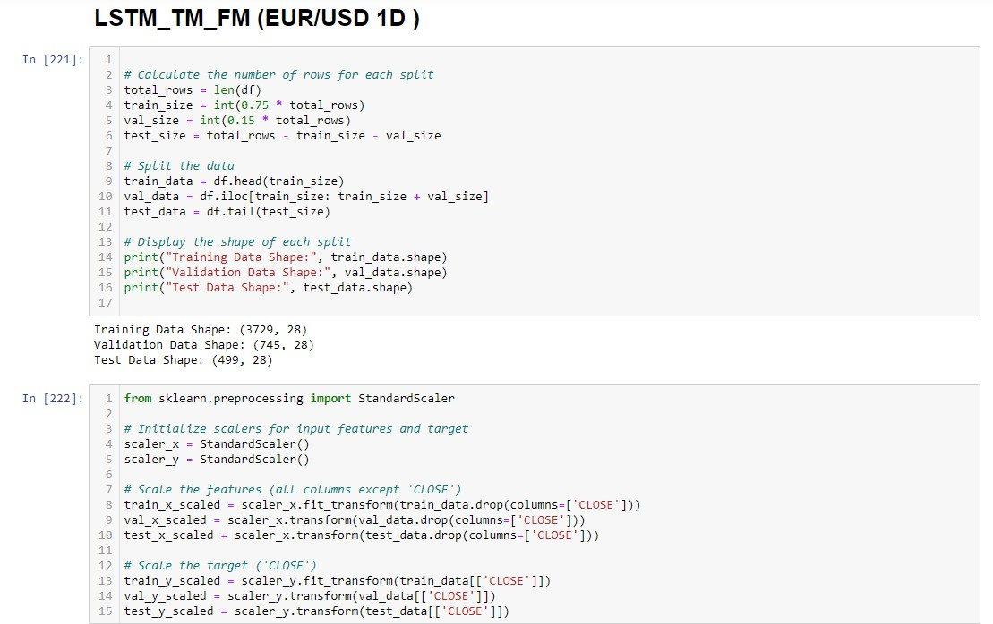

Figure 33: Code for the split and scale of the data.

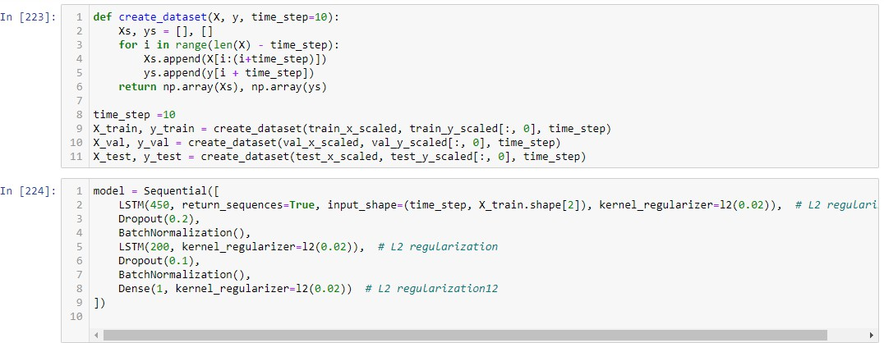
Figure 34: Code for the implementation of the LSTM model used for time series forecasting

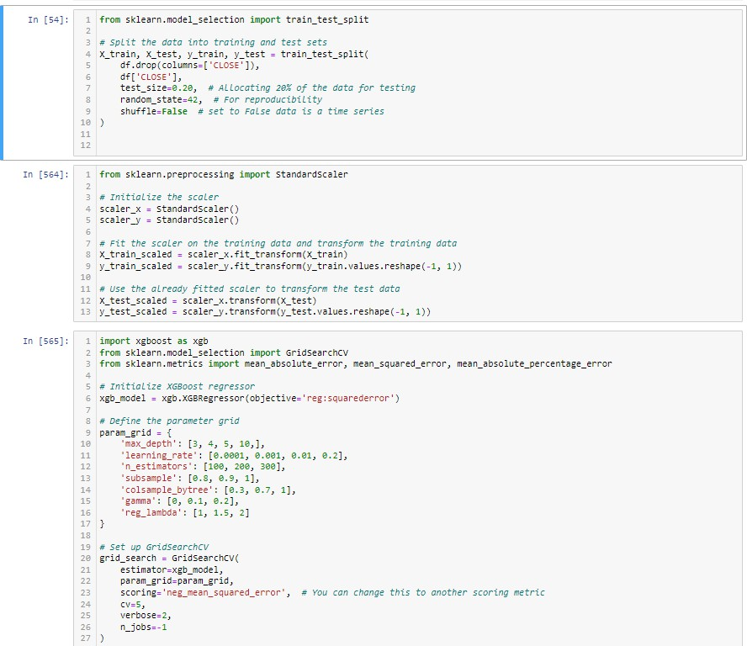
Figure 35: Code for the implementation of the XGBoost model used for predicting forex prices.

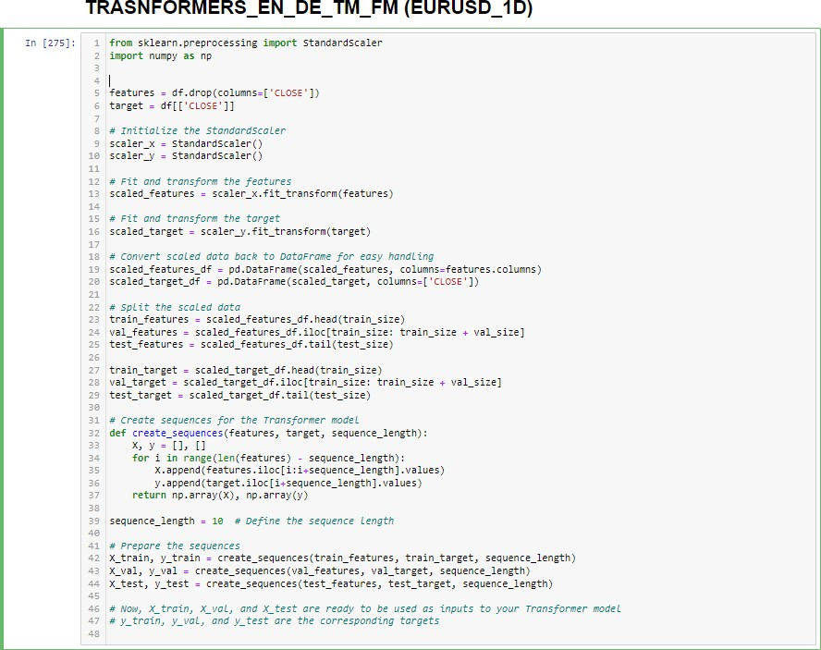
Figure 36: Code for the implementation of the Transformer Encoder and Decoder model used for se- quence modeling part-1.

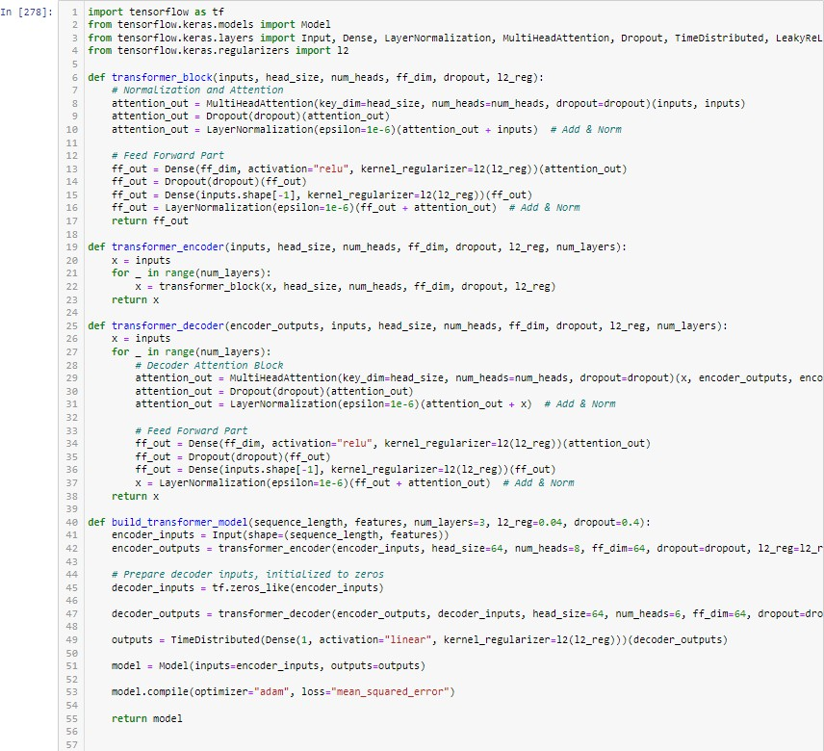
Figure 37: Code for the implementation of the Transformer Encoder and Decoder model used for se- quence modeling part-2.

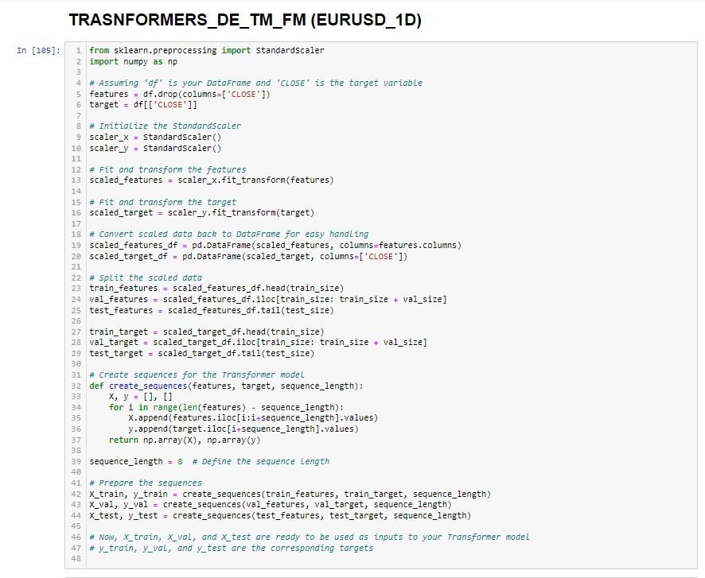
Figure 38: Code for the implementation of the Transformer Decoder model used for sequence modeling part-1.

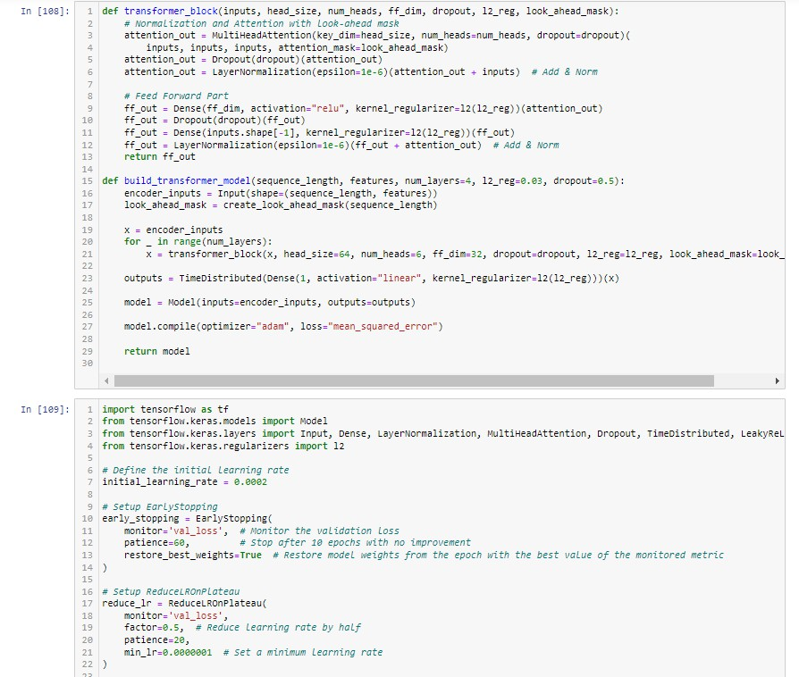
Figure 39: Code for the implementation of the Transformer Decoder model used for sequence modeling part-2.

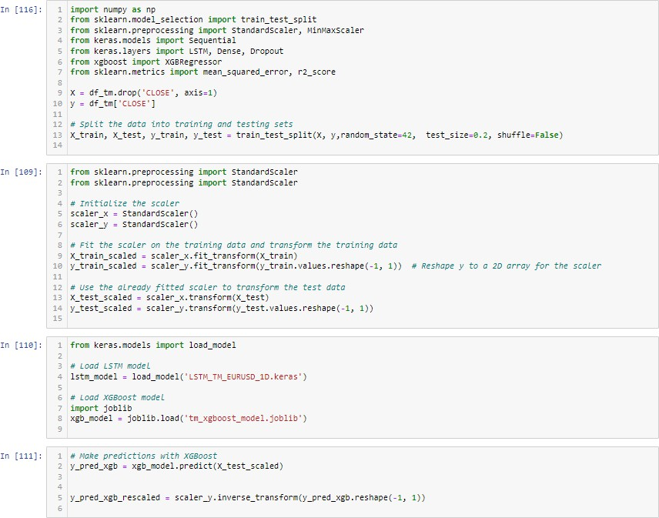

Figure 40: Code for the implementation of the Ensemble model combining LSTM and XGBoost part-1.

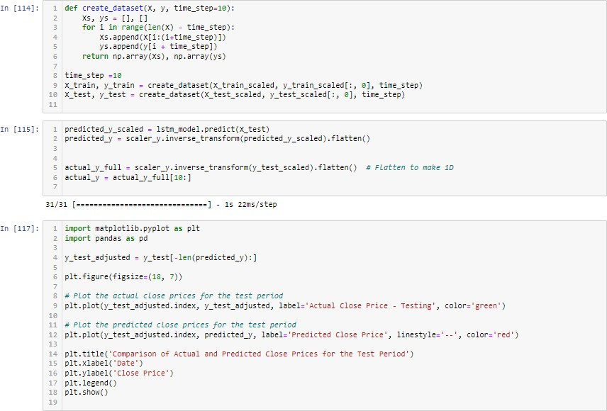

Figure 41: Code for the implementation of the Ensemble model combining LSTM and XGBoost part-2.

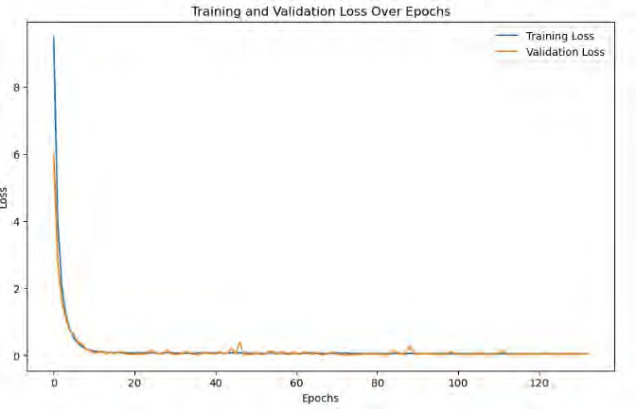
Figure 42: Training and validation loss over epochs for the LSTM TM FM model for EUR/USD.

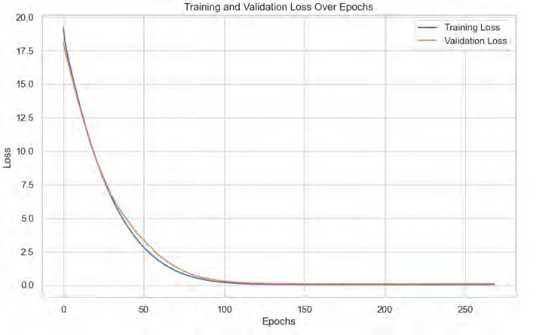
Figure 43: Training and validation loss over epochs for the TRANSFORMER EN DE TM FM model for EUR/USD.

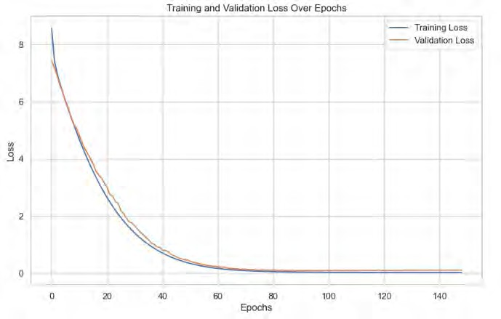
Figure 44: Training and validation loss over epochs for the TRANSFORMER DE TM FM model for EUR/USD.



Journal of Behavioral and Experimental Finance 36 (2022) 100747
Contents lists available at ScienceDirect

Journal of Behavioral and Experimental Finance
journal homepage: www.elsevier.com/locate/jbef

Full length article

Nonlinear nexus between cryptocurrency returns and COVID-19 news sentiment
Ameet Kumar Banerjee a,∗, Md Akhtaruzzaman b, Andreia Dionisio c,1, Dora Almeida d,1,
Ahmet Sensoy e,f,2
a XLRI - Xavier School of Management, Circuit House Area, Jamshedpur, 831 001, India
b Peter Faber Business School, Australian Catholic University, 532.6.15, Level 6, Tenison Woods House, 8-20 Napier Street, North Sydney, NSW 2060, Australia
c University of Evora, CEFAGE, School of Social Sciences, Management Department, Largo dos Colegiais, 2, 7000 Evora, Portugal
d University of Evora, School of Social Sciences, CEFAGE, Portugal
e Bilkent University, Faculty of Business Administration, Ankara, Turkey
f Lebanese American University, Adnan Kassar School of Business, Beirut, Lebanon

a r t i c l e i n f o

Article history:
Received 24 April 2022
Received in revised form 11 August 2022 Accepted 24 August 2022
Available online 1 September 2022

Keywords:
COVID-19 news sentiment Pandemic Cryptocurrencies Causality
Transfer entropy
a b s t r a c t

The paper examines how various COVID-19 news sentiments differentially impact the behaviour of cryptocurrency returns. We used a nonlinear technique of transfer entropy to investigate the relationship between the top 30 cryptocurrencies by market capitalisation and COVID-19 news sentiment. Results show that COVID-19 news sentiment influences cryptocurrency returns. The nexus is unidirectional from news sentiment to cryptocurrency returns, in contrast to past findings. These results have practical implications for policymakers and market participants in understanding cryptocurrency market dynamics under extremely stressful market conditions.
© 2022 Elsevier B.V. All rights reserved.

- Introduction

Signalling theory documents the importance of news as sig- nals to perceive future market behaviour (Connelly et al., 2011). The framework asserts the role of the signaller and the signal, and whenever the signal contains new or vital information, the markets tend to react accordingly to new signals (Fu et al., 2021; Romer, 1993; Wei and Zhou, 2016). Numerous news signals are available in the public domain and are used to understand as- set pricing behaviour (Gan et al., 2020; Sanford, 2020). Extant literature has supported that whenever news is unavailable in the public domain and it is released with a degree of surprise, the vibrancy in the markets is equally visible in prices and trad- ing volume (García et al., 2014; Banerjee et al., 2020; Banerjee and Pradhan, 2020a, 2021a). The most prominent news market

∗ Corresponding author.
E-mail addresses: ameet@xlri.ac.in (A.K. Banerjee),
Md.Akhtaruzzaman@acu.edu.au (M. Akhtaruzzaman), andreia@uevora.pt
(A. Dionisio), dmfa1982@gmail.com (D. Almeida), ahmet.sensoy@bilkent.edu.tr (A. Sensoy).
- Andreia Dionísio and Dora Almeida are pleased to acknowledge financial support from Fundação para a Ciência e a Tecnologia (grant UIDB/04007/2020).
- Ahmet Sensoy gratefully acknowledges support from Turkish Academy of Sciences under its Outstanding Young Scientist Award Program (TUBA-GEBIP).

https://doi.org/10.1016/j.jbef.2022.100747
2214-6350/© 2022 Elsevier B.V. All rights reserved.
participants regularly follow in anticipation that news may have novelty are the economic and financial news (Banerjee and Prad- han, 2020a; Banerjee et al., 2021; Büttner and Hayo, 2010). The impact of such news on various asset classes such as bonds, cur- rencies, stocks and futures markets is well-documented (Banerjee and Padhan, 2017; Banerjee and Pradhan, 2021a; Brenner et al., 2009; Luss and d’Aspremont, 2015).
Signalling theory remains a robust foundation for explaining investment decisions and strategic asset allocation (Alsos and Ljunggren, 2017; Frijns and Huynh, 2018; Griffith et al., 2020; Heston and Sinha, 2017), investor’s underreaction or overreaction to news (see Barberis et al., 1998; De Bondt and Thaler, 1985; DeFond and Zhang, 2014; Miwa, 2019; Banerjee and Pradhan, 2020b). Recently studying the credit default markets (CDS), Marsh and Wagner (2016) have asserted that swap dealers exploit the informational advantages against investors. Wei and Zhou (2016) documented the surge in bond trading activity before the re- lease of earning announcements in the expectation of information asymmetry in news signals. Bailey et al. (2014) reported a signifi- cant association between changes in the volatility index (VIX) and macroeconomic announcements by studying the high-frequency changes in VIX. Past literature has found a causal impact on financial journalism, media news and aggregate market prices (Banerjee et al., 2021; Dougal et al., 2012) and how management

disclosures work as a signal that drives investors (Koonce et al., 2016). Some varied examples of signalling theory are initial public offering (IPO) pricing, news sentiments influencing stock returns at the aggregate market level (Cutler et al., 1989; Garcia, 2013; Tetlock, 2007) and the individual stock level (Boudoukh et al., 2013; Chen et al., 2014). Information uncertainty originating from news sentiment increases expected stock return, thus affecting stock returns negatively (Zhang, 2006). Thus, the above reinstates that information asymmetry remains the mainstay of signalling theory, with the information intent and quality the critical factors (Stiglitz, 2002).
Currently, the literature has begun exploring the impact of news on newer asset classes such as cryptocurrencies, which are drawing much attention for their diversification properties and hedging role. Moreover, the assumption that analysing the impact of news on cryptocurrency returns may reveal newer perspec- tives is gaining ground in the literature (Bouri and Gupta, 2019; Bouri et al., 2020; Naeem et al., 2021; Rognone et al., 2020; Sal- isu and Ogbonna, 2021). Over the past decade, cryptocurrencies have seen remarkable growth and received extensive attention from market players interested in determining the driving fac- tors behind price formation (Aharon, 2020; Ciaian et al., 2016; Kristoufek, 2013; Raimundo Júnior et al., 2020; Subramaniam and Chakraborty, 2020; Youssef, 2020). However, cryptocurren- cies have a unique price, volume, and risk features (Sifat, 2021). Due to this uniqueness, cryptocurrency valuation is challenging (Ciaian et al., 2016). In addition, the literature on the mecha- nism of how news and sentiment influence cryptocurrency return is evolving (Corbet et al., 2019; Naeem et al., 2020; Poyser, 2019). The present paper contributes to the debate on how news and sentiment affect cryptocurrency prices, especially during the COVID-19 pandemic.
Apart from examining the effect of news sentiment on cryp- tocurrency return, we attempt to determine whether the nexus is linear or nonlinear. Most studies examine the linear relationship (Corbet et al., 2020a). We anticipate a nonlinear relationship, and we use the Brock, Dechert and Scheinkman (BDS) test of Broock et al. (1996) to examine the nonlinear structure in the return se- ries. The results of the BDS test reveal a nonlinear structure in the cryptocurrency return series. Hence, a nonlinear technique is bet- ter adapted to capture cryptocurrencies’ return and volatility dy- namics. We employ transfer entropy (TE), which measures asym- metric information flow and causality in complex systems (Kwon and Oh, 2012; Marschinski and Kantz, 2002). Though literature explored the information flow in financial markets, TE widens the possibility of detecting nonlinear relationships. Marschinski and Kantz (2002) use TE to measure the relationship between the U.S. Dow Jones Industrial Average and the German DAX Xetra Stock Index. In contrast, Kwon and Yang (2008) substantiated that the US stock market impacts major stock market indexes globally by applying TE. Sensoy et al. (2014) found a robust nonlinear relationship between exchange rates and stock prices.
The literature relating the COVID-19 pandemic to financial markets, including cryptocurrencies, has been evolving since the onset of the pandemic. For example, Corbet et al. (2020b) show that the COVID crisis has negatively impacted firms. Akhtaruzza- man et al. (2021a) report that firms across G7 countries and China significantly rose in conditional correlation. The study results support the findings of Banerjee (2021), who report that cross- market linkages cause contagion in futures markets in both de- veloped and emerging countries. Apart from financial contagion during the pandemic, the literature shows the changing dynamics of gold as a safe-haven property (Akhtaruzzaman et al., 2021b). The pandemic moderates the oil price exposure of industries (Akhtaruzzaman et al., 2020a; Banerjee and Pradhan, 2021b).
COVID-19 period. Recent studies examine the interaction be- tween cryptocurrency and other asset classes like foreign ex- change, commodities, and stocks (Akhtaruzzaman et al., 2020b; Pho et al., 2021). Gajardo et al. (2018) propose a non-symmetrical association between Bitcoin and equity markets. Aste (2019) and Gkillas et al. (2018) report that intra-market correlation among cryptocurrencies exhibits non-normal statistical properties in price fluctuation. Some of the recent literature discusses the effects of COVID-19 on cryptocurrency markets (e.g., see Conlon et al., 2020; Lahmiri and Bekiros, 2020; Wang et al., 2019). Several authors analysed if the COVID-19 pandemic affected the relationship between cryptocurrencies. For example, Bouri et al. (2021b) applied quantile-based connectedness measures. They revealed that the connectedness measures in the left and right tails are much higher than those in the mean and median of the conditional distribution, indicating that return shocks propagate more intensely during extreme events relative to calm periods. Aslanidis et al. (2021) aimed to answer whether cryptocurrencies are becoming more integrated between August 2015 and July 2020. They find a substantial increase in market linkages for both returns and volatilities, indicating a tighter relationship among cryptocurrencies in the COVID-19 period. Demiralay and Golitsis (2021) investigated the time-varying comovements employing a dynamic equicorrelation GARCH (DECO-GARCH) model in crypto markets. The study results show that the comovements across cryptos increased substantially in the wake of the COVID-19 pandemic. However, most studies ignore the possibility of the relationship’s nonlinear or asymmetric nature (Baur and Dimpfl, 2018). Changes in news content related to the COVID-19 crisis may have a differential impact on the prices of cryptocurrencies. Akyildirim et al. (2021) studied the dynamic network con- nectedness between 13 leading cryptos by market capitalisation and MarketPsych indices. The results supported the dominance of cryptocurrencies with higher market capitalisation. However, Bitcoin was losing its dominance to altcoins in return spillovers while still dominating in sentiment spillovers. Moreover, past studies emphasised that Bitcoin is against other major cryptocur- rencies that tend to have a significant presence in the market (Corbet et al., 2020a; Oad Rajput et al., 2020). However, there is a void in the literature studying the impact of different COVID-19 news sentiments on major cryptos. We address this void in this study by examining the nexus between the top 30 cryptocurren- cies (constituting approximately 79% of total market capitalisa- tion) and COVID-19 news sentiment obtained from the Ravenpack database. In contrast, some studies have found an association between other sources of news sentiment like Google Trend or MarketPsych indices and volatility (Akhtaruzzaman et al., 2021c; Akyildirim et al., 2021; Blitz et al., 2020; Philippas et al., 2019;
Shi and Ho, 2021; Smales, 2014; Lin, 2021).3
The study is the first to analyse the differential impact of dif- ferent categories of COVID–19 news sentiment on the behaviour of cryptocurrency returns. We investigate the reaction of the top 30 cryptocurrencies to COVID-19 news over the sample period from January 1, 2020 to April 15, 2021. The results indicate a significant positive nonlinear relationship between cryptocurren- cies’ return and news sentiment related to COVID-19. The re- sults reflect that cryptocurrencies witnessed a bullish run during the study period, and some of these reacted more to COVID– 19 developments. In particular, the media portrayal of COVID–19 conditions influences most cryptocurrency returns, which is more pronounced with Bitcoin Cash, DASH, Tether, and DAI.
Cryptocurrencies react vigorously to media exaggeration, where the recent Dogecoin fiasco represents a glaring example of market overreaction and herd behaviour (Hobbs, 2021). In

Moreover, Goodell and Goutte (2021) emphasise that cryp-
tocurrencies have failed to act as safe-haven assets during the 3 Source: https://coinmarketcap.com/.

Table 1
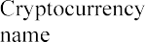
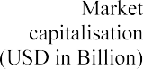

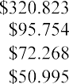
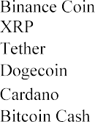
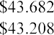
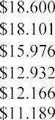
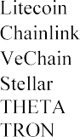
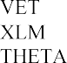
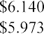

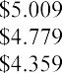
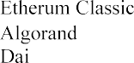
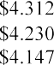

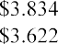
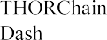
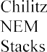
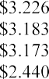
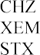
Top 30 cryptocurrencies by market capitalisation.
Note: The market capitalisation of cryptocurrencies is based on April 15, 2021.

comparison, fake and sentiment news have the most negligible impact on cryptocurrencies compared to other news sentiment indices. Globally, the news sentiment related to the COVID-19 influence almost all the cryptocurrency returns, contradicting the finding of Akyildirim et al. (2021). Thus, these results hold valuable insights for market participants. Moreover, uncertainty became relatively high in Ripple and saw a sudden price spurt during the pandemic (Bouri et al., 2021a). The recent bullish run seen in cryptocurrency prices does not reflect fundamental value. These episodes suggest the presence of considerable specula- tion and inefficiency in these markets (Dowd, 2014), potentially leading to bubbles (Dale et al., 2005). These results also support concerns over cryptocurrencies’ long-term viability for portfolio diversification, as excessive volatility and lower liquidity diminish the diversification benefits. Finally, these results give investors, policymakers, and regulators practical insights. This paper pro- ceeds as follows. Section 2 describes the data and descriptive statistics, Section 3 discusses the methodology, and the empirical results are part of Section 4. Finally, Section 5 sets forth our conclusions.
- Data and descriptive statistics

The source of news sentiment data on the COVID-19 panic,
COVID-19 pandemic.4 Our sample covers the period from Jan- uary 1, 2020 to April 15, 2021. The sample start date coincides with the introduction of news sentiment indices related to the COVID-19 by Ravenpack. Prices are taken for the top 30 cryp- tocurrencies by market capitalisation from CoinMarketCap (https:
//coinmarketcap.com). Table 1 presents a short description of cryptocurrencies. The estimation of daily cryptocurrency returns is as follows: r_{i} _{t} = ln ^{Pi,t} ∗ 100, where r_{i} _{t} is cryptocur-
, Pi,t−1 ,
( )
rency return i at day t; and P_{i},t and P_{i},t−1 are prices at day t and t − 1, respectively. Table 2 presents descriptive statistics. Results demonstrate that the average return (median) for all
the currencies is positive, and cryptocurrencies increased their valuation over the study period. The mean values are near zero for USDT and DAI. DAI is the least volatile cryptocurrency of the set, while DOGE is the most (although it does not allow the highest average return, which RUNE gave). Most cryptocurrency returns exhibit either negative or positive skewness, indicating a greater likelihood of considerable price variation. However, almost all the cryptocurrencies (20 in 30) showed a negative skew, meaning negative returns are more frequent than positive ones. The returns are leptokurtic and distinctively non-Gaussian. The rejection of the Jarque–Bera test lends support at the 1%

media hype, fake news, infodemic, sentiment, and media cover-

age index are from the Ravenpack database, which offers real- time media analytics, exploring announcements linked to the
4 Table A1 in the appendix provides the definition of the Ravenpack indexes on the COVID-19 pandemic.

Table 2
Descriptive statistics, January 1, 2020–April 15, 2021.
Cryptos | Mean | Median | Stdev | Skewness | Kurtosis | ADF test | PP test
BTC | 0.4657 | 0.2999 | 4.1236 | −2.8553 | 36.4047 | −7.6261*** | −22.8540***
ETH | 0.6299 | 0.6411 | 5.3881 | −2.3175 | 25.1589 | −7.6261*** | −22.8540***
BNB | 0.4282 | 0.7806 | 6.4425 | 0.1183 | 21.3872 | −7.2228*** | −23.5020***
XRP | 0.4760 | 0.2536 | 7.0978 | 0.0560 | 16.8048 | −7.8251*** | −23.6020***
USDT | 0.0001 | 0.0000 | 0.5066 | 0.1668 | 42.6054 | −12.6780*** | −47.2190***
DOGE | 0.9550 | 0.0687 | 10.4249 | 7.0499 | 96.0943 | −7.1074*** | −20.8150***
ADA | 0.8084 | 0.5980 | 6.3995 | −0.5948 | 9.5555 | −7.4485*** | −23.9900***
BCH | 0.3068 | 0.2976 | 5.9851 | −1.6480 | 19.0209 | −7.7515*** | −23.6620***
LTC | 0.4110 | 0.3326 | 5.4266 | −1.2886 | 11.2663 | −7.9719*** | −23.1970***
LINK | 0.6760 | 0.5305 | 6.9432 | −1.3321 | 13.9770 | −7.5428*** | −23.5210***
VET | 0.7467 | 0.4893 | 7.2907 | −1.0998 | 11.6196 | −7.4856*** | −24.3100***
XLM | 0.5035 | 0.4104 | 5.7931 | 0.5825 | 4.0205 | −7.1054*** | −23.0920***
THETA | 1.0562 | 0.7070 | 7.5554 | −0.7209 | 9.6662 | −7.1387*** | −23.8870***
TRX | 0.5339 | 0.4091 | 5.9810 | −0.9606 | 15.1603 | −7.6996*** | −23.6040***
XMR | 0.4972 | 0.7031 | 4.6373 | −0.0389 | 3.2028 | −8.0769*** | −25.0430***
LUNA | 0.8871 | 0.0441 | 7.7686 | 2.0443 | 12.2603 | −6.0358*** | −23.2840***
EOS | 0.2373 | 0.0000 | 5.7507 | −1.4887 | 14.1100 | −7.5987*** | −23.7560***
MIOTA | 0.5553 | 0.4726 | 6.4029 | −0.9486 | 13.5693 | −7.1828*** | −23.4540***
CRO | 0.4221 | 0.5938 | 5.7622 | −0.8477 | 20.8193 | −7.2775*** | −23.8250***
BTT | 0.7154 | 0.1353 | 7.4632 | 2.0165 | 28.0499 | −7.3113*** | −21.6060***
HT | 0.4342 | 0.2120 | 5.4999 | −0.0868 | 27.7893 | −8.3462*** | −25.0360***
XTZ | 0.3435 | 0.3809 | 6.3650 | −1.7636 | 17.9125 | −7.5456*** | −24.6590***
ETC | 0.3930 | 0.3610 | 5.9775 | −1.0310 | 14.4313 | −6.4224*** | −22.6370***
ALGO | 0.4196 | 0.2798 | 7.2276 | −1.3477 | 14.8941 | −7.8868*** | −22.6910***
DAI | 0.0004 | 0.0000 | 1.1510 | −0.5054 | 11.9009 | −10.5170*** | −48.3900***
RUNE | 1.1314 | 0.5128 | 8.4061 | −0.0714 | 1.9992 | −7.7539*** | −22.7610***
DASH | 0.4403 | 0.3377 | 6.6058 | 0.6895 | 13.4843 | −7.4976*** | −22.2580***
CHZ | 0.9183 | 0.2826 | 8.4353 | 0.8763 | 24.0266 | −6.1304*** | −21.1370***
XEM | 0.5550 | 0.2808 | 6.6671 | −0.4380 | 6.5745 | −7.2193*** | −23.1780***
STX | 0.7088 | 0.1359 | 8.4846 | 0.7461 | 26.7971 | −7.8474*** | −25.6710***
Notes:
The augmented Dickey–Fuller (ADF) and Philip–Perron (PP) test used to check the unit root of return series.
***Significance at the 5%.

significant level,5 consistent with the regular stylised fact of fat tails. The augmented Dickey–Fuller test (ADF) and Philip–Perron (PP) test demonstrate that cryptocurrency return series are sta- tionary (see Table 2). The media coverage index rose sharply during the beginning of the pandemic and peaked in March, coinciding with the period when the World Health Organization (WHO) declared COVID-19 a pandemic.6 The highest media cov- erage index, in March 2020, reflects that global financial markets witnessed sharp declines (Akhtaruzzaman et al., 2021a). Simi- larly, the panic, media hype, and infodemic indices peaked in March 2020.7 Interestingly, many cryptocurrencies experienced jumps in volatility in March 2020 and February–March 2021. The higher volatility in March 2020 is due to the onset of the pandemic (Corbet et al., 2021). The latter episode of volatility in 2021 reflects a surge, partly attributed to statements made by Elon Musk (Hobbs, 2021). Moreover, the volatility pattern reflects that the markets react immediately to news related to COVID-19
- Methodology

Analysis of causality holds great importance in studying fi- nancial market behaviour, and linear Granger causality is most commonly used to understand causal behaviour. However, at- tempts to understand behaviour and directional causality have motivated researchers to search for more efficient and global approaches (see, for example, Abdennadher and Hellara, 2018; Agbloyor et al., 2013; Comincioli, 1996; Stavroglou et al., 2019). However, the credit for testing causality goes to Granger (1969); the Granger causality test (GC) is one of the most popularly used in the financial literature to evaluate the bidirectional relation- ship between variables. GC assesses how past values of a given variable impact another variable in a vector autoregressive (VAR) framework, including past and present values of both variables.
Formally, a given variable Y Granger causes X, with lags k and
l, if
t−1
t−1

developments, which linear models may fall short in capturing
the behaviour. Further, to check the returns distribution pattern,
F (xt ⏐x(k) , y(l)
) ≠ F (x_{t} ⏐x(k) ) , (1)

we apply the BDS test of Broock et al. (1996) to examine spatial dependence and nonlinear structure. The results of the BDS test
t−1
reveal the presence of nonlinearity in return series. Thus, the BDS
meaning that the past values of Y can explain the present value of X, considering the past values of the variable. Similarly, it is possible to find whether X Granger causes Y, if

test results substantiate the application of a nonlinear framework
t−1
t−1
t−1
to test causal dependence (see Table 3).

F (yt ⏐x(k) , y(l)
) ≠ F (y_{t} ⏐y(l)
) . (2)

- Figures A1 and A2 in the appendix present the price and return series, respectively, of the 30 cryptocurrencies.
- Figure A3 in the appendix presents sentiment news indices by Ravenpack.
- Figure A4 in the appendix presents the conditional volatility of cryptocur- rency returns. Conditional volatility is estimated using a GARCH (1,1) model with a constant as the only regressor. We estimate the conditional volatility of cryptocurrency return using other GARCH models: GJR-GARCH (Glosten et al., 1993); EGARCH (Nelson, 1991); IGARCH (Engle and Bollerslev, 1986); APARCH (Ding et al., 1993) for our robustness check. We find similar conditional volatility of cryptocurrency return using these alternative GARCH models.
Granger causality is one of the best-known causality measures significantly used in major causality studies in the financial mar- ket. However, as it is a second-order statisitics, focusing on correlation-centred measure which has a severe limitation. It is limited to analysing the linear impact between variables, limiting its relevance to linear systems (Gencaga et al., 2015). As such, it may lead to a loss of information when the relationships between variables have nonlinear structures. Therefore, it is critical to use more global measures to capture both the linear and the nonlinear relationship between variables or between markets.

Table 3
BDS test results, January 1, 2020–April 15, 2021.

Table 3 (continued).
Cryptos m ε (1) ε (2) ε (3) ε (4)

Cryptos | m | ε (1) | ε (2) | ε (3) | ε (4) | CRO | 2 | 3.0030 | 3.5625 | 3.5455 | 4.2989
BTC | 2 | 2.9444 | 2.8544 | 2.6355 | 2.1587 |  |  | (0.0020) | (0.0003) | (0.0000) | (0.0000)
 |  | (0.0000) | (0.0000) | (0.0000) | (0.0000) |  | 3 | 3.8226 | 4.5618 | 4.1952 | 4.3306
 | 3 | 3.1339 | 2.4114 | 2.1990 | 1.9987 |  |  | (0.0001) | (0.0000) | (0.0003) | (0.0000)
 |  | (0.0000) | (0.0000) | (0.0000) | (0.0000) | BTT | 2 | 5.7594 | 4.2001 | 3.5203 | 3.1646
ETH | 2 | 2.4558 | 2.5094 | 2.5302 | 2.4289 |  |  | (0.0000) | (0.0000) | (0.0000) | (0.0000)
 |  | (0.0000) | (0.0000) | (0.0000) | (0.0000) |  | 3 | 7.0120 | 5.1449 | 4.4588 | 4.2519
 | 3 | 2.7203 | 2.8894 | 2.7510 | 2.7279 |  |  | (0.0000) | (0.0000) | (0.0000) | (0.0000)
 |  | (0.0000) | (0.0000) | (0.0000) | (0.0000) | HT | 2 | 8.8155 | 7.7846 | 8.4584 | 8.4622
BNB | 2 | 5.4762 | 6.9610 | 7.2520 | 7.1507 |  |  | (0.0000) | (0.0000) | (0.0000) | (0.0000)
 |  | (0.0000) | (0.0000) | (0.0000) | (0.0000) |  | 3 | 9.7909 | 8.1637 | 8.4173 | 8.7302
 | 3 | 6.6441 | 7.9203 | 7.4799 | 6.8558 |  |  | (0.0000) | (0.0000) | (0.0000) | (0.0000)
 |  | (0.0000) | (0.0000) | (0.0000) | (0.0000) | XTZ | 2 | 3.6261 | 3.7040 | 3.5781 | 3.4627
XRP | 2 | 7.9473 | 6.2280 | 6.1843 | 5.3456 |  |  | (0.0000) | (0.0000) | (0.0000) | (0.0000)
 |  | (0.0000) | (0.0000) | (0.0000) | (0.0000) |  | 3 | 4.5142 | 4.5377 | 4.5720 | 3.9142
 | 3 | 10.3679 | 7.7647 | 7.1115 | 6.3731 |  |  | (0.0000) | (0.0000) | (0.0000) | (0.0000)
 |  | (0.0000) | (0.0000) | (0.0000) | (0.0000) | ETC | 2 | 5.8804 | 4.9576 | 4.4929 | 4.3038
USDT | 2 | 11.1999 | 10.6716 | 10.6391 | 8.3295 |  |  | (0.0000) | (0.0000) | (0.0000) | (0.0000)
 |  | (0.0000) | (0.0000) | (0.0000) | (0.0000) |  | 3 | 7.2440 | 5.7141 | 4.8466 | 3.9393
 | 3 | 11.6899 | 11.0857 | 11.0759 | 8.4664 |  |  | (0.0000) | (0.0000) | (0.0000) | (0.0000)
 |  | (0.0000) | (0.0000) | (0.0000) | (0.0000) | ALGO | 2 | 2.2928 | 2.4566 | 2.0716 | 2.4315
DOGE | 2 | 10.6368 | 9.0406 | 8.5708 | 7.8353 |  |  | (0.0002) | (0.0000) | (0.0020) | (0.0004)
 |  | (0.0000) | (0.0000) | (0.0000) | (0.0000) |  | 3 | 2.7630 | 2.4352 | 2.4203 | 2.4306
 | 3 | 11.2474 | 9.2907 | 9.1241 | 8.2433 |  |  | (0.0001) | (0.0000) | (0.0012) | (0.0005)
 |  | (0.0000) | (0.0000) | (0.0000) | (0.0000) | DAI | 2 | 8.7258 | 8.3196 | 9.7448 | 10.1192
ADA | 2 | 2.5430 | 3.3264 | 3.0314 | 2.4549 |  |  | (0.0000) | (0.0000) | (0.0000) | (0.0000)
 |  | (0.0001) | (0.0008) | (0.0024) | (0.0014) |  | 3 | 15.1222 | 11.3237 | 11.5154 | 11.4856
 | 3 | 2.4869 | 3.2976 | 3.1062 | 2.6604 |  |  | (0.0000) | (0.0000) | (0.0000) | (0.0000)
 |  | (0.0002) | (0.0009) | (0.0018) | (0.0078) | RUNE | 2 | 3.2956 | 2.8392 | 2.5374 | 1.9622
BCH | 2 | 5.5857 | 4.4405 | 2.6581 | 1.3245 |  |  | (0.0009) | (0.0040) | (0.0011) | (0.0049)
 |  | (0.0000) | (0.0000) | (0.0000) | (0.0000) |  | 3 | 3.3511 | 3.3151 | 3.2717 | 2.7881
 | 3 | 5.2543 | 4.3471 | 3.0287 | 1.7869 |  |  | (0.0008) | (0.0009) | (0.0001) | (0.0053)
 |  | (0.0000) | (0.0000) | (0.0000) | (0.0000) | DASH | 2 | 5.3407 | 5.4767 | 5.8032 | 4.7984
LTC | 2 | 3.5150 | 3.9805 | 3.1962 | 2.0667 |  |  | (0.0000) | (0.0000) | (0.0000) | (0.0000)
 |  | (0.0004) | (0.0000) | (0.0013) | (0.0038) |  | 3 | 5.8277 | 6.1344 | 6.3439 | 5.1384
 | 3 | 3.4456 | 3.4398 | 2.9187 | 1.7721 |  |  | (0.0000) | (0.0000) | (0.0000) | (0.0000)
 |  | (0.0005) | (0.0000) | (0.0035) | (0.0076) | CHZ | 2 | 7.7515 | 7.9099 | 7.0493 | 6.8442
LINK | 2 | 2.0084 | 2.5722 | 2.8375 | 2.5628 |  |  | (0.0000) | (0.0000) | (0.0000) | (0.0000)
 |  | (0.0004) | (0.0012) | (0.0045) | (0.0010) |  | 3 | 9.4837 | 8.7427 | 7.7078 | 7.0862
 | 3 | 2.2614 | 2.9298 | 3.5832 | 3.2739 |  |  | (0.0000) | (0.0000) | (0.0000) | (0.0000)
 |  | (0.0002) | (0.0033) | (0.0030) | (0.0010) | XEM | 2 | 6.6542 | 5.7325 | 4.2819 | 3.0915
VET | 2 | 3.0629 | 2.7179 | 3.2055 | 3.6333 |  |  | (0.0000) | (0.0000) | (0.0000) | (0.0000)
 |  | (0.0002) | (0.0065) | (0.0013) | (0.0002) |  | 3 | 8.2862 | 6.7722 | 5.1389 | 3.2580
 | 3 | 3.8079 | 3.4912 | 3.8690 | 3.8415 |  |  | (0.0000) | (0.0000) | (0.0000) | (0.0000)
 |  | (0.0001) | (0.0004) | (0.0001) | (0.0001) | STX | 2 | 2.2920 | 2.1225 | 2.2529 | 2.2573
XLM | 2 | 4.8490 | 4.5723 | 4.5440 | 5.0854 |  |  | (0.0021) | (0.0033) | (0.0024) | (0.0000)
 |  | (0.0000) | (0.0000) | (0.0000) | (0.0000) |  | 3 | 3.9890 | 4.3345 | 4.2216 | 3.5092
 | 3 | 5.8883 | 5.5943 | 5.3281 | 5.7661 |  |  | (0.0000) | (0.0000) | (0.0000) | (0.0000)

(0.0002)
3 3.0465
(0.0002)

(0.0000)
4.5497
(0.0000)

(0.0000)
5.7261
(0.0000)

(0.0000)
5.5685
(0.0000)
Note: The entries are the BDS test (Broock et al., 1996) statistics, and p-values are within brackets. The parameter m is the embedding dimension, and ε is the epsilon values for close points.

Contrary to GC, information-theory-based measures, such as mutual information (MI) or transfer entropy (TE), consider the whole structure of time series (Darbellay and Wuertz, 2000), allowing to measure both linear and nonlinear dependencies between two-time series. MI is a bivariate measure based on the Shannon (1948) entropy as MI absolute values are not limited upwards, which makes MI an imperfect measure of dependence (Granger et al., 2004). It measures only mutual dependence allow- ing for quantifying the information shared between two random variables (Fiedor, 2014) or between two-time series. MI aids in inferring the amount of information about one random variable through the observation of another random one. However, it does not indicate causality direction between variables (Ferreira et al., 2017) and fails to measure or quantify the flow of information (Jizba et al., 2012), hence demands an asymmetric measure to quantify and measure the information flow in a finance context (Dimpfl and Peter, 2014). Schreiber (2000) introduced a dynamic structure to mutual information by considering transition proba- bilities. He coupled the Shannon (1948) entropy and the Kullback
 |  | (0.0000) | (0.0000) | (0.0000) | (0.0000)
THETA | 2 | 3.9868 | 4.2423 | 3.7313 | 3.3431
 |  | (0.0000) | (0.0000) | (0.0000) | (0.0000)
 | 3 | 4.5573 | 3.4912 | 4.4230 | 3.7923
 |  | (0.0000) | (0.0000) | (0.0000) | (0.0000)
TRX | 2 | 6.1200 | 5.3054 | 4.2226 | 3.4537
 |  | (0.0000) | (0.0000) | (0.0000) | (0.0000)
 | 3 | 7.9228 | 6.3764 | 5.0925 | 3.9047
 |  | (0.0000) | (0.0000) | (0.0000) | (0.0000)
XMR | 2 | 4.5862 | 3.8254 | 3.1035 | 2.7417
 |  | (0.0000) | (0.0001) | (0.0019) | (0.0006)
 | 3 | 4.1952 | 3.6294 | 2.6828 | 2.4519
 |  | (0.0000) | (0.0002) | (0.0073) | (0.0011)
LUNA | 2 | 4.5730 | 4.2742 | 4.3347 | 3.9288
 |  | (0.0000) | (0.0000) | (0.0000) | (0.0000)
 | 3 | 7.8450 | 5.7269 | 4.8076 | 4.2964
 |  | (0.0000) | (0.0000) | (0.0000) | (0.0000)
EOS | 2 | 4.2419 | 4.5851 | 5.0691 | 4.8544
 |  | (0.0000) | (0.0000) | (0.0000) | (0.0000)
 | 3 | 5.4566 | 5.1855 | 5.2238 | 4.6803
 |  | (0.0000) | (0.0000) | (0.0000) | (0.0000)
MIOTA | 2 | 2.2292 | 3.3372 | 4.2766 | 4.0858

and Leibler (1951) distance concepts and proposed a measure that allows for the above-referred assessment, the TE. TE not only allows to capture and measure of both linear and nonlinear rela- tionships, but it also measures information flow from one random variable (or time-series) to another. Thus, the information flow from Y to X is given by
asymmetry in the interaction (Porfiri, 2018). NetTE_{Y}→X (k, l) =
0 could mean that X and Y are independent (T_{Y}→X (k, l) = T_{X}→Y (k, l) = 0), or that there is no predominant direction of causality (TE_{Y}→X (k, l) > 0 and TE_{X}→Y (k, l) > 0) (Camacho et al., 2021). For this paper, we performed TE using open-source soft-
ware in the R language. Compared to MI, TE is better adaptive to

∑ ( (k) (l)) p (x
t t
t+1⏐x(k), y(l))
detect the direct exchange of information between two systems (Karkowska and Urjasz, 2022), justifying the application of TE for

TE_{Y}→X (k, l) =
p
x,y
xt+1, xt , yt
log
p (x

t+1
⏐x(k)) (3)
the current study.

Eq. (3) is an asymmetric directional measure of the depen- dence and relation between variables. It measures the informa- tion flow from Y to X, quantifying the additional information about the future value of X gained by observing past values of
t
Y. It can distinguish driving and responding elements and detect asymmetry in the interaction of time series. Thus, TE considers only the dependency is originating in source series Y, not con- sidering dependences caused by common external sources. Anal- ogously, used to calculate the information flow in the opposite
direction, i.e., TE_{X}→Y (l, k). Thus, considering the difference be-
tween TEs helps find the dominant direction of information flow
between pairs of variables (Behrendt et al., 2019). In contrast, the Granger causality or other tests identifies a source’s interventions that affect the target variable. TE focuses on whether observations of the source can help predict state transitions making TE a dy- namic and directional measure of predictive information (gener- ally meant to reduce uncertainty). Instead of being only a measure identifying the causal information flow (Caţaron and Andonie, 2018; Moldovan et al., 2020). Though similarities exist between Granger causality and TE, TE is an information-theoretic measure and model-free approach not limited to linearity and normality restrictions on data behaviour. Hence it is helpful for an in- depth evaluation of the complex behaviour of cryptocurrencies, unravelling the existence of relationships between variables and their respective magnitude and direction (Barnett et al., 2009).
Estimating TE is done by considering the dependence on the discretisation of space and the possible relevance of tails in the distributions (e.g., Jizba et al., 2012). To test the significance of TE estimations, we use the bootstrap method proposed by Dimpfl and Peter (2013), which employs 300 replications to obtain the estimated distribution for testing the null hypothesis of the ab- sence of information flow. TE has been used in extant literature to study financial markets (see, e.g., Baek et al., 2005; Dimpfl and Peter, 2013; Kim et al., 2020; Osei and Adam, 2020). In
addition to TE, we estimate net TE, given by NET TE_{Y}→X = TE_{Y}→X − TE_{X}→Y identifying which of the variables in each pair is a net influencer or is net influenced. As in causality analysis, it
is important to determine the direction of causality. In a two-way relation between X and Y variables, causality direction is assessed throughout the dominant direction of information flow between pairs of variables (Behrendt et al., 2019). The difference between
both TEs (i.e., TE_{Y}→X (k, l) and TE_{X}→Y (k, l)) defined by He and Shang (2017) as net TE (NetTE), NetTE_{X},Y (k, l), allows assessment
of the referred dominant direction of information flow. The NetTE
between X and Y variables is given by:
NetTE_{Y}→X (k, l) = TE_{Y}→X (k, l) − TE_{X}→Y (k, l) . (4)
In this context, a positive value for NetTE_{Y}→X (k, l) (TE_{Y}→X (k, l) − TE_{X}→Y (k, l) > 0) means that the NetTE is from Y to X, i.e., the dominant direction of information flow is from Y to X (Y influ-
ences X more than X influences Y ). Similarly, if TE is negative, then X influences Y more than the other way around, whereas
- Empirical results

To quantify the information flow between news sentiment in- dices related to the COVID–19 and the cryptocurrency returns, we applied TE. The results show that panic, media hype, fake news, infodemic, sentiment and the media coverage index of COVID-
19 significantly affects cryptocurrencies (Corbet et al., 2020c; Gurdgiev and O’Loughlin, 2020). The influence of the media hype index is statistically significant in the majority of the 30 cryp- tocurrencies, precisely 23. The media hype index measures the percentage of news about the novel coronavirus; this index sig- nificantly influences BCH, DASH, USDT, and DAI. More than half of the 30 cryptocurrencies are statistically significant influence by news sentiment. News sentiment indices commonly affect BCH, DASH, XMR, USDT, and DAI. The panic index influences VET, and the media coverage index influences ADA and XEM. However, the panic and media coverage indices are different; the former measures the level of news chatter that references panic or hysteria caused by the pandemic, while the latter calculates the percentage of all news sources covering the novel coronavirus. In contrast, the infodemic index is related to all entities (such as places, companies, and organisations) reported in the media alongside COVID-19.
Note that the fake news index influences 13 cryptos including BTC, BCH, and XMR. Fake news is the only sentiment index that appears to affect BTC significantly. This evidence is not surpris- ing as BTC is the first cryptocurrency launched and the most traded with the highest market capitalisation, a prima facie victim of fake news. On the other hand, sentiment shows statistically significant levels of influence in only 13 cryptocurrencies, with DAI standing out with a 1% significance level and USDT and LINK at a 5% significance level. Further, analysis indicates that all the sentiment news indices highly influence DAI at a 1% significance level; the only exception is the fake news index, with significance at 10%. The result is an exception as the DAI price is soft-pegged to the US dollar and collateralised by a mix of other cryptocurrencies.
In contrast, none of the indexes impacts DOGE. Moreover, the return series of BCH, XMR, DASH, USDT and DAI show greater levels of influence on the index used. Though coins and tokens differ in market capitalisation, the results indicate that sentiment indices influence the irrespective of the market capitalisation of cryptocurrencies, with our sample comprising 22 coins and
eight tokens.8 Given the TE results, it appears that the sentiment
indices more influence token cryptocurrencies.
Further, Naeem et al. (2021) suggest that sentiments related to optimism/happiness are better predictors of cryptocurrency returns than fear sentiments. Our sentiment indices are related more to fear or panic; thus, our results provide a contrarian perspective. Our results indicate that fatalistic and sensationalist news released via the internet greatly influences cryptocurren- cies. We check net TE to determine casualty direction, finding that news sentiment drives cryptocurrency returns. Keskin and

a negative value suggests (TE_{Y}→X (k, l) − TE_{X}→Y (k, l) < 0) the

dominant direction of information flow is the opposite (from
X to Y ). Both nonzero values are associated with a degree of
- Coins and tokens differ in their operational architecture. Coins have their own blockchains, while tokens do not.

Table 4
Results of impact of COVID-19 news on cryptocurrency returns using transfer

Table 5
Net transfer entropy values, January 1, 2020–April 15, 2021.

entropy, January 1, 2020–April 15  Cryptos Panic Media_ |  |  | , 2021.  Fake | Sentiment | Infodemic | Media_ |  | Cryptos | Panic | Media Hype | Fake | Sentiment | Infodemic | Media Coverage
 |  | Hype |  |  |  | Coverage |  | BTC | −0.0050 | −0.0164 | −0.0051 | −0.0085 | −0.0082 | −0.0076
BTC | 0.0205* | 0.0164* | 0.0222** | 0.0216* | 0.0070 | 0.0136* |  | ETH | −0.0022 | −0.0188 | −0.0004 | −0.0165 | −0.0093 | −0.0001
ETH | 0.0137* | 0.0078 | 0.0165* | 0.0171* | 0.0089 | 0.0069 |  | BNB | −0.0253 | −0.0245 | −0.0142 | −0.0171 | −0.0114 | −0.0036
BNB | 0.0137* | 0.0101* | 0.0132 | 0.0148 | 0.0107* | 0.0108* |  | XRP | 0.0045 | −0.0039 | −0.0002 | −0.0003 | −0.0032 | −0.0079
XRP | 0.0076 | 0.0107* | 0.0087 | 0.0063 | 0.0068 | 0.0101* |  | USDT | −0.0253 | −0.0245 | −0.0142 | −0.0171 | −0.0114 | −0.0036
USDT | 0.0396*** | 0.0366*** | 0.0223* | 0.0279** | 0.0166** | 0.0214*** |  | DOGE | −0.0061 | −0.0074 | −0.0072 | 0.0009 | −0.0056 | −0.0070
DOGE | 0.0091 | 0.0091 | 0.0085 | 0.0087 | 0.0091 | 0.0091 |  | ADA | −0.0024 | −0.0047 | −0.0013 | −0.0031 | −0.0023 | −0.0009
ADA | 0.0092 | 0.0115* | 0.0119 | 0.0039 | 0.0116* | 0.0118** |  | BCH | −0.0022 | −0.0203 | −0.0188 | 0.0040 | −0.0165 | −0.0093
BCH | 0.0278** | 0.0247*** | 0.0257*** | 0.0091 | 0.0243*** | 0.0225*** |  | LTC | −0.0112 | −0.0045 | 0.0036 | 0.0057 | −0.0085 | 0.0077
LTC | 0.0133* | 0.0114* | 0.0079 | 0.0071 | 0.0085 | 0.0077 |  | LINK | −0.0119 | −0.0057 | −0.0061 | −0.0033 | −0.0059 | −0.0040
LINK | 0.0195* | 0.0087 | 0.0148 | 0.0210** | 0.0112* | 0.0074 |  | VET | −0.0053 | −0.0046 | −0.0066 | 0.0091 | −0.0082 | −0.0010
VET | 0.0129** | 0.0108 | 0.0153* | 0.0077 | 0.0107** | 0.0106* |  | XLM | −0.0053 | −0.0110 | −0.0021 | −0.0001 | −0.0019 | −0.0017
XLM | 0.0145* | 0.0096* | 0.0093 | 0.0073 | 0.0086 | 0.0053 |  | THETA | −0.0020 | −0.0085 | 0.0046 | −0.0012 | −0.0048 | −0.0078
THETA | 0.0123 | 0.0115* | 0.0107 | 0.0078 | 0.0083 | 0.0106* |  | TRX | −0.0125 | −0.0085 | −0.0030 | −0.0053 | −0.0033 | −0.0082
TRX | 0.0075 | 0.0103* | 0.0105 | 0.0103 | 0.0068 | 0.0103* |  | XMR | −0.0051 | −0.0132 | −0.0223 | −0.0003 | −0.0133 | −0.0108
XMR | 0.0260** | 0.0192** | 0.0335*** | 0.0164* | 0.0207*** | 0.0208** |  | LUNA | −0.0064 | −0.0032 | −0.0086 | −0.0072 | −0.0078 | −0.0106
LUNA | 0.0106 | 0.0100* | 0.0149* | 0.0102* | 0.0132* | 0.0128* |  | EOS | 0.0198 | −0.0001 | −0.0042 | −0.0062 | −0.0001 | 0.0065
EOS | 0.0093 | 0.0086 | 0.0083 | 0.0124* | 0.0068 | 0.0054 |  | MIOTA | −0.0076 | −0.0100 | −0.0071 | −0.0032 | −0.0104 | −0.0010
MIOTA | 0.0246** | 0.0113* | 0.0143* | 0.0218* | 0.0130* | 0.0101* |  | CRO | −0.0094 | −0.0078 | −0.0105 | 0.0039 | −0.0126 | 0.0004
CRO | 0.0184* | 0.0129* | 0.0018 | 0.0101 | 0.0165* | 0.0084 |  | BTT | 0.0206 | −0.0065 | −0.0009 | −0.0018 | −0.0051 | −0.0043
BTT | 0.0111 | 0.0108* | 0.0144* | 0.0088 | 0.0112* | 0.0115 |  | HT | −0.0100 | −0.0024 | −0.0063 | −0.0036 | −0.0054 | −0.0030
HT | 0.0118* | 0.0119* | 0.0141* | 0.0098 | 0.0115* | 0.0094 |  | XTZ | −0.0056 | 0.0020 | −0.0018 | −0.0041 | −0.0008 | 0.0002
XTZ | 0.0175* | 0.0064 | 0.0128 | 0.0136* | 0.0065 | 0.0093 |  | ETC | 0.0280 | −0.0044 | 0.0015 | −0.0034 | 0.0035 | −0.0098
ETC | 0.0129 | 0.0124* | 0.0120 | 0.0127* | 0.0022 | 0.0110* |  | ALGO | 0.0250 | −0.0034 | −0.0058 | 0.0011 | −0.0035 | 0.0040
ALGO | 0.0081 | 0.0118* | 0.0118 | 0.0059 | 0.0126* | 0.0082 |  | DAI | −0.0027 | −0.0202 | −0.0138 | −0.0300 | −0.0155 | −0.0330
DAI | 0.0480*** | 0.0396*** | 0.0183* | 0.0489*** | 0.0293*** | 0.0462*** |  | RUNE | −0.0002 | −0.0013 | −0.0053 | 0.0032 | −0.0012 | −0.0082
RUNE | 0.0099 | 0.0117 | 0.0153* | 0.0107 | 0.0078 | 0.0106* |  | DASH | −0.0008 | −0.0164 | −0.0058 | −0.0115 | −0.0168 | −0.0157
DASH | 0.0271** | 0.0219*** | 0.0228* | 0.0191* | 0.0235*** | 0.0237** |  | CHZ | 0.0110 | −0.0047 | −0.0043 | 0.0030 | −0.0043 | −0.0027
CHZ | 0.0099 | 0.0125* | 0.0097 | 0.0098 | 0.0104* | 0.0091 |  | XEM | 0.0143 | −0.0014 | 0.0145 | −0.0063 | −0.0038 | −0.0010
XEM | 0.0129 | 0.0157* | 0.0129 | 0.0110 | 0.0122* | 0.0157** |  | STX | −0.0103 | −0.0093 | −0.0003 | −0.0063 | −0.0008 | −0.0011
STX 0.0113 0.0173** |  |  | 0.0111 | 0.0129* | 0.0063 | 0.0078 | Notes: Net transfer entropy (NetTE_{X},Y (k, l)) is estimated based on the Eq. (4). A
*Significance at the 10% level. |  |  |  |  |  |  | positive NetTE indicates the direction of information flow is from Y to X and if
**Significance at the 5% level.  ***Significance at the 1% level. |  |  |  |  |  |  | the value is negative the information flow is in the opposite direction i.e., from  X to Y. In Table 5, X is the news proxy and Y is cryptocurrency return.

Aste (2020) detect statistical causality between social sentiment changes and cryptocurrency returns, reporting a significant non- linear causal relationship in BTC, LTC, and XRP in both directions (from sentiments to returns and from returns to sentiments). In contrast to BTC, for LTC and XRP, net information transfer is in the direction of sentiment to returns. The findings support the study results of Anamika and Subramaniam (2022), who have asserted that news sentiment significantly impacts cryptocurrency returns (see Table 4).
Contrary to Keskin and Aste’s (2020) findings, but in line with Anamika and Subramaniam (2022) the present study finds a uni- directional flow of information from sentiments to returns during the COVID–19 period. We adopt the nonlinear causality test of Kwon and Oh (2012) and Výrost et al. (2015). The test results indicate unidirectional causality from COVID–19 news sentiment to cryptocurrency returns. The diverse and heterogeneous nature of the various cryptocurrencies causes each to respond differently
to the sentiment, further validating our results’ robustness (see Table 5). 9

- Conclusion

This study explores the impact of six COVID-19 news senti- ment indices on the market returns of the top 30 cryptocurrencies by market capitalisation. We check how news about the intensity of the pandemic affects the returns of these cryptocurrencies using the nonlinear technique of TE. Results reveal that the as- sociation between COVID-19 news sentiment and cryptocurrency returns is nonlinear, thus supporting Bouri et al. (2018) findings.

- The results are available upon request.
Moreover, most of the cryptocurrencies had positive gains during COVID periods, indicating the ability to absorb news shocks and react during pandemic conditions. These results are noteworthy from the angle of portfolio diversification, showing the anchoring of cryptocurrencies to news sentiment. The results of our study indicate that the benefits of using cryptocurrencies can dimin- ish because prices reflect excessive volatility in the pandemic period, consistent with previous findings (Cheah and Fry, 2015). This study shows that, contrary to expectations, cryptocurrencies are highly vulnerable to news content, especially media hype news. The cryptocurrency valuation is far from being realistic, and caution must be exercised while using cryptos for diversifica- tion. Besides, the cryptocurrency shares at least one stylised fact common to other markets: vulnerability to speculative bubbles impairing its hedging abilities. Thus, the present findings provide new insights on cryptocurrency markets to market participants, policymakers, and regulators. The current study has opened av- enues for future research. Future studies should look into risk embeddedness in cryptos markets and how the riskiness has in- creased during the COVID-19 period bringing newer insights into how cryptos respond to a sudden surge in information signals.

CRediT authorship contribution statement

Ameet Kumar Banerjee: Concept, Design, Analysis, Writing, or revision of the manuscript. Md Akhtaruzzaman: Concept, Design, Analysis, Writing, or revision of the manuscript. Andreia Dionisio: Concept, Design, Analysis, Writing, or revision of the manuscript. Dora Almeida: Concept, Design, Analysis, Writing, or revision of the manuscript. Ahmet Sensoy: Concept, Design, Analysis, Writing, or revision of the manuscript.

Acknowledgments

The authors are grateful to receive valuable comments and suggestions from the editor and the reviewers, which has helped them to improve the earlier version of the paper.

Appendix A. Supplementary data

Supplementary material related to this article can be found online at https://doi.org/10.1016/j.jbef.2022.100747.

References

Abdennadher, E., Hellara, S., 2018. Causality and contagion in emerging stock markets. Borsa Istanb. Rev. 18 (4), 300–311.
Agbloyor, E.K., Abor, J., Adjasi, C.K.D., Yawson, A., 2013. Exploring the causality links between financial markets and foreign direct investment in Africa. Res. Int. Bus. Finance 28, 118–134.
Aharon, D.Y., 2020. Uncertainty, fear and herding behavior: Evidence from size-ranked portfolios. J. Behav. Finance 1–18.
Akhtaruzzaman, M., Boubaker, S., Chiah, M., Zhong, A., 2020a. COVID-19 and oil price risk exposure. Finance Res. Lett. 101882.
Akhtaruzzaman, M., Boubaker, S., Lucey, B.M., Sensoy, A., 2021b. Is gold a hedge or a safe-haven asset in the COVID–19 crisis? Econ. Model. 102, 105588.
Akhtaruzzaman, M., Boubaker, S., Sensoy, A., 2021a. Financial contagion during COVID–19 crisis. Finance Res. Lett. 38, 101604.
Akhtaruzzaman, M., Boubaker, S., Umar, Z., 2021c. COVID–19 media coverage and ESG leader indices. Finance Res. Lett. 102170.
Akhtaruzzaman, M., Sensoy, A., Corbet, S., 2020b. The influence of bitcoin on portfolio diversification and design. Finance Res. Lett. 37, 101344.
Akyildirim, E., Goncu, A., Sensoy, A., 2021. Prediction of cryptocurrency returns using machine learning. Ann. Oper. Res. 297 (1), 3–36.
Alsos, G.A., Ljunggren, E., 2017. The role of gender in entrepreneur–investor relationships: A signaling theory approach. Entrepreneurship Theory Pract. 41 (4), 567–590.
Anamika, A., Subramaniam, S., 2022. Do news headlines matter in the cryptocurrency market? Appl. Econ. 1–17.
Aslanidis, N., Bariviera, A.F., Perez-Laborda, A., 2021. Are cryptocurrencies becoming more interconnected? Econom. Lett. 199, 109725.
Aste, T., 2019. Cryptocurrency market structure: connecting emotions and economics. Digit. Financ. 1 (1), 5–21.
Baek, S.K., Jung, W.S., Kwon, O., Moon, H.T., 2005. Transfer entropy analysis of the stock market. arXiv preprint physics/0509014.
Bailey, W., Zheng, L., Zhou, Y., 2014. What makes the VIX tick?. Available at SSRN 2143891.
Banerjee, A.K., 2021. Futures market and the contagion effect of COVID–19 syndrome. Finance Res. Lett. 102018.
Banerjee, A.K., Dionisio, A., Pradhan, H.K., Mahapatra, B., 2021. Hunting the quicksilver: Using textual news and causality analysis to predict market volatility. Int. Rev. Financ. Anal. 77, 101848.
Banerjee, A.K., Padhan, P.C., 2017. Herding behavior in futures market: an empirical analysis from India. SSRN 3014561.
Banerjee, A.K., Pradhan, H.K., 2020a. Responses of economic news on asset prices: A study of Indian stock index futures. Appl. Financ. Lett. 9 (SI), 3–14.
Banerjee, A.K., Pradhan, H.K., 2020b. Order flows, investor sentiments and feedback trade in index futures market. J. Quant. Econ. 18 (4), 767–782.
Banerjee, A.K., Pradhan, H.K., 2021a. Intraday analysis of macroeconomic news surprises, and asymmetries in Indian benchmark bond. Finance Res. Lett. 102135.
Banerjee, A.K., Pradhan, H.K., 2021b. Did precious metals serve as hedge and safe- haven alternatives to equity during the COVID-19 pandemic: New insights using a copula-based approach. SSRN 3934171.
Banerjee, A.K., Pradhan, H.K., Tripathy, T., Kanagaraj, A., 2020. Macroeconomic news surprises, volume and volatility relationship in index futures market. Appl. Econ. 52 (3), 275–287.
Barberis, N., Shleifer, A., Vishny, R., 1998. A model of investor sentiment. J. Financ. Econ. 49 (3), 307–343.
Barnett, L., Barrett, A.B., Seth, A.K., 2009. Granger causality and transfer entropy are equivalent for Gaussian variables. Phys. Rev. Lett. 103 (23), http://dx.doi. org/10.1103/PhysRevLett.103.238701.
Baur, D.G., Dimpfl, T., 2018. Asymmetric volatility in cryptocurrencies. Econom.
Lett. 173, 148–151.
Behrendt, S., Dimpfl, T., Peter, F.J., Zimmermann, D.J., 2019. R transfer entropy— Quantifying information flow between different time series using effective transfer entropy. SoftwareX 10, 100265.
Blitz, D., Huisman, R., Swinkels, L., van Vliet, P., 2020. Media attention and the volatility effect. Finance Res. Lett. 36, 101317.

Boudoukh, J., Feldman, R., Kogan, S., Richardson, M., 2013. Which News Moves Stock Prices? A Textual Analysis (No. W18725). National Bureau of Economic Research.
Bouri, E., Gabauer, D., Gupta, R., Tiwari, A.K., 2021a. Volatility connectedness of major cryptocurrencies: The role of investor happiness. J. Behav. Exp. Financ. 30, 100463.
Bouri, E., Gkillas, K., Gupta, R., 2020. Trade uncertainties and the hedging abilities of bitcoin. Econ. Notes 49 (3), e12173.
Bouri, E., Gupta, R., 2019. Predicting bitcoin returns: Comparing the roles of newspaper-and internet search-based measures of uncertainty. Finance Res. Lett. 101398.
Bouri, E., Gupta, R., Lahiani, A., Shahbaz, M., 2018. Testing for asymmetric nonlin- ear short-and long-run relationships between bitcoin, aggregate commodity and gold prices. Resour. Policy 57, 224–235.
Bouri, E., Saeed, T., Vo, X.V., Roubaud, D., 2021b. Quantile connectedness in the cryptocurrency market. J. Int. Financ. Mark. Inst. Money 71, 101302. http://dx.doi.org/10.1016/j.intfin.2021.101302.
Brenner, M., Pasquariello, P., Subrahmanyam, M., 2009. On the volatility and comovement of US financial markets around macroeconomic news announcements. J. Financ. Quant. Anal. 44 (6), 1265–1289.
Broock, W.A., Scheinkman, J.A., Dechert, W.D., LeBaron, B., 1996. A test for independence based on the correlation dimension. Econometric Rev. 15 (3), 197–235.
Büttner, D., Hayo, B., 2010. News and correlations of CEEC-3 financial markets.
Econ. Model. 27 (5), 915–922.
Camacho, M., Romeu, A., Ruiz-Marin, M., 2021. Symbolic transfer entropy test for causality in longitudinal data. Econ. Model. 94, 649–661.
Caţaron, A., Andonie, R., 2018. Transfer information energy: A quantitative indicator of information transfer between time series. Entropy 20 (5), 1–12. http://dx.doi.org/10.3390/e20050323.
Cheah, E.T., Fry, J., 2015. Speculative bubbles in bitcoin markets? An empirical investigation into the fundamental value of bitcoin. Econom. Lett. 130, 32–36. Chen, H., De, P., Hu, Y.J., Hwang, B.-H., 2014. Wisdom of crowds: The value of stock opinions transmitted through social media. Rev. Financ. Stud. 27 (5),
1367–1403.
Ciaian, P., Rajcaniova, M., Kancs, D.A., 2016. The economics of BitCoin price formation. Appl. Econ. 48 (19), 1799–1815.
Comincioli, B., 1996. The stock market as a leading indicator: An application of granger causality. Univ. Ave. Undergrad. J. Econ. 1 (1), 1.
Conlon, T., Corbet, S., McGee, R.J., 2020. Are cryptocurrencies a safe haven for equity markets? An international perspective from the COVID–19 pandemic. Res. Int. Bus. Finance 54, 101248.
Connelly, B.L., Certo, S.T., Ireland, R.D., Reutzel, C.R., 2011. Signaling theory: A review and assessment. J. Manage. 37 (1), 39–67.
Corbet, S., Hou, Y., Hu, Y., Larkin, C., Lucey, B., Oxley, L., 2021. Cryptocurrency liquidity and volatility interrelationships during the COVID-19 pandemic. Finance Res. Lett. 102137.
Corbet, S., Hou, Y.G., Hu, Y., Larkin, C., Oxley, L., 2020c. Any port in a storm: Cryptocurrency safe-havens during the COVID–19 pandemic. Econom. Lett. 194, 109377.
Corbet, S., Larkin, C., Lucey, B., 2020b. The contagion effects of the COVID–19 pandemic: Evidence from gold and cryptocurrencies. Finance Res. Lett. 35, 101554.
Corbet, S., Larkin, C., Lucey, B.M., Meegan, A., Yarovaya, L., 2020a. The impact of macroeconomic news on Bitcoin returns. Eur. J. Finance 26 (14), 1396–1416.
Corbet, S., Lucey, B., Urquhart, A., Yarovaya, L., 2019. Cryptocurrencies as a financial asset: A systematic analysis. Int. Rev. Financ. Anal. 62, 182–199.
Cutler, D.M., Poterba, J.M., Summers, L.H., 1989. What moves stock prices? J. Portf. Manage. 15 (3), 4–12.
Dale, R.S., Johnson, J.E., Tang, L., 2005. Financial markets can go mad: evidence of irrational behaviour during the South Sea Bubble 1. Econ. Hist. Rev. 58 (2), 233–271.
Darbellay, G.A., Wuertz, D., 2000. The entropy as a tool for analysing statistical dependences in financial time series. Physica A 287 (3–4), 429–439. http:
//dx.doi.org/10.1016/S0378-4371(00)00382-4.
De Bondt, W.F.M., Thaler, R., 1985. Does the stock market overreact? J. Finance 40 (3), 793–805.
DeFond, M., Zhang, J., 2014. A review of archival auditing research. J. Account.
Econ. 58 (2–3), 275–326.
Demiralay, S., Golitsis, P., 2021. On the dynamic equicorrelations in cryptocur- rency market. Q. Rev. Econ. Financ. 80, 524–533. http://dx.doi.org/10.1016/j. qref.2021.04.002.
Dimpfl, T., Peter, F.J., 2013. Using transfer entropy to measure information flows between financial markets. Stud. Nonlinear Dyn. Econom. 17 (1), 85–102.
Dimpfl, T., Peter, F.J., 2014. The impact of the financial crisis on transatlantic information flows: An intraday analysis. J. Int. Financ. Mark. Inst. Money 31 (1), 1–13. http://dx.doi.org/10.1016/j.intfin.2014.03.004.
Ding, Z., Granger, C.W., Engle, R.F., 1993. A long memory property of stock market returns and a new model. J. Empir. Financ. 1 (1), 83–106.
Dougal, C., Engelberg, J., Garcia, D., Parsons, C.A., 2012. Journalists and the stock market. Rev. Financ. Stud. 25 (3), 639–679.

Dowd, K., 2014. New Private Monies: A Bit-Part Player?. Institute of Economic Affairs Monographs, Hobart Paper, 174.
Engle, R.F., Bollerslev, T., 1986. Modelling the persistence of conditional variances. Econometric Rev. 5 (1), 1–50.
Ferreira, P., Dionísio, A., Movahed, S.M.S., 2017. Assessment of 48 stock markets using adaptive multifractal approach. Physica A 486, 730–750. http://dx.doi. org/10.1016/j.physa.2017.05.046.
Fiedor, P., 2014. Networks in financial markets based on the mutual information rate. Phys. Rev. E 89 (5), 1–7. http://dx.doi.org/10.1103/PhysRevE.89.052801.
Frijns, B., Huynh, T.D., 2018. Herding in analysts’ recommendations: The role of media. J. Bank. Financ. 91, 1–18.
Fu, L., Boehe, D., Akhtaruzzaman, M., 2021. Culture and mixed signals: Does ESG reduce risk everywhere? In: Academy of Management Proceedings. p. 10306. Gajardo, G., Kristjanpoller, W.D., Minutolo, M., 2018. Does Bitcoin exhibit the same asymmetric multifractal cross-correlations with crude oil, gold and DJIA as the Euro, Great British Pound and Yen? Chaos Solitons Fractals 109,
195–205.
Gan, B., Alexeev, V., Bird, R., Yeung, D., 2020. Sensitivity to sentiment: News vs social media. Int. Rev. Financ. Anal. 67, 101390.
Garcia, D., 2013. Sentiment during recessions. J. Finance 68 (3), 1267–1300.
García, C.J., Herrero, B., Ibáñez, A.M., 2014. Information and investor behavior surrounding earnings announcements. J. Behav. Finance 15 (2), 133–143.
Gencaga, D., Knuth, K.H., Rossow, W.B., 2015. A recipe for the estimation of information flow in a dynamical system. Entropy 17 (1), 438–470. http:
//dx.doi.org/10.3390/e17010438.
Gkillas, K., Bekiros, S., Siriopoulos, C., 2018. Extreme correlation in cryptocur- rency markets. Available at SSRN 3180934.
Glosten, L.R., Jagannathan, R., Runkle, D.E., 1993. On the relation between the expected value and the volatility of the nominal excess return on stocks. J. Finance 48 (5), 1779–1801.
Goodell, J.W., Goutte, S., 2021. Co-movement of COVID–19 and bitcoin: Evidence from wavelet coherence analysis. Finance Res. Lett. 38, 101625.
Granger, C.W., 1969. Investigating causal relations by econometric models and cross-spectral methods. Econometrica 424–438.
Granger, C.W., Maasoumi, E., Racine, J., 2004. A dependence metric for possibly nonlinear processes. J. Time Series Anal. 25 (5), 649–669.
Griffith, J., Najand, M., Shen, J., 2020. Emotions in the stock market. J. Behav.
Finance 21 (1), 42–56.
Gurdgiev, C., O’Loughlin, D., 2020. Herding and anchoring in cryptocurrency markets: Investor reaction to fear and uncertainty. J. Behav. Exp. Financ. 25, 100271.
He, J., Shang, P., 2017. Comparison of transfer entropy methods for financial time series. Physica A 482, 772–785.
Heston, S.L., Sinha, N.R., 2017. News vs. sentiment: Predicting stock returns from news stories. Financ. Anal. J. 73 (3), 67–83.
Hobbs, A., 2021. Analysing the Tesla–Bitcoin Investment: What’s Next for Cryptocurrencies?. SAGE Publications: SAGE Business Cases Originals.
Jizba, P., Kleinert, H., Shefaat, M., 2012. Rényi’s information transfer between financial time series. Physica A 391 (10), 2971–2989.
Karkowska, R., Urjasz, S., 2022. Linear and nonlinear effects in connectedness structure: Comparison between european stock markets. Entropy 24 (2), 303. Keskin, Z., Aste, T., 2020. Information-theoretic measures for nonlinear causality detection: application to social media sentiment and cryptocurrency prices.
R. Soc. Open Sci. 7 (9), 200863.
Kim, S., Ku, S., Chang, W., Song, J.W., 2020. Predicting the direction of US stock prices using effective transfer entropy and machine learning techniques. IEEE Access 8, 111660–111682.
Koonce, L., Seybert, N., Smith, J., 2016. Management speaks, investors listen: Are investors too focused on managerial disclosures? J. Behav. Finance 17 (1), 31–44.
Kristoufek, L., 2013. Bitcoin meets google trends and wikipedia: Quantifying the relationship between phenomena of the internet era. Sci. Rep. 3 (1), 1–7.
Kullback, S., Leibler, R.A., 1951. On information and sufficiency. Ann. Math. Stat.
22 (1), 79–86. http://dx.doi.org/10.24425/124266.
Kwon, O., Oh, G., 2012. Asymmetric information flow between market index and individual stocks in several stock markets. Europhys. Lett. 97 (2), 28007.
Kwon, O., Yang, J.S., 2008. Information flow between stock indices. Europhys.
Lett. 82 (6), 68003.
Lahmiri, S., Bekiros, S., 2020. The impact of COVID–19 pandemic upon stability and sequential irregularity of equity and cryptocurrency markets. Chaos Solitons Fractals 138, 109936.
Lin, Z.Y., 2021. Investor attention and cryptocurrency performance. Finance Res.
Lett. 40, 101702.
Luss, R., d’Aspremont, A., 2015. Predicting abnormal returns from news using text classification. Quant. Finance 15 (6), 999–1012.
Marschinski, R., Kantz, H., 2002. Analysing the information flow between financial time series. Eur. Phys. J. B 30 (2), 275–281.
Marsh, I.W., Wagner, W., 2016. News-specific price discovery in credit default swap markets. Financ. Manage. 45 (2), 315–340.
Miwa, K., 2019. Trading hours extension and intraday price behavior. Int. Rev.
Econ. Finance 64, 572–585.
Moldovan, A., Caţaron, A., Andonie, R., 2020. Learning in feedforward neural networks accelerated by transfer entropy. Entropy 22 (1), 102. http://dx.doi. org/10.3390/e22010102.
Naeem, M.A., Mbarki, I., Shahzad, S.J.H., 2021. Predictive role of online investor sentiment for cryptocurrency market: Evidence from happiness and fears. Int. Rev. Econ. Finance 73, 496–514.
Naeem, M.A., Mbarki, I., Suleman, M.T., Vo, X.V., Shahzad, S.J.H., 2020. Does Twitter happiness sentiment predict cryptocurrency? Int. Rev. Financ..
Nelson, D.B., 1991. Conditional heteroskedasticity in asset returns: A new approach. Econometrica 59 (2), 347–370.
Oad Rajput, S.K., Soomro, I.A., Soomro, N.A., 2020. Bitcoin sentiment index, bitcoin performance and US dollar exchange rate. J. Behav. Finance 1–16.
Osei, P.M., Adam, A.M., 2020. Quantifying the information flow between ghana stock market index and its constituents using transfer entropy. Math. Probl. Eng..
Philippas, D., Rjiba, H., Guesmi, K., Goutte, S., 2019. Media attention and Bitcoin prices. Finance Res. Lett. 30, 37–43.
Pho, K.H., Ly, S., Lu, R., Van Hoang, T.H., Wong, W.K., 2021. Is bitcoin a better portfolio diversifier than gold? A copula and sectoral analysis for China. Int. Rev. Financ. Anal. 74, 101674.
Porfiri, M., 2018. Inferring causal relationships in zebrafish-robot interactions through transfer entropy: a small lure to catch a big fish. Animal Behav. Cogn. 5 (4), 341–367.
Poyser, O., 2019. Exploring the dynamics of Bitcoin’s price: a Bayesian structural time series approach. Eurasian Econ. Rev. 9 (1), 29–60.
Raimundo Júnior, G.D.S., Palazzi, R.B., Tavares, R.D.S., Klotzle, M.C., 2020. Market stress and herding: a new approach to the cryptocurrency market. J. Behav. Finance 1–15.
Rognone, L., Hyde, S., Zhang, S.S., 2020. News sentiment in the cryptocurrency market: An empirical comparison with forex. Int. Rev. Financ. Anal. 69, 101462.
Romer, D., 1993. Rational asset-price movements without news. Amer. Econ. Rev.
1112–1130.
Salisu, A.A., Ogbonna, A.E., 2021. The return volatility of cryptocurrencies during the COVID–19 pandemic: Assessing the news effect. Glob. Financ. J. 100641.
Sanford, A., 2020. Does perception matter in asset pricing? Modeling volatility jumps using Twitter-based sentiment indices. J. Behav. Finance 1–19.
Schreiber, T., 2000. Measuring information transfer. Phys. Rev. Lett. 85 (2), 461–464. http://dx.doi.org/10.1103/PhysRevLett.85.461.
Sensoy, A., Sobaci, C., Sensoy, S., Alali, F., 2014. Effective transfer entropy approach to information flow between exchange rates and stock markets. Chaos Solitons Fractals 68, 180–185.
Shannon, C.E., 1948. A mathematical theory of communication. Bell Syst. Tech.
J. 27 (3), 379–423.
Shi, Y., Ho, K.Y., 2021. News sentiment and states of stock return volatility: Evidence from long memory and discrete choice models. Finance Res. Lett. 38, 101446.
Sifat, I., 2021. On cryptocurrencies as an independent asset class: Long-horizon and COVID–19 pandemic era decoupling from global sentiments. Finance Res. Lett. 102013.
Smales, L.A., 2014. News sentiment in the gold futures market. J. Bank. Financ.
49, 275–286.
Stavroglou, S.K., Pantelous, A.A., Stanley, H.E., Zuev, K.M., 2019. Hid- den interactions in financial markets. Proc. Natl. Acad. Sci. 116 (22), 10646–10651.
Stiglitz, J.E., 2002. Information and the change in the paradigm in economics.
Amer. Econ. Rev. 92 (3), 460–501.
Subramaniam, S., Chakraborty, M., 2020. Investor attention and cryptocurrency returns: Evidence from quantile causality approach. J. Behav. Finance 21 (1), 103–115.
Tetlock, P.C., 2007. Giving content to investor sentiment: The role of media in the stock market. J. Finance 62 (3), 1139–1168.
Výrost, T., Lyócsa, Š., Baumöhl, E., 2015. Granger causality stock market net- works: Temporal proximity and preferential attachment. Physica A 427, 262–276.
Wang, P., Zhang, W., Li, X., Shen, D., 2019. Is cryptocurrency a hedge or a safe haven for international indices? A comprehensive and dynamic perspective. Finance Res. Lett. 31, 1–18.
Wei, J., Zhou, X., 2016. Informed trading in corporate bonds prior to earnings announcements. Financ. Manage. 45 (3), 641–674.
Youssef, M., 2020. What drives herding behavior in the cryptocurrency market? J. Behav. Finance 1–10.
Zhang, X.F., 2006. Information uncertainty and stock returns. J. Finance 61 (1), 105–137.

