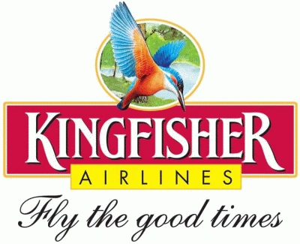

Collapse of companies

A Report by:

* Marwan ElSafty, 4690
* Omar Sherif, 5628

Under Supervision of:

* Dr. Wael Hassan

# Table of Contents

**Introduction** **2**

India’s Airline: 2

**Company’s Background** **3**

**Problem** **4**

The crisis: 4

Kingfisher acquire Air Deccan: 4

Problem Analysis: 4

Poor judgment and hasty decisions: 4

Excessive decisions: 5

Unused advantage: 5

Losing its own strength point: 5

Unwanted confusion: 6

Aircrafts (operational assets not fixed assets): 6

**Effect on the Company’s performance** **7**

Financial Analysis for the year 2011 7

Short Term Solvency Ratios: 7

Activity Ratios: 7

NB: the company doesn’t make production to any product so there is no product sales 7

and times of selling the inventory. 7

Financial Leverage Ratios: 8

Profitability : 8

Financial Analysis for the year 2011 9

Short Term Solvency Ratios: 9

Activity Ratios: 9

NB: the company doesn’t make production to any product so there is no product sales 9

and times of selling the inventory. 9

Financial Leverage Ratios: 10

Profitability : 10

*PS: all the negative values indicate loss not profit. 10

**Solution** **11**

**Conclusion** **12**

Years 2011 and 2012 were the worst years the company has faced so here are some comparisons between the available ratios: 12

# **Introduction**

## India’s Airline:

Air India and Indian airlines retained a monopoly over civil aviation in India until 1992. Air travel was patronised by the government, business and rich individuals and otherwise seen as a luxury, with the masses travelled by bus and train.The steady growth of the Indian economy after liberalisation at a compounded annual growth rate exceeding 6% increased the size of the economy, and hence demands for both business and leisure travel .

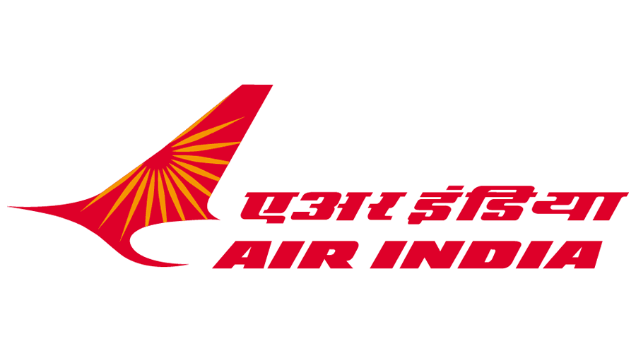

# 

# Company’s Background

Kingfisher rapidly morphed into a full service airline more in keeping with Mallya’s style and went head-on at Jetairways. By September 2007,Kingfisher had 34 aircrafts in its fleet and served 34 destinations.

Kingfisher Airlines began its operations on 9th May 2005 with its inaugural flight being from Mumbai to Delhi. Kingfisher’s income for the year ending in 30th June 2006 was INR 13.5 billion but this amount couldn’t overshadow losses amounting to INR 3.4 Billion. Soon it became an airline synonym with five star air travel and was becoming famous among business travellers.

Things were pretty much on the right track and were almost going as per plans.  
In 2008 it opened its own strength and unique selling point.

# Problem

Jetairways (a more stable carrier) surpassed Kingfisher’s airlines with market share of 25.5% whereas Kingfisher came down to 19.8%. In 2011 Kingfisher declared having some serious cash flow problems blaming the rise of fuel costs so they started not paying its dues to oil companies. Creditors warn them that if they fail to raise 159million in equity they won't be able to restructure its debt.

## The crisis:

In 2012, State Bank Of India (largest creditor of Kingfisher) declared Kingfisher Airlines as a non-performing asset.

Now Kingfisher Airlines all accounts stand frozen by banking agencies and export import houses due to non-payment of dues.

## Kingfisher acquire Air Deccan:

Kingfisher failed to Study the models carefully and blindly acquired Air Deccan. Kingfisher was a five star airliner then there was no reason to operate on two different business models at the same time. These were simply the over ambitious plans of the management of Kingfisher airlines.

The problem was that Kingfisher almost trashed all the marketing strategies of Air Deccan thinking of reducing the operational costs as Air Deccan had been in the market much before them; they thought it would bring their financial statements into green very soon.

## Problem Analysis:

### Poor judgment and hasty decisions:

Kingfisher failed to study the models carefully and blindly acquired Air Deccan . This is followed by unfulfilled studies or backing up their plans and examining if the two business models would go along. For Kingfisher, Air Deccan was a totally new business so it should have considered that Kingfisher Red will take some years to completely reap benefits of being a low cost carrier but Kingfisher believed that Air Deccan has been in the market much before Kingfisher Airlines so it should bring Kingfisher Airlines financial statements into green very soon.

### Excessive decisions:

Not only was the merge between the two companies poorly studied but also was unnecessary. Kingfisher was a five star airliner then there was no reason to operate on two different business models at the same time. These were simply the over ambitious plans of the management of Kingfisher Airlines.

Kingfisher Airlines was a favorite among business travelers hence it should have continued being a business centric airlines and even if it would have increased the prices say by ten per cent business travelers would have still travelled by Kingfisher only because they were sure of getting five star treatment along with on time departures and arrivals

### Unused advantage:

The primary way any low cost carrier makes money is by operating on non‐primary routes using secondary airports which reduces costs for the airlines and then the benefits are passed on to the customers unlike Kingfisher which charged low fare for Kingfisher Red but continued operating at prime routes including metros.

Kingfisher should have avoided flying even a single aircraft to metros and should have taken advantage of hundreds of uncommon routes and we all know that India is under penetrated market and much advantage could have been taken by exploring newer routes.

### Losing its own strength point:

Kingfisher most probably believed that people in majority are more important than people in minority but it forgot that there are four other players in the country serving the majority of people and it was the only one serving the minority and hence failed to capitalize upon its own strength and unique selling point (USP). The business fliers which were earlier loyal to Kingfisher Airlines used all their frequent flier miles, bought free tickets, gave the same to their family to enjoy and they never returned back to Kingfisher. For them Kingfisher Airlines became a compromised airliner and they started going back to Jet Airways which also is cash strapped but has a sustainable business model.

### Unwanted confusion:

Kingfisher requires double personnel just because of the fact that it operates aircrafts of two different makes. As mentioned before it used Airbus 320 but then wasted millions on ordering A‐380 jumbo aircrafts just to show dominance over other domestic airlines companies .This is absolutely an unwanted headache caused due to management’s poor decision making skills. If it would have relied only on Airbus then it could have easily reduced its operational costs.

### Aircrafts (operational assets not fixed assets):

Aircrafts are the most important assets of any airliner. Choosing and inducting the same requires major decision making skills. Kingfisher Airlines started with an Airbus A‐320 aircraft and went on using aircrafts on the same line. Now the business model of Kingfisher Airlines is such that it does not have any aircraft of its own. All the aircrafts of Kingfisher Airlines are dry leased. They have been offered a minimum of two years without insurance, crew, ground staff, supporting equipment, maintenance, etc.

The problem here is that aircrafts instead of being fixed assets for the airlines becomes an operational asset and plays a crucial role in cash flow calculations.

# Effect on the Company’s performance

## Financial Analysis for the year 2011

### Short Term Solvency Ratios:

**Current Ratio= Total Current Assets / Total Current Liabilities = 0.36 times**

* This means that the total current assets can cover the current liabilities 0.36 times per year only.

**Quick Ratio = Total Current Assets - Inventory / Total Current Liabilities = 0.32 times**

* This means that the current assets without the inventory cannot cover the current liabilities where it can only cover it 0.32 times per year

**Cash Ratio = Cash / Total Current Liabilities = 0.05 times**

* Cash can only cover current liabilities 0.05 times per year which is a very low Ratio.

### Activity Ratios:

**Total Assets Turnover = Total Operating Revenue / Total Average Assets = 0.77 times**

* This means that the company is not using its assets efficiently
* The airline makes 0.77 in sales to every 1 in assets.

**Receivables Turnover = Total Operating Revenue / Total Receivables = 14.14 times**

* This means that the company collects its receivables 14.14 times per year

**Days of Collection = 365 / 14.14 = 25.8 days**

* This means that the receivables are collected every 25.8 days

#### NB: the company doesn’t make production to any product so there is no product sales

#### and times of selling the inventory.

### Financial Leverage Ratios:

**Debt Ratio = Total Debt / Average Total Assets = 1.39 times**

- This means that every 1 RS assets is financed by 1.39 RS of debt which is so high.

**Equity Multiplier = Average Total Assets / Average Total Equity = 4.7 times**

**Interest Coverage = EBIT / Interest Expense = 0.38**

* This means that the firm has the ability to cover interest expense 0.38 time
* The interest coverage is below 1, this indicates the company is not generating sufficient revenues to satisfy the interest expense.

**Total Average Equity = 170090.255 RS**

* This ratio is used to measure the company’s financial leverage
* The higher this ratio it means that the company has been using more debt than equity

**Debt to Equity Ratio = Total Debt / Total Equity = 6.59 times**

* Which means that the firm has in every 1 RS equity , 6.59RS debt

### Profitability :

**Gross Profit Margin = EBIT / Total Operating Revenues= 0.014%**

* The business can extract 0.014 profit from its total sales after deducting COGS.

**Net Profit Margin = Net Income / Total Operating Revenues = 0.010**

* The net income that comes after paying all expenses represents 0.010% .

**Net Return On Assets = Net Income / Average Total Assets = 0.0079850**

* The business can generate 0.0079 net income from its total assets.

**Gross Return On Assets = EBIT / Average Total Assets = 0.001109%**

* The company can generate 0.0011 from its total assets.
* The ratio is very low; it indicates that using assets to generate earnings is not effective.

## Financial Analysis for the year 2011

### Short Term Solvency Ratios:

**Current Ratio = Total Current Assets / Total Current Liabilities = 0.19 times**

* This means that the total current assets can cover the current liabilities 0.19 times per year only.

**Quick Ratio = Total Current Assets - Inventory / Total Current Liabilities = 0.17 times**

* This means that the current assets without the inventory cannot cover the current liabilities where it can only cover it 0.17 times per year

**Cash Ratio = Cash / Total Current Liabilities = 0.02 times**

* Cash can only cover current liabilities 0.02 times per year which is a very low ratio.

### Activity Ratios:

**Total Assets Turnover = Total Operating Revenue / Total Average Assets = 0.63 times**

* This means that the company is not using its assets efficiently
* The airline makes 0.63 in sales to every 1 in assets.

**Receivables Turnover = Total Operating Revenue / Total Average Receivables = 17.5 times**

* This means that the company collects its receivables 17.5 times per year

**Days of Collection= 365/ 17.5 = 20.86 days**

* This means that the receivables are collected every 20.86 days

#### NB: the company doesn’t make production to any product so there is no product sales

#### and times of selling the inventory.

### Financial Leverage Ratios:

**Debt Ratio= Total Debt/ Average Total Assets = 1.63 times**

* This means that every 1 RS assets is financed by 1.63RS of debt which is so high.

**Equity Multiplier= Average Total Assets/ Average Total Equity = 2.16 times**

* This ratio is used to measure the company’s financial leverage
* The higher this ratio it means that the company has been using more debt than equity

**Interest Coverage = EBIT / Interest Expense = -1.699**

* This means that the firm has the ability to cover interest expense 0.38 time
* The interest coverage is below 1, this indicates the company is not generating sufficient revenues to satisfy the interest expense.

**Debt to Equity Ratio = Total Debt / Total Equity = 3.5 times**

* Which means that the firm has in every 1 RS equity, 3.5 RS debt

### Profitability :

**Net Return on Assets = Net Income / Average Total Assets = 0.0067199**

* The company gets 0.00067 net income from its total assets.

**Gross Return on Assets = EBIT / Average Total Assets = -0.0025027**

* The company can generate -0.0025 from its total assets.
* The ratio is very low; it indicates that using assets to generate earnings is not effective.

**Net Profit Margin = Net Income/ Total Operating Revenues = 0.01**

* The net income that comes after paying all expenses represents 0.01% .

**Gross Profit Margin = EBIT / Total Operating Revenue = -0.0039497**

* The business can extract -0.0039 profit from its total sales after deducting COGS.

#### *PS: all the negative values indicate loss not profit.

# Solution

Obviously, KingFisher have exhibited a strong case of financial mismanagement that has led to their imminent unofficial bankruptcy. However, there are a few potential steps to be taken by the airline to improve their situation in the airline market.

KingFisher are currently suffering from severe debt that has crippled their activity and has already led to losses in the range of Rs.6,524 crores and an almost equal amount in outstanding loans.Therefore, they need a huge cash induction by promoters or stakeholders that would pave the path into finally paying off their debts to oil companies, the IATA(International Air Transport Association) so that they can at least carry on providing regular flights at reasonable prices to their few remaining loyal customers.

On a second but not any less important point, fresh capital is urgently needed, and despite banks giving KingFisher a huge cash induction that was eventually converted to shares last year, this will probably not be repeated anytime soon as KingFisher’s shares have hit rock bottom in the market, meaning that their market value is at its lowest and that promoters and stakeholders can only ask for funds based on their personal guarantee.

Assurances need to be offered to any potential future investors.These assurances can only be made based on a well founded plan to restructure the entire failing business model that has led to their downfall.Once a new model has ben set, investors will at least have reason to expect an improvement, however slight, in the company’s fortunes.

To avoid any future losses and debt, no more requests for planes or major city airport accommodations should be made. This would help generate better cash flow because of the reduced costs. The focus should be on minor airports and achieving the best they could with the fleet on hand. The decrease in operational cost pressure will decrease risk factors for investing into the company.

Some other risks must be addressed urgently. At the fore is the issue of staff and pilots not being paid(at least on a regular basis). Not only does this cause unrest among the families, but it will only result in an even bigger crisis eventually.

Assurances need to be given to pilots, staff and their families in order avoid unneeded mishaps.

A possible step that can be made is a request to be made to the government for oil companies to provide tax free aviation. This will finally help KingFisher to expand their flights to a degree comparable to their earlier years. This also might apply to their frozen assets in the Reserve Bank of India being released for a certain period of time with guarantees until they form a proper restructuring plan.

# Conclusion

* The returned earnings and cash dividends are also unavailable due to lack of enough earnings.
* Creditors warned the firm in 2011 that if they could raise 159 million USD they won’t be able to restructure their debt after the crisis they had indulged themselves into with petrol companies when the fuel prices increased and they couldn’t pay.
* The company chose once more the wrong path until in 2012 the state bank of India stated that Kingfisher airlines is a non performing asset anymore after that their bank account has been frozen and the company was unofficially bankrupt but officially working with no fund.

### Years 2011 and 2012 were the worst years the company has faced so here are some comparisons between the available ratios:

* The short solvency ratios of 2011 are a bit better than 2012 although in both cases the company can’t fulfill its current liabilities with its current assets.
* For the activity ratios, assets in 2011 are working more than 2012 but also with a slight difference and both are not enough.
* Company has high ratios of trade receivables in which it collects its receivables form trade every 20 to 22 days, 2012 collects them a bit faster.
* Company depended on debt more than equity to get assets in both years but with the curve going down it depends on debt even more in 2012.
* The company works till now to pay all its debts and all the profit goes to the bank.