**Adidas AG Inc.**

Specialized Scientific Programs

Foundations of marketing

(Spring 2020)

Faculty of Engineering

University of Alexandria

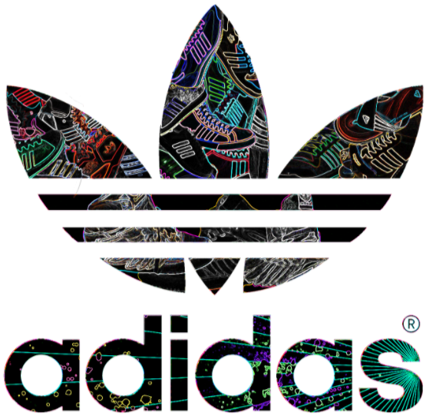

[Seif eldin Tarek] [ID: 5251]

[Marwan Khaled Shalaby] [ID: 5880]

[Raghda Sallam] [ID: 5837]

[Ibrahim Mostafa Ibrahim] [ID: 4715]

[Mayar Mostafa Kamel] [ID: 5502]

Instructor:

Dr. Abeer Hassan Ramadan

**Contents**

1 Introduction: 2

1.1 Profile: 2

1.1.1 Description: [1] 2

1.1.2 Contacts and Headquarters: [1] 3

1.1.3 People: [2] 5

1.2 Top executives: [1] 6

1.2.1 The executive board: 6

1.2.2 The supervisory board: 6

1.3 History: [1] 8

2 Product: 9

2.1 Categories: 9

2.1.1 Apparel: 9

2.1.2 Sportswear: 9

2.1.3 Accessories. 9

2.2 Features: 10

2.3 Quality: 10

References 11

# Introduction:

## Profile:

### Description: [1]

Adidas [AG](https://en.wikipedia.org/wiki/Aktiengesellschaft) is a German [multinational corporation](https://en.wikipedia.org/wiki/Multinational_corporation), founded and headquartered in [Herzogenaurach](https://en.wikipedia.org/wiki/Herzogenaurach), [Germany](https://en.wikipedia.org/wiki/Germany), that designs and manufactures shoes, clothing and accessories. It is the largest [sportswear](https://en.wikipedia.org/wiki/Sportswear_(activewear)) manufacturer in Europe, and the second largest in the world, after [Nike](https://en.wikipedia.org/wiki/Nike,_Inc.). [3]

It is the [holding company](https://en.wikipedia.org/wiki/Holding_company) for the Adidas Group, which consists of the [Reebok](https://en.wikipedia.org/wiki/Reebok) sportswear company, 8.33% of the German football club [Bayern München](https://en.wikipedia.org/wiki/FC_Bayern_Munich), and [Runtastic](https://en.wikipedia.org/wiki/Runtastic), an Austrian fitness technology company.

The company has products for specific athletic use such as training, running and soccer. Kid’s products are also available. The company provide products for casual use.

### Contacts and Headquarters: [1]

Website: [adidas - Home (adidas-group.com)](https://www.adidas-group.com/en/)

Key locations:

* 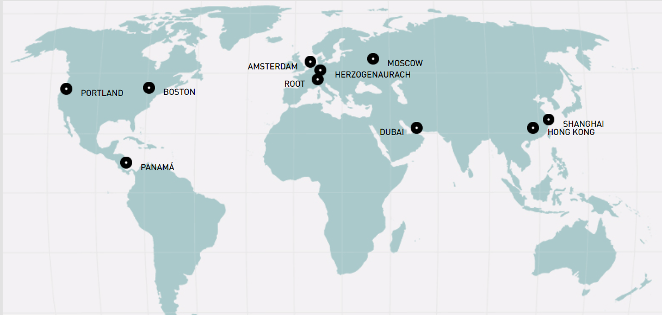Portland, Boston, Panama, Root, Moscow, Dubai, Shanghai and Hong Kong where The lead is taken from the global HQ in Herzogenaurach (Germany):

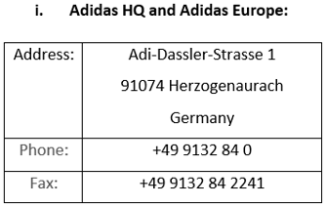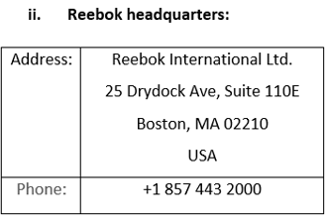

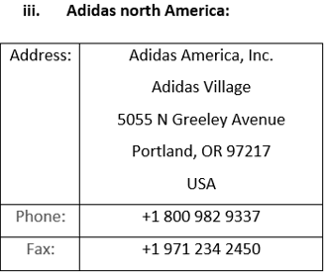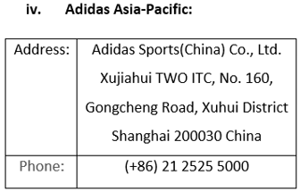

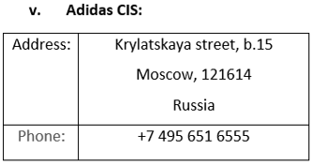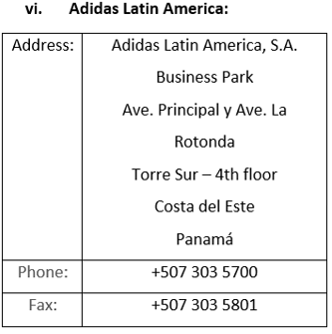

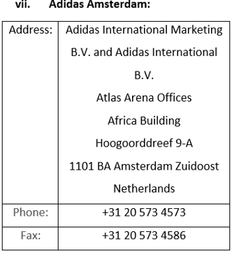

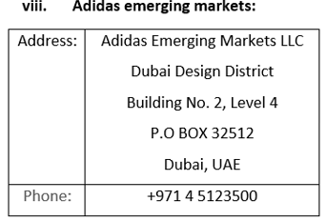

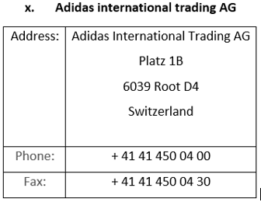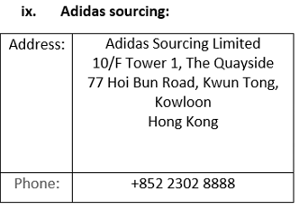

### People: [2]

Adidas has its roots in Germany but we are a truly global company. Around the world they employ over 59,000 people. [1]

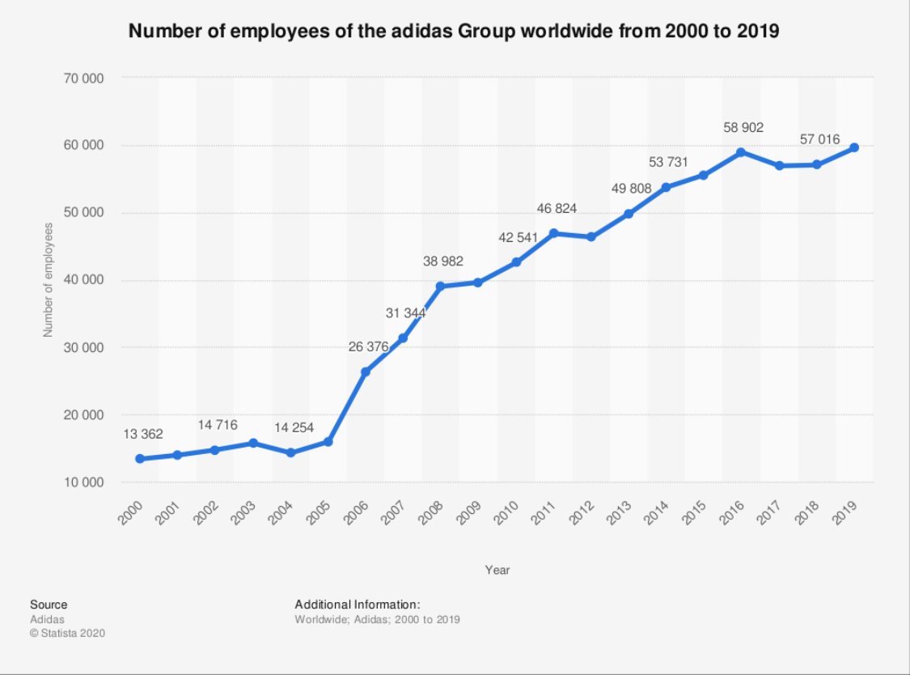

## Top executives: [1]

### The executive board:

* KASPER RORSTED - CHIEF EXECUTIVE OFFICER
* ROLAND AUSCHEL - GLOBAL SALES
* BRIAN GREVY - GLOBAL BRANDS
* HARM OHLMEYER – FINANCE
* MARTIN SHANKLAND - GLOBAL OPERATIONS

### The supervisory board:

* **THOMAS RABE:**

Chairman and Chief Executive Officer, Bertelsmann Management SE, Gütersloh, Germany

* **IAN GALLIENNE - DEPUTY CHAIRMAN**

Chief Executive Officer, Groupe Bruxelles Lambert, Brussels, Belgium

* **UDO MUELLER* - DEPUTY CHAIRMAN**

Manager History Management, Adidas AG, Herzogenaurach, Germany

* **PETRA AUERBACHER\***

Project Manager Creative Direction, Adidas AG, Herzogenaurach, Germany

* **ROSWITHA HERMANN\***

Director Projects, adidas AG, Herzogenaurach, Germany

* **HERBERT KAUFFMANN**

Independent Management Consultant, Stuttgart, Germany

* **CHRISTIAN KLEIN**

Chief Executive Officer (CEO), SAP SE, Walldorf, Germany

* **KATHRIN MENGES**

Self-employed Entrepreneur, Großenbrode, Germany

* **ROLAND NOSKO\***

District Manager of the Industrial Union IG Bergbau, Chemie, Energie, District of Nuremberg, Nuremberg, Germany

* **BEATE ROHRIG\***

State District Manager of the Industrial Union IG Bergbau, Chemie, Energie, State District Bavaria, Munich, Germany

* **NASSEF SAWIRIS**

Chief Executive Officer and Member of the Board of Directors, OCI N.V., Amsterdam, The Netherlands

* **FRANK SCHEIDERER**

Director Head Office – Brand & Sales Finance, adidas AG, Herzogenaurach, Germany

* **MICHAEL STORL**

Deputy Chairman of the Works Council Herzogenaurach, adidas AG, Herzogenaurach, Germany

* **BODO UEBBER**

Independent Management Consultant, Munich, Germany

* **JING ULRICH**

Vice Chairman of Global Banking and Asia Pacific, JPMorgan Chase & Co., New York, USA

* **GUENTER WEIGL**

Senior Vice President Global Sports Marketing & Brand Relations, adidas AG, Herzogenaurach, Germany

## History: [1]

Adidas’ great story started in a small town in Bavaria, Germany.

Adi Dassler registered the “Gebrüder Dassler Schuhfabrik” in 1924 and embarked on his mission to provide athletes with the best possible equipment after his first steps in his mother’s kitchen, where Gold medals in Amsterdam (1928, Lina Radke) and Berlin were first rewards and milestones –not only the start of the story-.

Later on, the association football (soccer) players switched to the company’s shoes, which were light in weight and featured screw-in cleats, Adidas grew steadily during the 1950s.

In 1963, the company created a line of sporting goods, introducing soccer footballs. Four years later, Adidas has been the biggest name in athletic shoes for many years, but competition particularly from newer companies such as Nike, increased during the 1970.

Adidas was owned by the scandal-tinted French business executive Bernard Tapie between 1990 and 1993, who failed to revive it.

The company was sold to investors who, as chief executive officer and chairman, had brought in another Frenchman, Robert louis-Dreyfus. Adidas acquired the Salomon group under his leadership in 1997. Although best known for winter sports products, the golf supplier TaylorMade was also owned by Salomon.

Adidas was renamed Adidas-Salomon AG and, following Nike’s lead, moved into retailing in 2001.

In 2004, the firm entered into a successful partnership with Stella McCartney, a clothing designer.

Adidas sold Salomon in 2005. But retained the TaylorMade brand. The corporate name was changed back to Adidas AG the following year. Subsequent acquisitions by Adidas included the Reebok Company (2006), which owned the shoe brand Rockport.  
Adidas sold TaylorMade in 2017.

# Product:

## Categories:

**Products offered by Adidas Brand is focused in three key categories:**

### Apparel:

As Adidas sells a range of clothing items, varying from men's and women's [t-shirts](https://en.wikipedia.org/wiki/T-shirt), [jackets](https://en.wikipedia.org/wiki/Jacket), [hoodies](https://en.wikipedia.org/wiki/Hoodie), [pants](https://en.wikipedia.org/wiki/Pants) and [leggings](https://en.wikipedia.org/wiki/Leggings). [4]

### Sportswear:

1. Association football
2. Basketball
3. Baseball
4. Cricket
5. Golf
6. Gymnastics
7. Ice hockey
8. Lacrosse
9. Running
10. Skateboarding
11. Tennis

### Accessories.

Slide style sandals, mobile accessories, watches, eyewear, bags, baseball caps, and socks are also made and designed by adidas.

Adidas now has a branded line of deodorants, perfumes, aftershave and lotions for men and women.

## Features:

The athletic footwear products of Adidas are primarily intended for a particular athletic use,  
Adidas places considerable emphasis on innovation and high-quality although a large percentage of the products are worn for casual or leisure use.

Adidas places considerable emphasis on innovation and high-quality construction in the development and production of products.

## Quality:

Product safety is a necessity! As a business, Adidas have to manage the risk of selling faulty products that can harm customers and/or impair their image.

Adidas have company-wide product safety policies in place to mitigate this risk, ensuring that

they consistently apply physical, chemical product safety and conformity standards across all

the company's brands.

To ensure the quality of the product and consumer-safe products, all materials and product samples must pass a rigid compliance process and are tested in accordance with standardized specifications and procedures for material and product testing.

# References

1. [adidas - adidas (adidas-group.com)](https://www.adidas-group.com/en/brands/adidas/)
2. (<https://www.statista.com/statistics>)
3. [Adidas Company Profile, News, Rankings | Fortune | Fortune](https://fortune.com/company/adidas/global500/)
4. [Adidas may have underestimated Tiger, this private equity firm may win (cnbc.com)](https://www.cnbc.com/2019/04/15/adidas-may-have-underestimated-tiger-this-private-equity-firm-may-win.html)