**Adidas AG Inc.**

Specialized Scientific Programs

Foundations of marketing

(Spring 2020)

Faculty of Engineering

University of Alexandria

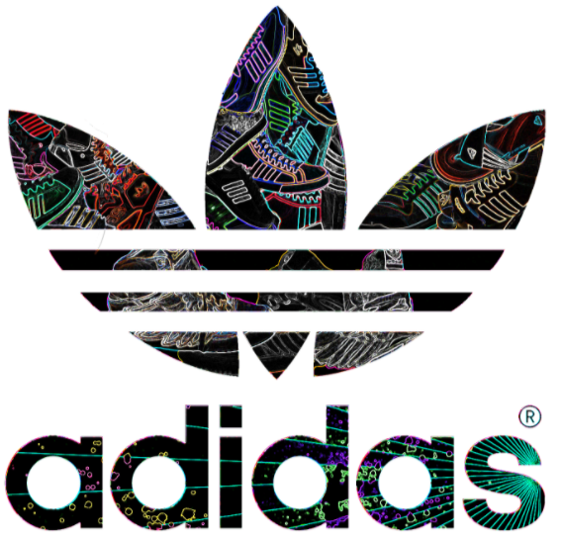

[Seif eldin Tarek] [ID: 5251]

[Marwan Khaled Shalaby] [ID: 5880]

[Raghda Sallam] [ID: 5837]

[Ibrahim Mostafa Ibrahim] [ID: 4715]

[Mayar Mostafa Kamel] [ID: 5502]

Instructor:

Dr. Abeer Hassan Ramadan

**Contents**

1 Introduction: 3

1.1 Profile: 3

1.1.1 Description: [1] 3

1.1.2 Contacts and Headquarters: [1] 4

1.1.3 People: [2] 6

1.2 Top executives: [1] 7

1.2.1 The executive board: 7

1.2.2 The supervisory board: 7

1.3 History: [1] 9

2 Product: 10

2.1 Categories: 10

2.1.1 Apparel: 10

2.1.2 Sportswear: 10

2.1.3 Accessories. 11

2.2 Features: 11

2.3 Quality: 11

3 Branding Department 12

3.1 Management 12

3.2 Organizational structure, managers and employees 12

4 Marketing Function 13

4.1 Research 13

4.2 Branding 13

4.3 Promotion 13

4.3.1 Sales 14

4.3.2 Public Relations 14

4.3.3 Advertising 14

4.3.4 Distribution 15

5 Key Competitors, Position and Marketing Strategy Overview 15

5.1 Key Competitors 15

5.1.1 Nike 15

5.1.2 Reebok 15

5.1.3 ASICS (Anime Senea In Corpore Sano) 15

5.1.4 Puma 15

5.1.5 Under Armor 16

5.1.6 Fila 16

5.1.7 Anta 16

5.1.8 New Balance 16

5.1.9 Sketchers 16

5.2 Adidas Position 16

5.3 Marketing strategy overview 17

5.3.1 Marketing mix (4Ps) 17

5.3.2 SWOT analysis 17

References 18

# Introduction:

## Profile:

### Description: [1]

Adidas [AG](https://en.wikipedia.org/wiki/Aktiengesellschaft) is a German [multinational corporation](https://en.wikipedia.org/wiki/Multinational_corporation), founded and headquartered in [Herzogenaurach](https://en.wikipedia.org/wiki/Herzogenaurach), [Germany](https://en.wikipedia.org/wiki/Germany), that designs and manufactures shoes, clothing and accessories. It is the largest [sportswear](https://en.wikipedia.org/wiki/Sportswear_(activewear)) manufacturer in Europe, and the second largest in the world, after [Nike](https://en.wikipedia.org/wiki/Nike,_Inc.). [3]

It is the [holding company](https://en.wikipedia.org/wiki/Holding_company) for the Adidas Group, which consists of the [Reebok](https://en.wikipedia.org/wiki/Reebok) sportswear company, 8.33% of the German football club [Bayern München](https://en.wikipedia.org/wiki/FC_Bayern_Munich), and [Runtastic](https://en.wikipedia.org/wiki/Runtastic" \o "Runtastic), an Austrian fitness technology company.

The company has products for specific athletic use such as training, running and soccer. Kid’s products are also available. The company provide products for casual use.

### Contacts and Headquarters: [1]

Website: [adidas - Home (adidas-group.com)](https://www.adidas-group.com/en/)

Key locations:

* Portland, Boston, Panama, Root, Moscow, Dubai, Shanghai and Hong Kong where The lead is taken from the global HQ in Herzogenaurach (Germany):

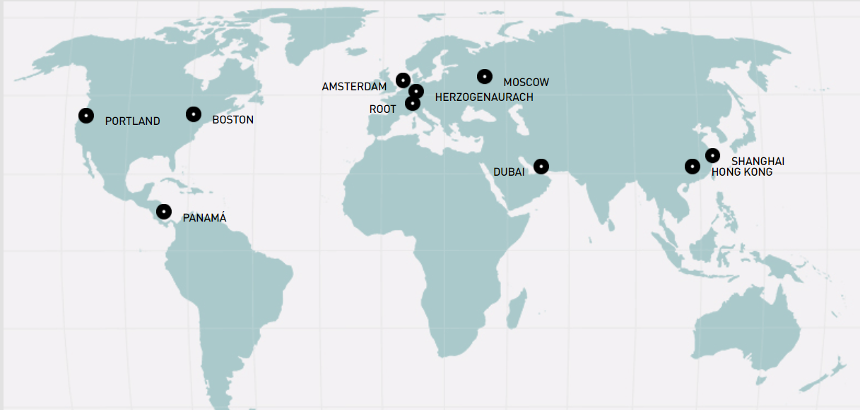

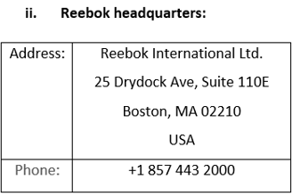

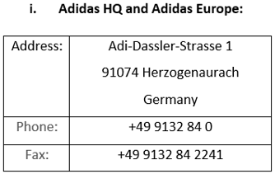

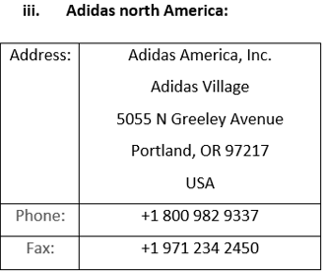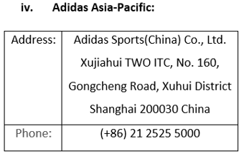

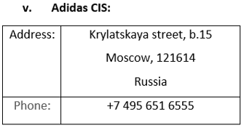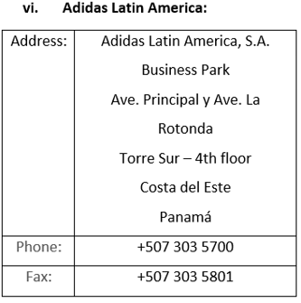

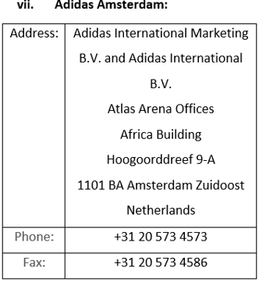

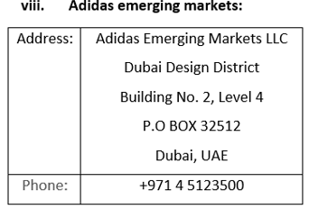

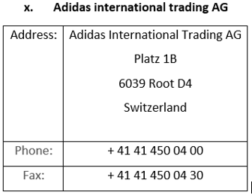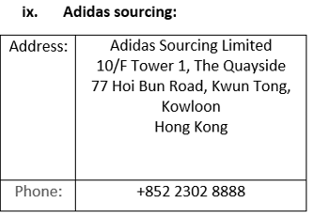

### People: [2]

Adidas has its roots in Germany but we are a truly global company. Around the world they employ over 59,000 people. [1]

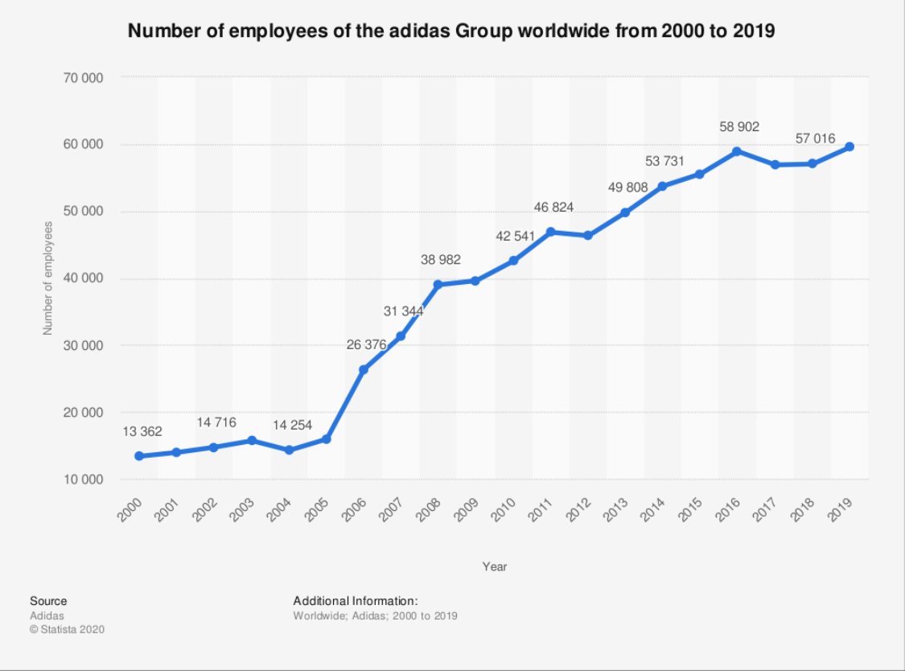

## Top executives: [1]

### The executive board:

* KASPER RORSTED - CHIEF EXECUTIVE OFFICER
* ROLAND AUSCHEL - GLOBAL SALES
* BRIAN GREVY - GLOBAL BRANDS
* HARM OHLMEYER – FINANCE
* MARTIN SHANKLAND - GLOBAL OPERATIONS

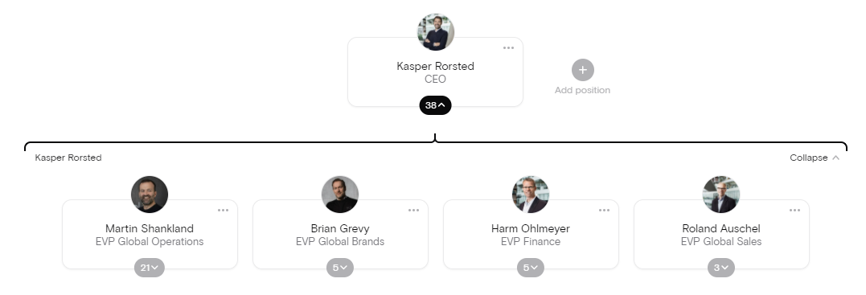

### The supervisory board:

* **THOMAS RABE:**

Chairman and Chief Executive Officer, Bertelsmann Management SE, Gütersloh, Germany

* **IAN GALLIENNE - DEPUTY CHAIRMAN**

Chief Executive Officer, Groupe Bruxelles Lambert, Brussels, Belgium

* **UDO MUELLER* - DEPUTY CHAIRMAN**

Manager History Management, Adidas AG, Herzogenaurach, Germany

* **PETRA AUERBACHER\***

Project Manager Creative Direction, Adidas AG, Herzogenaurach, Germany

* **ROSWITHA HERMANN\***

Director Projects, adidas AG, Herzogenaurach, Germany

* **HERBERT KAUFFMANN**

Independent Management Consultant, Stuttgart, Germany

* **CHRISTIAN KLEIN**

Chief Executive Officer (CEO), SAP SE, Walldorf, Germany

* **KATHRIN MENGES**

Self-employed Entrepreneur, Großenbrode, Germany

* **ROLAND NOSKO\***

District Manager of the Industrial Union IG Bergbau, Chemie, Energie, District of Nuremberg, Nuremberg, Germany

* **BEATE ROHRIG\***

State District Manager of the Industrial Union IG Bergbau, Chemie, Energie, State District Bavaria, Munich, Germany

* **NASSEF SAWIRIS**

Chief Executive Officer and Member of the Board of Directors, OCI N.V., Amsterdam, The Netherlands

* **FRANK SCHEIDERER**

Director Head Office – Brand & Sales Finance, adidas AG, Herzogenaurach, Germany

* **MICHAEL STORL**

Deputy Chairman of the Works Council Herzogenaurach, adidas AG, Herzogenaurach, Germany

* **BODO UEBBER**

Independent Management Consultant, Munich, Germany

* **JING ULRICH**

Vice Chairman of Global Banking and Asia Pacific, JPMorgan Chase & Co., New York, USA

* **GUENTER WEIGL**

Senior Vice President Global Sports Marketing & Brand Relations, adidas AG, Herzogenaurach, Germany

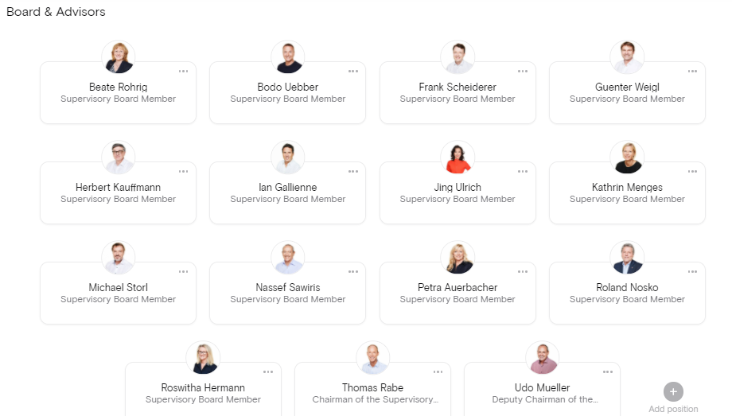

## History: [1]

Adidas’ great story started in a small town in Bavaria, Germany.

Adi Dassler registered the “Gebrüder Dassler Schuhfabrik” in 1924 and embarked on his mission to provide athletes with the best possible equipment after his first steps in his mother’s kitchen, where Gold medals in Amsterdam (1928, Lina Radke) and Berlin were first rewards and milestones –not only the start of the story-.

Later on, the association football (soccer) players switched to the company’s shoes, which were light in weight and featured screw-in cleats, Adidas grew steadily during the 1950s.

In 1963, the company created a line of sporting goods, introducing soccer footballs. Four years later, Adidas has been the biggest name in athletic shoes for many years, but competition particularly from newer companies such as Nike, increased during the 1970.

Adidas was owned by the scandal-tinted French business executive Bernard Tapie between 1990 and 1993, who failed to revive it.

The company was sold to investors who, as chief executive officer and chairman, had brought in another Frenchman, Robert louis-Dreyfus. Adidas acquired the Salomon group under his leadership in 1997. Although best known for winter sports products, the golf supplier TaylorMade was also owned by Salomon.

Adidas was renamed Adidas-Salomon AG and, following Nike’s lead, moved into retailing in 2001.

In 2004, the firm entered into a successful partnership with Stella McCartney, a clothing designer.

Adidas sold Salomon in 2005. But retained the TaylorMade brand. The corporate name was changed back to Adidas AG the following year. Subsequent acquisitions by Adidas included the Reebok Company (2006), which owned the shoe brand Rockport.  
Adidas sold TaylorMade in 2017.

# Product:

## Categories:

**Products offered by Adidas Brand is focused in three key categories:**

### Apparel:

As Adidas sells a range of clothing items, varying from men's and women's [t-shirts](https://en.wikipedia.org/wiki/T-shirt), [jackets](https://en.wikipedia.org/wiki/Jacket), [hoodies](https://en.wikipedia.org/wiki/Hoodie), [pants](https://en.wikipedia.org/wiki/Pants) and [leggings](https://en.wikipedia.org/wiki/Leggings). [4]

### Sportswear:

1. Association football
2. Basketball
3. Baseball
4. Cricket
5. Golf
6. Gymnastics
7. Ice hockey
8. Lacrosse
9. Running
10. Skateboarding
11. Tennis

### Accessories.

Slide style sandals, mobile accessories, watches, eyewear, bags, baseball caps, and socks are also made and designed by adidas.

Adidas now has a branded line of deodorants, perfumes, aftershave and lotions for men and women.

## Features:

The athletic footwear products of Adidas are primarily intended for a particular athletic use,  
Adidas places considerable emphasis on innovation and high-quality although a large percentage of the products are worn for casual or leisure use.

Adidas places considerable emphasis on innovation and high-quality construction in the development and production of products.

## Quality:

Product safety is a necessity! As a business, Adidas have to manage the risk of selling faulty products that can harm customers and/or impair their image.

Adidas have company-wide product safety policies in place to mitigate this risk, ensuring that

they consistently apply physical, chemical product safety and conformity standards across all

the company's brands.

To ensure the quality of the product and consumer-safe products, all materials and product samples must pass a rigid compliance process and are tested in accordance with standardized specifications and procedures for material and product testing.

# Branding Department

## Management

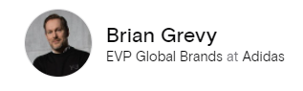Brian Grevy was born in Kolding, Denmark, in 1971 and is a Danish citizen. After his studies at the Business School in Vejle, Denmark, he held various leadership positions at adidas and Reebok Nordics between 1998 and 2006. In 2006, he transferred to the adidas Headquarters in Herzogenaurach, Germany, to become Director Men's Training and, as of 2010, Senior Vice President Training & Regional Sports. From 2012 to 2014, Brian Grevy acted as General Manager adidas Nordics in Stockholm, Sweden. During the years 2014 to 2016, he led the adidas Business Unit Training as General Manager in Herzogenaurach, Germany. Between 2016 and 2019, he was CMO and, most recently, CEO at GANT in Stockholm, Sweden. In 2020, Brian Grevy was appointed to the adidas Executive Board and is responsible for Global Brands.

## Organizational structure, managers and employees

The branding department is divided into several positions such as; Brand operation, Brand Communications, Event marketing, Global Sports Marketing and Global brand design the organizational structure is shown.

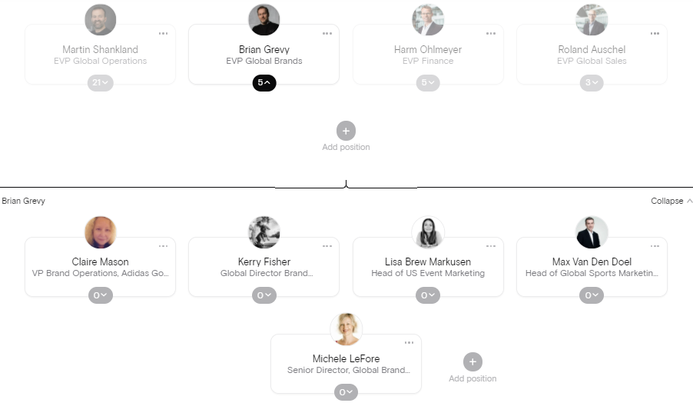

# Marketing Function

## Research

Adidas has a world class sport research lab with more than 40 researchers from different branches (biomedical engineering, biomechanical, physics, math, kinesiology, mechanical engineering and systems science). Their target is to create innovation of product to athletes everywhere through the use of science and technology by testing how to reduce injury risk and reach evolution in perception and feel. This offers the customer innovated products to give comfort and feel unique and support their products.

## Branding

Faf

## Promotion

The company made a lot of promotions which considered one of the “4P” elements to reach the market (marketing mix: product, price, place, promotion) and attract new customers or keep trust of its customers as advertisements either posters, on television of social media which is simple, but send a strong message, or by special offers, using celebrities and salesmen. This result in high revenues and attract companies to ask for sponsorship from it, all these elements mentioned known as: **“Promotion mix”**. Promotion mix include (sales, public relations and advertising).

### Sales

* Personal Selling

The company offers a trained sales staff to help the customer in making the best decision by introducing the products features and select the right product through personalized service. Customers experience support the sales, as they feel that was a better decision and recommend the product. This improve sales and help in building a relationship with customers.

* Direct Marketing

The company uses direct marketing to promote new products, using not only strong advertising, but also through sales people to reach target consumers either organizations or individuals (Example: sports organizations in college). This motivate target customers to purchase the company’s product and support sales.

* Sales Promotion

The company offers coupons and special offers which will give benefits to target consumers, as discounts or buying other free products. This motivates target customers and attract new ones, as they would be motivated by the product on basis of perceived benefits.

### Public Relations

he company uses public relations to address social issues related to its business as using sweatshops and improving green technology. Also, uses public relations at sport events and similar activities by sponsoring it. This is done to communicate with target customer to show business address relevant social issues, which promote the brand and give potential customers a better perception about brand and its products.

### Advertising

The company uses advertising to reach a great impact on large populations of target audiences. This is done through representing the products via well-known celebrities and famous athletes (Example: Muhammed Ali Klay, the boxer and David Beckham, the footballer). This motivates the target audience when watching his celebrity uses the brand, to try it and build a strong brand image of the company products which reach rewards and high demand, so they focus on their famous sports man country as a brand ambassador for marketing their products. This help to promote the brand.

### Distribution

The company distribute its products using different channels as resellers, super markets, e- commerce sites, retailers and company owned outlets to about 200 country over the world (425 brand factory store, 82 online store, 79 Converse store and 18 Hurley store), and its planning to open more stores and franchises to reach the target consumer and expand the buyers. This will lead to availability of products to satisfy consumer need and so increase the sales through distribution methods.

# Key Competitors, Position and Marketing Strategy Overview

## Key Competitors

Sports equipment, foot and sports’ wear have a wide range of competitors. Adidas top key competitors are especially Nike and Reebok regarding the foot wear, while other brand concentrate on other product and here are common Adidas top key competitors and their positions in 2018:

### Nike

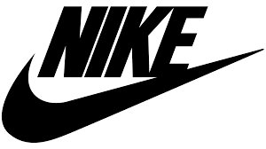The company was founded on January 25, 1964, as "Blue Ribbon Sports", by Bill Bowerman and Phil Knight, and officially became Nike, Inc. on May 30, 1971. It is occupy the “ 1ST “ place before Adidas in sport shoe sales. In 2019 it reaches 39.4$ billion with its 77,000 employees.

### Reebok

It is a subside company of Adidas work independently with 3$ billion worldwide revenue, considered “ 3rd “ ranking sport worldwide.

### ASICS (Anime Senea In Corpore Sano)

Founded in Kobe, Japan in 1949 with the first release of basketball shoes. Its total revenue 2.9$ billion and considered also in the “ 3rd “ ranking sport worldwide.

### Puma

Founded by Rudolf Dassler (Adidas founder brother) in Germany in 1948, employing 3000 employee with 2.5$ billion reaching the “ 4th “ place worldwide.

### Under Armor

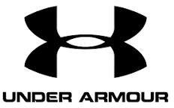Founded by Kevin Plank in Martland, USA in 1995starting with comfortable and light T-shirts, employing 15,000 employee with 1.1$ billion. The company compete with Nike sportswear especially.

### Fila

Founded in Pedemonte, Italy, by Fila Korea in 1911. It is part of Anta sports group and it is fighting for the fourth place in global ranking of sports brands by targeting a1.2$ billion revenue the next years.

### Anta

Founded in china in 1991, ranks “third in the market share” behind Nike and Adidas with 25,000 employee and revenue 1.08$ billion.

### New Balance

The company considered a strong Nike competitor in US and UK, as it is a private American company found in Boston in 1906 with 4.5$ billion revenue.

### Sketchers

Founded by Robert Green in California, US in 1992. With 12,600 employee and 4.5$ annual revenue.

## Adidas Position

Adidas considered a company that produce products with high quality and sell them with high price. Adidas top competitor Nike reaches 34.6$ billion and in 2019 it reaches 39.4$ billion with its 77,000 employees. Adidas is ranked the “2nd“among its competitors and considered from the leading of footwear market as footwear sales is maximum in total Adidas sales.



## Marketing strategy overview

The company follows an excellent marketing strategy that focuses on:

1. Costumer’s interests and demands (by producing sneakers shoes for young and old).

2. Using new technologies.

3. Sustained development of product over world which increase the market share and expand in the world

4. Products of high quality and low cost

5. Increase profits and sales annually by a percentage

### Marketing mix (4Ps)

* Product

Adidas offers a product to satisfy the customers need with its high quality and innovation from researchers.

* Price

Adidas follow value based pricing depending on the customer as he will pay more for the high quality and unique products. The company target customers who had enough money to but their products.

* Place

The company distribute itself all over the world to increase its sales and still aiming to have more stores.

* Promotion

As mentioned previously, the company offers a lot of promotions to attract customers as advertising, personal selling, direct marketing, public relations, social responsibility and reaching social media.

### SWOT analysis

* Strength
* Strong brand awareness
* Huge customer base
* Aimed for sustainability
* Superior marketing celebrities
* Side brands
* Low manufacturing cost
* Iconic relationship
* Weakness
* Poor labor conditions
* Pending debts
* Lawsuits
* Women sexual harassment
* Opportunity
* Emerging markets
* Innovative products
* Efficient integration
* Threats
* Increased competitive pressure
* Marketing budget pressure
* Currency foreign exchange risks
* Counterfeit products

# References

1. [adidas - adidas (adidas-group.com)](https://www.adidas-group.com/en/brands/adidas/)
2. (<https://www.statista.com/statistics>)
3. [Adidas Company Profile, News, Rankings | Fortune | Fortune](https://fortune.com/company/adidas/global500/)
4. [Adidas may have underestimated Tiger, this private equity firm may win (cnbc.com)](https://www.cnbc.com/2019/04/15/adidas-may-have-underestimated-tiger-this-private-equity-firm-may-win.html)
5. <https://theorg.com/org/adidas/org-chart>