**Adidas AG Inc.**

Faculty of Engineering

University of Alexandria

Specialized Scientific Programs

Foundations of marketing

(Spring 2020)

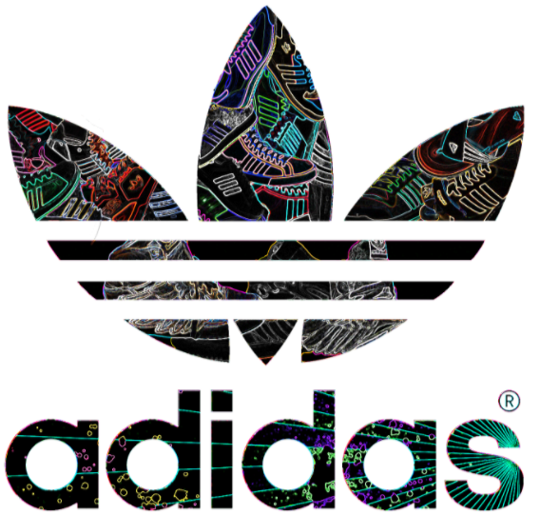

[Seif eldin Tarek] [ID: 5251]

[Marwan Khaled Shalaby] [ID: 5880]

[Raghda Sallam] [ID: 5837]

[Ibrahim Mostafa Ibrahim] [ID: 4715]

[Mayar Mostafa Kamel] [ID: 5502]

Instructor:

Dr. Abeer Hassan Ramadan

**Contents**

1 Introduction: 4

1.1 Profile: 4

1.1.1 Description: [1] 4

1.1.2 Contacts and Headquarters: [1] 4

1.1.3 People: [2] 6

1.2 Top executives: [1] 7

1.2.1 The executive board: 7

1.2.2 The supervisory board: 8

1.3 History: [1] 10

2 Product: 11

2.1 Categories: 11

2.1.1 Apparel: 11

2.1.2 Sportswear: 11

2.1.3 Accessories. 12

2.2 Features: 12

2.3 Quality: 12

3 Branding Department 13

3.1 Management 13

3.2 Organizational structure, managers and employees 13

4 Marketing Function 14

4.1 Research 14

4.2 Branding 14

4.3 Promotion 15

4.3.1 Sales 15

4.3.2 Public Relations 16

4.3.3 Advertising 16

4.3.4 Distribution 16

5 Key Competitors, Position and Marketing Strategy Overview 16

5.1 Key Competitors 16

5.1.1 Nike 17

5.1.2 Reebok 17

5.1.3 ASICS (Anime Senea In Corpore Sano) 17

5.1.4 Puma 17

5.1.5 Under Armor 17

5.1.6 Fila 17

5.1.7 Anta 17

5.1.8 New Balance 17

5.1.9 Sketchers 17

5.2 Adidas Position 18

5.3 Marketing strategy overview 18

5.3.1 Marketing mix (4Ps) 18

5.3.2 SWOT analysis 19

6. Distribution strategy 19

5.3 distribution channel 20

6.1.1 Main distribution channel 20

6.1.2 Product manufacturing and distribution 21

6.2 Distribution conflict 22

7. Social responsibilties 23

7.1 recycling 23

7.2 Labor condition 23

7.3 Animal welfare 24

8. Marketing process 25

8.1Traditional Marketing process 25

8.2 New Marketing process 26

References 28

# Introduction:

## Profile:

### Description: [1]

Adidas [AG](https://en.wikipedia.org/wiki/Aktiengesellschaft) is a German [multinational corporation](https://en.wikipedia.org/wiki/Multinational_corporation), founded and headquartered in [Herzogenaurach](https://en.wikipedia.org/wiki/Herzogenaurach), [Germany](https://en.wikipedia.org/wiki/Germany), that designs and manufactures shoes, clothing and accessories. It is the largest [sportswear](https://en.wikipedia.org/wiki/Sportswear_(activewear)) manufacturer in Europe, and the second largest in the world, after [Nike](https://en.wikipedia.org/wiki/Nike,_Inc.). [3]

It is the [holding company](https://en.wikipedia.org/wiki/Holding_company) for the Adidas Group, which consists of the [Reebok](https://en.wikipedia.org/wiki/Reebok) sportswear company, 8.33% of the German football club [Bayern München](https://en.wikipedia.org/wiki/FC_Bayern_Munich), and [Runtastic](https://en.wikipedia.org/wiki/Runtastic), an Austrian fitness technology company.

The company has products for specific athletic use such as training, running and soccer. Kid’s products are also available. The company provide products for casual use.

### Contacts and Headquarters: [1]

Website: [adidas - Home (adidas-group.com)](https://www.adidas-group.com/en/)

Key locations:

* Portland, Boston, Panama, Root, Moscow, Dubai, Shanghai and Hong Kong where The lead is taken from the global HQ in Herzogenaurach (Germany):

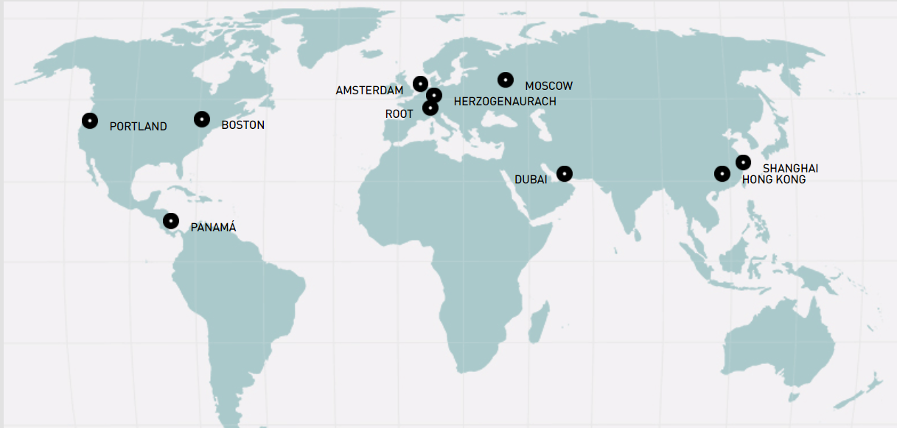

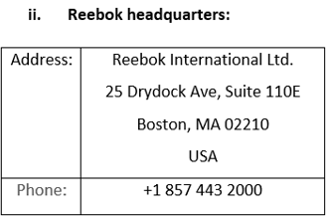

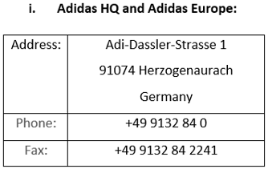

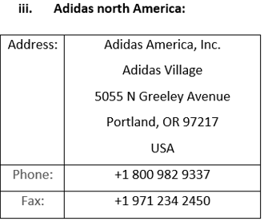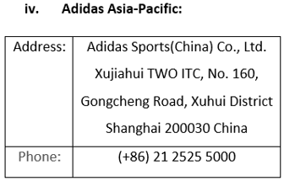

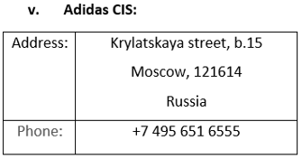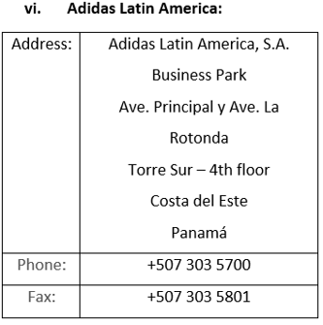

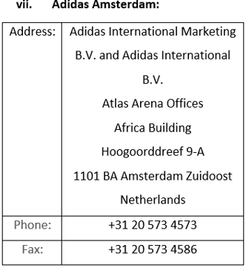

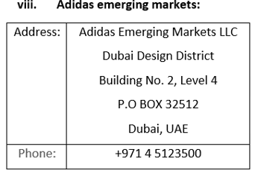

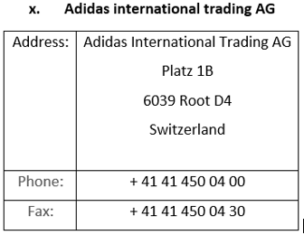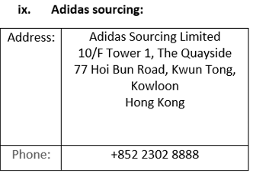

### People: [2]

Adidas has its roots in Germany but we are a truly global company. Around the world they employ over 59,000 people. [1]

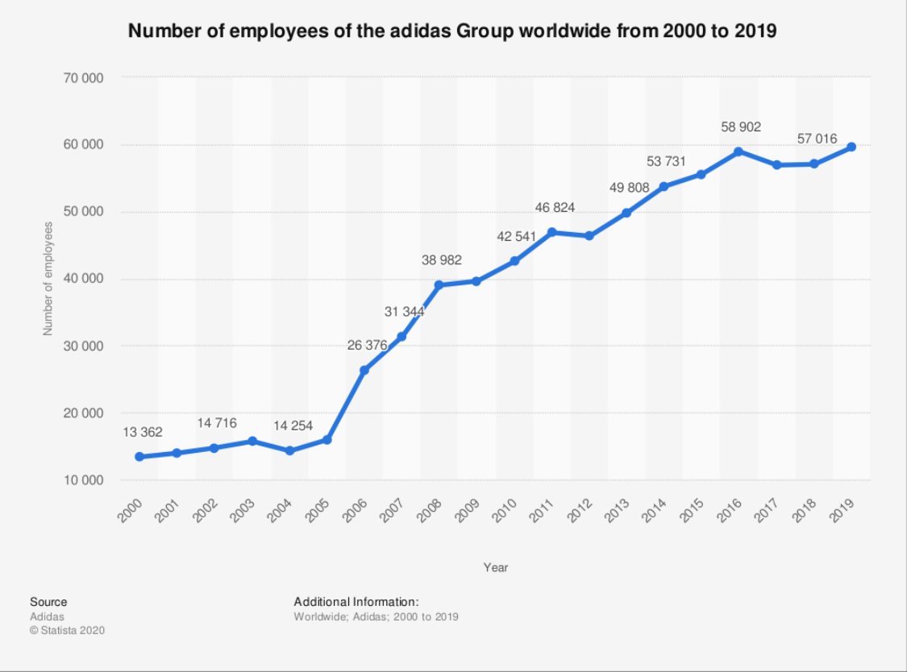

## Top executives: [1]

### The executive board:

* KASPER RORSTED - CHIEF EXECUTIVE OFFICER
* ROLAND AUSCHEL - GLOBAL SALES
* BRIAN GREVY - GLOBAL BRANDS
* HARM OHLMEYER – FINANCE
* MARTIN SHANKLAND - GLOBAL OPERATIONS

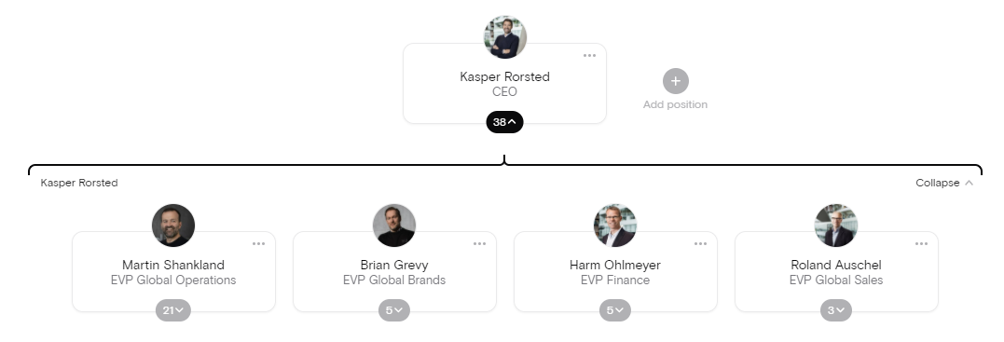

### The supervisory board:

* **THOMAS RABE:**

Chairman and Chief Executive Officer, Bertelsmann Management SE, Gütersloh, Germany

* **IAN GALLIENNE - DEPUTY CHAIRMAN**

Chief Executive Officer, Groupe Bruxelles Lambert, Brussels, Belgium

* **UDO MUELLER* - DEPUTY CHAIRMAN**

Manager History Management, Adidas AG, Herzogenaurach, Germany

* **PETRA AUERBACHER\***

Project Manager Creative Direction, Adidas AG, Herzogenaurach, Germany

* **ROSWITHA HERMANN\***

Director Projects, adidas AG, Herzogenaurach, Germany

* **HERBERT KAUFFMANN**

Independent Management Consultant, Stuttgart, Germany

* **CHRISTIAN KLEIN**

Chief Executive Officer (CEO), SAP SE, Walldorf, Germany

* **KATHRIN MENGES**

Self-employed Entrepreneur, Großenbrode, Germany

* **ROLAND NOSKO\***

District Manager of the Industrial Union IG Bergbau, Chemie, Energie, District of Nuremberg, Nuremberg, Germany

* **BEATE ROHRIG\***

State District Manager of the Industrial Union IG Bergbau, Chemie, Energie, State District Bavaria, Munich, Germany

* **NASSEF SAWIRIS**

Chief Executive Officer and Member of the Board of Directors, OCI N.V., Amsterdam, The Netherlands

* **FRANK SCHEIDERER**

Director Head Office – Brand & Sales Finance, adidas AG, Herzogenaurach, Germany

* **MICHAEL STORL**

Deputy Chairman of the Works Council Herzogenaurach, adidas AG, Herzogenaurach, Germany

* **BODO UEBBER**

Independent Management Consultant, Munich, Germany

* **JING ULRICH**

Vice Chairman of Global Banking and Asia Pacific, JPMorgan Chase & Co., New York, USA

* **GUENTER WEIGL**

Senior Vice President Global Sports Marketing & Brand Relations, adidas AG, Herzogenaurach, Germany

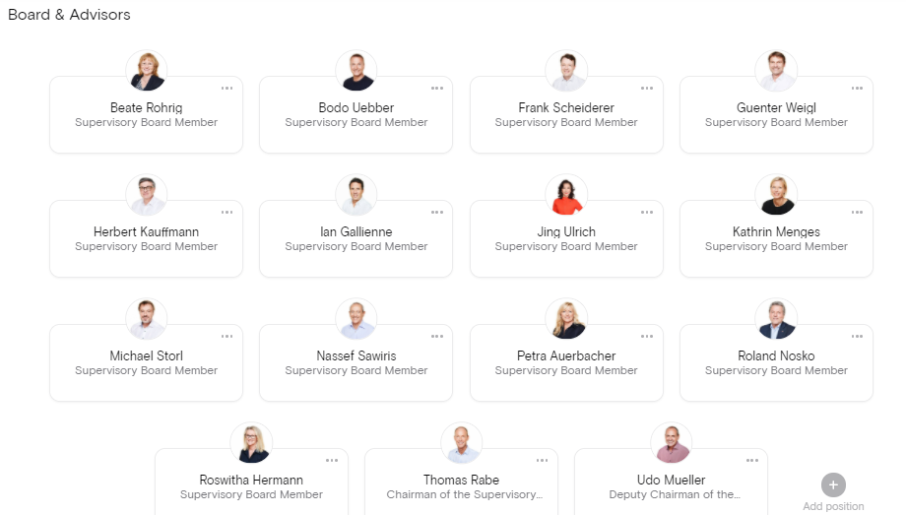

## History: [1]

Adidas’ great story started in a small town in Bavaria, Germany.

Adi Dassler registered the “Gebrüder Dassler Schuhfabrik” in 1924 and embarked on his mission to provide athletes with the best possible equipment after his first steps in his mother’s kitchen, where Gold medals in Amsterdam (1928, Lina Radke) and Berlin were first rewards and milestones –not only the start of the story-.

Later on, the association football (soccer) players switched to the company’s shoes, which were light in weight and featured screw-in cleats, Adidas grew steadily during the 1950s.

In 1963, the company created a line of sporting goods, introducing soccer footballs. Four years later, Adidas has been the biggest name in athletic shoes for many years, but competition particularly from newer companies such as Nike, increased during the 1970.

Adidas was owned by the scandal-tinted French business executive Bernard Tapie between 1990 and 1993, who failed to revive it.

The company was sold to investors who, as chief executive officer and chairman, had brought in another Frenchman, Robert louis-Dreyfus. Adidas acquired the Salomon group under his leadership in 1997. Although best known for winter sports products, the golf supplier TaylorMade was also owned by Salomon.

Adidas was renamed Adidas-Salomon AG and, following Nike’s lead, moved into retailing in 2001.

In 2004, the firm entered into a successful partnership with Stella McCartney, a clothing designer.

Adidas sold Salomon in 2005. But retained the TaylorMade brand. The corporate name was changed back to Adidas AG the following year. Subsequent acquisitions by Adidas included the Reebok Company (2006), which owned the shoe brand Rockport.  
Adidas sold TaylorMade in 2017.

# Product:

## Categories:

**Products offered by Adidas Brand is focused in three key categories:**

### Apparel:

As Adidas sells a range of clothing items, varying from men's and women's [t-shirts](https://en.wikipedia.org/wiki/T-shirt), [jackets](https://en.wikipedia.org/wiki/Jacket), [hoodies](https://en.wikipedia.org/wiki/Hoodie), [pants](https://en.wikipedia.org/wiki/Pants) and [leggings](https://en.wikipedia.org/wiki/Leggings). [4]

### Sportswear:

1. Association football
2. Basketball
3. Baseball
4. Cricket
5. Golf
6. Gymnastics
7. Ice hockey
8. Lacrosse
9. Running
10. Skateboarding
11. Tennis

### Accessories.

Slide style sandals, mobile accessories, watches, eyewear, bags, baseball caps, and socks are also made and designed by adidas.

Adidas now has a branded line of deodorants, perfumes, aftershave and lotions for men and women.

## Features:

The athletic footwear products of Adidas are primarily intended for a particular athletic use,  
Adidas places considerable emphasis on innovation and high-quality although a large percentage of the products are worn for casual or leisure use.

Adidas places considerable emphasis on innovation and high-quality construction in the development and production of products.

## Quality:

Product safety is a necessity! As a business, Adidas have to manage the risk of selling faulty products that can harm customers and/or impair their image.

Adidas have company-wide product safety policies in place to mitigate this risk, ensuring that

they consistently apply physical, chemical product safety and conformity standards across all

the company's brands.

To ensure the quality of the product and consumer-safe products, all materials and product samples must pass a rigid compliance process and are tested in accordance with standardized specifications and procedures for material and product testing.

# Branding Department

## Management

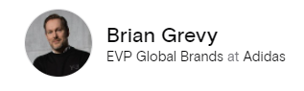Brian Grevy was born in Kolding, Denmark, in 1971 and is a Danish citizen. After his studies at the Business School in Vejle, Denmark, he held various leadership positions at adidas and Reebok Nordics between 1998 and 2006. In 2006, he transferred to the adidas Headquarters in Herzogenaurach, Germany, to become Director Men's Training and, as of 2010, Senior Vice President Training & Regional Sports. From 2012 to 2014, Brian Grevy acted as General Manager adidas Nordics in Stockholm, Sweden. During the years 2014 to 2016, he led the adidas Business Unit Training as General Manager in Herzogenaurach, Germany. Between 2016 and 2019, he was CMO and, most recently, CEO at GANT in Stockholm, Sweden. In 2020, Brian Grevy was appointed to the adidas Executive Board and is responsible for Global Brands.

## Organizational structure, managers and employees

The branding department is divided into several positions such as; Brand operation, Brand Communications, Event marketing, Global Sports Marketing and Global brand design the organizational structure is shown.

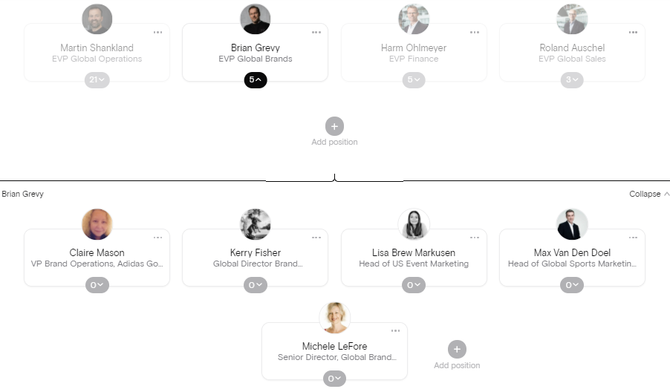

# Marketing Function

## Research

Adidas has a world class sport research lab with more than 40 researchers from different branches (biomedical engineering, biomechanical, physics, math, kinesiology, mechanical engineering and systems science). Their target is to create innovation of product to athletes everywhere through the use of science and technology by testing how to reduce injury risk and reach evolution in perception and feel. This offers the customer innovated products to give comfort and feel unique and support their products.

## Branding

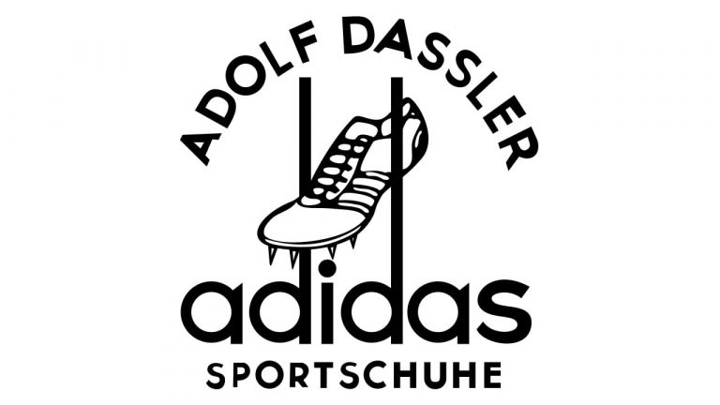The name adidas came from the founder, Adolf “Adi” Dassler’s name. He used his nickname, Adi, and the first three letters of his last name, Das, to create adidas.

On the very first Adidas logo, there was a spiked running shoe hanging between two long ends of letter “d”. However, it turned out that the same icon was already used by Karhu Sports, a major shoe brand. To resolve the dispute, Adolf Dassler, the founder of Adidas, purchased the trademark.

By the early 70s, the Adidas logo got three parallel stripes. Initially, Adidas added stripes to its running shoes to make them more durable. As a result of the 1971 rebranding campaign, the company introduced a revisited emblem with a trefoil. In 1991, the public saw a new logo version – three tilted stripes resembling a mountain. The mountain-shaped logo conveys the idea of overcoming challenges and pursuing your goals no matter what. As for the round emblem, it stands for the globe and fast adaptation to changes. The Adidas logo as we know it today was designed in the early 2000s and features a circle crossed by three curvy lines.

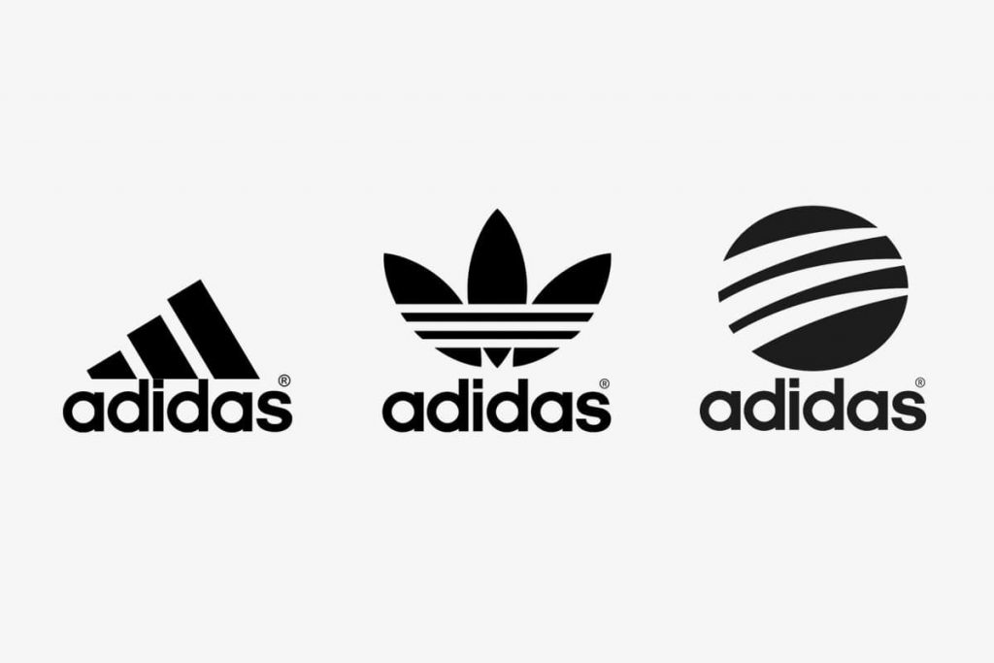

## Promotion

The company made a lot of promotions which considered one of the “4P” elements to reach the market (marketing mix: product, price, place, promotion) and attract new customers or keep trust of its customers as advertisements either posters, on television of social media which is simple, but send a strong message, or by special offers, using celebrities and salesmen. This result in high revenues and attract companies to ask for sponsorship from it, all these elements mentioned known as: **“Promotion mix”**. Promotion mix include (sales, public relations and advertising).

### Sales

* Personal Selling

The company offers a trained sales staff to help the customer in making the best decision by introducing the products features and select the right product through personalized service. Customers experience support the sales, as they feel that was a better decision and recommend the product. This improve sales and help in building a relationship with customers.

* Direct Marketing

The company uses direct marketing to promote new products, using not only strong advertising, but also through sales people to reach target consumers either organizations or individuals (Example: sports organizations in college). This motivate target customers to purchase the company’s product and support sales.

* Sales Promotion

The company offers coupons and special offers which will give benefits to target consumers, as discounts or buying other free products. This motivates target customers and attract new ones, as they would be motivated by the product on basis of perceived benefits.

### Public Relations

he company uses public relations to address social issues related to its business as using sweatshops and improving green technology. Also, uses public relations at sport events and similar activities by sponsoring it. This is done to communicate with target customer to show business address relevant social issues, which promote the brand and give potential customers a better perception about brand and its products.

### Advertising

The company uses advertising to reach a great impact on large populations of target audiences. This is done through representing the products via well-known celebrities and famous athletes (Example: Muhammed Ali Klay, the boxer and David Beckham, the footballer). This motivates the target audience when watching his celebrity uses the brand, to try it and build a strong brand image of the company products which reach rewards and high demand, so they focus on their famous sports man country as a brand ambassador for marketing their products. This help to promote the brand.

### Distribution

The company distribute its products using different channels as resellers, super markets, e- commerce sites, retailers and company owned outlets to about 200 country over the world (425 brand factory store, 82 online store, 79 Converse store and 18 Hurley store), and its planning to open more stores and franchises to reach the target consumer and expand the buyers. This will lead to availability of products to satisfy consumer need and so increase the sales through distribution methods.

# Key Competitors, Position and Marketing Strategy Overview

## Key Competitors

Sports equipment, foot and sports’ wear have a wide range of competitors. Adidas top key competitors are especially Nike and Reebok regarding the foot wear, while other brand concentrate on other product and here are common Adidas top key competitors and their positions in 2018:

### Nike

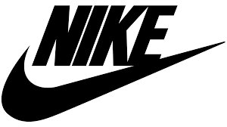The company was founded on January 25, 1964, as "Blue Ribbon Sports", by Bill Bowerman and Phil Knight, and officially became Nike, Inc. on May 30, 1971. It is occupy the “ 1ST “ place before Adidas in sport shoe sales. In 2019 it reaches 39.4$ billion with its 77,000 employees.

### Reebok

It is a subside company of Adidas work independently with 3$ billion worldwide revenue, considered “ 3rd “ ranking sport worldwide.

### ASICS (Anime Senea In Corpore Sano)

Founded in Kobe, Japan in 1949 with the first release of basketball shoes. Its total revenue 2.9$ billion and considered also in the “ 3rd “ ranking sport worldwide.

### Puma

Founded by Rudolf Dassler (Adidas founder brother) in Germany in 1948, employing 3000 employee with 2.5$ billion reaching the “ 4th “ place worldwide.

### Under Armor

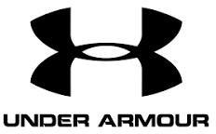Founded by Kevin Plank in Martland, USA in 1995starting with comfortable and light T-shirts, employing 15,000 employee with 1.1$ billion. The company compete with Nike sportswear especially.

### Fila

Founded in Pedemonte, Italy, by Fila Korea in 1911. It is part of Anta sports group and it is fighting for the fourth place in global ranking of sports brands by targeting a1.2$ billion revenue the next years.

### Anta

Founded in china in 1991, ranks “third in the market share” behind Nike and Adidas with 25,000 employee and revenue 1.08$ billion.

### New Balance

The company considered a strong Nike competitor in US and UK, as it is a private American company found in Boston in 1906 with 4.5$ billion revenue.

### Sketchers

Founded by Robert Green in California, US in 1992. With 12,600 employee and 4.5$ annual revenue.

## Adidas Position

Adidas considered a company that produce products with high quality and sell them with high price. Adidas top competitor Nike reaches 34.6$ billion and in 2019 it reaches 39.4$ billion with its 77,000 employees. Adidas is ranked the “2nd“among its competitors and considered from the leading of footwear market as footwear sales is maximum in total Adidas sales.



## Marketing strategy overview

The company follows an excellent marketing strategy that focuses on:

1. Costumer’s interests and demands (by producing sneakers shoes for young and old).

2. Using new technologies.

3. Sustained development of product over world which increase the market share and expand in the world

4. Products of high quality and low cost

5. Increase profits and sales annually by a percentage

### Marketing mix (4Ps)

* Product

Adidas offers a product to satisfy the customers need with its high quality and innovation from researchers.

* Price

Adidas follow value based pricing depending on the customer as he will pay more for the high quality and unique products. The company target customers who had enough money to but their products.

* Place

The company distribute itself all over the world to increase its sales and still aiming to have more stores.

* Promotion

As mentioned previously, the company offers a lot of promotions to attract customers as advertising, personal selling, direct marketing, public relations, social responsibility and reaching social media.

### SWOT analysis

* Strength
* Strong brand awareness
* Huge customer base
* Aimed for sustainability
* Superior marketing celebrities
* Side brands
* Low manufacturing cost
* Iconic relationship
* Weakness
* Poor labor conditions
* Pending debts
* Lawsuits
* Women sexual harassment
* Opportunity
* Emerging markets
* Innovative products
* Efficient integration
* Threats
* Increased competitive pressure
* Marketing budget pressure
* Currency foreign exchange risks
* Counterfeit products

**6. Distribution strategy:**

Adidas is one of the leading players in the sports shoe industry with a large market base and a strong sales and distribution network spread worldwide. Adidas has made several important changes to its business operation, marketing and supply chain strategies during the recent years. These changes have resulted in rising sales and revenue for the sports shoes, apparel and hardware brand. However, excellent marketing only works when you are committed to quality, have an excellent supply and distribution chain, great production capabilities as well as a deep understanding of market trends. The brand has formulated a great supply chain strategy that ensures high quality standards, higher availability as well as timely delivery at competitive costs.

The main strategy that gain high growth between year 2015 and 2020 is: Adidas’ store locator (unlike for most brands) works across national borders, independently of your location, and shows all points of sale, including own stores, partner stores, factory outlets or multiband retailers. If you think that’s today commonplace, test the store locators of your favorite brands. Any brands will ‘nearest store is 36.55 miles away’ from residential building. Its strategy is to be close to customer and makes the costume always nearby. In March 2015 Adidas introduced “three-pillar Top City Strategy 2020”, focusing on the six global cities Los Angeles, New York, London, Paris, Shanghai and Tokyo to push its sporting goods brand. Adidas expected to double sales in these core cities with a new brand distribution strategy, the impact of this strategy starts in 2017, in March 2017 Top City brand distribution channels. Adidas had rebound from the overall growth crisis with a sales growth of 18% and profit growth of 41%. So and the end of 2020 to review the impact of “three-pillar Top City Strategy 2020” it is found that, the company have 600 urban centers generate about 60% of global GDP60% of the new urban consumers is in 440 emerging cities Consumption in the emerging 440 cities is set to rise to $10 trillion and 1 billion new consumers in emerging market cities

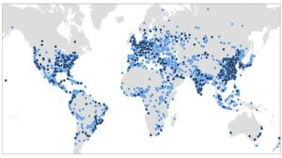

Adidas stores and covered area at the end of 2020

**6.1 Distribution channel:**

Supply chain plays the role of a central pillar of business driving speed and performance. Adidas has been able to improve its supply chain efficiency through its Global Operations functions making it highly competitive which is absolutely essential to survive the tough competition from the nearest and biggest competitor. A large and agile supply chain helps you satisfy your customers’ demands better and in this regard Adidas has proved itself innovative and smart

**6.1.1 Main distribution channel**

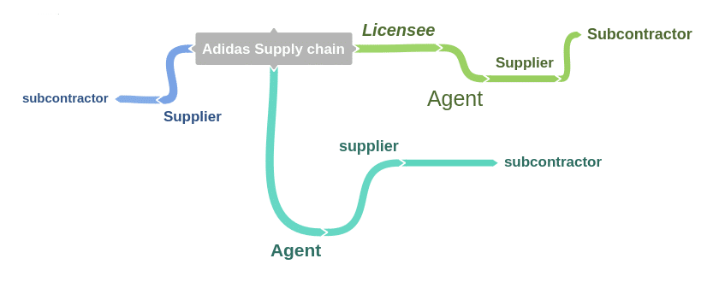

* Main suppliers: direct contractual relationship with Adidas for supply of product
* Subcontractor: these are factories that have subcontracted by suppliers to perform operations that main suppliers can’t
* Licensees: manages design production and district, Adidas works with 67 licensees who sourced products in 448 factories
* Agent: act as intermediaries to source product manufacturing and oversee production
* Retails and online retailers

Adidas number of total suppliers in 2017 are 800, Number of suppliers that Global Operations, Function worked with are 296, Number of strategic suppliers (more than 11 years old) – 109

|  |  |  |  |  |
| --- | --- | --- | --- | --- |
| Strategic Suppliers total | Footwear | Apparel | Hardware |  |
| 109 | 34 | 60 | 15 |  |

The target of Adidas is to become a fast sports company. It has made speed a strategic priority and its global Functions Operation is a key facilitator helping it bring fresh ideas to the market faster. Faster movement of products and ideas across its wholesale, retail and e-commerce channels is essential if Adidas wants to retain its competitive position against competitor. Majority of the production of Adidas products takes place through independent suppliers. Most of these suppliers, around 80 percent are in Asia. Adidas has outsourced its production nearly 100 percent to the independent third party suppliers. It provides its suppliers with the detailed specifications of productions and delivery. However, the suppliers are able to produce high volume good quality footwear cost efficiently. Adidas selects the suppliers that have excellent expertise in this area. It has also formed close and strong relationships with its suppliers and its products are made at 109 manufacturing facilities worldwide. In 2017, close to 50% of its existing suppliers have worked with Adidas for more than ten years and around 15% for more than 20 years. Adidas has set specific criteria for its suppliers and its Global Operations function regularly measures their performance against these criteria. However, apart from these suppliers, Adidas also has a few assembly sites in U.S., Canada and Germany. Both at its suppliers’ facilities and its own factories, the brand has enforced strict controls and inspection procedures. This is done in order to ensure that the factories meet the standards the customers expect.

**6.1.2 Product manufacturing and distribution**

In 2017, the Global operations function of Adidas worked with 296 independent suppliers or manufacturing partners. This was one less than the previous year. The largest part of Adidas’s supply chain is located in Asia. 79% of Adidas’ manufacturing partners are found there. In 2016, 80% of them were in Asia. Apart from it 11% of the supply chain is located in Americas, 9% in Europe and 1% in Africa.

* Footwear Production:

In 2017, 97% of the total footwear volume of Adidas was produced in Asia. Europe and Americas together accounted for 3% of the entire footwear volume. Largest part of footwear production took place in Vietnam. Its share was 44% in 2017 followed by Indonesia at 25% and China at 19%. The total footwear production in 2017 equaled 403 million pairs which was 43 million pairs higher than the previous year. 11% of the entire volume in 2017 came from a single largest factory. China and the Asia region have become the preferred destination of brands for sourcing raw materials.

* Apparel Production:

Asia again played a major role in the production of Apparel for Adidas in 2017. China is the biggest supplier country for apparel, supplying almost 23% followed by Cambodia at 22% of the entire apparel volume. Vietnam remained the third largest supplier supplying for 18% of the volume. The total production in number of units was 404 million units of apparel which was 22 million units higher than the previous year. A single factory produced the highest volume which was equal 10% of the entire volume. In terms of apparel production also, the Asia region has the biggest collection of suppliers because of the cost efficiency it offers based on low labor costs and lower costs of raw material.

* Hardware Production:

Asia accounted for the largest share of hardware production (like balls and bags) supplying 82% of hardware production in 2017 which was slightly higher than the production level of 2016 (79%). 16% of the production took place in Europe and 2% in the Americas. China was again the biggest supplier supplying 40% of the entire volume. Pakistan and Turkey supplied 18% and 15% of the volume respectively. Total volume of hardware sourced by Adidas in 2017 equaled 110 million units which was 1 million units higher than the previous year. One single factory in Adidas’ supply chain accounted for 10% of the total production

**6.2 Distribution conflicts:**

* On 23 April 2014 on of main sneakers factory in china doesn’t supplies any product for 5 days due to a wage dispute at a huge sneaker factory that supplies brands including Adidas escalated Wednesday. Tens of thousands of employees have been off work for a second week, forcing Adidas to switch production to some of its other suppliers
* On October 2012 one of main factory in Indonesia cut off its suppliers fir one day because More than 1,300 people clashed with security guards at an Indonesian shoe factory which supplies sportswear giants Adidas and Mizuno, police said on Thursday, a few months after they were sacked for striking over better pay.

Those two conflict is the only in the distribution history and they doesn’t affect the distribution because of rapid realization and make other factories woks for full load to compensate the volume production

**7. Social responsibilities:**

**7.1 Recycling**

Sustainability at Adidas goes far beyond recycled plastic. Adidas also continues to improve its environmental performance during the manufacturing of products. This includes the use of sustainable materials, the reduction of CO2 emissions, and waste prevention. In 2018 alone, the company saved more than 40 tons of plastic waste in its offices, retail stores, warehouses, and distribution centers worldwide and replaced them with more sustainable solutions.

The company plans to reduce greenhouse gas emissions by 30 per cent by 2030. In addition, it is committed to using only recycled polyester in every product and on every application where a solution exists by 2024. The company sources only sustainably produced cotton. In addition, the company hasn’t used plastic bags in its stores since 2016.

In 2018, Adidas produced more than five million pairs of shoes containing recycled plastic waste. The company plans to more than double that figure this year. To reach this goal, the company has partnered with global collaboration network Parley for the Oceans, which intercepts plastic waste on beaches before it can reach the oceans. The waste is then made into a yarn, which becomes a key component in Adidas footwear. The company also produces other apparel from the recycled material.

**7.2 Labor condition:**

When it comes to labor, Adidas’ rating is ‘It’s A Start’: it received a score of 61-70% in the Fashion Transparency Index, and some of its supply chain is certified by FLA Workplace Code of Conduct including all of the final stage of production.In more good news, Adidas traces and audits most of its supply chain. The brand publishes a detailed list of suppliers in the final stage of production, some information about the second and first stages of production, and some information about the findings of supplier audits, as well as some information about forced labour, gender equality, or freedom of association. In the spirit of transparency, Adidas publishes detailed information about its supplier policies, audits, and remediation processes. Importantly, the brand also discloses policies to protect suppliers and workers in its supply chain from the impacts of COVID-19.One area where Adidas has a long way to go is ensuring workers in its supply chain are paid a living wage. The Foul Play report by the Clean Clothes Campaign and the difference between the ever increasing amount of money paid on sponsorships to sports stars and other marketing expenses, compared to the reduction of the share of the final price of your sports gear paid to workers in the supply chain. The report calls on Adidas to commit to paying living wages across their supply chains by a specific date and other supporting action. Doing so would really help to boost the brand’s score for people.

**7.3 Animal Welfare:**

Adidas’ animal rating is ‘It’s A Start’. It has a general statement about minimising animal suffering but not a formal animal welfare policy. It does not use fur, exotic animal skin, exotic animal hair, or angora, but it is still using leather. Adidas states that it uses wool from non-mulesed sheep and that it traces some animal products to the first stage of production.

**8. Marketing process:**

**8.1 Traditional process**

The Marketing process is “Segmentation, targeting, positioning” in the Marketing strategy of Adidas

Adidas is one of biggest sportswear manufacturer of Europe & one of the biggest in the world, Adidas is segmented based on demographic, psychographic & behavioral factors. The Adidas group has four brands in its strong portfolio “Reebok, Adidas, Rockport & Taylor” made meant for different segment customer groups.

Adidas uses differentiated targeting strategy to target young adults, adults as well as children who have passion for fitness & sports. Although it targets customers in the age group of 13-40 years but majority of its customers are of 15-30 years of age who hail from upper middle class or the luxury class of customers.

User & benefit based positioning are the strategies Adidas uses to create distinctive image in the mind of the prospective consumer. By emphasizing the value of quality products from a trusted brand Adidas is able to maintain its brand essence. The portfolio is divided as follows.

They have Adidas-performance in Competitive sports,Reebok & Reebok classics in Active sports & casual sports, &Adidas originals, Adidas Fun, Rockport in Sports fashion.

The Adidas group has 4 main subsidiaries. The first is its own brand name – Adidas, which is present in clothes as well as footwear. The second is Reebok which has overtaken Adidas and is one of the leading subsidiaries in the Adidas group. The 3rd is Rockport which specializes in outdoor footwear, apparel’s and accessories and 4th is Taylor made which is focused on golfing clothes, equipment etc. Out of all the above subsidiary’s, Reebok is the strongest followed by Adidas.

Adidas has various products. The major product of Adidas is off course their footwear. Coming in various design and style, Adidas footwear is robust and athletic. The secondary product of Adidas is apparel’s and accessories. Apparel’s like T-Shirts, jackets, sweatshirts, shorts are in great demand. Where Reebok is stronger in footwear, Adidas is stronger in apparel’s.The aim of Adidas is to give the best footwear to their customers who have the combination of technology and design. These products are not need based. In fact, the shoes are bought by customers to satisfy their wants and desires. Similarly, the apparel’s are targeted towards comfort during heavy activity. However, although the main target is sports, the apparel’s are frequently used as a style statement by youngsters.

**8.2 New marketing process**

Adidas’s five-year strategy that issued in 2015 has the name “Creating the New”. Describing itself as a digital company, Adidas wants to be the world’s best sporting apparel brand. In order to achieve this, they use subsequent digitalization as the key part of their marketing strategy. For the “Best” means designing, building and selling the best sports goods in the world. The company spends 90% of its marketing budget on digital campaigns and social media.

* Speed

High-speed manufacturing is one of the essential parts of Adidas’ digital marketing strategy. They digitized the production process with 3D printing technology and robotics at Speed factory. Future craft 4D shoes that crafted with light and oxygen are one successful example of the brand’s advanced technology.The purpose of the manufacturing process is to deliver the most innovative and personalized running shoes for every athlete. The sporting goods brand always tries to meet the high demand. Created with innovation and collaboration, the fresh and desirable products always ready for customers where and when they want them to purchase.

* Relationship with consumers

They try to interact with their customers and create premium, connected and personalized experiences. In other words, they create enthusiasm and excitement about sports on a personal level. The brand takes every touch point like mobile, social and retail that consumers can interact to provide a consistent experience. By taking insights from digital analysis and Big Data, Adidas tries to be everywhere its consumers are. Adidas promises to deliver multichannel, unified and also unique experiences.

* Open-source innovations and collaborations

Adidas opens its doors and calls all the creative including athletes, consumers and partners to learn, create, share and shape future sports and sports culture. They try to bring cool products to the market. Parley for the Ocean cooperation is a part of that initiative which includes producing 3 new Ultra Boost models from plastic waste from the sea.

* Strategic cities

Six cities (London, Los Angeles, New York, Paris, Shanghai, and Tokyo) where shape the consumers’ perception, trends, and buying decisions have strategic importance for Adidas. In Europe, they focus on selling especially soccer products, but the US is a key country for other subsidiaries like basketball and baseball. North America is the biggest market in the sporting goods industry, and its total share is 40%.

* Portfolio

The company is constantly revisiting its portfolio and concentrating on the core brand Adidas and Reebok. Thus the brand makes more precise targeting and reduces complexities. Footwear and apparel under Adidas Neo and Originals names continue to grow. Adidas has repositioned Reebok for more profitability during 2018. For Reebok, they collaborate with influential women designers like Victoria Beckham and women who want to change the world like “Ariana Grande and Gigi Hadid”.

# References

1. [adidas - adidas (adidas-group.com)](https://www.adidas-group.com/en/brands/adidas/)
2. (<https://www.statista.com/statistics>)
3. [Adidas Company Profile, News, Rankings | Fortune | Fortune](https://fortune.com/company/adidas/global500/)
4. [Adidas may have underestimated Tiger, this private equity firm may win (cnbc.com)](https://www.cnbc.com/2019/04/15/adidas-may-have-underestimated-tiger-this-private-equity-firm-may-win.html)
5. <https://theorg.com/org/adidas/org-chart>
6. [Adidas Supply Chain and Distribution Network (notesmatic.com)](https://notesmatic.com/supply-chain-management-at-adidas/)
7. <https://report.adidas-group.com/2019/en/group-management-report-our-company/corporate-strategy/sales-and-distribution-strategy.html>
8. <http://textilefocus.com/apparel-brand-adidas-focusing-corporate-social-responsibility/>
9. <https://www.marketing91.com/marketing-strategy-of-adidas/>
10. <https://digitalagencynetwork.com/digital-marketing-strategy-of-adidas/>
11. <https://www.logaster.com/blog/adidas-logo/>