ANALYSE SUJET

Ware : Ensemble de jeux très courts, les uns a la suite des autres

Rythme soutenu
Contexte : Ware pour MOBILE, reactualiser le genre
format flexible, ADAPTATIF

Cible : Adolescent européens/occidentaux joueur enthousiastes “timefiller”

Volonté de buzz : Thème et propos singuliers qui attirent la curiosité
Objectif : Communauté en compétition amicale et fidélisée

OBJECTIF COURT : orienter la production vers un contenu fort en incarnation et en détachement

Notes annexes :

A game about games. Teach us about game design
Absurdities between fiction and rules
COLLECT ! AVOID ! RUN !
Quickly figure out how we affect each new world

3 points : What am I (visual, efficient) What is my goal (catch ! Break ! Etc… ) How can I do that ?
In WarioWare, being good at videoGames make you good at that. Is it what we want for our players ?
Transition must bea clear, not to confuse more the player, allready missed out with each different game.
Why are WarioWareGame’s so diversified, because on each, game designers used the most understable context as possible to optimize the comprehension lag of the player.

ETUDE DE MARCHÉ
kommandotech.com
2,4 billion gamers
10 % of time spent on a mobile phone is for game
95 % of app stor erevenue from gaming comes from in app puchases
63 % of all mobile gamers are women (Mediakix)
Men and women prefer different mobile game genres. Match tree/ family/farm simulator 69 % women, sports and tactical shooters 98/96 % male
Growing of hyper casual game
78 % mobile gamers are android users
57,9 % market penetration for puzzle game, highest played
1 on 3 users played Candy Crush in 2019
Helix Jump is the most downloaded game in 2018
66 % of mobile gamers influence the purchasing decision of others
Games commonly used between 6 p.m. and 10 p.m.
Pokémon Go is the game that generated the most money
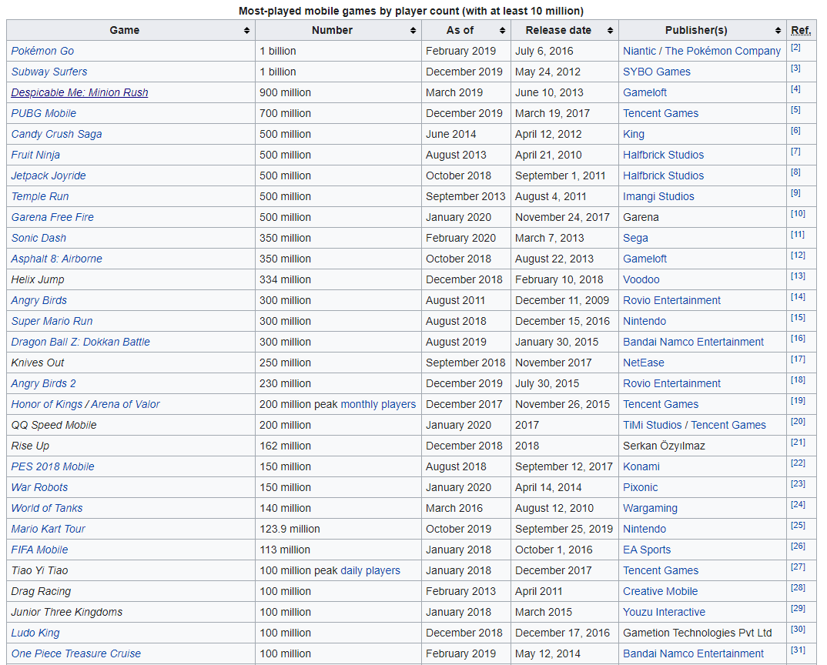
source : Wikipedia

