Office Desk & Room Booking App
Database Schema & Design Rationale

1. Entity-Relationship Diagram
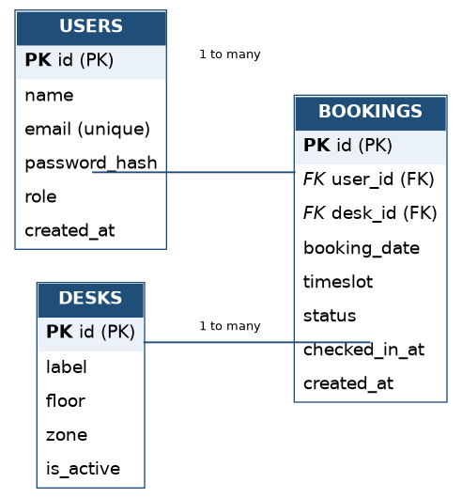
Three core entities — Users, Desks, and Bookings — support the MVP. Bookings is the transactional table joining the other two, and carries the fields needed for both the concurrency guarantee and the no-show auto-release logic.

2. Table Definitions

USERS
Represents employees who can reserve desks.
Column | Type | Constraints | Notes
id | UUID / Serial | Primary Key | Unique identifier
name | VARCHAR(120) | NOT NULL | Display name
email | VARCHAR(255) | UNIQUE, NOT NULL | Login identifier
password_hash | VARCHAR(255) | NOT NULL | Bcrypt/Argon2 hash — never store plaintext
role | VARCHAR(20) | NOT NULL, DEFAULT 'employee' | 'employee' or 'admin'
created_at | TIMESTAMP | NOT NULL, DEFAULT now() | Account creation time

DESKS
Represents a bookable physical asset (a desk, or later a room).
Column | Type | Constraints | Notes
id | UUID / Serial | Primary Key | Unique identifier
label | VARCHAR(50) | NOT NULL | e.g. "3F-A12"
floor | INTEGER | NOT NULL | Building floor number
zone | VARCHAR(50) | NULLABLE | e.g. "Quiet Zone", "Collaboration Area"
is_active | BOOLEAN | NOT NULL, DEFAULT true | Soft-disable a desk under repair

BOOKINGS
The transactional core of the system — joins a user to a desk for a given date and timeslot.
Column | Type | Constraints | Notes
id | UUID / Serial | Primary Key | Unique identifier
user_id | UUID / Serial | Foreign Key → users.id | Who booked the desk
desk_id | UUID / Serial | Foreign Key → desks.id | Which desk was booked
booking_date | DATE | NOT NULL | Calendar date of the booking
timeslot | VARCHAR(20) | NOT NULL | e.g. "AM", "PM", "FULL_DAY"
status | VARCHAR(20) | NOT NULL, DEFAULT 'confirmed' | confirmed / checked_in / released / cancelled
checked_in_at | TIMESTAMP | NULLABLE | Set when the employee checks in; used by the no-show job
created_at | TIMESTAMP | NOT NULL, DEFAULT now() | Booking creation time

3. Design Rationale

3.1 Preventing double-bookings
Rather than checking for conflicts in application code before an insert — which is vulnerable to a race condition when two requests arrive at nearly the same time — the schema enforces this at the database level:
ALTER TABLE bookings
ADD CONSTRAINT unique_desk_slot
UNIQUE (desk_id, booking_date, timeslot)
WHERE status IN ('confirmed', 'checked_in');

A second request for the same desk, date, and timeslot will fail at the database layer with a constraint violation, which the API layer catches and returns as a "desk no longer available" response. This removes the race condition entirely rather than trying to detect it in application logic.

3.2 Supporting the no-show / ghost-booking user story
The status and checked_in_at columns on Bookings exist specifically to support the auto-release requirement identified in Phase 2. A scheduled job can run every few minutes and:
- Find bookings where status = 'confirmed', the timeslot has started, and checked_in_at IS NULL.
- If more than 15 minutes have elapsed, update status to 'released', freeing the desk for same-day booking by someone else.
Because release is a status change rather than a row deletion, the booking history is preserved for later analytics (e.g. "which desks have the highest no-show rate").

3.3 Why status is a string enum, not a boolean
An early design temptation is a simple is_active boolean on Bookings. A string status column was chosen instead because the booking lifecycle has more than two states (confirmed, checked_in, released, cancelled), and future features — like admin-cancellations or waitlists — extend more naturally onto an enum than a boolean flag.

3.4 Why role lives on Users rather than a separate table
For the MVP, only two roles are needed (employee, admin), so a single column is simpler to query and index than a full roles/permissions join table. This is a deliberate scope decision — a many-to-many roles table would be the natural next step if the app grows to support department-level admins or floor managers.

4. Deferred / Out of Scope for MVP
- Rooms as a separate entity (Desks could be generalized to a polymorphic "Resources" table later).
- SSO-linked identity fields on Users (deferred per the Phase 2 scoping note).
- Recurring bookings (would require a separate booking_series table).

