Modified DMA example instructions

- Set aside memory for OpenCPI user-mode DMA

a) find a “usable” contiguous memory range by grep’ing the /var/log/messages for unused memory regions
b) calculate starting memory address by subtracting 0x20000000 from the largest memory region available, as long as it is greater than 0x20000000 (512MB). In the example above, the 2nd region is the largest: 0xBFEF0000 - 0x100000 = 0xBFEF0000 = 3,219,062,784 (~3GB). The starting memory address (0xBFEF0000 - 0x20000000) would be 0x9FEF0000.

c) edit grub.conf (/etc/grub.conf) to add the reserved memory. To do this, add memmap=512$<your_starting_address> (from earlier example memap=512$0x9FEF0000) to the first line that starts with kernel. Add the memmap after root=/dev/... (example root=/dev/vg00/1v01 or root=/dev/VolGroup00/LogVol00). Do not change anything else in your grub.conf file.
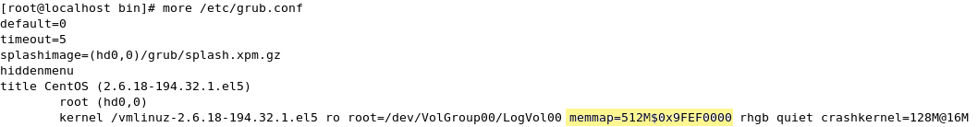

d) Add environment variable OCPI_DMA_MEMORY and set it to “512M\$0x9FEF0000”. Do not miss the backslash before the $ in the environment variable.
e) Reboot.

2) Find the PCI address for the FPGA card
cd $(OCPI_HOME)/scripts
./ocfrp_check
In the example “0000:02:00.0” is the PCI address

3) Run DMA test: testRpl, dmaTestBasic985, and dmaTestMostBasic
./testRpl -r1if -r3of -N0o 1 -N1i 1 -N3o 1 -N0i 1 -I 0 -i 1 0000:02:00.0
Success demonstrated by the line “Successfully sent and received 1 messages”
./dmaTestBasic985 0000:02:00.0
Success demonstrated by multiple lines that end in SUCCEEDED like “For -r1ip -r3op -N0o 3 -N1i 3 -N3o 3 -N0i 3 -I 0 -i 200 0000:02:00.0 ... SUCCEEDED”
./dmaTestMostBasic 0000:02:00.0
Success is similar to the dmaTestBasic985.

