README – Grazioso Salvare Animal Database

# Purpose of the Module

The CRUD Python module was developed for Grazioso Salvare to manage animal data received from Austin area shelters. It allows Create, Read, Update, and Delete operations on the MongoDB animal collection through a reusable object-oriented Python class.

# How to Use

- Driver Used: pymongo  
 Chosen because it is the official MongoDB driver for Python and supports full CRUD operations with easy integration.  
  
- Functionality Overview:  
 • create(data): Inserts a new document into the collection.  
 • read(query): Retrieves documents matching the query.  
 • update(query, new_values): Updates documents using MongoDB operators like $set.  
 • delete(query): Deletes documents matching the query.

# Demonstration Screenshots

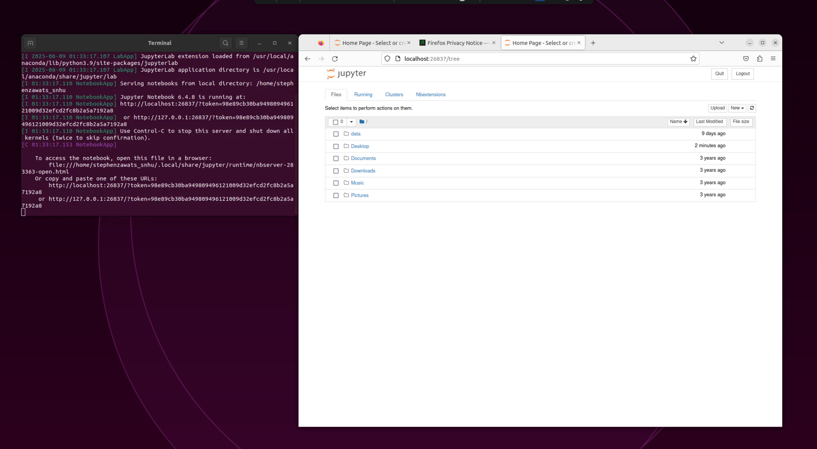

Screenshot: f5af4b69-c8e9-43e3-b407-c98ae7954f7d.png

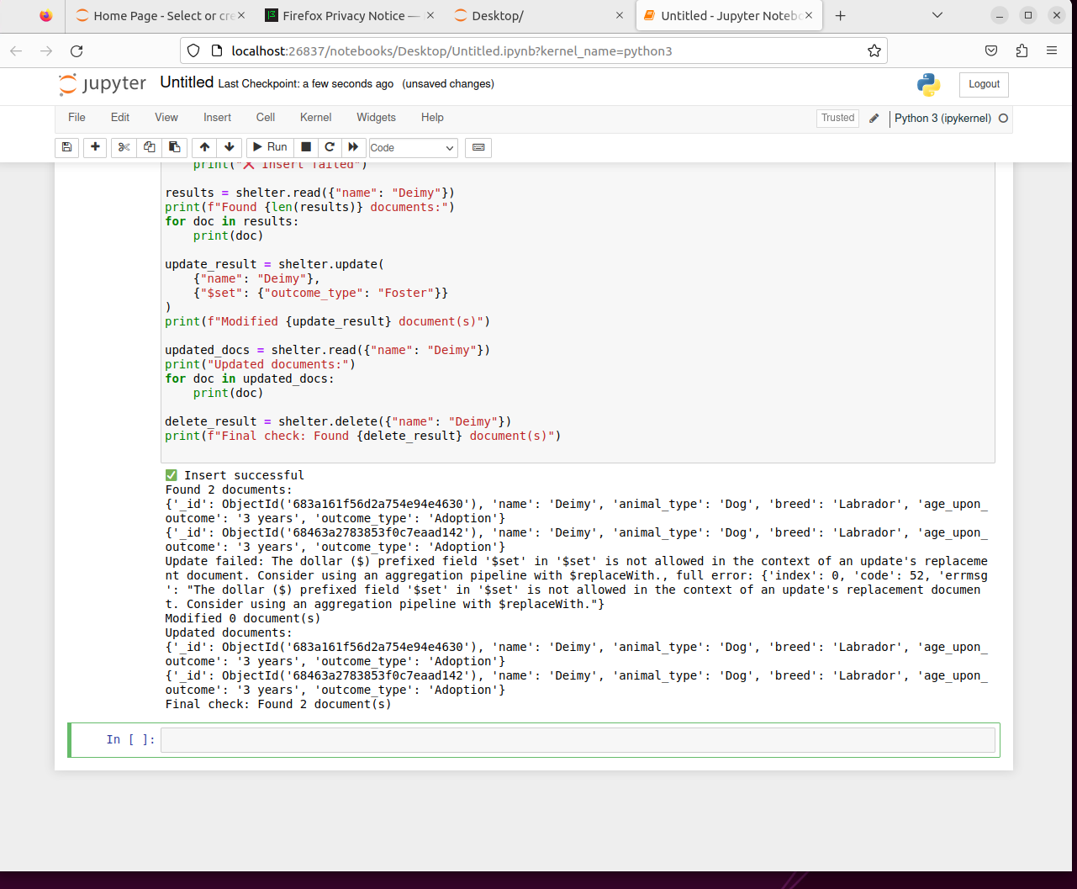

Screenshot: 358f4afe-7563-435c-b6d7-3e6bae83e304.png

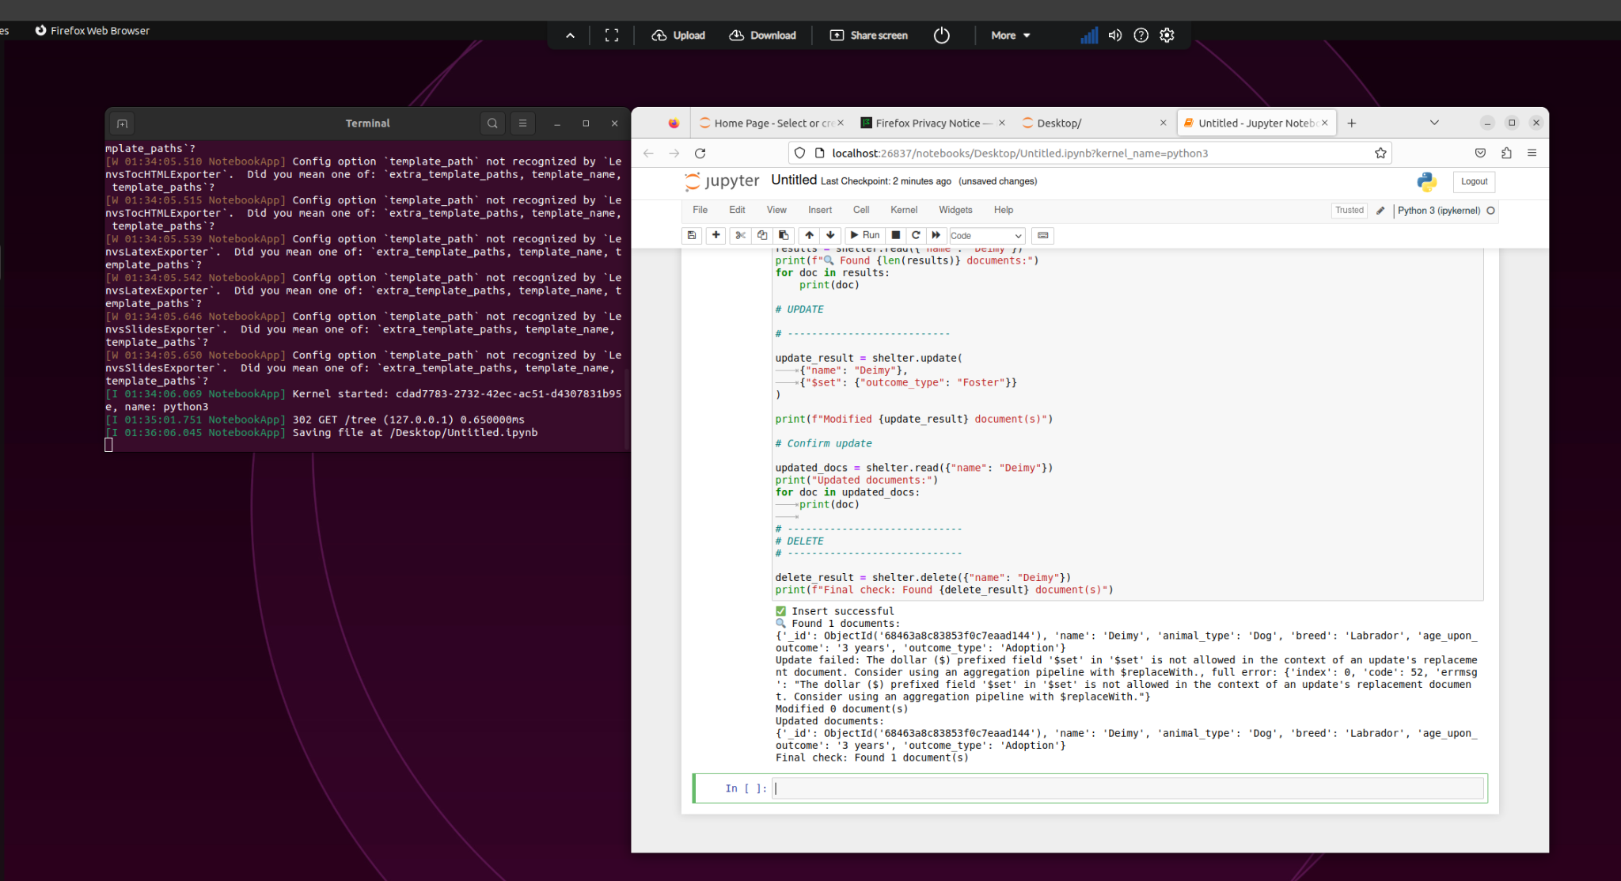

Screenshot: 6fe3982e-21a9-480a-9936-8ff9dc2fbcf3.png

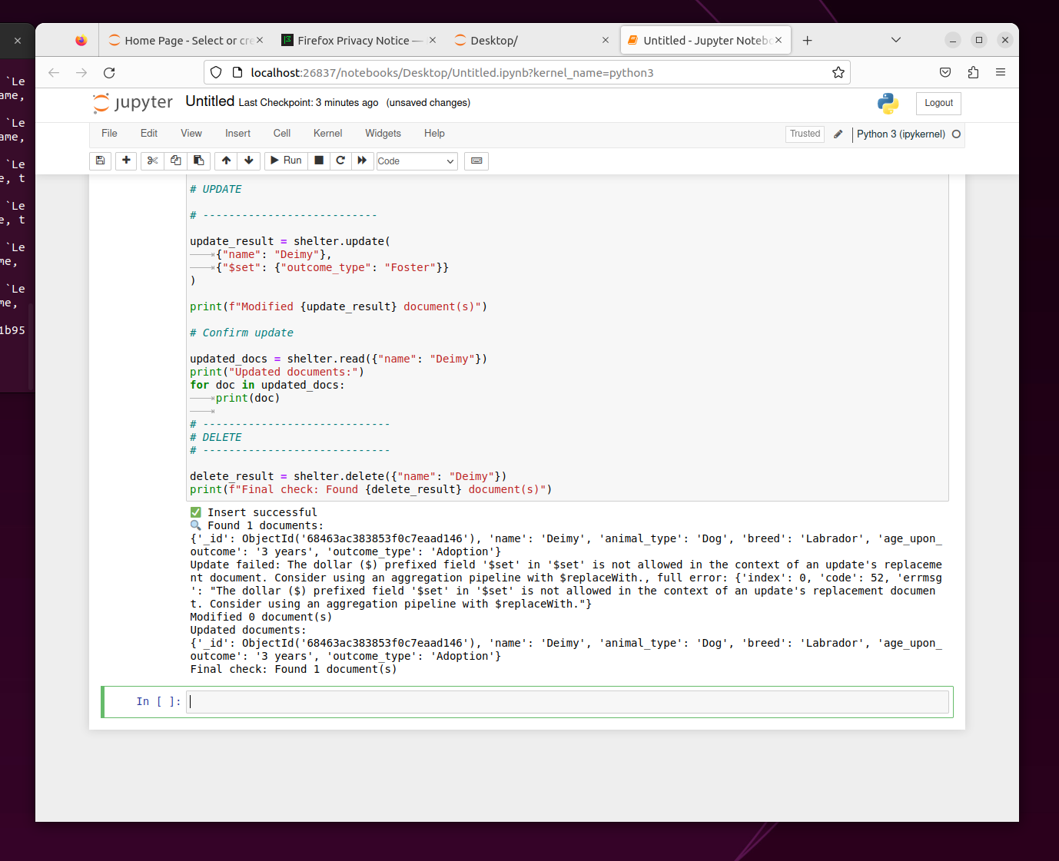

Screenshot: 56d5e671-0713-41ea-9240-b983ae476bce.png