DUAL-CORE OPTICAL MOTION
TESTBED
FIRMWARE, HOST SOFTWARE & RESULTS
  - STM32H747 MotionIPC, live telemetry, automated characterization, and measured operation
Prepared by | Herder Elektronische Systemen
Report scope | Dual-core firmware architecture, host GUI, telemetry integrity, test automation, and measured motion performance
Evidence basis | Source code, engineering plots, project photographs, CAD/PCB artifacts, and recorded demonstrations
Revision | 4.0 - 5 August 2026

DOCUMENT PURPOSE
This report documents the software-controlled testbed: target-side motion control, dual-core interprocessor communication, operator software, data products, safeguards, and measured behavior. Hardware and PCB implementation are intentionally contained in the companion platform report.

1. System Role and Delivered Capability
The system combines a dual-core STM32H747 target with a host application that commands motion, displays live encoder and speed telemetry, executes repeatable tests, and writes analysis-ready records. The public evidence package separates control-plane messaging from high-rate motion-data movement and preserves the distinction between demonstrated behavior and recommended release actions.
- Cortex-M7 and Cortex-M4 workloads connected through OpenAMP/RPMsg and a custom AXI-SRAM shared ring.
- Live host console for connection, scripted test selection, telemetry plots, CSV logging, and metadata capture.
- Measured low-speed tracking, constant-speed error, step response, and closed-loop frequency-response evidence.
- Fault, heartbeat, sequence-gap, dropped-record, and ring-status observability.
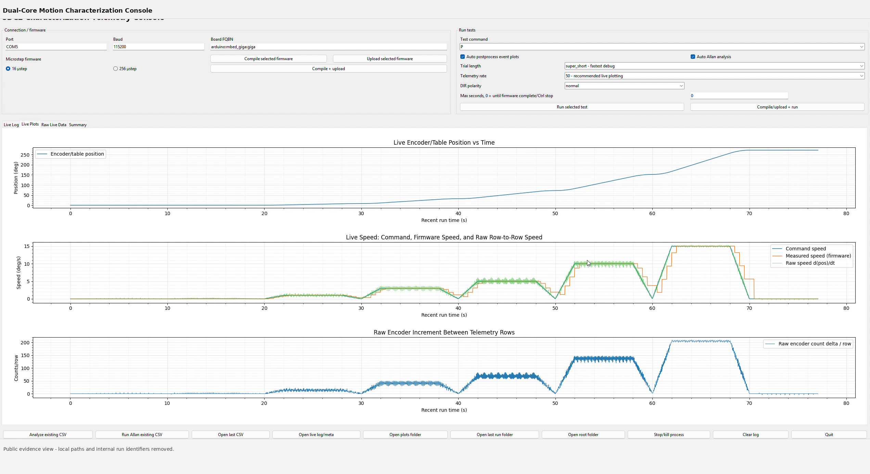
Figure 1. Live host telemetry console during an automated characterization sequence.

2. Dual-Core Firmware Architecture
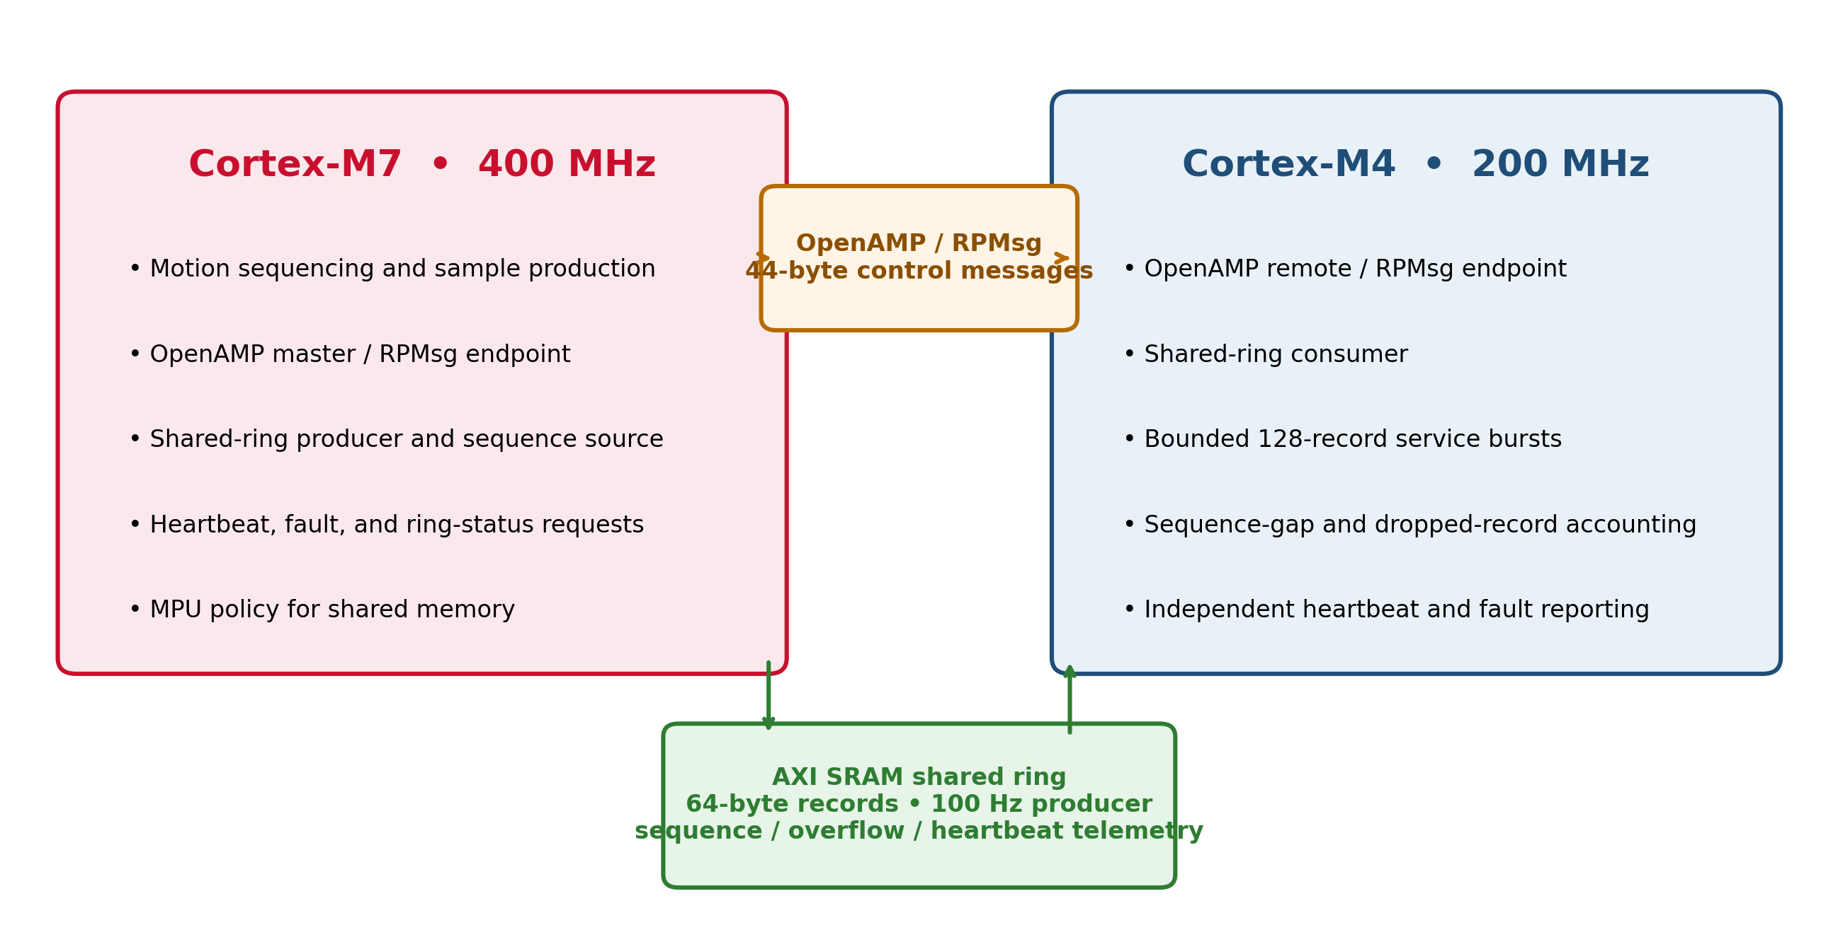
Figure 2. Dual-core architecture with physically separated control-message and shared-ring paths.
Interface | Verified role | Representative parameter
OpenAMP / RPMsg | Low-rate command and status coordination | 44-byte application message
AXI-SRAM ring | High-rate aligned motion records | 64-byte records; 4,096 nominal entries
M7 producer | Motion sequencing and sample publication | 100 Hz sample production in the reviewed package
M4 consumer | Bounded service and accounting | Up to 128 records per service burst

3. Shared Memory, Timing, and Integrity
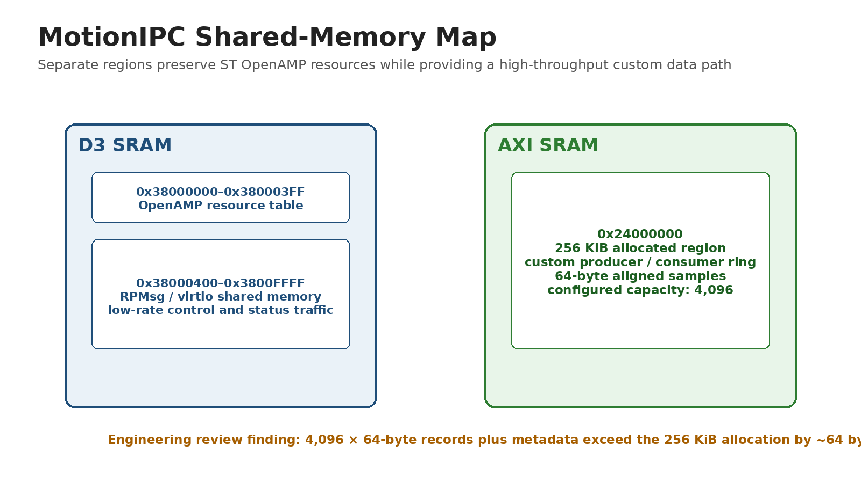
Figure 3. MotionIPC shared-memory allocation and the engineering review finding on nominal ring capacity.
- OpenAMP resources occupy D3 SRAM while the custom producer/consumer ring is allocated in AXI SRAM.
- Records are aligned to cache-line boundaries and include sequence, overflow, and heartbeat information.
- Engineering review identified that 4,096 records plus metadata exceed a 256 KiB allocation by approximately one record; release should use 4,095 entries or enlarge the reserved region.
- The target reports independent heartbeat and fault state so host-side silence is distinguishable from target-side failure.

4. Host Application and Test Workflow
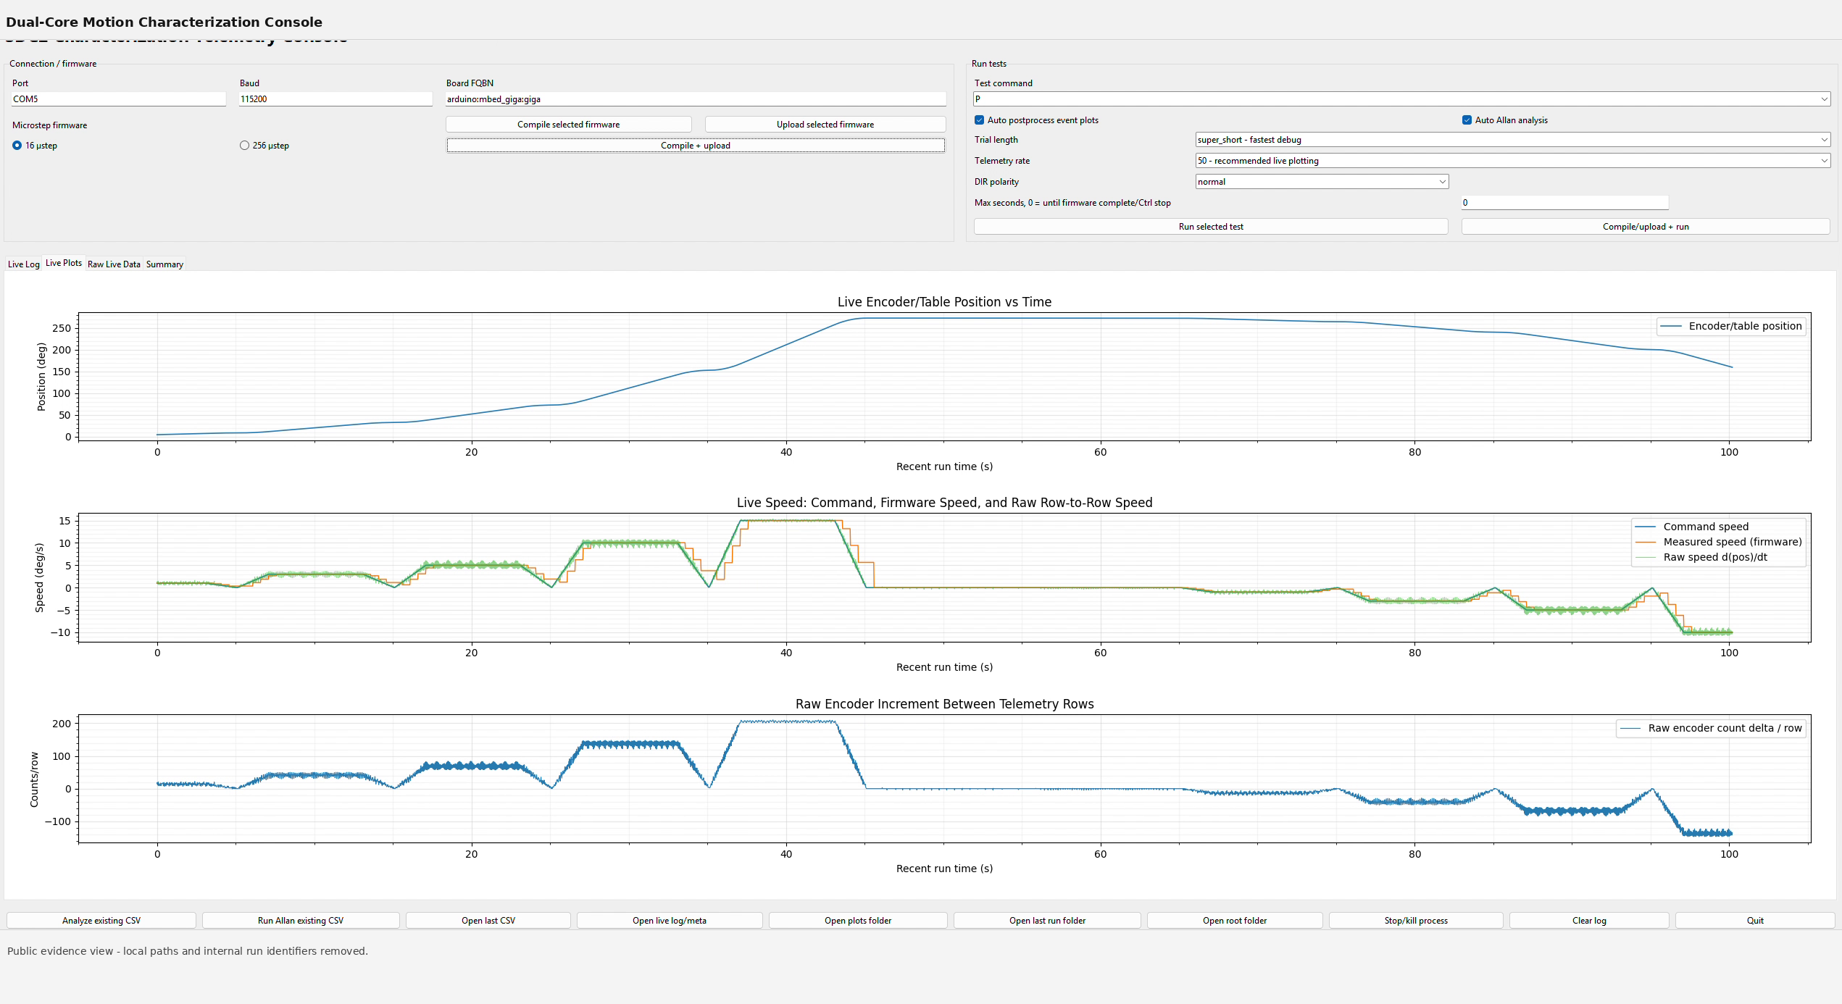
Figure 4. Host console view showing live position, commanded/measured speed, and raw encoder increments.
Workflow stage | Operator action | Recorded output
Connect | Select serial port and baud rate | Target identity and connection state
Configure | Select firmware and test definition | Run metadata and configuration
Execute | Start automated sequence | Live plots and telemetry rows
Review | Open generated outputs | CSV, figures, logs, and summary metrics

5. Low-Speed Tracking Results
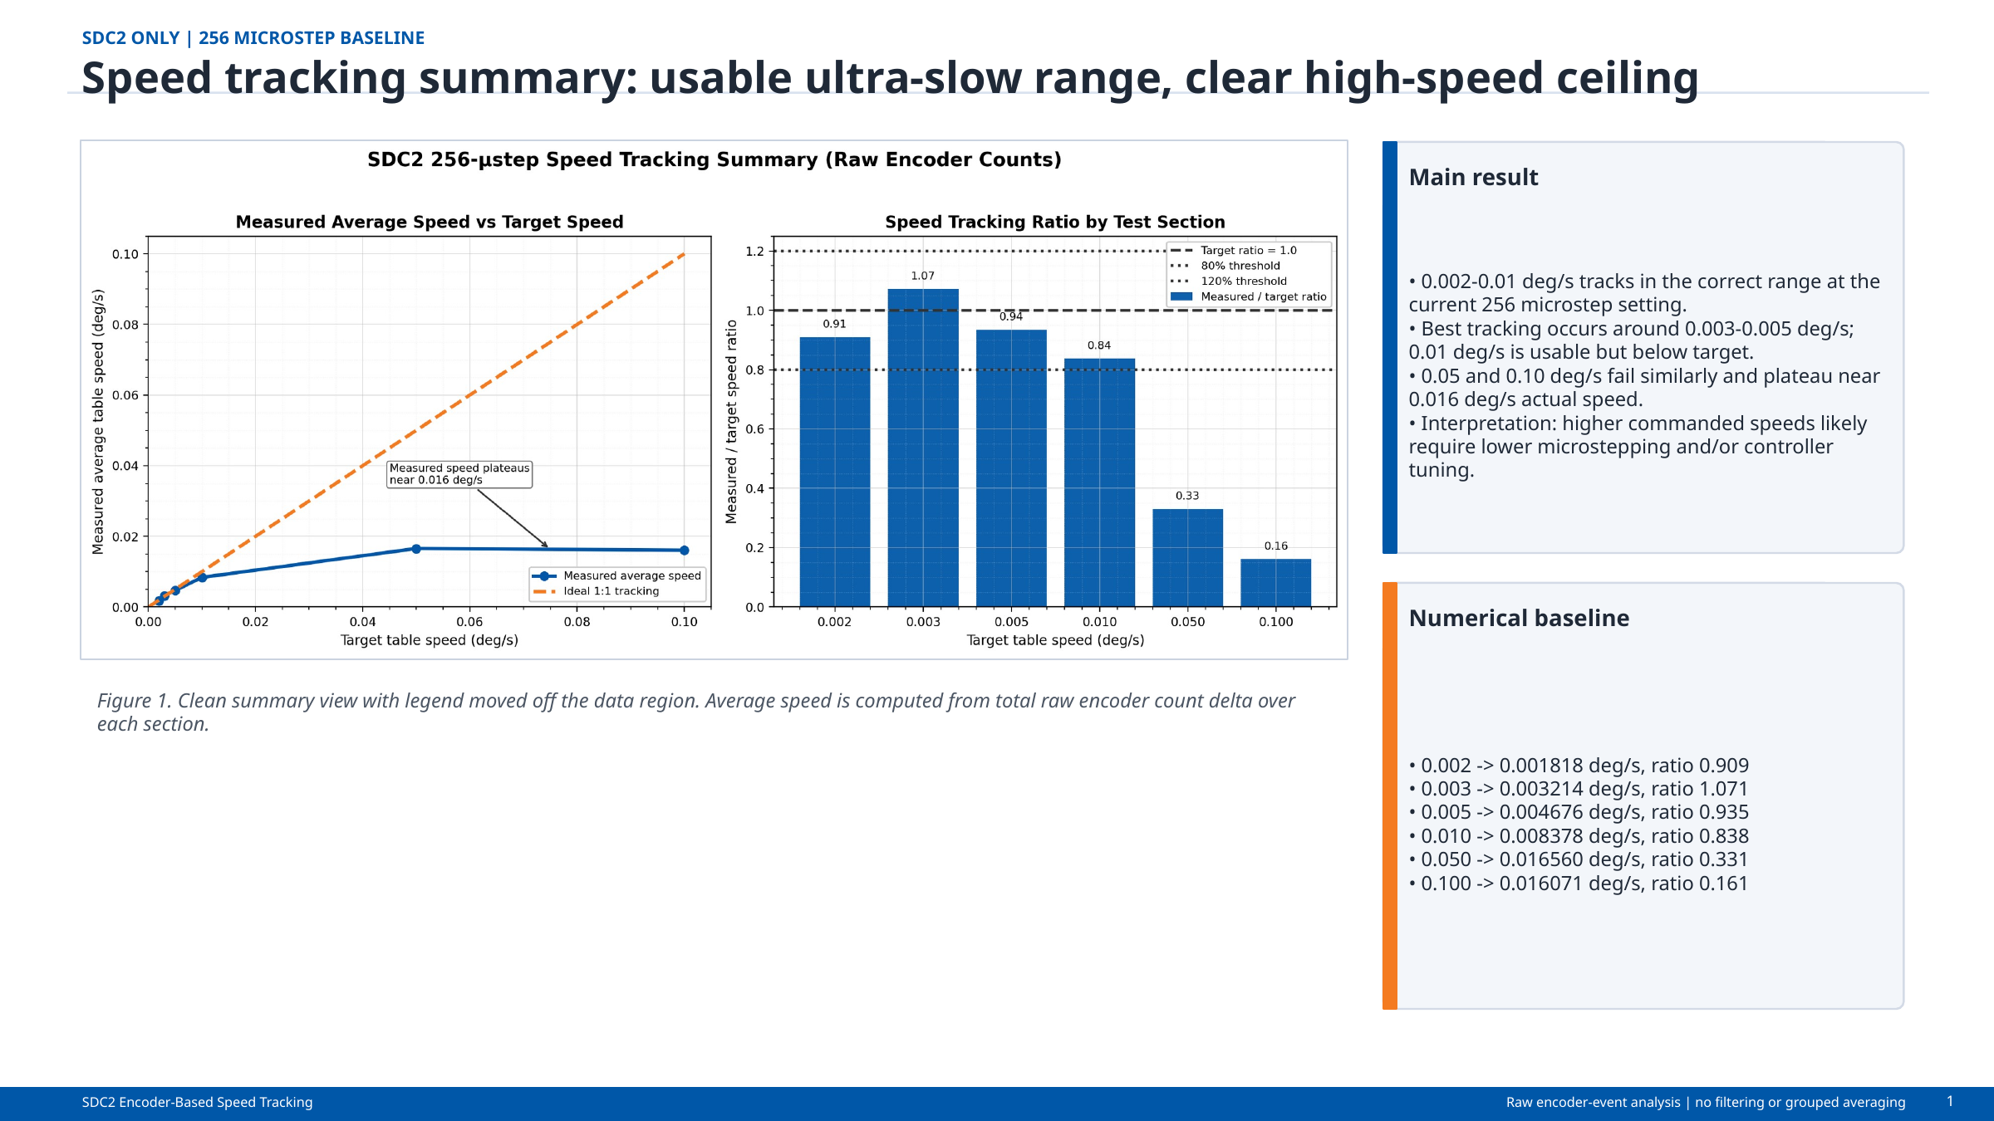
Figure 5. Speed-tracking summary showing the usable ultra-slow range and high-speed ceiling.
Commanded speed (deg/s) | Measured speed (deg/s) | Interpretation
0.002 | 0.001818 | Trackable near the lower practical limit
0.003 | 0.003214 | Best agreement region
0.005 | 0.004676 | Strong low-speed tracking
0.010 | 0.008378 | Usable with increasing bias
0.050-0.100 | ~0.016 plateau | Configuration-limited ceiling

6. Constant-Speed and Step-Response Characterization
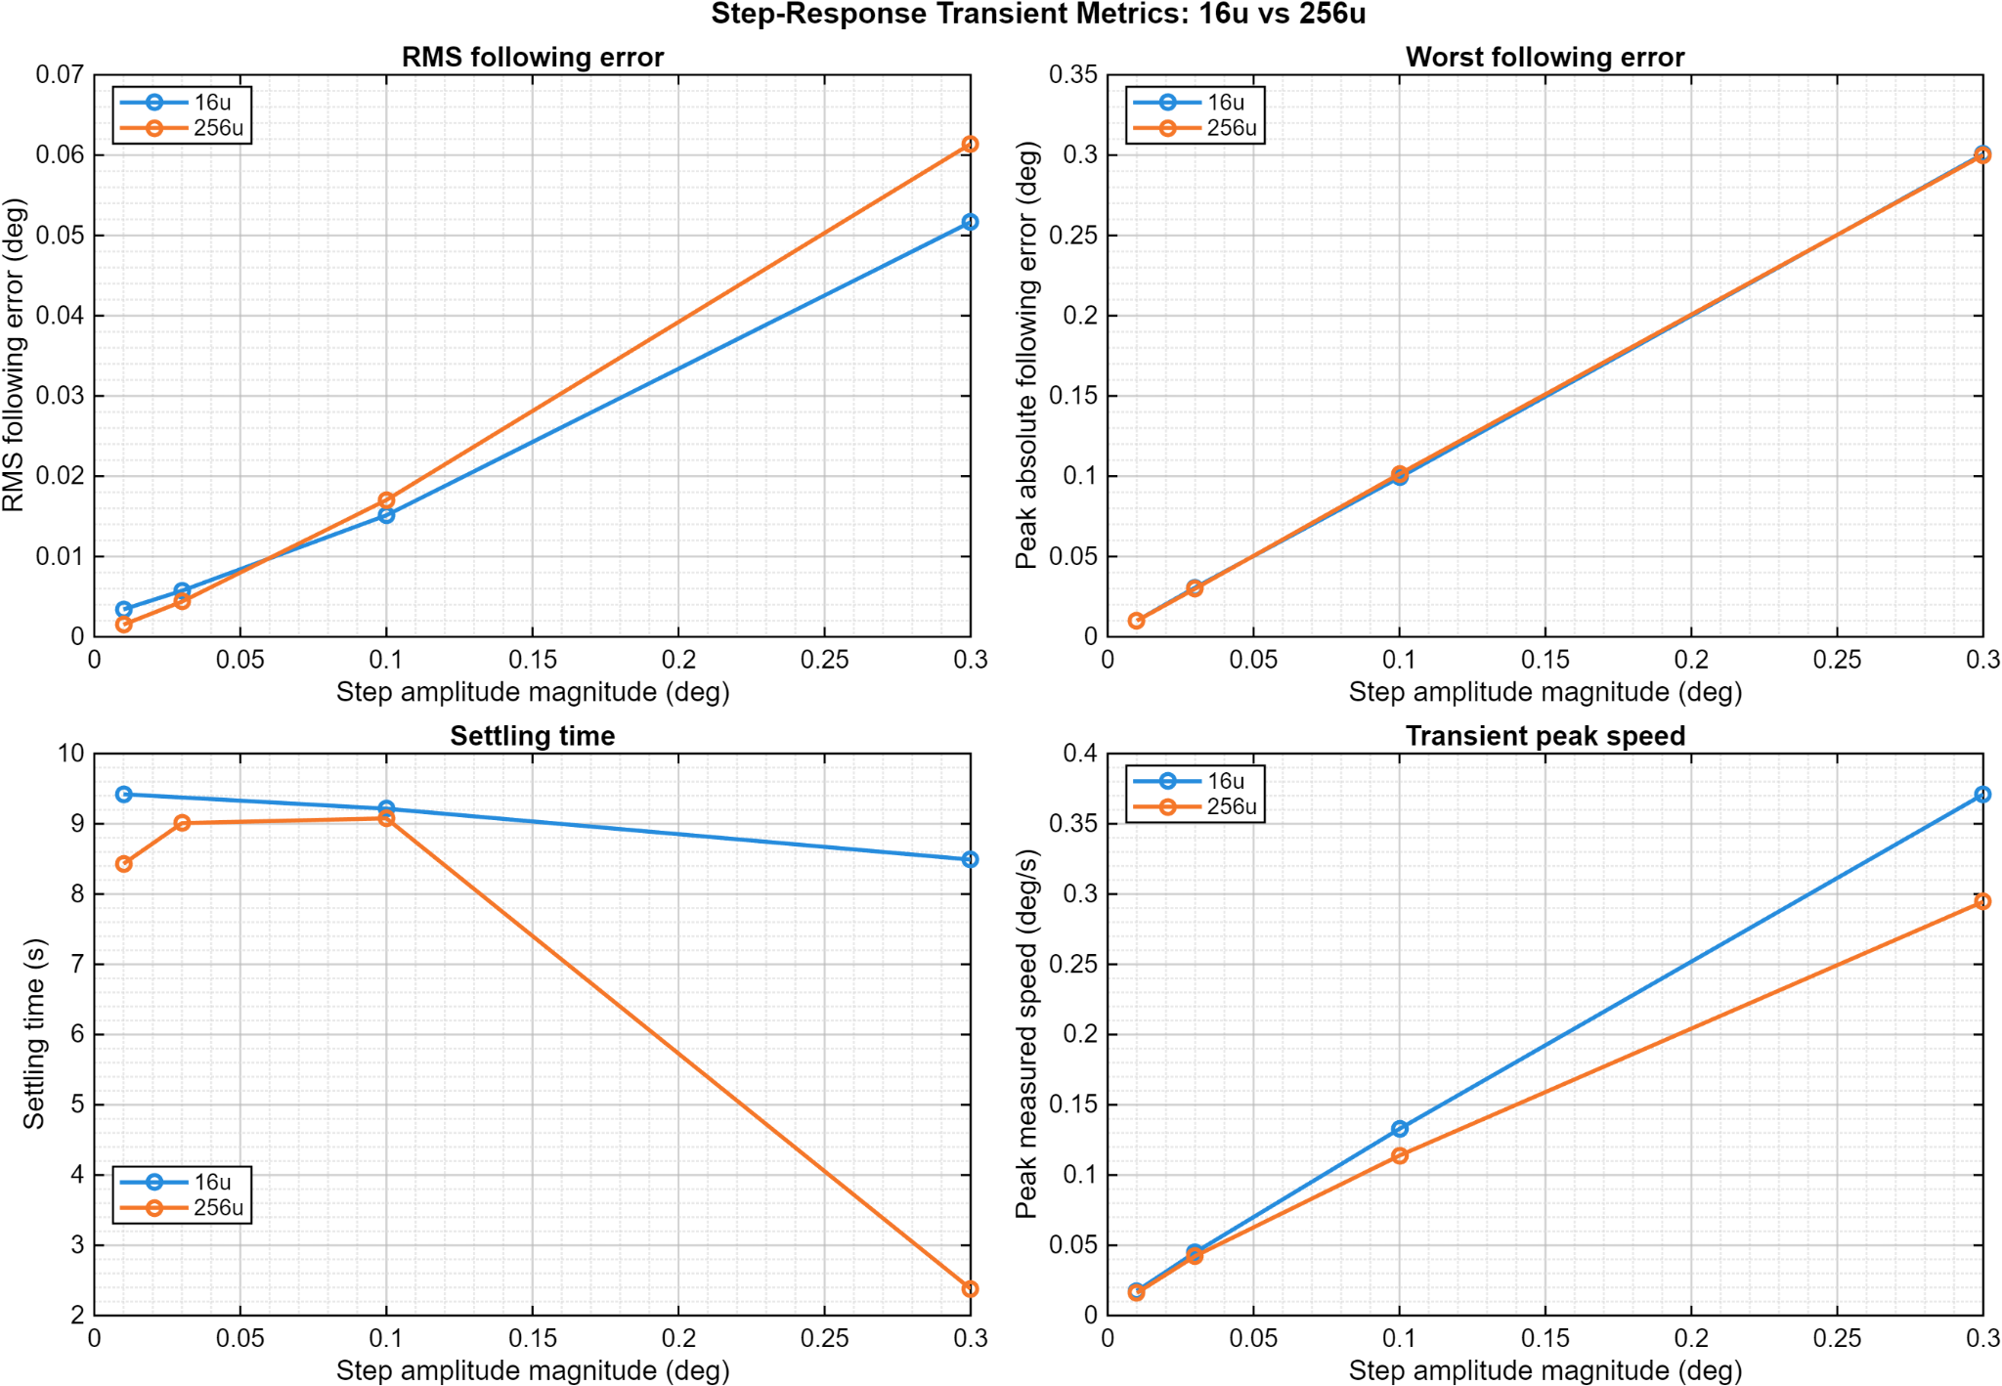
Figure 6. Extended constant-speed tracking and Allan-style stability summary.
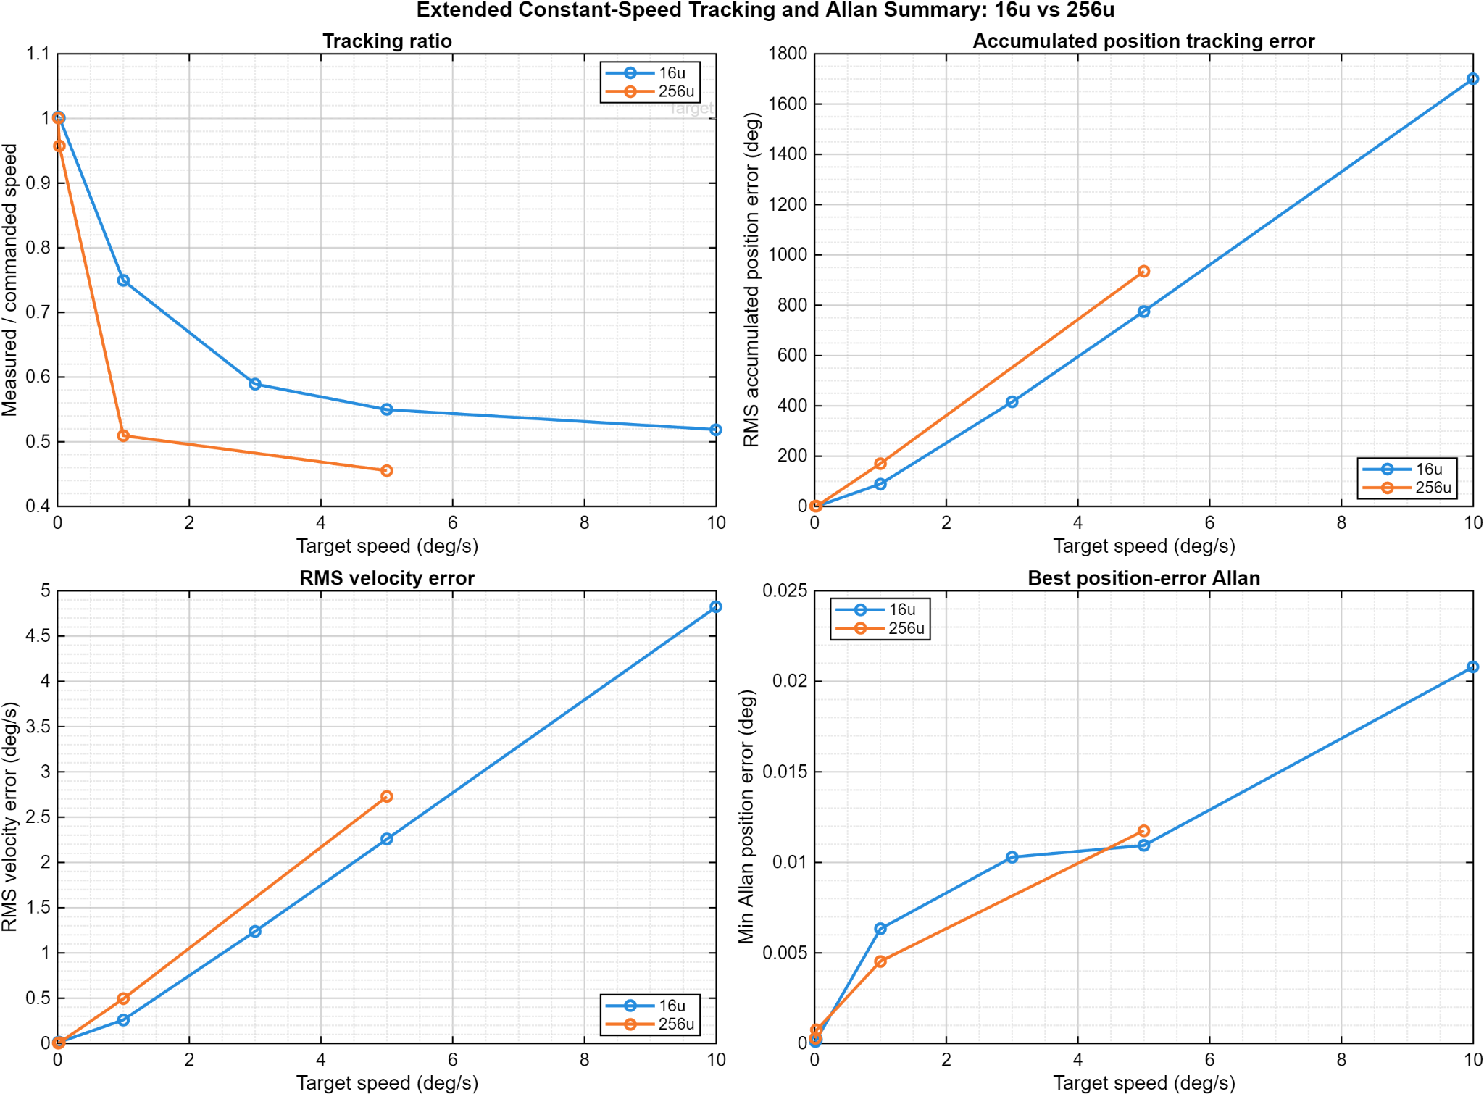
Figure 7. Step-response metrics for RMS following error, worst following error, gain, and position-area measures.

7. Closed-Loop Frequency Response
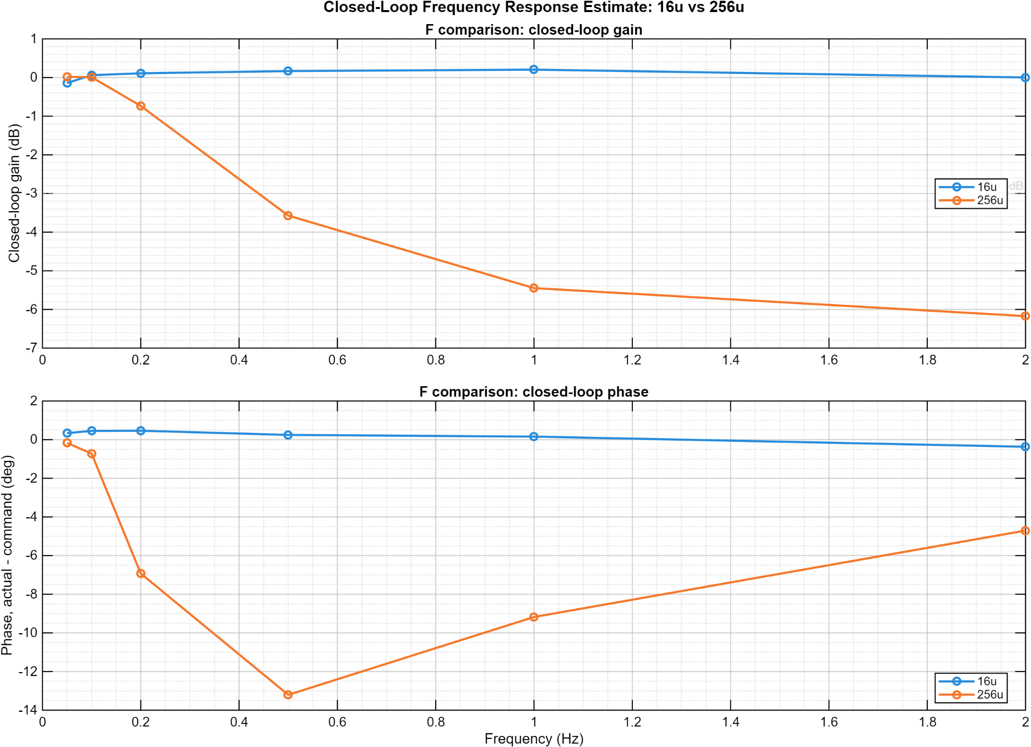
Figure 8. Closed-loop response estimate across the tested 0.33-2 Hz range.
The available evidence supports reporting response across the tested frequencies. It does not, by itself, establish a formal -3 dB bandwidth because the plotted data do not demonstrate a complete crossing with sufficient surrounding points.

8. Safety, Reliability, and Release Controls
Control | Implemented behavior | Release consideration
Host heartbeat | Periodic host presence message | Target deadman should remain enabled
Pulse-rate cap | 25,000 pulses/s maximum | Verify against final drivetrain and driver
Backlog bound | Maximum 25 pulses emitted per loop | Prevents unlimited catch-up bursts
Telemetry limits | Selectable 10/20/50/100 Hz | Full ASCII rows may constrain sustainable rate
Fault accounting | Sequence gaps, drops, heartbeat, fault counters | Expose in final operator status panel
At 115,200 baud, full 24-field ASCII telemetry rows cannot be assumed to sustain 100 Hz under all conditions. The configured option should be treated separately from demonstrated end-to-end serial throughput; 50-60 Hz is a more realistic full-row operating range without a binary protocol or higher link rate.

9. Limitations and Document Control
Item | Controlled statement
Prototype maturity | No formal shock, vibration, thermal, EMC, or long-duration certification is claimed.
MotionIPC package | Reviewed v0.1 sample producer is 100 Hz and should not be represented as the final integrated motor-control workload without the corresponding integrated revision.
Bandwidth claim | Tested response is reported; formal bandwidth is not claimed.
Release package | Preserve tagged source, host build, test definitions, and representative datasets together.

Attribution
Herder Elektronische Systemen developed the public-facing engineering package and documents the dual-core firmware integration, host software, test workflows, and measured evidence represented here. No third-party affiliation or endorsement is claimed.

Revision record
Revision | Date | Description
4.0 | 2026-08-05 | Rebuilt from scratch with restored GUI, architecture, and measured-result imagery; removed inherited layout defects and preserved evidence boundaries.

