DUAL-CORE OPTICAL MOTION TESTBED
MECHANICAL PLATFORM & INTERFACE PCB
Rotary/translation hardware, differential encoder interface, STEP/DIR control, and physical verification
Customer-facing technical report
Revision 2.9 - 4 August 2026

Executive Summary
This report presents the physical and electrical platform of the Dual-Core Optical Motion Testbed: the load-bearing rotary and translational platform, differential encoder receiver, STEP/DIR motor interface, and the firm-designed PCB with a dedicated solid-copper ground plane. The companion firmware report documents the Cortex-M7/M4 architecture, GUI, telemetry, safety behavior, and measured results.
Prepared by | Herder Elektronische Systemen
Primary subject | Mechanical platform, custom PCB, encoder and motor-driver interfaces, and physical verification
Firmware context | STM32H747 Cortex-M7/M4 target with OpenAMP and shared-memory IPC
Distribution | Customer-facing; complete editable fabrication and private development archives excluded
DOCUMENT PURPOSE
This report is the physical and electrical half of the project. It leads with the custom interface PCB and mechanical platform, while the companion firmware FRD covers the dual-core target, GUI, telemetry, and results.

1. Platform and PCB Overview
The system combines a load-bearing rotary and translational optical platform with a firm-designed encoder/STEP-DIR interface PCB. The mechanical assembly provides controlled motion and optical mounting; the PCB provides differential encoder reception, logic-level feedback, motor commands, power/reference distribution, and a solid-copper ground plane for signal integrity.
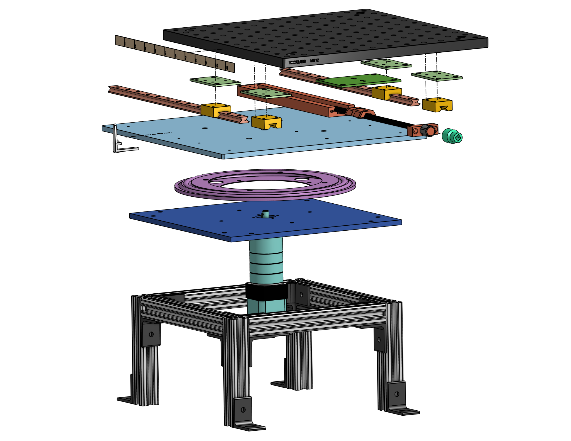  Figure 1. Exploded mechanical assembly and load path. | 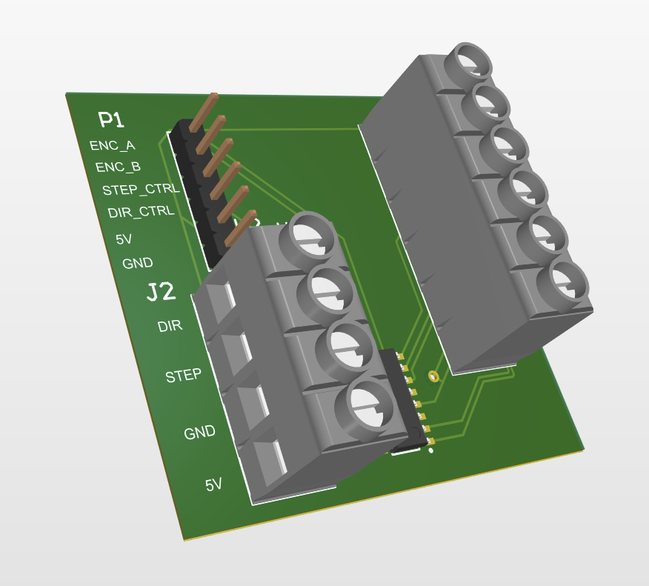  Figure 2. Populated interface PCB.
Subsystem | Purpose
Rotational stage | Continuous controlled rotation of the optical assembly
Translation stage | Manual lateral offset for alignment and crosstalk studies
Structural frame | Supports the optical breadboard and demonstrated static load
Interface PCB | Conditions encoder feedback and routes STEP/DIR control
Safety chain | Emergency-stop and target-side timeout behavior

2. Mechanical Architecture

Figure 3. Exploded assembly showing the translation carriage, rotating platform, bearing structure, drive, and frame.
The lower structure supports the rotary axis and drive train. The upper carriage translates on parallel guides using a lead-screw mechanism, allowing the optical axis to be offset while preserving the load path through the frame.
Mechanical requirement | Demonstrated or designed capability
Static load | 40 lb demonstrated
Translation | More than ±3 in
Operator-readable translation | Approximately 1/32 in
Rotating footprint | Approximately 12 × 12 in
Rotation | Continuous; operating speed depends on microstep and pulse configuration

3. Assembled Platform and Translation
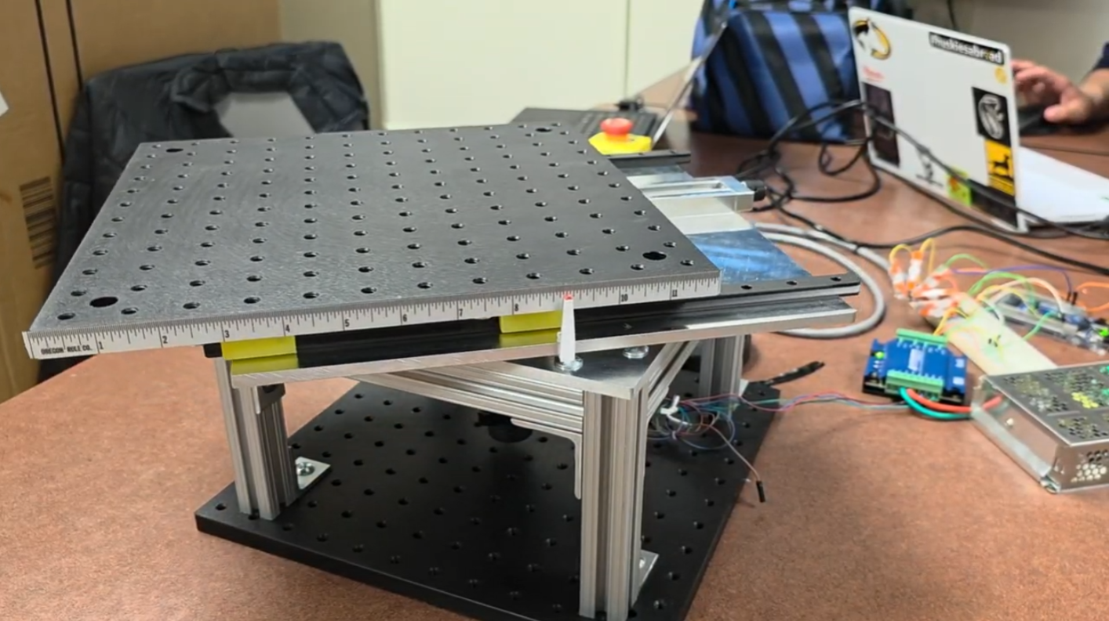
Figure 4. Assembled dual-axis optical motion platform.
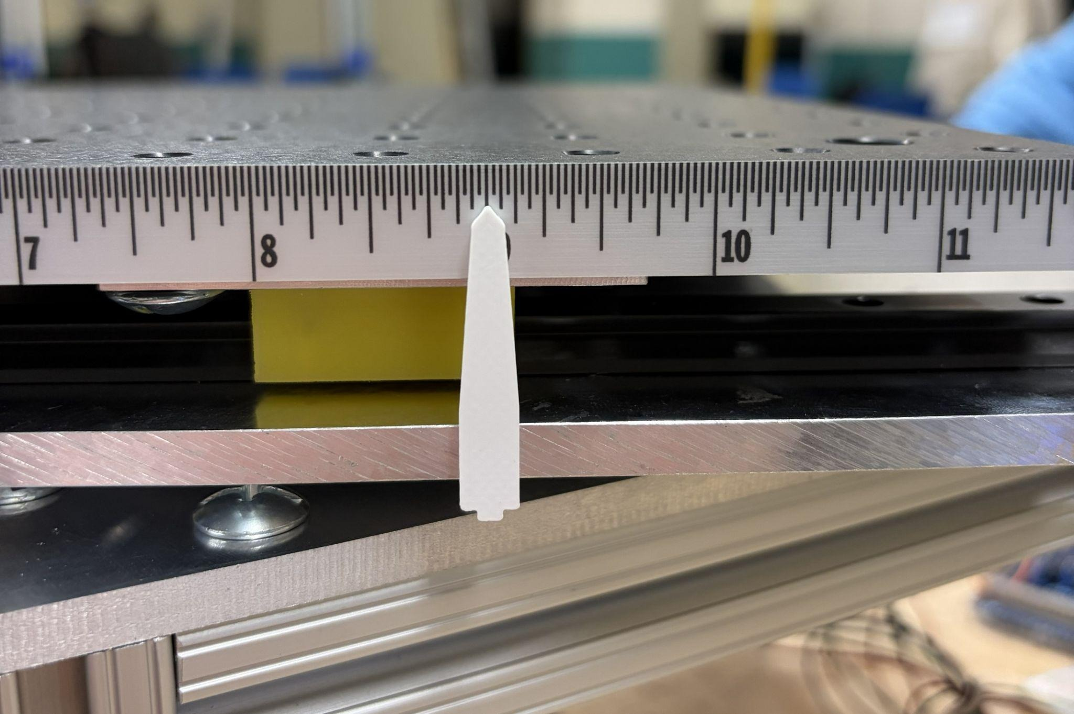
Figure 5. High-contrast pointer and fixed scale for manual translation measurement.

4. Load and Safety Evidence
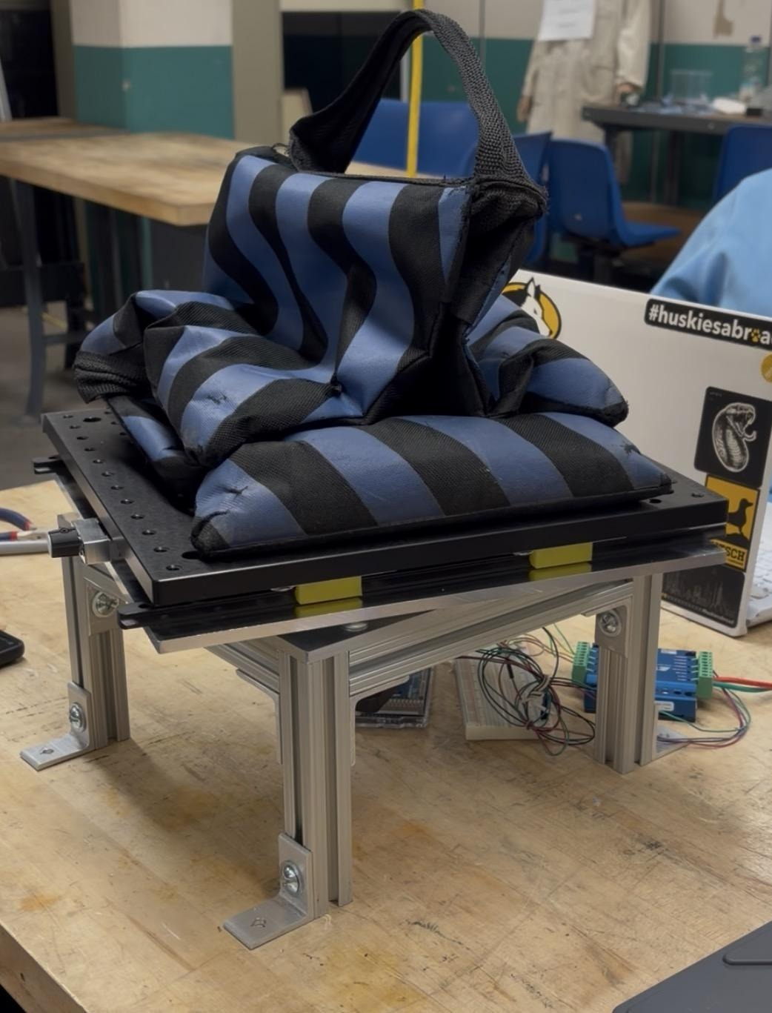
Figure 6. Static-load demonstration on the assembled platform.
The structure demonstrated the specified static load while retaining the rotary and translational architecture. This is prototype validation, not a formal structural or environmental certification.
- Emergency-stop behavior removes drive power independently of the GUI.
- Target-side deadman supervision stops motion after loss of host heartbeat.
- Operator procedures must clear pinch points, moving cables, and optical hardware before motion.
- The system requires a rigid optical table or equivalent mounting surface.

5. Encoder and STEP/DIR Interface Schematic
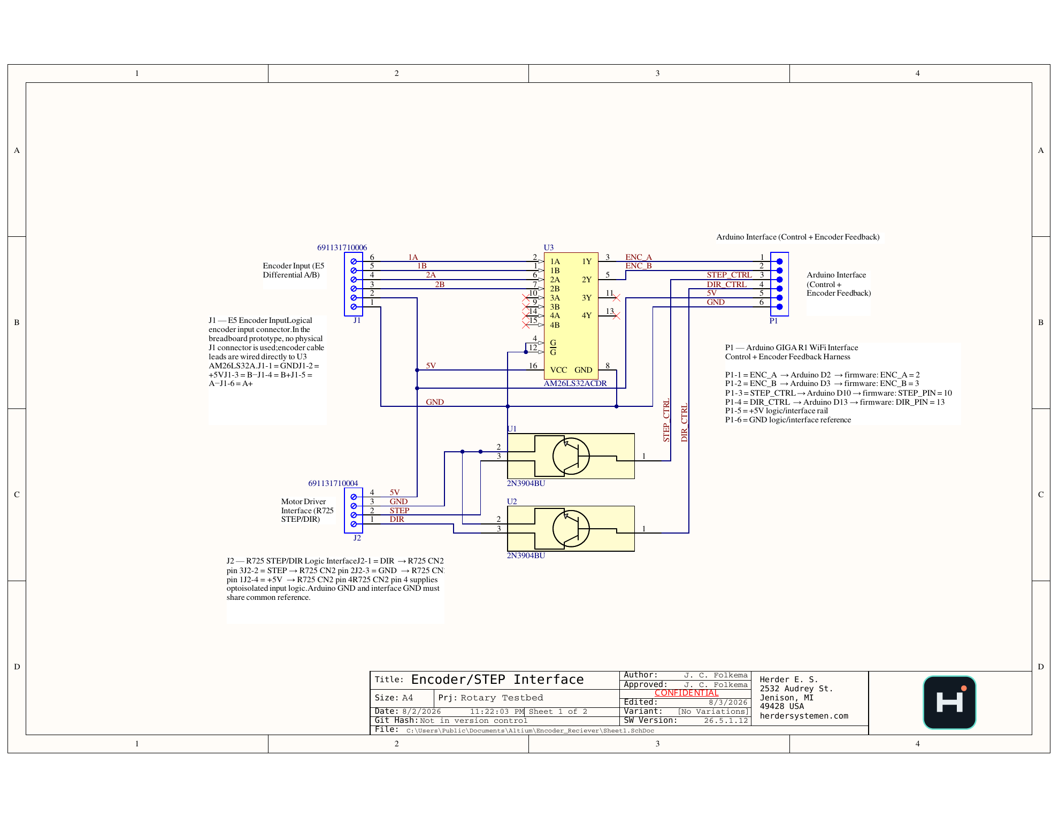
Figure 7. Featured encoder and STEP/DIR interface schematic.
The interface receives differential A/B encoder signals through the AM26LS32 line receiver, provides logic-level encoder feedback to the controller, and routes STEP/DIR control to the R725 motor driver. The controller, interface board, and driver share a defined 5 V logic rail and common ground reference.
Connector | Signals / function
J1 | Differential encoder A+/A− and B+/B−, 5 V, GND
P1 | ENC_A, ENC_B, STEP_CTRL, DIR_CTRL, 5 V, GND to the controller
J2 | DIR, STEP, GND, 5 V to the motor-driver interface

6. PCB Routing and Solid Ground Plane
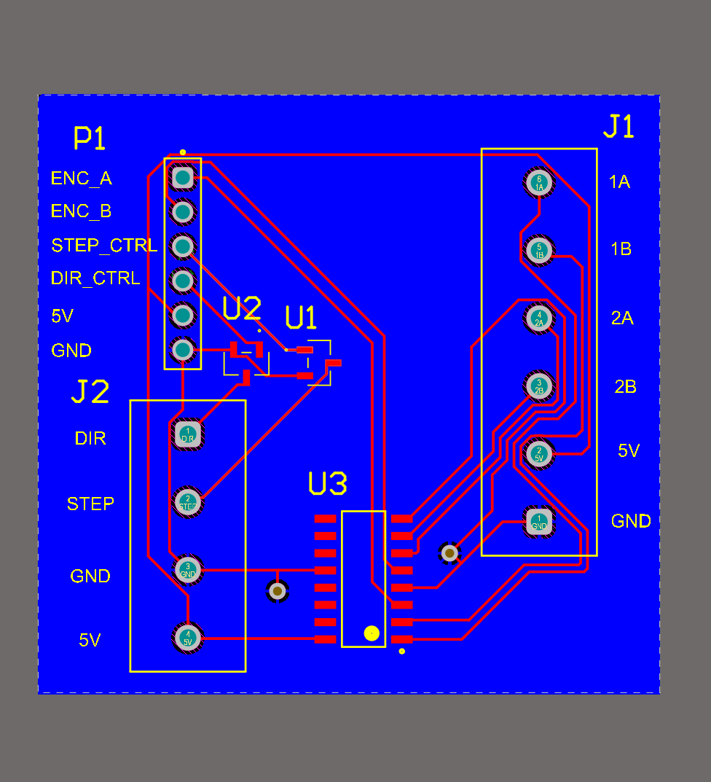  Figure 8. Routed signal layer and labeled interfaces. | 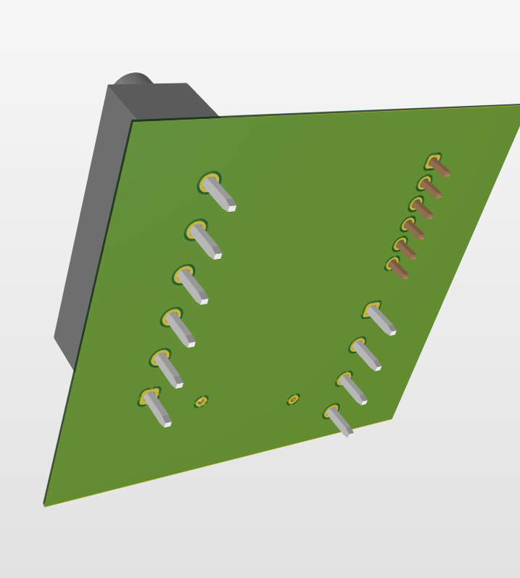  Figure 9. Dedicated solid-copper ground plane.
The redesigned board intentionally uses one layer as a continuous copper ground reference. Signal routing remains on the opposite layer wherever practical, reducing return-path discontinuities and making the reference strategy immediately reviewable.
Design feature | Engineering purpose
Solid ground plane | Continuous low-impedance logic return path
Short receiver routing | Limits loop area between connector and AM26LS32
Explicit connector labels | Reduces wiring and commissioning errors
Common logic reference | Maintains valid thresholds across controller and driver
Mounting clearances | Supports serviceable installation and connector access
PUBLIC DESIGN EVIDENCE
The customer-facing repository includes the schematic, routed-layer image, ground-plane image, and 3D renders. Editable fabrication files remain controlled engineering assets.

7. PCB Assembly and Component Placement
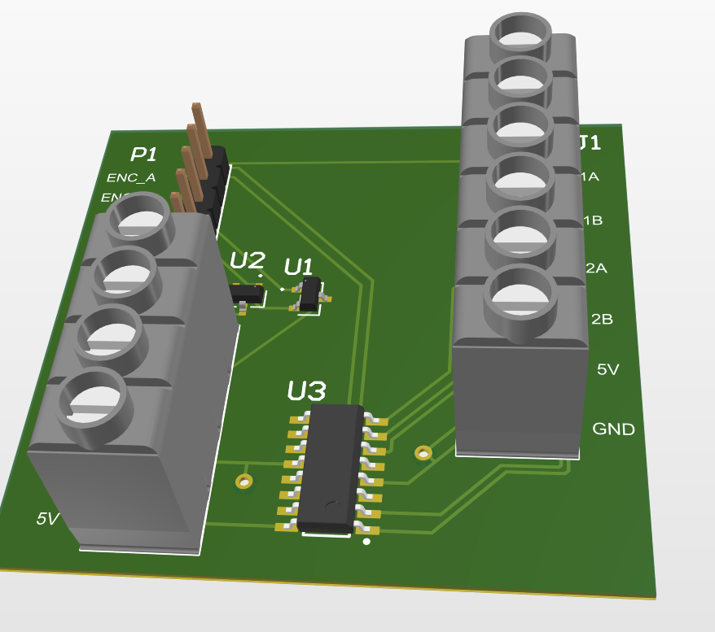  Figure 10. Front PCB assembly view. |   Figure 11. Angled PCB assembly view.
Designator / group | Function
U3 — AM26LS32 | Quad differential line receiver for encoder A/B
U1, U2 — NPN stages | STEP/DIR interface translation
J1 | Six-position encoder terminal block
J2 | Four-position motor-driver terminal block
P1 | Six-position controller header

8. Controller, Encoder, and Drive Scaling
The PCB connects the mechanical plant to the STM32H747 target. Encoder feedback is captured through an interrupt-driven input path, and STEP/DIR commands are generated on the target. The physical scaling determines the relationship between firmware pulses, encoder counts, and table motion.
Parameter | Value
Gear ratio | 24.65:1
Motor full steps/revolution | 200
Microsteps/full step | 256 in the ultra-slow configuration
Pulses/table revolution | 1,262,080
Pulses/table degree | 3,505.78
Command increment | ~0.000285°/pulse
Encoder CPR | 5,000
Effective table counts/revolution | 246,500
Measured increment | ~0.001460°/count

9. Physical Motion Evidence
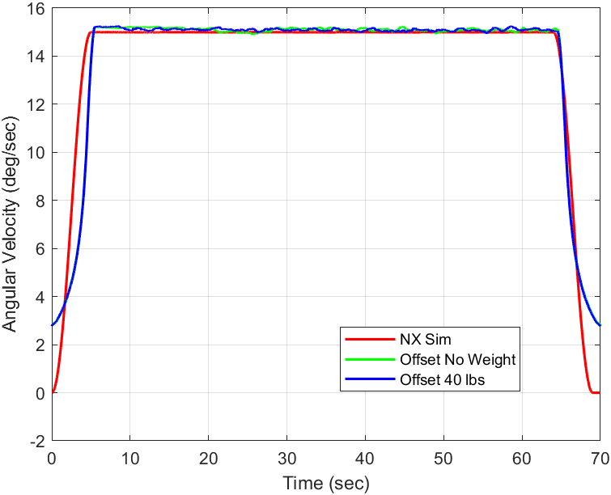
Figure 12. Representative rotation-rate demonstration under multiple load and offset conditions.
The physical platform demonstrated commanded rotation, lateral offset, encoder feedback, and load support. Configuration-specific speed limits are documented in the companion firmware report rather than treated as one universal mechanical range.
EVIDENCE SCOPE
The physical evidence supports prototype operation and integration. It does not constitute formal production, EMC, environmental, or downstream optical-system qualification.

10. Requirements and Verification Status
ID | Requirement | Status / evidence
MECH-01 | Support the optical assembly and applied static load | 40 lb demonstration
MECH-02 | Provide lateral adjustment | More than ±3 in travel
MECH-03 | Provide operator-readable translation | Fixed scale and high-contrast pointer
ELEC-01 | Receive differential encoder A/B | AM26LS32 interface schematic and PCB
ELEC-02 | Route STEP/DIR control | Controller and R725 interface documented
ELEC-03 | Provide deliberate ground reference | Solid-copper plane and common ground
SAFE-01 | Provide independent stop behavior | Emergency stop and target deadman

11. Limitations and Release Actions
Item | Controlled statement
Prototype manufacture | No formal shock, vibration, thermal, EMC, or long-duration certification.
Electrical power | Idle, steady-state, and peak system power remain to be measured.
Fabrication release | Editable board files and final manufacturing package remain controlled.
Integrated build | Preserve one tagged firmware/hardware release for configuration traceability.
Metrology | Motion-platform characterization does not certify downstream optical performance.

12. Attribution and Revision Control
Herder Elektronische Systemen developed the Dual-Core Optical Motion Testbed platform architecture, custom encoder/STEP-DIR PCB, dual-core firmware integration, host software, test workflows, and customer-facing documentation represented here. No third-party affiliation or endorsement is claimed.
Rev | Date | Description
2.9 | 2026-08-04 | Renamed the public project and rewrote the platform report identity while retaining the exploded assembly, schematic, routed copper, solid-copper ground plane, PCB renders, and physical verification evidence.

