DUAL-CORE FIRMWARE, HOST SOFTWARE & RESULTS
STM32H747 MotionIPC Architecture, Live GUI, Telemetry, and Characterization
Customer-facing technical report
Revision 2.4 • 3 August 2026
Prepared by | Herder Elektronische Systemen
Primary subject | Dual-core firmware, host GUI, telemetry, logging, and measured system behavior
Evidence basis | MotionIPC source, motion firmware, GUI video, plots, logs, slide reviews, and technical reports
Distribution | Customer-facing; selected source excerpts and measured evidence included
DOCUMENT PURPOSE
This report presents the complete software side of the project: deep dual-core firmware, live operator software, data integrity, safety behavior, and measured results from the physical platform.

1. System Outcome
The completed system combines a custom STM32H747 dual-core IPC architecture with target-side motion control, encoder acquisition, host supervision, live visualization, structured logging, automated workflows, and postprocessing. The 400 MHz Cortex-M7 and 200 MHz Cortex-M4 communicate through OpenAMP/RPMsg for control traffic and a custom AXI-SRAM ring for motion records. The desktop application exposes the resulting system as an operable laboratory instrument rather than a firmware demonstration.
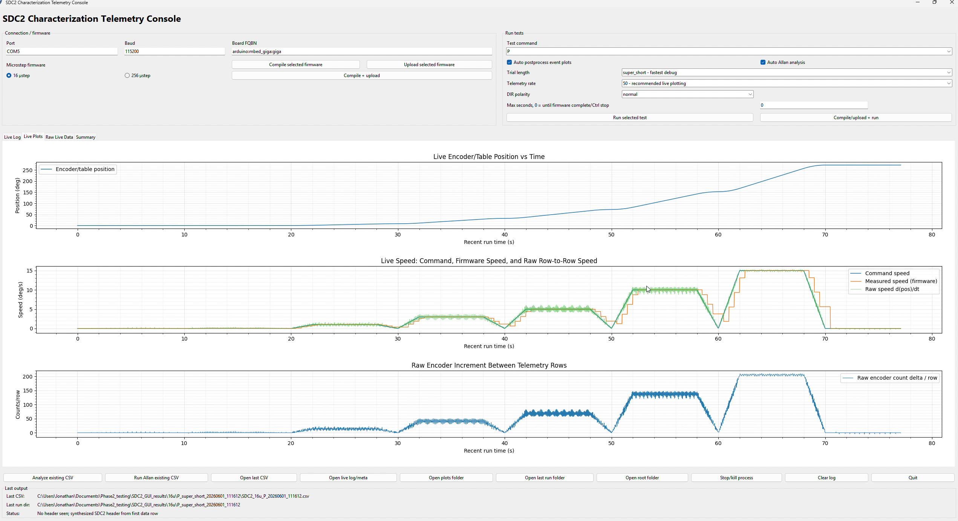
Figure 1. Operator-facing host application with connection controls, test selection, status, and live telemetry.
CUSTOMER-VISIBLE RESULT
An operator can connect the target, select a test, monitor command and encoder behavior, record timestamped data, recover interrupted runs, and launch analysis without controlling real-time motion from the PC.

2. Dual-Core Architecture
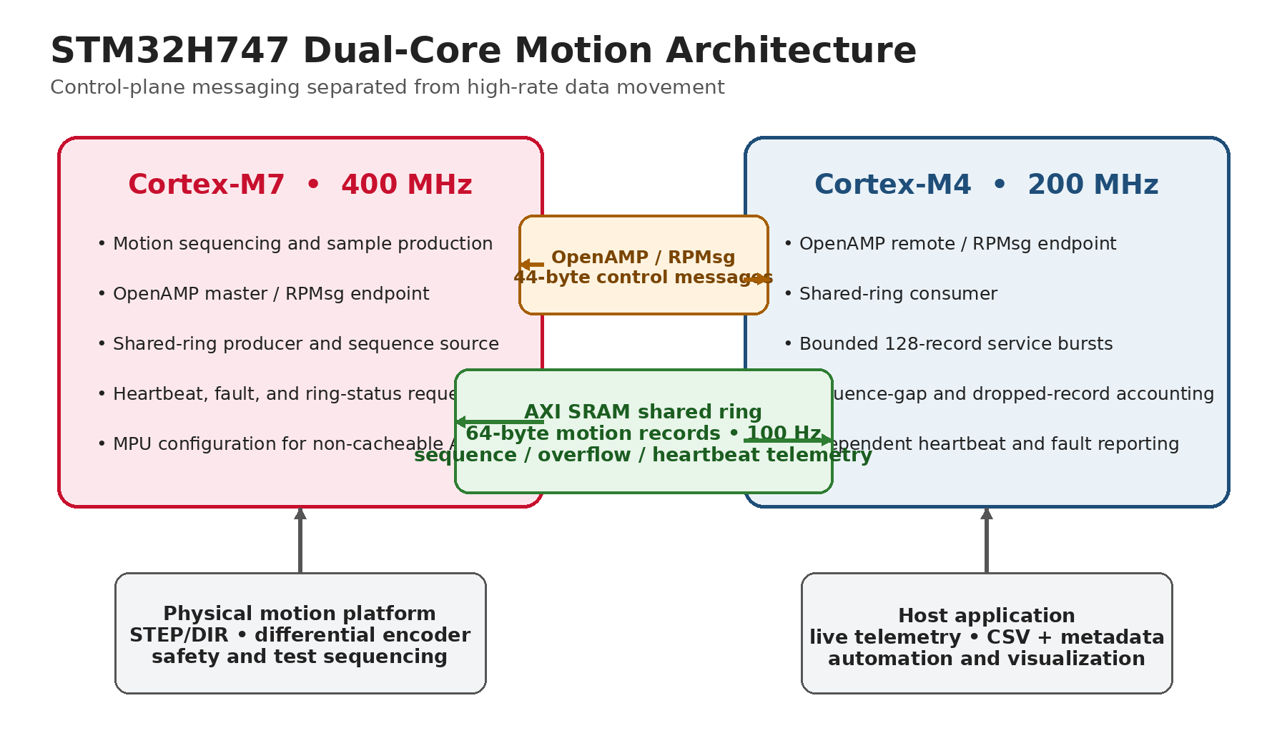
Figure 2. STM32H747 architecture separating the OpenAMP/RPMsg control plane from the AXI-SRAM motion-data path.
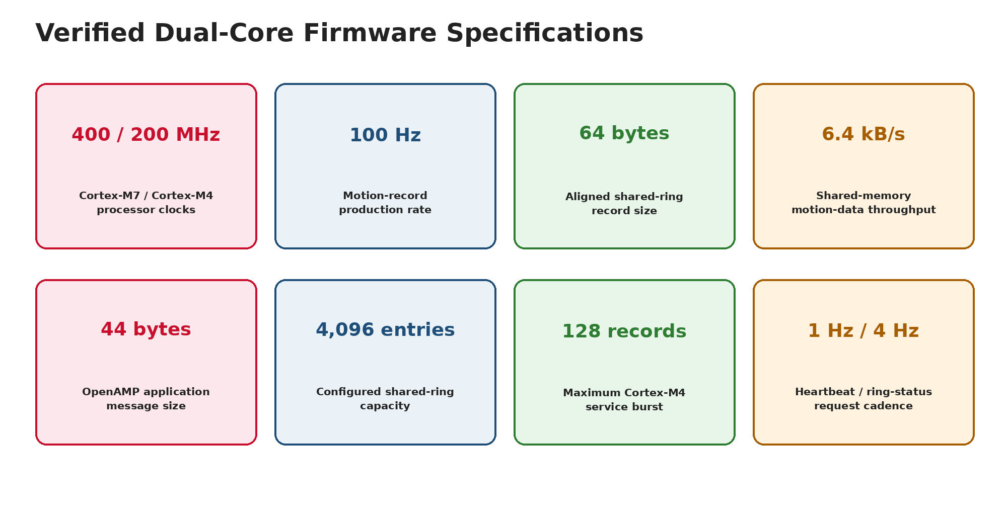
Figure 3. Source-verified processor, IPC, buffering, and service-cadence specifications.

2.1 Verified implementation table
Item | Verified implementation
Cores | 400 MHz Cortex-M7 + 200 MHz Cortex-M4
Control IPC | OpenAMP/RPMsg; 44-byte application messages
Data IPC | 256 KiB AXI-SRAM producer/consumer ring
Motion record | 64 bytes, cache-line aligned
Record rate | 100 Hz; 6.4 kB/s internal throughput
Consumer service | Up to 128 records per M4 service pass
Health cadence | 1 Hz per-core heartbeat; 4 Hz ring-status requests

3. Core Ownership and Boot Sequence
Cortex-M7 ownership | Cortex-M4 ownership
MPU/cache setup and HSEM release | Wake from STOP and initialize remote core
OpenAMP master and RPMsg endpoint | OpenAMP remote and RPMsg endpoint
Shared-ring producer and sequence source | Shared-ring consumer
Motion record production | Bounded 128-record processing bursts
Heartbeat and status requests | Gap, drop, heartbeat, and fault reports

3.1 Startup flow
Stage | M7 | M4
1 | Configure memory policy and clocks | Wait in STOP mode
2 | Release HSEM0 | Wake on HSEM event
3 | Initialize producer | Initialize consumer
4 | Create OpenAMP master endpoint | Create OpenAMP remote endpoint
5 | Produce records and service messages | Consume records and service messages
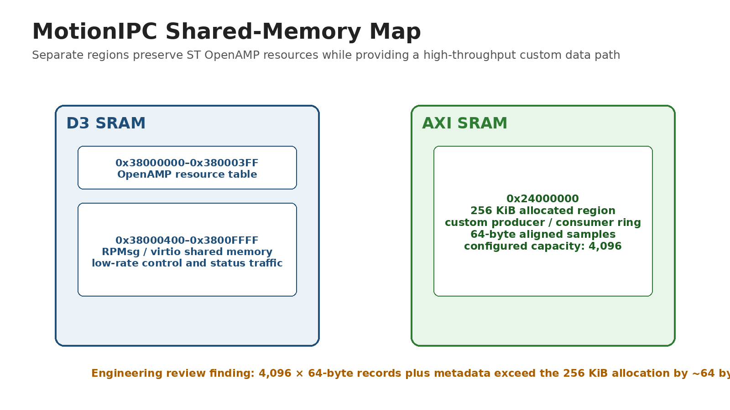
Figure 4. Shared-memory map and the identified ring-capacity correction.

4. IPC Protocol, Data Integrity, and Reliability
Mechanism | Implementation outcome
Sequence continuity | Monotonic sequence numbers and CM4 gap counting expose missing records.
Overflow visibility | Producer-side drop counter reports a full ring instead of silently overwriting data.
Independent liveness | Separate M7/M4 heartbeat counters distinguish core-local failures.
Fault propagation | RPMsg fault messages and per-core flags carry diagnostic state.
Bounded workload | M4 consumes no more than 128 records per pass to preserve OpenAMP service.
Memory ordering | Barriers protect producer/consumer state transitions.
Cache coherency | M7 MPU marks the AXI ring non-cacheable.
REVIEW FINDING
The configured 4,096 × 64-byte sample array fills the 256 KiB allocation before metadata is counted. A production release should use 4,095 entries or enlarge the region.

4.1 Motion record contents
Field group | Contents
Identity and time | Sequence number and microsecond timestamp
Motion state | Encoder count, position, commanded speed, measured speed, tracking error
Execution state | Target state, flags, and status fields

5. Target Motion Firmware
Real-time pulse generation, encoder capture, test progression, and deadman behavior remain on the embedded target. The host requests actions and records results but does not schedule motion.
Control or safety item | Verified value
STEP pulse high time | 4 µs
Step-rate safety cap | 25,000 pulses/s
Maximum pulse backlog | 25 pulses/pass
Loop-overrun warning | 25 ms
Speed-estimation window | 500 ms
Host heartbeat | 500 ms
Target deadman timeout | 2,000 ms
Position correction | 20 pulse-Hz/degree; 250 Hz absolute cap; 5% relative cap

5.1 Encoder and drive scaling
Parameter | Value
Gear ratio | 24.65:1
256-microstep pulses/table revolution | 1,262,080
Command increment | ~0.000285°/pulse
Encoder CPR | 5,000
Effective table counts/revolution | 246,500
Measured increment | ~0.001460°/count

6. Host GUI and Live Operation
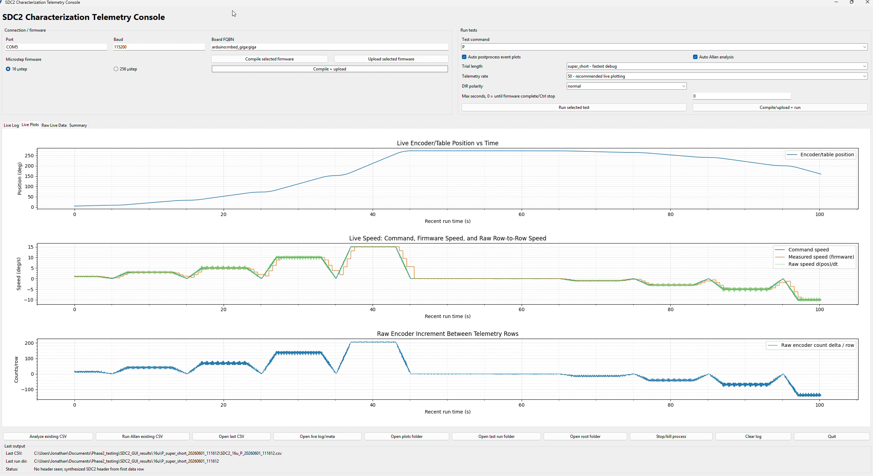
Figure 5. Active host-target test showing live command, measured motion, encoder position/rate, status, and logging state.
The GUI integrates connection management, command execution, test selection, live plots, file naming, logging state, and operator feedback. It provides one working surface for the embedded target rather than requiring separate serial terminals and analysis scripts.
- Live command-versus-measured speed and encoder-position plots.
- Raw encoder-rate visualization for diagnosing quantization and event timing.
- Target status, test progression, connection state, and completion markers.
- Automated filename generation, CSV capture, and separate metadata/comment retention.
- Launch and supervision of tracking, static, step, Allan, and sine-response workflows.
DEMONSTRATION ASSET
The repository includes the host-target interface video showing a scripted physical test progressing through positive and negative motion while telemetry and plots update live.

7. Telemetry, Logging, and Recovery
Capability | Implementation
Host transport | 115,200-baud serial
Selectable output | 10, 20, 50, or 100 Hz requests
Record schema | 24 timestamped CSV fields
Validation | Header and row-width checks; malformed-row detection
Run completion | Test-specific completion markers
Metadata | Controller comments and run context stored separately
Recovery | Partial-run preservation after serial interruption
Safety | 500 ms heartbeat and 2 s target deadman

7.1 Bandwidth result
A 115,200-baud 8-N-1 link provides an idealized 11,520 payload bytes/s. Representative 24-field ASCII rows can approach 189 bytes, limiting sustained full-record output to roughly 50–60 rows/s. The 100 Hz selection therefore identifies the need for shorter records, binary framing, or a faster external transport; the internal shared-memory path remains independent of this bottleneck.
ARCHITECTURE BENEFIT
High-rate inter-core motion data uses AXI SRAM rather than the external serial link. The host interface can evolve without redesigning the M7–M4 data plane.

8. Automated Test Workflow
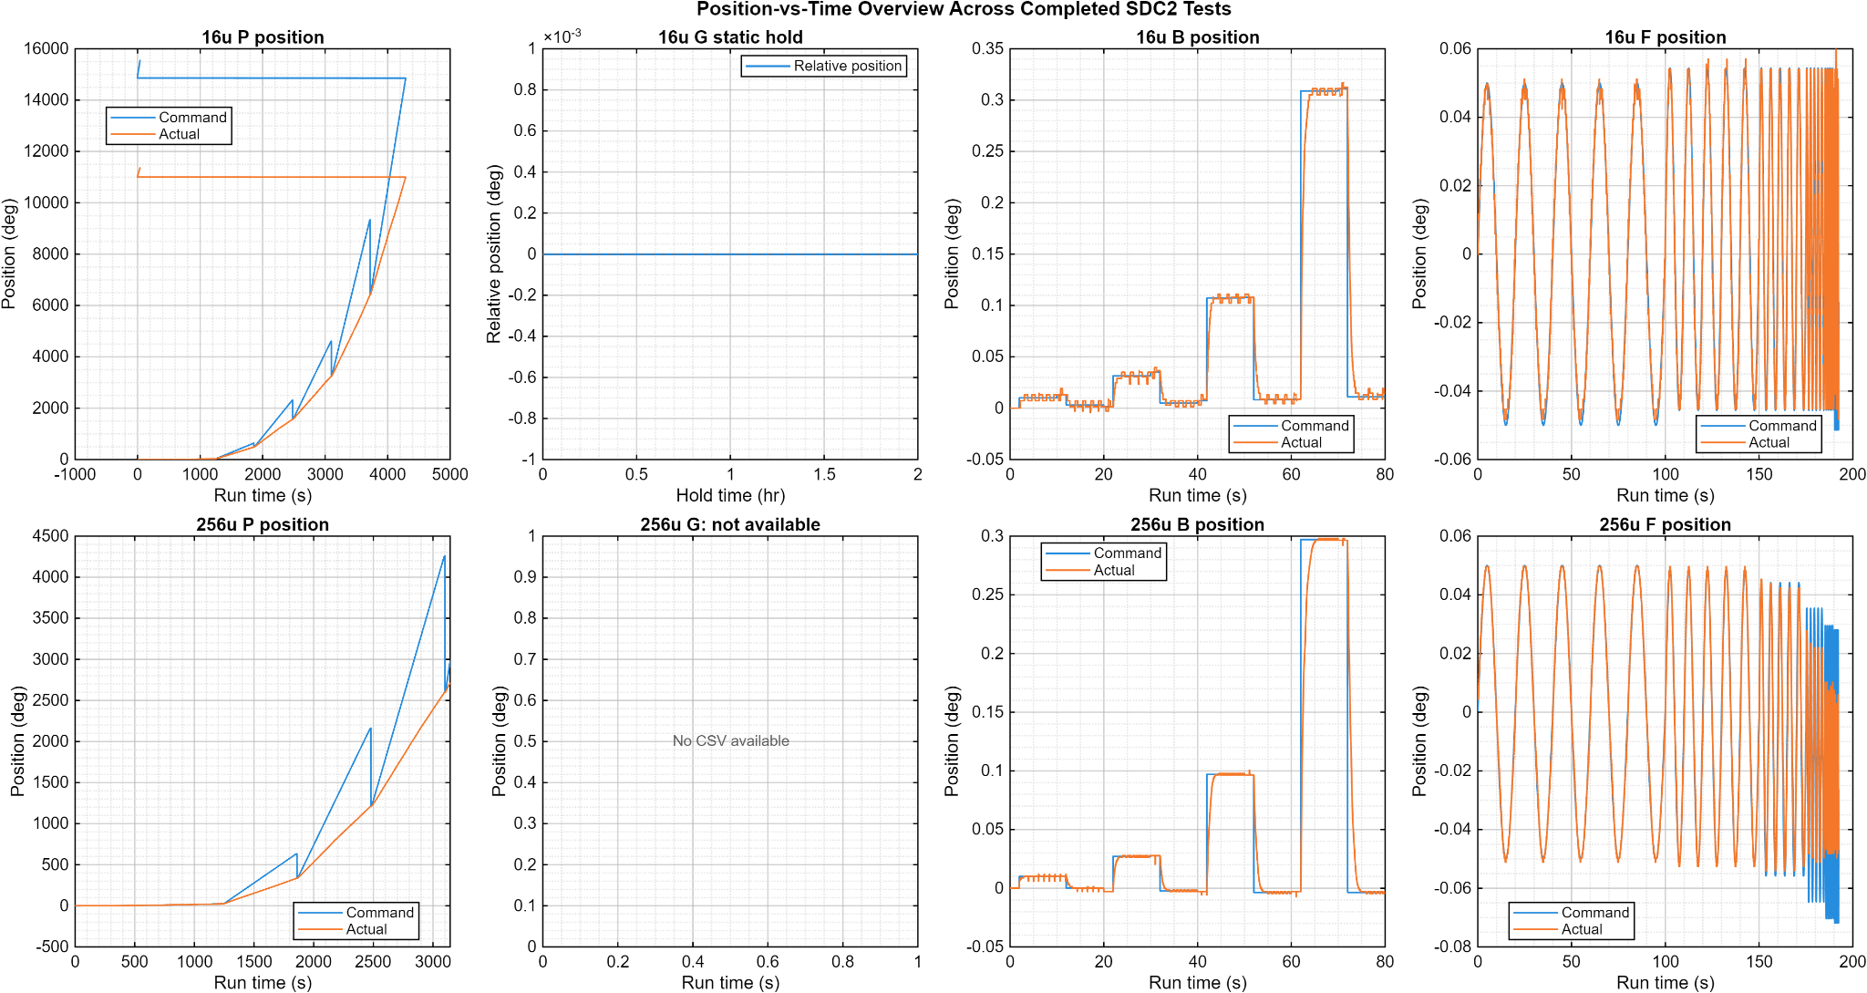
Figure 6. Representative scripted test sequences generated and recorded through the target/host workflow.
Workflow | Configured execution
Static hold | 50 Hz × 180 s or 100 Hz × 90 s; 9,000 records
Dynamic tracking | 100 Hz requested; 6,000 records per 60 s segment
Step response | Scripted command steps with rise, overshoot, settling, RMS, and peak-error analysis
Allan analysis | Static position and dynamic residual workflows
Sine response | Closed-loop command/actual response over approximately 0.33–2 Hz
Target-side sequencing keeps timing deterministic while the host application supervises, logs, validates, and postprocesses the resulting data.

9. Low-Speed Tracking Results
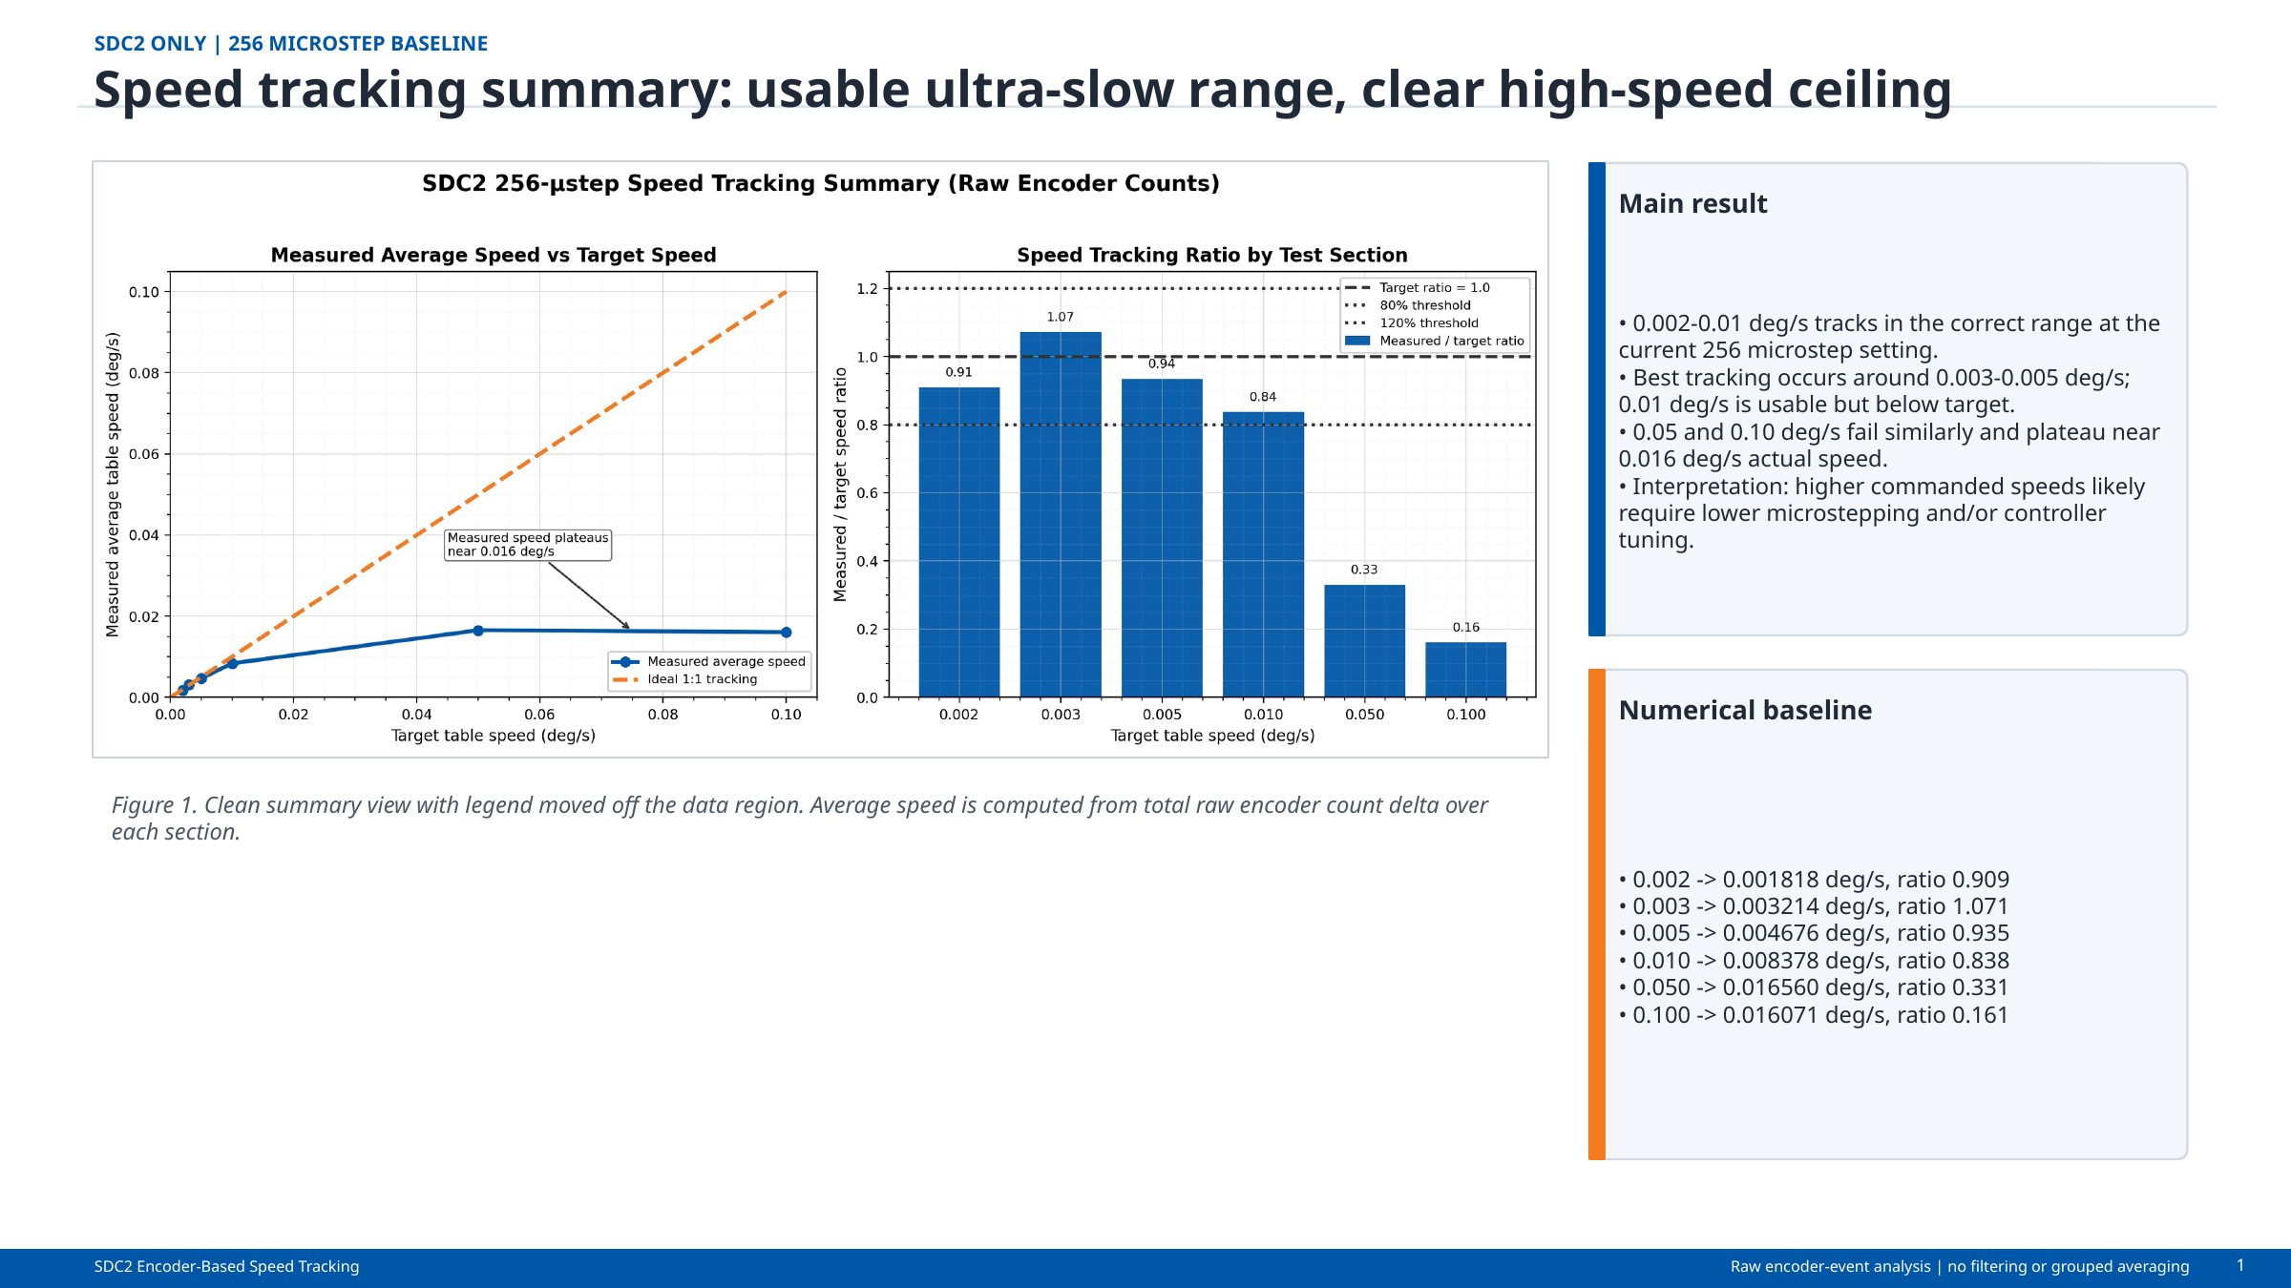
Figure 7. Measured low-speed performance in the 256-microstep configuration.
Command (deg/s) | Measured (deg/s) | Ratio / interpretation
0.002 | 0.001818 | 0.909
0.003 | 0.003214 | 1.071
0.005 | 0.004676 | 0.935
0.010 | 0.008378 | 0.838
0.050 | ~0.016 | Configuration throughput ceiling
0.100 | ~0.016 | Configuration throughput ceiling
RESULT
The 256-microstep setup is an ultra-slow configuration. Best tracking occurred near 0.003–0.005°/s; faster commands plateaued near 0.016°/s and require a different microstep or pulse-rate configuration.

10. Constant-Speed and Step-Response Results
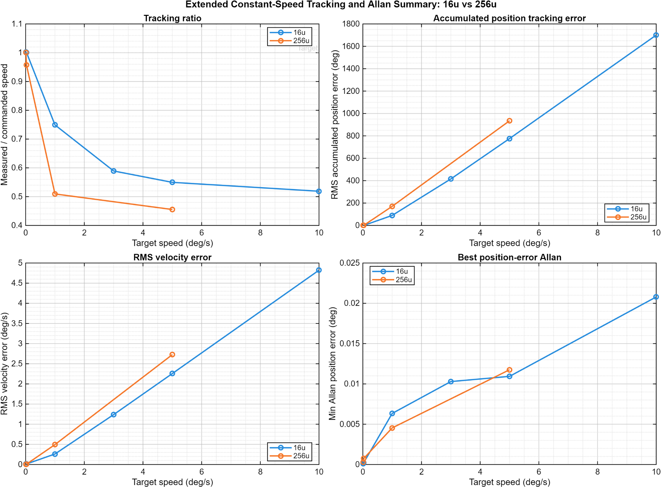
Figure 8. Representative constant-speed command and measured-motion tracking.
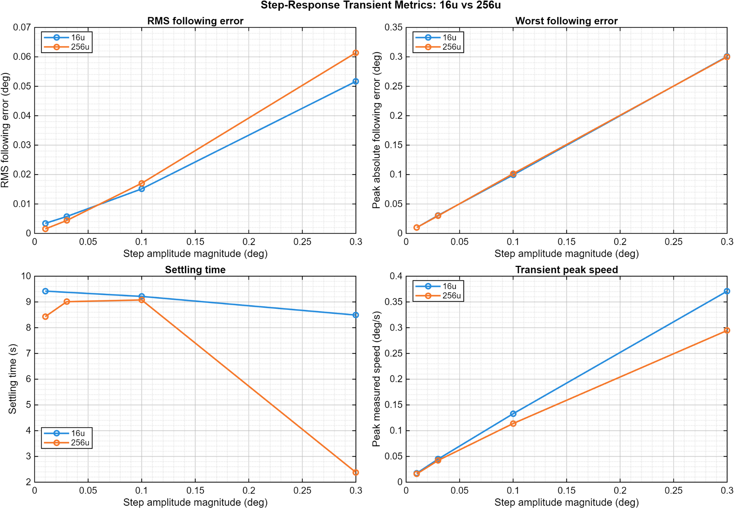
Figure 9. Representative scripted step-response characterization.
These results demonstrate that the embedded sequencing, timestamped acquisition, host logging, and analysis pipeline operated together on the physical platform. Step metrics are computed from retained records rather than from GUI rendering timestamps.

11. Closed-Loop Frequency-Response Results
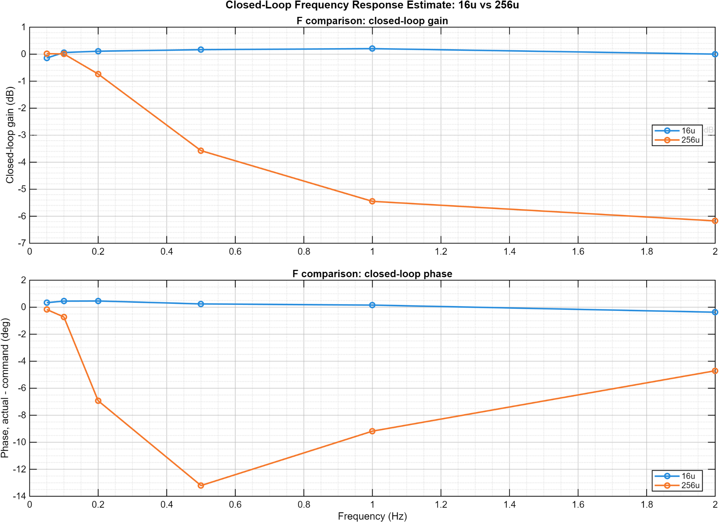
Figure 10. Closed-loop actual/command response over the tested sine-response range.
The workflow estimates gain and phase of measured motion relative to the commanded trajectory. It is a closed-loop response characterization, not a claim of open-loop plant identification or formal phase-margin measurement.
EVIDENCE SCOPE
The tested points span approximately 0.33–2 Hz. A precise interpolated −3 dB bandwidth is not claimed unless a validated crossing is present in the retained dataset.

12. Delivered Software Capabilities
Layer | Delivered capability
Dual-core firmware | OpenAMP/RPMsg coordination, shared-memory ring, HSEM startup, coherency policy, sequence/drop/fault accounting
Motion firmware | Pulse generation, encoder capture, correction, automated sequencing, heartbeat, deadman, and overrun monitoring
Host application | Connection, command execution, live plotting, test orchestration, logging, metadata, and recovery
Analysis | Low-speed, tracking, step response, Allan deviation, and closed-loop sine-response processing
Documentation | Architecture diagrams, FRDs, selected source excerpts, videos, plots, and public repository

13. Limitations and Release Actions
Item | Controlled statement
Ring allocation | Reduce capacity to 4,095 or reserve more than 256 KiB.
Integrated build | Tag and preserve one release binary/build proving final module integration.
IPC timing | Instrument end-to-end latency and worst-case jitter.
External telemetry | Use binary framing or faster transport for sustained 100 Hz full records.
Power | Measure idle, steady-state, and peak electrical power.
Reliability | Mechanisms are present; no MTBF percentage is claimed.

14. Attribution and Revision Control
Herder Elektronische Systemen developed the dual-core firmware architecture, motion-control integration, host software, logging and analysis workflows, interface electronics, and customer-facing documentation represented here. No third-party affiliation or endorsement is claimed.
Rev | Date | Description
2.4 | 2026-08-03 | Complete firmware/software report integrating dual-core architecture, GUI, telemetry, reliability behavior, automated workflows, and measured results.
RELEASE GATE
Correct the ring allocation, preserve a tagged integrated build, measure IPC timing and electrical power, and validate sustained external transport before production release.

