MECHANICAL PLATFORM & ELECTRICAL INTEGRATION
Dual-Axis Optical Motion Testbed — Physical System, Interfaces, and Verification
Customer-facing technical report
Revision 2.4 • 3 August 2026
Prepared by | Herder Elektronische Systemen
Primary subject | Mechanical architecture, load path, encoder and motor interfaces, custom PCB, and physical verification
Companion report | Dual-Core Firmware & Host Software FRD
Distribution | Customer-facing; editable manufacturing sources and private development archives excluded
DOCUMENT EMPHASIS
This report presents the physical platform and electrical integration as a distinct engineering deliverable. The companion firmware FRD covers the STM32H747/OpenAMP implementation in depth.

1. Executive Summary
The dual-axis optical motion testbed combines a load-bearing rotary platform, manual lateral translation, differential encoder feedback, STEP/DIR actuation, emergency-stop behavior, and a custom encoder/motor interface PCB. This report focuses on the physical architecture, interfaces, manufacturable electronics, and verification evidence that make the embedded control system usable as an experimental instrument.
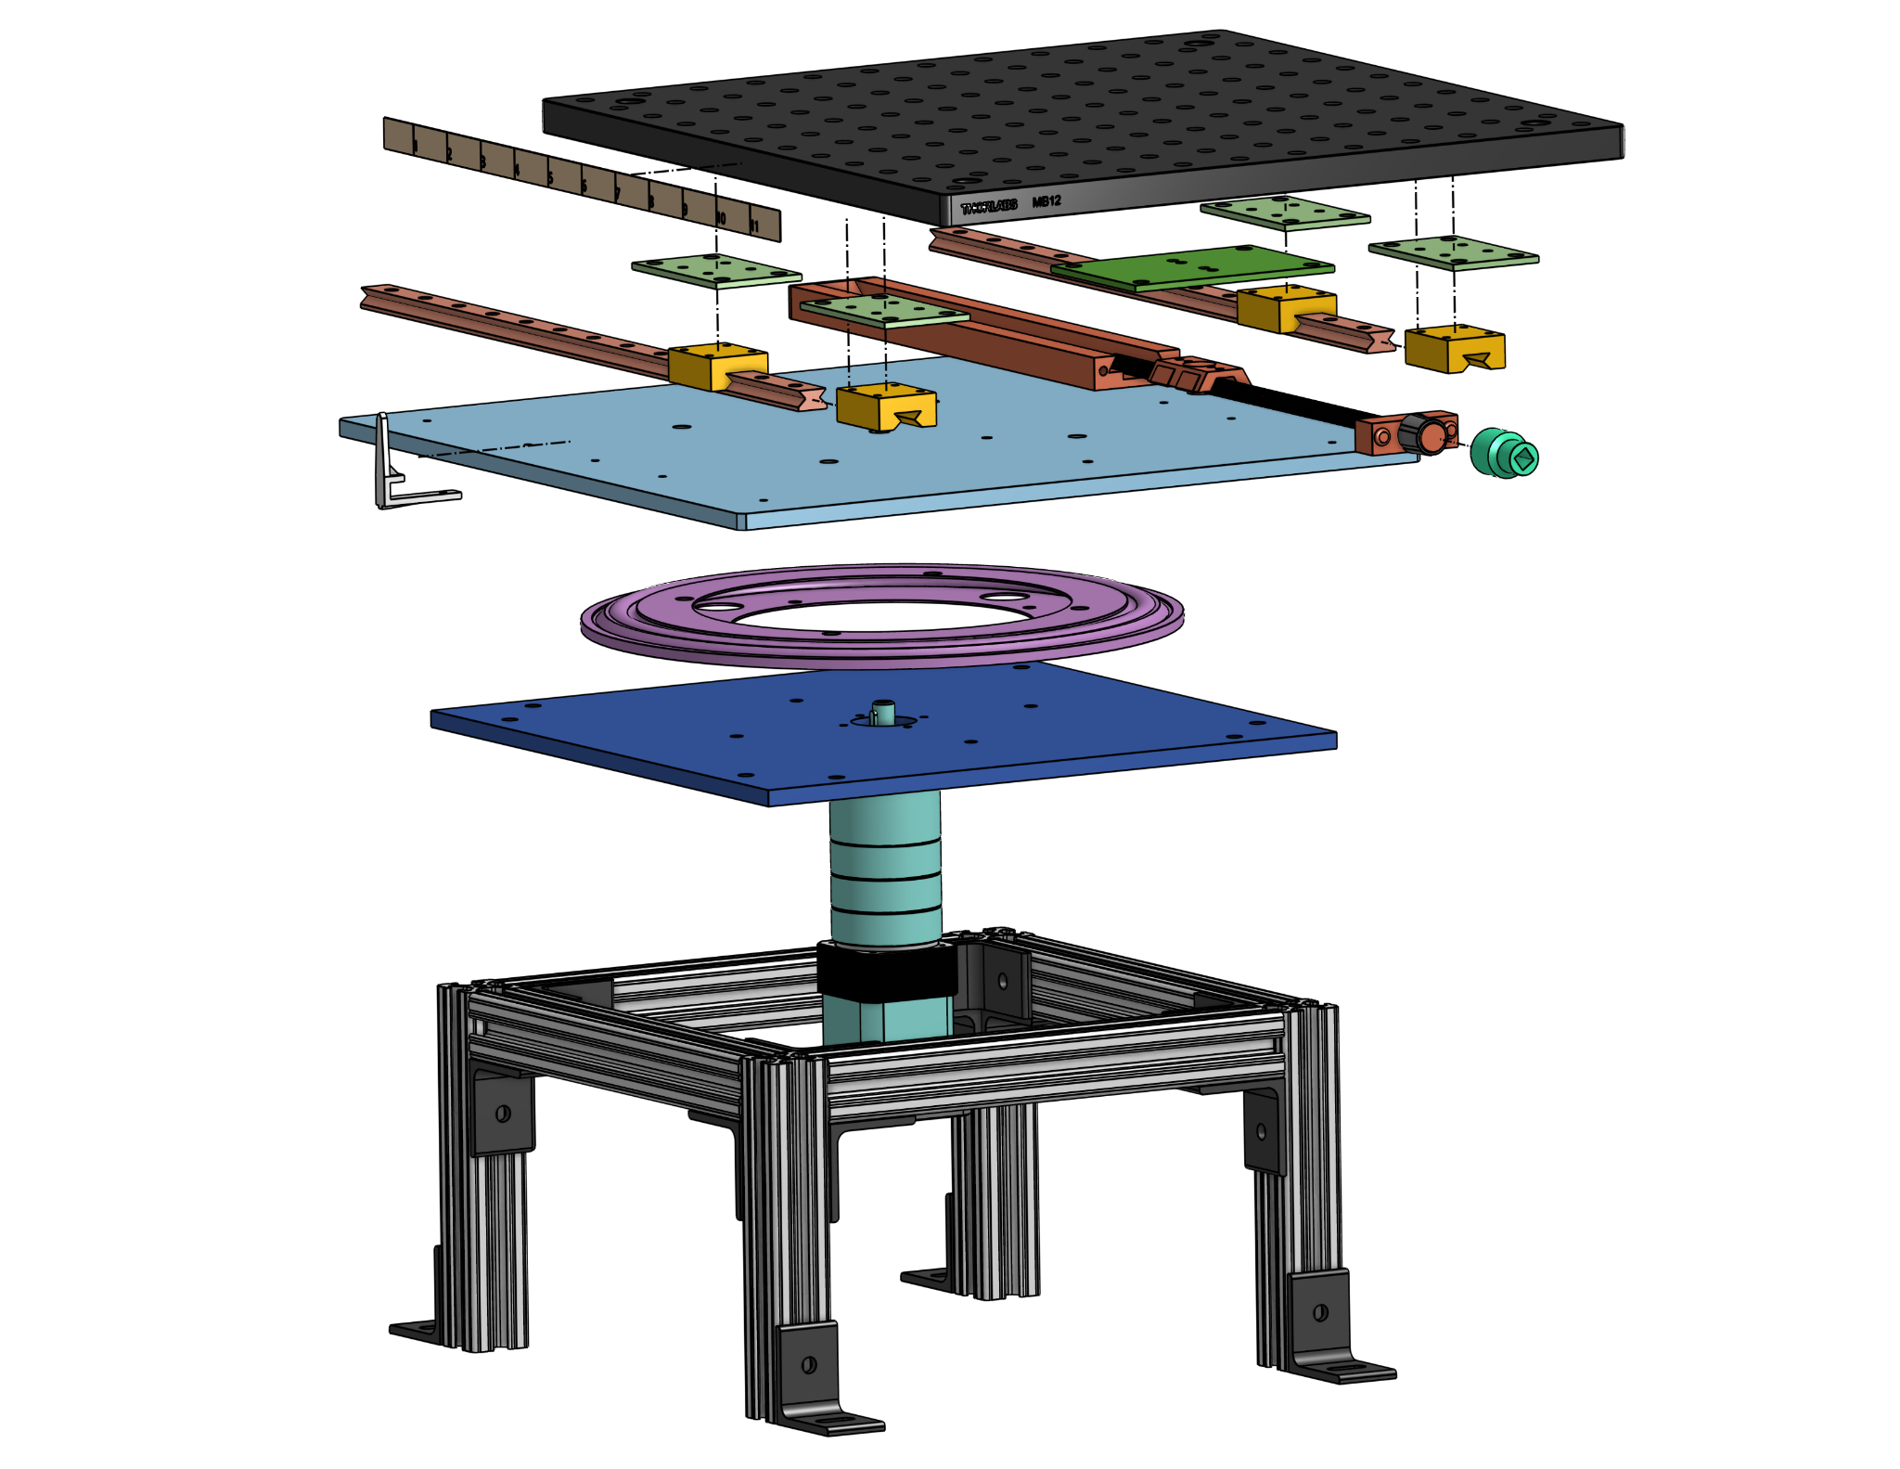
Figure 1. Exploded mechanical assembly showing the structural frame, rotary stage, translation mechanism, and optical mounting platform.

2. Physical System Requirements
ID | Requirement
MECH-01 | Support continuous rotary motion and independent lateral alignment.
MECH-02 | Carry the optical assembly and a demonstrated 40 lb static load.
MECH-03 | Provide more than ±3 in of lateral travel with an operator-readable scale.
ELEC-01 | Accept differential A/B encoder feedback and provide logic-level outputs to the controller.
ELEC-02 | Provide STEP/DIR motor-driver interfacing with a common logic reference.
SAFE-01 | Provide emergency power removal independent of host software.
DOC-01 | Expose customer-readable schematics, PCB evidence, and physical verification results.

3. Mechanical Architecture
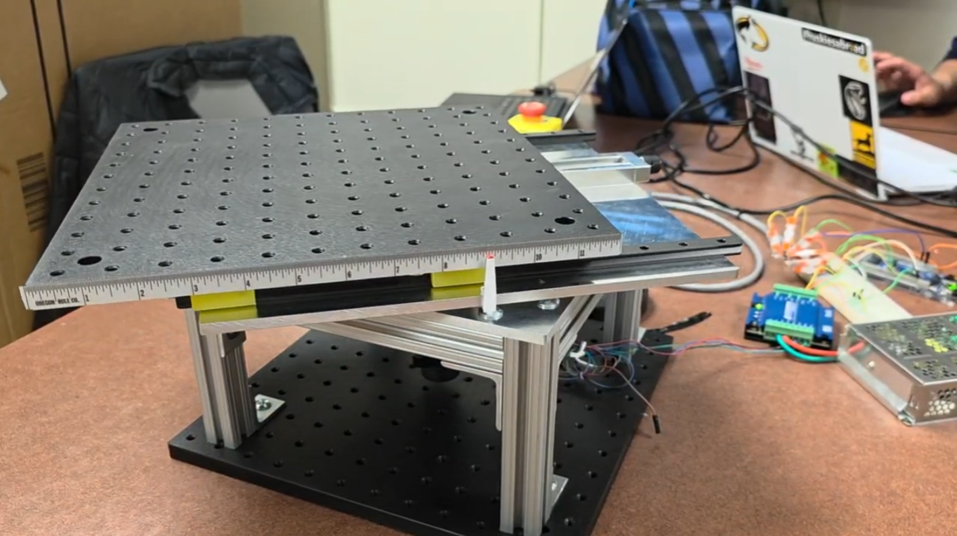
Figure 2. Assembled dual-axis optical motion testbed.
The lower structure supports the rotary stage and drivetrain. The upper optical platform rides on parallel guides and is translated manually through a lead-screw mechanism. This arrangement separates angular motion from lateral alignment while retaining access to the motor, encoder, wiring, and embedded controller.
Feature | Demonstrated or designed value
Static load demonstration | 40 lb
Lateral travel | More than ±3 in
Rotating platform | Approximately 12 × 12 in
Readable translation increment | Approximately 1/32 in
Rotational drivetrain | Stepper motor through 24.65:1 gearing

3.1 Translation and operator alignment
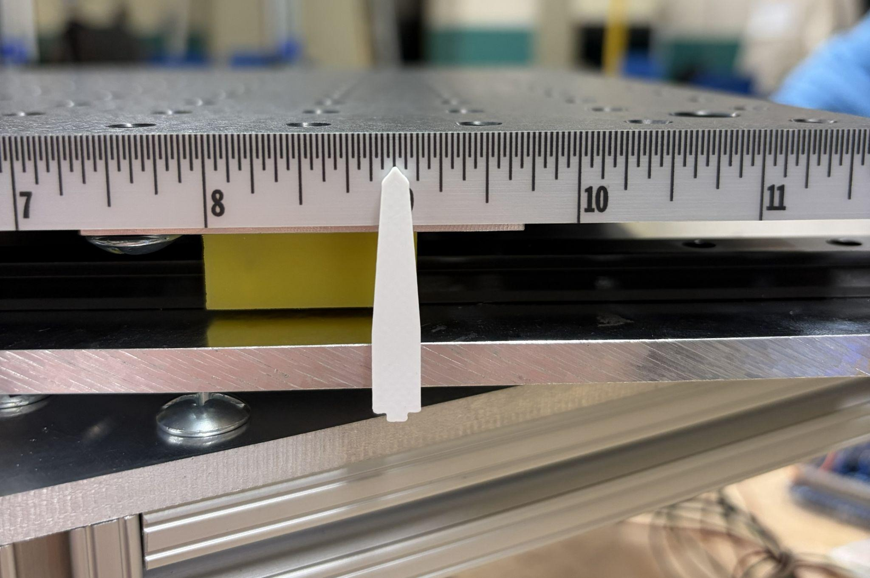
Figure 3. High-contrast translation pointer and fixed measurement scale.
The fixed scale and high-contrast pointer provide direct visual confirmation of lateral offset without requiring the host application. The mechanical adjustment remains independent of the rotary control loop.

4. Load Path, Assembly, and Safety
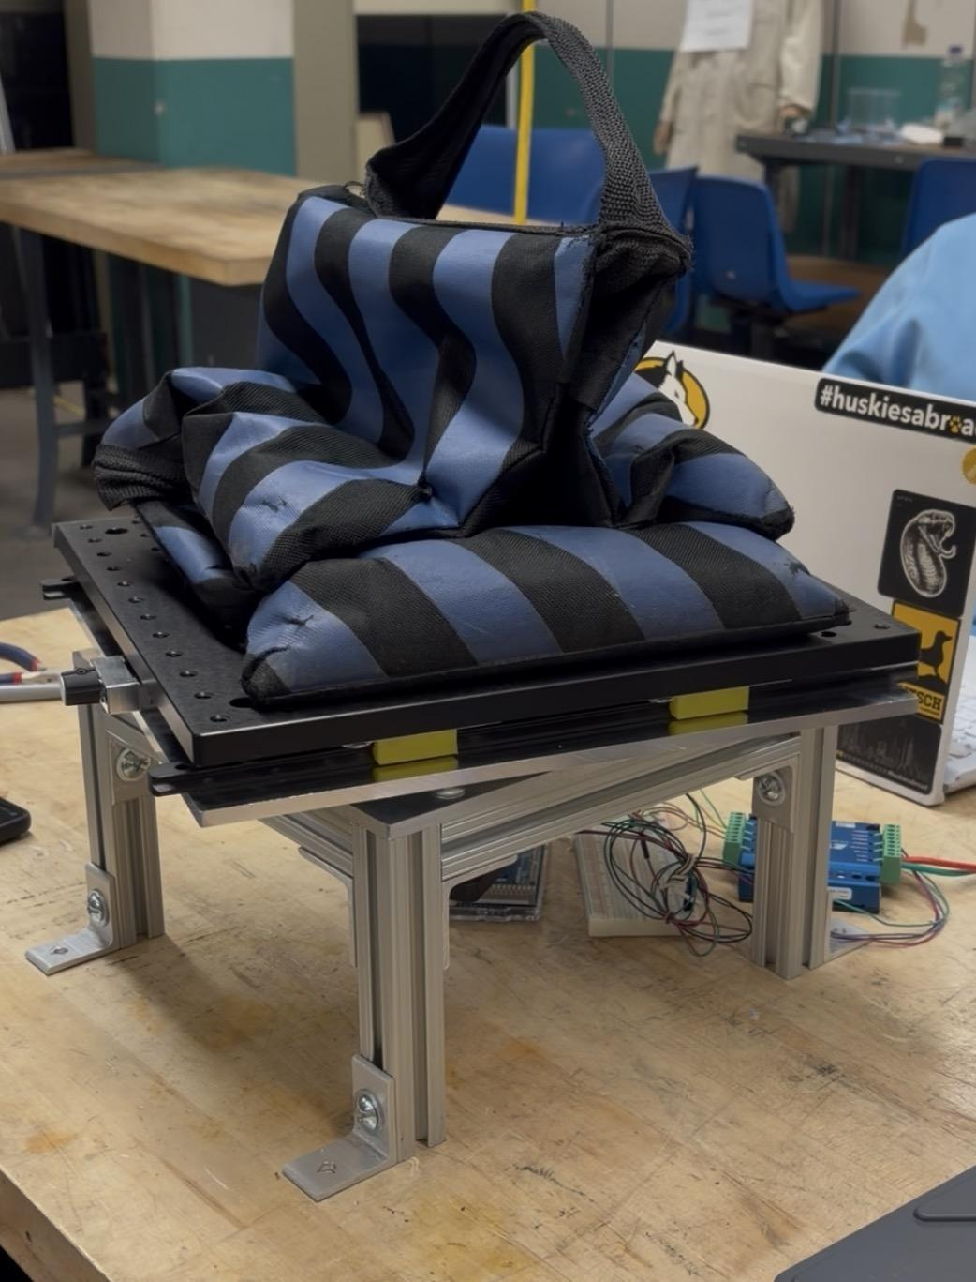
Figure 4. Static-load demonstration on the assembled platform.
The frame transfers optical-platform loads through the guide and rotary structures into the bench interface. Standard fasteners and accessible subassemblies support adjustment and service. Emergency-stop behavior removes drive power independently of GUI state.
- Clear moving cables and optical hardware before operation.
- Mount the assembly to a rigid optical table or equivalent base.
- Keep hands clear of the translation mechanism and rotary interfaces.
- Verify emergency-stop function before powered testing.

5. Encoder and Motor-Driver Interface
The interface electronics connect an E5 differential quadrature encoder, the embedded controller, and the R725 STEP/DIR motor driver. Differential encoder signals are converted through an AM26LS32 receiver before reaching controller inputs; discrete interface stages route STEP and DIR control to the motor driver.
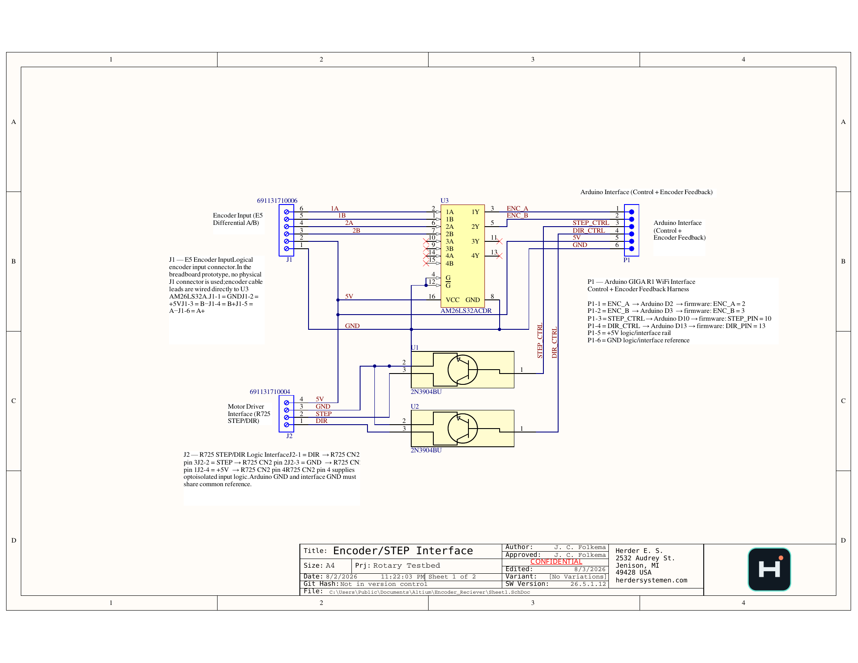
Figure 5. Encoder and STEP/DIR interface schematic.
Designator | Function
J1 | Differential encoder input: A±, B±, +5 V, GND
P1 | Controller harness: ENC_A, ENC_B, STEP_CTRL, DIR_CTRL, +5 V, GND
J2 | Motor-driver logic interface: DIR, STEP, GND, +5 V
U3 | AM26LS32 differential line receiver
U1/U2 | NPN STEP/DIR interface stages

6. PCB Design and Return-Path Control
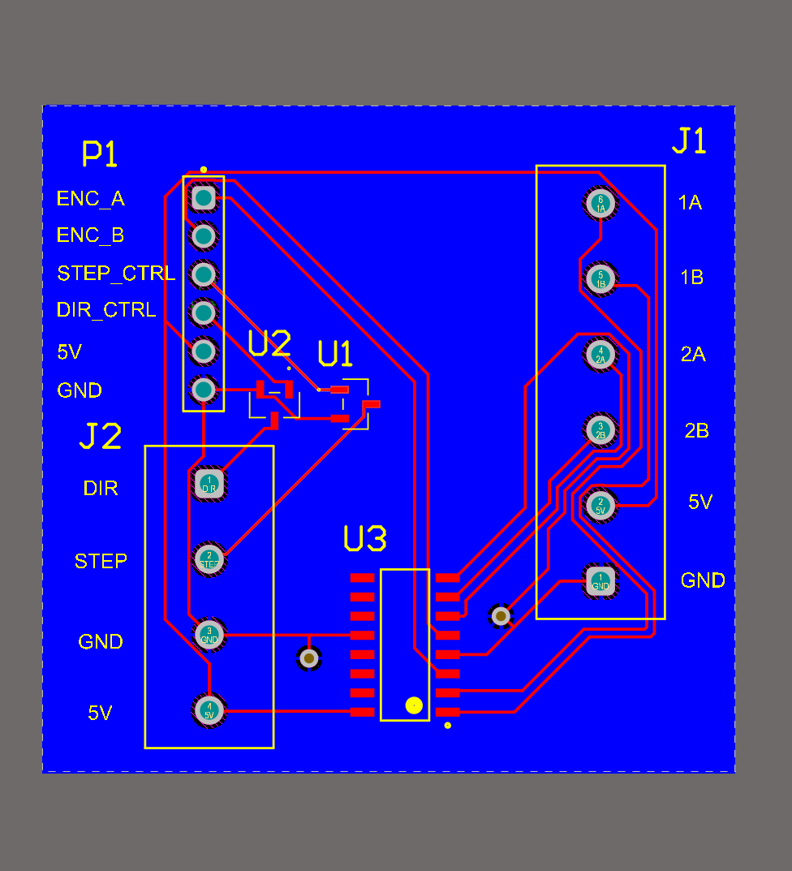
Figure 6. Routed signal and power layer.
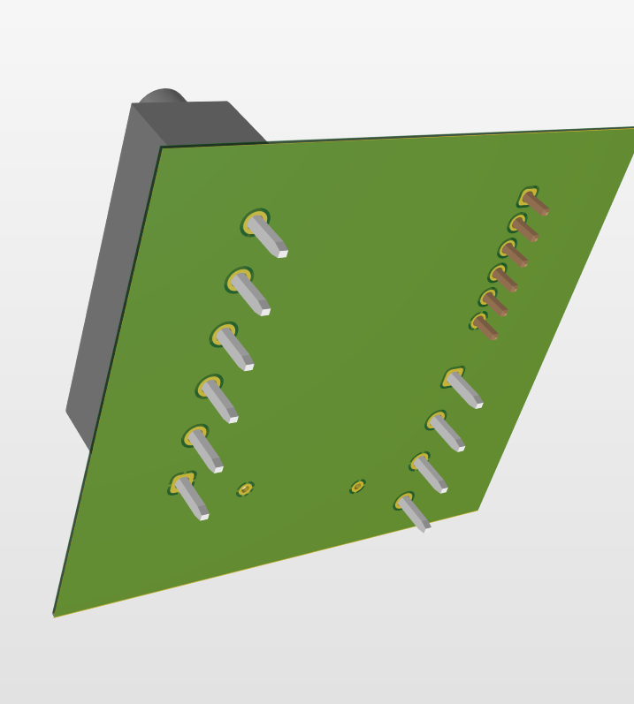
Figure 7. Dedicated solid-copper ground-reference layer.
The revised PCB adds a continuous ground-reference layer for the differential receiver, controller harness, and motor-driver interface. Connector labels, polarity marks, mounting clearances, and external access were reviewed in the 3D assembly before publication.

6.1 Public design checks
- Connector polarity and pin-1 indicators verified.
- Power and ground nets labeled at external interfaces.
- Trace widths and clearances reviewed for logic-level operation.
- Component and connector access reviewed in 3D.
- Editable source and fabrication outputs retained as controlled design assets.

7. PCB Assembly and System Wiring
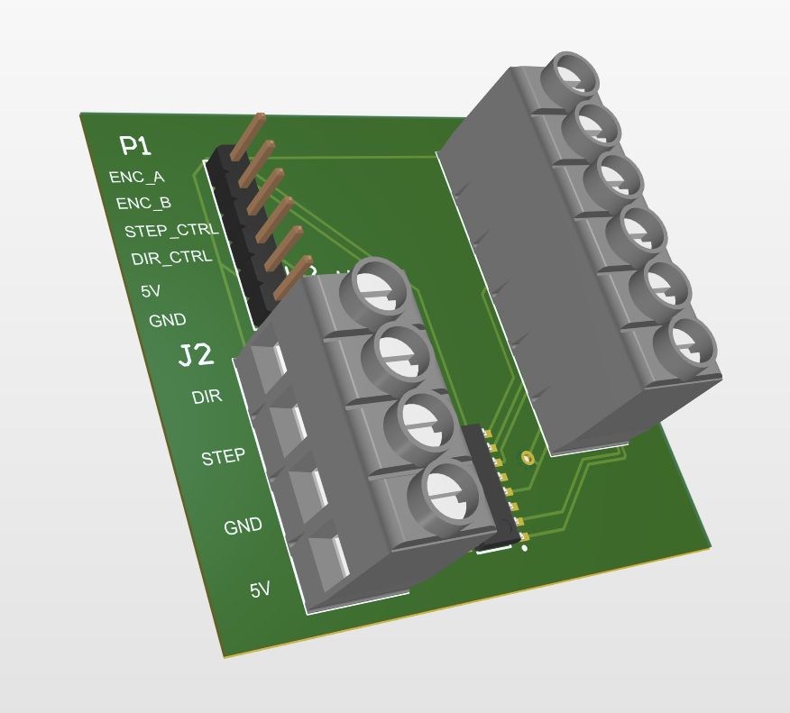
Figure 8. Populated 3D view of the encoder and STEP/DIR interface PCB.
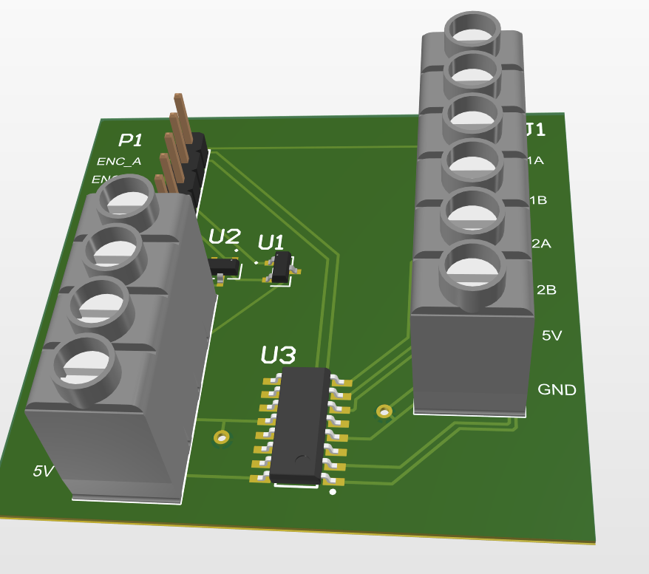
Figure 9. Front view showing connectors, receiver, and interface components.
Path | Implementation
Encoder signal path | Differential A/B → AM26LS32 → controller inputs
Motion command path | Controller STEP/DIR → interface stages → R725 driver
Logic reference | Shared +5 V and ground reference across the interface
Target connection | Controller harness carries encoder feedback and control outputs

8. Physical Verification Evidence
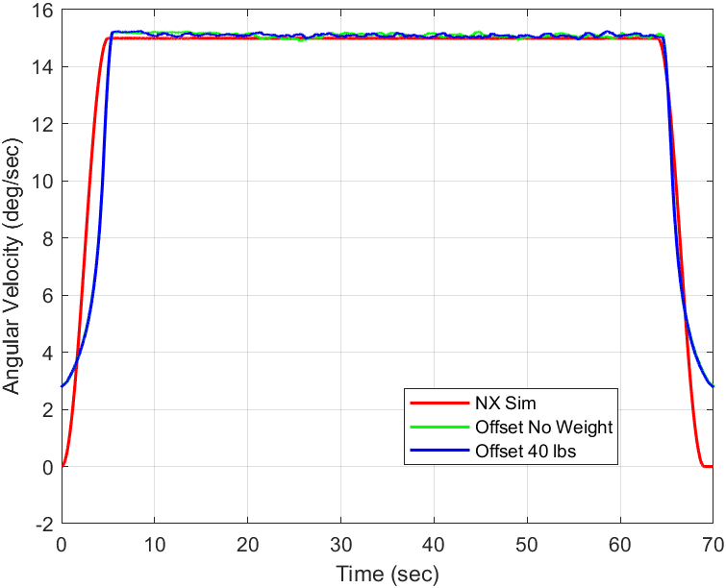
Figure 10. Representative rotation-rate demonstration from the physical platform.
The retained evidence demonstrates rotation, lateral adjustment, static loading, encoder feedback, and operator-visible motion. Speed capability is configuration dependent: the 256-microstep mode prioritizes very small command increments, while faster operation requires a different microstep or pulse-rate configuration.
Quantity | Value / interpretation
256-microstep command increment | Approximately 0.000285°/pulse
Effective encoder resolution | Approximately 0.001460°/count after gearing
Demonstrated ultra-slow range | Approximately 0.002–0.010°/s
Historical faster-speed evidence | Separate operating configuration
Mechanical load evidence | 40 lb static demonstration

9. Relationship to the Firmware System
The mechanical and electrical platform supplies the physical plant, encoder signals, and motor-drive interface used by the dual-core controller. The companion firmware report documents how the Cortex-M7 and Cortex-M4 divide coordination and high-rate motion-data workloads. Keeping these reports separate lets customers assess the hardware and deep firmware contributions independently.
COMPANION DOCUMENT
See SCD2_DualCore_Firmware_Host_FRD_v2.4 for OpenAMP/RPMsg, shared-memory ring, timing, telemetry, safety, and host-software details.

10. Customer-Facing Deliverables
- Mechanical Platform & Electrical Integration FRD.
- Dual-Core Firmware & Host Software FRD.
- Exploded assembly and system photographs.
- Featured interface schematic and PCB renders.
- Physical-system and mechanical-animation videos.
- Selected configuration-specific motion evidence.

11. Limitations and Open Validation
Item | Controlled statement
Production qualification | Prototype platform; no formal shock, vibration, thermal, EMC, or long-duration reliability certification.
Power measurements | System-level idle, steady-state, and peak electrical power are not yet documented.
Speed envelope | Operating range remains configuration dependent; ultra-slow and faster modes must be identified separately.
Metrology | Motion-platform characterization does not certify downstream optical-system performance.
Fabrication release | Editable manufacturing files remain controlled and require a final production review before fabrication.

12. Attribution and Revision Control
Herder Elektronische Systemen developed the public mechanical/electrical design package, interface PCB, embedded-control integration, verification materials, and customer-facing documentation represented here. No third-party affiliation or endorsement is claimed.
Rev | Date | Description
2.3 | 2026-08-03 | Platform/electrical report with exploded mechanical view, physical requirements, PCB evidence, load-path documentation, and companion firmware/results cross-reference.
RELEASE GATE
Before production deployment, complete electrical power measurements, finalize fabrication review, and perform environmental and EMC validation.

