DUAL-CORE FIRMWARE, HOST SOFTWARE & RESULTS
STM32H747 MotionIPC, Live GUI, Telemetry, and Characterization
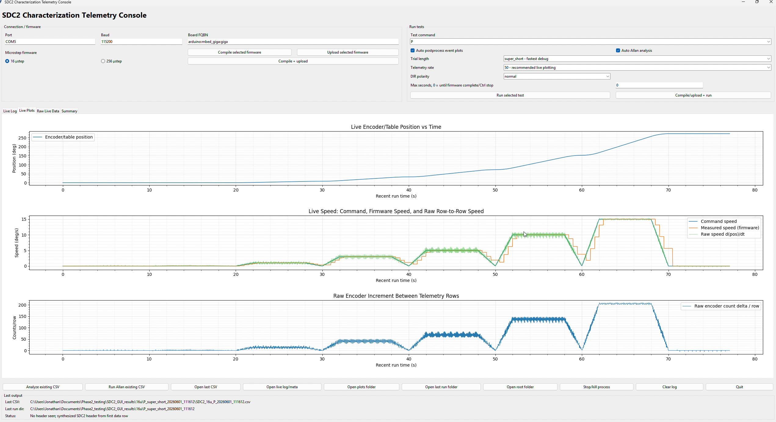
Customer-facing technical report
Revision 2.6 • 3 August 2026
Prepared by | Herder Elektronische Systemen
Primary subject | Dual-core firmware, host GUI, telemetry, reliability controls, and measured operation
Evidence basis | MotionIPC source, motion firmware, GUI video, plots, logs, slide reviews, and reports
Distribution | Customer-facing; selected source excerpts and engineering evidence included
DOCUMENT PURPOSE
This report presents the complete software-controlled instrument: dual-core firmware, target-side motion control, live operator software, data integrity, safety behavior, and measured results. Hardware and PCB implementation are documented only in the companion platform report.

1. System Outcome
The completed system combines a custom STM32H747 dual-core IPC architecture with target-side motion control, encoder acquisition, host supervision, live visualization, structured logging, automated workflows, and postprocessing. The 400 MHz Cortex-M7 and 200 MHz Cortex-M4 communicate through OpenAMP/RPMsg for coordination and a custom AXI-SRAM ring for motion records.
Figure 1. Operator-facing host application with connection controls, test selection, status, and live telemetry.
CUSTOMER-VISIBLE RESULT
An operator can connect the target, select a test, monitor command and encoder behavior, record timestamped data, recover interrupted runs, and launch analysis while real-time motion remains on the embedded target.

2. Dual-Core Architecture
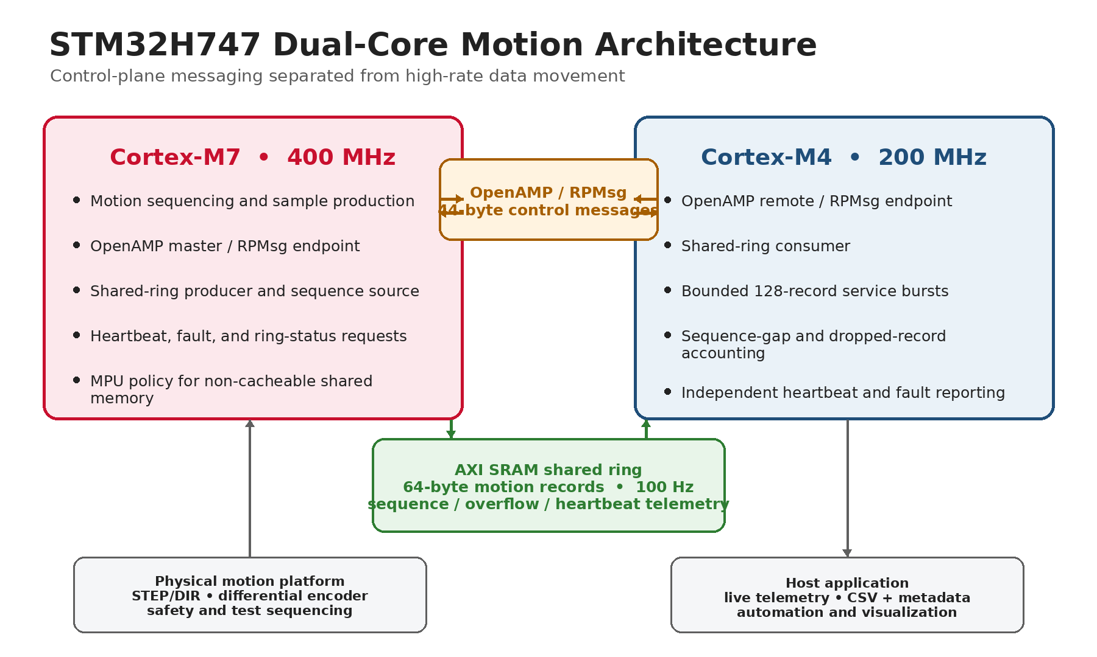
Figure 2. STM32H747 architecture separating low-rate OpenAMP/RPMsg coordination from the AXI-SRAM motion-data path.
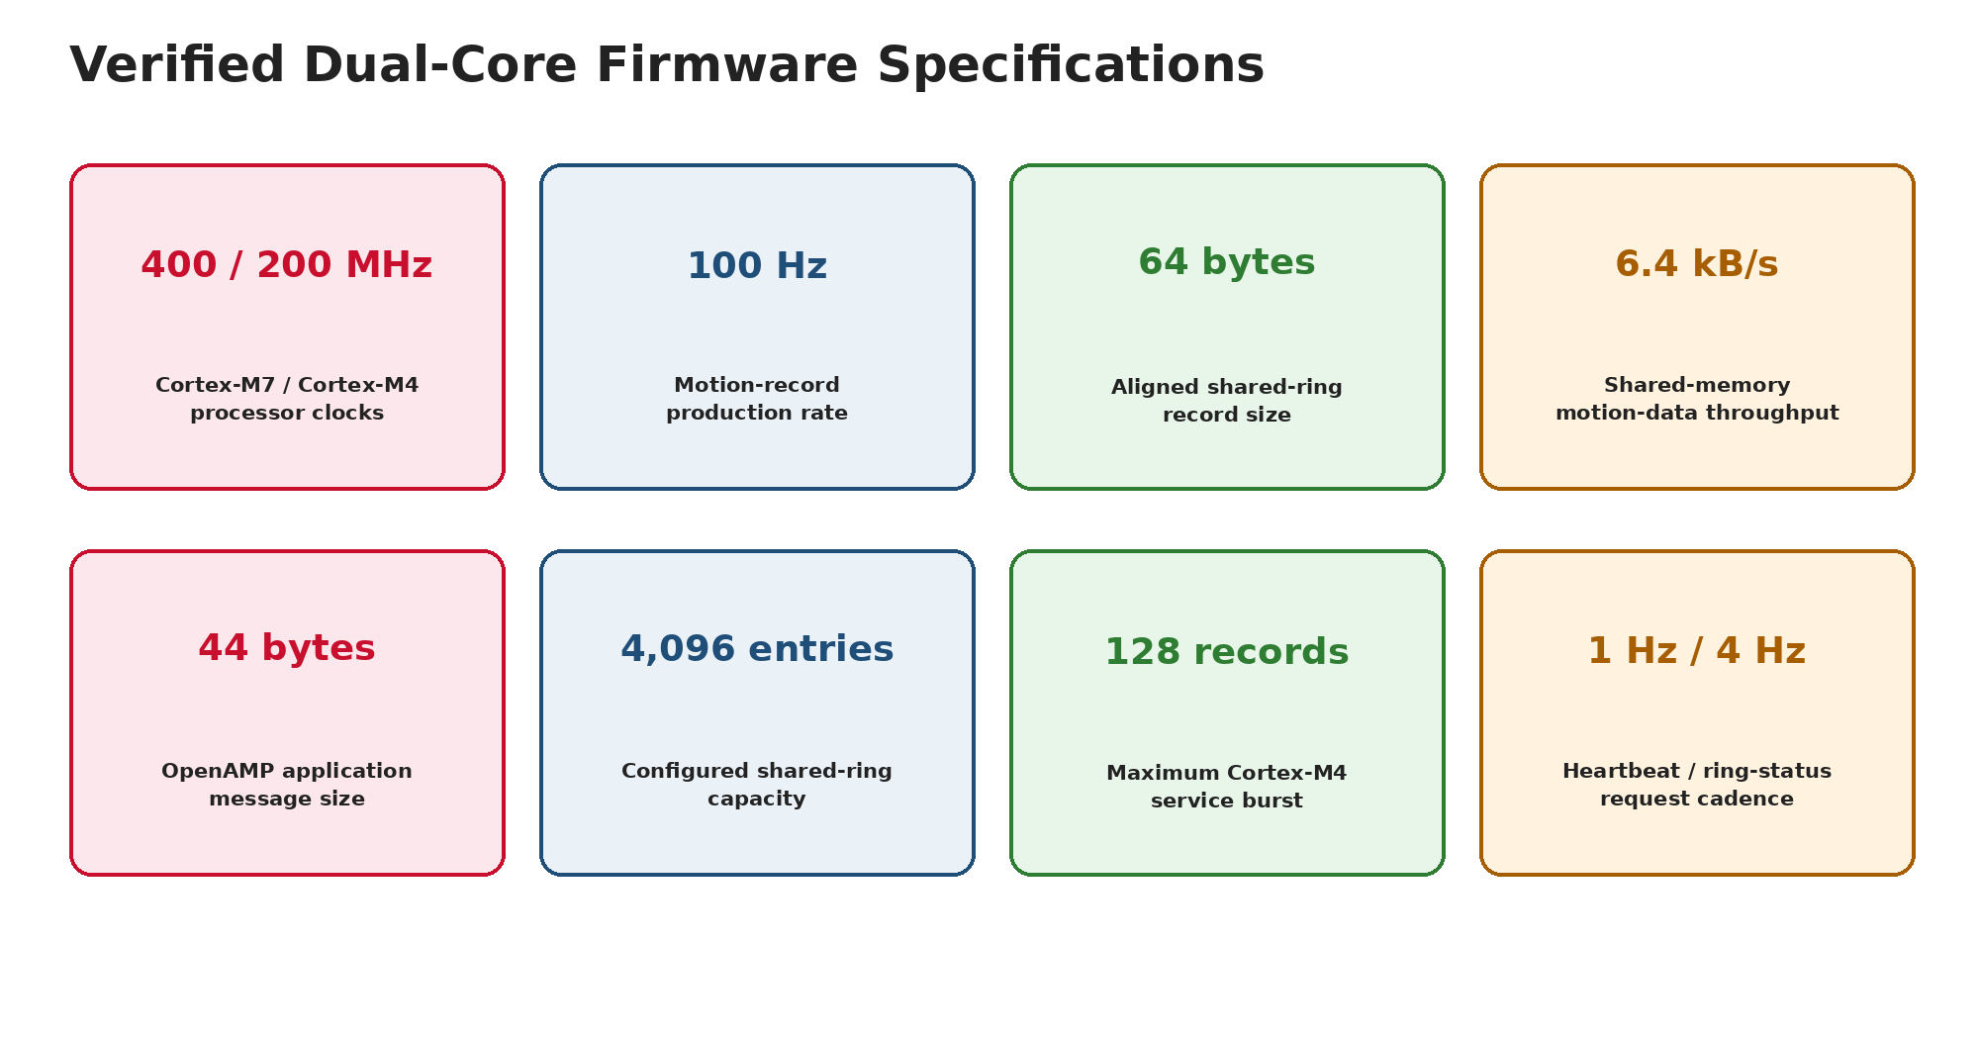
Figure 3. Source-verified processor, IPC, buffering, and service-cadence specifications.

3. Core Ownership, IPC, and Memory
Item | Verified implementation
Cores | 400 MHz Cortex-M7 + 200 MHz Cortex-M4
Control IPC | OpenAMP/RPMsg; 44-byte application messages
High-rate IPC | 256 KiB AXI-SRAM producer/consumer ring
Motion record | 64 bytes, cache-line aligned
Record rate | 100 Hz; 6.4 kB/s internal throughput
Consumer service | Up to 128 records per M4 service pass
Health cadence | 1 Hz per-core heartbeat; 4 Hz ring-status requests
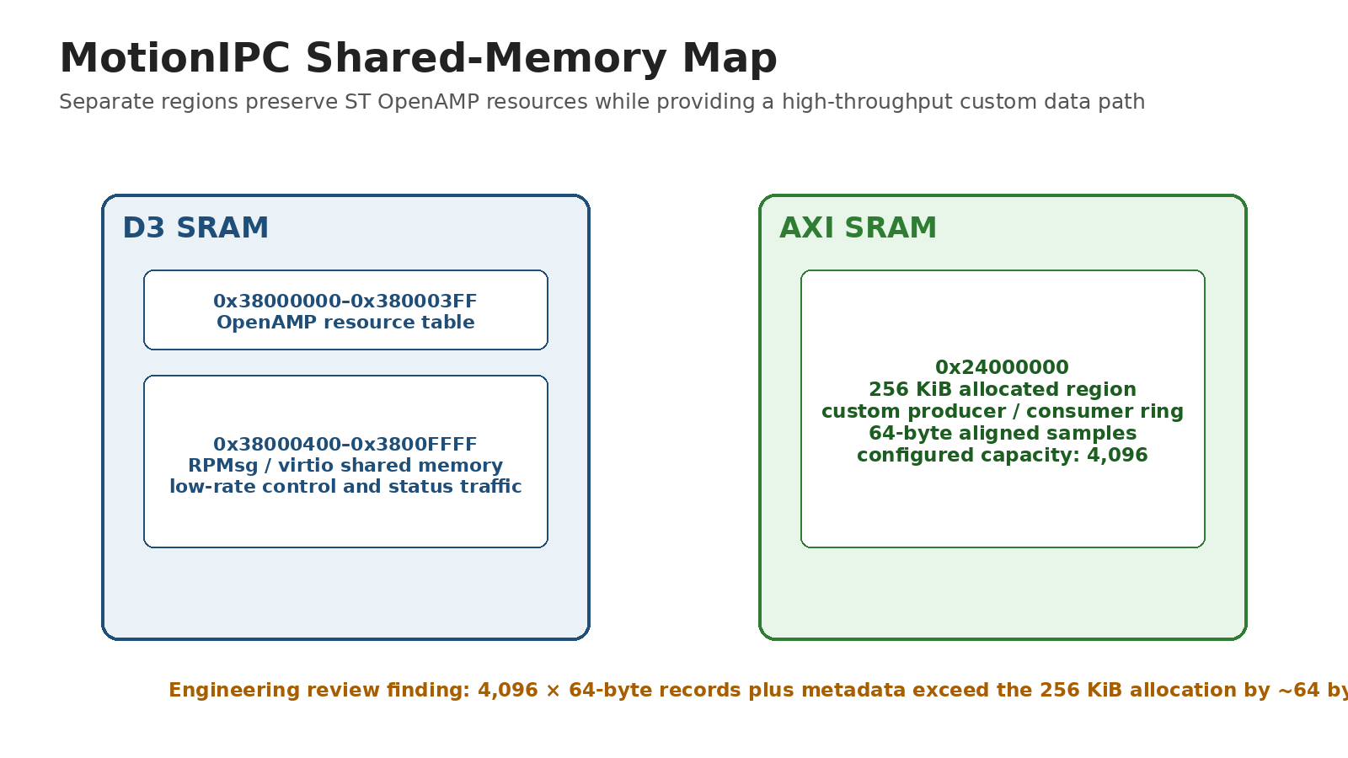
Figure 4. Shared-memory map and the identified ring-capacity correction.
ENGINEERING REVIEW FINDING
The configured 4,096 × 64-byte sample array fills the 256 KiB allocation before metadata is counted. A production release should use 4,095 entries or enlarge the reserved region.

4. Target I/O Boundary
The firmware owns the controller-facing signal boundary: interrupt-driven encoder inputs, target-generated STEP/DIR outputs, motion-state transitions, and fault-safe shutdown behavior. Electrical conditioning, connectorization, routed copper, and the dedicated ground plane are documented exclusively in the companion platform and electrical report.
Signal or boundary | Firmware responsibility
ENC_A / ENC_B | Interrupt-driven encoder capture and direction decoding
STEP / DIR | Target-generated motor command timing
5 V / GND reference | Assumed external logic interface boundary; electrical implementation in companion FRD
Emergency stop / deadman | Independent hardware stop plus target-side host-timeout response
SEPARATION OF CONCERNS
This report focuses on firmware behavior and software outcomes. PCB design evidence appears only in the Mechanical Platform & Interface PCB FRD.

5. Target Motion Firmware and Safety
Real-time pulse generation, encoder capture, test progression, and deadman behavior remain on the embedded target. The host requests actions and records results but does not schedule motion.
Control or safety item | Verified value
STEP pulse high time | 4 µs
Step-rate safety cap | 25,000 pulses/s
Maximum pulse backlog | 25 pulses/pass
Loop-overrun warning | 25 ms
Speed-estimation window | 500 ms
Host heartbeat | 500 ms
Target deadman timeout | 2,000 ms
Position correction | 20 pulse-Hz/degree; 250 Hz absolute cap; 5% relative cap

5.1 Encoder and drive scaling
Parameter | Value
Gear ratio | 24.65:1
256-microstep pulses/table revolution | 1,262,080
Command increment | ~0.000285°/pulse
Encoder CPR | 5,000
Effective table counts/revolution | 246,500
Measured increment | ~0.001460°/count

6. Host GUI and Live Operation
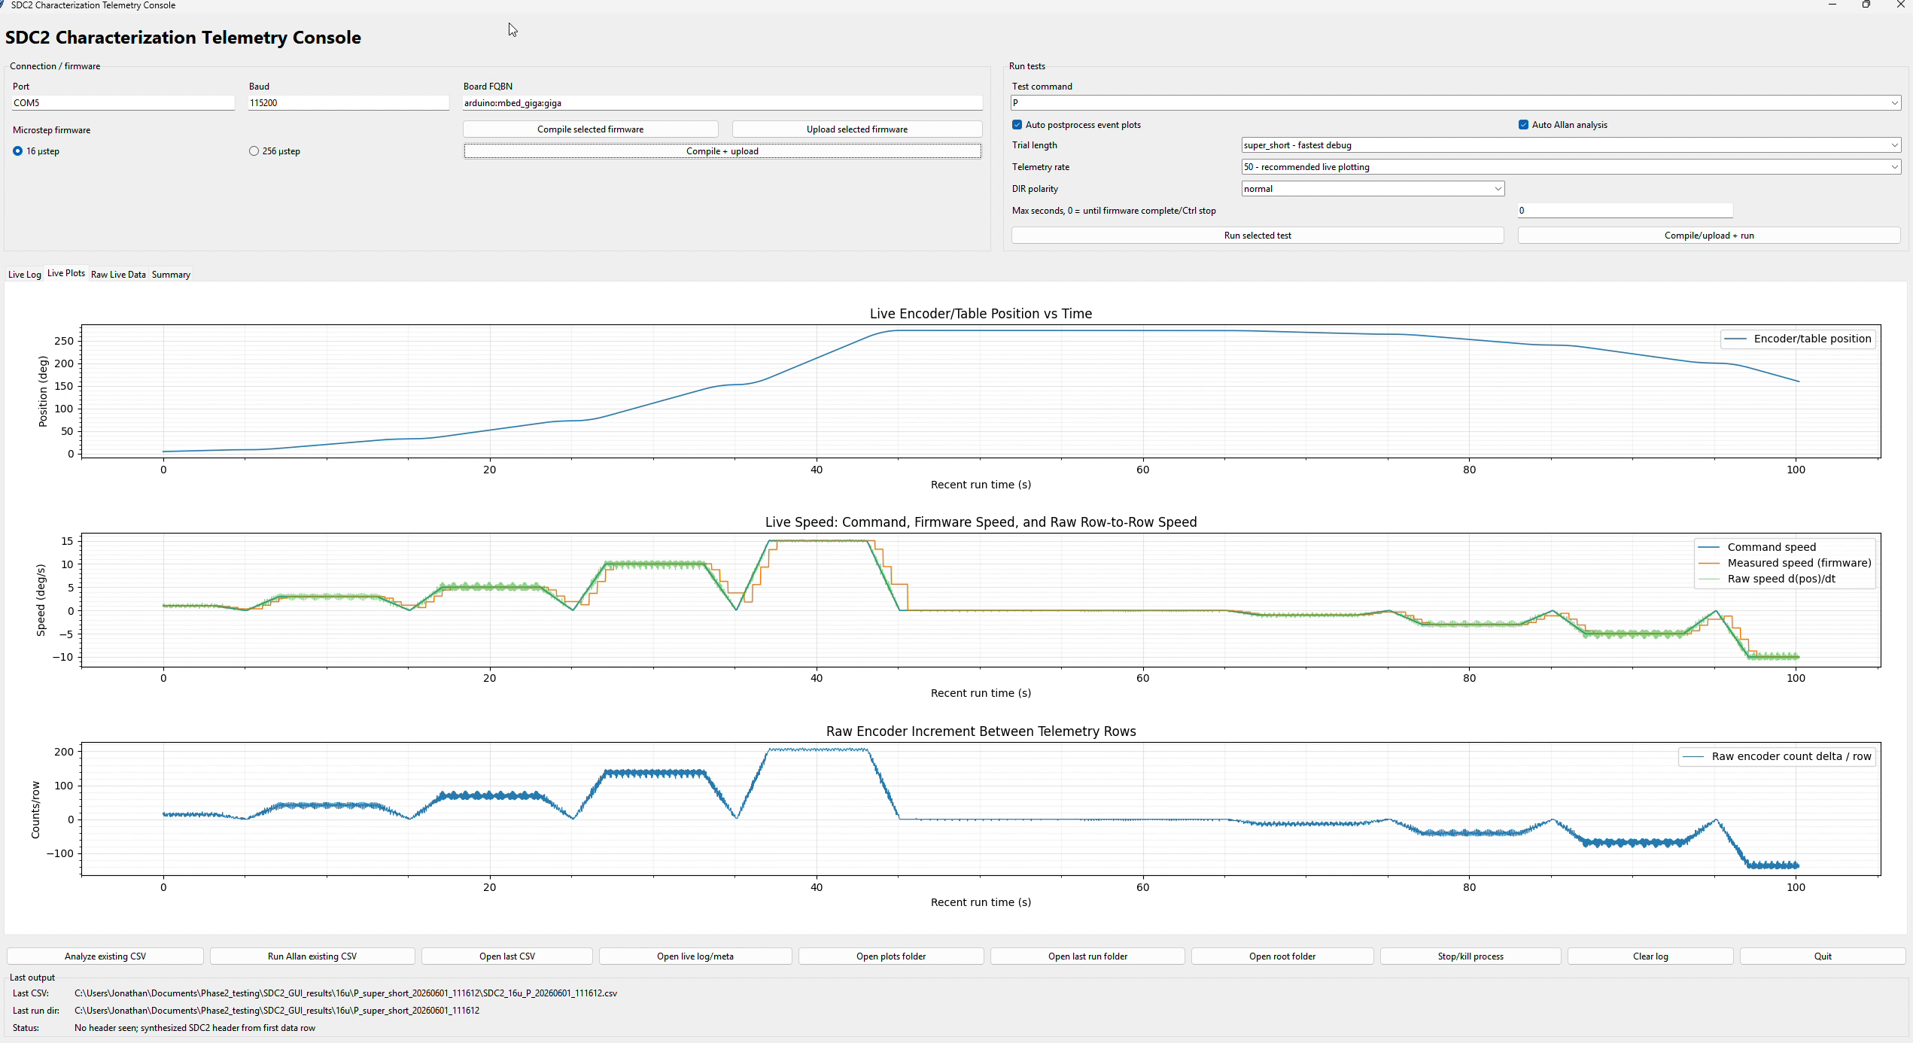
Figure 7. Active host-target test showing command, measured motion, encoder position/rate, status, and logging state.
The GUI integrates connection management, command execution, test selection, live plots, file naming, logging state, and operator feedback. It provides one working surface for the target instead of requiring separate serial terminals and analysis scripts.
- Live command-versus-measured speed and encoder-position plots.
- Raw encoder-rate visualization for diagnosing quantization and event timing.
- Target status, test progression, connection state, and completion markers.
- Automated filename generation, CSV capture, and separate metadata/comment retention.
- Supervision of tracking, static, step, Allan, and sine-response workflows.

7. Telemetry, Logging, and Recovery
Capability | Implementation
Host transport | 115,200-baud serial
Selectable output | 10, 20, 50, or 100 Hz requests
Record schema | 24 timestamped CSV fields
Validation | Header and row-width checks; malformed-row detection
Run completion | Test-specific completion markers
Metadata | Controller comments and run context stored separately
Recovery | Partial-run preservation after serial interruption
Safety | 500 ms heartbeat and 2 s target deadman

7.1 Bandwidth result
A 115,200-baud 8-N-1 link provides an idealized 11,520 payload bytes/s. Representative 24-field ASCII rows can approach 189 bytes, limiting sustained full-record output to roughly 50–60 rows/s. The 100 Hz selection therefore motivates shorter records, binary framing, or a faster external transport; the internal shared-memory path remains independent of this bottleneck.

8. Automated Test Workflow
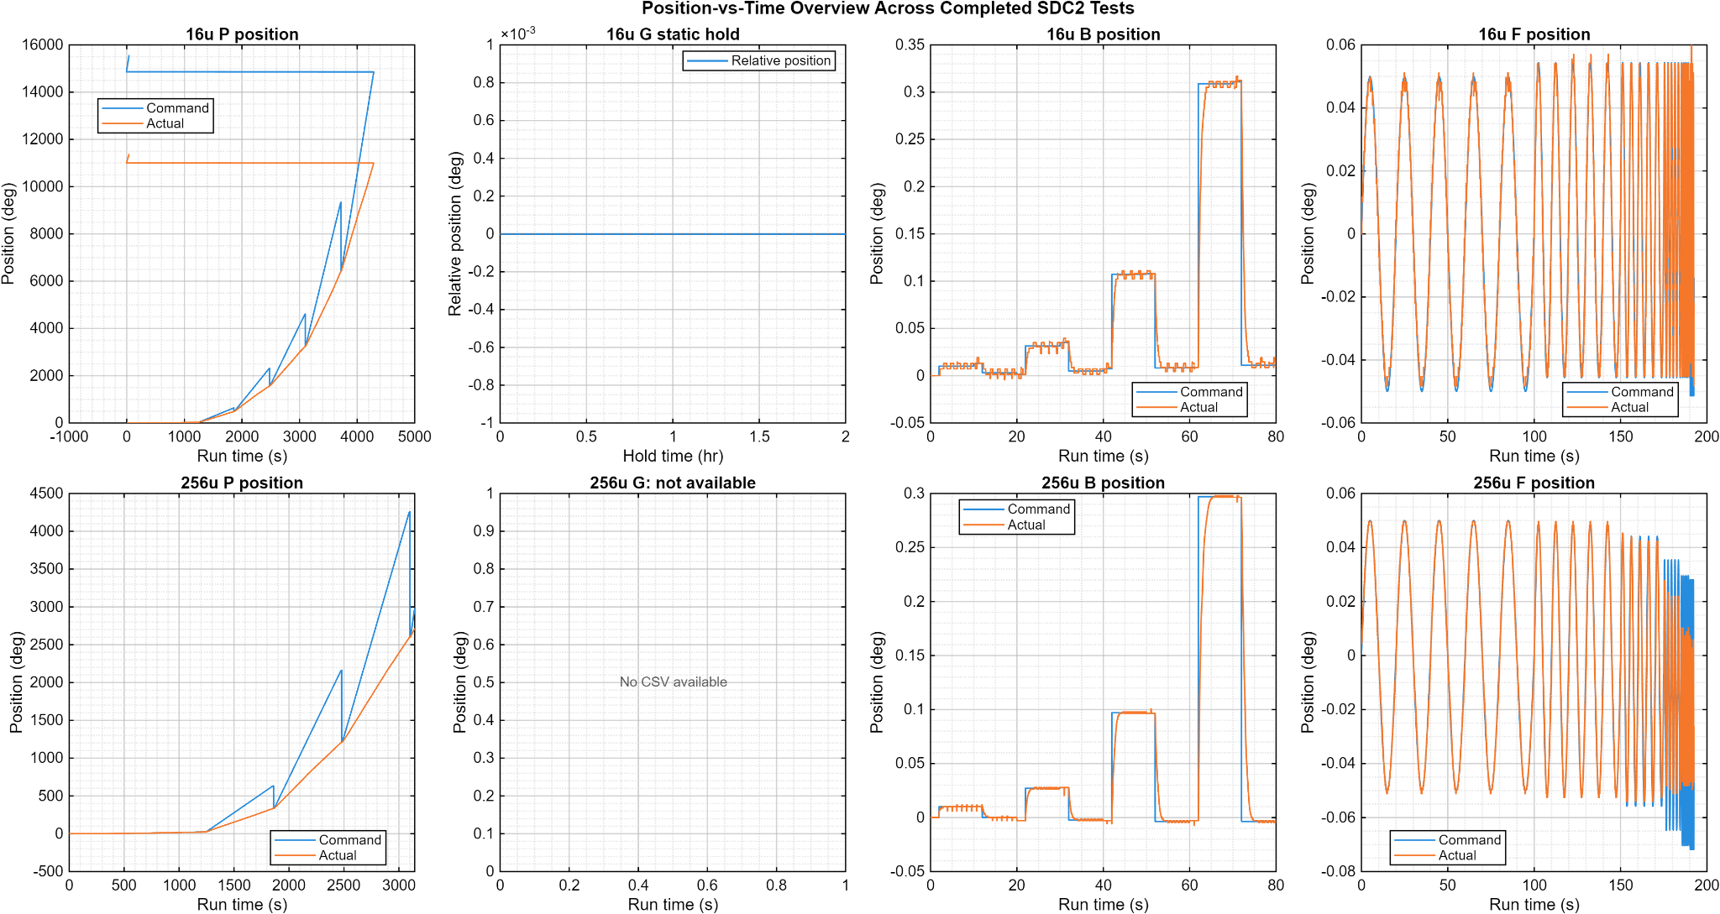
Figure 8. Representative scripted test sequences generated and recorded through the target/host workflow.
Workflow | Configured execution
Static hold | 50 Hz × 180 s or 100 Hz × 90 s; 9,000 records
Dynamic tracking | 100 Hz requested; 6,000 records per 60 s segment
Step response | Scripted steps with rise, overshoot, settling, RMS, and peak-error analysis
Allan analysis | Static position and dynamic residual workflows
Sine response | Closed-loop command/actual response over approximately 0.33–2 Hz

9. Low-Speed Tracking Results
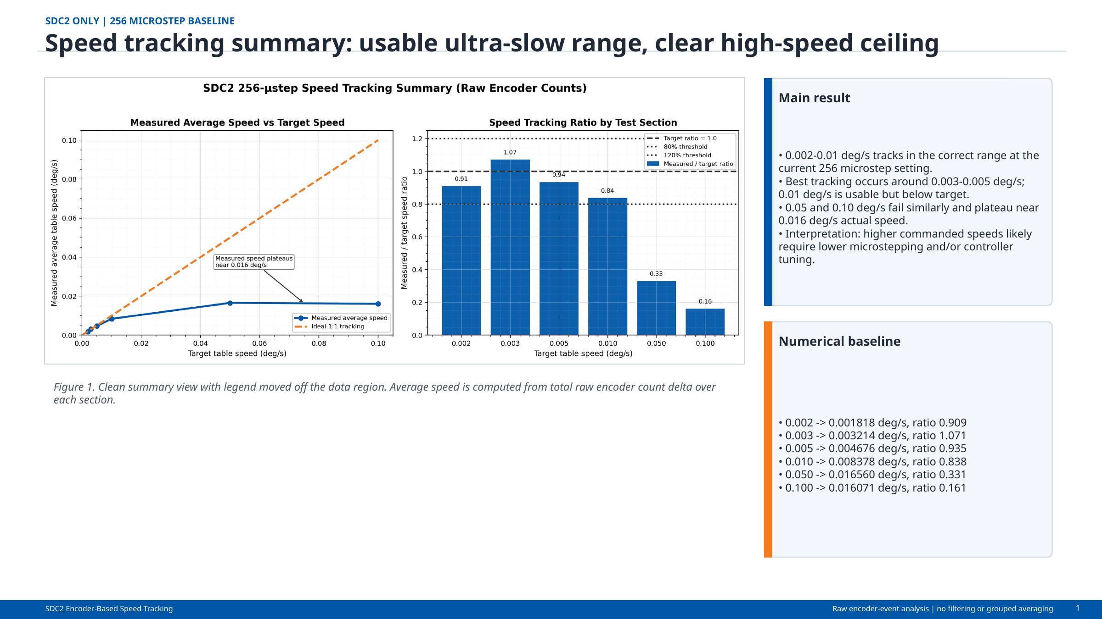
Figure 9. Measured low-speed performance in the 256-microstep configuration.
Command (deg/s) | Measured (deg/s) | Ratio / interpretation
0.002 | 0.001818 | 0.909
0.003 | 0.003214 | 1.071
0.005 | 0.004676 | 0.935
0.010 | 0.008378 | 0.838
0.050 | ~0.016 | Configuration throughput ceiling
0.100 | ~0.016 | Configuration throughput ceiling
RESULT
The 256-microstep setup is an ultra-slow configuration. Best tracking occurred near 0.003–0.005°/s; faster commands plateaued near 0.016°/s and require a different microstep or pulse-rate configuration.

10. Tracking, Step, and Frequency Results
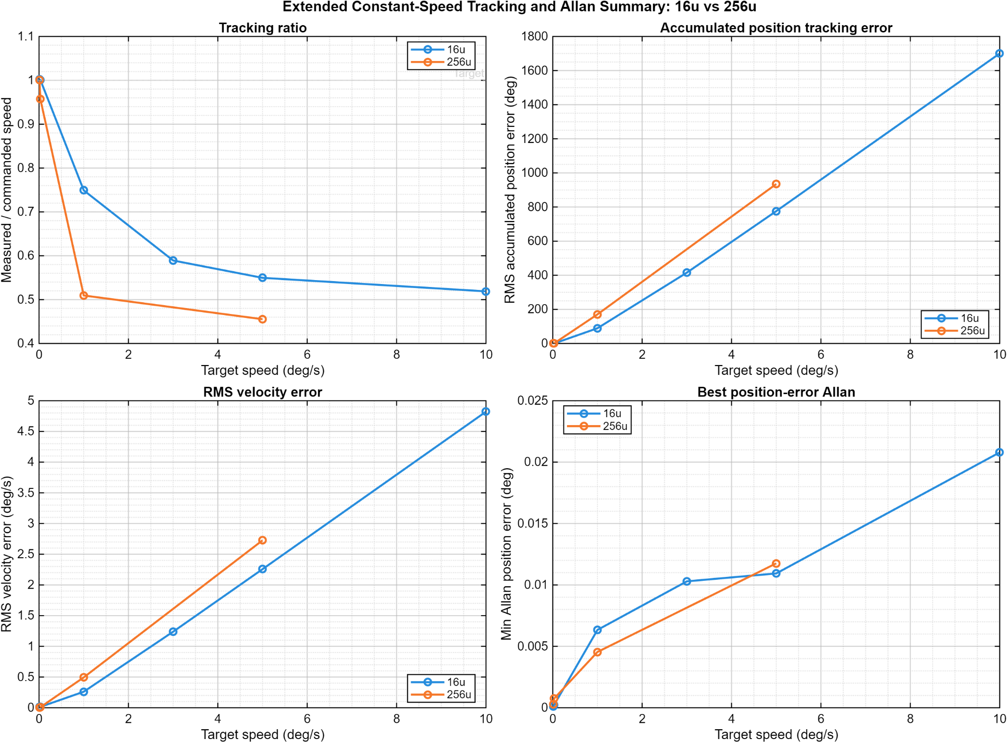  Figure 10. Constant-speed command and measured motion. | 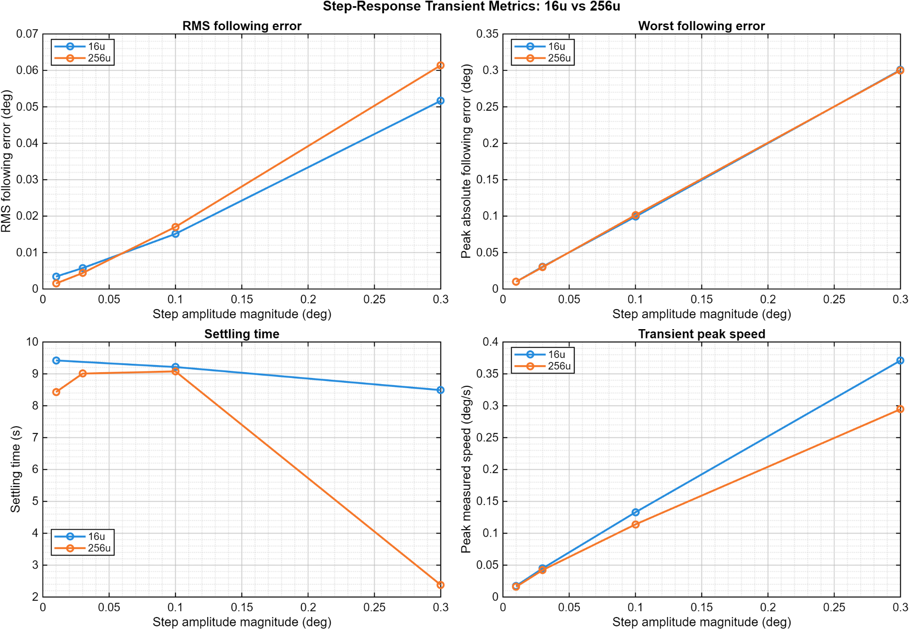  Figure 11. Scripted step-response characterization.
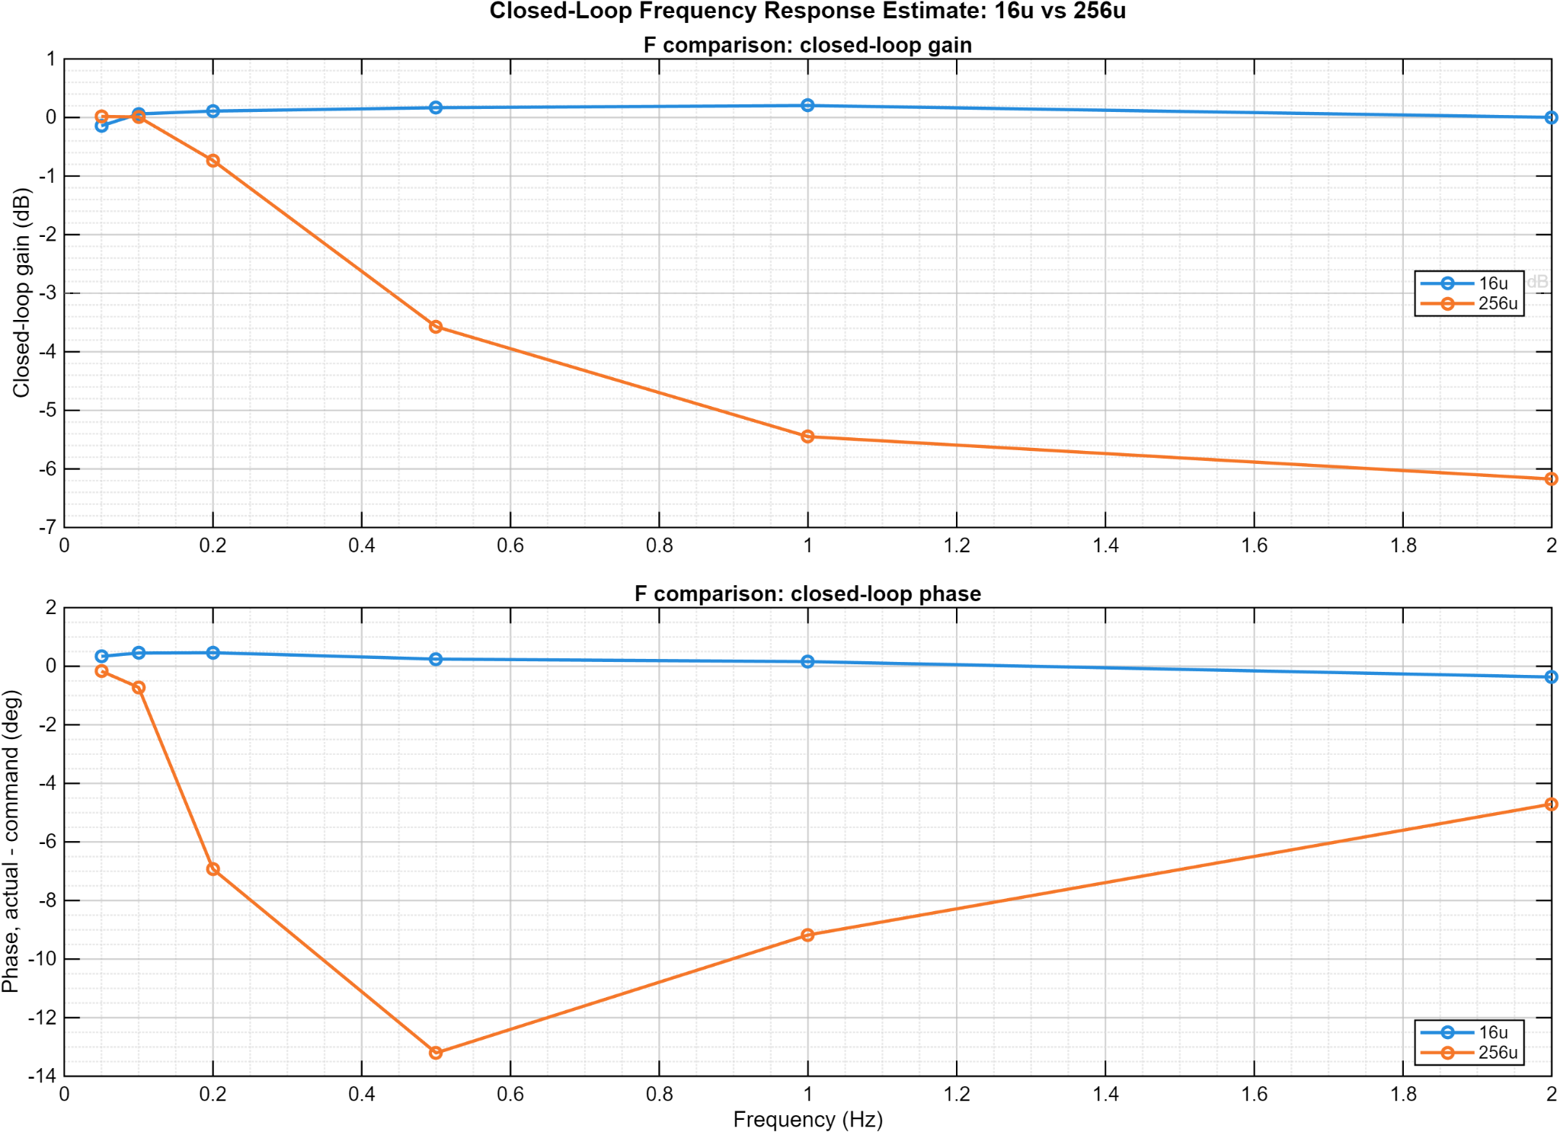
Figure 12. Closed-loop actual/command response over approximately 0.33–2 Hz.
These results show the firmware, physical stage, timestamped acquisition, host logging, and analysis pipeline operating as one system. The frequency result is a closed-loop characterization, not a claim of open-loop plant identification or formal phase margin.

11. Delivered Capabilities and Release Actions
Layer | Delivered capability
Dual-core firmware | OpenAMP/RPMsg coordination, shared-memory ring, HSEM startup, coherency policy, sequence/drop/fault accounting
Motion firmware | Pulse generation, encoder capture, correction, automated sequencing, heartbeat, deadman, and overrun monitoring
Host application | Connection, commands, live plotting, orchestration, logging, metadata, and recovery
Analysis | Low-speed, tracking, step response, Allan deviation, and closed-loop sine-response processing
Release item | Required action
Ring allocation | Reduce capacity to 4,095 or reserve more than 256 KiB.
Integrated build | Tag and preserve one release binary/build proving final module integration.
IPC timing | Instrument end-to-end latency and worst-case jitter.
External telemetry | Use binary framing or faster transport for sustained 100 Hz full records.
Power and EMC | Measure idle/peak power and complete EMC/environmental validation.

12. Attribution and Revision Control
Herder Elektronische Systemen developed the dual-core firmware architecture, motion-control integration, host software, logging and analysis workflows, and customer-facing documentation represented here. No third-party affiliation or endorsement is claimed.
Rev | Date | Description
2.6 | 2026-08-03 | Firmware-first report featuring the dual-core architecture, live GUI, target I/O boundary, reliability controls, telemetry, and measured results; PCB evidence moved exclusively to the companion platform FRD.

