HERDER ELEKTRONISCHE SYSTEMEN ENGINEERING REPORT | REV 7.0

DUAL-CORE OPTICAL MOTION TESTBED
FIRMWARE, HOST SOFTWARE & RESULTS
1 kHz dual-core motion control, encoder feedback, telemetry, operator software, and measured characterization
Public portfolio technical report
Revision 7.0 - 12 August 2026

Prepared by | Herder Elektronische Systemen
Document scope | System behavior, public requirements, measured motion results, telemetry observability, and software-level safety boundaries
Evidence basis | GUI captures, measured plots, test records, and engineering review evidence
Distribution | Public portfolio release; implementation-level intellectual property omitted

DOCUMENT PURPOSE
Defines public-facing functional requirements, system boundaries, verification evidence, demonstrated results, and limitations without disclosing source code, model files, manufacturing data, setup procedures, or implementation-specific design details.

1. Purpose and System Boundary
This FRD defines the externally observable behavior of the STM32H747 dual-core motion-control and host-software subsystem. The underlying private firmware archive was reviewed to reconcile public claims with the implemented architecture. This public release intentionally omits source code, model files, build/flash procedures, memory addresses, cache/MPU settings, barrier placement, board pin maps, and detailed scheduling logic.
Boundary element | Included in this public FRD | Explicitly omitted
Target behavior | Dual-core workload separation, commanded motion, telemetry, fault visibility, and safe-state expectations. | Source code, task scheduling, timer configuration, cache policy, MPU configuration, memory map, and synchronization implementation.
Host behavior | Command entry, live visualization, automated characterization, logging, and result review. | Application source, internal software architecture, deployment scripts, and setup instructions.
Verification | Measured tracking, step response, frequency-response evidence, and integrity observability. | Private debug tooling, internal test harnesses, and implementation-level instrumentation.

Users and Review Context
Operators, test engineers, technical reviewers, and prospective customers can use this document to understand demonstrated capability and verification evidence without receiving reusable implementation details.

2. Functional and Quality Requirements
ID | Requirement | Rationale | Verification
FW-FR-001 | The system shall isolate the fixed-rate motion/encoder control workload from variable-latency communications and telemetry activity. | Workload separation protects deterministic control timing while preserving observability and communications. | Architecture review against the private firmware archive and observed prototype behavior.
FW-FR-002 | The host shall display commanded and measured motion state during operation. | Operators need immediate confirmation of system response. | Captured host telemetry and completed test runs.
FW-FR-003 | The system shall execute repeatable motion-characterization profiles and retain analysis-ready results. | Repeatable test execution reduces operator variation and supports comparison between runs. | Completed datasets and generated result plots.
FW-FR-004 | The system shall expose fault, heartbeat, and data-integrity status sufficient to distinguish loss of communication from loss of target activity. | Observable state is required for safe diagnosis and trustworthy results. | Fault/heartbeat observability during target-host operation.
FW-FR-005 | Shared-memory data exchange shall prevent consumption of stale, partially published, or out-of-bounds data. | Dual-core shared memory creates coherency, ordering, and boundary-integrity requirements. | Private source review confirms bounded layout guards; public evidence is limited to integrity/continuity behavior.
FW-FR-006 | Public claims shall distinguish commissioned encoder-based control from uncommissioned current-sensed FOC integration work. | Prevents the portfolio from overstating the maturity of the inverter-control path. | Source-to-document claim audit.

3. Dual-Core Architecture Rationale
The private firmware implements an STM32H747 dual-core architecture with a fixed-rate 1 kHz motion-control task on the control side and a separate inter-core communications/data path. The design objective is workload isolation: timing-sensitive motion and encoder processing are kept distinct from communications, telemetry handling, and other variable-duration work. The public FRD documents this architectural trade without disclosing scheduler, timer, IPC, interrupt, or memory-map implementation details.

Shared-Memory Coherency Requirement
Inter-core data exchange uses shared memory as part of the architecture. Because the Cortex-M7 includes data caching while data is exchanged with the second core, coherency is a system-level correctness requirement rather than a throughput optimization. The private implementation includes explicit memory-region policy, bounded shared-memory layout, and compile-time structural guards. The public release does not disclose addresses, cache/MPU attributes, barrier placement, publication ordering, or synchronization code. Public verification is therefore limited to the requirement, the failure modes it controls, and the observed integrity/continuity behavior.
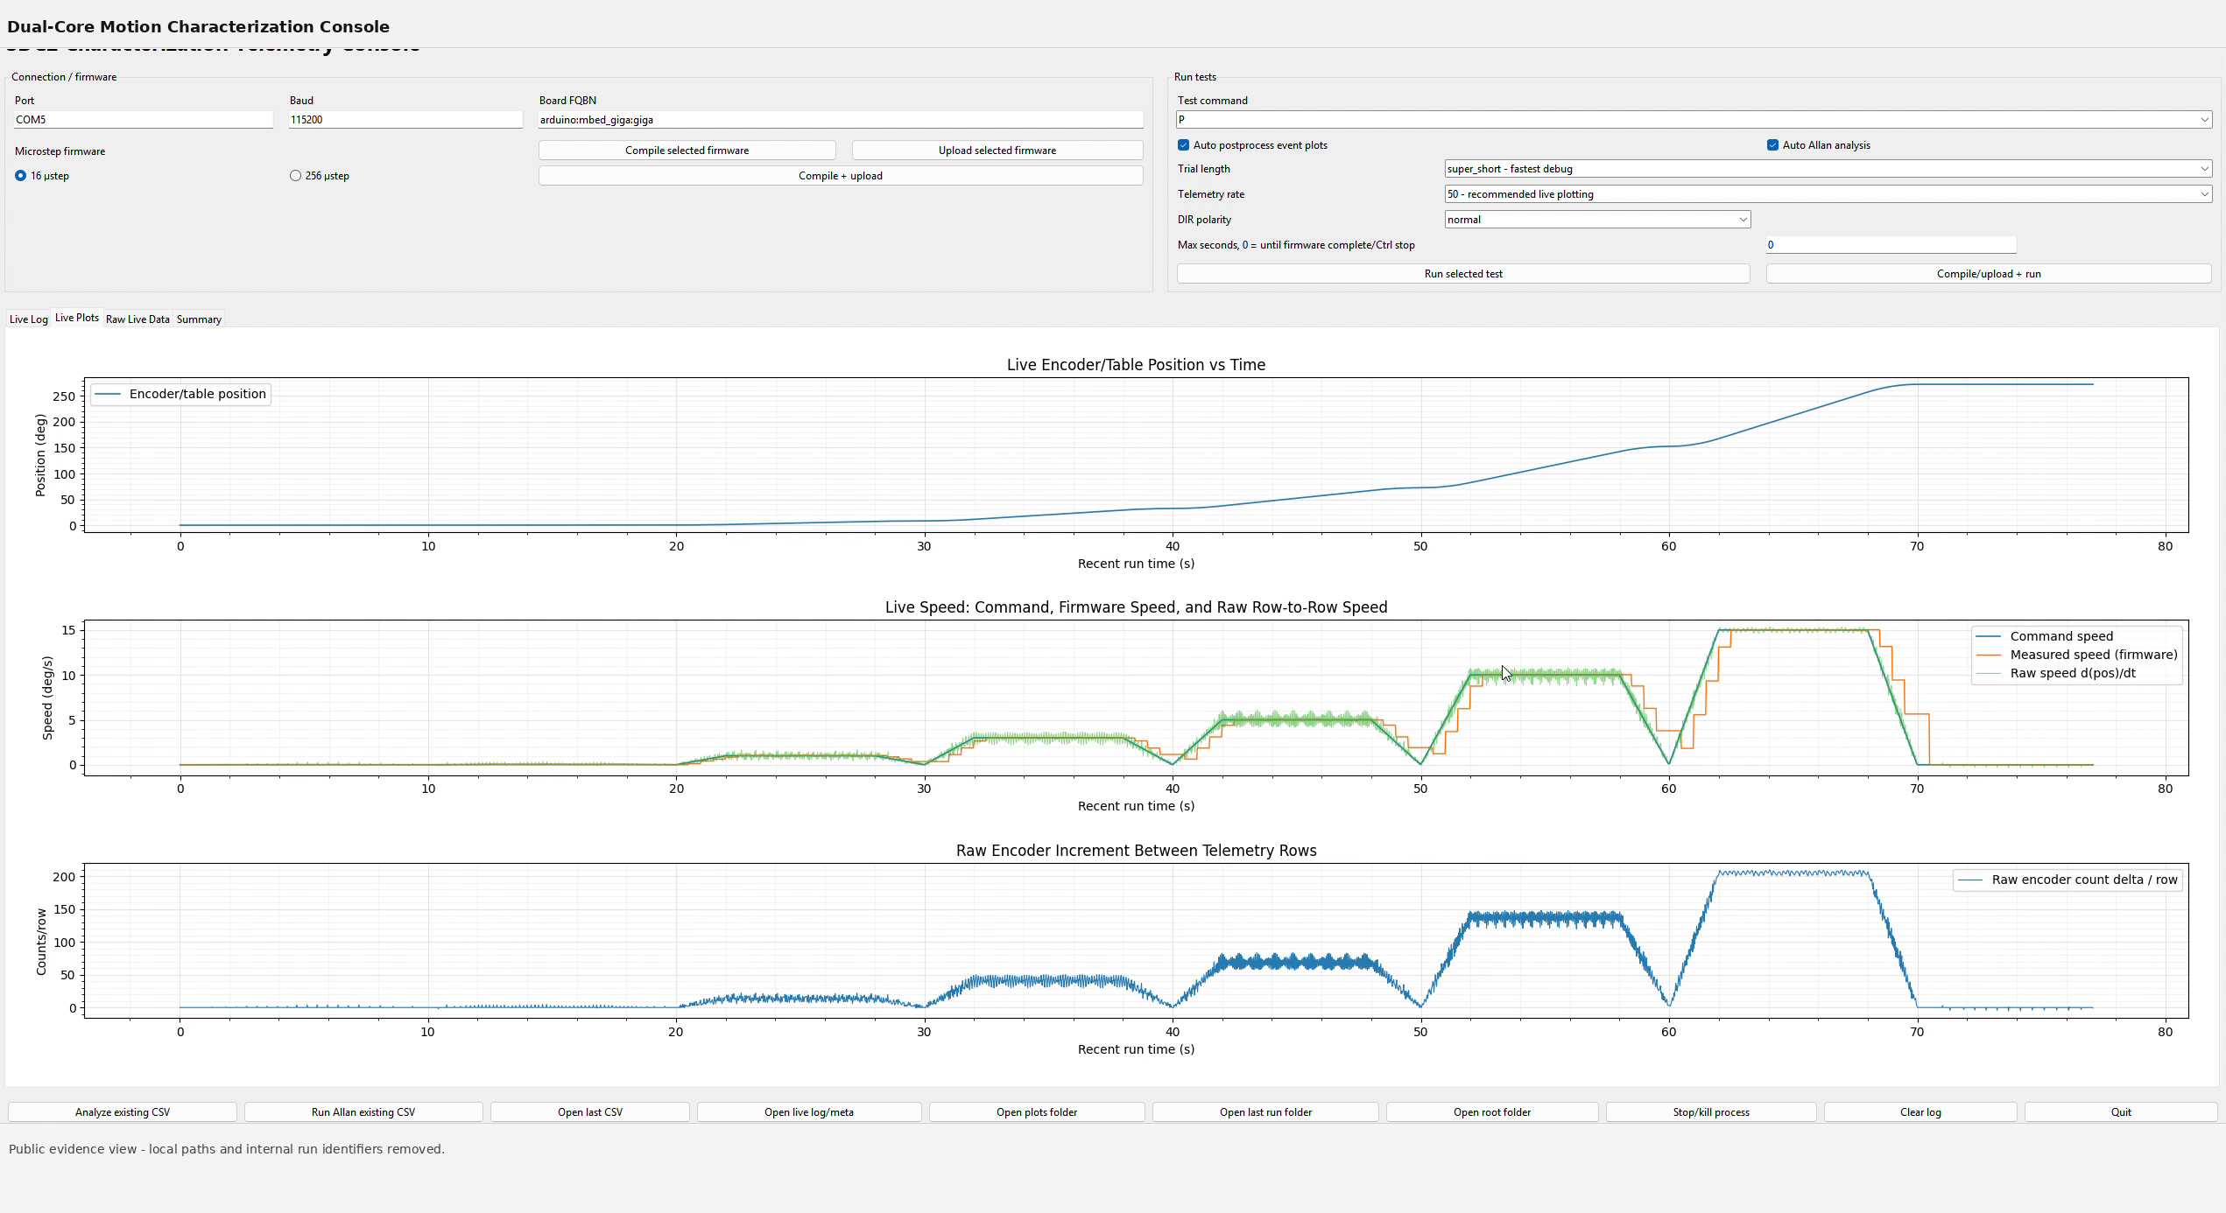

4. Source-Grounded Firmware Status
The private v0.3 encoder-safe firmware archive confirms the dual-core IPC framework, a fixed-rate encoder-feedback control path, bounded shared-memory telemetry, explicit fault-state handling, and guarded output behavior. The board-specific power-stage hooks remain intentionally separated from the reusable control logic.
The currently deployable control path is encoder-based closed position/speed control that produces a sensored rotating voltage vector. It is not represented publicly as commissioned current-regulated field-oriented control. The archive contains an integration path for current-sensed FOC, but that path requires calibrated phase-current feedback and board-specific power-stage integration before it can be claimed as commissioned hardware operation.
The private source also contains structural checks that prevent the shared telemetry object from exceeding its reserved memory region. The public package records the existence of these boundary guards without publishing record counts, addresses, linker placement, or data-structure definitions.
Figure 1. Public host telemetry view during automated motion characterization.

5. Host Software and Test Evidence
The host application provides live visibility into position, commanded speed, measured speed, and run progression. Automated characterization reduces manual intervention and produces retained datasets suitable for comparison. This public report focuses on observed behavior and measured outputs rather than application internals.
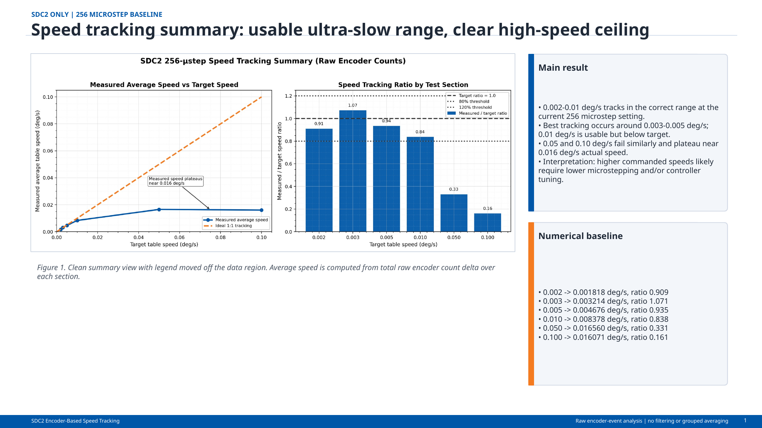
Figure 2. Speed-tracking summary illustrating the characterized low-speed range and the observed high-speed ceiling.

6. Measured Motion Performance
Testing characterized ultra-low-speed tracking, constant-speed behavior, transient response, and closed-loop response across the available test range. Results are presented as prototype evidence, not as certification or a production performance guarantee.
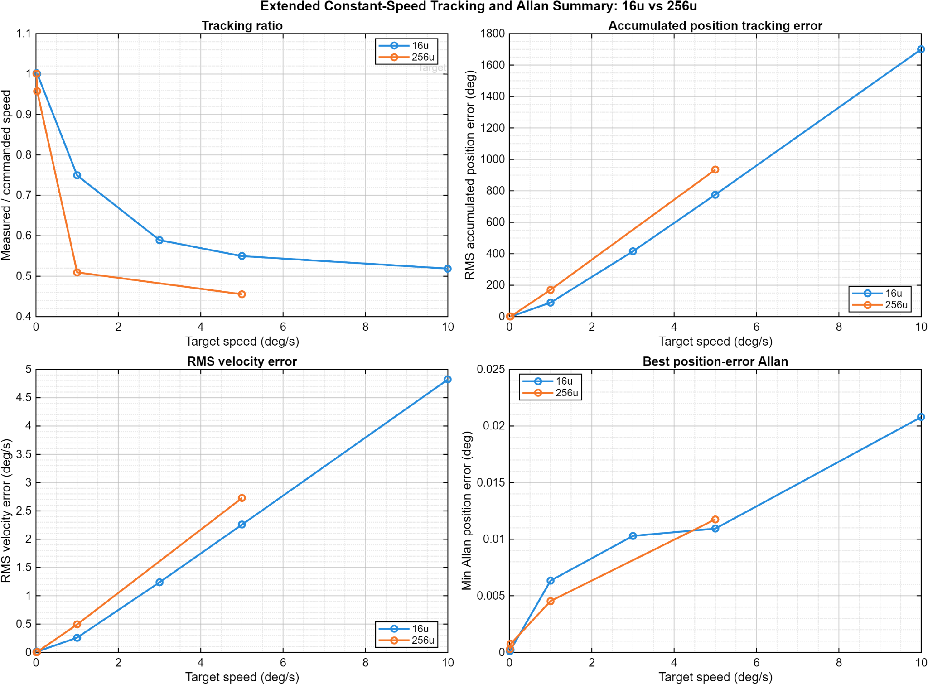
Figure 3. Constant-speed tracking and stability metrics from retained test data.
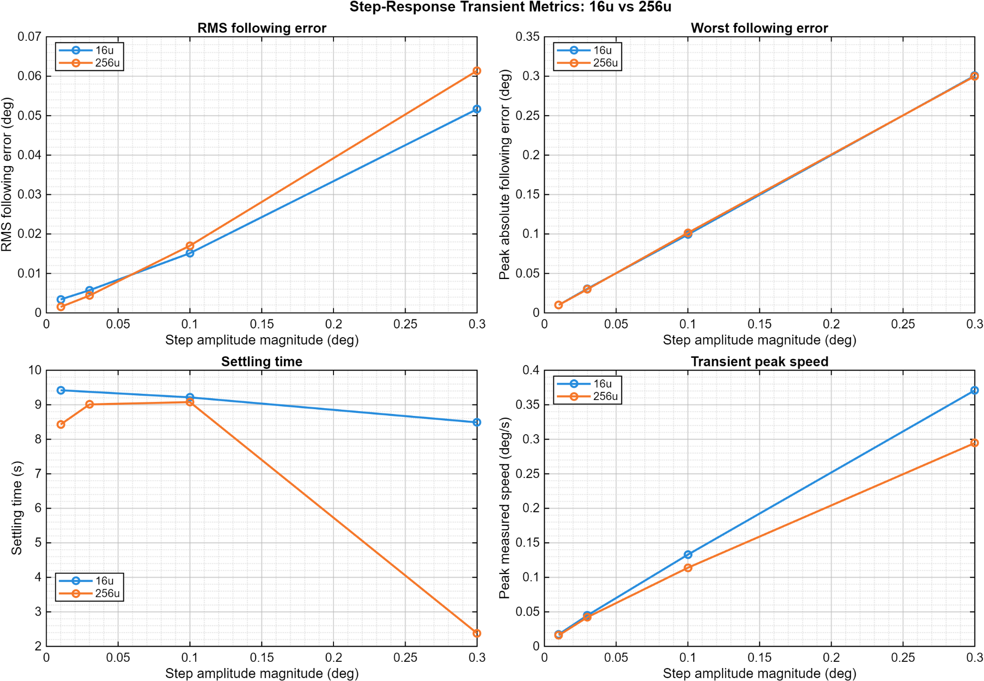
Figure 4. Step-response metrics from the characterized operating points.
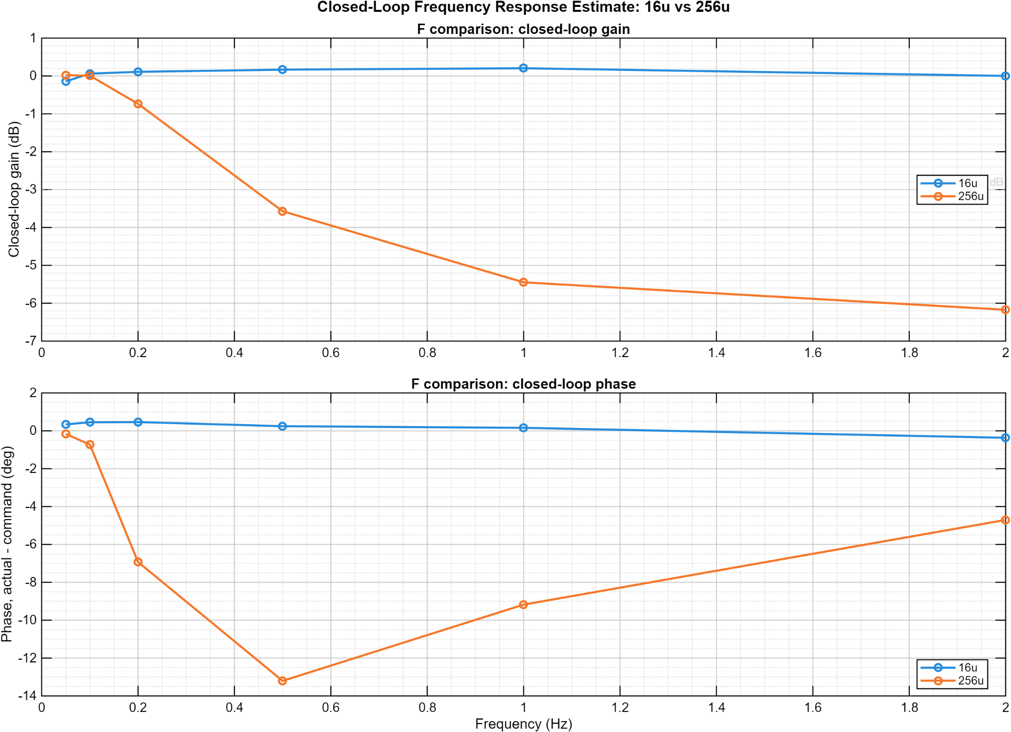
Figure 5. Closed-loop response estimate across the tested frequency range.

7. Safety, Reliability, and Public Release Boundary
- Loss of host presence or target health shall be observable and shall not result in uncontrolled continued motion.
- Telemetry configuration shall not be presented as demonstrated throughput unless end-to-end testing supports the claim.
- Shared-memory coherency is treated as a correctness-critical design requirement because cache or ordering mistakes can create intermittent data-integrity failures that are difficult to reproduce. Public evidence documents the requirement and verification basis; exact cache policy, MPU configuration, cache-maintenance sequence, barriers, publication ordering, and synchronization code remain private.
- The public repository excludes source code, Simulink/model files, setup or flashing instructions, pinouts, memory maps, and reusable implementation artifacts.

Requirements Verification and Traceability
The following matrix links public requirements to evidence retained in this portfolio package. Verification statements are intentionally limited to observable behavior and measured results; implementation internals are outside the public release boundary.
Requirement | Public evidence | Disposition
FW-FR-001 | Measured motion tests and high-level architecture rationale | Demonstrated at prototype level
FW-FR-002 | Host telemetry capture | Demonstrated
FW-FR-003 | Retained characterization plots and datasets | Demonstrated
FW-FR-004 | Health/integrity observability in host-target operation | Demonstrated
FW-FR-005 | Engineering review and concurrent-operation consistency testing | Verified privately; requirement disclosed publicly
FW-FR-006 | Private source archive reviewed against public statements | Satisfied

8. Limitations
The public evidence establishes prototype motion-control capability and repeatable characterization. It identifies shared-memory coherency as a correctness-critical requirement and documents the associated verification objective, but it intentionally does not disclose the implementation details required to reproduce the mechanism. The exact cache/MPU policy, maintenance sequence, memory barriers, publication ordering, scheduler design, and interrupt timing remain private engineering implementation details. Environmental, EMC, long-duration, and downstream optical-performance certification are outside the scope of this report.

Document Control
This document is a public engineering summary. It does not constitute a manufacturing package, source release, setup manual, or certification record.
Revision | Date | Description
7.0 | 2026-08-12 | Rebuilt public-facing firmware report against the private v0.3 encoder-safe source archive. Clarified implemented dual-core/encoder-control capability, bounded shared-memory safeguards, FOC maturity, and public/private IP boundary.

