HERDER ELEKTRONISCHE SYSTEMEN ENGINEERING REPORT | REV 7.0

DUAL-CORE OPTICAL MOTION TESTBED
MECHANICAL PLATFORM & PHYSICAL VERIFICATION
Rotary/translation test platform, physical integration, and demonstrated bench performance
Public portfolio technical report
Revision 7.0 - 12 August 2026

Prepared by | Herder Elektronische Systemen
Document scope | Mechanical requirements, physical integration, public verification evidence, and prototype limitations
Evidence basis | Fabrication photographs, physical measurements, load demonstrations, and retained test results
Distribution | Public portfolio release; implementation-level intellectual property omitted

DOCUMENT PURPOSE
Defines public-facing functional requirements, system boundaries, verification evidence, demonstrated results, and limitations without disclosing source code, model files, manufacturing data, setup procedures, or implementation-specific design details.

1. Purpose and System Boundary
This FRD defines the public-facing mechanical and physical-verification requirements for the optical-motion test platform. It documents demonstrated travel, structural integration, representative static loading, and system-level interfaces without publishing CAD/model files, PCB design files, schematics, BOMs, pinouts, switch settings, fabrication details, or setup procedures.
Boundary element | Included in this public FRD | Explicitly omitted
Mechanical platform | Integrated rotary/translation structure, physical travel, load demonstration, and visible system integration. | CAD/NX models, dimensions needed for reproduction, manufacturing drawings, assembly instructions, and detailed component selection.
Electrical integration | System-level presence of motor drive, encoder feedback, controller, and interface electronics. | Schematics, PCB artwork, BOM, pinout, DIP-switch configuration, wiring, grounding implementation, and manufacturing package.
Verification | Photographic evidence, observed travel, static loading, and representative motion results. | Calibration procedures, setup instructions, private test fixtures, and production qualification methods.

Users and Review Context
The intended audience is technical reviewers and prospective customers evaluating demonstrated platform capability without receiving information sufficient to reproduce the hardware.

2. Functional and Quality Requirements
ID | Requirement | Rationale | Verification
PL-FR-001 | The platform shall provide integrated rotary and translational motion in a rigid bench-scale assembly. | The testbed must support combined motion experiments in one physical platform. | Physical inspection and demonstration imagery.
PL-FR-002 | The translation axis shall demonstrate travel greater than plus/minus 3 inches. | The platform must cover the intended bench adjustment range. | Visible displacement references and retained photographs.
PL-FR-003 | The completed prototype shall support the demonstrated 40 lb static offset load without visible loss of assembly integrity. | Representative payload testing provides evidence of prototype structural capability. | Static-load demonstration photographs.
PL-FR-004 | The platform shall provide motion-actuation and encoder-feedback interfaces suitable for closed-loop characterization. | The private firmware archive confirms encoder-feedback control integration while board-specific inverter details remain outside the public boundary. | Integrated motion evidence and source-to-interface review.
PL-FR-005 | The public release shall omit reproducible hardware implementation information. | Protect manufacturing and integration IP while still demonstrating completed engineering work. | Public-package content audit.

3. Physical Architecture and Demonstrated Capability
The platform combines a rigid lower frame, an upper motion surface, rotary actuation, and translational adjustment into a single bench-scale test article. The public report intentionally treats the platform as a completed system rather than exposing reproducible geometry or fabrication information.
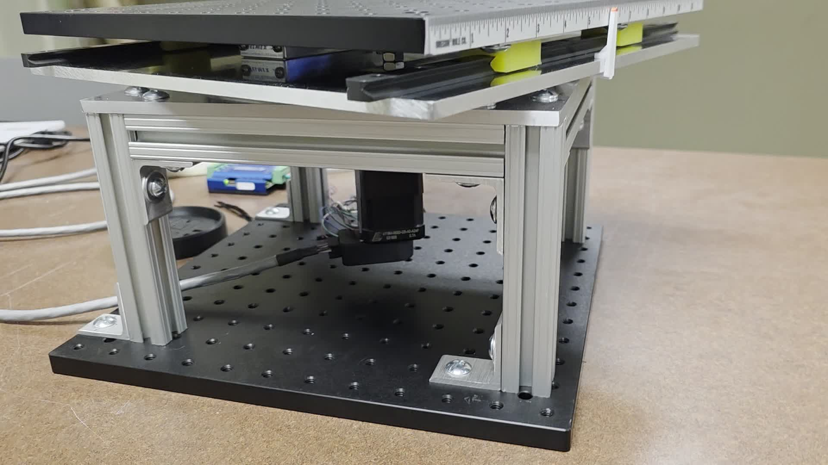
Figure 1. Completed bench-scale motion platform.

4. Translation Verification
Translation was verified using visible physical references across the stage travel. The retained evidence demonstrates motion beyond plus/minus 3 inches. The public package does not include dimensional drawings, lead-screw details, rail geometry, or assembly instructions.
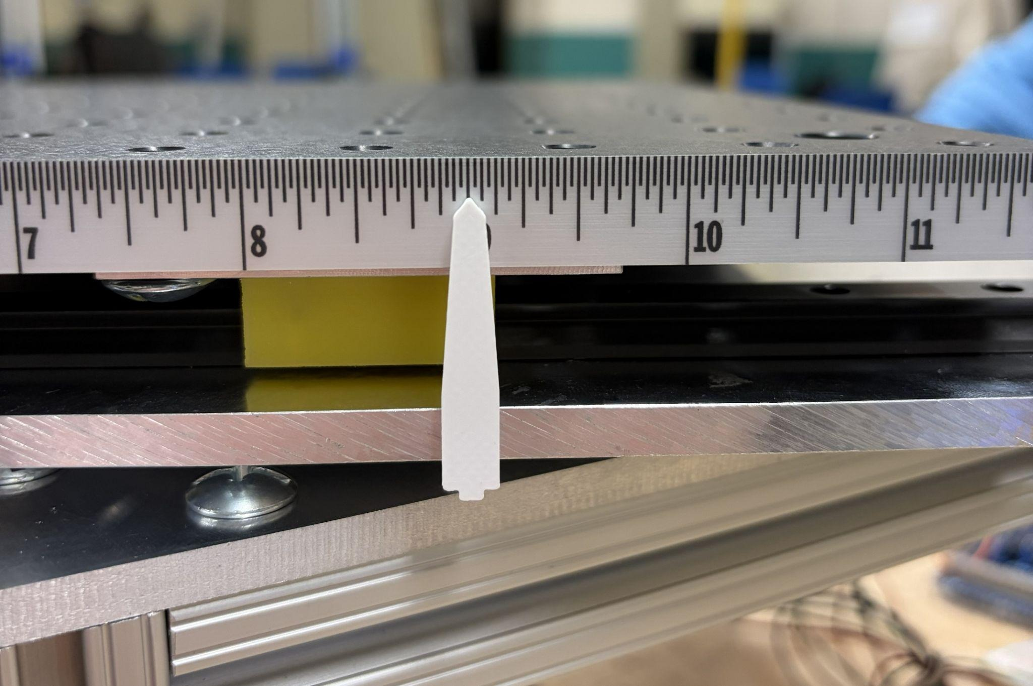
Figure 2. Translation reference near one measured position.
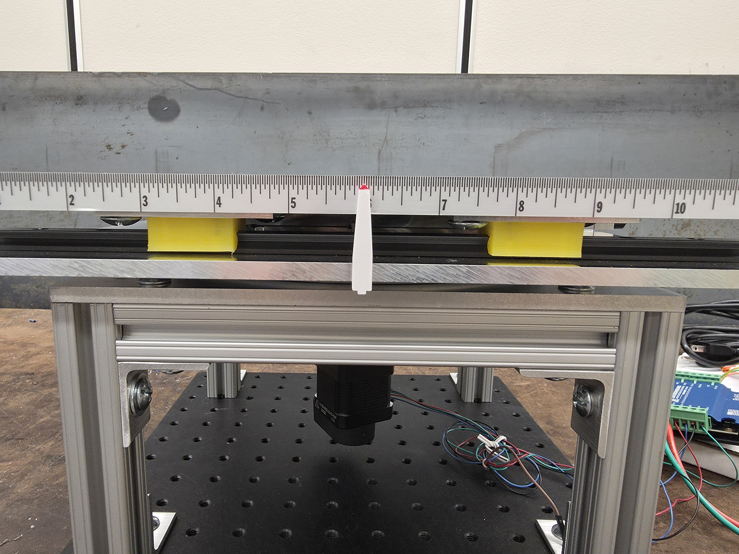
Figure 3. Translation reference at an alternate stage position.

5. Static-Load Demonstration
The completed prototype was subjected to a 40 lb static offset-load demonstration. This provides useful structural evidence for the prototype but is not a rated payload specification and does not substitute for shock, vibration, fatigue, or long-duration qualification.
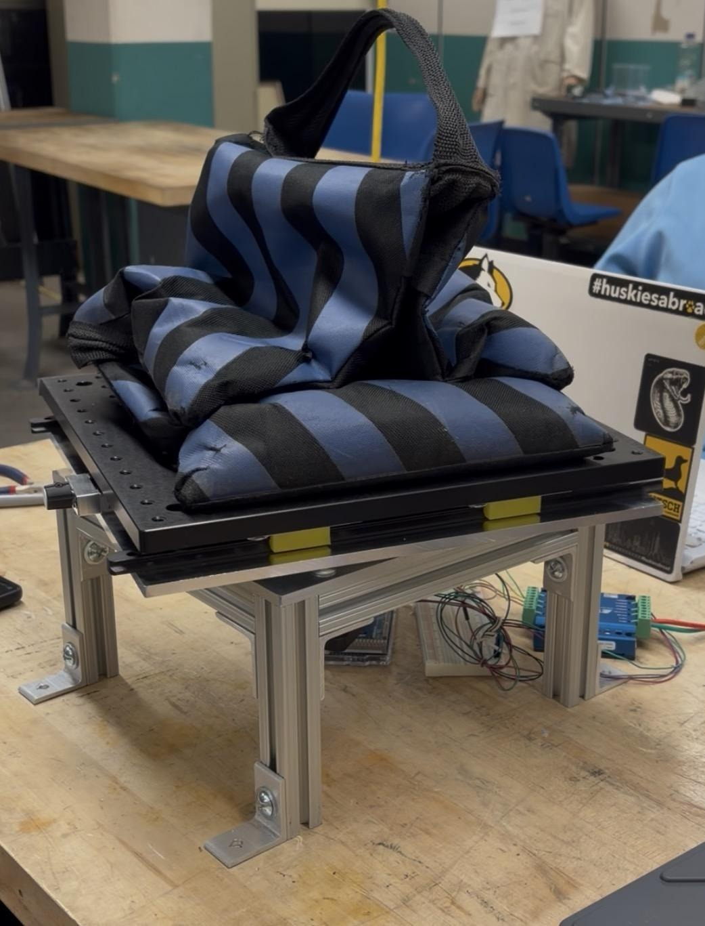
Figure 4. Representative 40 lb static offset-load demonstration.

6. Representative Motion Evidence
System-level motion testing demonstrated commanded rotational behavior with the integrated platform. Public evidence is limited to the observed response; driver configuration, gearing details, controller pinout, wiring, and tuning remain outside the public release.
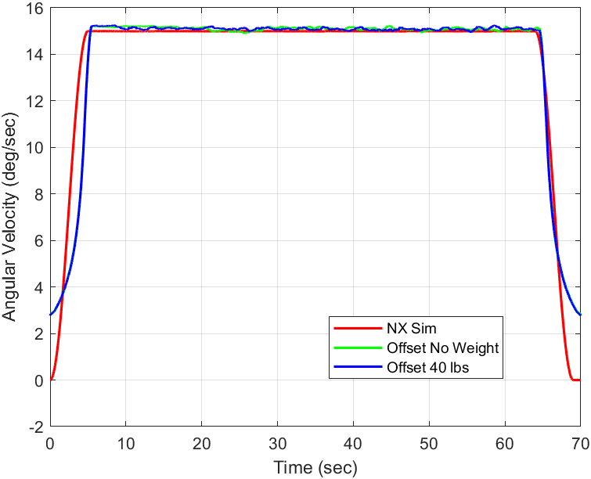
Figure 5. Representative measured rotational response from an integrated platform test.

Firmware Integration Status
The private firmware archive contains an encoder-based closed position/speed control path and a separate current-sensed FOC integration path. The latter is not claimed as commissioned platform operation because the archive itself identifies missing board-specific phase-current, timer, and power-stage integration. Public platform claims therefore remain limited to demonstrated physical motion, encoder feedback, and prototype verification evidence.

7. Public Release Boundary
Firmware ownership boundary. The physical platform provides the motion and encoder-feedback interfaces consumed by the dual-core controller. Review of the private v0.3 firmware archive confirms that shared-memory coherency, bounded telemetry storage, control-state logic, and output gating are firmware-owned responsibilities. This platform FRD records those dependencies only at the system boundary and does not publish cache/MPU settings, memory attributes, synchronization logic, pin maps, PWM configuration, or other reproduction-level firmware details.
- No CAD, NX, Simulink, schematic, PCB layout, or other editable engineering model is included.
- No BOM, connector pinout, DIP-switch table, wiring diagram, assembly sequence, power-up procedure, or setup instruction is included.
- No dimensions or component-level details sufficient to reproduce the platform are provided.
- Photographs and measured results are retained only as evidence of completed integration and prototype performance.

Requirements Verification and Traceability
The following matrix links public requirements to evidence retained in this portfolio package. Verification statements are intentionally limited to observable behavior and measured results; implementation internals are outside the public release boundary.
Requirement | Public evidence | Disposition
PL-FR-001 | Completed-platform photograph and integrated motion evidence | Demonstrated
PL-FR-002 | Translation reference photographs | Demonstrated
PL-FR-003 | 40 lb static offset-load photograph | Demonstrated, not certified
PL-FR-004 | Integrated motion-result evidence | Demonstrated at system level
PL-FR-005 | Sanitized public package audit | Satisfied

8. Limitations
The report documents a completed prototype and selected verification evidence. It does not constitute a fabrication release, assembly manual, electrical design package, rated payload certification, calibrated metrology report, EMC qualification, or production drawing set. Reusable mechanical and electrical implementation details are intentionally retained privately.

Document Control
This document is a public engineering summary. It does not constitute a manufacturing package, source release, setup manual, or certification record.
Revision | Date | Description
7.0 | 2026-08-12 | Reconciled public platform claims with the private v0.3 encoder-safe firmware archive while preserving the sanitized hardware and firmware IP boundary.

