DUAL-CORE OPTICAL MOTION TESTBED
MECHANICAL PLATFORM & PHYSICAL VERIFICATION
Rotary/translation test platform, structural integration, travel verification, static loading, and measured motion evidence
Customer-facing technical report
Revision 7.3 - 13 August 2026
MECHANICAL PLATFORM & PHYSICAL VERIFICATION
Rotary/translation mechanics, structural integration, physical verification, and demonstrated bench performance
ENGINEERING REQUIREMENTS DOCUMENT | REVISION 7.3 | 13 AUGUST 2026

Prepared by | Herder Elektronische Systemen
Document scope | Mechanical platform requirements, physical integration, travel/load verification, and measured bench evidence
Evidence basis | Physical photographs, measured displacement references, load demonstrations, motion results, and engineering review
Distribution | Public portfolio release; CAD, schematics, manufacturing data, and reproduction instructions withheld
DOCUMENT PURPOSE
Defines public functional, performance, interface, safety, verification, and acceptance requirements for the mechanical platform and physical test article while withholding reproduction-level design data.

Functional Requirements and Engineering Context
Public release intent
This FRD preserves the established engineering-report template and provides detailed requirements, rationale, verification evidence, and performance interpretation without publishing CAD, schematics, PCB artwork, dimensions sufficient for reproduction, BOMs, wiring, pinouts, switch settings, assembly procedures, or setup instructions.

Purpose, Scope, and System Boundary
This document governs the public-facing mechanical and physical-verification requirements for the bench-scale optical motion platform. It covers structural integration, rotary/translation functionality, physical travel, representative static loading, visible alignment evidence, and integrated motion results. Electronics are described only at a functional interface level; implementation details remain private.
Boundary element | Included publicly | Withheld
Mechanical structure | Integrated bench platform, functional role, physical verification, measured travel/load evidence | CAD/NX models, manufacturing drawings, dimensions sufficient for reproduction, assembly sequence
Electrical integration | Existence and purpose of motor drive, encoder feedback, controller, and interface electronics | Schematics, PCB layout, grounding implementation, BOM, pinout, wiring, switch settings
Verification | Physical photographs, displacement references, static loading, representative motion response | Calibration/setup procedures, fixtures, internal commissioning instructions
Firmware boundary | System-level requirement that valid feedback and safe actuation states are exchanged with the controller | Source, models, board hooks, cache/MPU/synchronization implementation

1. Platform Role and Delivered Capability
The platform is a bench-scale rotary/translation test article intended to carry optical or instrumentation payloads while providing controlled angular and linear adjustment. The structural design integrates a rigid lower frame, upper mounting surface, rotary actuation, and a translation mechanism into a single serviceable assembly. Public evidence focuses on what the completed platform does rather than how to reproduce it.
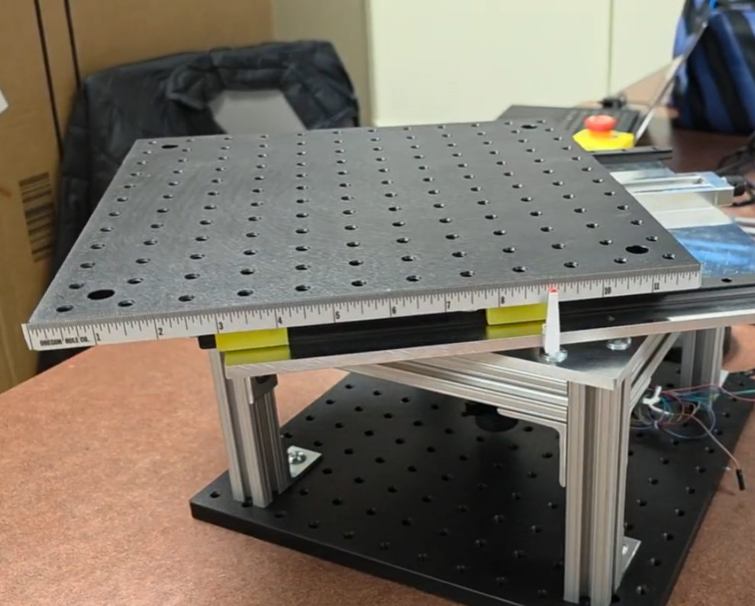
Figure 1. Completed motion platform; the photograph is cropped to keep the public evidence focused on the test article.
Capability | Public evidence | Engineering interpretation
Integrated rotary/translation platform | Completed assembly photograph and motion records | Both motion functions are physically integrated into one bench-scale article.
Translation travel | Visible reference measurements beyond +/-3 in; detailed record supports approximately +/-3 13/32 in | Demonstrates the intended adjustment range without releasing drive geometry.
Static loading | 40 lb offset static-load demonstration | Exceeds the original 25 lb design objective in the demonstrated static condition; not a rated payload specification.
Rotational behavior | Measured integrated-platform response | Confirms motion execution under representative test conditions.

2. Functional and Performance Requirements
ID | Requirement | Rationale | Verification
PL-FR-001 | The platform shall provide integrated rotary and translational motion on a rigid bench-scale structure. | The test article must support two-axis experimental positioning without separate fixtures. | Physical inspection and demonstration imagery.
PL-FR-002 | The translation mechanism shall demonstrate travel greater than +/-3 inches. | The usable adjustment range must cover the intended bench experiments. | Visible displacement references.
PL-FR-003 | The completed prototype shall support the demonstrated 40 lb static offset load without visible loss of structural integrity. | Payload margin is important for representative optics/instrumentation fixtures. | Static-load demonstration.
PL-FR-004 | The platform shall retain mechanical alignment sufficiently for repeatable motion testing across the demonstrated travel. | Translation/rotation evidence is only useful if the structure remains mechanically coherent. | Centered/displaced reference photographs and repeated motion tests.
PL-FR-005 | The physical interface shall provide encoder feedback and commanded actuation paths compatible with the target controller. | Closed-loop firmware requires a measurable motion state and a controllable actuator interface. | Integrated-system operation; interface review.
PL-FR-006 | Public documentation shall not expose reproduction-level mechanical or electrical design information. | Portfolio evidence should prove capability without distributing reusable design IP. | Public-package content audit.

3. Mechanical Integration and Alignment
The completed structure uses a rigid frame and upper motion surface to support the moving assembly while maintaining access to the drive and feedback subsystems. The public report intentionally omits the internal CAD stack-up and dimensional design. What matters for verification is that the physical assembly remains coherent across the demonstrated travel and load conditions.
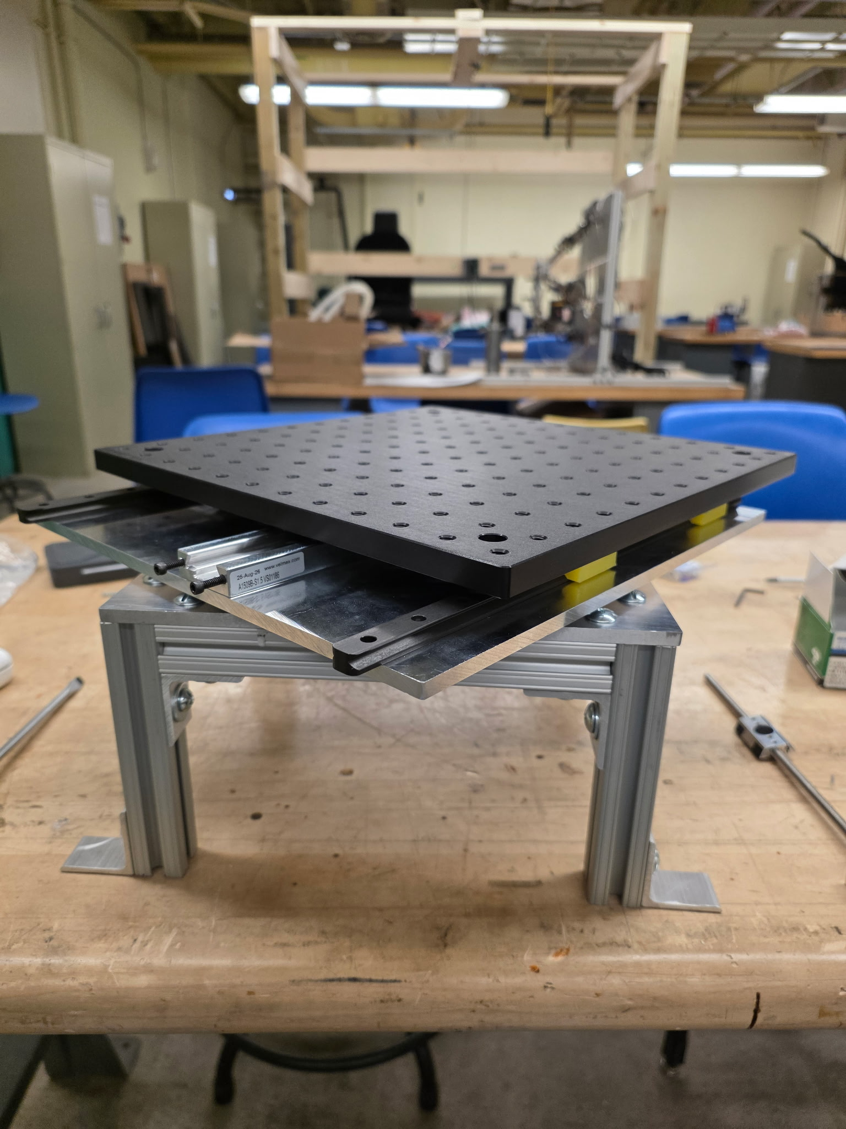
Figure 2. Fabrication-stage photograph documenting physical integration of the motion structure.
Fabrication evidence is useful because it demonstrates that the architecture progressed beyond CAD or simulation into a physical test article. It is not presented as an assembly guide; fastener selection, alignment procedure, component spacing, and fabrication dimensions remain private.

4. Translation Verification
Translation was verified using visible reference measurements at multiple stage positions. The retained evidence demonstrates travel beyond +/-3 inches, with detailed project records supporting approximately +/-3 13/32 inches. The public FRD reports the achieved range but intentionally omits lead-screw geometry, drive ratios, rail spacing, and other reproduction-level dimensions.
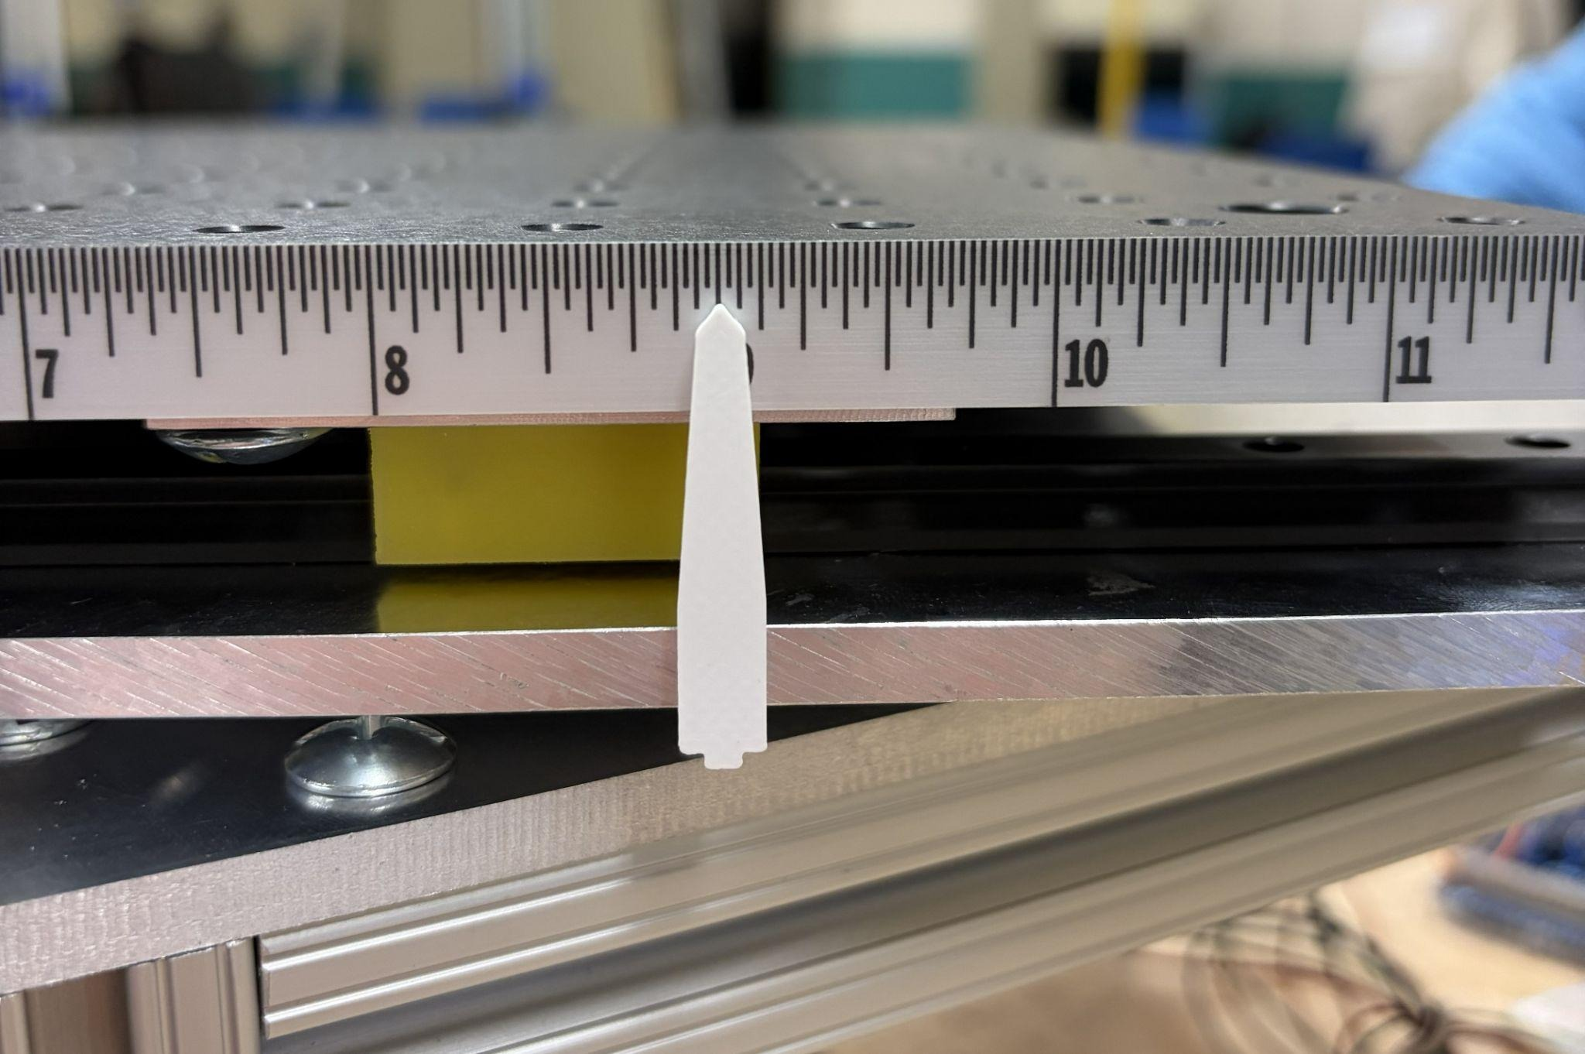
Figure 3. Translation reference near a centered/measured stage position.
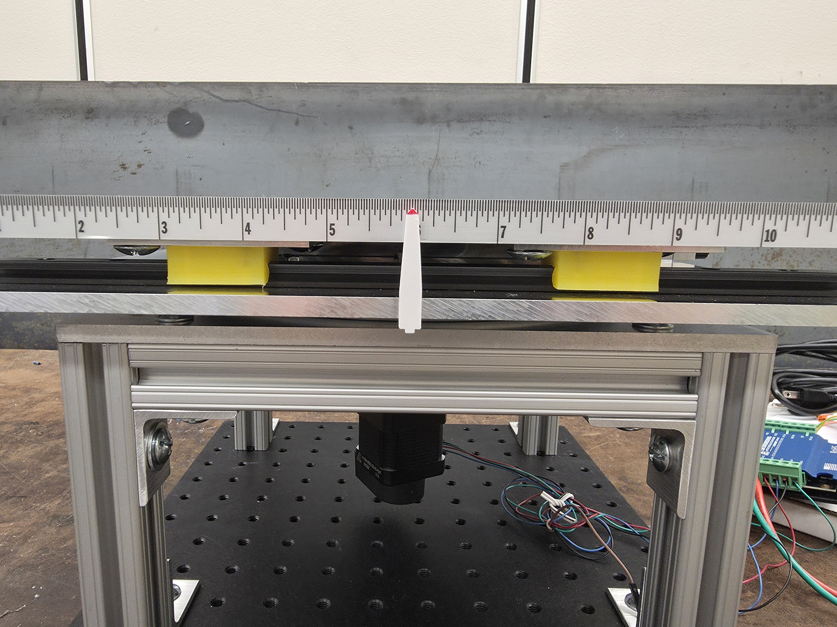
Figure 4. Translation reference at an alternate stage position.
Verification aspect | Observed evidence | Boundary of claim
Travel magnitude | More than +/-3 in demonstrated; detailed record approximately +/-3 13/32 in | Prototype travel evidence, not calibrated metrology certification.
Alignment | Reference pointer remains usable across displaced positions | Qualitative/bench alignment evidence.
Repeatability | Repeated motion testing completed on the integrated platform | No formal uncertainty budget is claimed.

5. Static-Load Demonstration
The original platform objective included support for a representative payload of 25 lb. The completed prototype was subsequently demonstrated with a 40 lb static offset load. This is a useful margin demonstration, but it is not a rated working-load limit and does not substitute for fatigue, shock, vibration, or long-duration structural qualification.
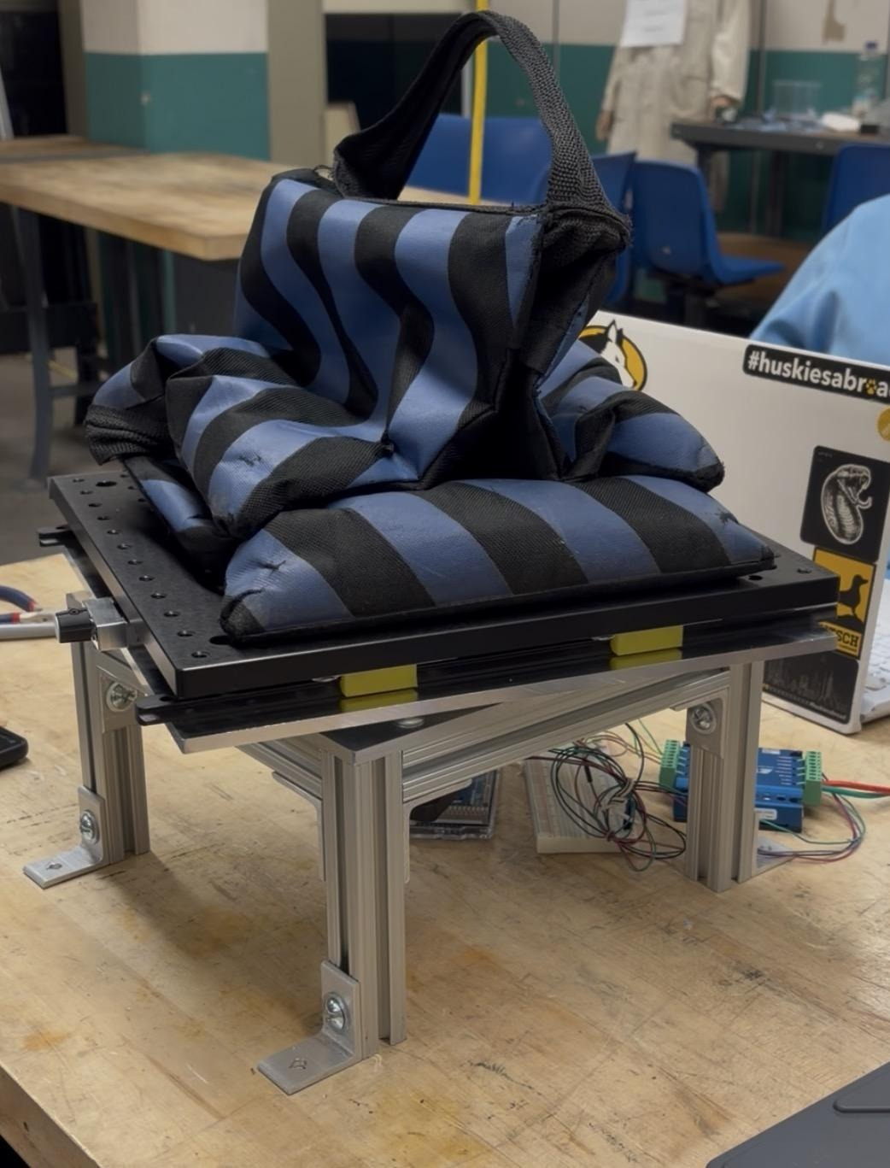
Figure 5. Representative 40 lb static offset-load demonstration.
Load statement | Meaning
25 lb original objective | Design target used to frame representative payload capability.
40 lb demonstrated static load | Observed prototype condition without visible structural failure during the demonstration.
Not claimed | Rated payload, fatigue life, shock/vibration qualification, or safety factor certification.

6. Integrated Motion Evidence
The platform was tested as an integrated motion system rather than only as a static mechanical assembly. Representative response data show commanded angular behavior and the measured system response under physical test conditions. The public package preserves the result while omitting driver configuration, gearing details, electrical wiring, and controller implementation.
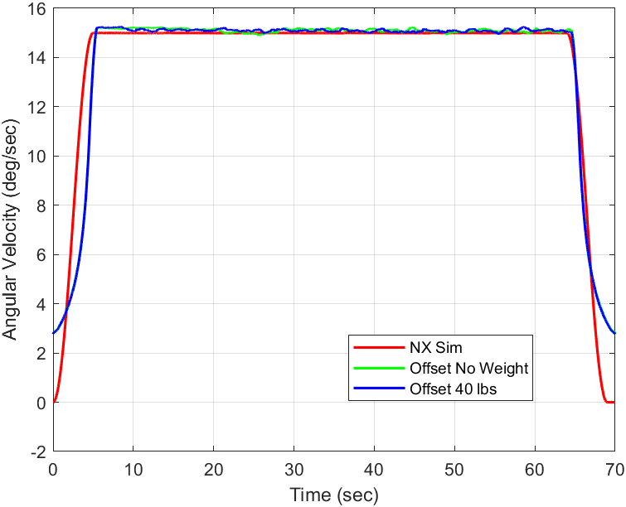
Figure 6. Representative integrated-platform rotational response under test.
The plot should be interpreted as system-level evidence: it demonstrates that the physical platform, feedback path, controller, and actuator were integrated successfully. It is not a component datasheet and does not establish a universal bandwidth or payload/speed envelope.

7. Controller and Feedback Interface Boundary
The mechanical platform depends on two functional interfaces: a commanded actuation path and a measured feedback path. The private controller implementation consumes encoder-derived motion state and applies state/fault gating before energizing actuation. The public platform FRD intentionally stops at this functional boundary; circuit implementation, connector mapping, grounding strategy, and power-stage details remain private.
Interface responsibility | Platform-side requirement | Firmware-side responsibility
Motion feedback | Provide a physically valid encoder-derived representation of stage motion | Validate freshness/plausibility and use feedback only within permitted control states.
Actuation | Provide a controllable physical drive path capable of executing commanded motion | Validate feedback freshness/plausibility, update the encoder-supervisory control path at its defined cadence, and keep high-rate actuation timing independent of host/service activity.
Fault containment | Physical hardware shall support immediate de-energization of the motion path | Software shall default to disabled/neutral output outside valid running conditions.
Shared data | System shall expose sufficient measured state for test verification | Firmware shall preserve integrity and fault observability across inter-core/host data paths.

8. Verification, Acceptance, and Traceability
Requirement | Evidence | Disposition
PL-FR-001 | Completed-platform and fabrication photographs | Demonstrated
PL-FR-002 | Multiple translation reference photographs | Demonstrated
PL-FR-003 | 40 lb static offset-load photograph | Demonstrated, not certified
PL-FR-004 | Centered/displaced references and repeated motion evidence | Demonstrated at bench level
PL-FR-005 | Integrated closed-loop motion evidence | Demonstrated at system level
PL-FR-006 | Public-package audit excluding reproduction-level artifacts | Satisfied by release construction

Acceptance for the public portfolio is evidence-based: the report must show the completed physical article, documented travel, load demonstration, integrated motion behavior, and a clear interface to the companion firmware FRD. It must not include the artifacts needed to rebuild the mechanical/electrical implementation.

9. Limitations and Public Release Controls
- No CAD/NX/Simulink models, schematics, PCB artwork, BOMs, pinouts, DIP-switch tables, wiring diagrams, assembly sequences, dimensions sufficient for reproduction, or setup instructions are included.
- The 40 lb result is a static demonstration, not a rated working-load certification.
- Translation references are bench verification and do not constitute calibrated metrology certification.
- Representative motion results are specific to the tested configuration and are not generalized as universal platform limits.
- Formal shock, vibration, thermal, EMC, fatigue, and production qualification remain outside this portfolio release.

Document Control
Revision | Date | Description
7.3 | 13 August 2026 | Final public platform FRD aligned with the reviewed firmware evidence boundary while preserving mechanical requirements, physical verification, system-interface responsibilities, acceptance criteria, and traceability without reproduction-level design data.

