DUAL-CORE FIRMWARE & HOST SOFTWARE
STM32H747 MotionIPC Architecture, Telemetry, and Characterization
Customer-facing technical report
Revision 2.0 • 3 August 2026
Prepared by | Herder Elektronische Systemen
Primary subject | STM32H747 dual-core firmware, inter-core communications, and host software
Evidence basis | MotionIPC source package, motion firmware, GUI video, logs, slides, plots, and technical reports
Distribution | Customer-facing; selected public source excerpts included; complete development archives excluded
DOCUMENT EMPHASIS
This revision makes the dual-core firmware architecture the primary engineering result. Mechanical and test-platform material is included only where it explains the target workload or validates the software stack.

1. Executive Summary
The system uses an STM32H747 heterogeneous dual-core microcontroller to separate high-rate motion data movement from low-rate control and coordination. A 400 MHz Cortex-M7 acts as the OpenAMP master and shared-ring producer; a 200 MHz Cortex-M4 acts as the OpenAMP remote and shared-ring consumer. The design combines RPMsg control messages with a custom AXI-SRAM ring buffer so motion records do not compete with command, heartbeat, fault, and status traffic.
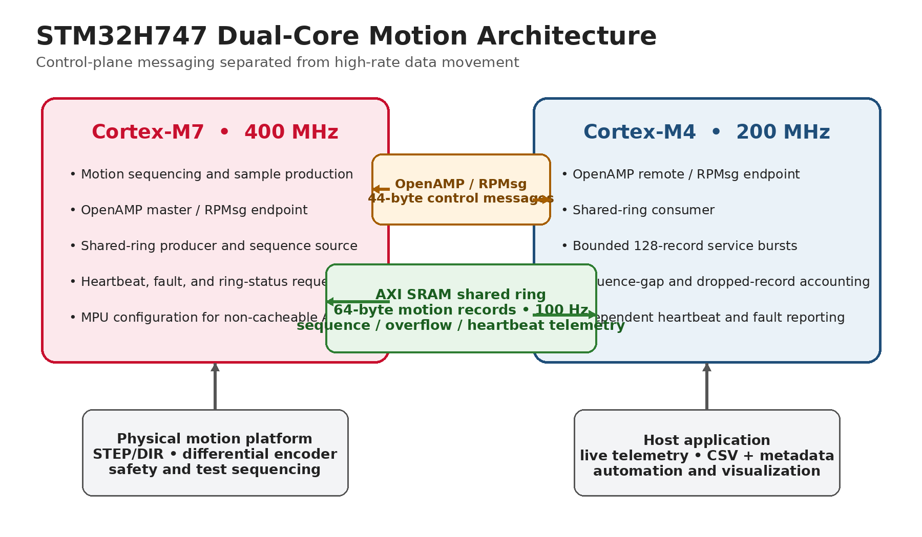
Figure 1. Dual-core architecture: OpenAMP/RPMsg control plane and AXI-SRAM high-rate data plane.
KEY ENGINEERING RESULT
The firmware is not a single-core application placed on a dual-core board. It defines explicit ownership, memory regions, protocol messages, producer/consumer synchronization, cache behavior, sequence accounting, and per-core health reporting.

2. Verified Architecture Specifications
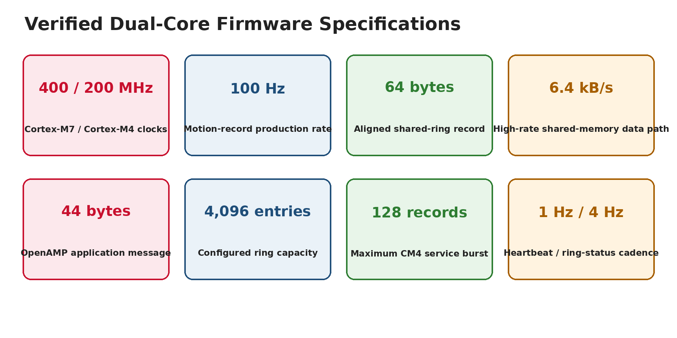
Figure 2. Source-verified processor, IPC, buffering, and service-cadence specifications.
Item | Verified implementation
Processor | STM32H747: 400 MHz Cortex-M7 + 200 MHz Cortex-M4
Control IPC | OpenAMP/RPMsg service named motion_ipc
High-rate IPC | Custom producer/consumer ring in AXI SRAM
Motion record | 64-byte, 32-byte-aligned MotionRawSample
Application message | 44-byte MotionIpcMessage with 8 × 32-bit arguments
Production rate | 100 Hz in the supplied MotionIPC integration revision
Ring allocation | 256 KiB at 0x24000000
Configured capacity | 4,096 entries; engineering review identifies a ~64-byte allocation overrun
Consumer service | Bounded bursts of up to 128 records per CM4 pass
Health/status | 1 Hz core heartbeats and 4 Hz ring-status requests

3. Core Partitioning and Boot Sequence

3.1 Cortex-M7 responsibilities
- Configures the MPU and cache policy before enabling the high-rate shared-memory path.
- Boots and releases the Cortex-M4 through hardware semaphore HSEM0.
- Initializes the AXI-SRAM ring as producer and OpenAMP as RPMsg master.
- Produces timestamped motion records and owns the monotonically increasing record sequence.
- Sends heartbeat and ring-status requests and receives fault/status replies.

3.2 Cortex-M4 responsibilities
- Wakes from STOP mode in response to HSEM signaling and initializes as the OpenAMP remote.
- Consumes motion records from the shared ring without routing each record through RPMsg.
- Processes up to 128 records per service pass so OpenAMP polling remains responsive.
- Counts samples, sequence gaps, dropped records, and last-consumed sequence.
- Reports independent heartbeat, ring status, and fault information to the M7.

3.3 Inter-core boot and service flow
Stage | M7 action | M4 action
1 | Configure MPU/cache and initialize HAL/clock | Wait in STOP mode
2 | Release HSEM0 | Wake and clear HSEM event
3 | Initialize shared-ring producer | Initialize shared-ring consumer
4 | Create OpenAMP master endpoint | Create OpenAMP remote endpoint
5 | Produce records; poll messages | Consume records; service messages
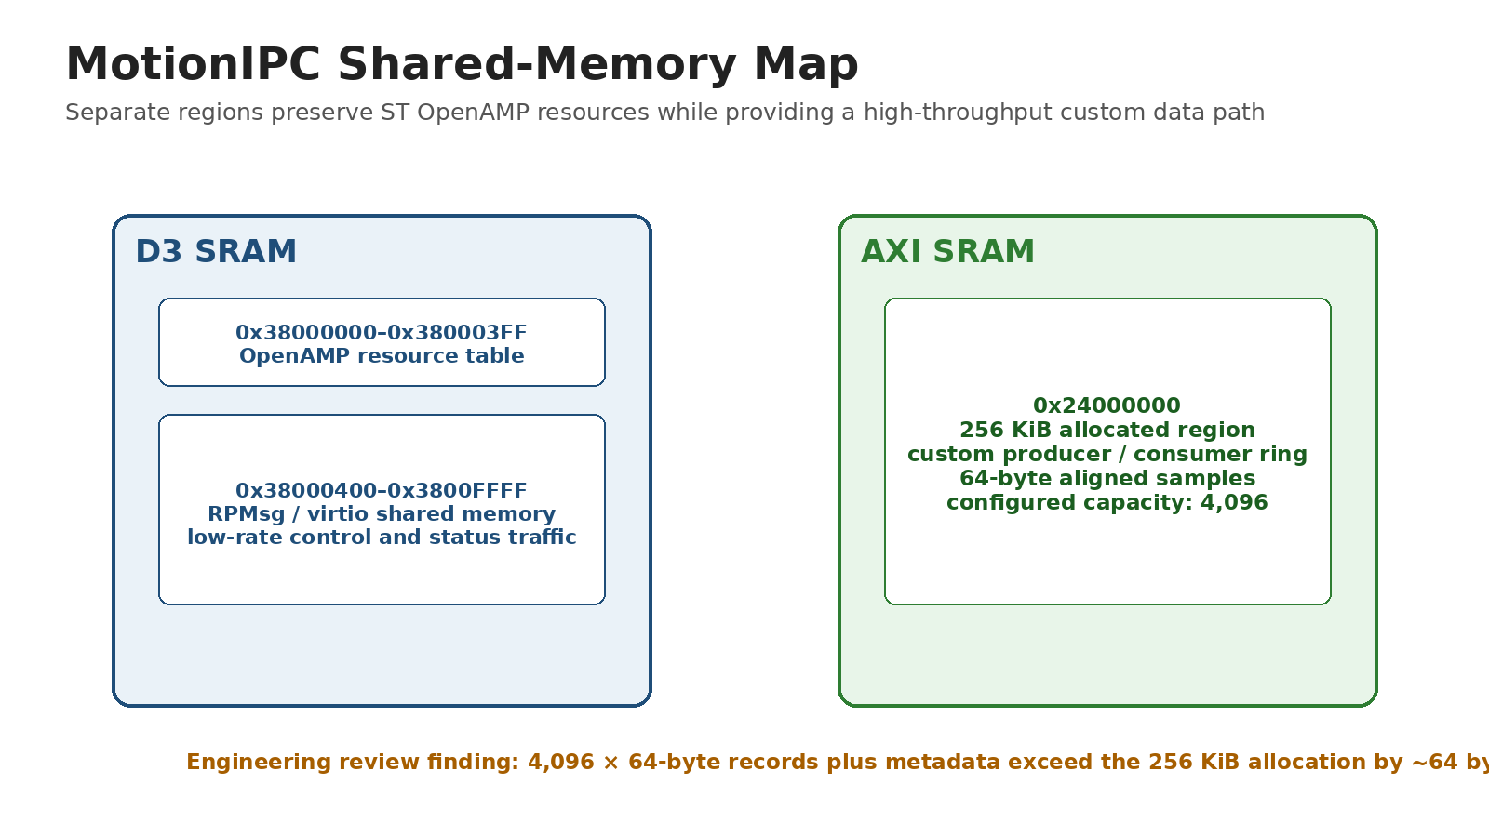
Figure 3. Shared-memory layout and the source-derived capacity review finding.

4. IPC Protocol and Data Structures

4.1 Control-plane message set
Message | Purpose
HEARTBEAT_REQ / REPLY | Per-core liveness, record counts, gaps, and drops
RING_STATUS_REQ / REPLY | Read/write indices, samples read, last sequence, and overflow statistics
START_SEGMENT / STOP_SEGMENT | Worker-state transition hooks and end-of-segment reporting
CLEAR_STATS | Reset consumer counters for a new run
FAULT | Propagate core-local fault flags

4.2 High-rate motion record
Field | Role
seq | Record sequence number
t_us | Microsecond timestamp
encoder_count | Raw encoder count
position_mdeg | Position in millidegrees
target_speed_mdeg_s | Commanded speed in millidegrees per second
measured_speed_mdeg_s | Measured speed in millidegrees per second
error_mdeg | Position or tracking error in millidegrees
state / flags | Compact target-state and condition indicators
WHY TWO IPC PATHS
RPMsg is used where message semantics matter. The ring is used where deterministic, low-overhead record transfer matters. This avoids paying RPMsg framing and endpoint-service costs for every sample.

4.3 Throughput
At 100 records/s and 64 bytes/record, the custom shared-memory path moves 6.4 kB/s (51.2 kb/s), or approximately 384 kB/min. Regular control traffic is only several hundred application bytes per second before RPMsg framing, so the communication architecture preserves substantial headroom.

5. Concurrency, Coherency, and Reliability
Mechanism | Engineering effect
Sequence continuity | Monotonic record numbers and CM4 gap counting expose missing data.
Overflow visibility | Producer increments a drop counter when the ring cannot accept a record.
Core liveness | Independent M7 and M4 heartbeat counters distinguish core-local failures.
Fault propagation | Each core maintains fault flags; RPMsg fault messages transfer status.
Bounded worker load | CM4 consumes no more than 128 records per pass, preserving OpenAMP service cadence.
Memory ordering | Shared-ring implementation uses barriers around producer/consumer state.
Cache safety | M7 MPU policy marks the AXI ring region non-cacheable for coherency.

5.1 Capacity review finding
CORRECTIVE ACTION
The configured 4,096 × 64-byte sample array consumes the full 256 KiB allocation before ring metadata is counted. The public report therefore records this as an engineering review finding. The clean correction is to reduce configured capacity to 4,095 entries or enlarge the reserved memory region.

5.2 Maturity boundary
The supplied source set verifies the dual-core IPC architecture and also contains the target motion-control, telemetry, GUI, and characterization stack. The reviewed archive does not provide one release binary proving every module was merged into a single final build; public claims therefore distinguish verified architecture modules from a fully release-qualified integrated binary.

6. Target Motion Firmware
The target-side motion application keeps pulse timing, encoder capture, test sequencing, and safety behavior on the embedded controller rather than relying on desktop timing. The implementation uses microsecond timing, a fractional pulse accumulator, bounded correction, and target-side health monitoring.
Control/safety item | Verified value
STEP pulse high time | 4 µs
Step-rate safety cap | 25,000 pulses/s
Maximum pulse backlog emitted per pass | 25 pulses
Loop-overrun warning threshold | 25 ms
Speed-estimation window | 500 ms
Position-correction gain | 20 pulse-Hz/degree
Absolute correction cap | 250 Hz
Relative correction cap | 5% of feedforward rate
Host heartbeat | 500 ms
Target deadman timeout | 2,000 ms

6.1 Encoder and motion scaling
Parameter | Value
Motor full steps/revolution | 200
Microsteps/full step | 256 in ultra-slow configuration
Gear ratio | 24.65:1
Driver pulses/table revolution | 1,262,080
Pulse command increment | ~0.000285°/pulse
Encoder CPR | 5,000
Effective table counts/revolution | 246,500
Measured angular increment | ~0.001460°/count

7. Host Software and External Telemetry
The host application provides operator control, live plotting, data capture, metadata retention, test orchestration, and postprocessing. It is intentionally supervisory: target timing remains on the embedded system.
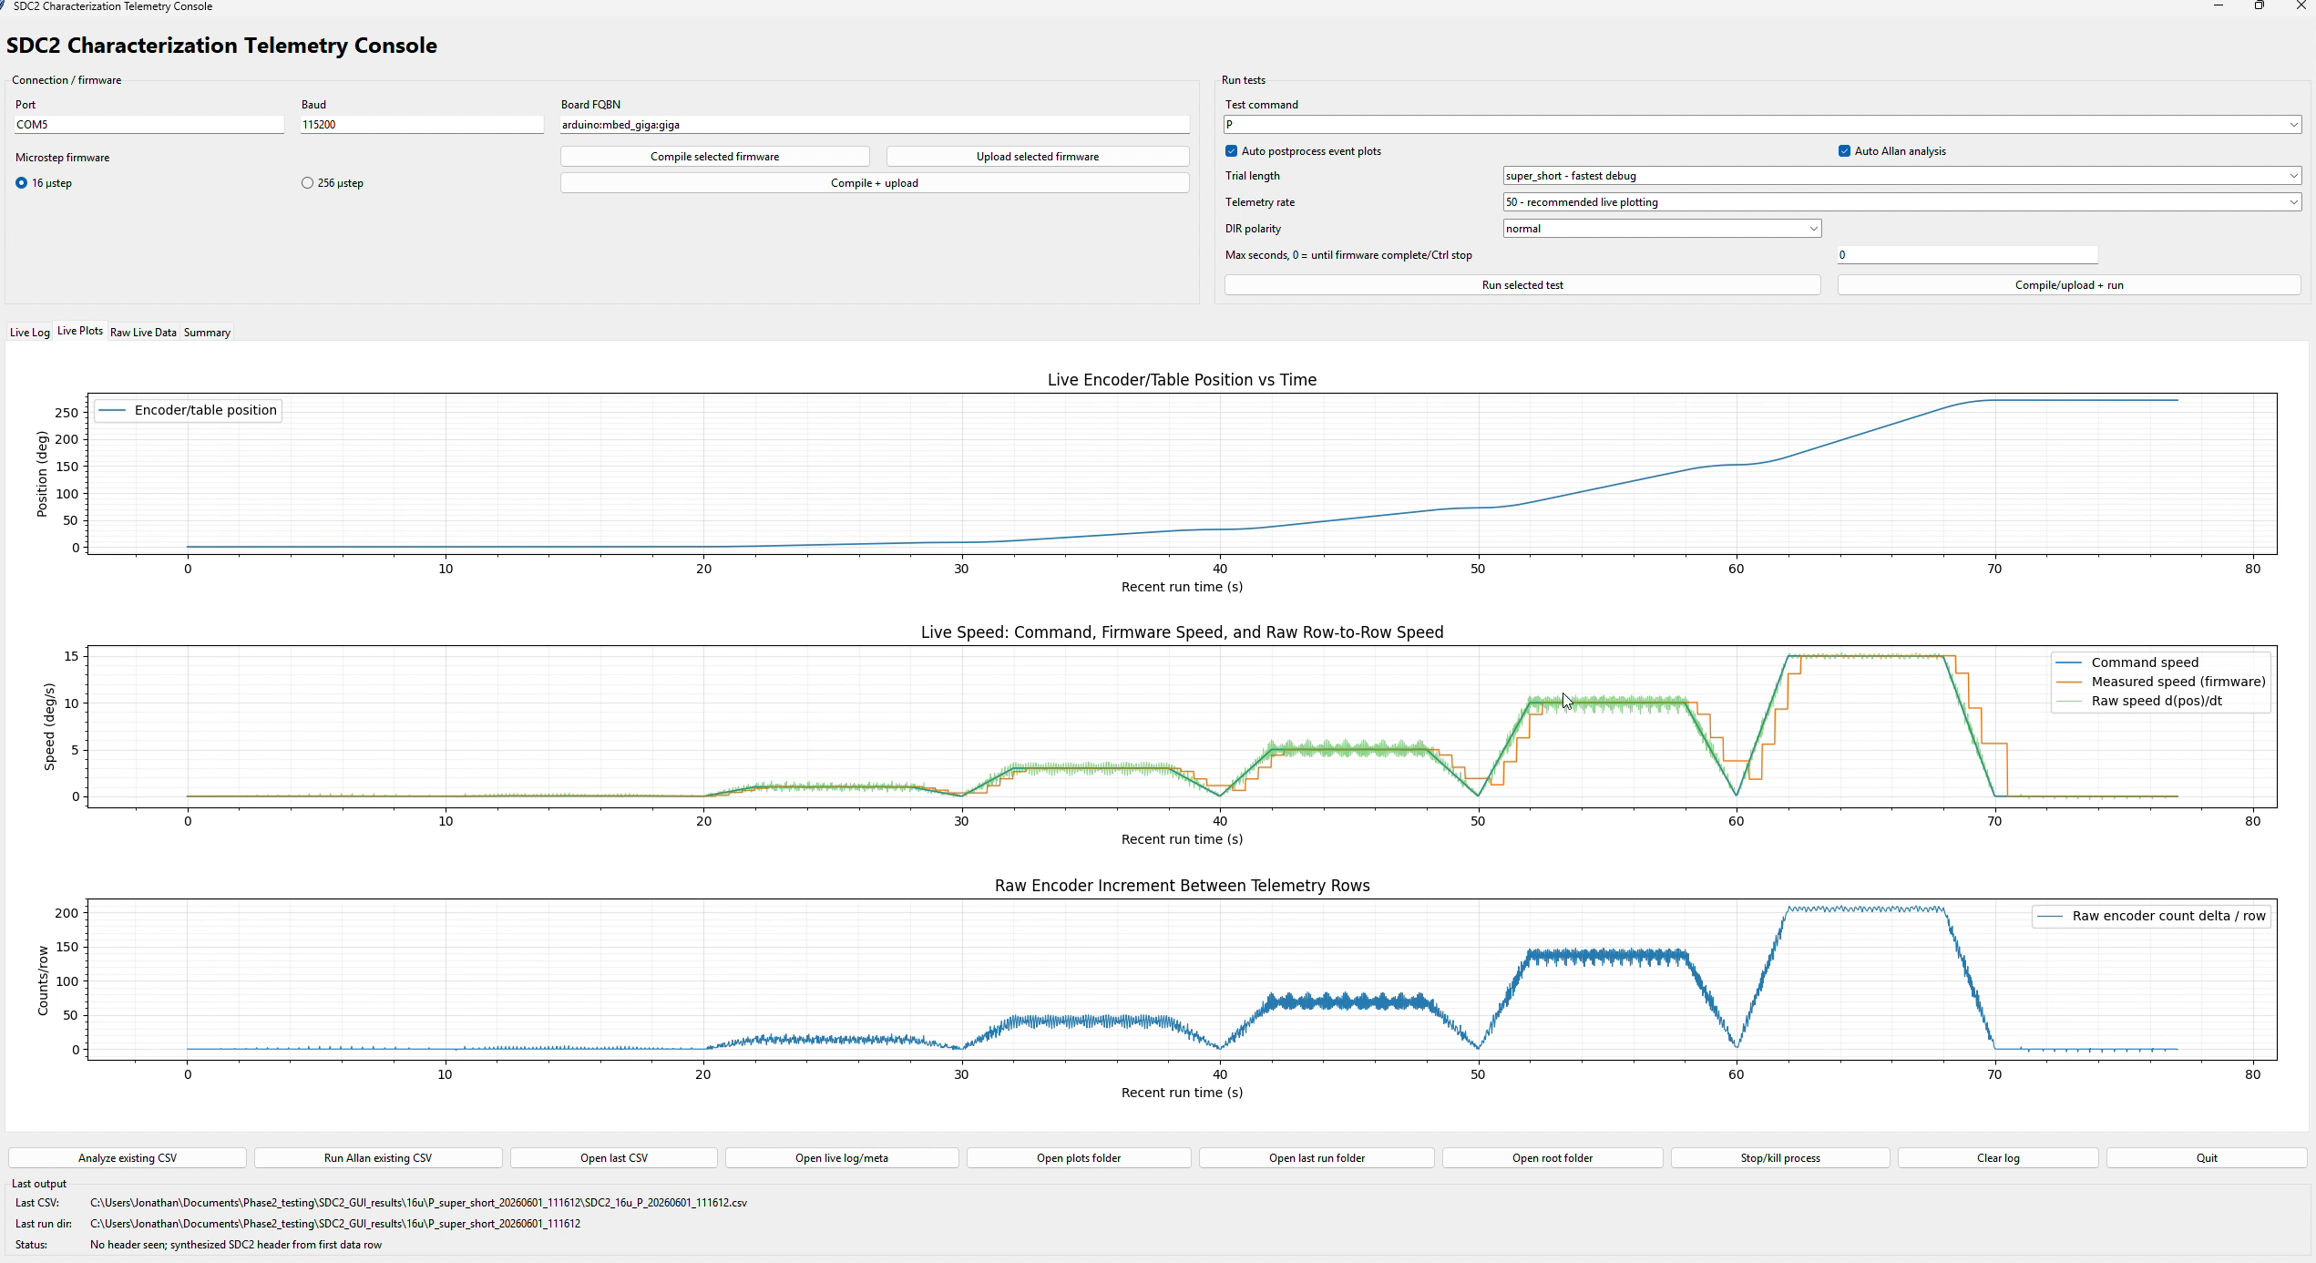
Figure 4. Host interface overview with connection, test, and live-telemetry controls.
- 115,200-baud serial host interface with selectable 10, 20, 50, or 100 Hz telemetry requests.
- 24-field timestamped CSV records with separate metadata and controller-comment retention.
- Header and row-width validation, malformed-row detection, completion-marker handling, and partial-run recovery.
- Live command-versus-measured speed, encoder position, raw encoder rate, status, and logging state.
- Automated execution and postprocessing for tracking, static hold, step response, Allan deviation, and closed-loop sine response.

7.1 External serial bandwidth review
A 115,200-baud 8-N-1 link provides an idealized 11,520 payload bytes/s. Full 24-field ASCII records can approach roughly 189 bytes each, so a requested 100 Hz stream would require about 18.9 kB/s. The interface therefore supports a 100 Hz selection, but sustainable full-record transmission is closer to approximately 50–60 Hz unless the row is shortened, the link rate is increased, or binary framing is used.
ENGINEERING OUTCOME
The dual-core shared-memory path removes high-rate inter-core data movement from the external serial bottleneck. The serial link remains an operator and logging interface rather than the internal real-time transport.

8. Characterization Evidence
Characterization results are retained as evidence that the firmware and host workflow operated against a physical motion platform. They are supporting evidence—not the primary contribution of this report.
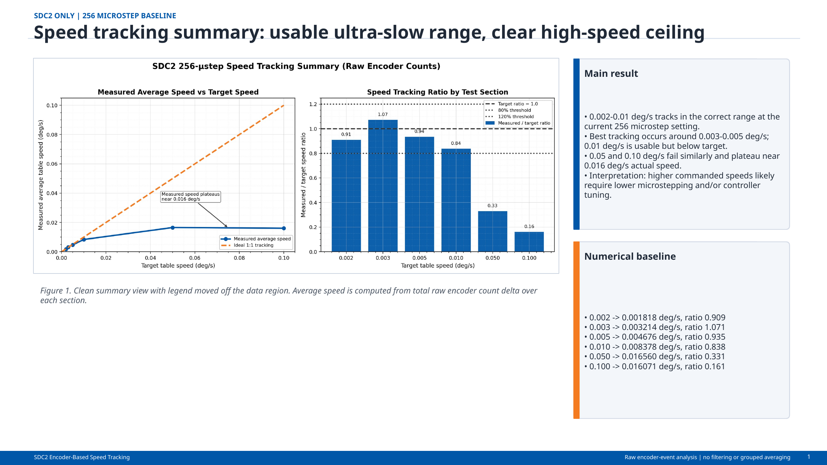
Figure 5. Configuration-specific low-speed tracking summary for the 256-microstep mode.
Command (deg/s) | Measured (deg/s) | Tracking ratio / note
0.002 | 0.001818 | 0.909
0.003 | 0.003214 | 1.071
0.005 | 0.004676 | 0.935
0.010 | 0.008378 | 0.838
0.050 | ~0.016 | Throughput ceiling
0.100 | ~0.016 | Throughput ceiling

8.1 Test and acquisition capabilities
Capability | Configured scope
Static acquisition | 50 Hz × 180 s or 100 Hz × 90 s; 9,000 records
Dynamic segment | 100 Hz requested; 6,000 records per 60 s segment
Closed-loop sine tests | Approximately 0.33–2 Hz
Safety supervision | 500 ms host heartbeat; 2 s target-side deadman

9. Public Deliverables and Source Boundary
- This firmware/software FRD in PDF and DOCX formats.
- Dual-core architecture, memory-map, and verified-specification graphics.
- Selected owned source excerpts defining protocol, memory map, and shared-ring records.
- Host-target demonstration video and representative GUI captures.
- Sanitized characterization plots and configuration-specific low-speed data.
- Complete private development archives, credentials, local paths, and duplicate historical packages excluded.

10. Limitations and Open Validation
Item | Controlled statement
Integrated release binary | Architecture and application modules are source-verified; a single final merged binary is not included in the reviewed evidence package.
Ring allocation | Configured 4,096-entry ring requires a capacity or memory-reservation correction.
IPC latency/jitter | No instrumented end-to-end latency or worst-case jitter result is present.
Serial throughput | 100 Hz is selectable, but full ASCII rows exceed 115,200-baud sustainable throughput.
Power | Total electrical power and peak-current measurements are not present.
Reliability percentage | Mechanisms are implemented, but no MTBF or percentage improvement is claimed.

11. Attribution and Revision Control
Herder Elektronische Systemen developed the public architecture, firmware, host software, analysis workflow, interface electronics, technical documentation, and curated case-study package represented here. No third-party affiliation or endorsement is claimed.
Rev | Date | Description
2.0 | 2026-08-03 | Firmware-first rewrite adding verified STM32H747/OpenAMP architecture, memory map, IPC rates, timing constants, coherency controls, and public source excerpts.
RELEASE GATE
Before a production release, correct the ring allocation, integrate and tag the final build, instrument IPC latency and jitter, and validate sustained host throughput.

