PLATFORM & ELECTRICAL INTEGRATION
Dual-Core Optical Motion Testbed Hardware Supporting the STM32H747 Architecture
Customer-facing technical report
Revision 2.0 • 3 August 2026
Prepared by | Herder Elektronische Systemen
Primary subject | Mechanical platform, encoder/motor interfaces, and electrical support for dual-core embedded control
Architecture context | STM32H747 Cortex-M7/M4 target with OpenAMP and shared-memory IPC
Distribution | Customer-facing; editable fabrication and complete firmware archives excluded
DOCUMENT EMPHASIS
The physical platform is presented as the plant and interface layer for a deep dual-core firmware system. The STM32H747 architecture governs signal flow, data acquisition, and operator interaction throughout the report.

1. Executive Summary
The testbed combines a load-bearing rotary and translational optical platform with differential encoder feedback, STEP/DIR motion control, custom interface electronics, emergency-stop behavior, and an STM32H747 dual-core embedded controller. The electrical design exists to preserve signal integrity and deterministic target-side operation while the Cortex-M7 and Cortex-M4 divide motion data and coordination workloads.
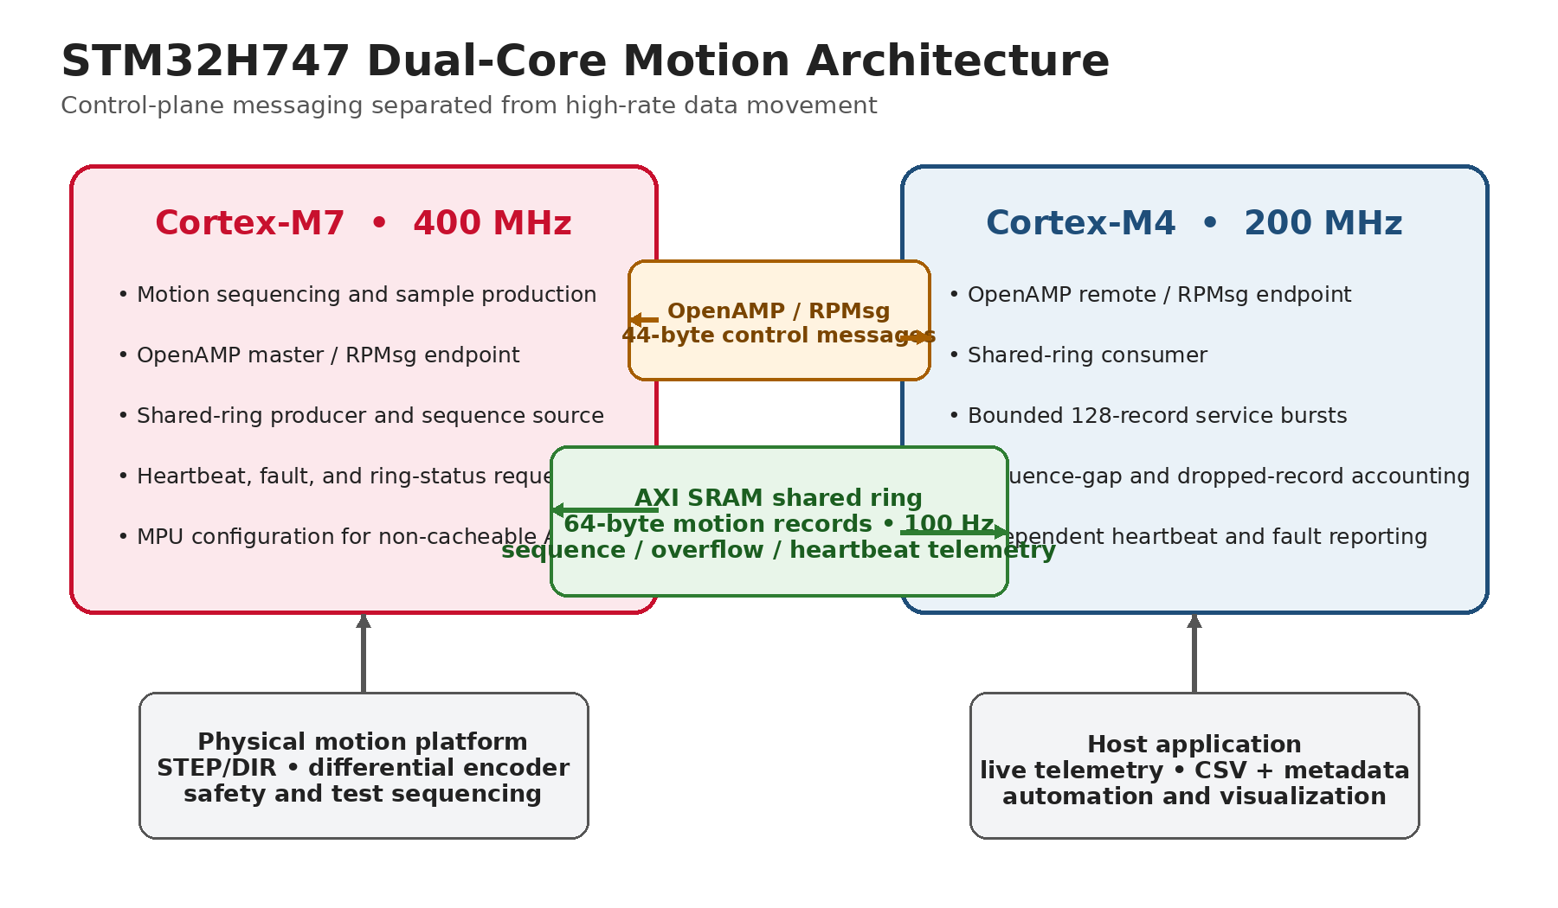
Figure 1. Governing dual-core system architecture and its connection to the physical platform and host software.

2. System-Level Requirements
ID | Requirement
SYS-01 | Support independent rotation and lateral alignment of optical hardware.
SYS-02 | Provide differential encoder feedback to the embedded target.
SYS-03 | Provide STEP/DIR motor-drive control with a shared logic reference.
SYS-04 | Keep motion timing and safety behavior on the embedded target.
SYS-05 | Support dual-core data transfer without forcing high-rate records through the host link.
SYS-06 | Provide emergency power removal independent of the GUI.
SYS-07 | Support configuration-dependent ultra-slow and faster-scan operation.

3. Embedded Controller and Signal Architecture
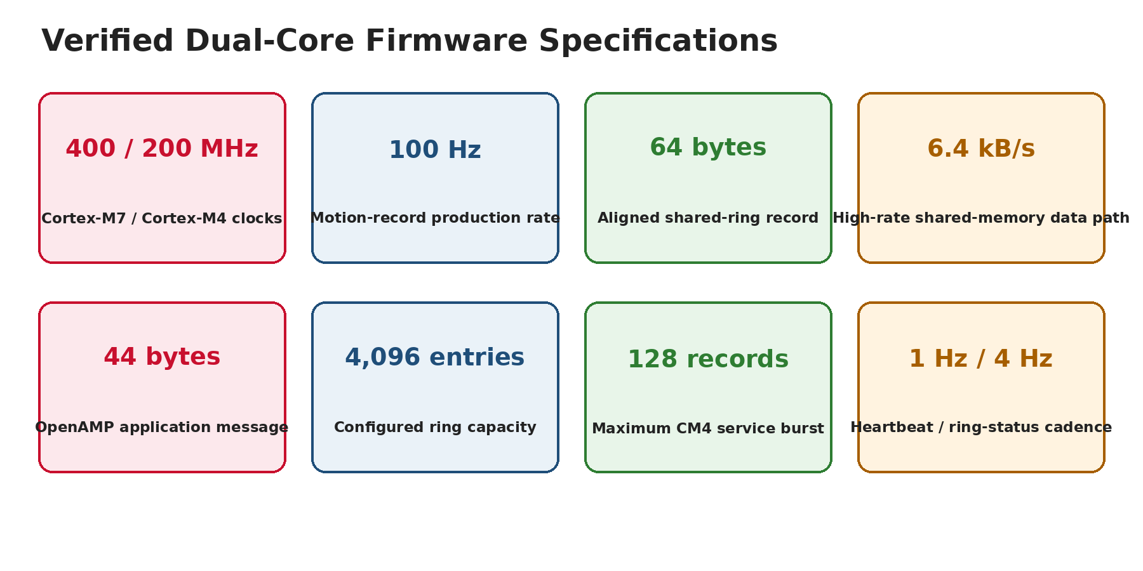
Figure 2. Verified controller and inter-core communications specifications that drive the hardware interface.
The physical interfaces feed a 400 MHz Cortex-M7 / 200 MHz Cortex-M4 system. OpenAMP/RPMsg handles command and status messages, while a 256 KiB AXI-SRAM ring transfers 64-byte motion records at 100 Hz. The controller therefore requires stable encoder logic, deterministic STEP/DIR signaling, and a common reference between the interface PCB and motor driver.

3.1 Hardware-facing firmware quantities
Parameter | Verified value
STEP pulse high time | 4 µs
Step-rate safety cap | 25,000 pulses/s
Encoder interface | 5,000 CPR differential quadrature encoder
Effective table resolution | ~0.001460°/count after gearing
256-microstep command increment | ~0.000285°/pulse
Host safety | 500 ms heartbeat and 2 s target deadman

4. Mechanical Platform
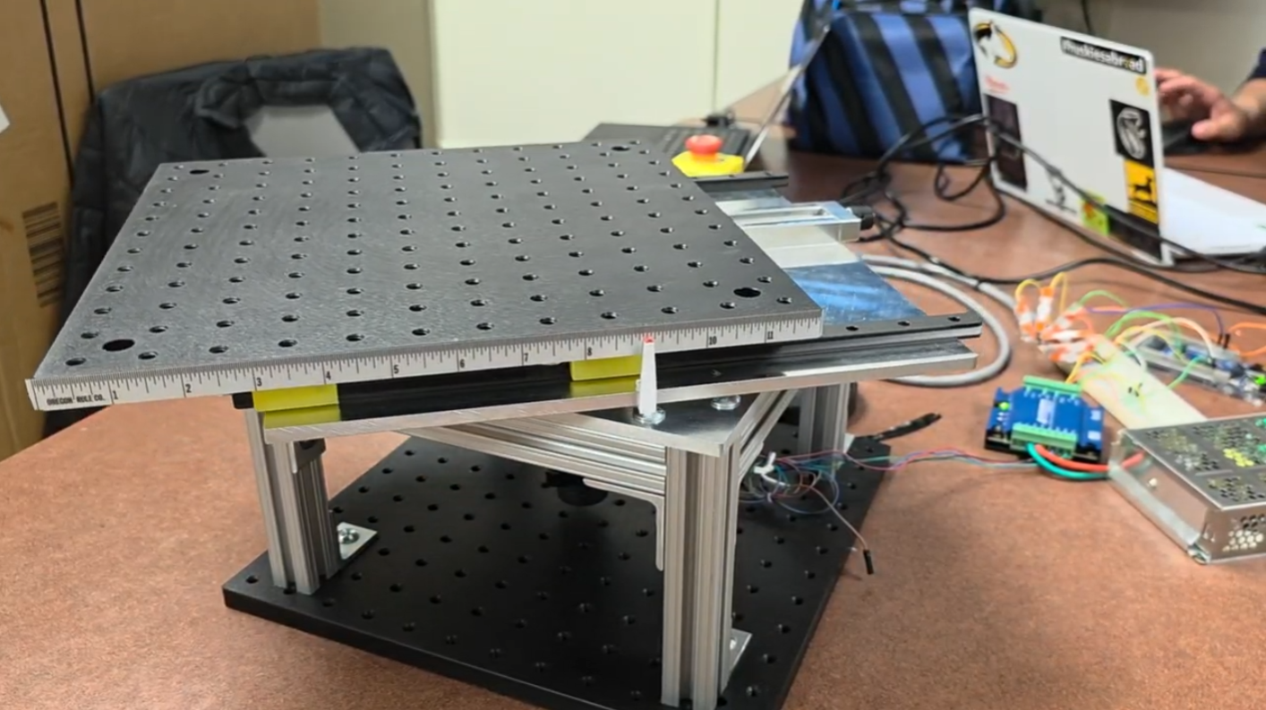
Figure 3. Assembled dual-axis optical motion testbed.
The mechanical platform combines continuous rotational motion with manual lateral offset. The structure carries the optical assembly, preserves access to the embedded controller and motor interface, and supports repeatable alignment and crosstalk studies.
Feature | Demonstrated or designed value
Static load demonstration | 40 lb
Lateral travel | More than ±3 in
Rotating-platform footprint | Approximately 12 × 12 in
Readable translation scale | Approximately 1/32 in
Rotational actuation | Stepper drive through 24.65:1 gearing
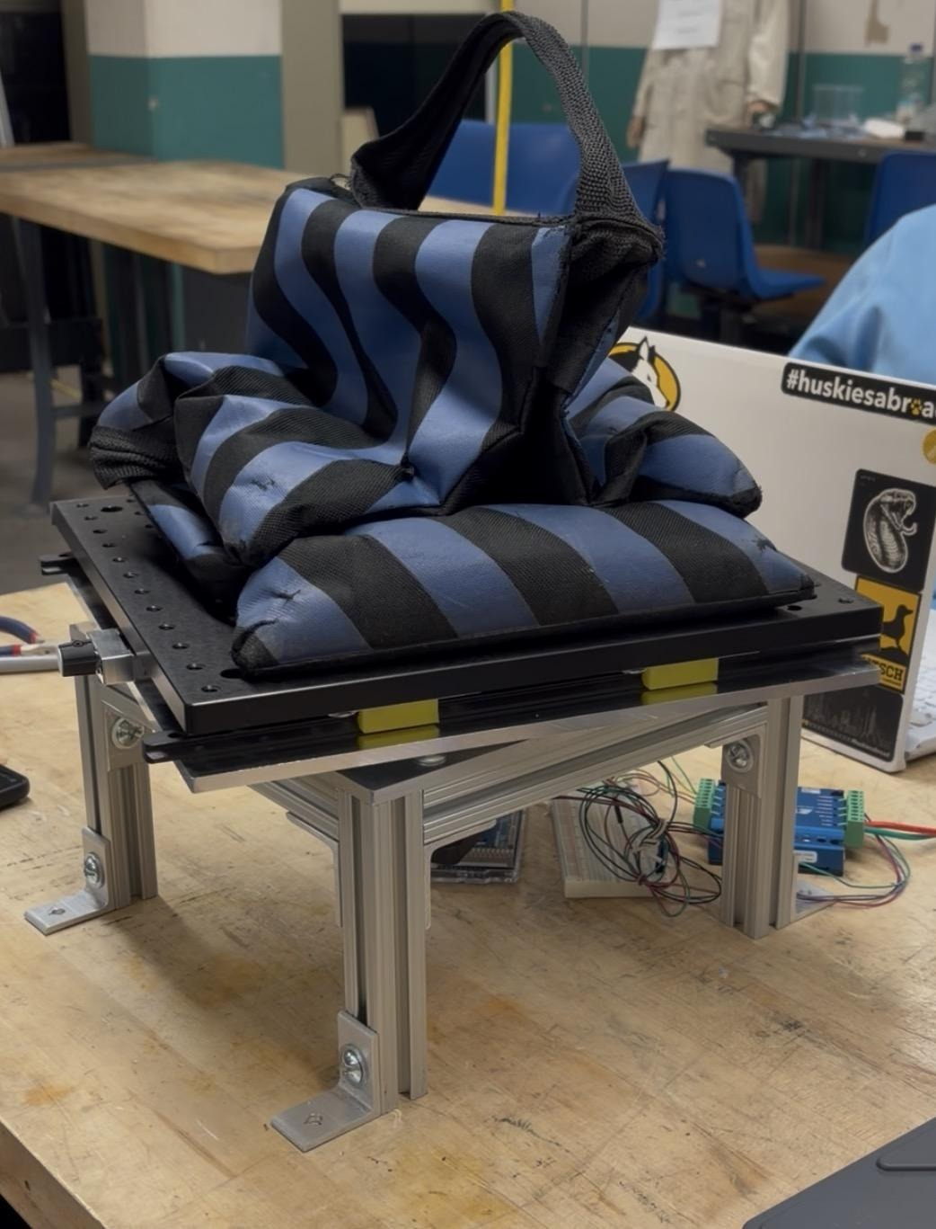
Figure 4. Static-load demonstration on the assembled structure.

5. Encoder and STEP/DIR Interface PCB
The firm-designed interface PCB receives differential A/B encoder signals, converts them through an AM26LS32 line receiver, routes encoder feedback to the controller, and provides STEP/DIR connections to the R725 motor driver. The revised board includes a dedicated solid-copper ground plane and explicit connector labeling.
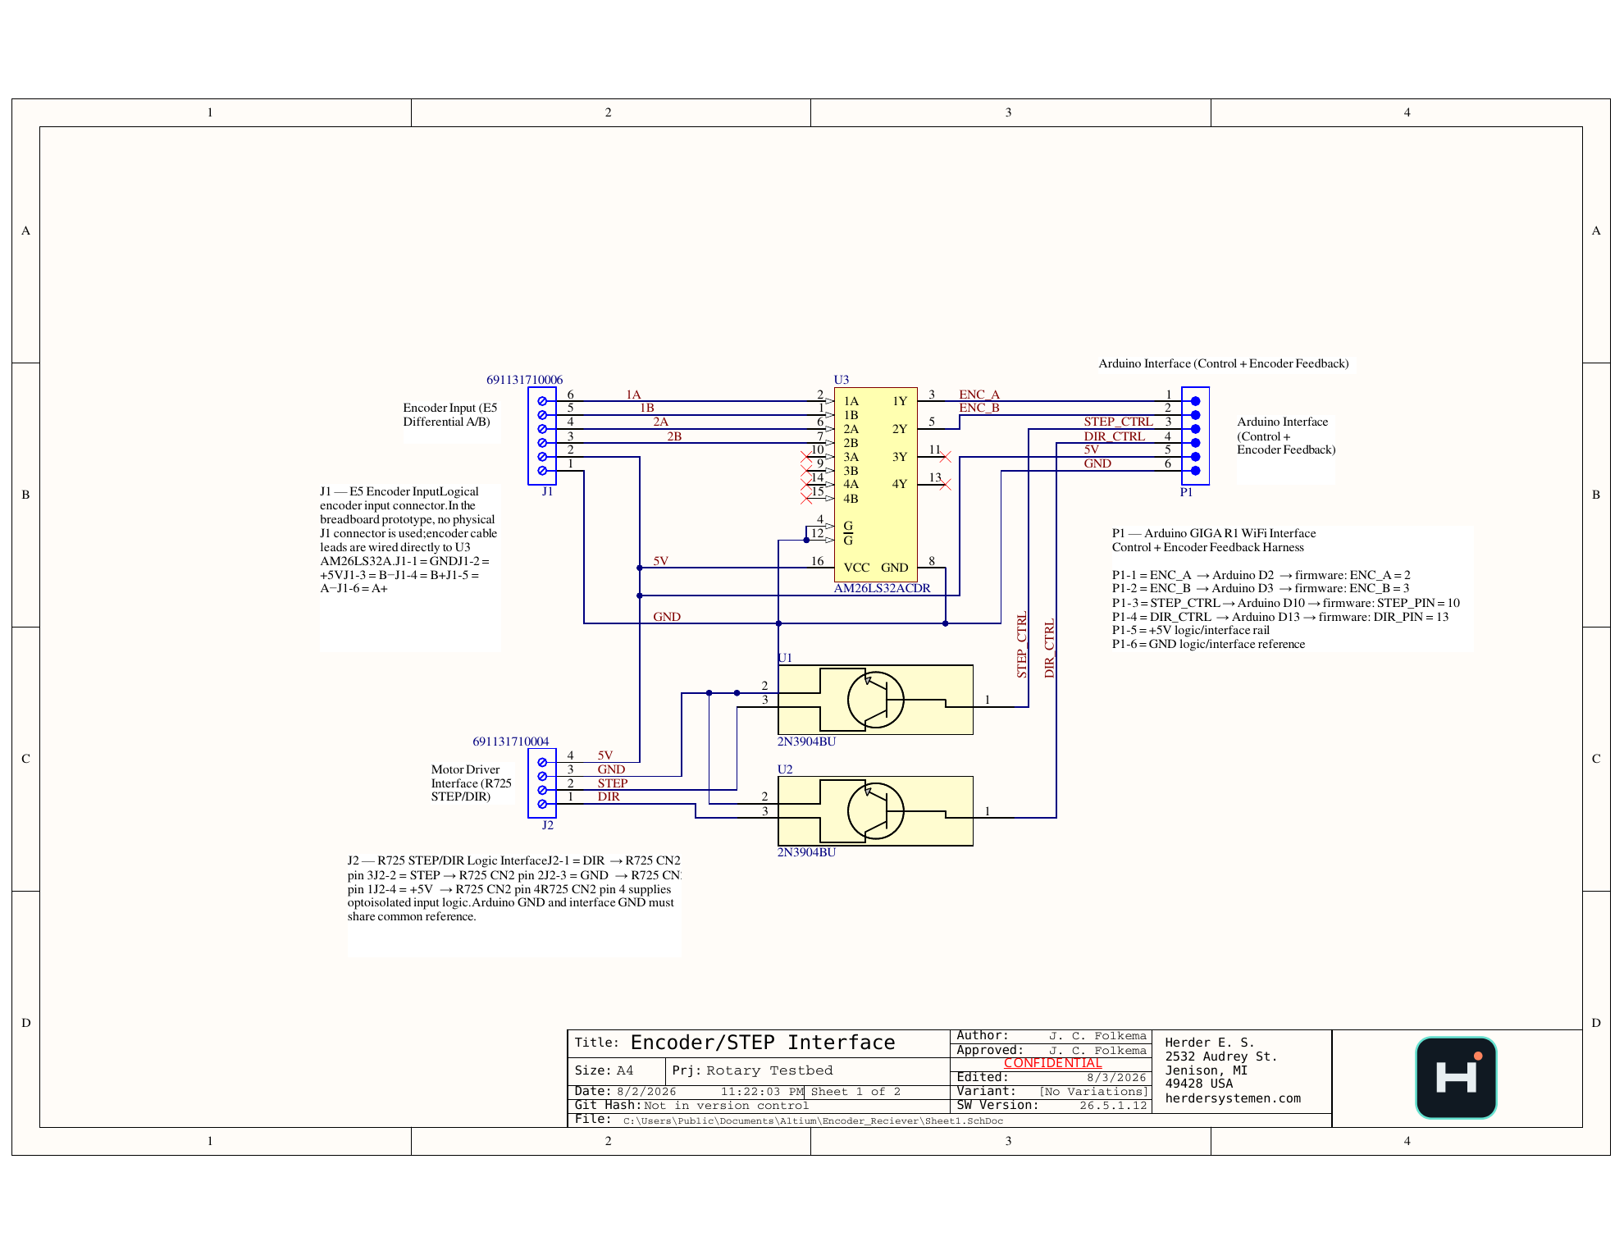
Figure 5. Featured encoder and STEP/DIR interface schematic.
Designator | Function
J1 | E5 differential encoder input: A±, B±, +5 V, GND
P1 | Controller harness: ENC_A, ENC_B, STEP_CTRL, DIR_CTRL, +5 V, GND
J2 | R725 logic interface: DIR, STEP, GND, +5 V
U3 | AM26LS32 differential line receiver
U1/U2 | NPN interface stages for STEP/DIR control

6. PCB Layout and Return-Path Design
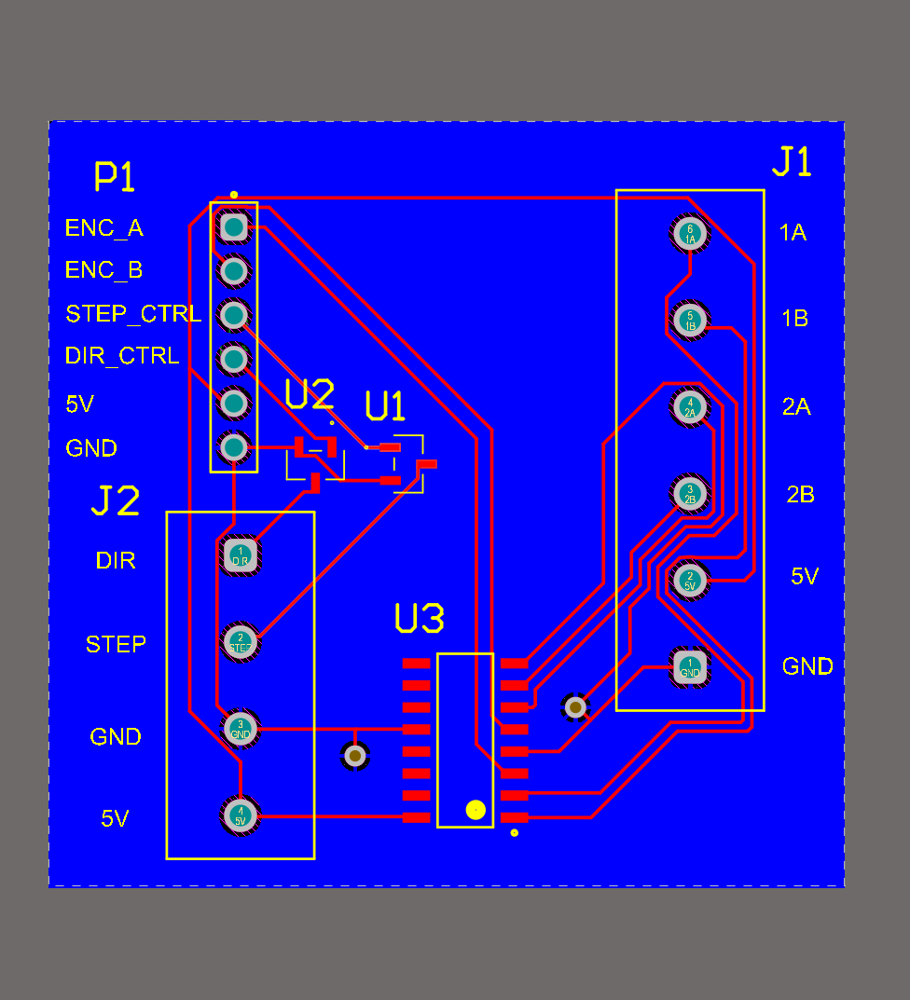
Figure 6. Routed signal and power layer.
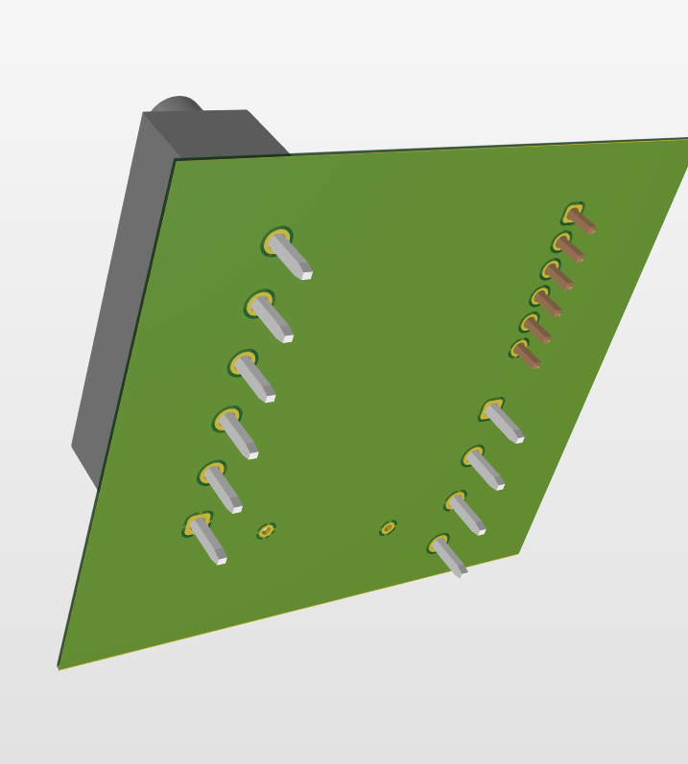
Figure 7. Dedicated solid-copper ground-reference layer.
The ground plane provides a continuous logic reference for the differential receiver, controller harness, and motor-driver interface. This replaces the earlier prototype routing approach and better supports the dual-core target’s encoder acquisition and deterministic pulse-generation requirements.

6.1 Public release checks
- Connector polarity and pin-1 indicators verified.
- Power and ground nets labeled across external interfaces.
- Trace widths and clearances reviewed for logic-level operation.
- 3D access and mechanical clearance reviewed.
- Editable manufacturing source and complete fabrication package retained as controlled assets.

7. Electrical/Embedded Integration
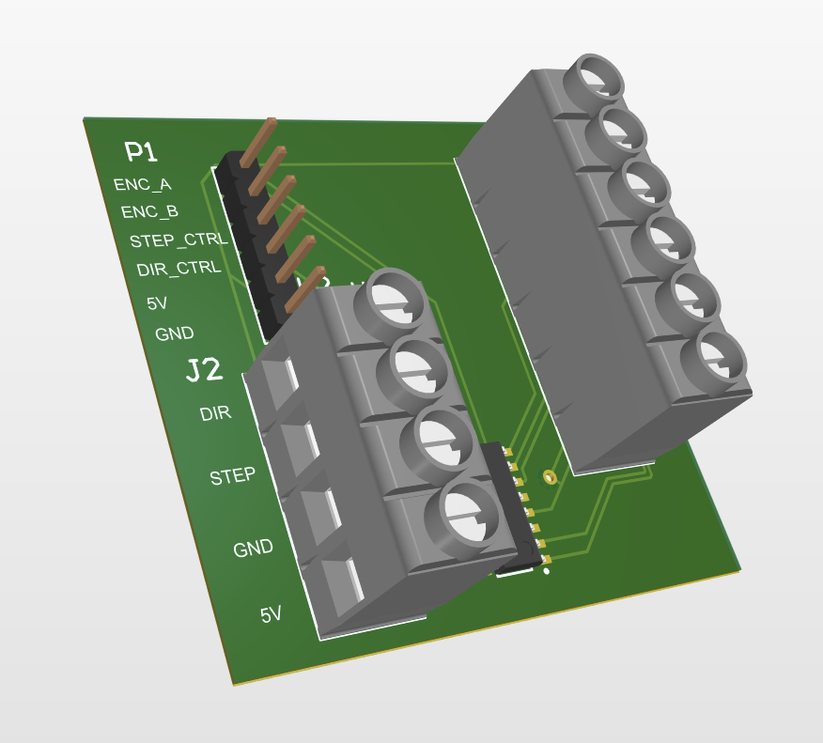
Figure 8. Populated 3D view of the interface board.
The board closes the physical path between the encoder, controller, and motor driver. The controller converts encoder events into timestamped motion records, places those records into the AXI shared-memory ring, and uses target-side pulse timing to command motion independently of the host GUI.
Path | Implementation
Encoder path | Differential A/B → AM26LS32 → controller interrupt inputs
Motion command path | Cortex-M7 target logic → STEP/DIR interface → R725 driver
Inter-core data path | M7 producer → AXI SRAM ring → M4 consumer
Control/status path | OpenAMP/RPMsg + HSEM mailbox
Host path | 115,200-baud serial for commands, telemetry, and logging

8. Configuration-Specific Motion Capability
The hardware can support multiple speed configurations. The 256-microstep configuration prioritizes ultra-low command increments and should not be represented as the universal high-speed mode. Higher-speed operation requires a lower microstep setting, a different pulse-rate limit, or revised drivetrain scaling.
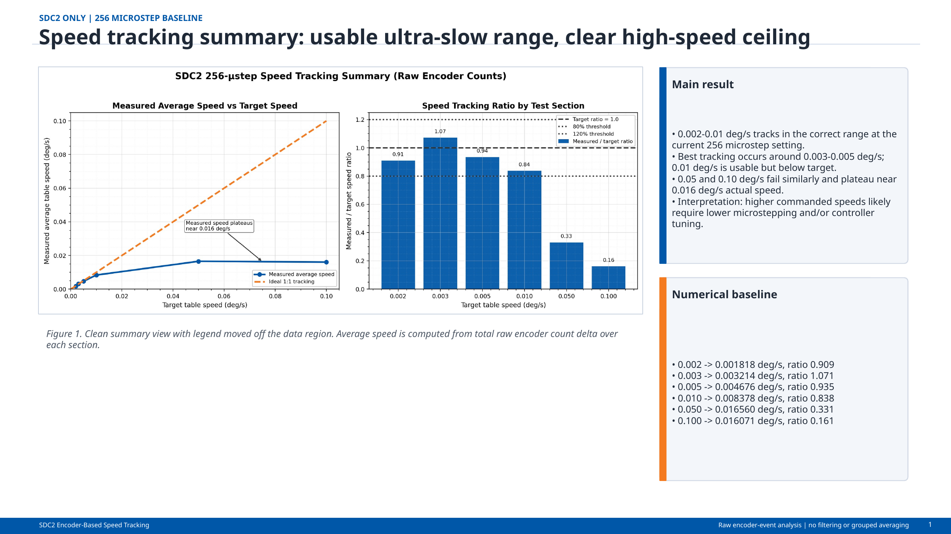
Figure 9. Low-speed results for the 256-microstep configuration.
Quantity | Value / interpretation
Pulses/table revolution | 1,262,080
Pulses/table degree | 3,505.78
Command increment | ~0.000285°/pulse
25 kHz firmware cap | ~7.13°/s theoretical pulse-rate limit
Demonstrated useful low-speed range | ~0.002–0.010°/s
Observed 256-microstep plateau | ~0.016°/s in reviewed tests

9. Verification Evidence
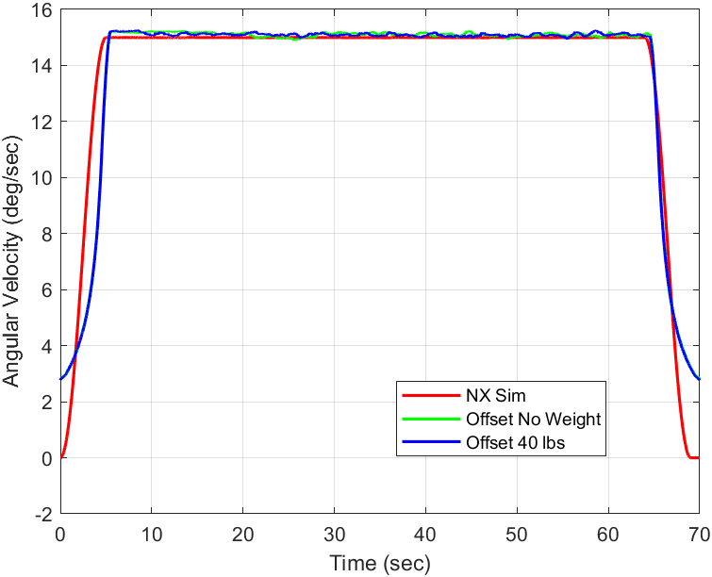
Figure 10. Historical faster-speed rotation-rate demonstration from a separate operating configuration.
The physical system demonstrates load support, translation, rotation, differential feedback, and operator-visible motion. Firmware-side evidence adds timestamped records, dual-core health/status, target-side deadman behavior, and host visualization. These elements collectively show a complete instrument platform rather than an isolated PCB or mechanical assembly.

10. Public Deliverables
- Platform and Electrical Integration FRD.
- Dual-Core Firmware and Host Software FRD.
- Featured interface schematic and PCB renders.
- System, load, and motion demonstration media.
- Dual-core architecture and memory-map graphics.
- Selected firmware source excerpts and sanitized results.

11. Limitations and Open Validation
Item | Controlled statement
Production qualification | Prototype platform; no formal shock, vibration, thermal, EMC, or long-duration reliability certification.
Power measurements | System-level idle, steady-state, and peak electrical power are not present.
Integrated build | Reviewed evidence does not include one tagged release binary combining every firmware module.
Ring allocation | 4,096-entry shared ring requires correction or a larger reserved region.
Speed envelope | Operating range is configuration dependent; ultra-slow and faster-speed modes must remain separately identified.
Metrology | Motion-platform characterization does not certify downstream optical-system performance.

12. Attribution and Revision Control
Herder Elektronische Systemen developed the public system architecture, interface PCB, embedded firmware, host software, test workflows, documentation, and curated case-study package represented here. No third-party affiliation or endorsement is claimed.
Rev | Date | Description
2.0 | 2026-08-03 | Dual-core-led rewrite connecting the mechanical and electrical platform directly to the STM32H747/OpenAMP architecture and verified timing quantities.
RELEASE GATE
Before manufacturing or production deployment, complete electrical power measurements, correct the ring reservation, tag the integrated firmware release, and perform environmental and EMC validation.

