DUAL-CORE OPTICAL MOTION TESTBED
FIRMWARE, HOST SOFTWARE & RESULTS
STM32H747 dual-core control, 1 kHz encoder loop, telemetry, verification, and measured characterization
Customer-facing technical report
Revision 7.3.2 - 13 August 2026
FIRMWARE, HOST SOFTWARE & RESULTS
STM32H747 dual-core control architecture, 1 kHz encoder loop, telemetry integrity, automated characterization, and measured results
ENGINEERING REQUIREMENTS DOCUMENT | REVISION 7.3.2 | 13 AUGUST 2026
Prepared by | Herder Elektronische Systemen
Document scope | Dual-core firmware architecture, host telemetry, safety behavior, verification, and measured motion performance
Evidence basis | Private firmware review, GUI recordings, measured plots, test evidence, and controlled engineering analysis
Distribution | Public portfolio release; implementation-level IP and reproduction instructions withheld
DOCUMENT PURPOSE
Defines public functional, performance, interface, safety, verification, and acceptance requirements for the dual-core firmware and host test system while preserving implementation-level intellectual property.

Functional Requirements and Engineering Context
Public release intent
This document is deliberately detailed about requirements, architectural decisions, operating behavior, verification, failure modes, and measured performance. It does not publish source code, memory addresses, linker placement, MPU/cache settings, synchronization primitives, board-specific mappings, build instructions, or any information intended to enable reproduction of the implementation.

Purpose, Scope, and System Boundary
This FRD governs the public-facing behavior of the STM32H747 dual-core motion-control subsystem and its host-side telemetry/test environment. The controlled scope includes workload separation, closed-loop encoder control, operator command/state behavior, telemetry integrity, fault handling, automated characterization, and measured performance evidence. Mechanical construction and manufacturing details remain in the companion platform FRD.
The reviewed reviewed v0.3 firmware implementation evidence is used only as an evidence basis for public claims. Implementation-level details remain private. The current archive supports an encoder-based closed position/speed path and a separate current-sensed FOC integration path; only the behavior actually supported by the reviewed implementation is claimed here.
Boundary element | Included publicly | Withheld
Target control | Core roles, control cadence, state behavior, fault classes, command/telemetry behavior | Source, ISR/timer implementation, peripheral mappings, tuning constants, board hooks
Inter-core communication | Logical separation of command/status and continuous telemetry; integrity observability | Memory map, cache/MPU policy, barriers, synchronization code, exact buffer layout
Host/test | Live telemetry, logging purpose, automated characterization, retained evidence | Source code, deployment/configuration procedures, internal file formats
Verification | Measured plots, requirements traceability, known limitations, failure-mode coverage | Private benches, reproduction procedures, internal debugging infrastructure

1. System Role and Architectural Decision
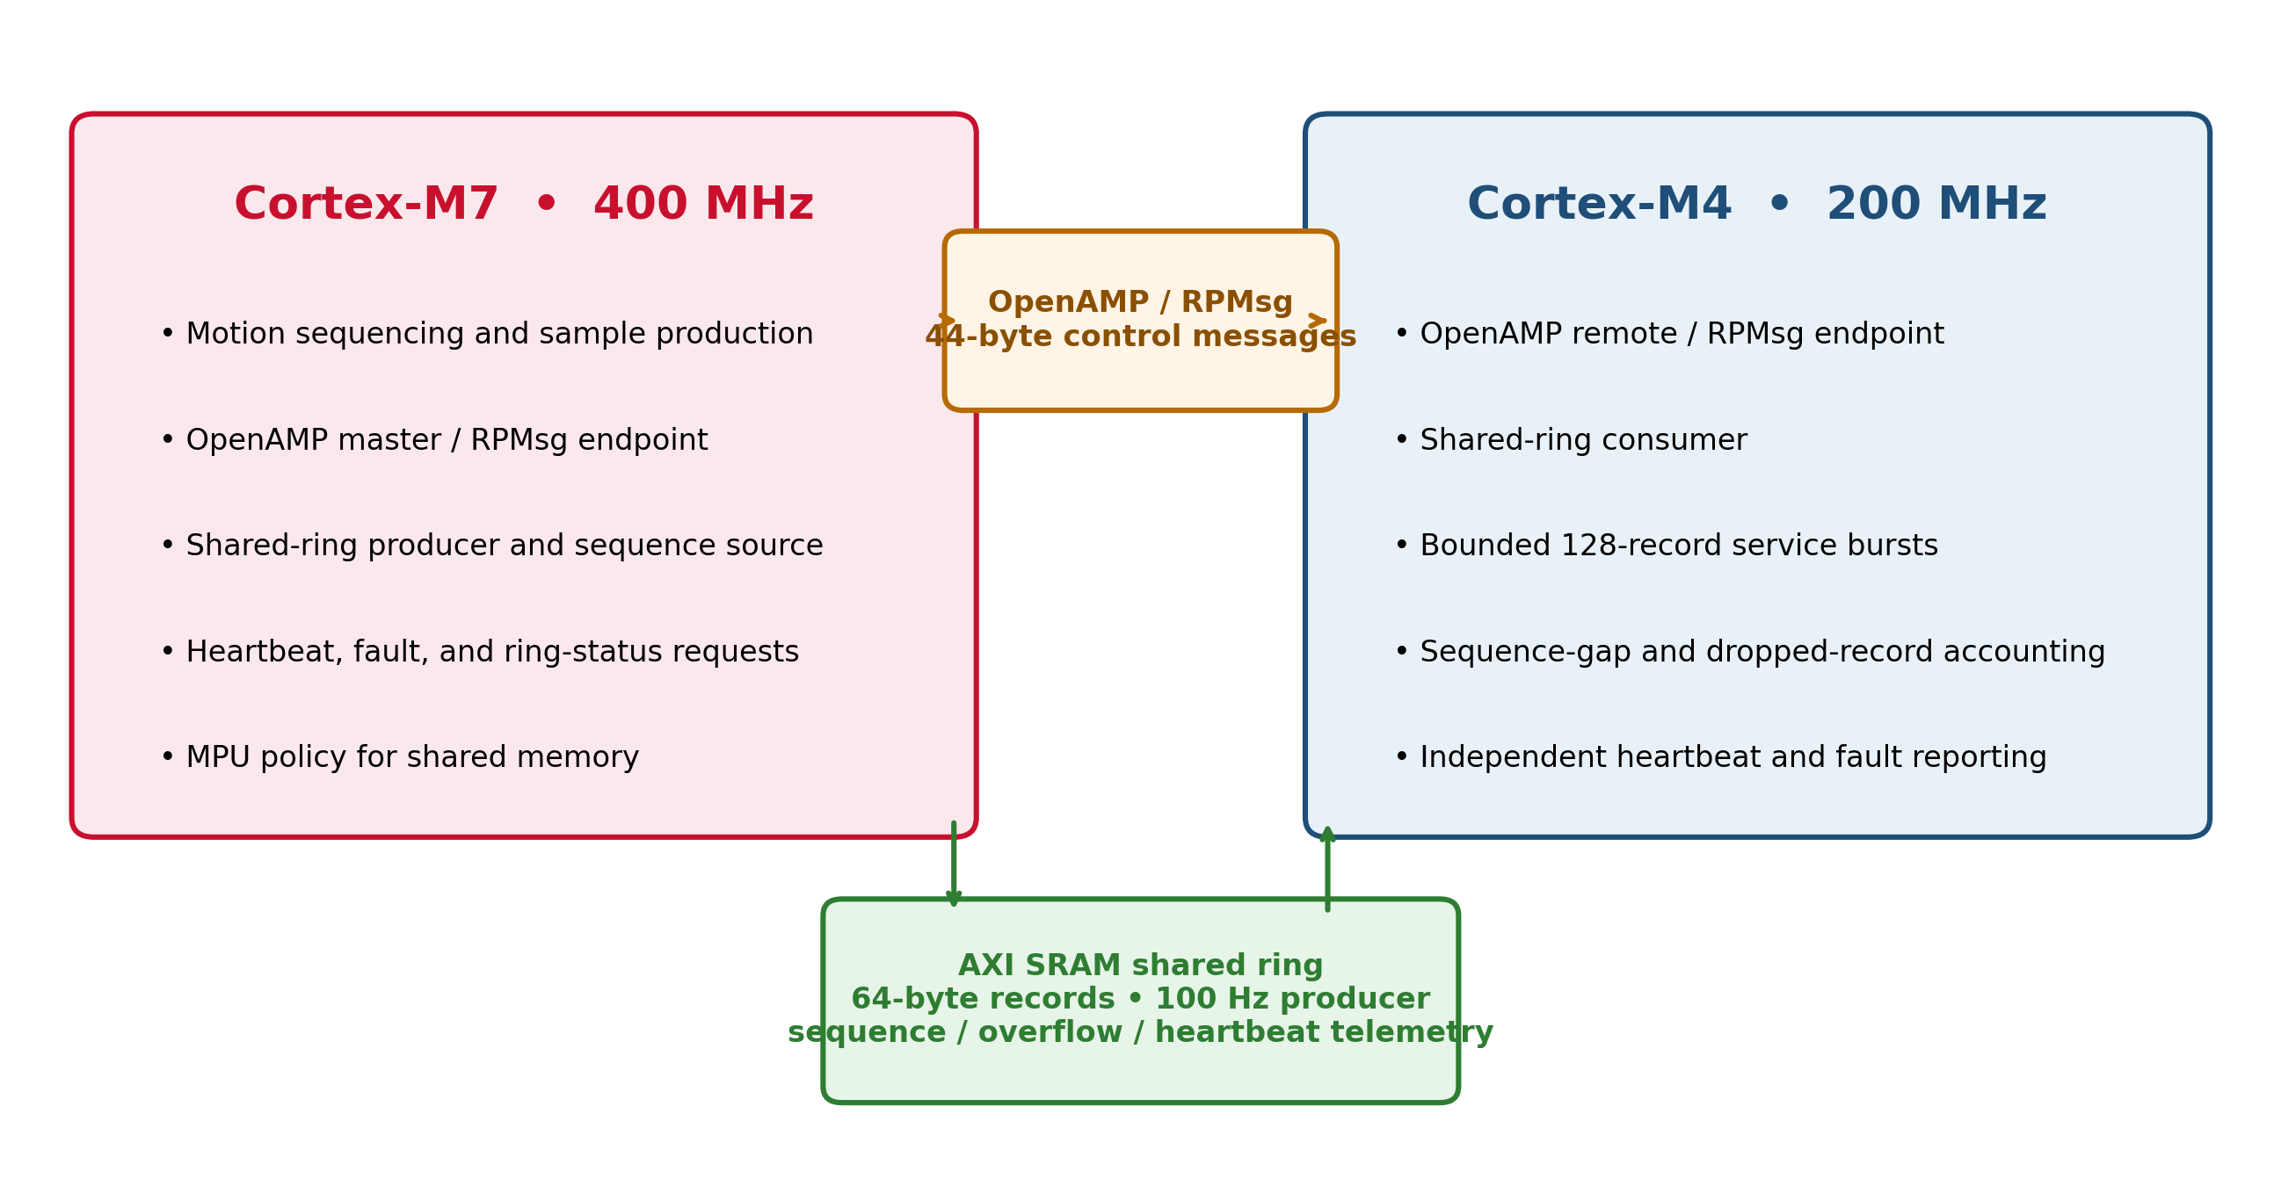
Figure 1. Dual-core STM32H747 architecture separating motion-control responsibilities from inter-core service and telemetry work.
The architecture figure is intentionally functional rather than reproduction-level: it shows the workload boundary and communication roles without exposing private memory placement, MPU settings, cache policy, or synchronization implementation.
The project uses the STM32H747 as a heterogeneous dual-core controller, with a 400 MHz Cortex-M7 and a 200 MHz Cortex-M4. The architectural decision was not driven by the modest public telemetry rate. It was driven by the need to preserve deterministic motion-generation headroom while communication, telemetry, diagnostics, and test orchestration continue concurrently.
The dual-core split originated from the need to protect timing-critical motion work while command, telemetry, diagnostics, and test activity continued concurrently. Earlier step-driven operation placed increasing pressure on event timing as fine microstepping and higher mechanical speed were combined. The reviewed v0.3 branch retains the same workload-isolation principle but applies it to encoder-supervised three-phase actuation: the CM7 control task updates motion state and actuation demand at 1 kHz while high-rate carrier/event generation remains a separate hardware-timed responsibility.
Architecture trade-off
A single 400 MHz M7 can easily process 100 Hz telemetry. Dual-core operation is justified here by workload isolation and timing margin, not by the telemetry bandwidth itself. This distinction is retained explicitly so the portfolio does not overstate the need for multicore processing.

Decision factor | Single-core consequence | Dual-core benefit
Timing-critical motion work | Shares scheduling and interrupt budget with communications and diagnostics | Control workload can be isolated from variable-latency service work
Higher motion-event rates | More sensitivity to blocking host/telemetry activity | Additional execution margin and clearer ownership boundaries
Telemetry/test expansion | Feature growth increases coupling to control timing | Growth can be absorbed on the service side without redesigning the control path
Complexity | Simpler implementation and debugging | Requires explicit IPC, state ownership, coherency, startup, and fault contracts

2. Functional Requirements
ID | Requirement | Engineering rationale | Verification
FW-FR-001 | The subsystem shall separate timing-critical control work from communication/telemetry service work. | Prevents nondeterministic host/service activity from consuming the control execution budget. | Architecture review and concurrent-load test.
FW-FR-002 | The reviewed encoder/supervisory control path shall execute at a nominal 1 kHz update cadence; high-rate PWM carrier or STEP-event timing shall remain independent of this supervisory rate. | Separates control-law update timing from the much faster hardware-timed actuation carrier/event rate and prevents the 1 kHz value from being misrepresented as a carrier frequency. | Target control-cadence observation plus independent carrier/event-rate validation.
FW-FR-003 | The subsystem shall expose commanded state, measured state, operating state, and fault state to the host. | Operators need direct observability of whether actual behavior follows requested behavior. | GUI/telemetry demonstration.
FW-FR-004 | Inter-core data transfer shall make loss, stalling, overflow, and sequence discontinuity observable. | Silent corruption or silent data loss is unacceptable in characterization data. | Counter/sequence fault-injection test.
FW-FR-005 | PWM/actuation outputs shall be inhibited outside the permitted running state or whenever a fault is active. | The software safe state must dominate commanded operation. | State-transition and fault-response test.
FW-FR-006 | Position commands shall be constrained by configured travel limits and invalid encoder/timing conditions shall prevent active output. | Motion control must remain bounded by validated operating conditions. | Boundary-command and invalid-feedback tests.
FW-FR-007 | The host shall support repeatable characterization with retained telemetry and analysis context. | Results must be traceable to the commanded test rather than exist only as screenshots. | Automated test run and retained-data review.
FW-FR-008 | Public claims shall distinguish the active encoder-only voltage-vector control path from the future current-sensed d/q FOC integration path. | Prevents the portfolio from presenting uncommissioned current-regulated FOC as demonstrated operation. | Document/source reconciliation.

3. Control, State, and Safety Behavior
The reviewed v0.3 control architecture is built around an encoder-only position/speed path. At each nominal 1 kHz supervisory update the control side derives position and speed from encoder feedback, applies bounded position/speed control, evaluates safety conditions, refreshes the actuation demand, and publishes telemetry. The 1 kHz update is explicitly not the PWM carrier or a STEP-pulse frequency; carrier/event generation belongs to dedicated board hardware and must be validated independently. The state model distinguishes disabled, homing, armed, running, and fault conditions, with energized output permitted only in RUNNING and only when no fault is active.
Behavior | Public requirement | Reason
Fixed-rate control | Nominal 1 kHz supervisory/control-law update; not the PWM carrier or a STEP-pulse frequency | Provides bounded estimation/control updates while leaving high-rate actuation timing to dedicated hardware.
Encoder validity | Fresh, plausible feedback is required for active closed-loop operation | Prevents stale or invalid position feedback from being treated as current state.
Timing supervision | Unexpected control timing is treated as a fault condition | Avoids applying control laws with invalid sample intervals.
Travel/speed supervision | Commanded and measured motion remain within configured operating limits | Constrains the controller to the verified mechanical envelope.
Output gating | Actuation is enabled only in a valid running state with no active fault | Ensures fault handling dominates normal command execution.
Watchdog/fault recovery | Faults require deliberate recovery before motion resumes | Avoids automatic re-energization after abnormal behavior.

4. Dual-Core IPC and Shared-Memory Correctness
The dual-core subsystem uses two logical communication classes: low-rate command/status exchange and a bounded shared-memory path for continuous motion records. That separation keeps command semantics independent of streaming telemetry and allows the service core to consume data without forcing every record through the command channel.
The important engineering risk is not bandwidth; it is correctness at the ownership boundary. The Cortex-M7 cache architecture means shared memory can become stale, partially published, or observed out of order unless the implementation defines a coherent memory policy and synchronization contract. Cache coherency is therefore treated as a system-level requirement, not an implementation footnote.
Integrity concern | Required property | Public verification statement
Cache coherency | A consumer shall not act on stale or partially published shared data. | Concurrent-core stress testing and consistency checks are required.
Publication ordering | Record contents shall become valid before ownership/index state advertises the record. | Sequence and consistency tests verify complete-record observation.
Buffer bounds | Metadata plus retained records shall remain within the reserved object boundary. | Compile-time size contracts guard against layout regression.
Sequence continuity | Loss or overwrite shall be observable rather than silent. | Sequence-gap and drop accounting are part of verification.
Timestamp rollover | Elapsed-time reconstruction shall remain valid across finite-width timestamp wrap. | Host/analysis rollover tests are part of the validation set.
Version compatibility | Protocol revisions shall remain representable and explicitly checked. | Interface-version validation is required before accepting messages.

Shared-buffer sizing contract
The retained record capacity is defined together with metadata so the complete shared object fits within its reserved memory boundary. Compile-time layout checks enforce record size, metadata offset, and total-object fit. Public documentation states the invariant without exposing addresses or linker placement.

5. Host Application, Telemetry, and Test Workflow
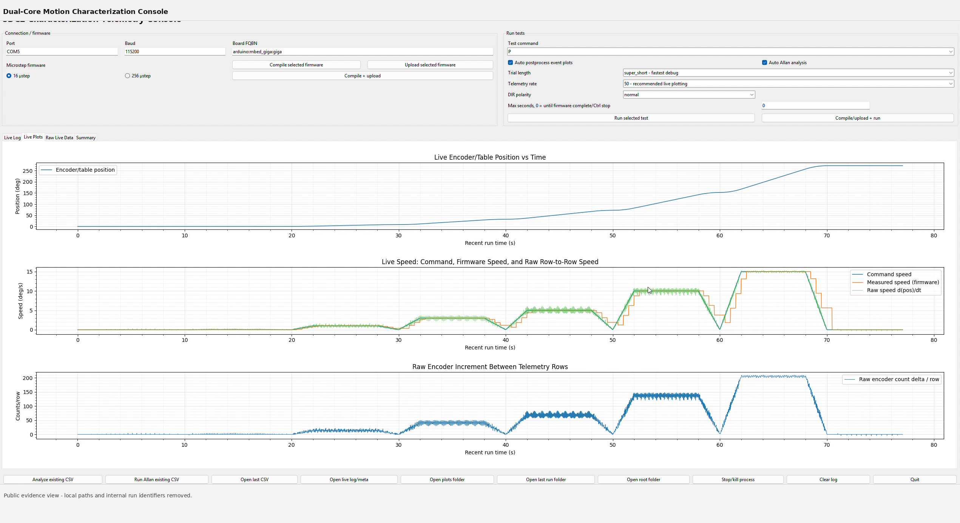
Figure 2. Host telemetry console during an automated characterization sequence.
The host view demonstrates live position and speed visualization, run selection, telemetry capture, and analysis workflow while leaving model files, source code, and setup instructions outside the public release.
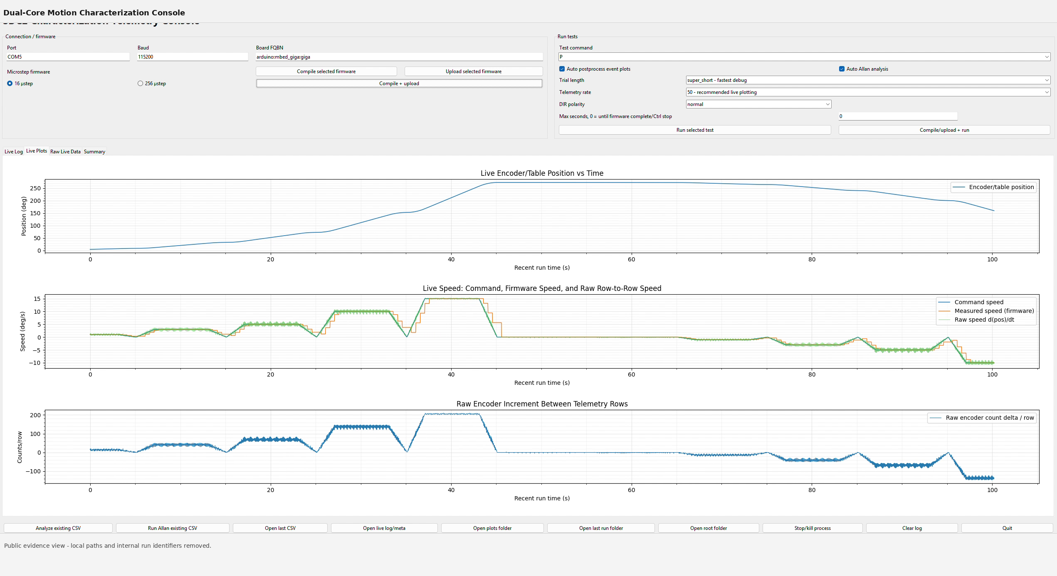
Figure 3. Host console view showing live encoder position, commanded and measured speed, and raw encoder increments.
The host application provides the operator-facing layer for connection state, command entry, live position and speed monitoring, scripted characterization, data retention, and analysis. The host is treated as a test/observability subsystem rather than a hard real-time controller; time-critical safety behavior remains on the target.

Figure 1. Host telemetry interface showing commanded/measured motion and live encoder-derived data.
Host function | Required behavior | Evidence retained
Connection/status | Make target availability and operating state visible | GUI state and run records
Live telemetry | Display commanded and measured motion without hiding fault/integrity state | Captured GUI plots
Automated tests | Execute repeatable motion profiles and retain run identity/context | Characterization datasets and plots
Logging | Preserve analysis-ready measurements with enough context to trace each run | CSV/metadata evidence
Recovery | Differentiate a communication interruption from a target fault or invalid run | Observed reconnect/fault behavior

6. Measured Motion Characterization
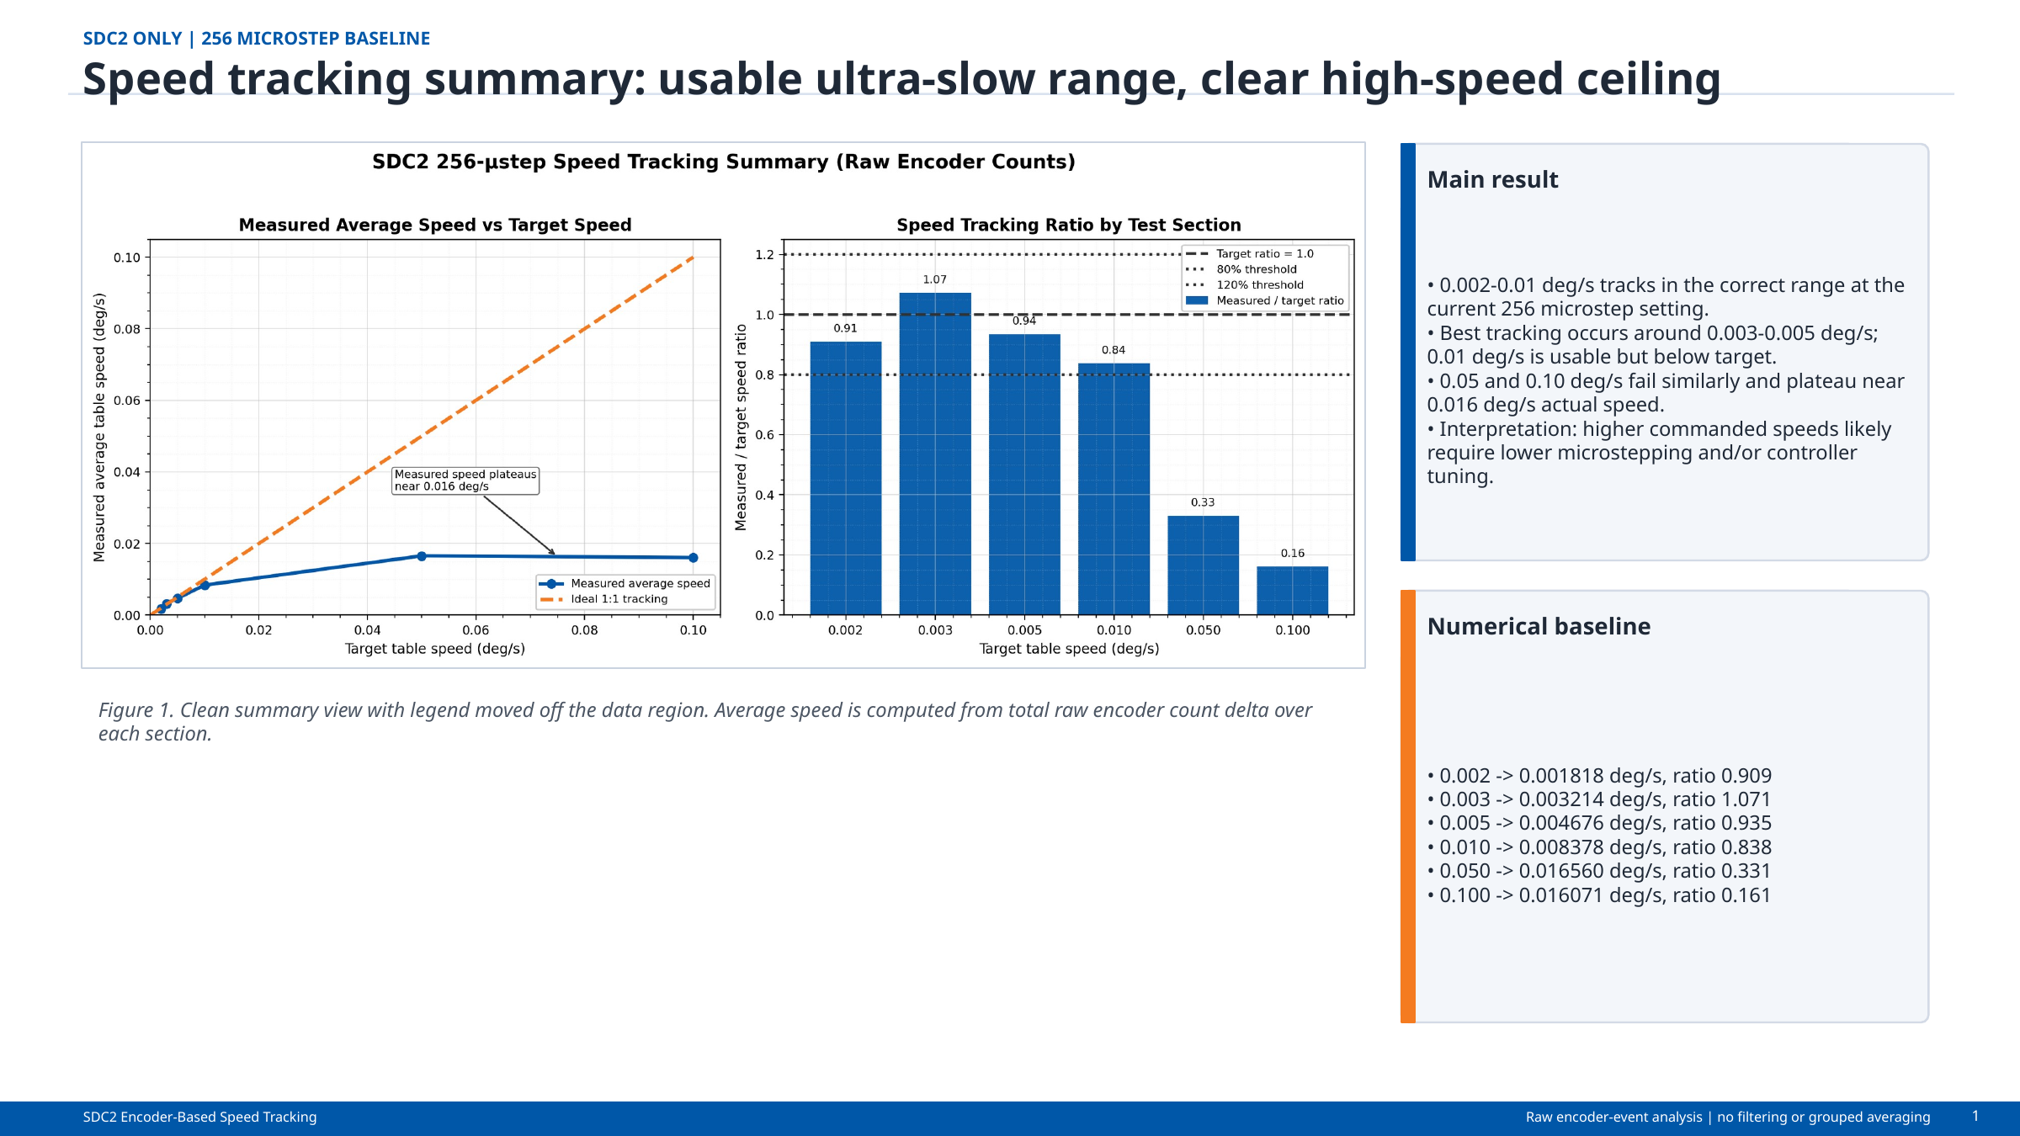
Figure 4. Speed-tracking summary across the characterized low-speed operating range and observed high-speed ceiling.
These results document measured behavior of the integrated testbed. They are retained as evidence of system performance rather than as tuning instructions or a reproduction recipe.
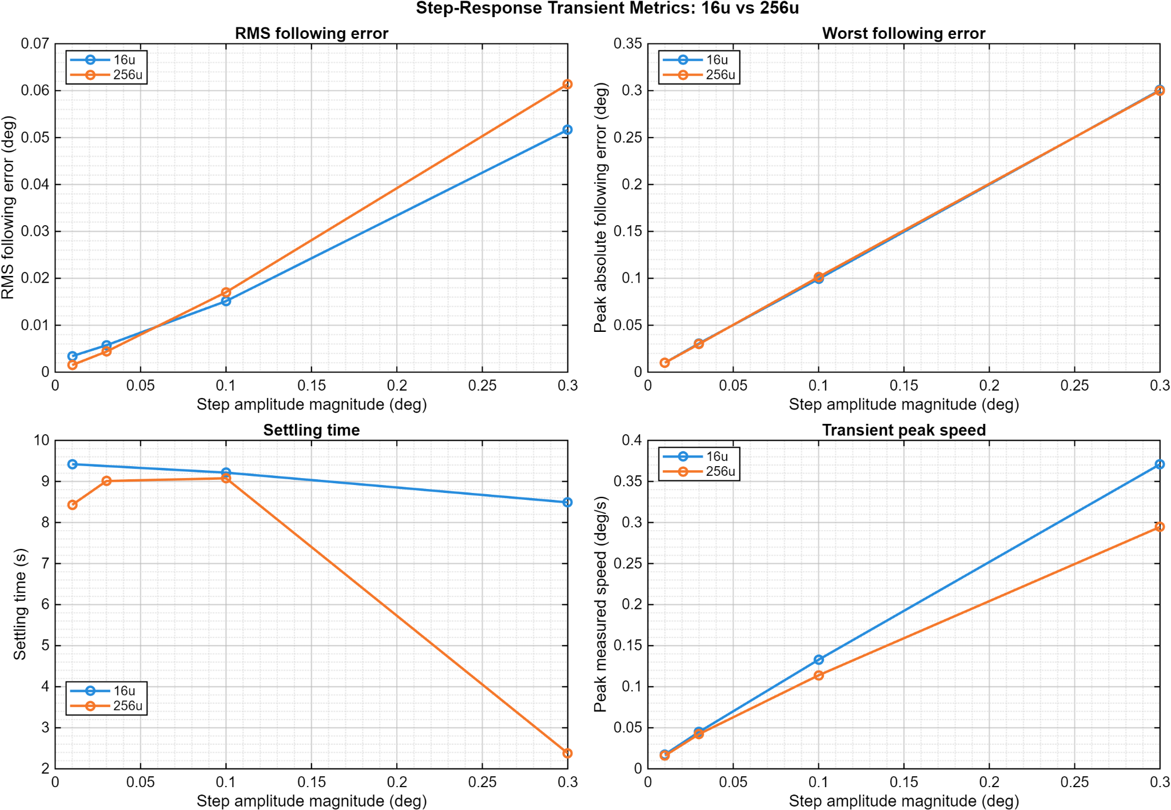
Figure 5. Extended constant-speed tracking and stability summary for representative operating points.
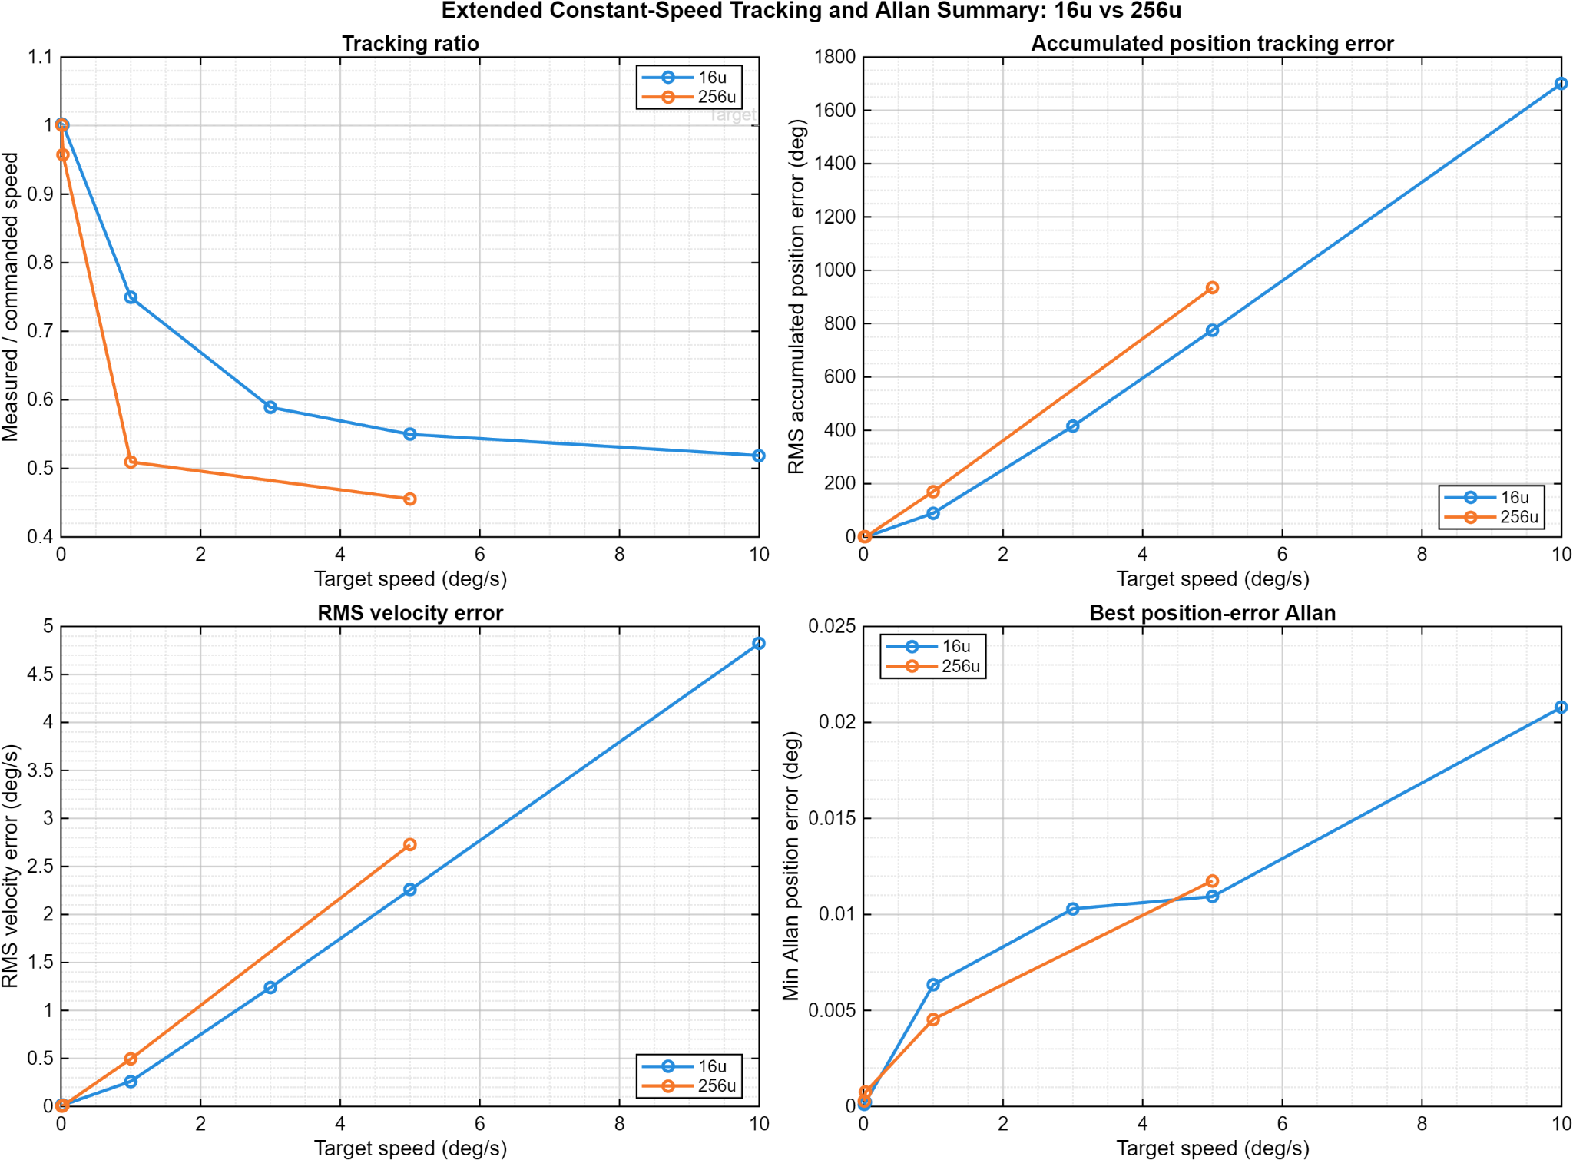
Figure 6. Step-response characterization showing following-error, gain, and position-area metrics.
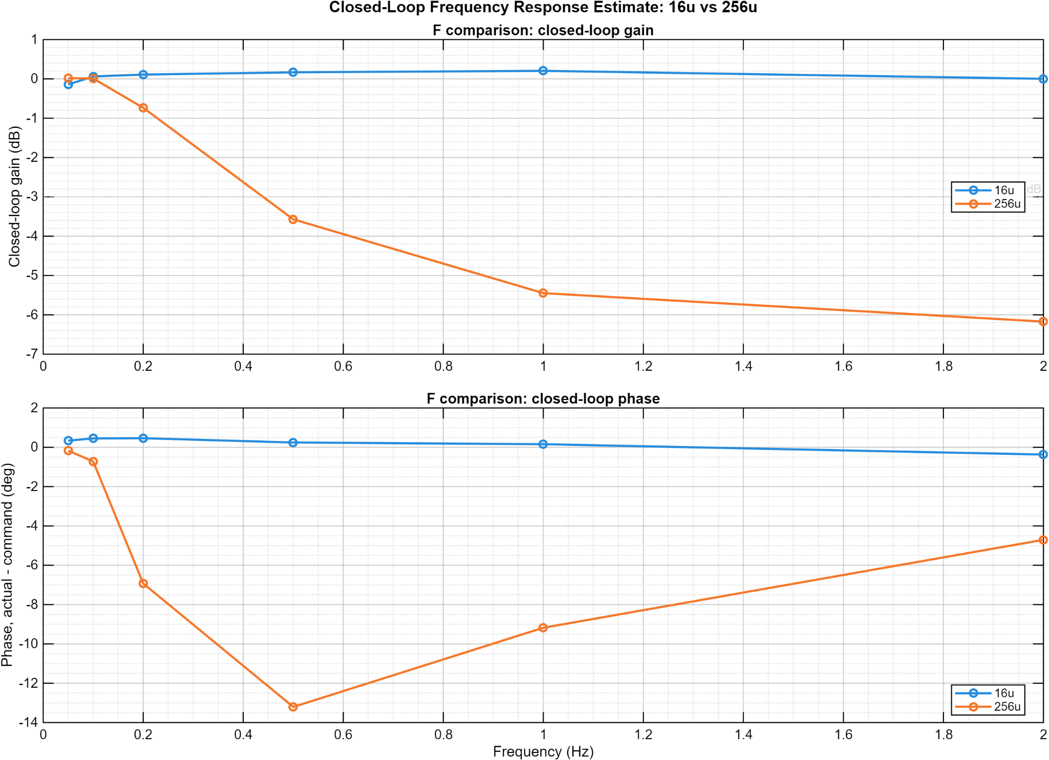
Figure 7. Closed-loop response estimate across the tested frequency range.
The public evidence set retains measured motion behavior rather than implementation internals. The useful ultra-low-speed range, constant-speed tracking, transient response, and closed-loop sine-response tests collectively show how the integrated control/test system behaves across different operating conditions. These figures are evidence, not a substitute for the withheld implementation.

Figure 2. Low-speed tracking summary showing the usable ultra-slow range and the observed high-speed ceiling of the tested configuration.
The low-speed data show the strongest tracking in the approximate 0.003-0.005 deg/s region. At higher requested speed in the tested fine-resolution configuration, the measured response approaches a ceiling rather than continuing linearly. That behavior is one of the reasons the architecture work focused on preserving motion-generation headroom while retaining fine motion resolution.
Commanded speed | Measured speed | Interpretation
0.002 deg/s | 0.001818 deg/s | Low-speed operation demonstrated; quantization and estimator effects are increasingly visible.
0.003 deg/s | 0.003214 deg/s | Strong agreement in the tested ultra-slow region.
0.005 deg/s | 0.004676 deg/s | Strong agreement with modest negative bias.
0.010 deg/s | 0.008378 deg/s | Tracking remains usable but error increases.
0.05-0.10 deg/s | Approximately 0.016 deg/s plateau in this configuration | Demonstrates a configuration-specific ceiling rather than a universal system limit.

Figure 3. Extended constant-speed tracking and stability characterization.

Figure 4. Step-response characterization using multiple transient error and tracking metrics.

Figure 5. Closed-loop sine-response estimate across the tested 0.33-2 Hz range.
The frequency-response evidence supports reporting behavior across the tested frequencies. It does not independently establish a formal -3 dB bandwidth because the available data do not demonstrate a complete, well-resolved crossing. Public claims are intentionally limited to the measured range.

7. Current Firmware Maturity and FOC Boundary
The reviewed v0.3 archive contains two distinct motor-control paths. The deployable path supported by the available feedback is an encoder-based closed position/speed controller that produces a sensored rotating voltage command. It is not current-regulated field-oriented control. A separate current-sensed FOC integration path is present for future commissioning once calibrated phase-current feedback and the required power-stage integration are available.
Capability | Current public disposition
Dual-core command/telemetry architecture | Implemented and reviewed at the application-contract level; production memory-map and synchronization details remain private.
Encoder-based position/speed control | Implemented as encoder-only closed position/speed control producing a sensored rotating voltage-vector demand.
1 kHz control cadence | Nominal supervisory/control-law cadence in the reviewed integration. It is not the PWM carrier or STEP-event rate; those remain independently hardware-timed and validated.
Current-regulated d/q FOC | Current-sensed d/q control logic exists as an integration path, but commissioned current-regulated FOC is not claimed.
Power-stage/peripheral-specific implementation | Board-specific timer, current-sense, gate-drive, mapping, calibration, and energized commissioning details remain outside the public release boundary.

8. Verification and Traceability
Requirement | Verification evidence | Disposition
FW-FR-001 | Architecture review and concurrent workload analysis | Satisfied at architecture level
FW-FR-002 | Reviewed 1 kHz supervisory-control cadence plus requirement for independent hardware carrier/event timing | Implemented at control-task level; carrier/event timing is a separate hardware validation item
FW-FR-003 | GUI captures and logged commanded/measured state | Demonstrated
FW-FR-004 | Integrity counters, sequence continuity, and fault-observability requirements | Implemented/verified privately; public method stated
FW-FR-005 | State/fault gating review and safe-output requirement | Implemented in reviewed integration
FW-FR-006 | Travel/speed/invalid-feedback boundary behavior | Defined and privately verified
FW-FR-007 | Automated characterization plots and retained data products | Demonstrated
FW-FR-008 | Source-to-document reconciliation of encoder path versus FOC path | Satisfied

9. Limitations and Public Release Controls
- No source code, Simulink/model files, memory maps, linker placement, cache/MPU configuration, synchronization code, pinouts, schematics, PCB files, BOMs, or setup/flash procedures are included.
- Measured performance is specific to the tested hardware/configuration and is not presented as a universal controller limit.
- Current-sensed FOC commissioning is not claimed by the reviewed v0.3 evidence.
- The public coherency discussion defines the correctness requirement and verification intent, not the private implementation method.
- Formal EMC, environmental, functional-safety, and production qualification are outside the scope of this portfolio FRD.

Document Control
Revision | Date | Description
7.3 | 13 August 2026 | Final public FRD aligned to reviewed v0.3 evidence.

